Documentation

Introduction to WebScanPro
WebScanPro is an automated web application security testing tool developed as part of an internship project to understand the internal working of vulnerability scanners and modern security assessment methodologies. The primary objective of this project is to design and implement a modular scanning system capable of identifying common web application vulnerabilities based on the OWASP Top 10 standards.
The tool scans a target web application — DVWA (Damn Vulnerable Web Application) in our case — and performs both automated and controlled manual testing to detect vulnerabilities such as SQL Injection and Cross-Site Scripting (XSS). The project focuses on simulating real-world attack techniques, analyzing HTTP responses, and generating structured vulnerability reports.

Week 1 – Project Initialization and Environment Setup
Objective of Week 1:
Week 1 focused on establishing the foundational infrastructure required for developing WebScanPro. The primary objective during this phase was to define the project goals, set up a controlled testing environment, and install all necessary tools and dependencies. This included configuring Python and its required libraries, creating an isolated virtual environment, installing Docker, and deploying DVWA as the target application. The purpose of this phase was to create a stable and secure lab environment where vulnerability testing and automated scanning modules could be safely developed and executed.

1. Software & Tools Installed

A. Python
Python is used to build the automated scanner.
Installation verified using:
python --version
pip --version
Python is responsible for:
- Sending HTTP requests
- Automating login
- Crawling web pages
- Performing vulnerability tests (later stages)

B. Virtual Environment (venv)
A virtual environment was created to isolate project dependencies.
Creation:
python -m venv venv
Activation (Windows):
venv\Scripts\activate
Purpose:
- Keeps project libraries separate from system Python
- Avoids dependency conflicts
- Ensures reproducibility

C. Installed Python Libraries
Installed using pip:
pip install requests
pip install beautifulsoup4
pip install selenium

Library Purpose:
- requests → Sends HTTP GET and POST requests to websites
- beautifulsoup4 → Parses HTML to extract forms and links
- selenium → Browser automation (for advanced testing)
A requirements.txt file was created to list these dependencies.

2. Docker Installation & DVWA Setup

A. Docker Desktop
Docker is used to run DVWA inside a container.
Verification:
docker --version
Purpose of Docker:
- Runs DVWA in an isolated environment
- No need to manually configure Apache, PHP, MySQL
- Easy start/stop of vulnerable environment

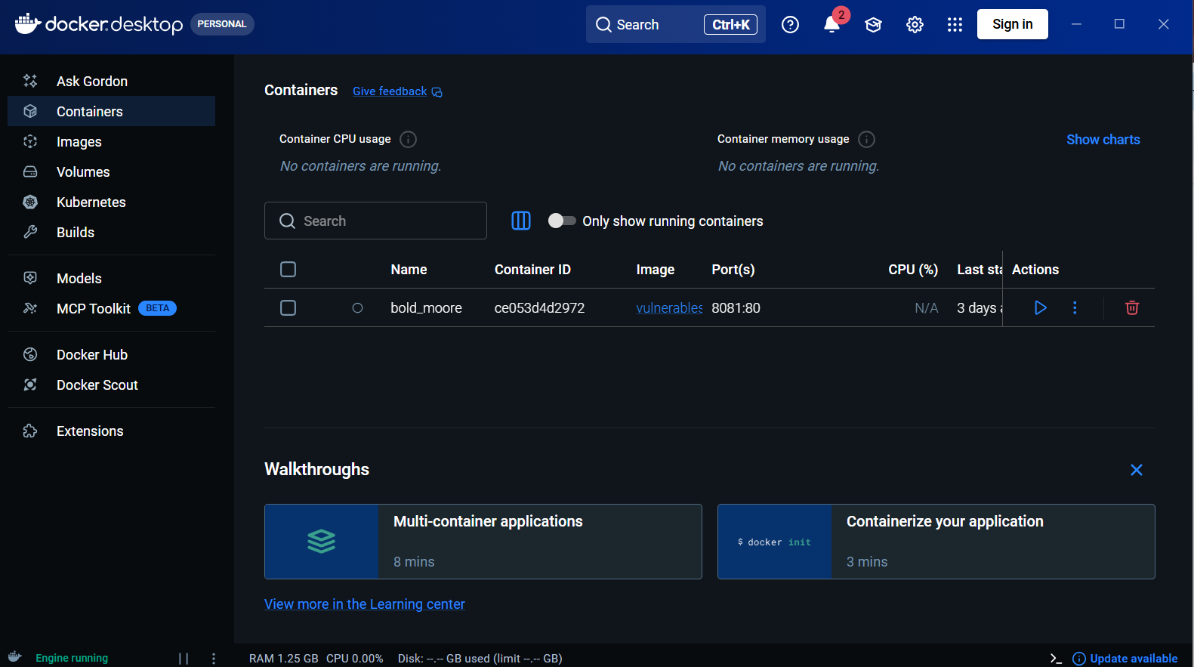

B. DVWA Installation

DVWA was deployed using Docker to create a safe and isolated testing environment.
The DVWA image was downloaded using:
docker pull vulnerables/web-dvwa
This command fetched the pre-configured DVWA application containing Apache, PHP, and MySQL.
The container was started using:
docker run -d -p 8081:80 vulnerables/web-dvwa
Here:
- -d runs the container in background
- -p 8081:80 maps local port 8081 to port 80 inside the container
Since DVWA runs on port 80 inside the container, accessing:
http://localhost:8081
opens the DVWA application in the browser.
Docker was used to ensure easy setup, isolation, and safe vulnerability testing.

~ What is DVWA?
DVWA (Damn Vulnerable Web Application) is an intentionally insecure web application designed for:
- Security testing practice
- Learning web vulnerabilities
- Developing automated scanners
It contains built-in vulnerabilities such a0s:
- SQL Injection
- XSS
- Command Injection
- File Inclusion
- Brute Force
- CSRF
DVWA is used as the safe target application for this project.

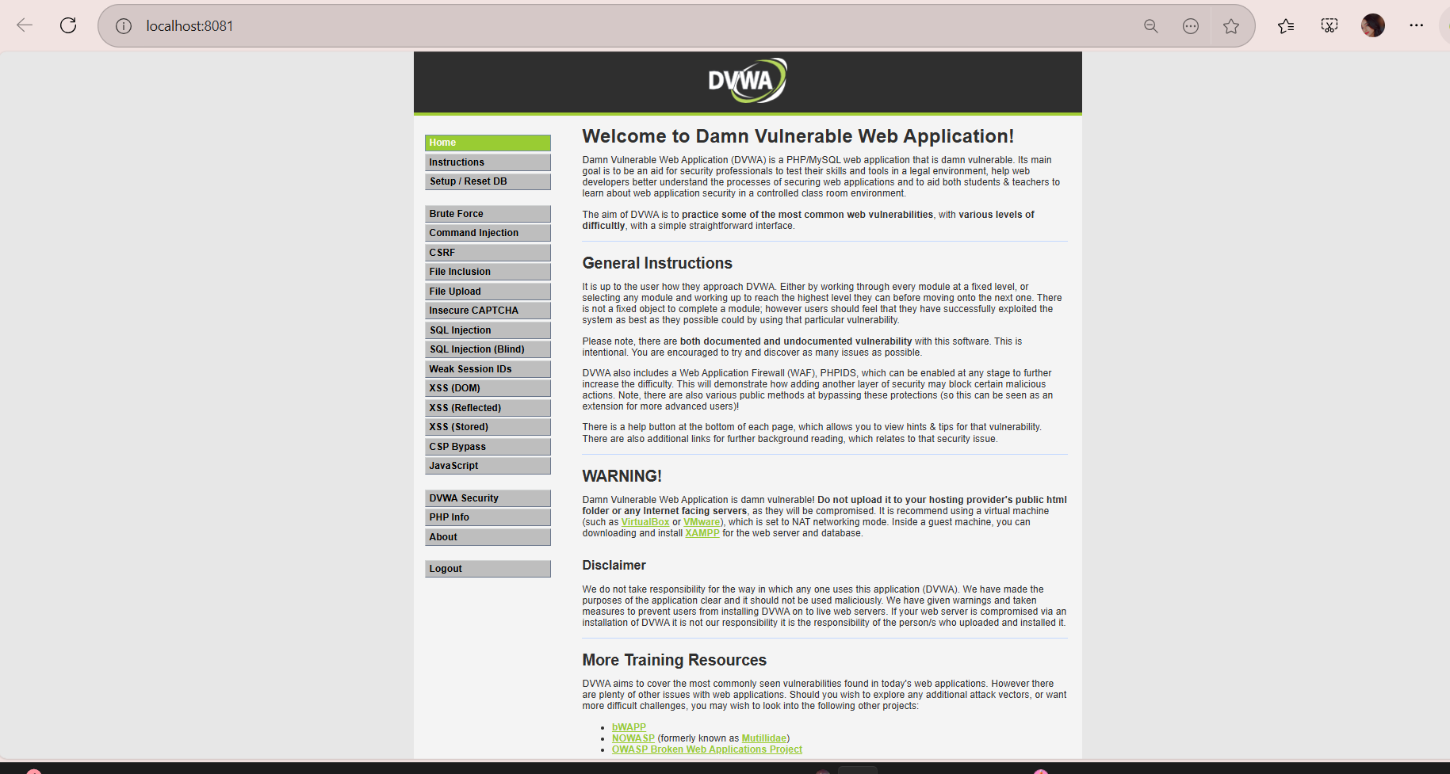

3. Project Folder Structure
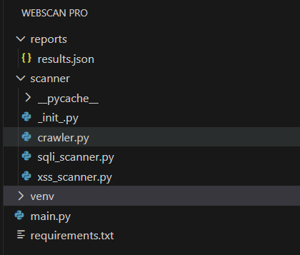

A. venv/
This folder contains the virtual environment created for the project.

Purpose
The purpose of this folder is to:
- Maintain isolated Python dependencies
- Avoid conflicts with system-wide Python packages
- Ensure consistent execution across systems
It contains installed libraries such as:
- requests
- beautifulsoup4
- other required modules
This folder is not part of the core application logic and is usually not uploaded to GitHub.

B. scanner/
This folder contains the core scanning modules of the project.
All vulnerability detection logic is implemented here.

(i) __init__.py
This file makes the scanner folder a Python package.

Purpose
It allows importing modules like:
- from scanner.crawler import crawl
- from scanner.sqli_scanner import scan_sql
Without this file, Python cannot treat the folder as a package.

(ii) crawler.py
This module is responsible for exploring the target website.

Purpose
The purpose of this module is to:
- Discover all accessible links
- Extract HTML forms
- Identify input fields
- Detect GET and POST parameters

What It Does
- Sends HTTP request to target URL.
- Parses HTML using BeautifulSoup.
- Extracts:
  - <a> tags (links)
  - <form> tags
  - <input> fields
- Returns structured data to other modules.
This module helps in identifying attack surfaces for vulnerability testing.

(iii) sqli_scanner.py
This file detects SQL Injection vulnerabilities.

Purpose
It attempts to inject SQL payloads into discovered input fields and checks if the application is vulnerable.

What It Does
- Takes form data from crawler.
- Inserts SQL payloads such as:
' OR '1'='1
- Submits modified request.
- Analyzes server response for:
  - SQL syntax errors
  - Authentication bypass
  - Abnormal database behavior
If database errors appear, it confirms SQL Injection vulnerability.

(iv) xss_scanner.py
This file detects Cross-Site Scripting vulnerabilities.
Purpose
It injects JavaScript payloads into input fields and checks whether they are reflected in the response.

What It Does
- Receives forms from crawler.
- Injects payload:
<script>alert('XSS')</script>
- Submits form.
- Checks if script appears in response unescaped.
If payload is reflected in page source, XSS is confirmed.

C. reports/
- Stores scan results
- Will contain JSON/HTML reports in later stages

D. main.py
- Entry point of the application
- Controls execution flow
- Performs:
  - Connection check
  - Login automation
  - Calls crawler
When running:
python main.py
Execution starts from this file.

E. requirements.txt
- Lists all required Python libraries
- Allows installation using:
pip install -r requirements.txt

Ensures environment can be recreated easily.

4. Manual Vulnerability Testing in DVWA
The following section describes the manual testing of vulnerabilities performed on DVWA (Damn Vulnerable Web Application). All tests were conducted with the security level set to Low in order to clearly observe insecure behaviors and understand how vulnerabilities occur due to improper input handling.

A. SQL Injection

Introduction
SQL Injection is a vulnerability that occurs when user input is directly included in a database query without proper validation or parameterization. This allows an attacker to manipulate the structure of the SQL query and retrieve unauthorized data.

Manual Testing Procedure
The SQL Injection module was accessed from the DVWA interface. Initially, a normal input value of 1 was entered into the User ID field. The application returned a single user record corresponding to that ID.
After verifying normal behavior, a malicious input was provided:
1' OR '1'='1
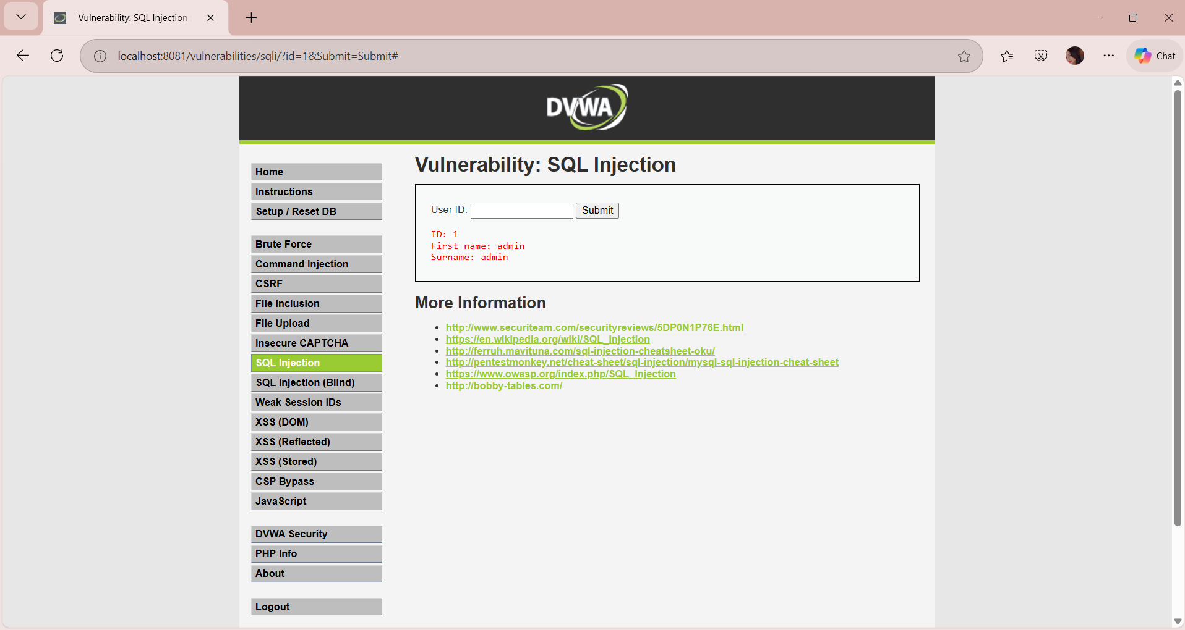
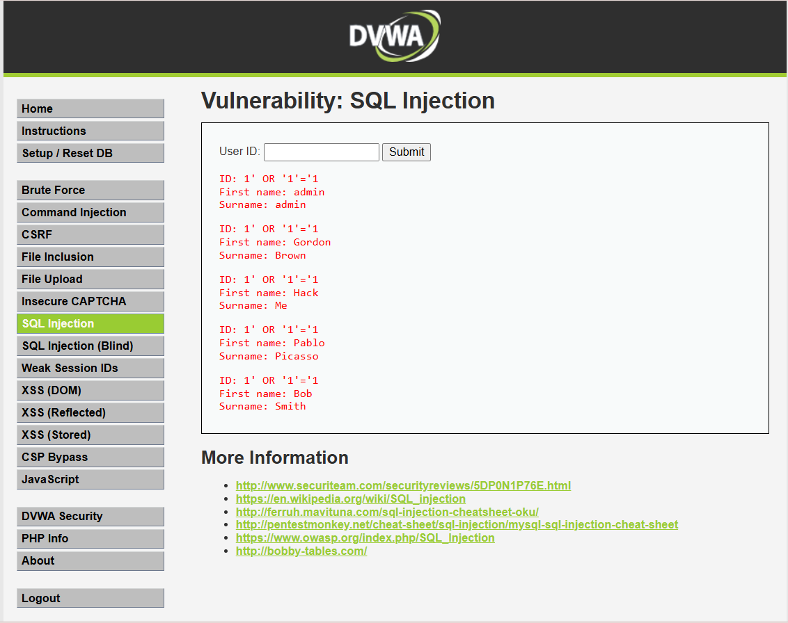

Result
The application displayed multiple user records instead of one. This confirmed that the input was not properly validated and that the system was vulnerable to SQL Injection.

Conclusion
The vulnerability exists because user input is directly embedded into the SQL statement without using prepared statements or parameterized queries.

B. Reflected Cross-Site Scripting (XSS)

Introduction
Reflected Cross-Site Scripting occurs when user input is immediately reflected back in the webpage without proper sanitization, allowing execution of malicious JavaScript code.

Manual Testing Procedure
The XSS (Reflected) module was opened. The following payload was entered in the input field:
<script>alert('XSS')</script>
The form was then submitted
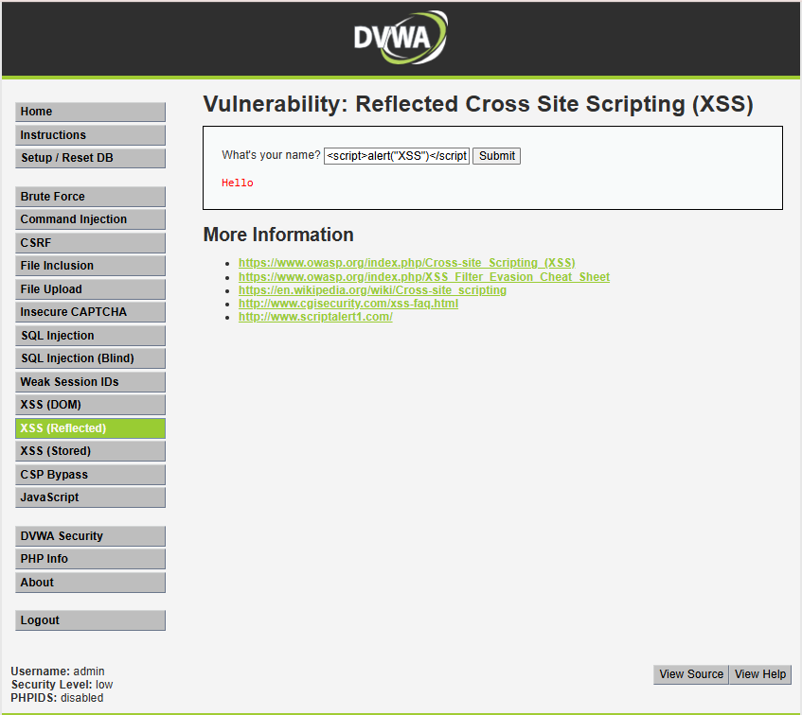
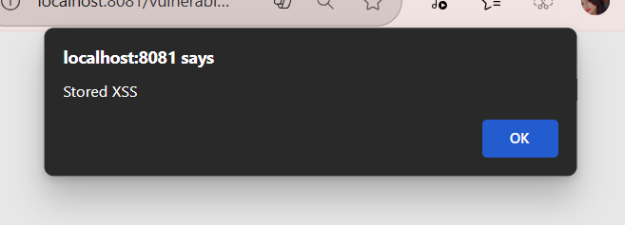
.

Result
An alert box appeared in the browser. This confirmed that the script was executed successfully, indicating the presence of a reflected XSS vulnerability.

Conclusion
The vulnerability exists because the application fails to sanitize or escape HTML special characters before rendering user input.

C. Stored Cross-Site Scripting (Stored XSS)

Introduction
Stored XSS is a persistent form of XSS in which malicious input is stored in the database and executed whenever the page is accessed.

Manual Testing Procedure
The XSS (Stored) module was accessed. The following payload was entered into the message field:
<script>alert('Stored')</script>
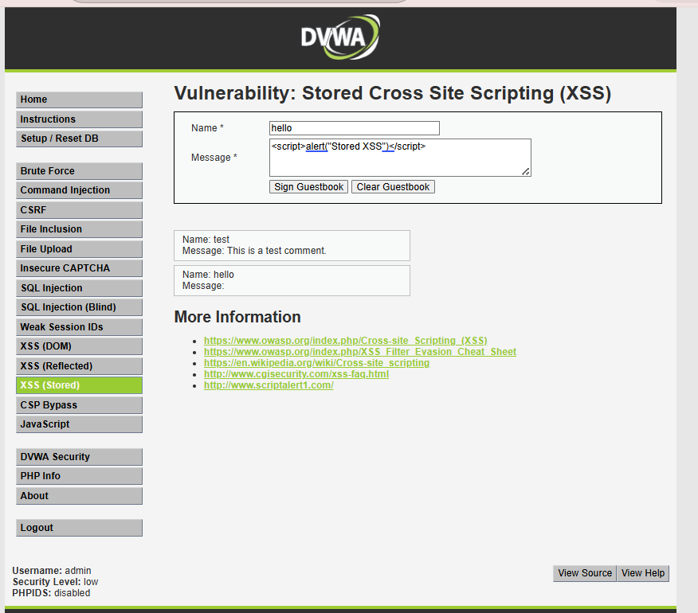
The form was submitted and the page was refreshed.

Result
The alert box appeared each time the page was loaded. This confirmed that the malicious script was permanently stored and executed repeatedly.

Conclusion
Stored XSS is more dangerous than reflected XSS because it affects every user who accesses the page. The vulnerability exists due to lack of input validation before storing data.

D. Command Injection

Introduction
Command Injection occurs when user input is directly passed to system-level commands without validation, allowing execution of arbitrary operating system commands.

Manual Testing Procedure
The Command Injection module was opened. First, a normal IP address such as:
127.0.0.1

was entered, and the application displayed the ping result.
Then, the following malicious input was provided:
127.0.0.1; ls
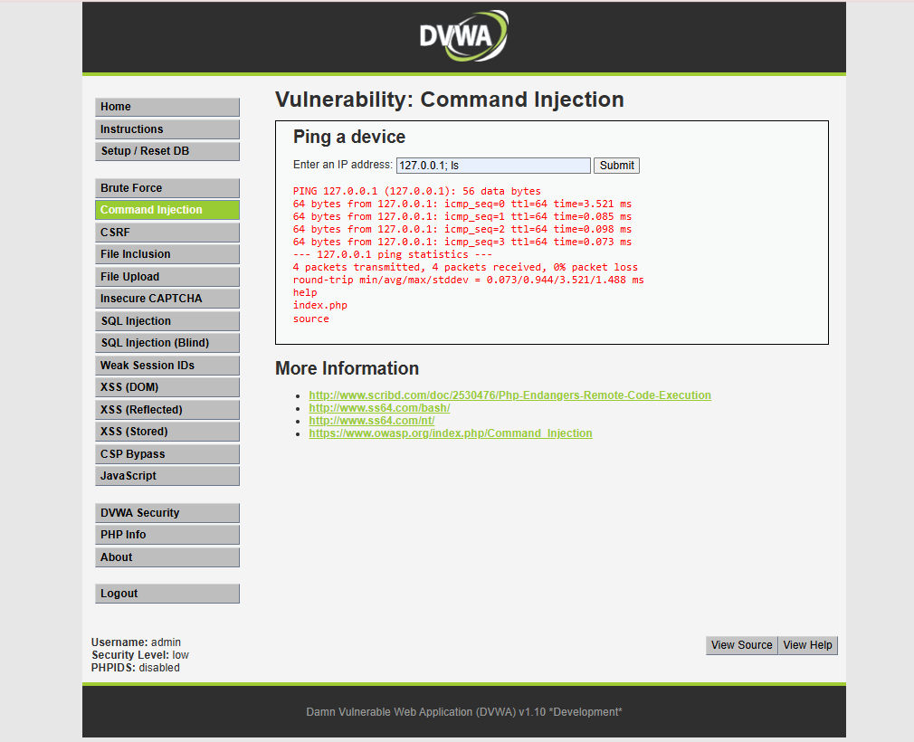

Result
The output displayed not only the ping result but also the list of files in the directory. This confirmed that arbitrary system commands could be executed.

Conclusion
The vulnerability exists because the application does not validate or sanitize input before passing it to the system command.

5. Outcome of Week 1
By the end of Week 1, the foundational environment and project structure for WebScanPro were successfully established.
The system was capable of:
- Successfully installing and configuring Python and required libraries
- Creating and activating a virtual environment for dependency isolation
- Installing and running Docker
- Deploying and accessing DVWA** (Damn Vulnerable Web Application)** in a controlled environment
- Verifying successful connection to the target application (HTTP status validation)
- Understanding and manually testing core vulnerabilities such as:
  - SQL Injection
  - Reflected XSS
  - Stored XSS
  - Command Injection
- Designing the project folder structure
- Setting up the core execution file (main.py)
- Preparing the scanner architecture for future automation modules
Week 1 successfully completed the Environment Setup and Vulnerability Understanding Phase, creating a secure lab setup and establishing the technical groundwork required for automated scanning implementation in the upcoming weeks.

