Documentation

Week 2 – Target Scanning Module Implementation

Objective of Week 2
The primary objective of Week 2 was to develop an automated crawling mechanism capable of discovering the attack surface of the target web application.
This involved:
- Automatically exploring internal pages
- Extracting HTML forms
- Identifying input parameters
- Structuring discovered metadata
- Saving results for future vulnerability testing modules

1. Crawler Module Development (crawler.py)
During Week 2, a recursive crawler was implemented inside the scanner module.
The crawler performs the following tasks:
- Sends authenticated HTTP requests using session object
- Parses HTML content using BeautifulSoup
- Extracts <form> elements
- Identifies <input> fields within each form
- Extracts form action URL
- Identifies HTTP method (GET or POST)
- Recursively visits internal links
- Avoids duplicate crawling using a visited set
This ensures complete internal attack surface mapping.

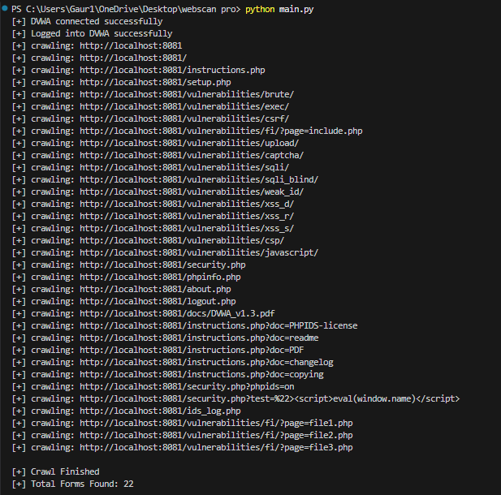

2. Attack Surface Discovery
After successful authentication, the crawler explored the DVWA application and discovered multiple vulnerability modules including:
- SQL Injection
- XSS (Reflected, Stored, DOM)
- Command Injection
- File Upload
- CSRF
- Brute Force
- File Inclusion
- Authentication modules
The crawler identified all form-based input points across these modules.
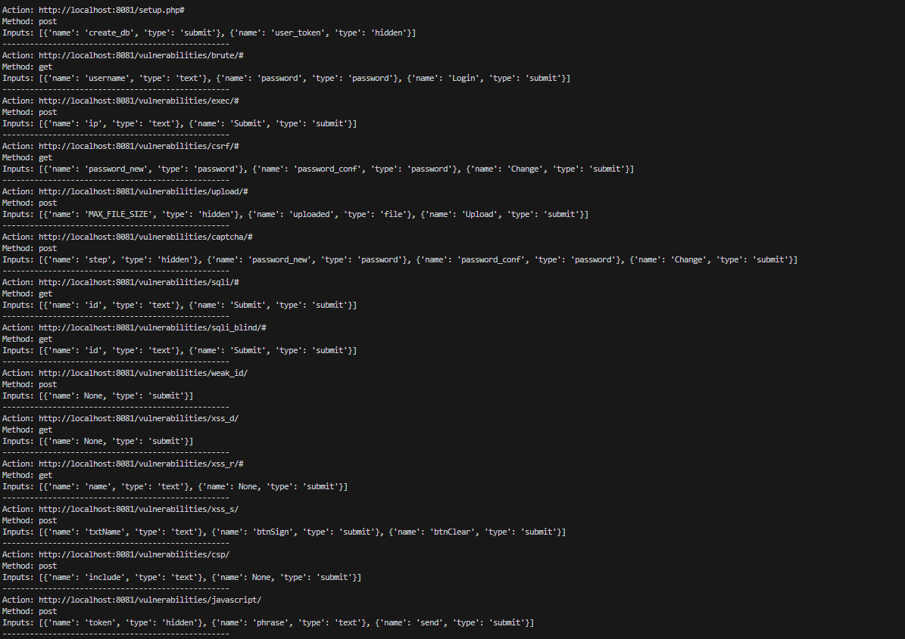

3. Results Obtained
The crawler successfully discovered:
- Target URL: http://localhost:8081
- Total Forms Identified: 22
Each discovered form includes:
- Action endpoint
- HTTP request method
- Input parameter names
- Input types
This confirms successful attack surface mapping.

4. Structured Metadata Storage (JSON Output)
The extracted data was saved into:
reports/results.json

The JSON structure contains:
- target → Base application URL
- total_forms → Total discovered forms
- forms → List of structured form objects
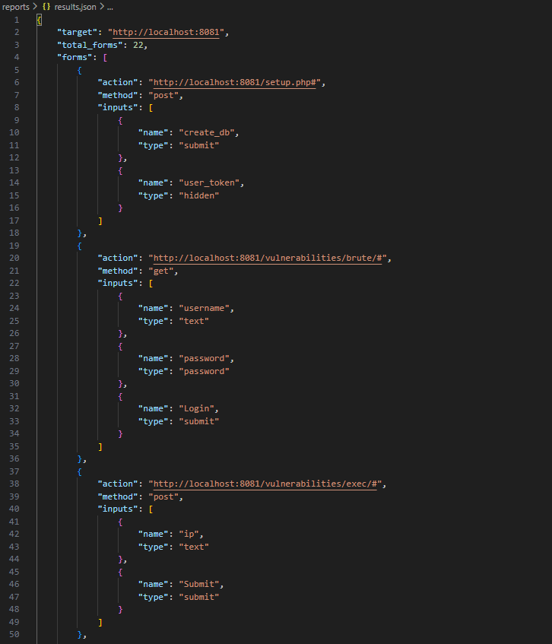
This structured format allows seamless integration with SQL Injection and XSS testing modules in the next milestone.

5. Technical Significance of Week 2
Week 2 established the foundational layer of the scanner by:
- Automating page discovery
- Identifying injection points
- Structuring attack surface data
- Enabling modular vulnerability testing
Without this stage, automated vulnerability detection would not be possible.

6. Outcome of Week 2
By the end of Week 2, the system was capable of:
- Authenticating with the application
- Recursively crawling internal endpoints
- Extracting form-based input parameters
- Persisting structured metadata
- Preparing input data for SQL Injection and XSS modules
This successfully completed the Target Scanning Module as defined in Milestone 1.

