WebScanPro Project - Week 1 Setup Documentation

1. Objective
The objective of Week 1 was to initialize the WebScanPro project environment, install required tools, deploy a vulnerable web application using Docker, and explore its structure and functionality.

2. Tools and Software Installed
- Windows 10 Operating System
- Docker Desktop
- Windows Subsystem for Linux (WSL 2)
- Git and GitHub
- Visual Studio Code
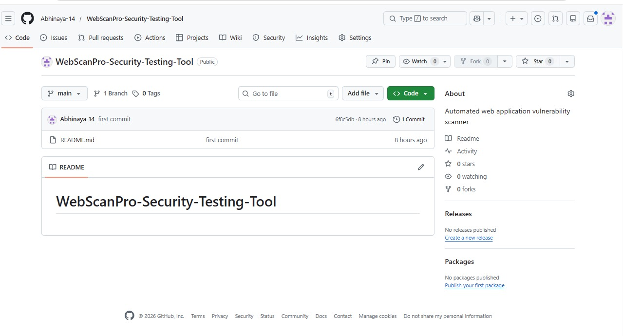

3. Docker and WSL Setup
Docker Desktop was installed and configured on Windows 10. WSL 2 was updated using administrative PowerShell commands. After restarting the system, Docker Engine was verified to be running successfully.
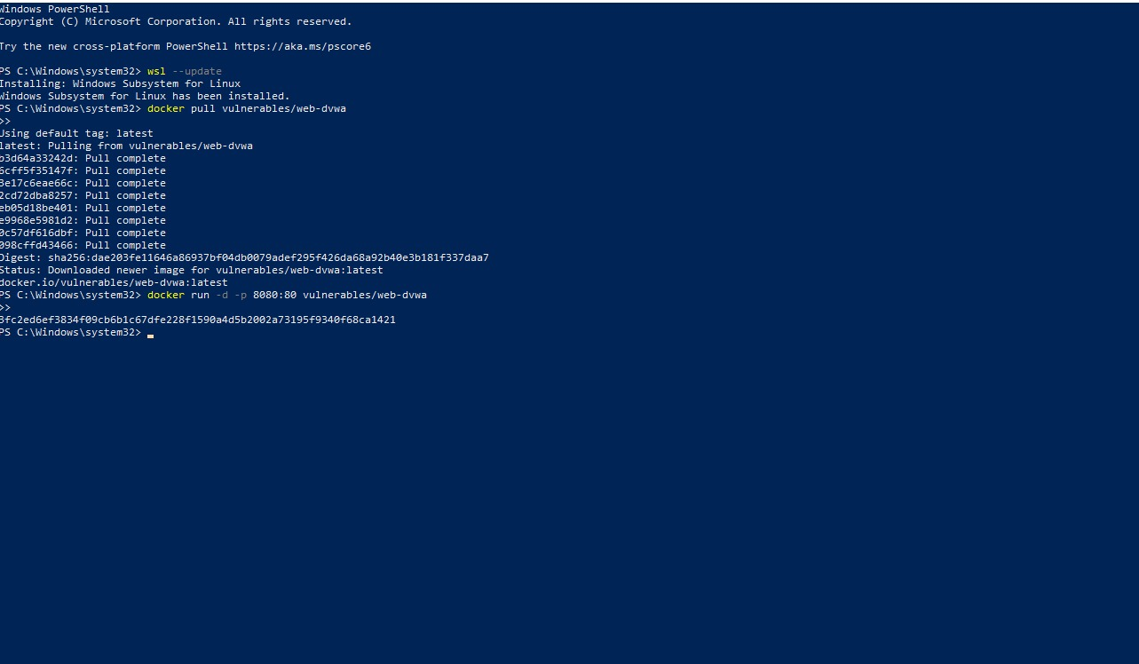

4. DVWA Deployment Using Docker
The DVWA (Damn Vulnerable Web Application) container was downloaded and executed using the following commands:
docker pull vulnerables/web-dvwa
docker run -d -p 8080:80 vulnerables/web-dvwa
The application was accessed through http://localhost:8080.
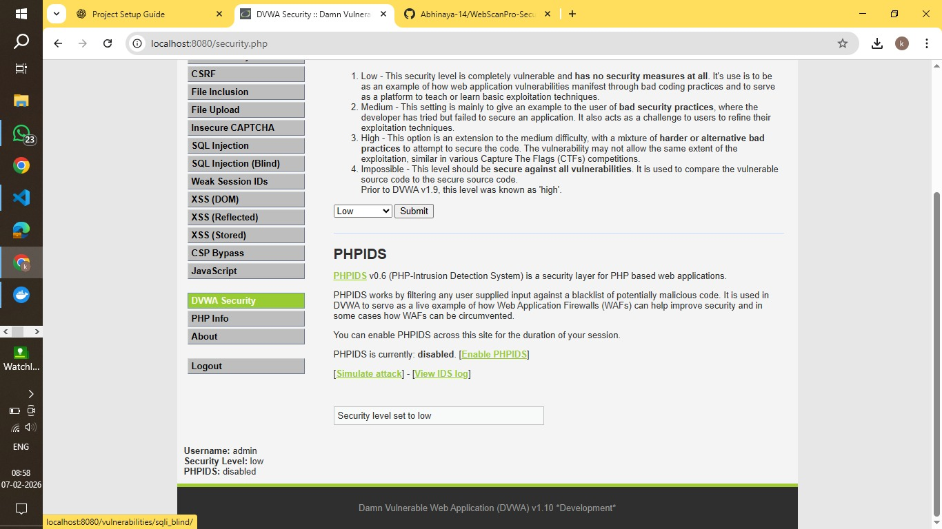

5. Database Setup
The DVWA database was initialized by clicking the 'Create / Reset Database' button. After setup, login was completed using the default credentials (admin / password).
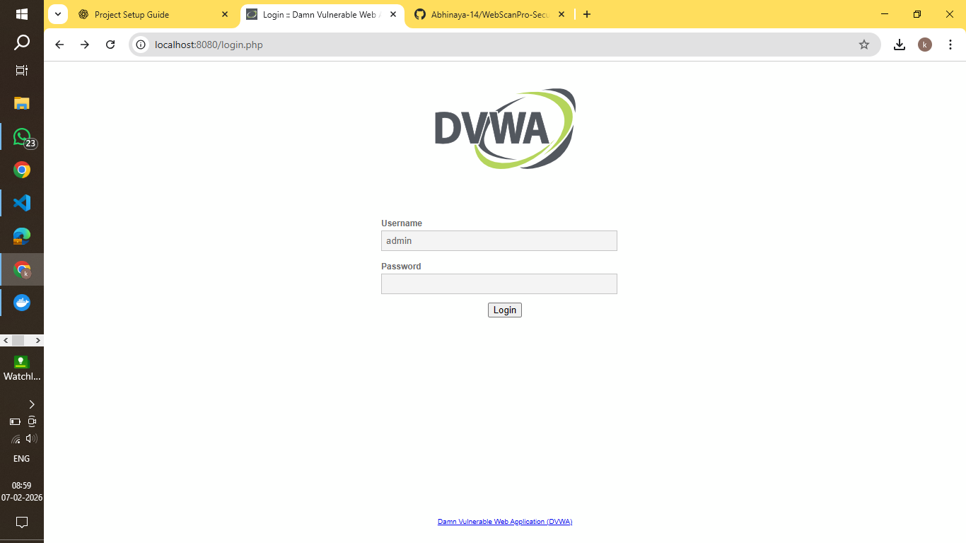

6. Security Configuration
The security level in DVWA was set to 'Low' to allow easier testing of vulnerabilities during development.
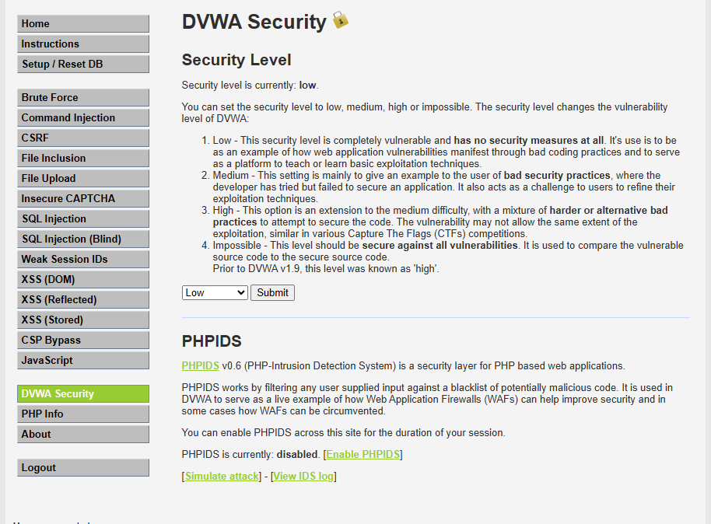

7. Exploration of Application
The DVWA modules such as SQL Injection, Cross-Site Scripting (XSS), and authentication features were explored to understand the structure and built-in vulnerabilities.
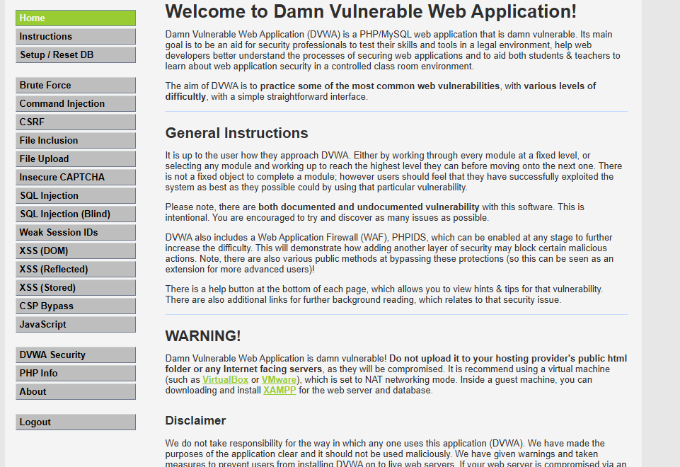

8. Outcome
The project environment was successfully created. DVWA is running locally, and the system is ready for developing automated security testing modules in the upcoming milestones.

