BIKE SHARING DEMAND PREDICTION
SPRINGBOARD 6.0
BATCH 5

UNDER GUIDANCE OF
VISHWANTH PRAYAGA
DATA SCIENTIST AT INFOSYS

SUBMITTED BY
Preetham N

TABLE OF CONTENTS

 | S.NO | TITLE |  |  |  |  | PAGE NO
 |  | CHAPTER
01 |  | CHAPTER 1 | INTRODUCTION
 |  | 1.1 | INTRODUCTION
 |  | 1.2 | MOTIVATION
02 |  | CHAPTER 2 | OBJECTIVE & METHODOLOGY
 |  | 2.1 | ONBJECTIVES
 |  | 2.2 | METHODOLOGY
 |  |  | 2.2.1 | DATASET
 |  |  | 2.2.2 | DATA PREPROCESSING
 |  |  | 2.2.3 | BACKGROUND OF MODELS
 |  |  |  | 2.2.3.1 |  | LINEAR REGRESSION
 |  |  |  | 2.2.3.2 |  | LASSO
 |  |  |  | 2.2.3.3 |  | RIDGE
 |  |  |  | 2.2.3.4 |  | ELASTIC NET
 |  |  |  | 2.2.3.5 |  | DECISION TREE
 |  |  |  | 2.2.3.6 |  | RANDOM FOREST
 |  |  |  | 2.2.3.7 |  | GRADIENT BOOSTING
 |  |  | 2.2.4 | TRAINING MODEL
 |  |  | 2.2.5 | TESTING WITH UNSEEN DATA
 |  |  | 2.2.6 | BEST MODEL
03 |  | CHAPTER 3 | RESULTS & CONCLUSION
 |  | 3.1 |  | RESULTS
 |  |  |  | 3.1.1 | TRAINING PHASE
 |  |  |  | 3.1.2 | TESTING PHASE
 |  |  |  | 3.1.3 | USER INTERFACE
 |  | 3.2 |  | CONCLUSION

1.INTRODUCTION

1.1 INTRODUCTION
Urban mobility isn’t just evolving—it is being completely reimagined. Cities are steadily shifting toward smarter and greener modes of transportation, and bike-sharing systems have become a key part of this transformation. They offer a flexible, low-cost, and eco-friendly solution for short-distance travel, while also helping to reduce traffic congestion and pollution.
However, bike-sharing demand is highly dynamic. People do not rent bikes uniformly every day. Their rental behaviour changes with:
- Weather conditions (temperature, humidity, windspeed)
- Seasons (summer, winter, fall, spring)
- Weekdays vs. weekends
- Holidays vs. normal working days
For example, a cloudy, rainy day can cause a sudden drop in rentals, while a sunny weekend can cause demand to spike sharply. This makes predicting bike usage challenging and uncertain.
This project addresses that challenge.
Using the UCI Bike Sharing Dataset, the system analyzes historical rental patterns along with weather and calendar information, and then trains machine learning models to predict daily bike rental counts. The goal is to convert raw real-world usage data into accurate and useful demand predictions that can support data-driven decision making for bike-sharing operators.

1.2 MOTIVATION
As cities grow denser, traditional transportation systems struggle to deliver efficiency, sustainability, and affordability. Problems such as:
- Traffic congestion
- Increasing fuel costs
- Environmental pollution
- Limited parking and road capacity
have motivated governments, planners, and commuters to look for alternative modes of transport. Bike-sharing systems have emerged as a strong candidate because they are:
- Environmentally friendly
- Suitable for short trips
- Flexible and easy to use
- Cost-effective
However, simply deploying bikes in a city is not enough. The effectiveness of a bike-sharing system depends on its ability to anticipate user demand. If demand is underestimated or overestimated:
- Some stations may run out of bikes
- Other locations may have too many idle bikes
- Maintenance and rebalancing operations become inefficient
- Users may face inconvenience and lose trust in the service
This highlights the need for a data-driven demand forecasting system.
The motivation behind this project is to use historical data and machine learning techniques to build a robust prediction model for daily bike-sharing demand. Accurate demand prediction helps operators:
- Optimize fleet distribution
- Plan maintenance and staff allocation
- Improve service reliability
- Reduce operational costs
- Support sustainable and intelligent urban transportation
By transforming patterns in historical usage data into actionable insights, this project contributes to smarter transportation planning and more efficient urban mobility.

2.1 Objectives
The primary objective of this project is to develop a reliable machine learning system capable of predicting daily bike-sharing demand using historical usage patterns, weather conditions, and temporal (date and calendar) features.
Specific Objectives
- Predict Bike-Sharing Demand
Develop a regression-based prediction system that estimates daily rental counts using relevant historical and environmental features.
- Compare Multiple Machine Learning Models
Train, evaluate, and benchmark several regression algorithms—such as Linear Regression, Ridge, Lasso, Elastic Net, Random Forest, and Gradient Boosting—to identify the most effective model for demand forecasting.
- Build a Robust End-to-End Pipeline
Implement a complete pipeline covering:
- Data loading and preprocessing
- Feature engineering
- Train–test splitting
- Model training and evaluation
- Hyperparameter tuning using GridSearchCV
- Saving models and scalers for deployment
- Identify Key Predictors of Demand
Analyze feature importance to understand how:
- Temperature
- Humidity
- Windspeed
- Season
- Holiday and working day information
influence bike rental behaviour.
- Test Model Performance on Unseen Data
Validate the final model using new data to ensure generalizability, reliability, and real-world readiness.
- Generate Actionable Operational Insights
Use the model results to provide insights for:
- Fleet rebalancing
- Resource planning
- Strategic operation of bike-sharing systems
- Deploy a User-Friendly Interface
Build a Streamlit-based web application that allows users to input ride conditions and obtain predicted bike demand in real time.
- Document and Visualize Findings
Present the entire pipeline and results through clear documentation, tables, and visualizations for better interpretability.

2.2 Methodology
The methodology follows a structured machine learning workflow, from raw data to deployment.
Overall Steps:
- Dataset overview and loading
- Data cleaning and preprocessing
- Exploratory data analysis and feature engineering
- Splitting into training and test sets
- Training multiple regression models
- Hyperparameter tuning using GridSearchCV
- Evaluation on training and test data
- Selecting the best model
- Saving the model and scaler
- Building and integrating a Streamlit web interface

2.2.1 Dataset Description
This project uses the UCI Bike Sharing Dataset, a widely recognized benchmark for time-series forecasting and urban mobility research. The dataset captures two years (2011–2012) of bike rental activity in Washington D.C., combined with rich weather metadata and temporal features. Each record represents a snapshot of bike-sharing demand at a specific time, influenced by environmental conditions and user behavior patterns.
Below is an overview of every feature included in the dataset:
1. Identification & Time Features
These columns provide context for when the rental event occurred:
Feature | Description
instant | Unique record index used for ordering observations.
dteday | Actual calendar date of each observation.
season | Season of the year — (1: Spring, 2: Summer, 3: Fall, 4: Winter).
yr | Year indicator — (0: 2011, 1: 2012).
mnth | Month of the year (1–12).
hr | Hour of the day (0–23) — available in the hourly dataset.
weekday | Day of the week (0 = Sunday … 6 = Saturday).
holiday | Whether the day was officially declared a holiday.
workingday | Indicates whether the day was a working day (1 = working day, 0 = weekend/holiday).
Table: 1 Identification & Time Features
These features help capture temporal patterns, rider habits, morning-evening peaks, and seasonal changes.

2. Weather & Environmental Features
Weather plays a huge role in predicting demand. The dataset provides normalized continuous measures and a categorized weather condition field:
Feature | Description
weathersit | Overall weather situation categorized as:
 | 1 — Clear, Few Clouds, Partly Cloudy
 | 2 — Mist + Clouds, Mist + Broken Clouds
 | 3 — Light Snow or Light Rain with Thunderstorm
 | 4 — Severe Weather (Heavy Rain, Ice Pellets, Snow + Fog)
temp | Normalized actual temperature in Celsius (divided by 41).
atemp | Normalized “feels-like” temperature (divided by 50).
hum | Normalized humidity (divided by 100).
windspeed | Normalized wind speed (divided by 67).
Table:2 Weather & Environmental Features
These variables help the model understand how heat, cold, rain, humidity, and wind influence people’s decision to rent a bike.
3. User Behaviour Features
These fields describe rental activity:
Feature | Description
casual | Number of non-registered (walk-in) users.
registered | Number of registered users with memberships.
cnt | Total count of rented bikes (casual + registered) — this is the target variable.
Table:3 User Behaviour Features
cnt reflects overall demand and is the core variable the machine learning model attempts to predict.

2.2.2 Data Preprocessing
This stage prepares the dataset for modeling by ensuring data quality and consistency.
Steps Involved
- Data Cleaning:
Removal of duplicates, correction of inconsistent values, and validation of data types to ensure reliability.
Tools: Pandas, Excel, Power Query
- Encoding Categorical Variables:
Transforming non-numeric attributes into numeric format for model compatibility.
Methods: Label Encoding, One-Hot Encoding
- Scaling Numerical Features:
Standardizing feature ranges to avoid bias from varying magnitudes.
Methods: StandardScaler, MinMaxScaler
- Feature Engineering:
Creating new meaningful features such as weekday/weekend flags, season grouping, temperature bins, or ratio-based attributes.
Purpose: Improve model learning by exposing more informative patterns.
- Feature Selection:
Identifying and retaining only the most relevant features to reduce noise and improve model performance.
Methods: RFE, SelectKBest, Feature Importance plots
- Train–Test Split:
Dividing the dataset into training and testing sets to evaluate generalization.
Method: train_test_split()

2.2.3 Background of Models
This project evaluates multiple regression algorithms to identify the most suitable approach for predicting daily bike-sharing demand. Each model offers different strengths in terms of interpretability, complexity, and ability to capture patterns in the data.
2.2.3.1. Linear Regression
- Assumes a linear relationship between features and target.
- Simple, interpretable, and computationally efficient.
- Provides baseline performance and helps interpret feature impact.
- Limitation: struggles with non-linear relationships and multicollinearity.
2.2.3.2 Lasso Regression (L1 Regularization)
- Adds an L1 penalty (sum of absolute values of coefficients).
- Can shrink some coefficients to exactly zero → performs feature selection.
- Useful when many features are present and some may be irrelevant.
- May be unstable if features are highly correlated.

2.2.3.3 Ridge Regression (L2 Regularization)
- Adds an L2 penalty (sum of squared coefficients).
- Shrinks coefficients but does not make them zero.
- Helps reduce overfitting and handles multicollinearity better than plain linear regression.
2.2.3.4 Elastic Net Regression
- Combines both L1 (Lasso) and L2 (Ridge) regularization.
- Balances sparsity (feature selection) and stability.
- Particularly useful when:
  - There are many correlated predictors
  - Pure Lasso/Ridge alone is not sufficient
Even though Elastic Net is imported in the modeling workflow, its main role in this project is conceptual comparison as part of the family of regularized linear models.

2.2.3.5 Decision Tree Regressor
- Splits the data recursively into regions with similar target values.
- Captures non-linear relationships easily.
- Interpretable through tree structure.
- Limitation: prone to overfitting and sensitive to small data changes.

2.2.3.6 Random Forest Regressor
- An ensemble of multiple decision trees.
- Each tree is trained on a random subset of data and features (bagging + feature randomness).
- Final prediction is the average of all trees.
- Advantages:
  - Reduces overfitting compared to a single tree
  - Handles complex, non-linear relationships
  - Robust to noise and feature interactions
Random Forest becomes the primary best-performing model in this project.

2.2.3.7 Gradient Boosting Regressor
- Builds trees sequentially: each new tree corrects the errors of the previous ones.
- Learns from the gradient of the loss function (hence the name).
- Highly powerful for capturing complex patterns.
- More sensitive to hyperparameters and can be slower than Random Forest.
Gradient Boosting is included as an advanced ensemble method for performance comparison.

2.2.4 Training Model Procedure
The model training pipeline was implemented in Python using a structured, reproducible workflow. The goal was to build multiple regression models, evaluate their performance, and store each model for later testing and deployment.
Below is the complete process followed during training.
1. Dataset Loading
The preprocessed dataset (preprocessed_day.csv) was loaded from the project’s data directory.
- Ensures all missing values are handled
- All categorical encoding is completed
- Outliers, skewness, and feature inconsistencies are addressed
- Dataset is fully ready for modeling
2. Defining Paths & Save Directory
A dedicated folder, saved_models/, was created to store the trained models, scalers, and artifacts.
This ensures an organized, modular pipeline and allows seamless reuse during testing or deployment.
3. Train–Test Split
The dataset was split into 80% training and 20% testing using train_test_split().
- Features (X): all columns except cnt
- Target (y): cnt (total bike rentals)
A fixed random seed (random_state=42) ensures reproducibility.
4. Feature Scaling (Numeric Columns Only)
Only numerical continuous columns were scaled using StandardScaler:
- temp
- atemp
- hum
- windspeed
This follows the best practice of:
- Fitting the scaler only on training data
- Applying the transformation to both train and test
- Saving the fitted scaler (scaler.pkl) for future inference
This prevents data leakage and keeps the pipeline clean.

5. Model Selection
Multiple regression models were chosen to compare performance across both linear and non-linear families:
- Lasso Regression
- Ridge Regression
- Decision Tree Regressor
- Random Forest Regressor
- Linear regression
Each model brings a unique learning capability—from simple linear trends to complex non-linear decision boundaries.
6. Training All Models
Each model was fitted using the training dataset:
for name, model in models.items():
model.fit(X_train, y_train)
This loop ensures:
- Clean, modular structure
- No code duplication
- Easy to add/remove models anytime
Once trained, each model was saved as a .pkl file inside the saved_models/ directory.
This step enables:
- Later evaluation on unseen data
- Integration into the Streamlit app
- Quick reproduction without retraining

7. Saving Artifacts
Both the scaler and all trained models were stored using Python’s pickle module.
Saved components include:
- scaler.pkl
- Lasso.pkl
- Ridge.pkl
- Linear regression.pkl
- DecisionTree.pkl
- RandomForest.pkl
These artifacts form the foundation for the inference pipeline and UI deployment.

2.2.5 Testing Phase – Evaluating Trained Models on Unseen Data
Once the models were trained, tuned, and optimized, the next critical stage was to validate their performance on completely unseen data. This step ensures that the model is not just memorizing patterns but genuinely learning relationships that generalize to new real-world scenarios. The testing pipeline was structured as follows:
1. Loading the Test Dataset
The unseen dataset is first imported, and the target variable (cnt) is preserved separately so we can later compare actual vs. predicted values.
Any irrelevant identifiers or non-model features (like instant, dteday, casual, registered) are removed to match the exact structure used during training.

2. Recreating the Same Preprocessing Steps
A model is only as good as the consistency of its input pipeline.
To avoid feature mismatches, the test dataset is preprocessed using the same transformations applied during training:
a. One-Hot Encoding
Categorical columns such as season, month, weekday, weathersit are encoded using one-hot encoding.
Only the drop_first=True variant is used to maintain the exact column format used earlier.

b. Aligning Test Columns with Training Columns
The model expects the test data to have the exact same feature columns, in the exact same order, as the training data.
So we:
- Read the processed training dataset
- Extract the required feature list
- Add missing columns to the test set (with default value 0)
- Reorder columns to match perfectly
This ensures no feature mismatch or shape error occurs during model prediction.
3. Applying the Saved Scaler
Numeric columns (temp, atemp, hum, windspeed) are transformed using the same StandardScaler/MinMaxScaler that was fit on the training data.
This guarantees identical scaling ranges and prevents data leakage.
4. Loading All Trained Models
The previously trained models—Random Forest, Decision Tree, Gradient Boosting—are loaded from disk.
Each model is now ready to predict on the unseen test features.
5. Predicting & Calculating RMSE
Each model generates predictions for the entire test dataset.
To evaluate how well it performs:
- RMSE (Root Mean Squared Error) is computed
- Lower RMSE = better real-world prediction capability
This step gives a clear, numerical comparison of all models under identical conditions.

2.2.6 Selecting the Best Model
Once all RMSE scores are recorded, the model with the lowest error is selected as the best performing model on unseen data.
This selection is objective, data-driven, and ensures the final model is the strongest one for deployment.
1. Saving the Best Model
The winning model is serialized and saved separately inside the bestModel directory.
This makes it the default model for prediction or deployment and prevents confusion across versions.
2. Storing Predictions for Analysis
A final DataFrame is created with:
- Actual values
- Predicted values from the best model
Only the first 10 rows are displayed for quick inspection, and the full predictions file is stored as:
saved_models/bestModel/Predictions.csv
This file becomes the foundation for error analysis, visualization, or integration into a user interface later.
3. RESULTS
PREPROCESSING
Preprocessing Results & Bike Rental Trends
- By Season: Highest demand occurs in Fall (Season 3), lowest in Spring (Season 1), with Summer and Winter showing intermediate levels.
- By Year: Bike rentals increased from Year 0 to Year 1, reflecting growth in popularity or service expansion.
- By Holiday: Average demand is higher on non-holiday days, indicating consistent weekday usage.
- Weekday vs Weekend: Demand is stable throughout the week, with weekdays and weekends averaging slightly over 4,500 rentals; the difference is negligible.
- By Weekday: Peak demand occurs on Friday, while Sunday sees the lowest rentals.
- By Working Day: Slightly higher demand on working days than non-working days, but overall demand remains consistent.
- By Weather: Demand decreases as weather worsens; Category 1 (Clear) sees the highest rentals, while Category 3 (Light Rain/Snow) drops significantly.
- By Month: Annual cycle is evident — demand rises from winter/early spring, peaks in June to September (~5,800 rentals), and drops sharply after October, reflecting seasonal effects.

3.1.1 TRAINING
Training Results Overview
The training phase involved evaluating five regression models on the processed dataset:
Linear Regression, Lasso Regression, Ridge Regression, Decision Tree Regression, and Random Forest Regression.
Each model was assessed using:
- MAE (Mean Absolute Error)
- MSE (Mean Squared Error)
- RMSE (Root Mean Squared Error)
- R² Score
Interpretation of Results
1. Linear Models (Linear, Lasso, Ridge)
- All three linear models achieved R² scores around 0.845–0.846, indicating moderate predictive capability.
- Their RMSE values were all in the 726 range, showing similar performance.
- Lasso and Ridge provided slight improvements over plain Linear Regression due to regularization, but not significantly.
2. Decision Tree Regression
- The Decision Tree model achieved a higher R² of 0.8643, outperforming all linear models.
- It captured non-linear relationships better, leading to lower error (RMSE ≈ 681).
- However, it still showed some overfitting compared to ensemble methods.
3. Random Forest Regression (Best Model)
- Random Forest delivered the best performance across all metrics.
- It achieved the highest R² score (0.9094) and the lowest RMSE (556.99).
- This indicates that Random Forest captured complex interactions in the data far more effectively than other models.
- Its significantly lower error demonstrates strong generalization capability.
Key Insights
- Random Forest is the clear winner, achieving the highest accuracy and lowest error.
- Decision Tree performs better than all linear models, but not as well as Random Forest.
- Linear models show consistent but limited performance, as they cannot capture non-linear patterns present in bike-sharing demand.
- Ensemble models (Random Forest) are most suitable for this prediction problem due to their robustness and ability to model complex relationships.

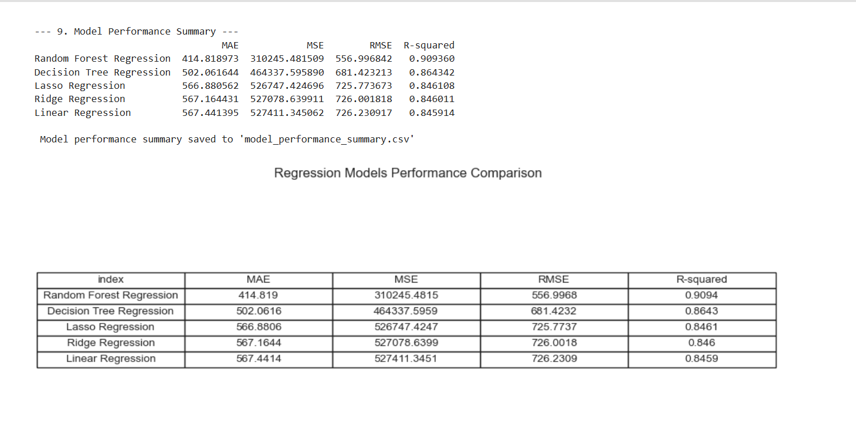
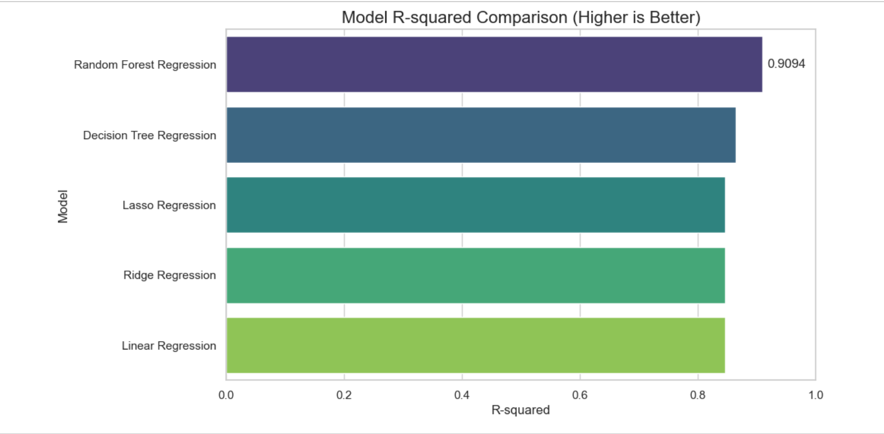

3.1.2 TESTING
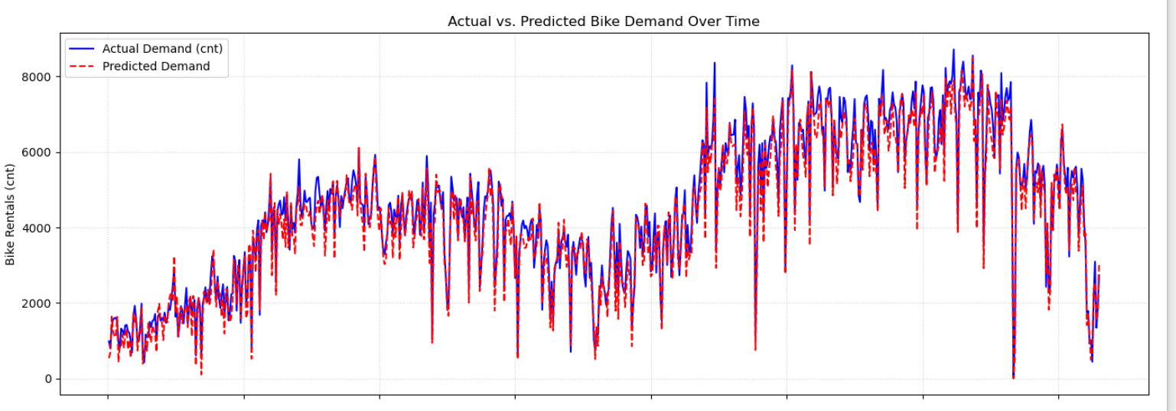
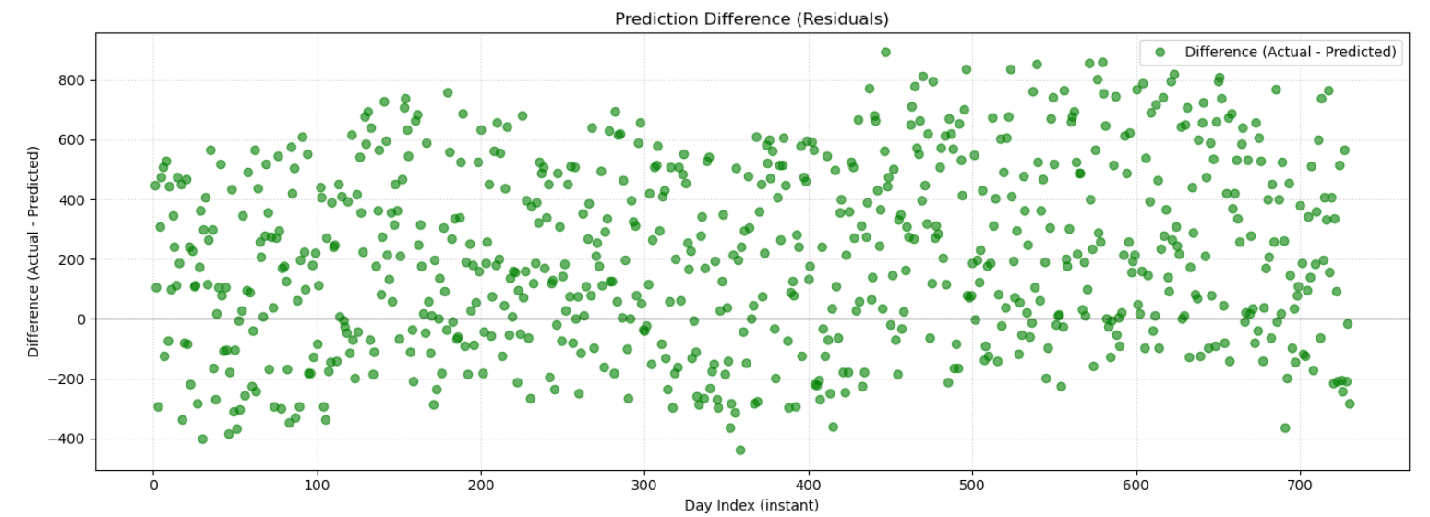

3.1.3 USER INTERFACE

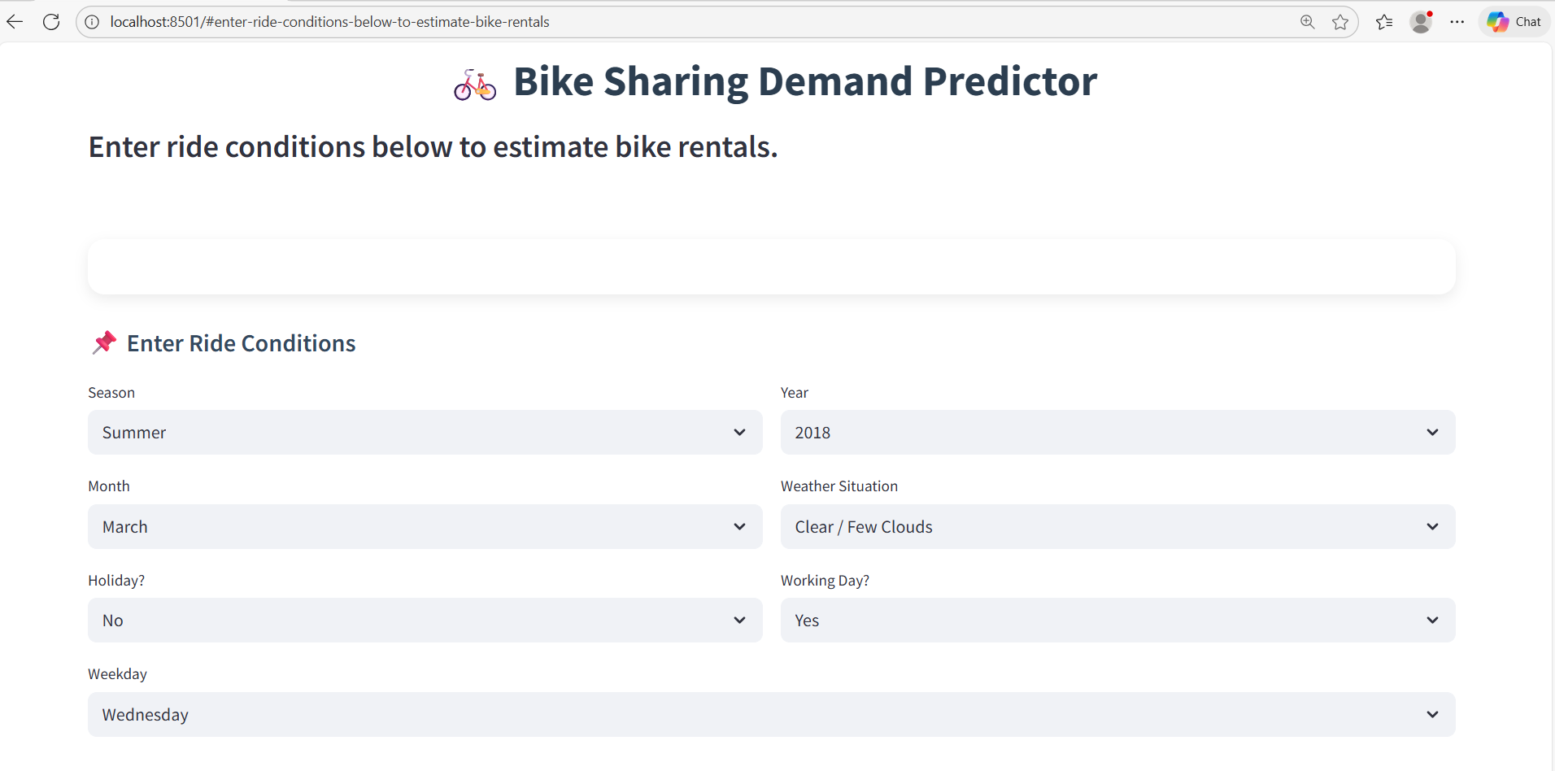

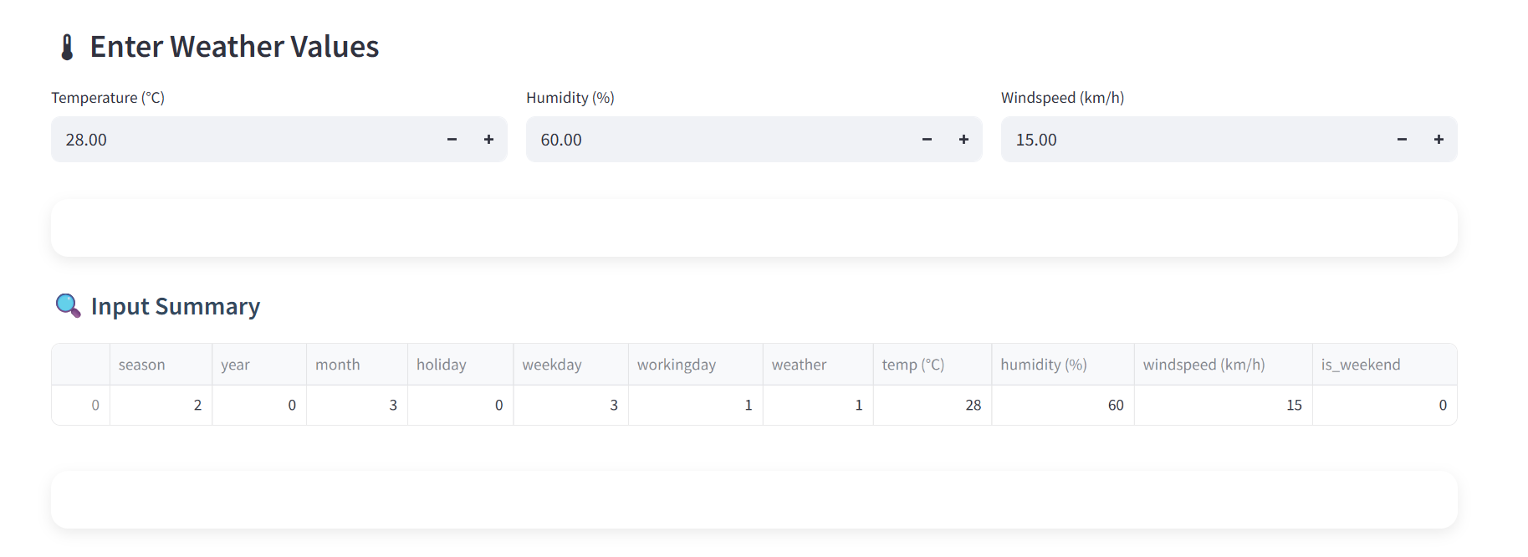
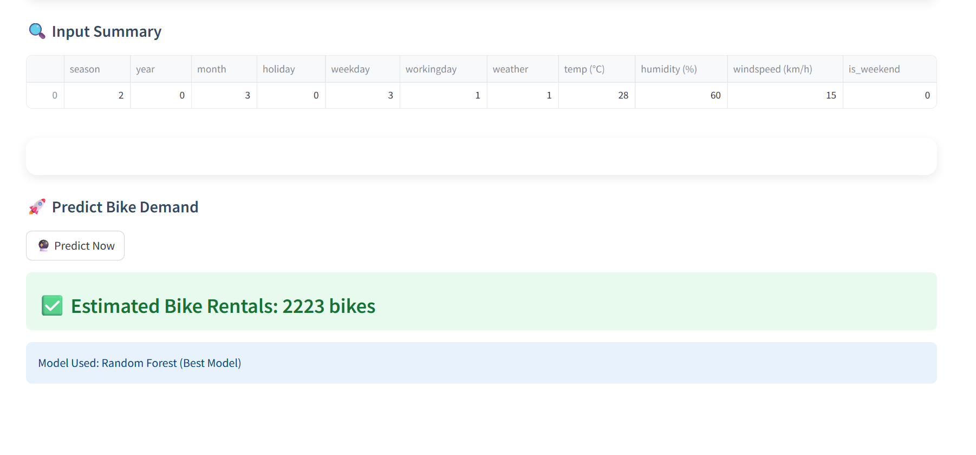

3.2 CONCLUSION
The Random Forest Regressor emerged as the most effective and reliable model for predicting daily bike-sharing demand. Among all models evaluated, it achieved the lowest training RMSE (≈ 556.99) and the highest R² score (≈ 0.9094), demonstrating its strong ability to capture complex, non-linear relationships present in the dataset. When tested on unseen data, the model continued to perform consistently, confirming its robustness and generalization capability.
Compared to linear models such as Linear Regression, Lasso, and Ridge—whose R² values remained around 0.845–0.846—and the Decision Tree model, which showed improvement but still exhibited overfitting tendencies, Random Forest provided the best balance of accuracy, stability, and predictive strength. Its ensemble-based architecture enabled it to learn intricate interactions between temporal features (season, month, weekday), weather-related variables (temperature, humidity, windspeed, weather situation), and user behaviour patterns.
The results of this project highlight the importance of end-to-end preprocessing, meaningful feature engineering, and systematic model evaluation in developing a dependable prediction system. The final Random Forest model forms a strong foundation for real-world applications such as fleet distribution planning, station rebalancing, demand forecasting, and resource optimization in bike-sharing operations. Overall, this project demonstrates how data-driven machine learning solutions can support smarter, more efficient, and more sustainable urban mobility systems.

