CLIMATESCOPE: VISUALIZING GLOBAL WEATHER TRENDS AND CLIMATE RISK ANALYSIS

A Project Report Submitted as part of

Infosys Springboard Virtual Internship 6.0

Submitted by
VENKAT THAPPETLA
Intern

Under the Guidance of
N. Shanmukha Priya
Data Scientist

April 2026

2.ACKNOWLEDGEMENT

I would like to express my sincere gratitude to my mentor, N. Shanmukha Priya, Data Scientist, for her guidance and support throughout this project.

I would also like to thank the Infosys Springboard Virtual Internship 6.0 program for providing me with the opportunity to work on this project and enhance my practical knowledge in data analytics and visualization.

This project has helped me gain valuable experience in working with real-world datasets, developing interactive dashboards, and understanding climate data analysis.

Finally, I would like to thank everyone who supported and encouraged me during the completion of this project.

3. TABLE OF CONTENTS

Abstract .................................................
1. Introduction ........................................
2. Objectives ..........................................
3. Dataset Description ............................
4. Data Preprocessing .............................
5. Methodology .......................................
6. System Architecture ............................
7. Dashboard Implementation .................
8. Visualization Techniques .....................
9. Results and Insights ............................
10. Project Milestones .............................
11. Applications .......................................
12. Limitations .........................................
13. Future Work .......................................
14. Conclusion .........................................
15. References .........................................

4. LIST OF FIGURES

Figure 1: ClimateScope Dashboard Overview
Figure 2: Global Climate Risk Gauge
Figure 3: Interactive Global Climate Distribution Map
Figure 4: Yearly Heatmap of Temperature Variation
5.ABSTRACT

Climate change has significantly increased the frequency and intensity of extreme weather events across the globe. This project presents ClimateScope, an interactive dashboard designed to analyse global weather data and assess environmental risk.

The system utilizes the Global Weather Repository dataset and integrates temperature, precipitation, and wind speed to compute a Composite Climate Risk Score. The dashboard is developed using Python, Streamlit, and Plotly, enabling users to explore climate patterns through interactive visualizations.

The results highlight increasing climate variability and demonstrate how data-driven systems can support decision-making in environmental monitoring, disaster management, and policy planning.

6. INTRODUCTION

Climate change has emerged as one of the most critical global challenges. Rising temperatures, irregular rainfall, and increasing extreme weather events are affecting ecosystems, agriculture, and human life.

Although large-scale weather datasets are available, extracting meaningful insights from them is difficult due to their complexity and volume. Traditional analysis methods lack interactivity and fail to communicate insights effectively.

To address this problem, ClimateScope is developed as an interactive dashboard that transforms raw weather data into meaningful visual insights. The system enables users to explore global climate trends, identify high-risk regions, and understand environmental changes through intuitive visualizations.

7. OBJECTIVES

• Analyse global weather data
• Identify climate trends and seasonal patterns
• Detect extreme weather events
• Develop an interactive dashboard
• Compute a composite climate risk score
• Provide meaningful insights through visualization

8. DATASET DESCRIPTION
The dataset used in this project is the Global Weather Repository obtained from Kaggle. It contains global weather data collected across multiple countries.
The dataset includes the following attributes:

• Temperature (°C)
• Precipitation (mm)
• Wind speed (kph)
• Humidity
• Pressure
• UV index
• Date and location details

The dataset is initially uncleaned and contains missing values and inconsistencies. Therefore, preprocessing is required before analysis.

9. DATA PREPROCESSING

Data preprocessing was an essential step in this project.

the following operations were performed:

• Converted date column into datetime format
• Handled missing values
• Removed inconsistent data
• Clipped pressure values to a valid range
• Normalized temperature, rainfall, and wind speed
• Created new features:
- Risk Score
- Extreme Event indicator

Normalization ensured all variables are on the same scale, improving analysis accuracy.

10. METHODOLOGY

A Composite Climate Risk Score was calculated using the formula:

Risk Score = 0.45 × Temperature + 0.25 × Rainfall + 0.30 × Wind

Temperature is assigned higher weight due to its long-term impact, while rainfall and wind contribute to extreme weather events.

Extreme events were identified using the following thresholds:

• Heatwave: Temperature > 40°C
• Flood: Rainfall > 100 mm
• Storm: Wind speed > 60 kph

11. SYSTEM ARCHITECTURE

The system follows a pipeline architecture:

1. Data Acquisition (Kaggle dataset)
2. Data Preprocessing (cleaning and transformation)
3. Feature Engineering (risk score calculation)
4. Data Analysis (statistical computations)
5. Visualization (charts and maps)
6. Dashboard (interactive interface)

This modular design ensures scalability and efficient data processing.

12. DASHBOARD IMPLEMENTATION

The Climate Scope dashboard was developed using Streamlit and provides an interactive interface for analysing climate data

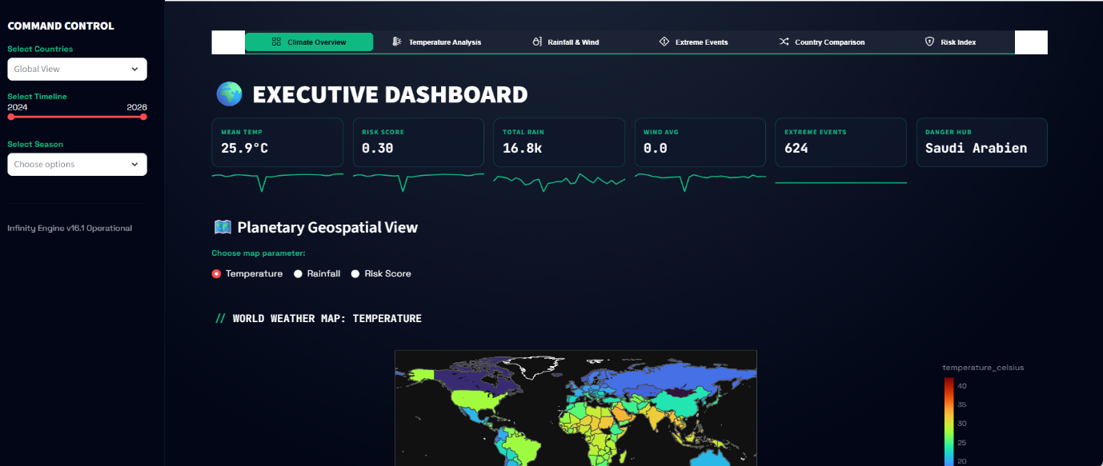

Figure 1: Climate Scope Dashboard Overview

This figure shows the main dashboard interface containing KPI cards, filters, and global climate visualizations. It provides an overall summary of temperature, rainfall, wind, and risk indicators.
The dashboard consists of multiple modules:

• Climate Overview
• Temperature Analysis
• Rainfall and Wind Analysis
• Extreme Events Monitoring
• Country Comparison
• Risk Index Dashboard

Key features include:

• Country-based filtering
• Time range selection
• Seasonal filtering
• Dynamic visualization updates

The dashboard also includes KPI cards displaying:

• Mean temperature
• Risk score
• Total rainfall
• Wind speed
• Extreme event count

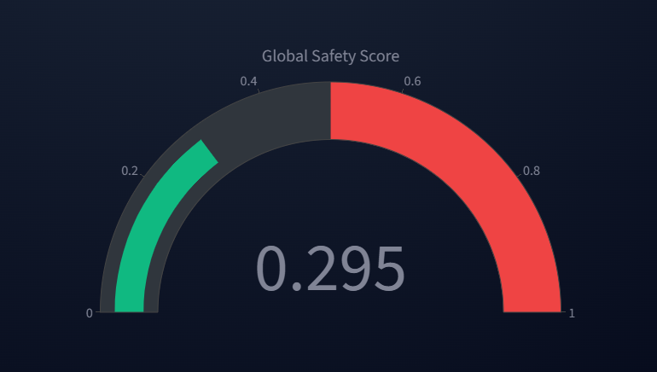

Figure 2: Global Climate Risk Gauge

This gauge represents the overall climate risk score calculated using temperature, rainfall, and wind data. It provides a quick and intuitive understanding of the current global environmental risk level.

13. VISUALIZATION TECHNIQUES

Various visualization techniques were used:

• Choropleth maps for global distribution
• Line charts for time-series trends
• Heatmaps for seasonal analysis
• Scatter plots for correlation analysis
• Bar charts for comparisons

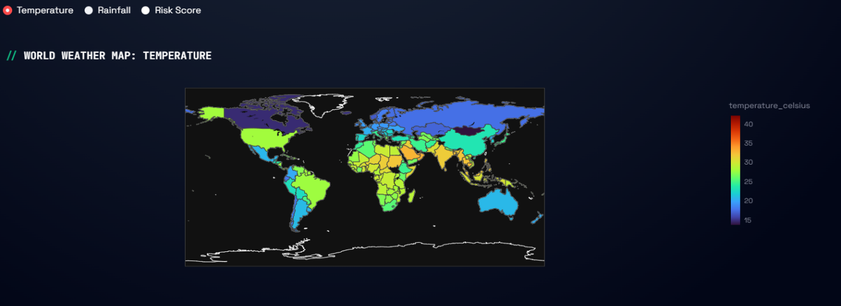

Figure 3: Interactive Global Climate Distribution Map
This figure represents an interactive global climate distribution map that allows users to switch between temperature, rainfall, and risk score views. It provides a comprehensive geographical understanding of climate conditions across different regions.

By using the toggle feature, users can analyze how different environmental factors vary globally and identify regions with higher temperature intensity, heavy rainfall, or increased climate risk. This multi-dimensional visualization enhances the ability to compare and interpret climate patterns effectively.

These visualizations help in understanding complex climate patterns effectively.

14. RESULTS AND INSIGHTS

The analysis revealed the following insights:

• Climate risk is increasing faster than temperature
• Extreme weather events are becoming more frequent
• Certain regions consistently show higher risk
• Seasonal patterns are becoming unpredictable

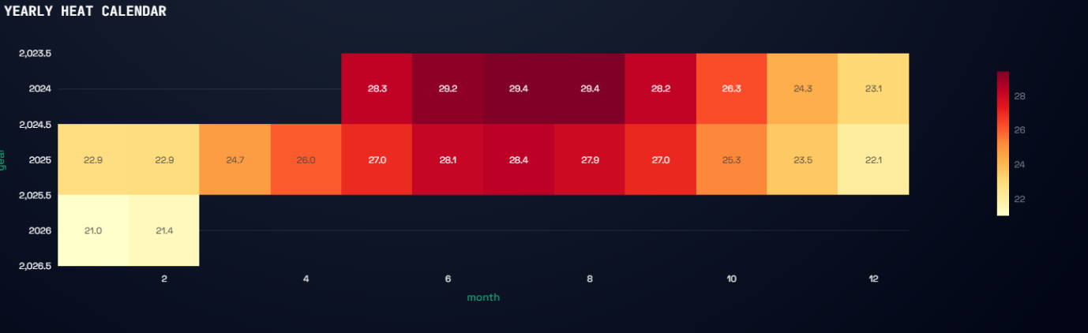

Figure 4: Yearly Heatmap of Temperature Variation
This heatmap represents the variation of temperature across different months and years. It helps in identifying seasonal patterns and trends, showing how temperature intensity changes over time.
The dashboard enables users to explore these patterns interactively.

15. PROJECT MILESTONES

Milestone 1: Data Preparation
Dataset collection, cleaning, and preprocessing.

Milestone 2: Analysis
Statistical analysis and visualization planning.

Milestone 3: Development
Dashboard creation with interactive features.

Milestone 4: Finalization
Testing, validation, and documentation.

16. APPLICATIONS

• Disaster management
• Agricultural planning
• Climate monitoring
• Policy making

17. LIMITATIONS

• No real-time data integration
• Static threshold-based model

18. FUTURE WORK

• Integration of real-time APIs
• Machine learning-based prediction
• Automated alert systems

19. CONCLUSION

Climate Scope successfully demonstrates how data visualization and analytics can be used to understand climate patterns and risks.
The system provides an interactive platform for analysing global weather data and identifying trends. It highlights the importance of data-driven approaches in addressing climate-related challenges.
This project demonstrates the practical application of data analytics and visualization techniques in solving real-world climate challenges.

20. REFERENCES

Kaggle Global Weather Dataset
Streamlit Documentation
Plotly Documentation

