ClimateScope: Visualizing Global Weather Trends and Extreme Events
Final Project Report

Abstract
ClimateScope is a data visualization system developed to analyze and interpret global weather patterns using the Global Weather Repository dataset. The primary goal of this project is to transform structured weather data into meaningful and actionable insights through the use of interactive dashboards. By leveraging tools such as pandas for data processing, Plotly for visualization, and Streamlit for application development, the system enables users to explore temporal trends, compare weather conditions across different regions, and identify extreme variations effectively. The project follows a milestone-based development approach that includes data preparation, exploratory analysis, visualization design, and final deployment. The resulting system provides a responsive and user-friendly interface that significantly enhances data interpretability and supports informed decision-making.

1. Introduction
In recent years, the rapid growth in the availability of global weather datasets has created new opportunities for data-driven analysis and insight generation. However, raw data in its original form often lacks clarity and is difficult for users to interpret without appropriate tools.
The ClimateScope project addresses this challenge by converting structured weather data into visually intuitive and interactive representations. The system is specifically designed to simplify complex datasets and allow users to analyze patterns, compare regional weather conditions, and identify anomalies with ease. By integrating data analysis techniques with visualization strategies, the project ensures that users can derive meaningful insights without requiring deep technical expertise.

2. Objectives
The primary objective of this project is to develop an efficient and interactive system for analyzing global weather data and presenting it in a clear and understandable format. More specifically, the project aims to enable users to understand long-term weather trends, compare variations across different geographical regions, identify extreme weather conditions, and interact dynamically with the dataset through a well-structured dashboard interface. The overall focus is on ensuring clarity, usability, and effective communication of data-driven insights.

3. Technology Stack
The implementation of the ClimateScope project is carried out using a combination of widely adopted tools and technologies. Python 3 is used as the core programming language for development, while the pandas library is utilized for efficient data manipulation and analysis. Plotly is employed to create interactive and visually appealing charts, and Streamlit is used to build the web-based dashboard interface. Additionally, Tableau is explored for supplementary visualization purposes, and the Kaggle API is used to access and download the dataset required for the project.

4. Implementation (Milestone-Based Approach)

4.1 Milestone 1: Data Preparation and Initial Analysis
The first phase of the project focuses on acquiring the dataset, understanding its structure, and ensuring that it is suitable for further analysis. The dataset is downloaded from Kaggle using the Kaggle API and loaded into a pandas DataFrame for inspection. Various exploratory steps are performed, including examining the dataset structure using functions such as df.info(), reviewing column names and data types, and identifying key variables such as temperature, humidity, and other relevant weather indicators.
In addition to structural analysis, the dataset is thoroughly checked for data quality issues such as missing values, inconsistencies, and anomalies. Upon careful evaluation, it is observed that the dataset is already clean and well-structured, with no missing values or inconsistencies present. As a result, no major preprocessing or cleaning steps are required.
This significantly streamlines the workflow and allows more time to be allocated to deeper analysis and visualization tasks. The outcome of this phase is a dataset that is fully prepared and ready for direct analytical processing.
Figures
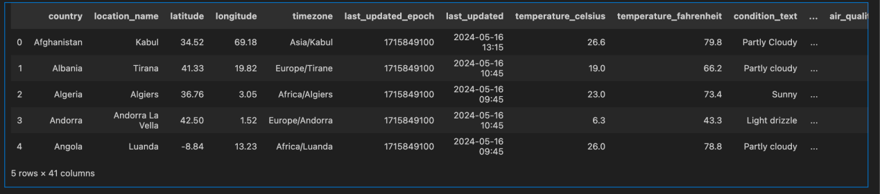
fig 1. Dataset Preview (df.head())
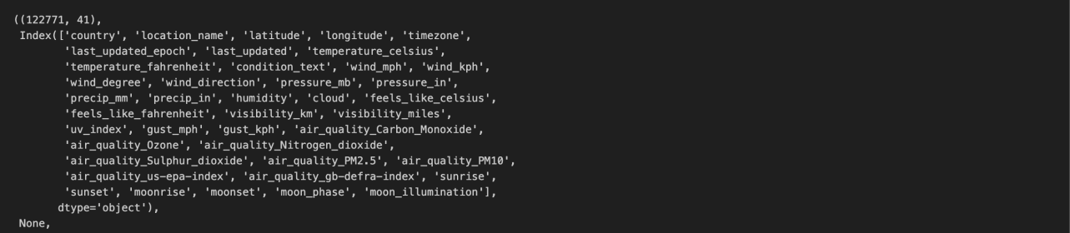
fig 2. Dataset Structure (df.info())

4.2 Milestone 2: Exploratory Analysis and Visualization Design
The second phase of the project involves performing detailed exploratory data analysis to understand patterns and relationships within the dataset, followed by designing an appropriate visualization strategy. During this phase, statistical measures such as mean, maximum, and minimum values are calculated to gain a better understanding of the data distribution.
Further analysis reveals noticeable trends in temperature variations over time, as well as clear differences across geographical regions. These observations help in identifying meaningful patterns such as seasonal variations and regional disparities.
Based on these insights, a structured visualization plan is developed. Line charts are selected to represent time-series trends, bar charts are used for regional comparisons, scatter plots are chosen to explore relationships between variables, and heatmaps are used to identify patterns and correlations.
A logical dashboard layout is also designed to ensure that related visualizations are grouped together and presented in a clear and organized manner. The outcome of this phase is a well-defined analytical understanding of the dataset and a clear roadmap for dashboard development

Tableau Public Link -
https://public.tableau.com/app/profile/aishwarya.garikapati/viz/milestone2_17715983102370/Dashboard1
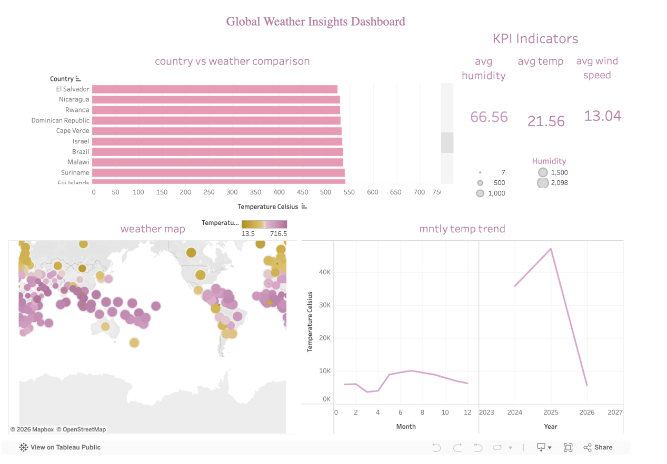
fig 3. Global Weather Insight Dashboard using Tableau

4.3 Milestone 3: Visualization Development and Interactivity
In this phase, the focus shifts to implementing the visualizations and building the interactive dashboard using Streamlit. The dataset is integrated into the application, and key performance indicators such as average temperature, maximum temperature, and minimum temperature are calculated and displayed prominently.
Interactive visualizations are created using Plotly, including line charts to represent temperature trends and distribution charts to illustrate variations in data. Additional features such as filters and selection options are implemented to allow users to control the data view and explore specific aspects of the dataset dynamically.
Significant attention is given to improving the visual design of the dashboard, including the use of consistent color schemes, clear titles, properly labeled axes, and a structured layout that enhances navigation. The outcome of this phase is a fully functional interactive dashboard that allows users to explore data in an intuitive and engaging manner.
Figures:
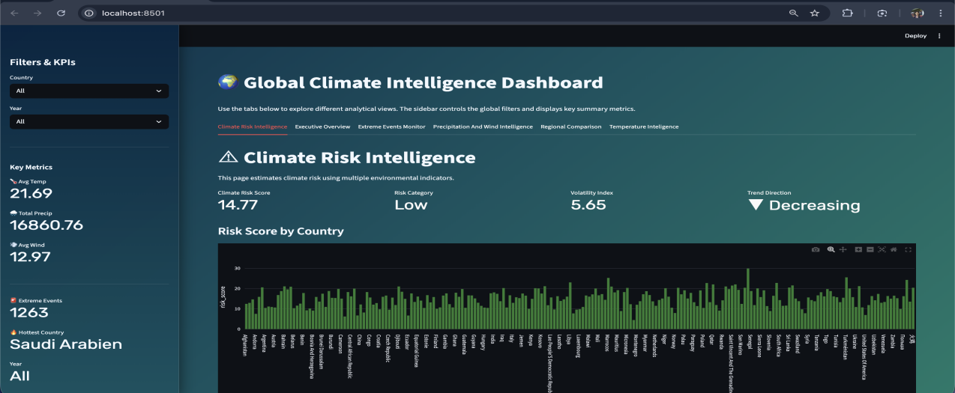
fig 4. Climate risk intelligence.py
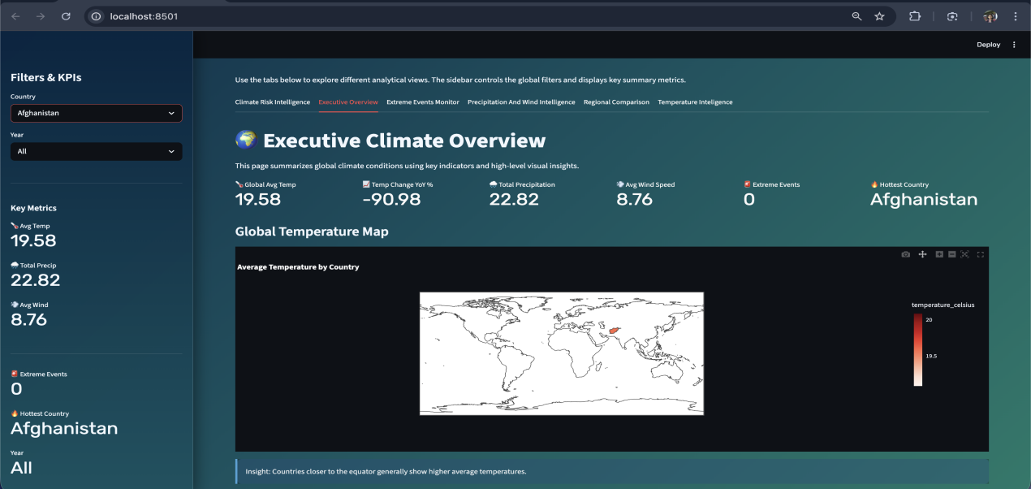
fig 5. executive overview.py
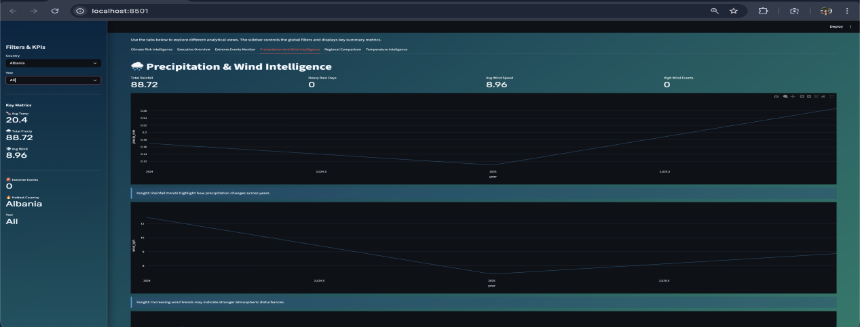
fig 6. precipitation and wind intelligence.py
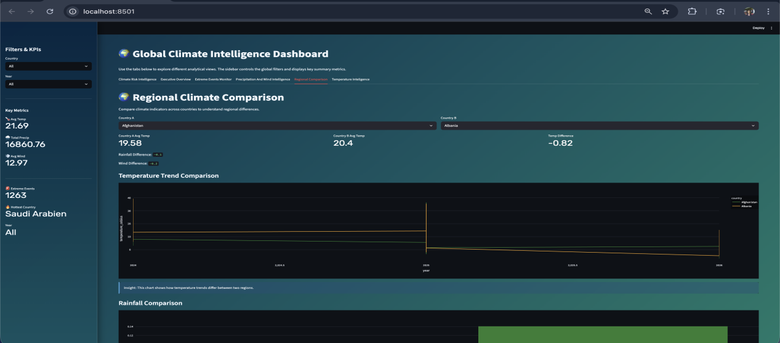
fig 7. regional comparison.py
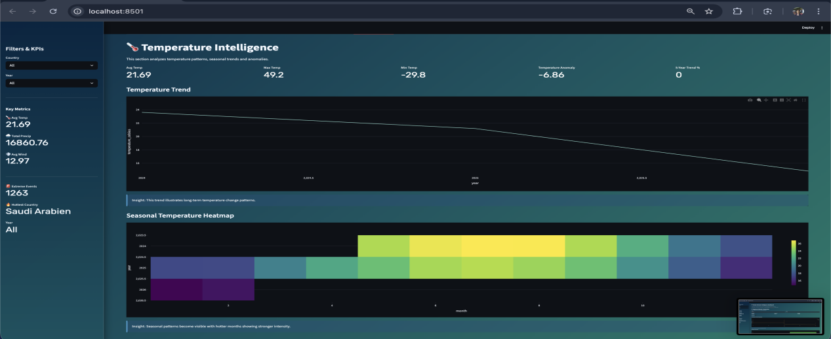
fig 8. tempearture intelligence.py
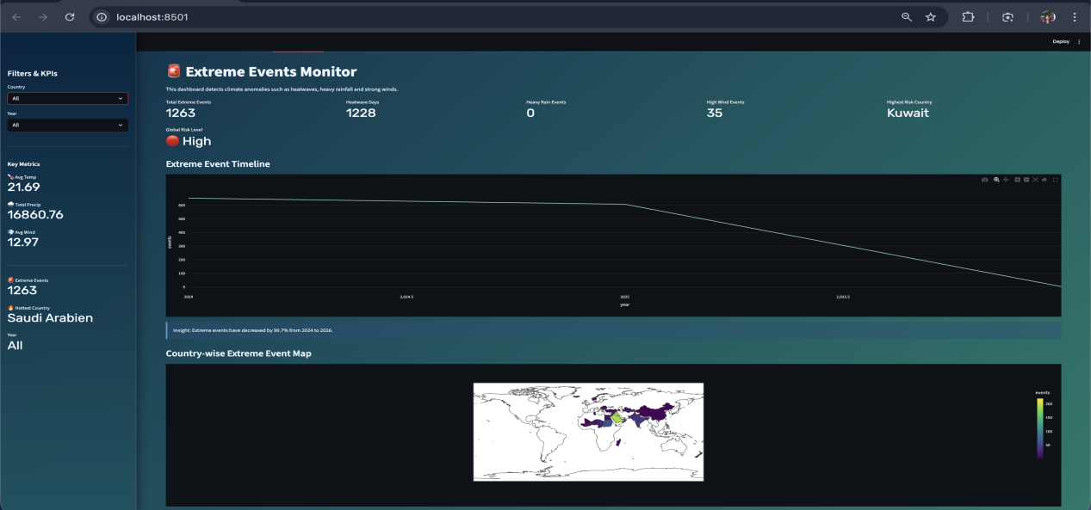
fig 9. extreme events monitor.py

4.4 Milestone 4: Finalization, Testing, and Documentation
The final phase of the project focuses on refining the dashboard, ensuring its reliability, and preparing comprehensive documentation. Extensive testing is conducted to verify the correctness of displayed data and to ensure that all interactive components function as expected.
Improvements are made to the dashboard layout to enhance readability and visual clarity, including adjustments to spacing, labeling, and overall presentation. Key insights are summarized based on the analysis performed, and the entire workflow is documented in detail.
The outcome of this phase is a stable, user-friendly, and well-documented system that is ready for demonstration and submission.

5. Key Insights
The analysis reveals that temperature exhibits noticeable variation over time, indicating the presence of clear temporal trends. Additionally, significant differences are observed across regions, highlighting the impact of geographical factors on weather conditions. Certain data points indicate extreme values, which may correspond to unusual or noteworthy climate conditions. Overall, the dataset supports meaningful comparative analysis and provides valuable insights into global weather patterns.

6. Challenges Faced
One of the primary challenges encountered during the project was designing visualizations that are both simple and informative without overwhelming the user. Another challenge involved structuring the dashboard in a way that ensures intuitive navigation and logical grouping of information. Additionally, maintaining performance while incorporating interactive features required careful optimization.

7. Future Enhancements
Future improvements to the system may include the integration of real-time weather data through external APIs, the addition of predictive models for forecasting future trends, and the development of more advanced region-specific analyses. Enhancements to the user interface and visualization techniques can further improve the overall user experience.

8. Conclusion
The ClimateScope project successfully demonstrates how structured global weather data can be transformed into an interactive and insightful dashboard. Each milestone contributes to a systematic development process that results in a functional and reliable final product.
The project highlights strong capabilities in data analysis, visualization design, and dashboard development, while also providing a solid foundation for future enhancements and real-world applications.

