Visualising Global Weather Trends and Extreme Events
Internship Domain: Data Visualisation
Mentor:Shanmukha Priya
Name:Boddupalli Geethika

PROJECT OVERVIEW:

The Global Weather Analytics Dashboard project is designed to analyze and visualize large-scale weather data to uncover meaningful insights related to climate patterns. With the increasing importance of environmental monitoring, this project focuses on transforming raw weather data into an interactive and user-friendly dashboard.
The system collects and processes data related to temperature, rainfall, wind speed, humidity, and pressure across different countries and regions. Using data preprocessing techniques, the dataset is cleaned and structured to ensure accuracy and consistency.

ABSTRACT:

The Global Weather Analytics Dashboard project focuses on analyzing and visualizing large-scale weather data to extract meaningful insights about climate patterns, trends, and extreme weather events. With the growing importance of environmental monitoring and climate awareness, the need for effective data analysis and visualization tools has become essential.

This project utilizes weather data containing parameters such as temperature, rainfall, wind speed, humidity, and pressure across multiple countries and regions. The data is first preprocessed to remove inconsistencies, handle missing values, and transform it into a structured format suitable for analysis.

In the next phase, statistical analysis techniques are applied to understand data distributions, identify correlations between variables, and detect seasonal trends. Special emphasis is given to identifying extreme weather conditions such as heatwaves, heavy rainfall, and high wind events based on predefined thresholds.

Finally, an interactive dashboard is developed using Microsoft Power BI to present the analyzed data in a visually intuitive manner. The dashboard includes various visualizations such as line charts, bar charts, scatter plots, and heatmaps, along with interactive features like slicers and filters to enhance user experience.

The developed system enables users to explore weather patterns, compare regional conditions, and gain insights into climate variability efficiently. This project demonstrates the effectiveness of combining data analytics and visualization techniques to simplify complex datasets and support informed decision-making.

CHAPTER 1:

Problem Statement

With the rapid increase in global climate changes, large volumes of weather data are being generated daily from multiple sources. This data includes parameters such as temperature, rainfall, wind speed, humidity, and atmospheric pressure across different regions and time periods. However, this raw data is often unstructured, complex, and difficult to interpret using traditional methods.

One of the major challenges is the lack of an efficient system to:

Process and analyze large-scale weather datasets

Identify meaningful patterns and seasonal trends

Detect extreme weather events such as heatwaves, heavy rainfall, and strong winds

Compare weather conditions across different regions

Present insights in an easy-to-understand visual format

Manual analysis of such datasets is time-consuming and prone to errors, making it difficult for users to extract actionable insights. Additionally, without proper visualization tools, understanding relationships between different weather parameters becomes challenging.

To address these issues, there is a need for an integrated solution that can:

Clean and preprocess weather data efficiently

Perform statistical and trend analysis

Detect anomalies and extreme conditions

Provide interactive and dynamic visualizations

This project aims to develop a Global Weather Analytics Dashboard using Microsoft Power BI, which transforms complex weather data into meaningful visual insights. The system enables users to explore data interactively, understand climate patterns, and make informed decisions based on analyzed results.

Objective of project

The main objective of the Global Weather Analytics Dashboard project is to analyze large-scale weather data and present meaningful insights through interactive visualizations. The project aims to simplify complex weather datasets and enable users to understand climate patterns effectively.

Primary Objectives

- To collect and preprocess global weather data for analysis
- To clean and transform raw data into a structured format
- To analyze key weather parameters such as temperature, rainfall, wind speed, humidity, and pressure
- To identify trends, seasonal patterns, and variations across different regions

To build a comprehensive and user-friendly weather analytics system that transforms raw data into actionable insights, helping users better understand global climate behavior.

Scope of the Project

The Global Weather Analytics Dashboard project focuses on analyzing and visualizing weather data to provide meaningful insights into climate patterns across different regions. The scope of this project includes data processing, analysis, and interactive visualization using modern tools.

Functional Scope

The project covers the following functionalities:

Collection and preprocessing of global weather data

Analysis of key weather parameters such as:

Temperature

Rainfall

Wind speed

Humidity and pressure

Identification of trends and seasonal variations

Detection of extreme weather events (heatwaves, heavy rainfall, high wind conditions)

Comparison of weather conditions across multiple countries and regions

1.4methodology

The methodology of the Global Weather Analytics Dashboard project follows a systematic and step-by-step approach to transform raw weather data into meaningful insights through analysis and visualization. The entire process is divided into three major phases (milestones): Data Preparation, Data Analysis, and Dashboard Development.

Overview of Methodology

The workflow of the project is as follows:
- Data Collection
- Data Cleaning & Preprocessing
- Data Analysis
- Visualization Design
- Dashboard Development
- User Interaction & Insights

CHAPTER 2

MILESTONE 1 - DATA COLLECTION & PREPROCESSING

The primary objective of Milestone 1 is to collect, clean, and preprocess the global weather dataset to make it suitable for further analysis and visualization. Since raw data is often incomplete and inconsistent, this phase focuses on improving data quality and structure.

Key Objectives

1. Data Collection
- To gather global weather data from a reliable source
- To ensure the dataset includes important parameters such as:
  - Temperature
  - Rainfall
  - Wind speed
  - Humidity and pressure
  - Country and date information

2. Data Cleaning
- To identify and handle missing values
- To remove duplicate records
- To correct inconsistent or invalid data entries
- To ensure accuracy and reliability of the dataset

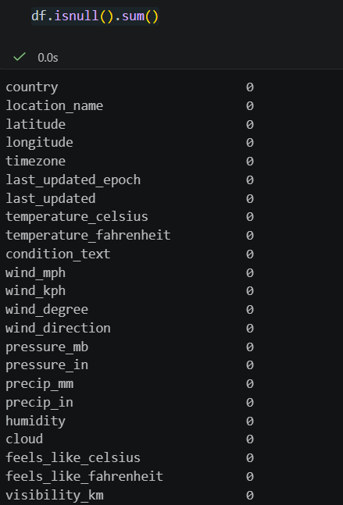

3. Data Transformation
- To convert data into appropriate formats (e.g., date to year/month)
- To standardize column names and values
- To create new derived columns for better analysis

4. Data Structuring
- To organize the dataset in a structured format
- To ensure compatibility with analysis tools and visualization platforms

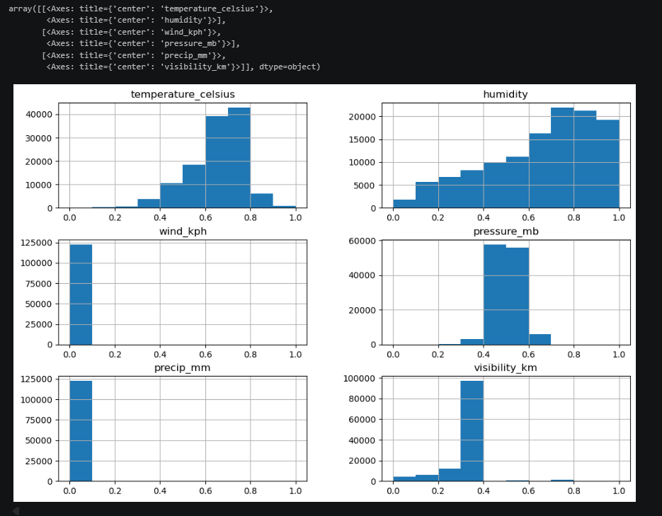

5. Data Aggregation
- To group data based on country or time period
- To calculate summary values such as:
  - Average temperature
  - Total rainfall
  - Average wind speed

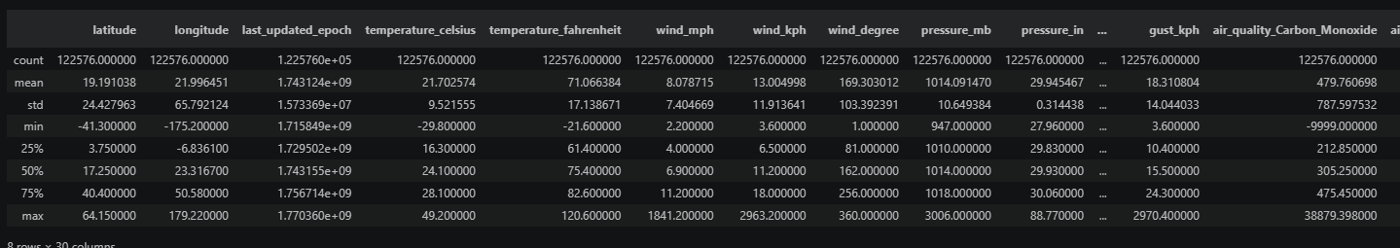

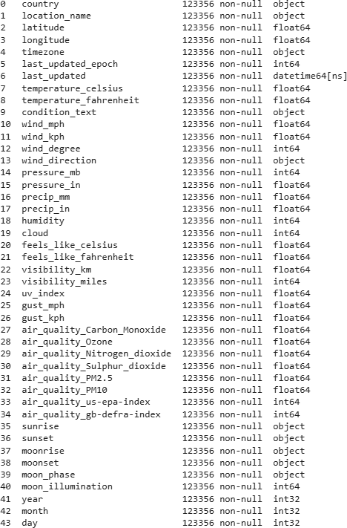

CHAPTER 3

MILESTONE 2 – CORE ANALYTICAL INSIGHTS &INTERACTIVE VISUALIZATION

The main objective of Milestone 2 is to perform in-depth analysis of the cleaned weather dataset and design an interactive visualization system to present meaningful insights. This phase focuses on understanding data behavior, identifying patterns, and structuring the dashboard layout for effective communication of results.

Key Objectives
1. Statistical Analysis
- To compute key statistical metrics such as:
  - Average temperature
  - Average humidity
  - Wind speed
  - Pressure
- To understand the distribution and summary of weather data
- Implemented using:
filtered_df.describe()

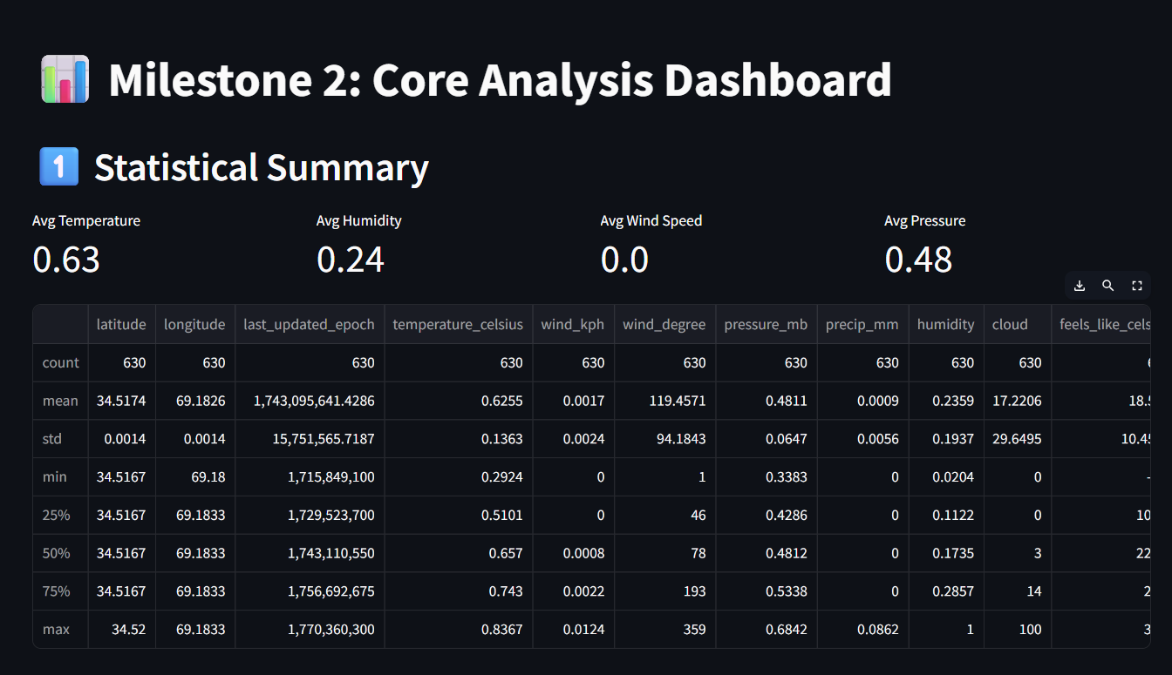
2. Correlation Analysis
- To identify relationships between different weather parameters
- To analyze how variables like temperature, rainfall, humidity, and wind speed interact
- Visualized using a correlation heatmap
corr = filtered_df[numeric_cols].corr()
sns.heatmap(corr)

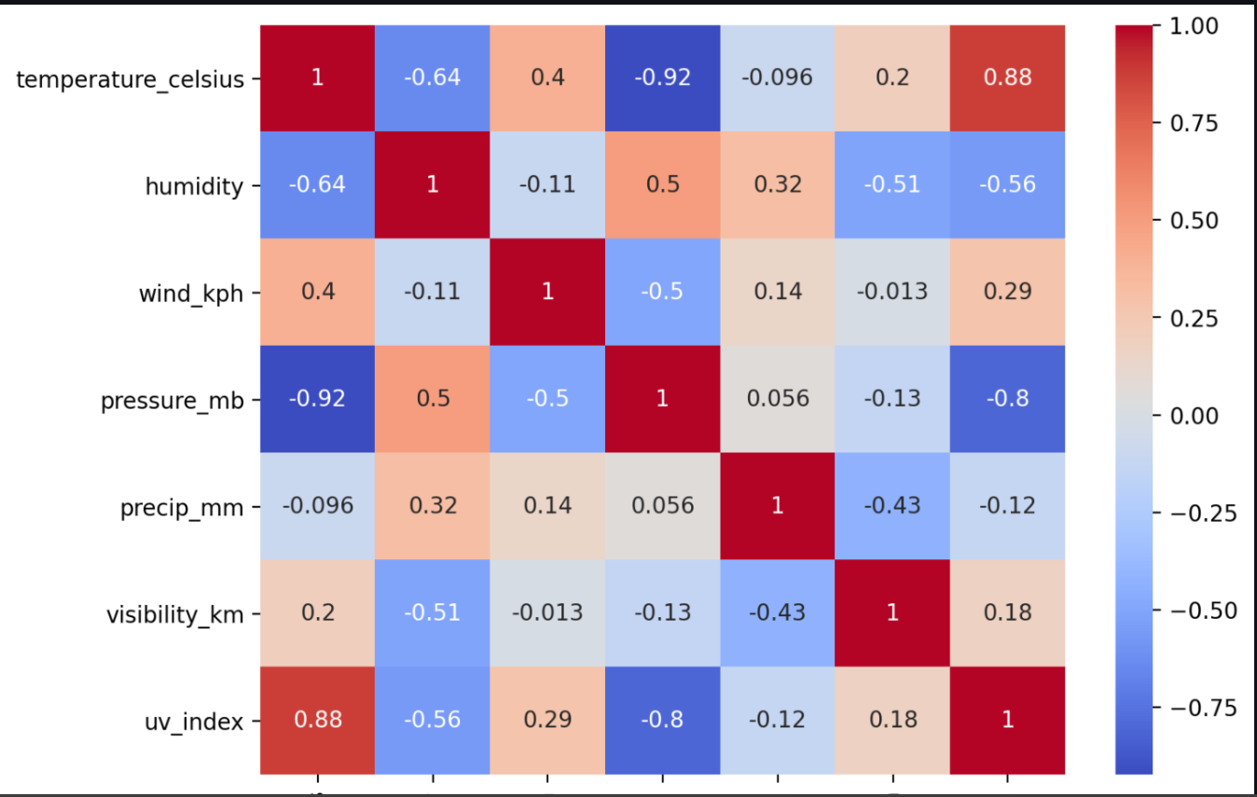

3. Seasonal Trends & Pattern Analysis
- To analyze how temperature varies across months
- To identify seasonal patterns in weather data
- Implemented using grouping and visualization:
filtered_df.groupby("month")["temperature_celsius"].mean()

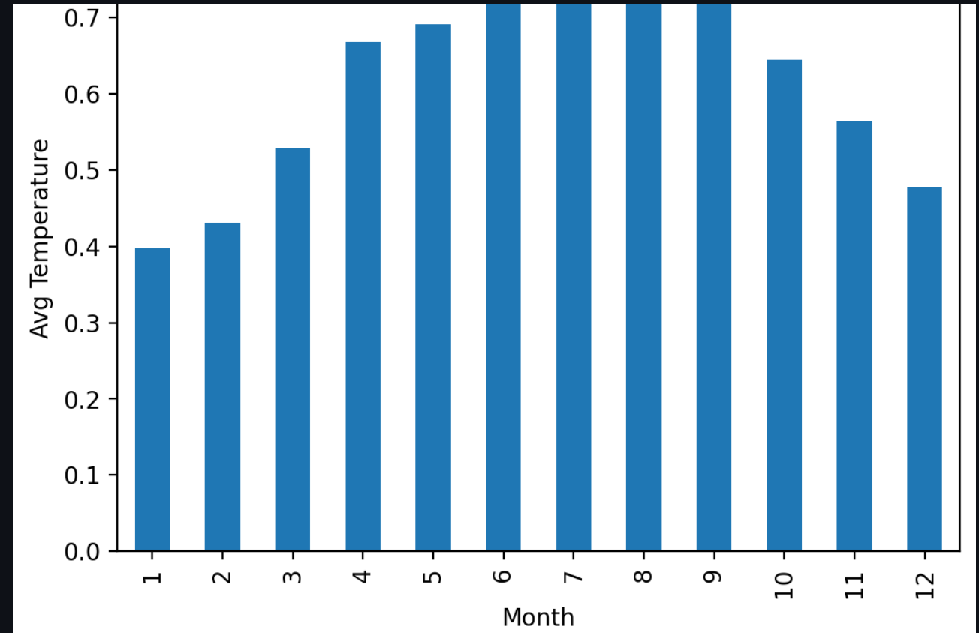

4. Extreme Weather Event Detection
- To identify unusual or extreme weather conditions
- Defined using quantile-based thresholds (top 5%)
filtered_df["temperature_celsius"].quantile(0.95)
- Detect:
  - High temperature events
  - Heavy rainfall events
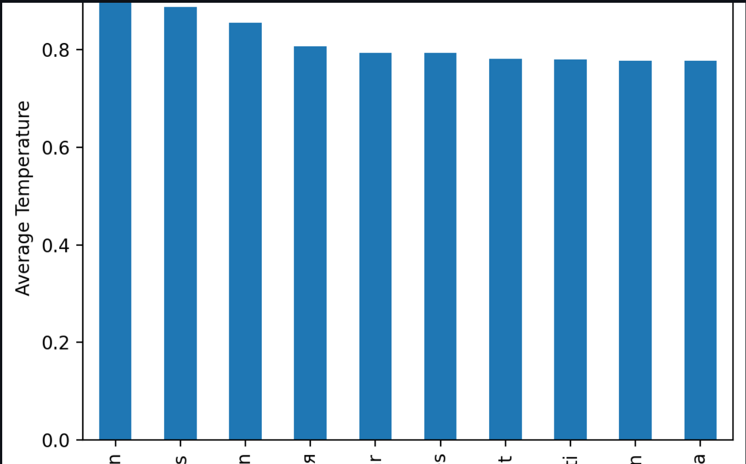

5. Regional Comparison
- To compare weather conditions across different countries
- To identify top regions based on temperature
df.groupby("country")["temperature_celsius"].mean()

6. Dashboard Design & Interactivity
- To design an interactive dashboard using Streamlit
- To enable user-driven filtering:
  - Country selection
  - Date range selection
st.sidebar.selectbox()
st.sidebar.date_input()

CHAPTER 4

MILESTONE 3 – VISUALIZATION & DASHBOARD ARCHITECTURE

The primary objective of Milestone 3 is to transform the analytical results obtained in Milestone 2 into a fully functional, interactive, and visually appealing dashboard. This phase focuses on integrating multiple visualizations, enabling user interactivity, and presenting insights in a clear and effective manner.

Key Objectives
1. Dashboard Development
- To design and build a comprehensive dashboard using Microsoft Power BI
- To organize the dashboard into multiple sections such as:
  - Executive Overview
  - Temperature Analysis
  - Rainfall & Wind Analysis
  - Extreme Events Monitoring
  - Regional Comparison
  - Climate Risk Analysis

2. Integration of Visualizations
- To implement various types of charts for better data representation:
  - Line charts → Trend analysis
  - Bar/Column charts → Comparisons
  - Scatter plots → Correlation analysis
  - Heatmaps → Seasonal patterns
  - KPI cards → Key performance indicators

3. Interactivity Implementation
- To enhance user experience by adding interactive features:
  - Slicers for Country, Year, and Date range
  - Dynamic filtering across visuals
  - Cross-filtering between charts
- To allow users to explore data based on their preferences

4. Dashboard Design & Aesthetics
- To improve the visual appearance of the dashboard:
  - Use of consistent color themes
  - Clear labels and titles
  - Logical layout and alignment
- To make the dashboard user-friendly and easy to interpret

5. Insight Highlighting
- To present key findings clearly within the dashboard:
  - Temperature trends
  - Rainfall variations
  - Extreme weather events
  - Regional comparisons
- To ensure insights are easily understandable for users

6. KPI and Metrics Development
- To define and calculate key metrics such as:
  - Average Temperature
  - Total Rainfall
  - Average Wind Speed
  - Extreme Events Count
- To display these metrics using KPI cards

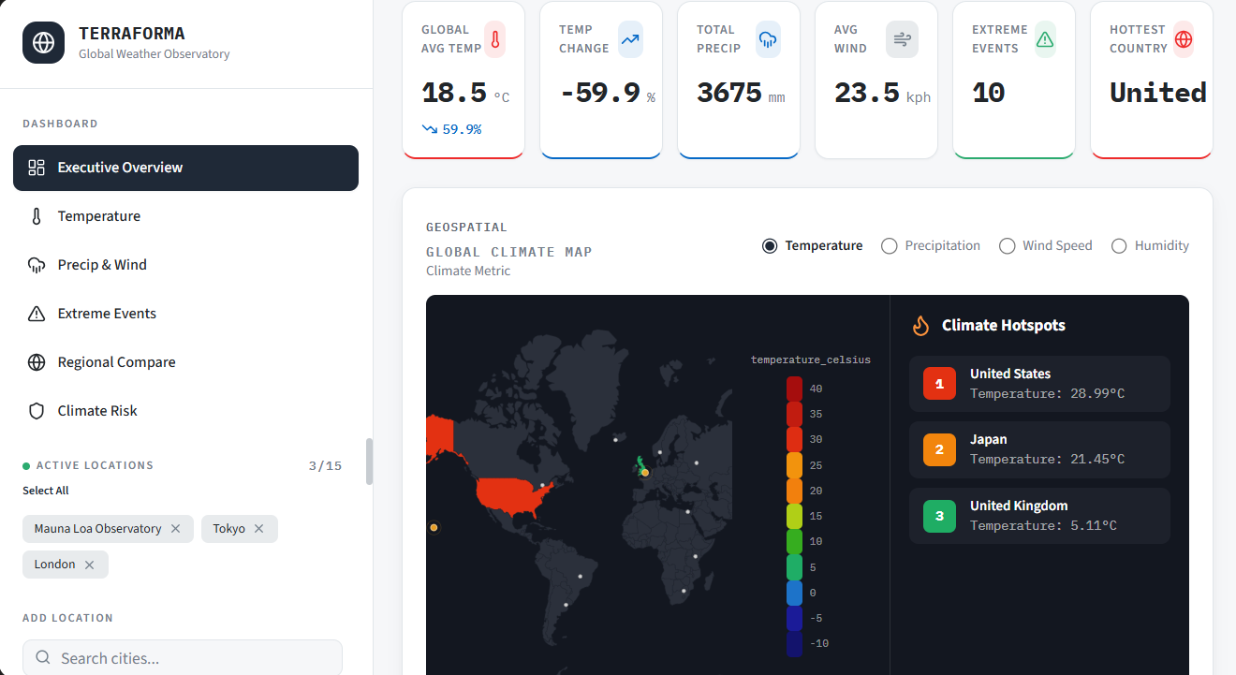

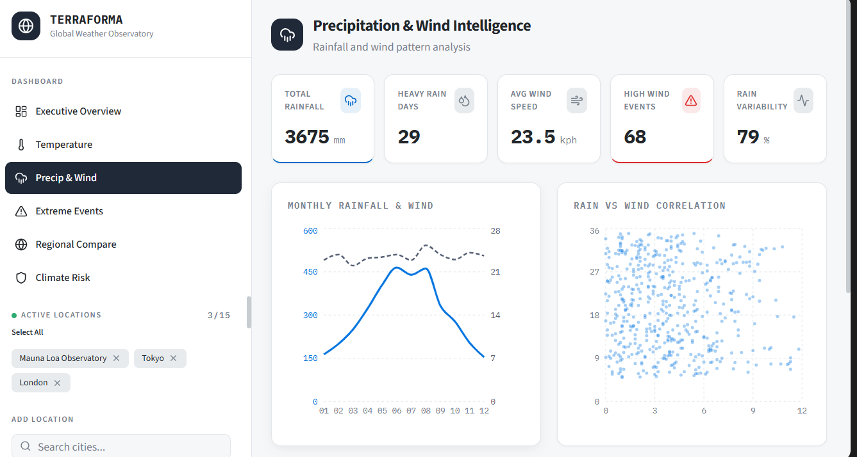

Conclusion:

The Global Weather Analytics Dashboard project successfully demonstrates the effective use of data analytics and visualization techniques to analyze large-scale weather data. The project was carried out in a systematic manner through three key milestones: data preparation, data analysis, and dashboard development.

In the initial phase, raw weather data was cleaned, transformed, and structured to ensure accuracy and reliability. This provided a strong foundation for further analysis. In the second phase, detailed statistical analysis was performed to understand data distributions, identify correlations between weather parameters, and detect seasonal patterns and extreme weather events. These analytical insights helped in designing meaningful visualizations.
In the final phase, an interactive dashboard was developed using Microsoft Power BI, integrating various visualizations such as line charts, bar charts, scatter plots, and heatmaps. The inclusion of slicers and filters enhanced user interaction, allowing dynamic exploration of data across different countries and time periods.
The dashboard effectively presents key insights such as temperature trends, rainfall variations, wind patterns, and extreme weather conditions. It simplifies complex datasets into easy-to-understand visual formats, making it useful for analysis and decision-making.
Overall, this project highlights the importance of data visualization in understanding climate behavior and demonstrates how analytical tools can transform raw data into actionable insights. The developed system serves as a strong foundation for future enhancements such as real-time data integration and predictive analytics.

