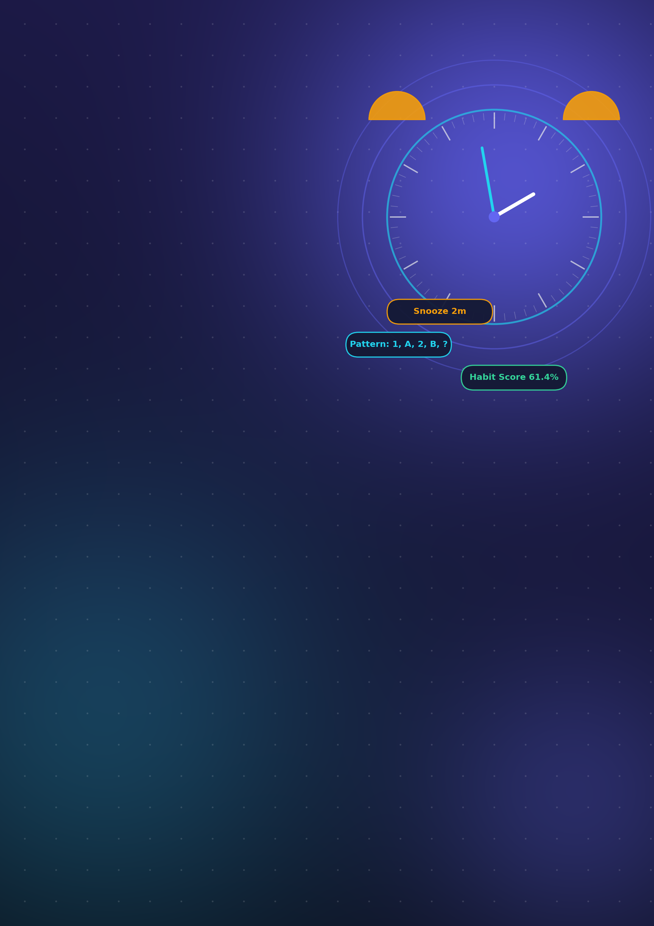
FINAL PROJECT REPORT
Intelligent
Cognitive Alarm
Platform
Wake up the brain, not just the body — an AI-driven system that turns every alarm into a habit-building challenge.
DOMAIN AI-Powered Productivity & Wellness
ROLES User • Wellness Coach • Administrator
STACK React.js • FastAPI • PostgreSQL / MongoDB • Docker
SUBMITTED BY [Add student / team name]
YEAR 2026

CONTENTS
What this report covers
01 | Executive Summary | The project at a glance
02 | Problem Statement & Motivation | Why a smarter alarm is needed
03 | Aim & Objectives | What the platform sets out to achieve
04 | How the Platform Works | End-to-end wake-up workflow
05 | System Architecture & Technology | Layers, services and tools
06 | Feature Modules | Ten modules that make up the system
07 | The Intelligence Layer | Adaptive difficulty, habit score and coach rules
08 | Application Walkthrough | Annotated output screens
09 | Results & Observations | What the data shows
10 | Development Roadmap | Four milestones across eight weeks
11 | Testing & Validation | How quality was verified
12 | Challenges & Solutions | Problems met and how they were solved
13 | Learnings & Team Reflections | Skills and experience gained
14 | Future Scope | Planned enhancements
15 | Conclusion | Summary and outlook

01 Executive Summary
Most alarms fail at the exact moment they matter: a single tap silences them and the user falls back asleep. The Intelligent Cognitive Alarm Platform replaces that tap with a short cognitive challenge, such as a pattern-recognition or math puzzle, that must be solved before the alarm can be dismissed. Waking becomes an act of thinking, which makes it far harder to ignore.
Beyond the alarm itself, the platform works as a behavioral coach. Every answer, completion and snooze is recorded and turned into analytics, a weighted habit score and personalized recommendations. Users see their own progress on interactive dashboards, while wellness coaches and administrators see a platform-wide view that highlights who needs support.

61.4%  HABIT SCORE | 100%  CHALLENGE ACCURACY | 100%  COMPLETION RATE | 29  PLATFORM USERS
Values shown are taken from the platform’s Analytics and Coach dashboards (see Section 09).
Project in one line
A full-stack web platform that forces cognitive engagement to dismiss alarms, adapts challenge difficulty to each user, and converts wake-up behavior into measurable habit scores and coaching insights.

02 Problem Statement & Motivation
Oversleeping and snooze dependence are common among students and working professionals. Conventional alarm apps share three weaknesses that this project set out to address:
- Effortless dismissal. A reflex tap is enough to silence the alarm, so the user is often still asleep when it stops.
- No feedback. Users get no insight into how consistently they wake up, how often they snooze or how their routine is changing.
- No personalization. The same alarm is used regardless of how the person actually behaves, so it cannot adapt, coach or motivate.
The motivation was therefore to build a system that makes waking up an active, measurable and gradually improving habit rather than a daily struggle.

03 Aim & Objectives
Aim: to develop an AI-powered cognitive alarm platform that helps users build consistent wake-up habits through personalized challenges, adaptive difficulty and behavioral analytics.
# | Objective | Expected Outcome
1 | Cognitive dismissal | Alarms can only be dismissed after a multi-question puzzle is solved correctly.
2 | Adaptive difficulty | Challenge difficulty moves between five levels according to performance and behavior.
3 | Habit measurement | A weighted habit score summarizes consistency, completion, snooze reduction and sleep adherence.
4 | Insight & coaching | Users get personal analytics; coaches get attention flags and a recommendation feed.
5 | Secure, role-based access | Separate experiences and permissions for users, wellness coaches and administrators.
6 | Reporting & deployment | PDF/Excel exports and a containerized, deployable build.

04 How the Platform Works
The platform follows a closed-loop workflow. The user configures an alarm, solves a challenge to dismiss it, and the resulting behavior is analyzed and fed back into the system so that the next challenge is better matched to the user.
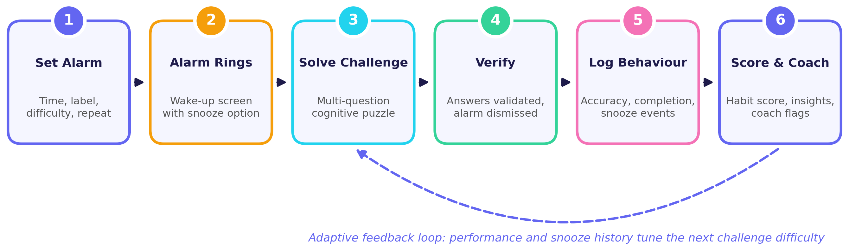
Figure 1 • End-to-end wake-up workflow with adaptive feedback loop
Stage | What Happens
Set Alarm | The user creates an alarm with a time, label, challenge category, difficulty and repeat pattern (for example daily).
Alarm Rings | A full-screen wake-up card appears showing the time, label, difficulty and puzzle type, with a Start Challenge button and a timed Snooze option.
Solve Challenge | The user answers a series of questions with a progress indicator, for example identifying the next element in a letter-number pattern.
Verify | Each answer is validated. The alarm is dismissed only when the challenge is completed, and the completion is recorded.
Log Behaviour | Accuracy, completions and snooze events are stored for analytics and scoring.
Score & Coach | The habit score, charts and recommendations are updated, and coach attention rules are evaluated.

05 System Architecture & Technology
The platform uses a layered architecture that separates the user interface, API gateway, business services, intelligence logic and data storage. This keeps each concern independent, easier to test and ready to scale.
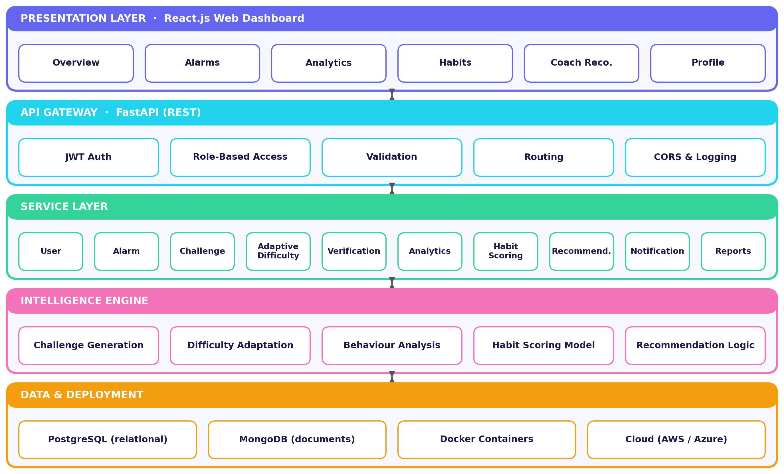
Figure 2 • Layered system architecture of the Cognitive Alarm Platform

Technology Stack
Layer | Technologies and Purpose
Frontend | React.js and Tailwind CSS for a responsive dark-theme interface; Chart.js / Plotly-style visualizations for bar, donut, line and radar charts.
Backend | Python with FastAPI for REST endpoints, request validation and JWT-based authentication with role checks.
Databases | PostgreSQL for structured data such as users, alarms and scores; MongoDB for flexible document data such as preferences and logs.
Analytics & AI | Pandas and NumPy for behavioral metrics; rule-based and statistical logic for adaptive difficulty, habit scoring and recommendations.
DevOps | Docker for containerization, Git and GitHub for version control, Postman for API testing, VS Code for development.

06 Feature Modules
The system is organized into ten cooperating modules. Together they cover the full journey from account creation to coaching and reporting.
Authentication & Access  Registration, login, JWT sessions and role-based access for users, coaches and administrators. | Profile & Habit Management  Wake-up time, sleep target, daily focus goal, difficulty preference and habit keywords.
Alarm Scheduling  Create, snooze, complete and delete alarms; multiple alarms, daily repeat and quick-add. | Cognitive Challenge Engine  Generates multi-question puzzles (pattern and math categories), validates answers and tracks accuracy.
Adaptive Difficulty Engine  Moves challenges across Beginner, Easy, Medium, Hard and Expert based on performance. | Wake-Up Verification  Dismisses alarms only after challenge success and logs completions and snoozes.
Behavioral Analytics  Computes accuracy, completion rate, snooze reduction and wake consistency over time. | Recommendation & Coaching  Personalized tips plus a coach dashboard with attention flags and follow-ups.
Notifications  In-app notification bell for reminders, alerts and progress updates. | Reports & Export  Analytics reports with one-click PDF and Excel export.

07 The Intelligence Layer
Three mechanisms turn raw alarm activity into personalization: an adaptive difficulty ladder, a weighted habit score and a set of coach attention rules.
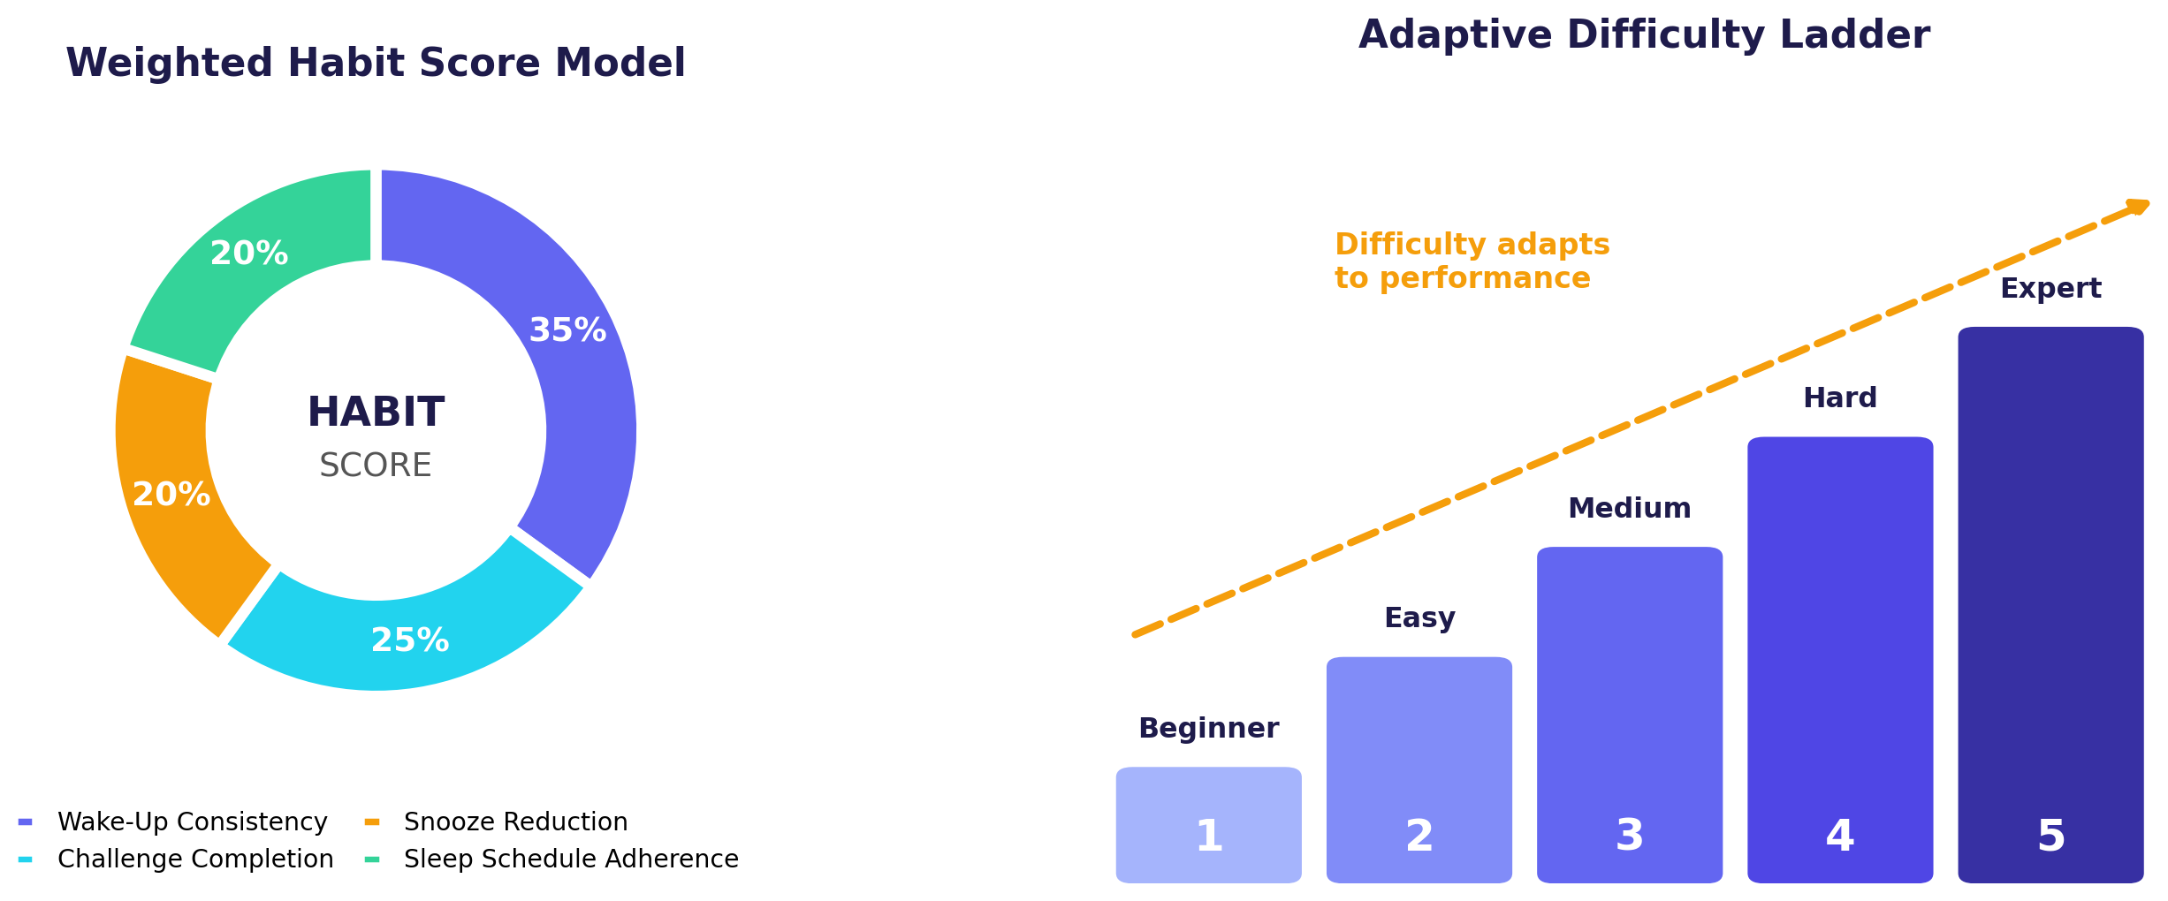
Figure 3 • Weighted habit score model and adaptive difficulty ladder

Adaptive Difficulty
Each user has a preferred difficulty, and the engine adjusts the challenge level across five steps as performance and snooze patterns change. Consistently accurate users are moved toward harder puzzles to keep their brain engaged, while struggling users are eased back to avoid frustration. This keeps the challenge demanding enough to wake the mind but never discouraging.

Habit Score
The habit score is a single percentage built from four weighted components. Consistency carries the most weight because the platform’s core goal is a reliable routine, followed by challenge completion, snooze reduction and adherence to the user’s sleep schedule.
Component | Weight | Interpretation
Wake-Up Consistency | 35% | How regularly the user wakes and completes alarms as planned.
Challenge Completion Success | 25% | Share of started challenges that are solved.
Snooze Reduction | 20% | How well the user avoids snoozing over time.
Sleep Schedule Adherence | 20% | Match between configured sleep and wake targets and actual alarm behavior.

Coach attention rules
Users are flagged for coaching when they show repeated snoozing (3 or more in 7 days), low wake consistency despite recorded completions, or challenge accuracy below 50% after a minimum number of attempts. Sleep duration is a user-configured target; the application does not measure actual sleep.

08 Application Walkthrough
The screens below follow the natural user journey: dashboard, habit setup, alarm creation, the alarm trigger, the challenge, personal analytics and finally the administrator’s coaching view.

Screen 1 • User Overview Dashboard
The landing page after login summarizes a user’s activity at a glance and links to every module through the top navigation bar.
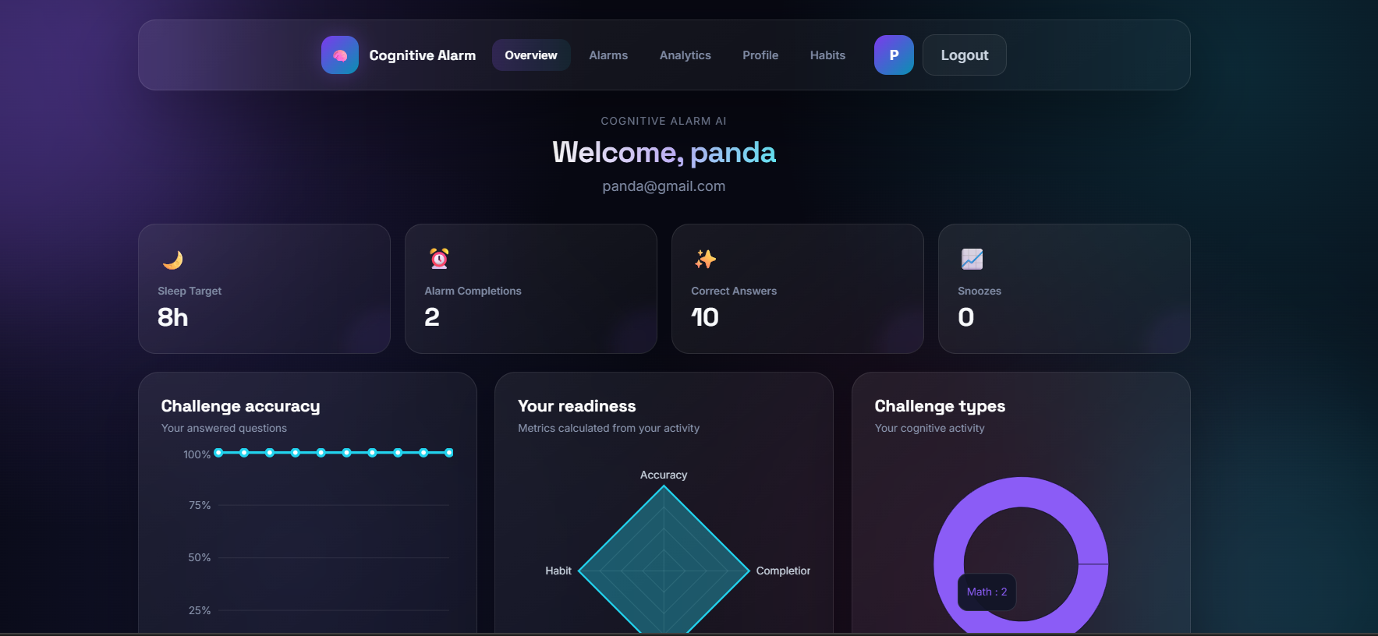
Figure 4 • Overview dashboard with sleep target, completions, correct answers and snoozes
- Quick stats: 8h sleep target, 2 alarm completions, 10 correct answers and 0 snoozes.
- Charts for challenge accuracy, a readiness radar and challenge types give instant visual feedback.

Screen 2 • Habit Customization
Here the user defines the routine the platform should support, and sees a live preview of how it affects planned sleep and difficulty.
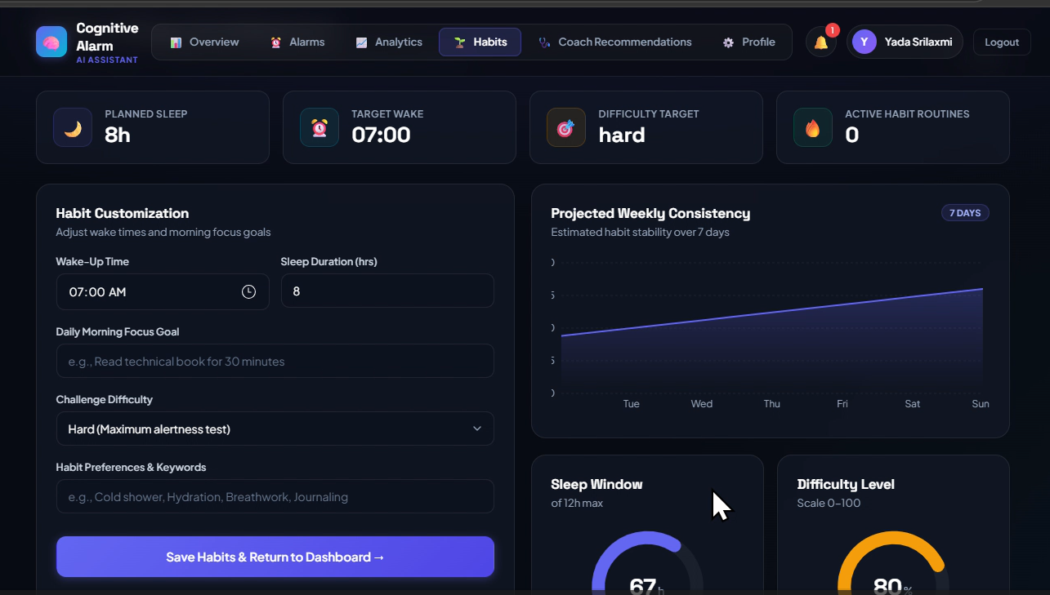
Figure 5 • Habit customization with weekly consistency projection
- Inputs: wake-up time, sleep duration, daily morning focus goal, challenge difficulty and habit keywords.
- Summary cards show planned sleep (8h), target wake (07:00) and difficulty target (hard); gauges show the sleep window and difficulty level.

Screen 3 • Scheduled Alarms
The alarm manager lists every alarm with its status and configuration and exposes quick actions.
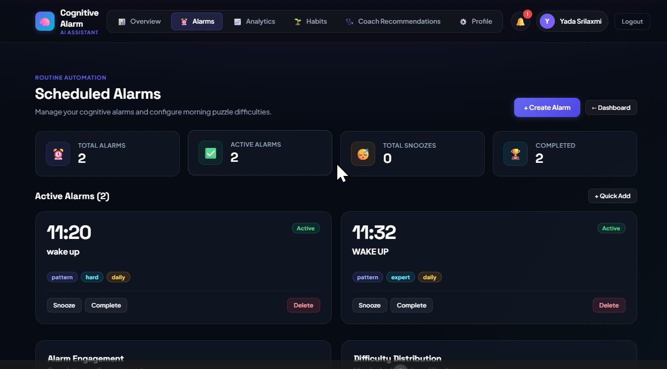
Figure 6 • Scheduled alarms with challenge type, difficulty and repeat tags
- Counters for total, active, snoozed and completed alarms.
- Each card carries tags such as pattern, hard/expert and daily, with Snooze, Complete and Delete actions.

Screen 4 • Alarm Trigger
When the alarm fires, the user must engage with the system rather than simply silence it.
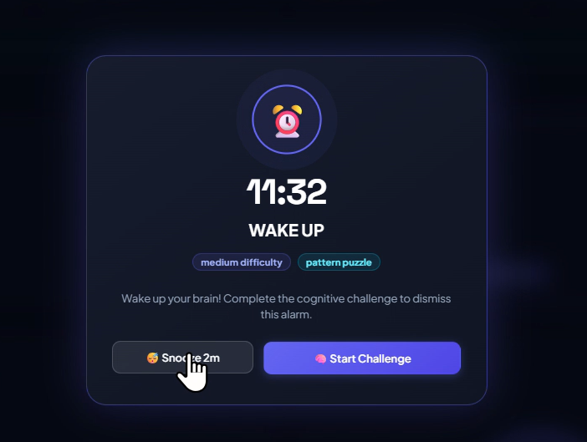
Figure 7 • Alarm ringing screen with Start Challenge and timed snooze
- Shows time, label, difficulty and puzzle type with the message to complete the cognitive challenge to dismiss the alarm.
- A timed snooze (2 minutes) is available but is recorded and affects the snooze-reduction score.

Screen 5 • Cognitive Challenge
The challenge screen presents the puzzle, the answer field and progress through the question set.
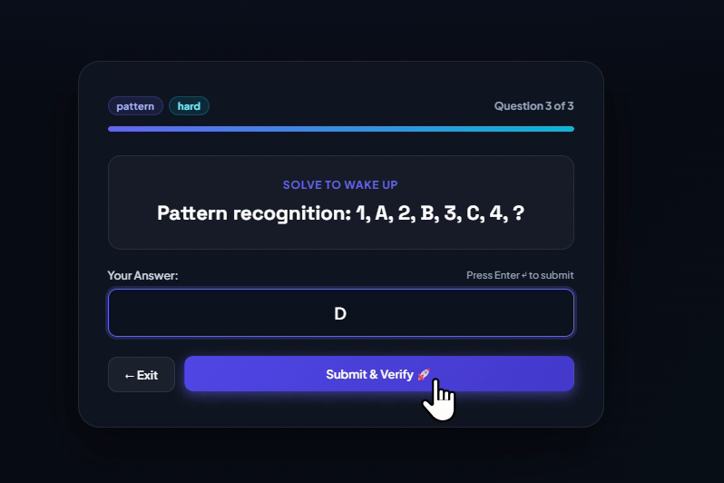
Figure 8 • Pattern-recognition challenge (question 3 of 3)
- Progress bar and question counter (3 of 3) with difficulty and category tags.
- Example puzzle: the sequence 1, A, 2, B, 3, C, 4, ? expects the answer D; answers can be submitted with the button or the Enter key.

Screen 6 • Cognitive Analytics & Trends
The analytics page converts activity into key indicators and visual comparisons, and lets users export reports.
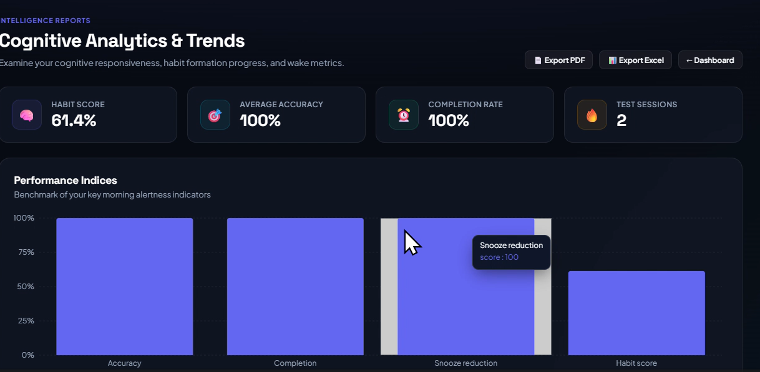
Figure 9 • Analytics KPIs and performance indices with PDF and Excel export
- KPIs: habit score 61.4%, average accuracy 100%, completion rate 100% and 2 test sessions.
- Performance Indices bar chart compares accuracy, completion, snooze reduction and habit score.
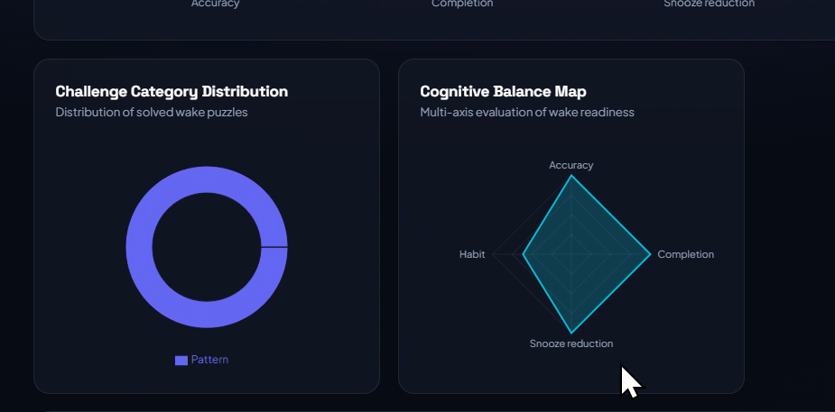
Figure 10 • Challenge category distribution and cognitive balance radar
- The donut chart shows the types of puzzles solved; the Cognitive Balance Map radar evaluates wake readiness on four axes.

Screen 7 • Admin Wellness Coach Dashboard
Coaches and administrators get a cross-user view designed to prioritize who needs support.
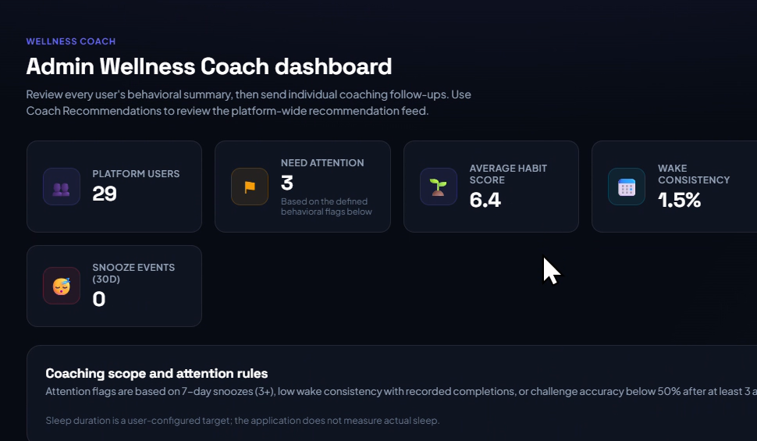
Figure 11 • Admin wellness coach dashboard with attention flags
- Platform metrics: 29 users, 3 needing attention, average habit score 6.4, wake consistency 1.5% and 0 snooze events in 30 days.
- A rules panel documents exactly how attention flags are calculated, keeping coaching transparent.

09 Results & Observations
The figures below were recorded from the running application during testing and demonstration.
Metric | Observed | Interpretation
Challenge accuracy | 100% | All 10 answered questions in the sample account were correct, so the validation and scoring path works end to end.
Alarm completion rate | 100% | Both alarms in the sample account were completed through the challenge flow.
Snooze events | 0 | No snoozes were recorded for the sample users, which feeds a full snooze-reduction score.
Habit score | 61.4% | Below 100% even with perfect accuracy, showing that the weighted model also rewards sustained consistency over time.
Platform users | 29 | The coach dashboard aggregates all registered accounts.
Users needing attention | 3 | Flags are generated automatically by the defined coaching rules.
Average platform habit score | 6.4 | Reflects accounts that are still early in habit formation.

Key takeaway
The platform delivers its full loop: puzzle-based dismissal, behavior tracking, scoring and coach-level visibility. The low platform-wide averages are expected for new accounts and give a clear baseline against which future improvement can be measured.

10 Development Roadmap
Development followed an eight-week plan divided into four milestones, each ending with a working, demonstrable increment.
WEEKS 1–2  Foundation | WEEKS 3–4  Challenges | WEEKS 5–6  Intelligence | WEEKS 7–8  Delivery
- Objectives, architecture and database design  - UI wireframes and environment setup  - Authentication and role-based access  - Profile, habit and alarm scheduling modules | - Cognitive challenge engine  - Puzzle generation workflows  - Wake-up verification  - Answer evaluation and challenge analytics | - Adaptive difficulty engine  - Behavioral analytics workflows  - Weighted habit scoring  - Recommendations and coach dashboard | - Analytics dashboards and reports  - PDF and Excel export  - Testing and validation  - Docker deployment and documentation

11 Testing & Validation
Testing focused on the critical wake-up flow and on the correctness of the numbers shown to users and coaches.
Area | What Was Verified | Method
Authentication & roles | Registration, login, protected routes, and different views for users versus coach or administrator accounts. | Manual, Postman
Alarm lifecycle | Creating, snoozing, completing and deleting alarms; counters and status tags update correctly. | Functional
Challenge validation | Correct and incorrect answers, progress through the question set, and dismissal only on success. | End-to-end
Analytics accuracy | KPIs, charts and habit score update after new activity and handle empty data gracefully. | Data checks
Reports | PDF and Excel exports generate from the analytics page. | Manual
Deployment | Frontend and backend run together as containers. | Docker

12 Challenges & Solutions
Challenge | Approach Taken
Balancing puzzle difficulty | Introduced five difficulty levels and adaptation based on accuracy and snooze behavior so puzzles stay demanding but fair.
Defining reliable behavior metrics | Standardized formulas for accuracy, completion, snooze reduction and consistency, with safe defaults when little data exists.
Separating role experiences | Implemented JWT authentication with role checks so users, coaches and administrators see only their own tools and data.
Alarm state handling in a web app | Modelled alarm states (active, snoozed, completed) explicitly so triggering, snoozing and dismissal stay consistent across pages.
Frontend–backend integration | Agreed on API response structures and handled null and empty datasets so charts render correctly for new users.
Fair coaching thresholds | Used clear, documented rules (for example 3 or more snoozes in 7 days) so flags are transparent and not triggered by too little data.

13 Learnings & Team Reflections

Skills Acquired
- Full-stack engineering with React.js, FastAPI and relational and document databases.
- Secure API design using REST principles, JWT authentication and role-based authorization.
- Behavioral analytics and scoring including weighted models and adaptive logic.
- Data visualization and reporting with bar, donut, line and radar charts and PDF/Excel export.
- DevOps practices such as Docker containerization, Git workflows and API testing.

Team Reflections
What the team took away
Building an AI-assisted product showed how user behavior data can be turned into useful feedback. The milestone-based plan made delivery predictable, collaboration through version control improved code quality, and completing a full application from design to deployment built confidence in real-world development.

14 Future Scope
Enhancement | Benefit
Mobile app (React Native) | Native alarm scheduling and push notifications for more reliable wake-up triggering.
Wearable and health integration | Use measured sleep data (for example from Google Fit or HealthKit) instead of user-set targets.
Reinforcement learning | Learn the best challenge and difficulty for each individual user over time.
More challenge types | Memory games, word games, riddles, quick quizzes and time-based challenges.
Cloud scale-out | Deployment on AWS or Azure with monitoring and CI/CD for large user bases.

15 Conclusion
The Intelligent Cognitive Alarm Platform successfully demonstrates that an alarm can be more than a sound. By requiring active thinking to dismiss it, adapting to each user’s performance, scoring habits and giving coaches clear visibility, the system addresses oversleeping and inconsistent routines in a practical and measurable way.
The project delivered a complete end-to-end workflow, from secure account creation and alarm scheduling to cognitive verification, analytics and coaching, while providing valuable hands-on experience in full-stack development, data-driven design and teamwork. It forms a strong foundation for future extensions such as mobile support, wearable integration and learned personalization, and aligns well with future careers in software development and AI-driven product engineering.

