INFOSYS SPRINGBOARD INTERNSHIP
INTELLIGENT COGNITIVE
ALARM PLATFORM
Milestone 1 | Project Design and Planning
Project Objectives • System Architecture • UI Wireframes
Prepared by: Tanmaya Deshpande
College: TCET
Date: 25 August 2026

1. Project Objectives and Cognitive Alarm Workflows

1.1 Introduction
The Intelligent Cognitive Alarm Platform is an AI-powered alarm and habit-management system designed to improve users' wake-up consistency. Unlike conventional alarms that can be dismissed or snoozed easily, the platform requires the user to complete a cognitive challenge, such as a mathematical problem, memory task, logic puzzle, word challenge or pattern-recognition activity, before dismissing the alarm.
The platform records information such as challenge accuracy, response time, snooze frequency, sleep schedule and wake-up consistency. Based on this data, it adjusts the difficulty of future challenges, calculates a habit score and provides personalized recommendations. It also offers alarm scheduling, performance analytics, notifications and role-based dashboards. The application will use React or React Native for the frontend, FastAPI for the backend, PostgreSQL for data storage and Firebase for notifications.

1.2 Main Project Objective
The main objective of the Intelligent Cognitive Alarm Platform is to develop a smart and reliable alarm system that helps users wake up on time by actively engaging their minds through personalized cognitive challenges.
The system aims to reduce excessive snoozing, verify that the user is awake, track wake-up behaviour and gradually improve the user's sleep and morning habits. It will analyse the user's challenge performance and automatically adjust challenge difficulty. The platform will also calculate habit scores, display progress through an analytics dashboard and provide personalized recommendations for improving wake-up consistency and productivity.

1.3 Cognitive Alarm Workflow
The cognitive alarm workflow covers the process from user registration to alarm dismissal and performance analysis. The user creates a profile, sets sleep goals and configures an alarm with its time, recurrence, challenge type, difficulty and snooze limit. At the scheduled time, the alarm activates locally on the device and displays a cognitive challenge.
If the submitted answer is incorrect, the system provides another attempt or generates a new task. Snoozing is allowed only while the configured limit remains. A correct answer confirms wakefulness, dismisses the alarm and records response time, attempts, challenge accuracy and snooze count. These values are then used to update challenge difficulty, the habit score and personalized recommendations.
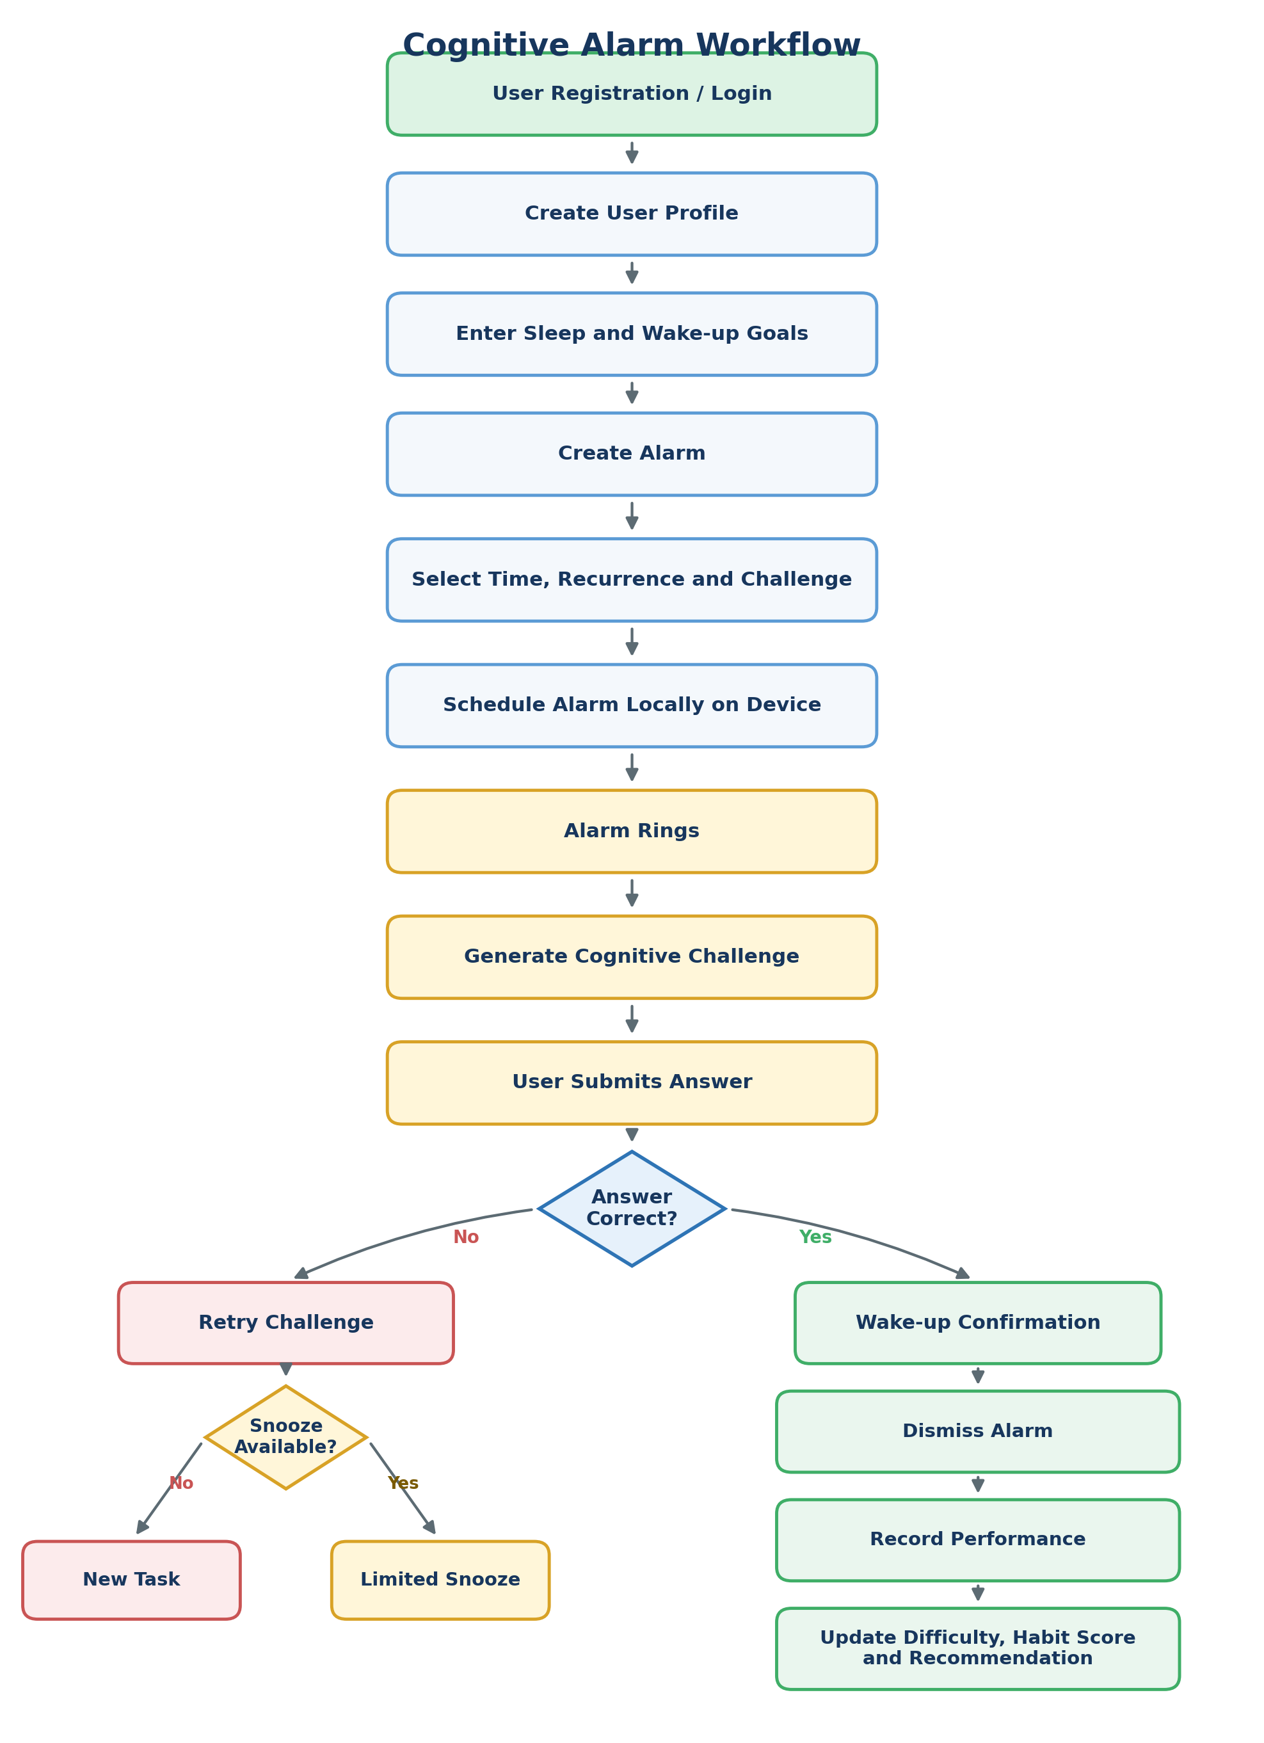
Figure 1: Cognitive Alarm System Workflow

1.4 Registration and Onboarding Workflow
A new user creates an account, signs in, selects a time zone, sets a target sleep and wake-up time, and chooses preferred challenge types. After the profile is saved, the system opens the dashboard.
Register → Login → Create Profile → Set Time Zone and Goals → Choose Challenges → Dashboard

1.5Alarm Scheduling Workflow
The user creates an alarm by selecting its time, recurrence, challenge type, difficulty and snooze limit. The alarm is stored in the database and scheduled locally so that it can operate even when internet access is unavailable.
Create Alarm → Select Time → Set Recurrence → Configure Challenge → Set Snooze Limit → Save and Schedule

1.6 Alarm Activation Workflow
At the scheduled time, the device activates the alarm, displays the selected cognitive challenge and starts measuring response time. The system validates each submitted answer and controls retry or snooze behaviour.
Scheduled Time → Alarm Rings → Display Challenge → Submit Answer → Validate Response

1.7 Habit Score Calculation
The habit score combines four normalized performance measures. Each measure is calculated on a 0-100 scale, so the final result is also presented out of 100.
Habit Score = 0.35C + 0.25H + 0.20S + 0.20A
- C = Wake-up consistency score
- H = Challenge completion score
- S = Snooze-reduction score
- A = Sleep-schedule adherence score

2. System Architecture and Database Schema

2.1 Proposed Technology Stack
Component | Technology
Frontend | React.js / React Native
Backend | FastAPI using Python
Primary Database | PostgreSQL
Optional Database | MongoDB for unstructured analytics data
Authentication | JWT / OAuth2
Notifications | Firebase Cloud Messaging
Deployment | Docker with AWS or Azure
API Testing | Postman
UI Design | Figma, PowerPoint or diagrams.net

2.2 System Architecture
The proposed solution uses a layered architecture. React or React Native provides the user interface, while FastAPI exposes secure application APIs. The backend is organized into independent modules for authentication, alarms, challenges, adaptive intelligence, analytics and notifications. PostgreSQL stores structured application data, Firebase delivers notifications, and Docker supports deployment on AWS or Azure.
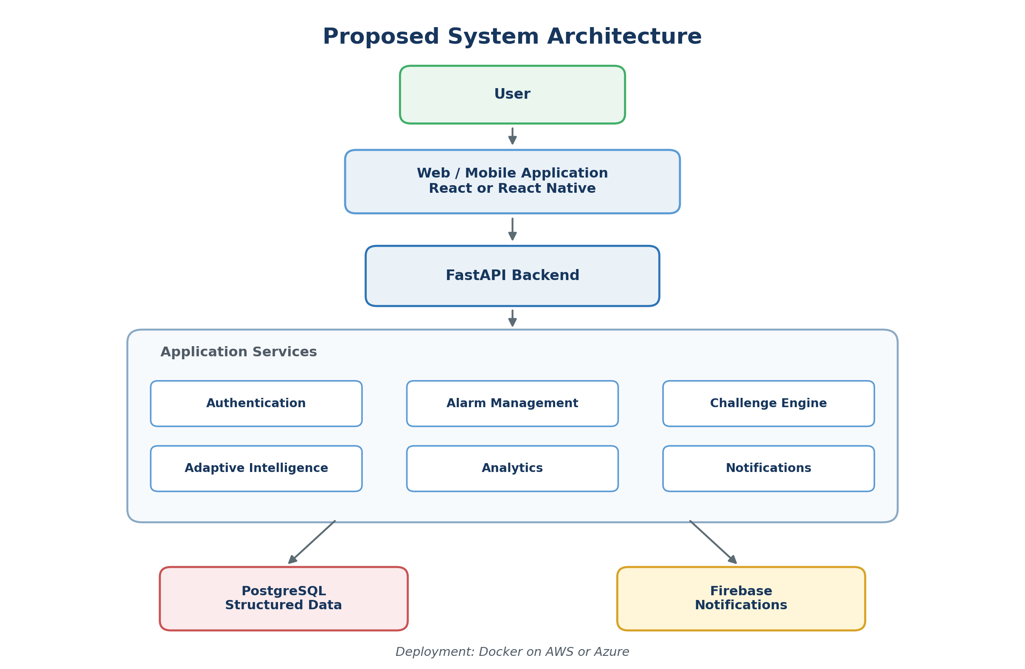
Figure 2: Proposed System Architecture of the Intelligent Cognitive Alarm Platform

2.3 Component Description
Component | Responsibility
Web/Mobile Application | Collects user input and displays alarms, challenges, scores and recommendations.
Authentication Module | Handles registration, login, password security and JWT/OAuth2 access control.
Alarm Management Module | Creates, updates, deletes and synchronizes one-time or recurring alarms.
Cognitive Challenge Engine | Generates and validates math, logic, memory, word and pattern challenges.
Adaptive Intelligence | Adjusts challenge difficulty using recent accuracy, attempts and response time.
Analytics Module | Calculates habit scores, trends, streaks and wake-up consistency.
Notification Module | Sends bedtime reminders, wake-up alerts and progress notifications.
Data Layer | Stores users, profiles, alarms, sessions, attempts, scores and recommendations.

2.4 Database Schema
The database schema separates account information, user preferences, alarms, alarm activations, cognitive challenges, attempts, scores and recommendations. Primary and foreign keys maintain relationships and avoid duplication of data.
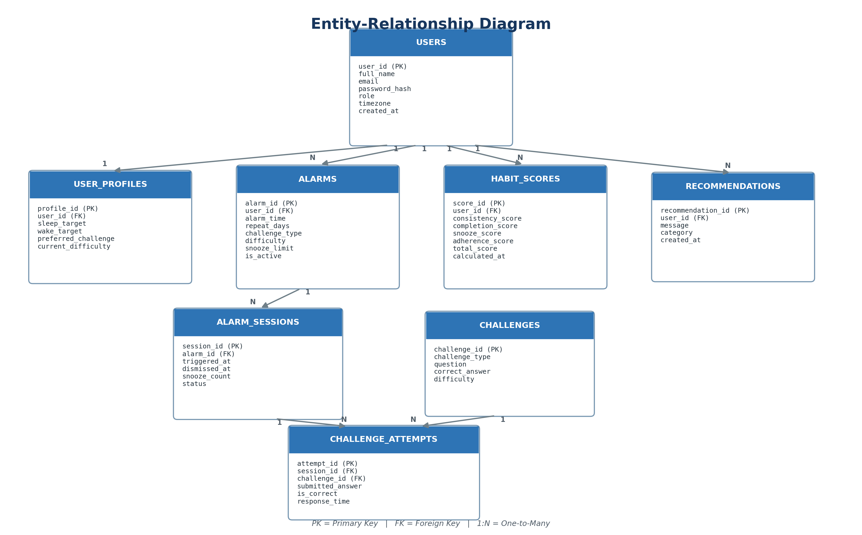
Figure 3: Database Schema of the Intelligent Cognitive Alarm Platform

2.5 Database Table Description
Table | Purpose
USERS | Stores user account, login and role details.
USER_PROFILES | Stores sleep goals and cognitive-challenge preferences.
ALARMS | Stores alarm time, recurrence, difficulty and snooze settings.
ALARM_SESSIONS | Records every alarm activation, snooze and dismissal.
CHALLENGES | Stores cognitive challenge questions, answers and difficulty.
CHALLENGE_ATTEMPTS | Records submitted answers, correctness and response time.
HABIT_SCORES | Stores calculated user performance and habit scores.
RECOMMENDATIONS | Stores personalized sleep and wake-up suggestions.

3. UI Wireframes and Workflow Planning

3.1 UI Design Overview
The interface is designed as a simple mobile-first experience. Important actions such as creating an alarm, solving a challenge and checking progress are reachable in a small number of steps. Clear typography, large touch targets and consistent colours help users interact with the application immediately after waking up.

3.2 Login and Registration Screen
The screen provides email and password fields, login, registration and password-recovery options. Validation messages guide the user when information is incomplete or incorrect.

3.3 User Dashboard
The dashboard displays the next alarm, current habit score, wake-up streak, average response time and a direct button for creating a new alarm. A bottom navigation bar provides access to alarms and analytics.

3.4 Create Alarm Screen
The user selects alarm time, repeat days, challenge type, difficulty and snooze limit. Saving the configuration schedules the alarm locally and synchronizes it with the backend.
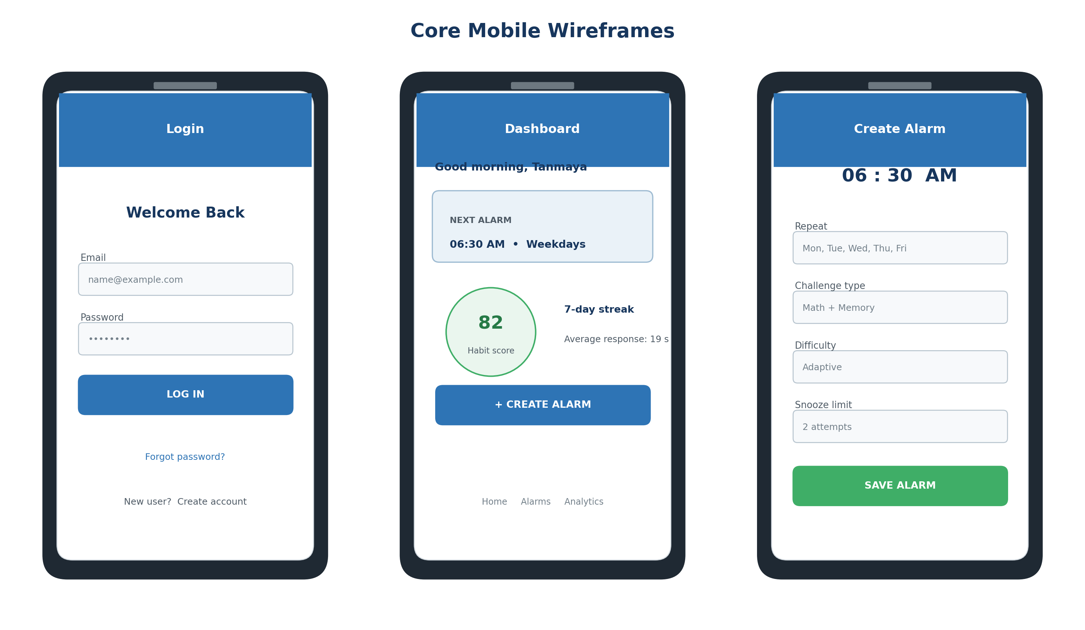
Figure 4: Login, Dashboard and Create Alarm Wireframes

3.5 Alarm Challenge Screen
When the alarm rings, the screen presents a cognitive task, answer field, attempt count and remaining snoozes. The alarm can be dismissed only after successful verification or an authorized emergency action.

3.6 Performance Analytics Screen
After successful verification, a confirmation screen displays response time, wake-up streak and the updated habit score. The analytics screen summarizes weekly consistency, challenge accuracy, average response time, snooze count and personalized recommendations.
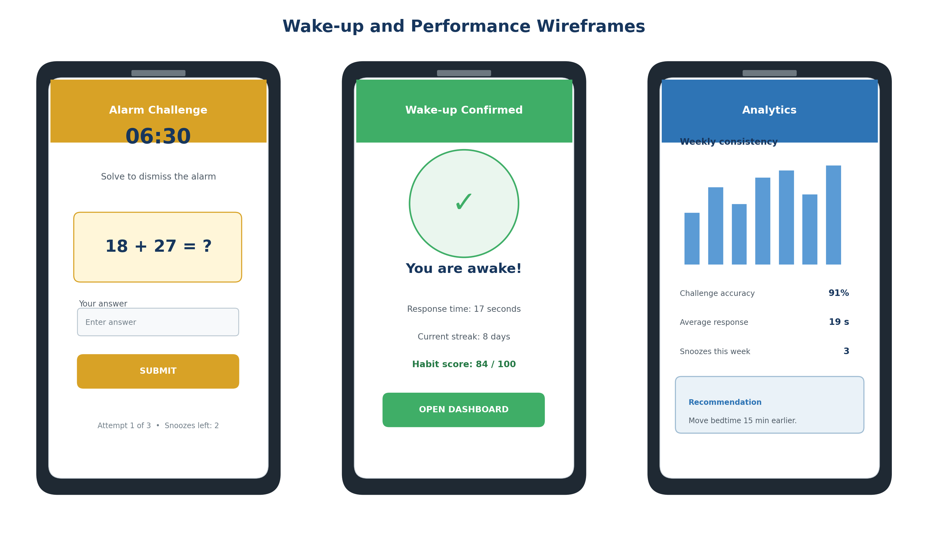
Figure 5: Alarm Challenge, Wake-Up Confirmation and Analytics Wireframes

4. Conclusion
Milestone 1 defines the foundation of the Intelligent Cognitive Alarm Platform through clear project objectives, cognitive-alarm workflows, a modular system architecture, a normalized database schema and mobile-first UI wireframes. The design supports an achievable internship MVP while leaving room for future expansion into richer analytics, wearable integration and advanced personalization. The next stage is to implement the database models, authentication flow, alarm APIs and initial user-interface screens.

