Trust Share: Secure File-Sharing System

Task 1: Project Objectives and Secure Collaboration Workflows

1.1 Project Overview
Trust Share is a web-based platform that lets users upload, store and share files securely. Every file is encrypted on the server with AES-256 before it reaches cloud storage, and every access is controlled by authentication, permissions and time-limited links. The platform suits organizations, educational institutions and businesses that exchange sensitive documents.

1.2 Project Objectives
The main objective is to build a secure file-sharing and document management platform in which sensitive documents stay protected during upload, storage, sharing and download.
Specific objectives:
- Authentication: register and log in users with JWT sessions, multi-factor authentication, OAuth2 and password recovery.
- Access control: enforce role-based access control and per-file permissions on every request.
- Encrypted storage: encrypt each file with its own AES-256 key before it is stored in AWS S3 or Azure Blob Storage.
- Secure sharing: provide share links that expire, can be revoked, and can limit downloads and access level.
- File management: support upload, folders, categories, search, metadata and version history.
- Monitoring: record every login, upload, share and download in audit logs and flag suspicious activity.
- Notifications: tell users when files are shared, accessed or about to expire, and warn them of security events.
- Analytics: show storage, activity and security dashboards for users and administrators.
- Deployment: package the platform with Docker and deploy it on AWS or Azure.

Success criteria
The source document asks for high accuracy and stable performance without fixed numbers. The targets below are proposed so that each objective can be tested.
- Encryption: 100% of stored files are encrypted with AES-256; no plain text file is ever written to cloud storage.
- Access control: no file can be retrieved without a valid token and a matching permission or share link.
- Share links: expired and revoked links are rejected every time.
- Audit logging: every login, upload, share, download and failed access attempt is logged.
- Performance: metadata API calls respond in under 500 ms, and the system handles multiple users at once.

1.3 Scope
In scope
- Responsive web application built with React/Next.js and Tailwind CSS
- FastAPI backend with PostgreSQL, MongoDB and Redis
- Server-side AES-256 encryption with per-file keys and key rotation
- Authentication, role-based access control, secure sharing, monitoring, notifications and analytics
- Docker-based deployment on AWS or Azure
Out of scope
- Native mobile and desktop clients (this project covers the web platform only)
- In-browser editing of documents or real-time co-editing
- Client-side (end-to-end) encryption, because the design uses server-side encryption

1.4 User Roles and Permissions
Trust Share has four roles. A file shared with a user or through a link carries one of three access levels: View, Download or Edit.
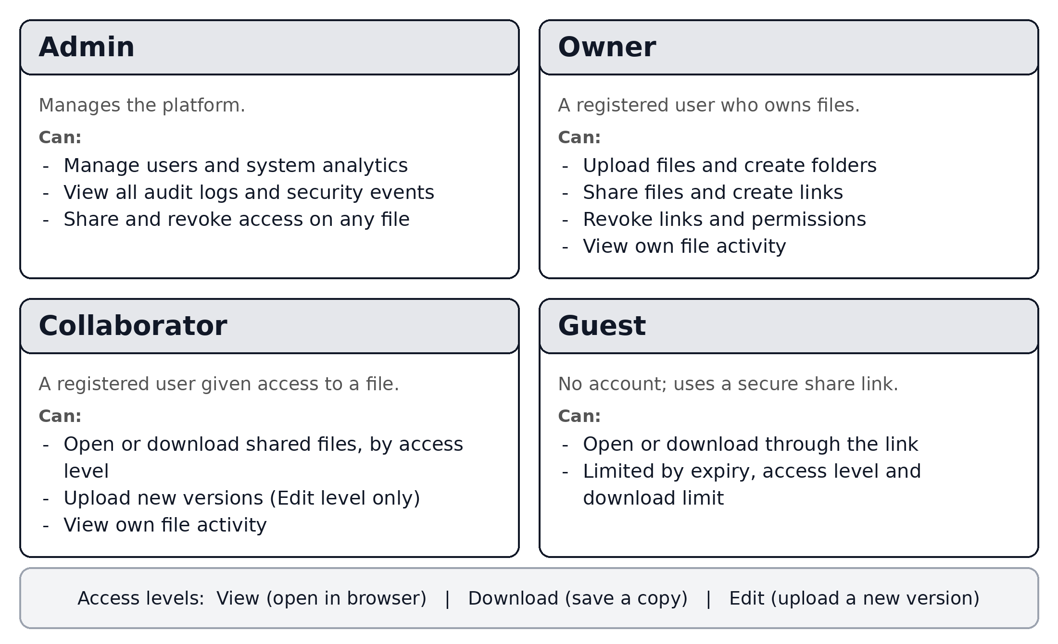
Figure 1: User roles, their permissions and access levels

1.5 Secure Collaboration Workflows
Six workflows cover the full life of a shared file. Each step shows who acts, what happens, and the security control that protects it.

Workflow 1: Registration and login
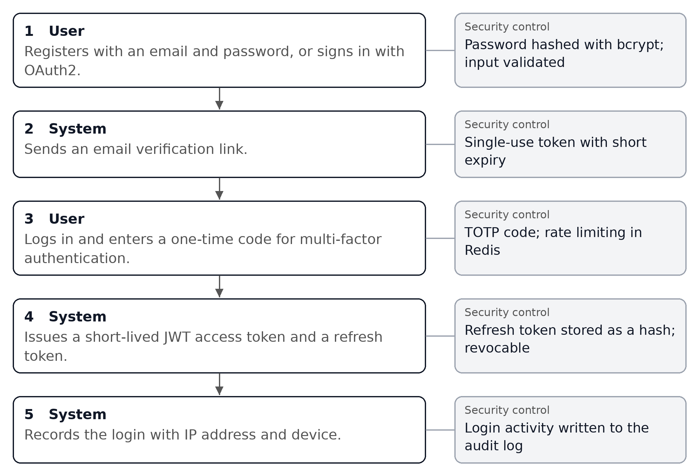

Workflow 2: Upload and encrypt a file
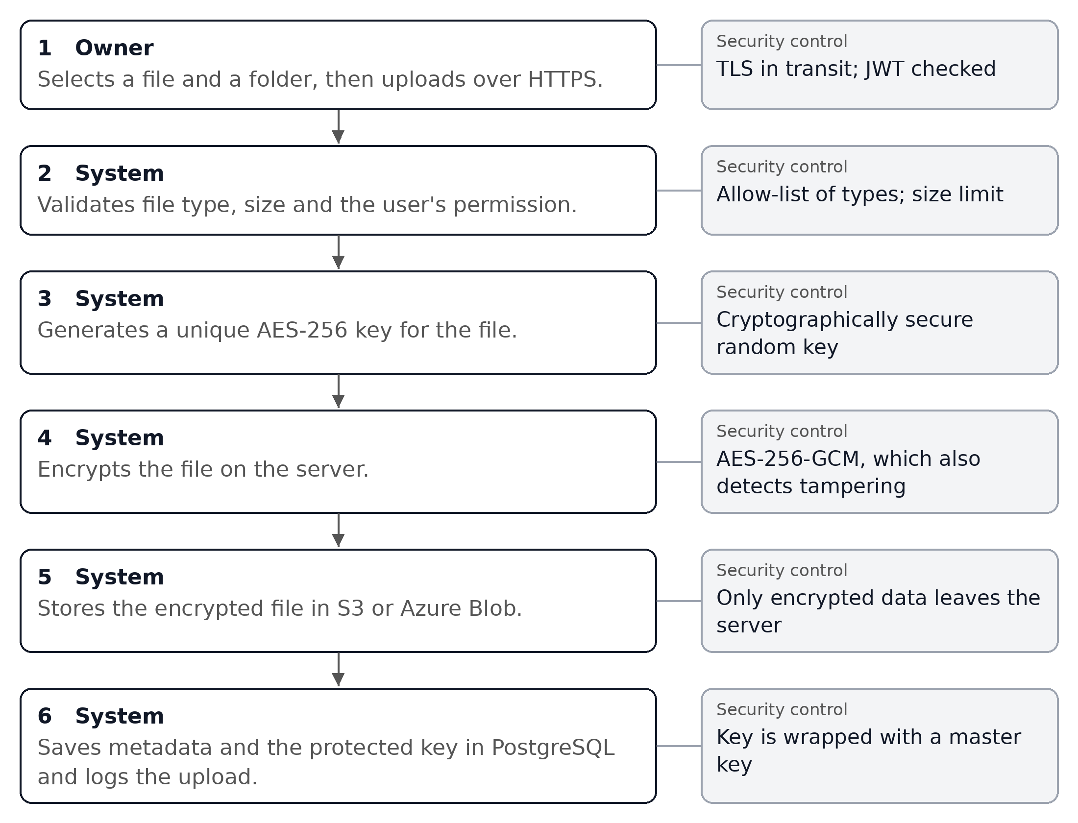

Workflow 3: Share a file
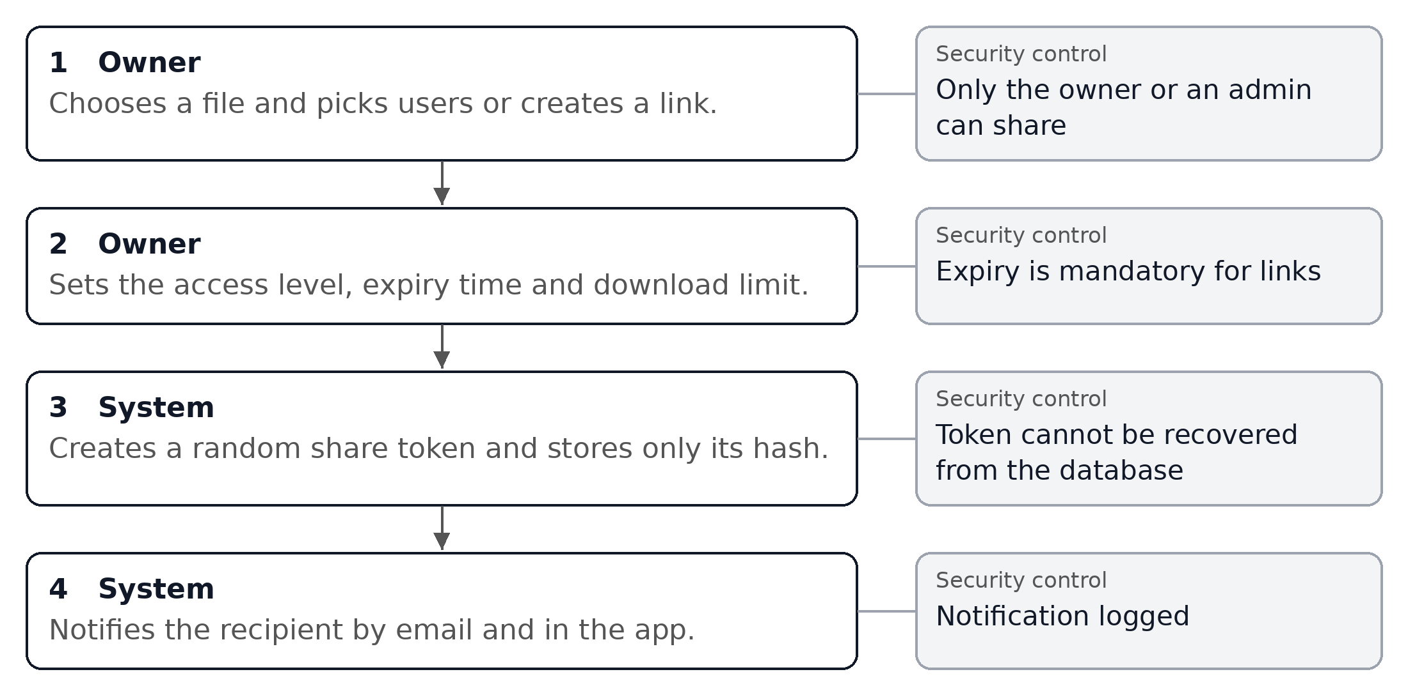

Workflow 4: Access a shared file
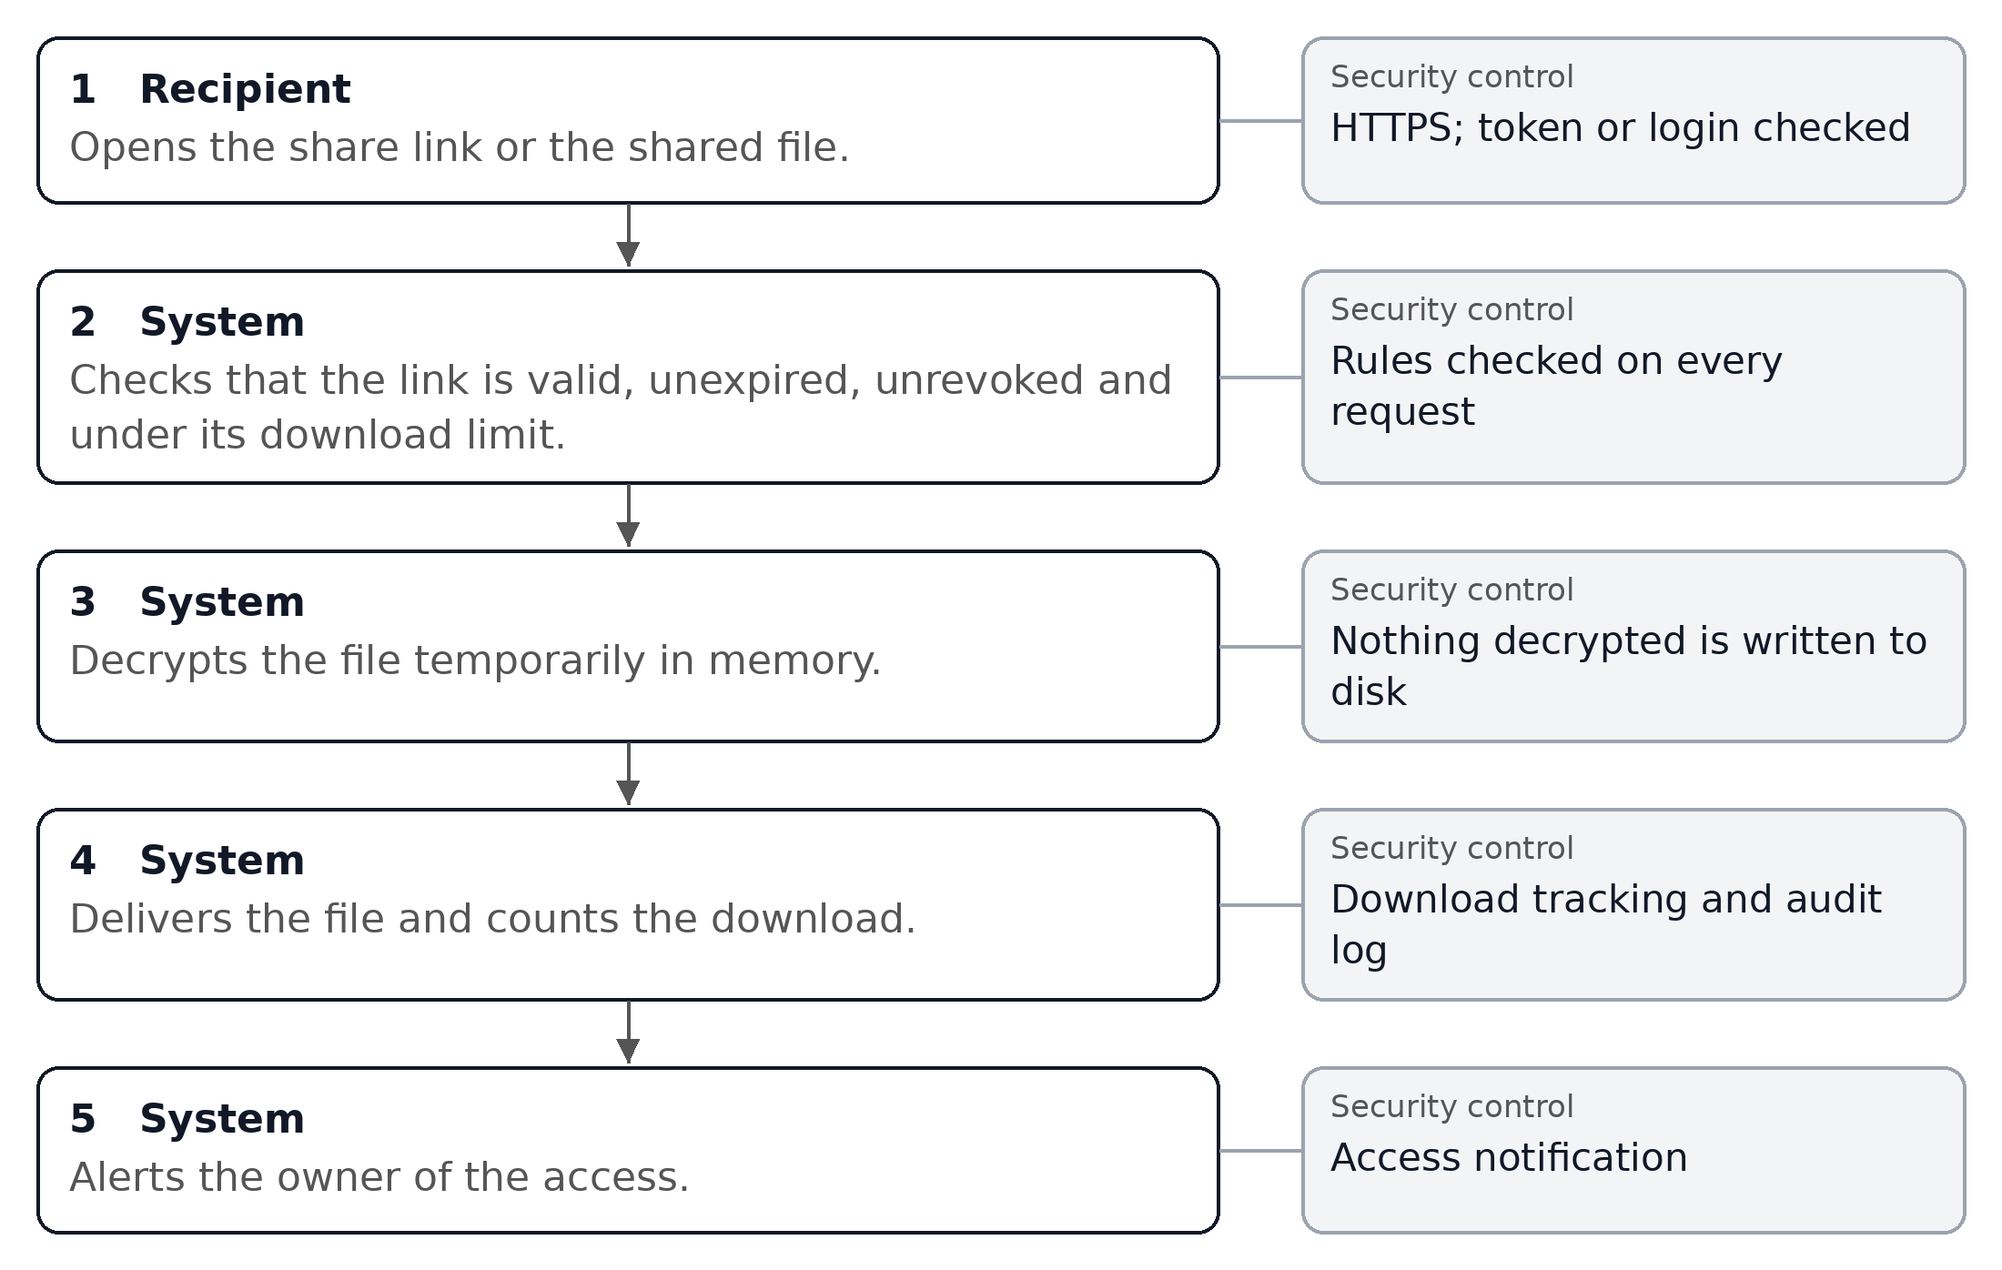

Workflow 5: Expiry, revocation and key rotation
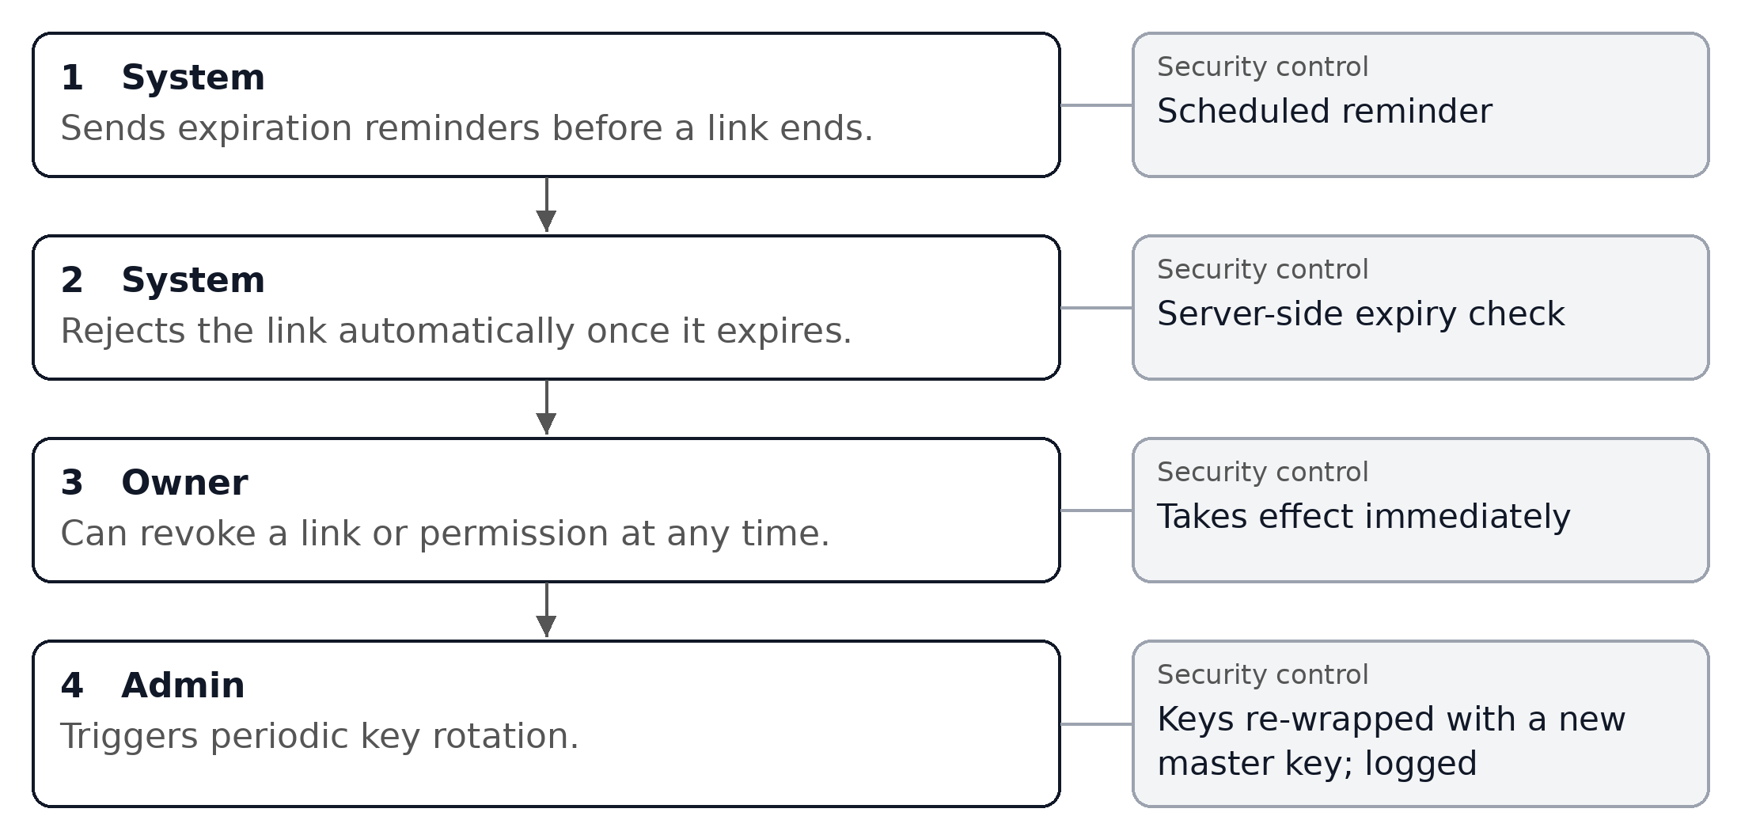

Workflow 6: Monitoring and alerts
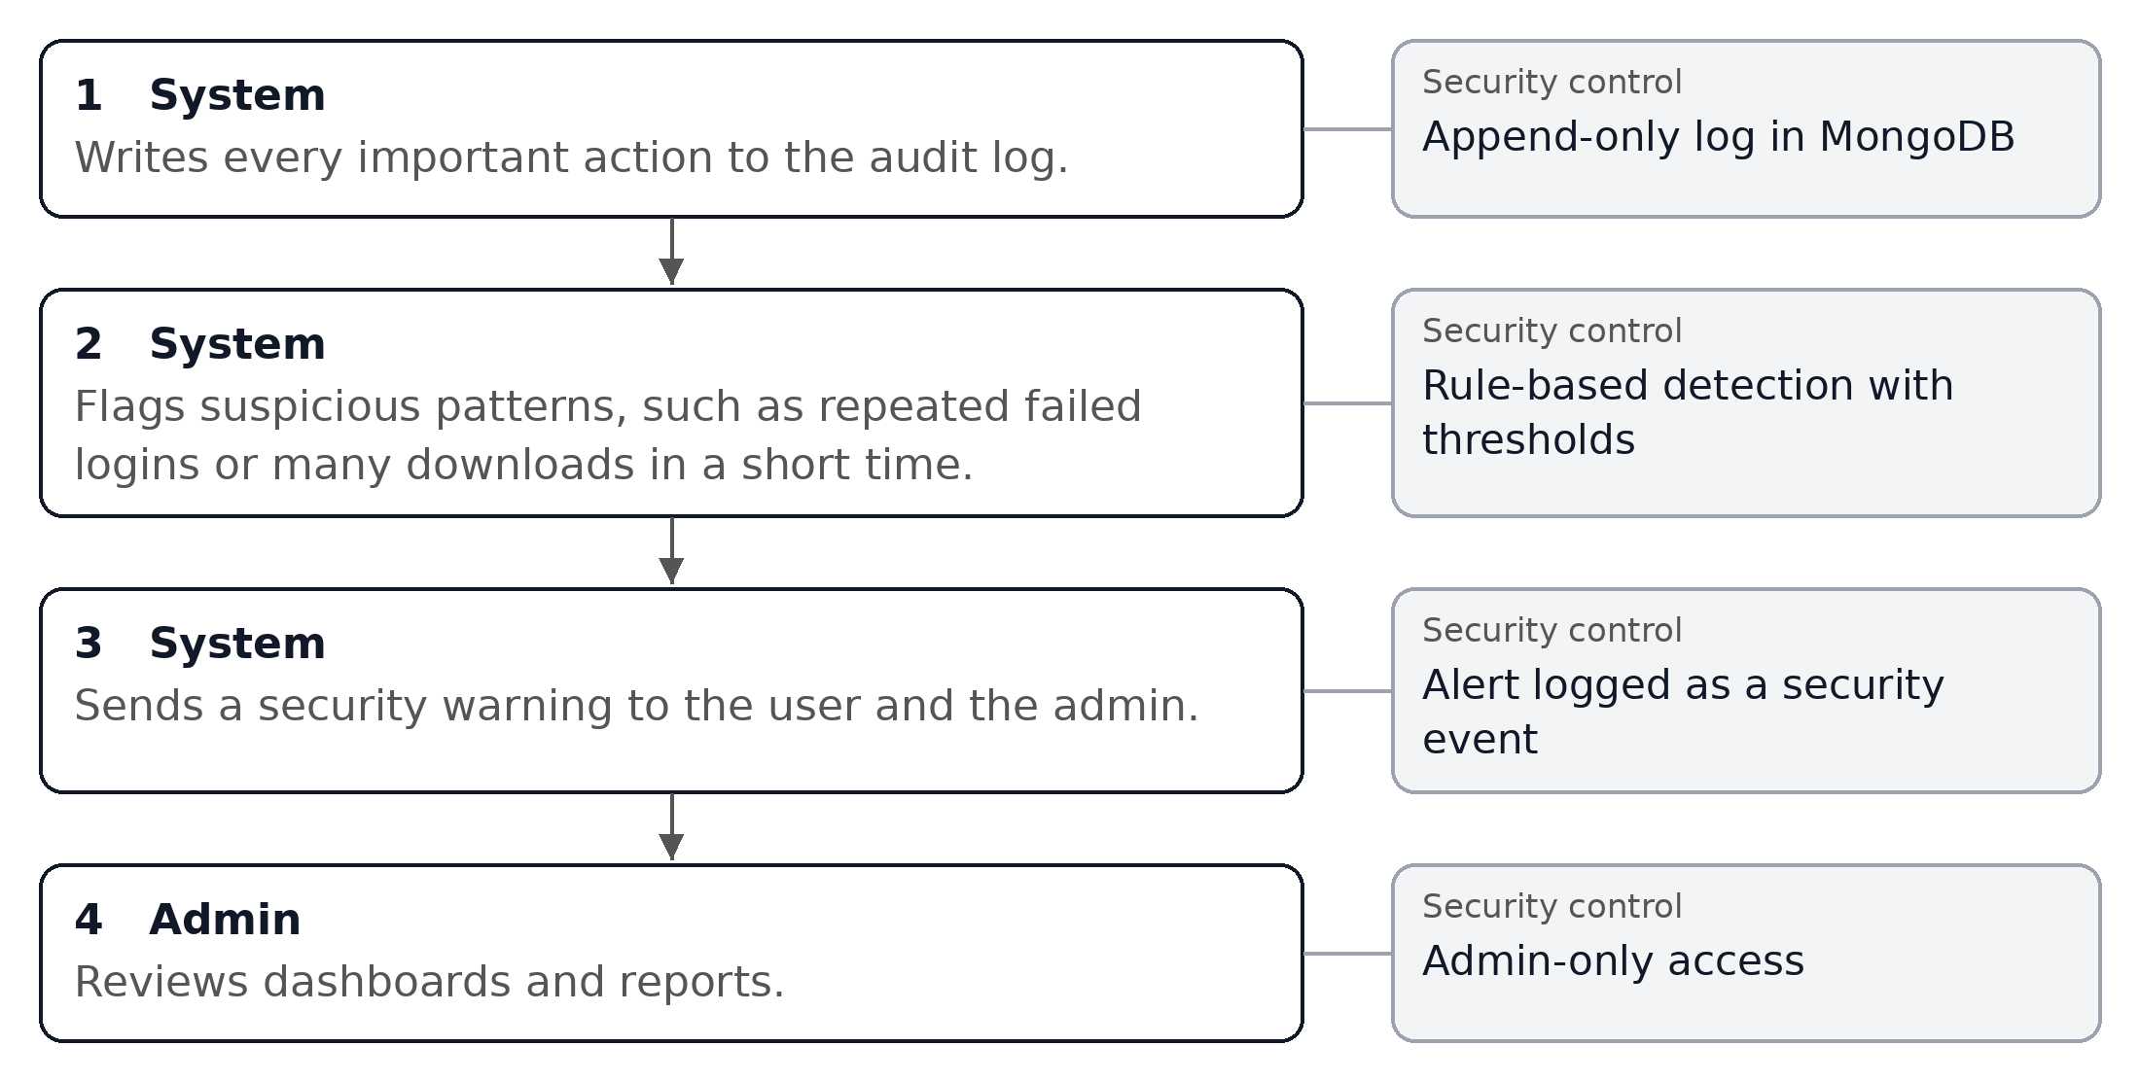

1.6 Security Requirements
- All traffic uses HTTPS/TLS.
- Passwords are hashed with bcrypt; plain passwords are never stored.
- Access is protected by JWT, optional multi-factor authentication and OAuth2.
- Every API request is checked against the user's role and the file's permissions.
- Each file is encrypted with its own AES-256 key before storage, and keys are never shown to users.
- Share links use random tokens, have an expiry time and can be revoked.
- Every login, upload, share, download and failed access attempt is logged.
- Encryption keys are rotated periodically.

Task 2: Secure System Architecture and Database Schema

2.1 Architecture Overview
Trust Share uses server-side encryption. The browser talks to a FastAPI backend over HTTPS. The backend encrypts files before storing them in cloud storage and keeps metadata, logs and sessions in separate databases.
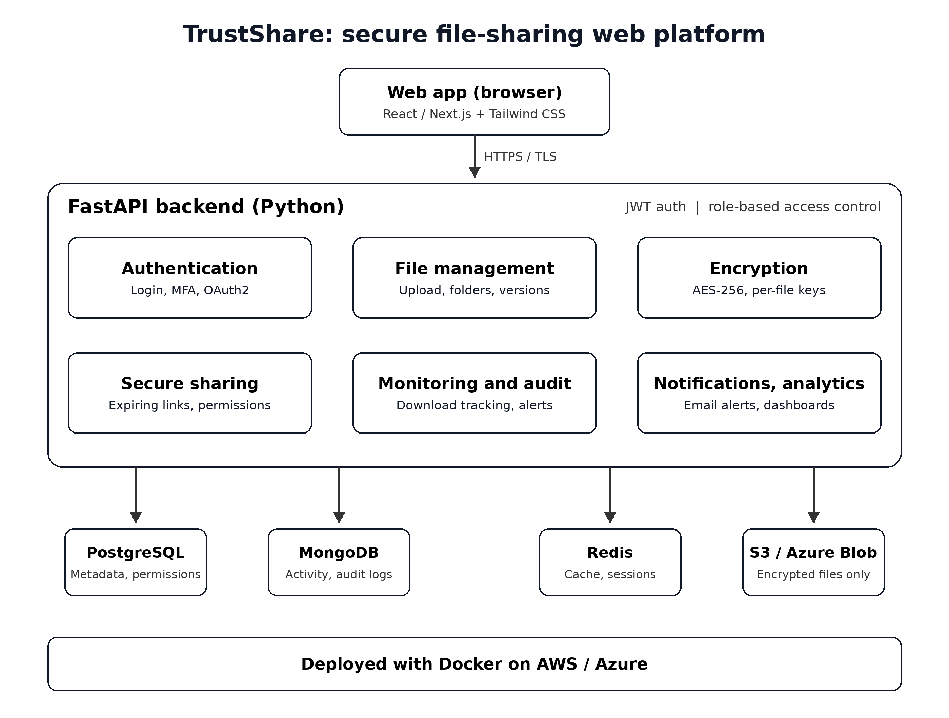
Figure 2: Trust Share system architecture (web platform)
Layers
- Web app: React/Next.js with Tailwind CSS. Users upload, share and manage files; admins see dashboards.
- FastAPI backend: One application with six modules: authentication, file management, encryption, secure sharing, monitoring and audit, and notifications and analytics.
- Data layer: PostgreSQL for users, file metadata and permissions; MongoDB for activity and audit logs; Redis for sessions, cache and rate limits; S3 or Azure Blob for encrypted files.
- Infrastructure: Docker containers deployed on AWS or Azure.

2.2 Technology Stack
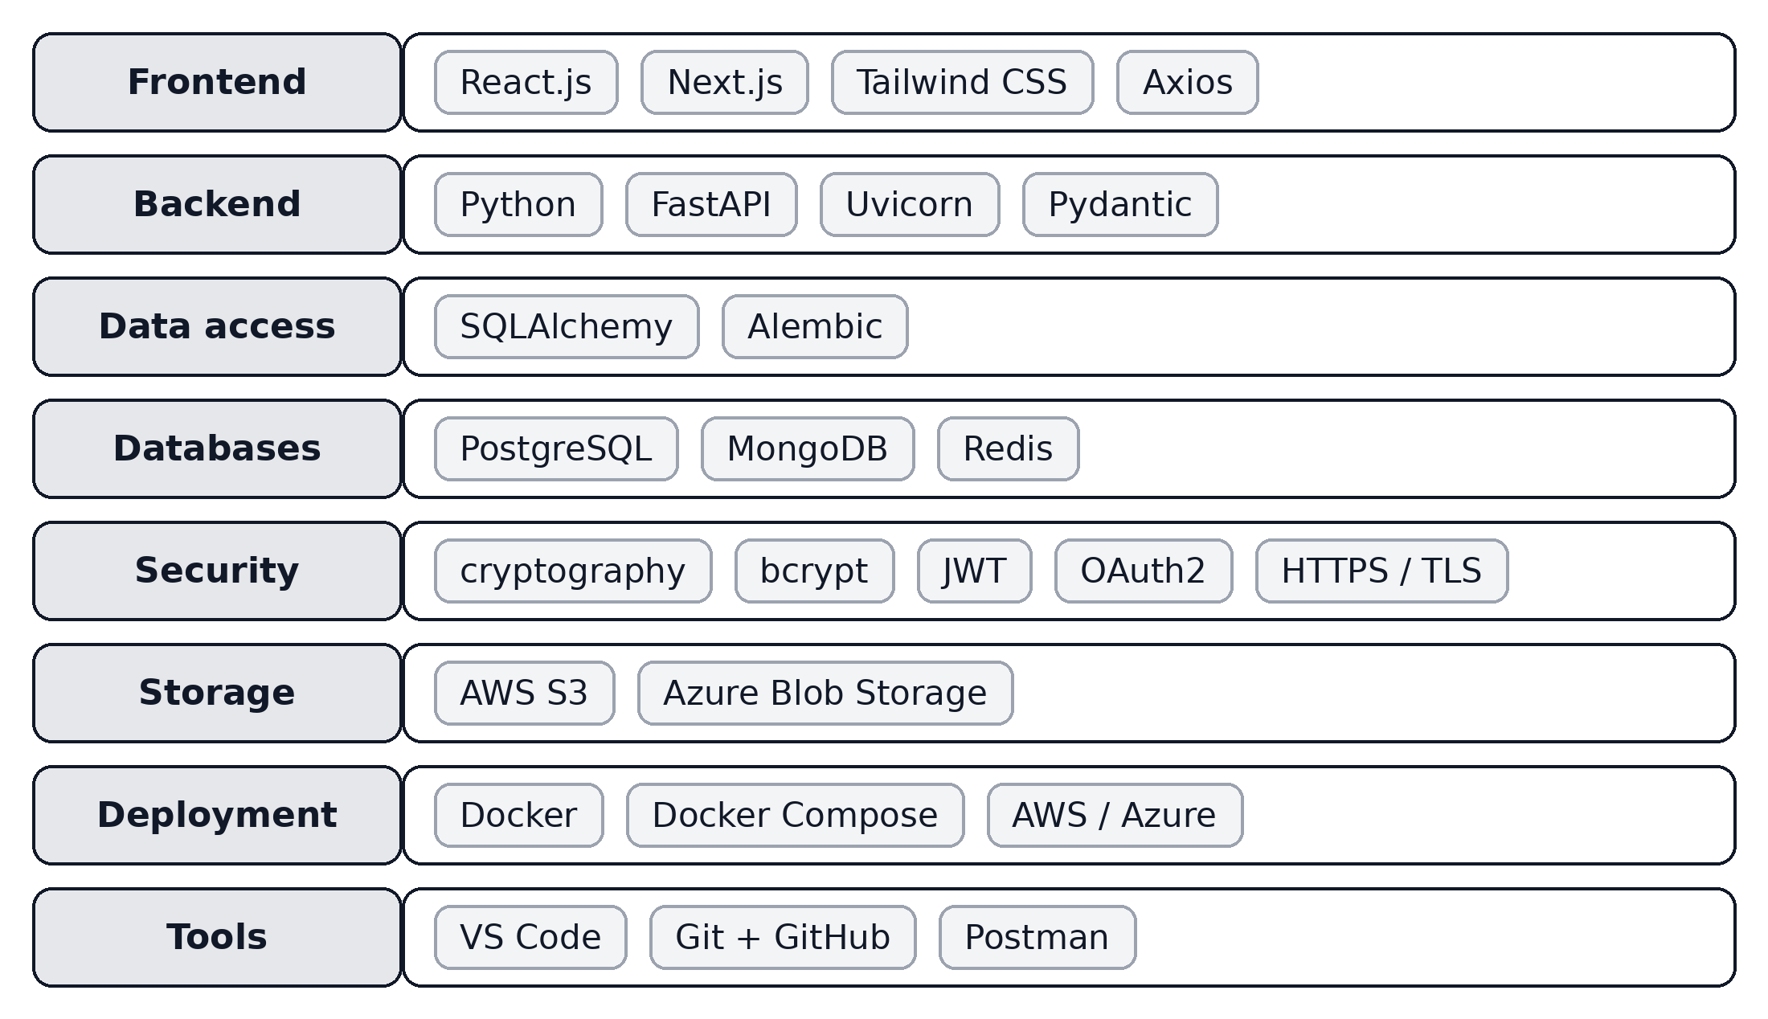
Figure 3: Technology stack

2.3 Encryption and Key Management Design
Each uploaded file gets its own random 256-bit key. The file is encrypted with AES-256-GCM using the Python cryptography library. The key itself is then protected before it is saved, so a copy of the database alone cannot decrypt any file.
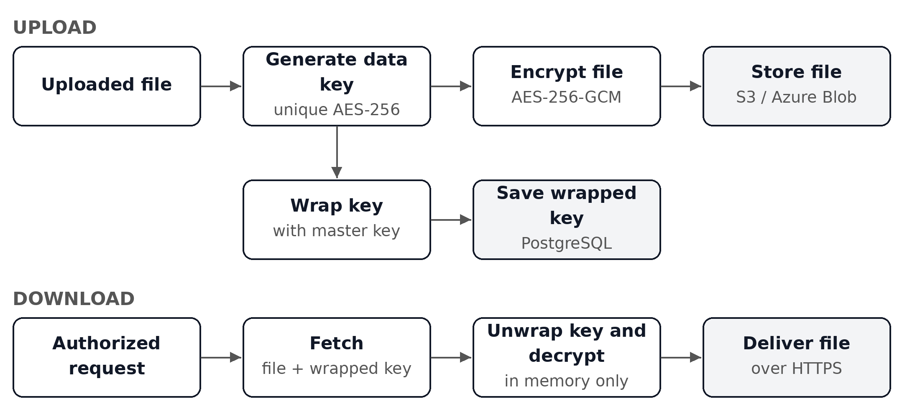
Figure 4: Upload and download encryption flow
- Key protection: the data key is wrapped (encrypted) with a master key and saved in the encryption_keys table.
- Master key: kept on the server side, outside the database, in an environment secret or cloud secrets manager.
- Large files: encrypted in chunks, so memory use stays low.
- Key rotation: a new master key re-wraps all data keys, so files do not need to be re-encrypted. Each key records its master key version.
- Key exposure: keys are never sent to the browser or shown in any response.

2.4 Security Design
- Authentication: short-lived JWT access tokens with refresh tokens; multi-factor authentication using one-time codes; OAuth2 sign-in.
- Authorization: a FastAPI dependency checks role and file permission on each endpoint.
- Password protection: bcrypt hashing; password recovery tokens are single-use and expire in minutes.
- Share tokens: generated with a secure random generator; only the hash is stored.
- Abuse protection: Redis-based rate limiting on login, share and download endpoints.
- Upload safety: file type allow-list, size limits and a checksum recorded for each file.

2.5 Database Schema
Trust Share uses three data stores. PostgreSQL holds structured data that needs relationships and consistency. MongoDB holds high-volume logs. Redis holds short-lived data. All PostgreSQL primary keys are UUIDs.

2.5.1 PostgreSQL: accounts and sessions
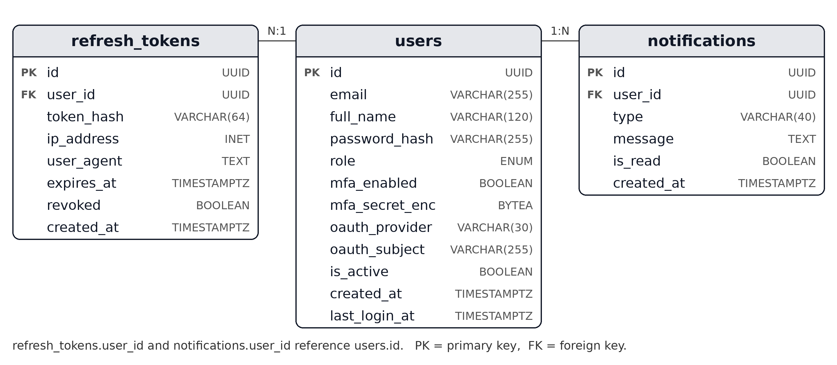
Figure 5: Users, sessions and notifications

2.5.2 PostgreSQL: files, versions, keys and sharing
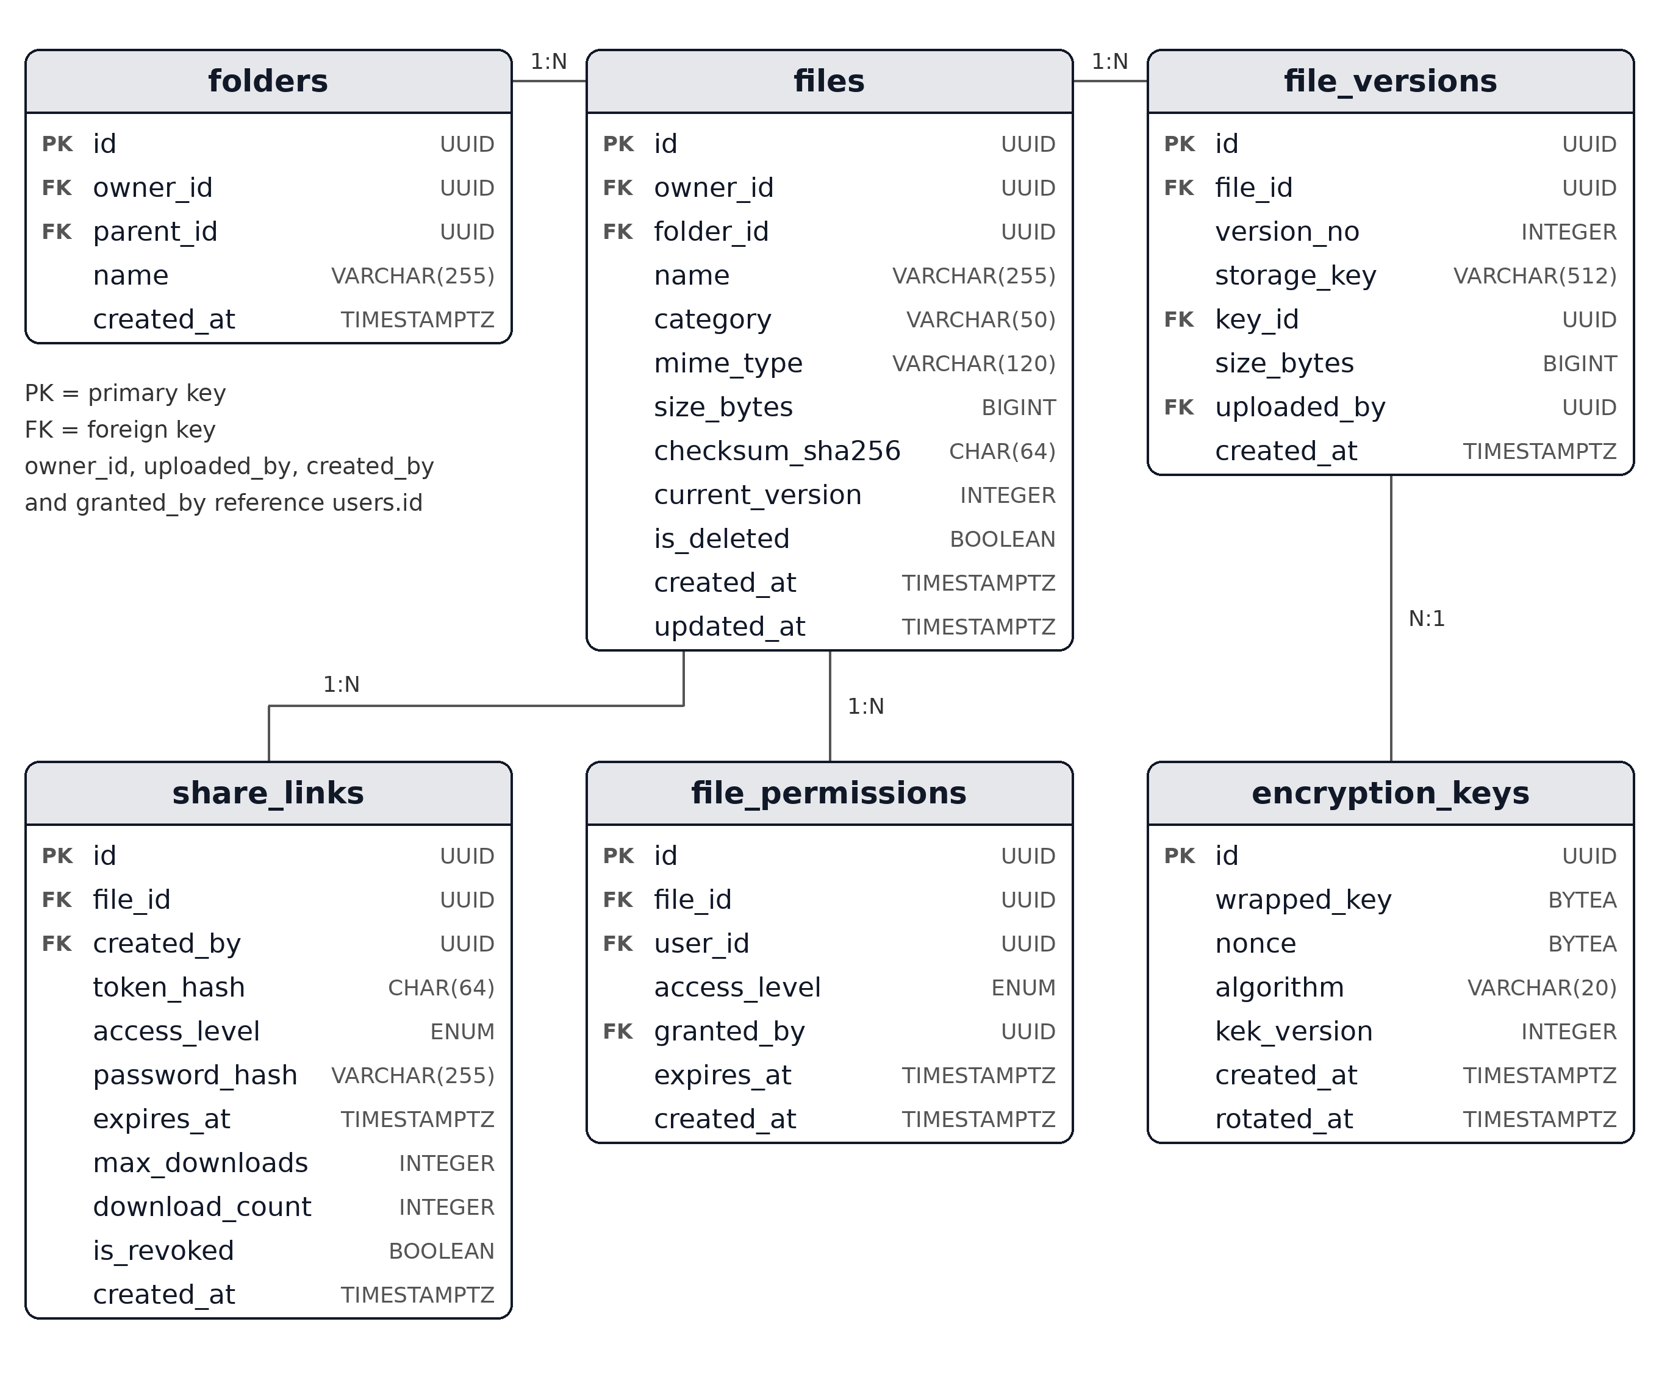
Figure 6: Files, folders, versions, encryption keys and sharing

2.5.3 MongoDB collections and Redis keys
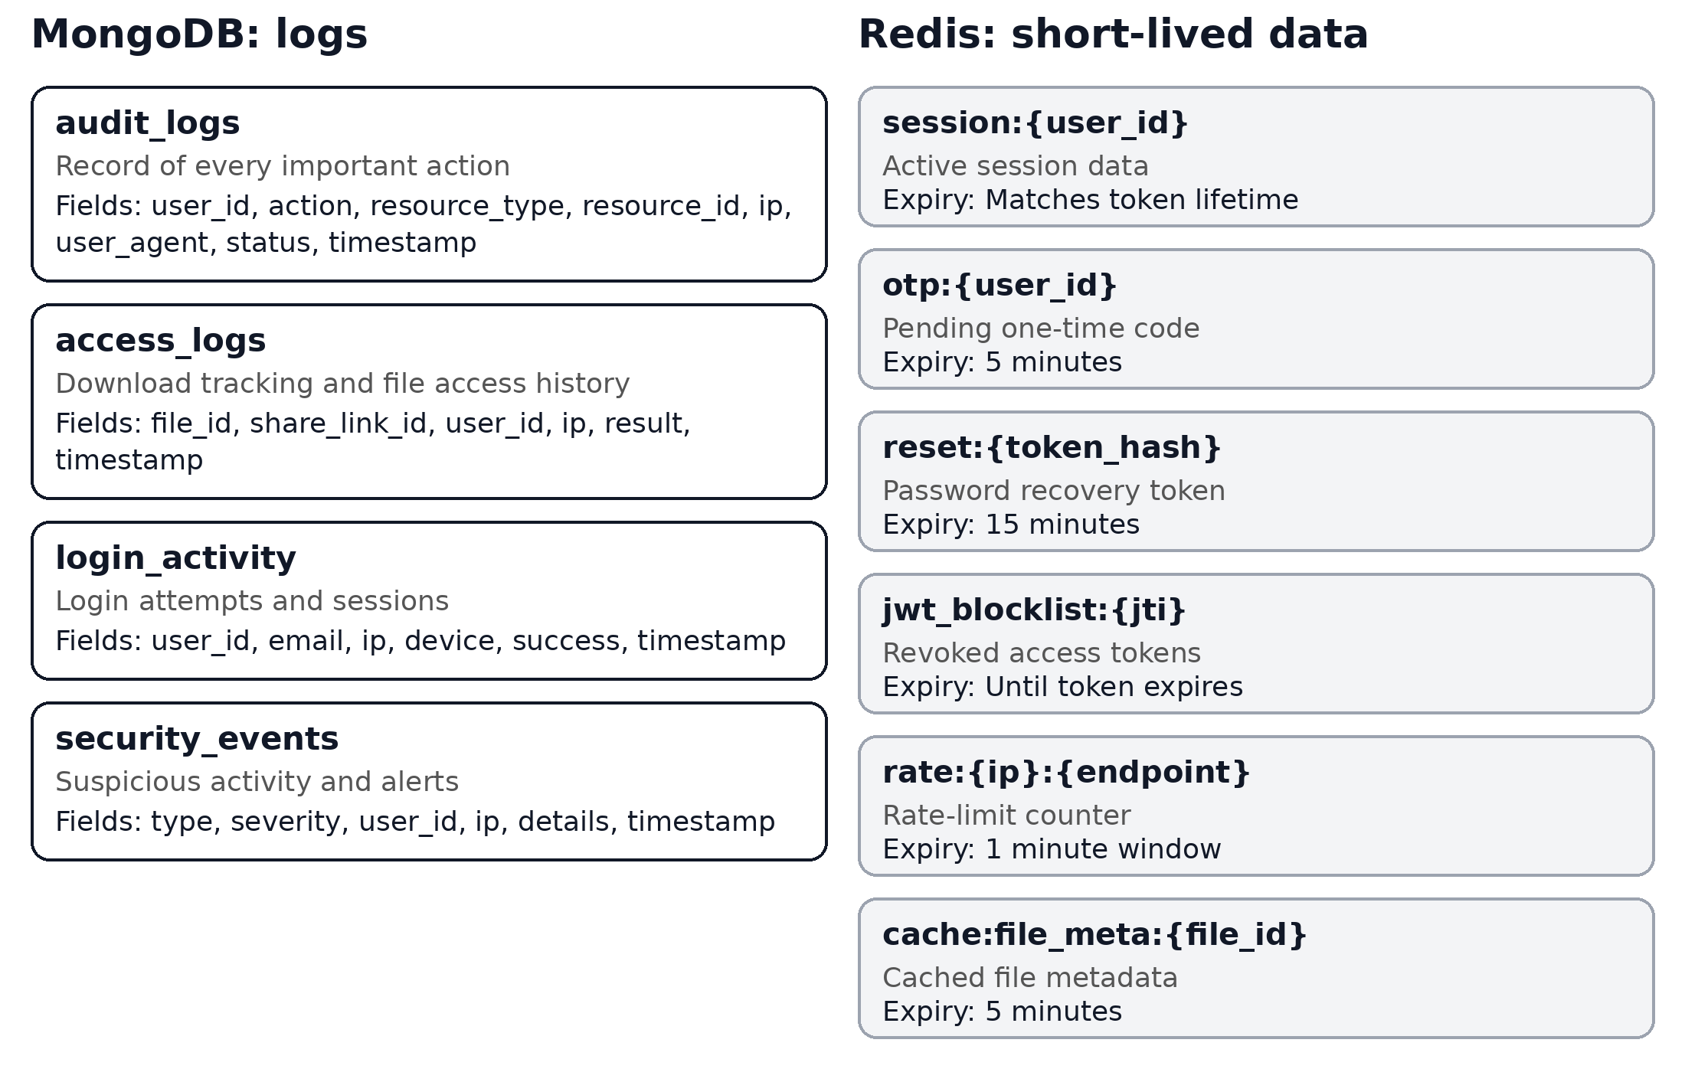
Figure 7: MongoDB log collections and Redis keys

2.5.4 Design notes
- Index files by (owner_id, folder_id) for folder views, and share_links by token_hash for fast link lookup.
- Index audit_logs and access_logs by timestamp and user_id for reports and suspicious-activity checks.
- Use soft delete for files so audit history stays complete.
- Keep logs in MongoDB so heavy write traffic does not slow the main database.

1. Design Approach
The wireframes cover the web platform only. They are low-fidelity grayscale layouts that show structure and content, not final colors or styling. Each screen supports one of the TrustShare workflows from Task 1 and connects to a backend module from Task 2.
Design principles
- Security is visible: lock icons, expiry times and download limits are always shown, so users can see how a file is protected.
- Few steps: uploading and sharing each take one dialog, with sensible defaults such as a 7-day expiry.
- Role-based screens: users see their own files, guests see only a single file page, and admins get a separate dashboard.
- Clear states: every screen needs loading, empty, error, expired-link and access-denied states.
- Responsive web: layouts collapse to a single column on small screens, with the sidebar becoming a menu.

2. Site Map
The platform has four areas: public pages, the user workspace, insight pages, and the admin area.
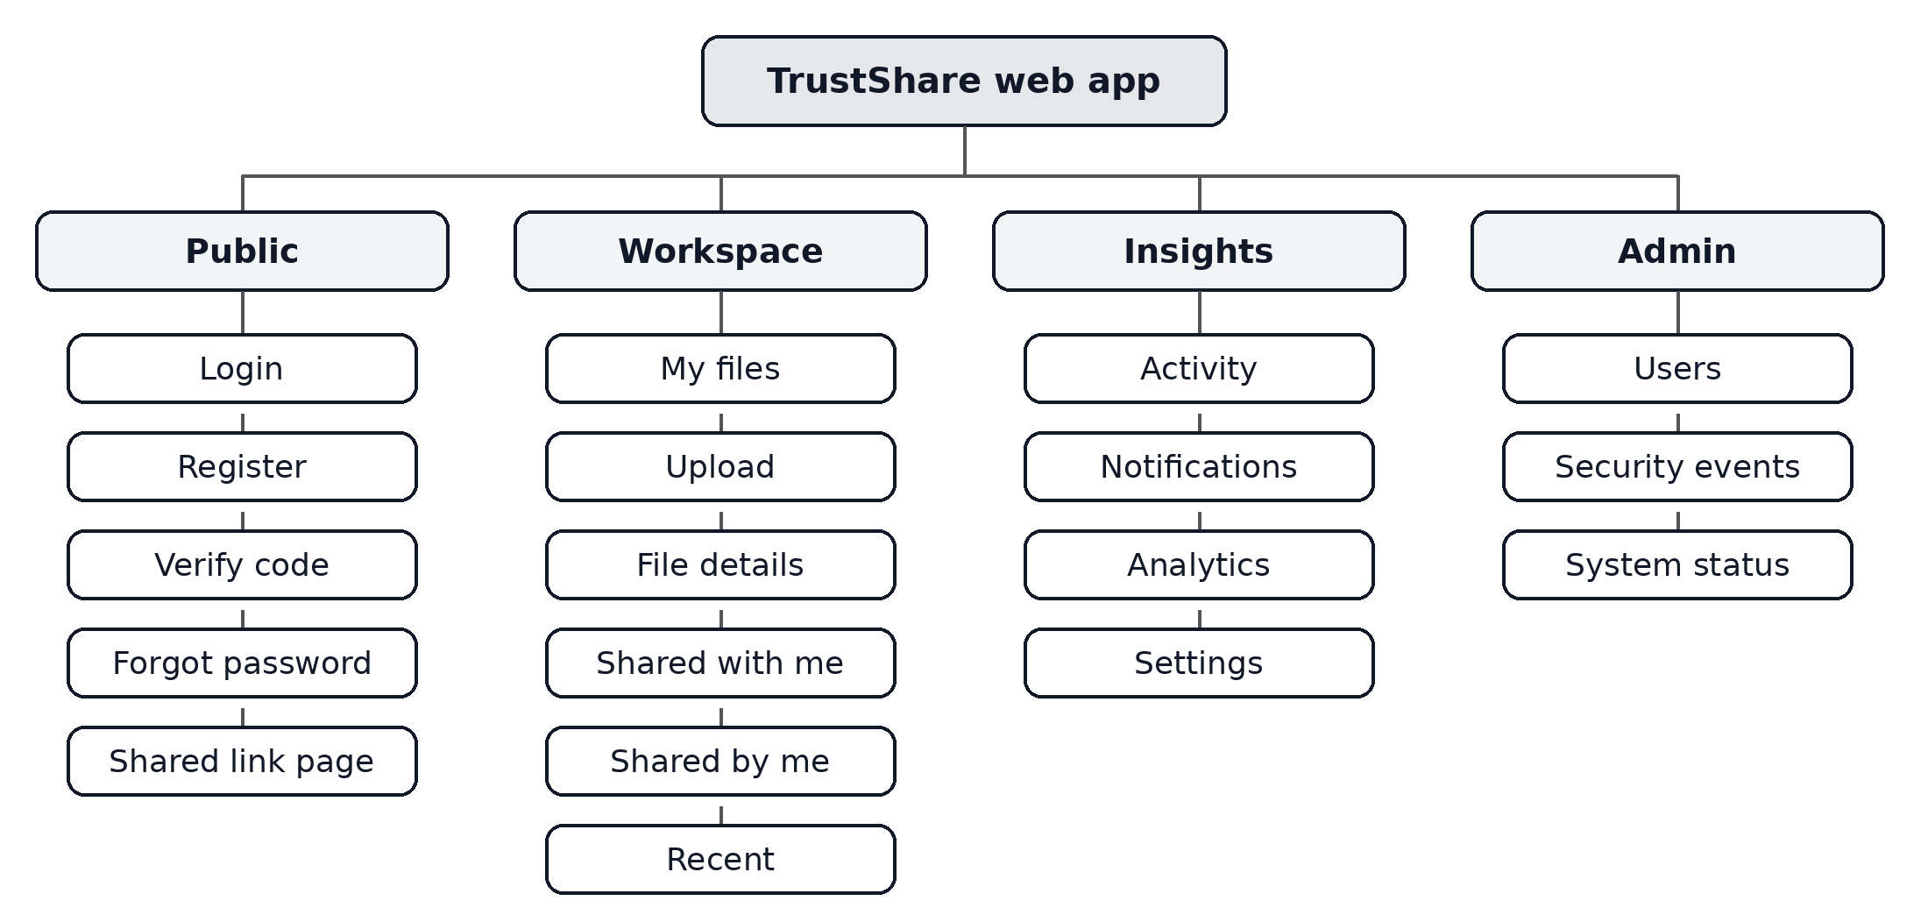
Figure 1: Site map of the TrustShare web app

3. Wireframes

3.1 Authentication screens
Sign in, create account and two-step verification. These map to Workflow 1 (registration and login).
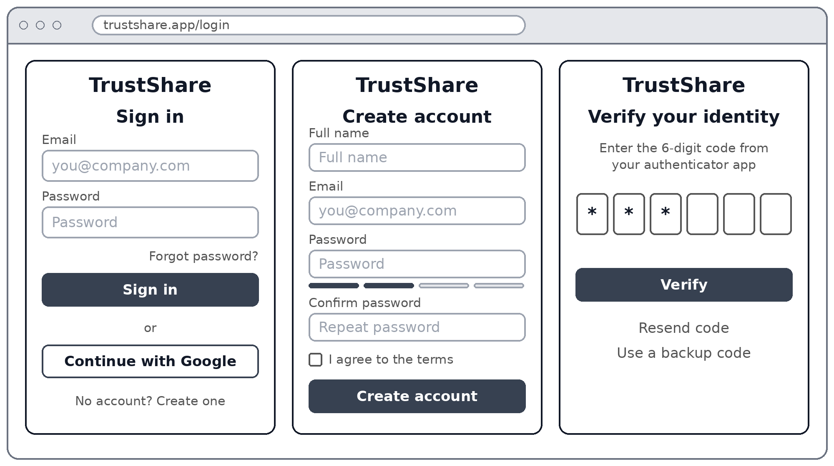
Figure 2: Authentication screens
Key elements
- Sign in: email, password, forgot-password link and a Google (OAuth2) option.
- Create account: name, email, password with a strength meter, and terms checkbox.
- Verify code: six-digit one-time code, with resend and backup-code options.

3.2 My files (main dashboard)
The home screen after login, used for folders, search and file lists.
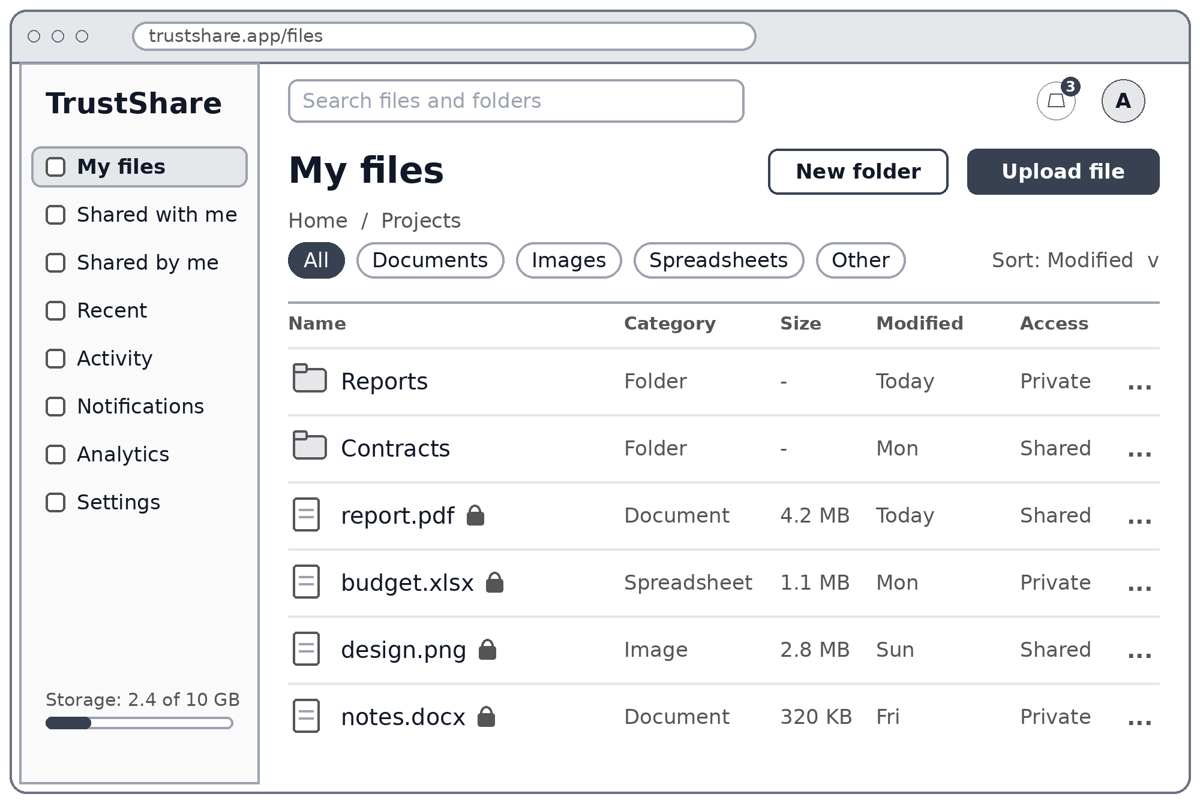
Figure 3: My files (main dashboard)
Key elements
- Sidebar: navigation to all areas, plus a storage usage bar.
- Top bar: search, notification bell with unread count, and the profile avatar.
- Actions: New folder and Upload file buttons.
- File list: category filters, sorting, a lock icon on encrypted files, and a share state for each item.

3.3 Upload dialog
Uploading a file with validation and encryption feedback. This maps to Workflow 2.
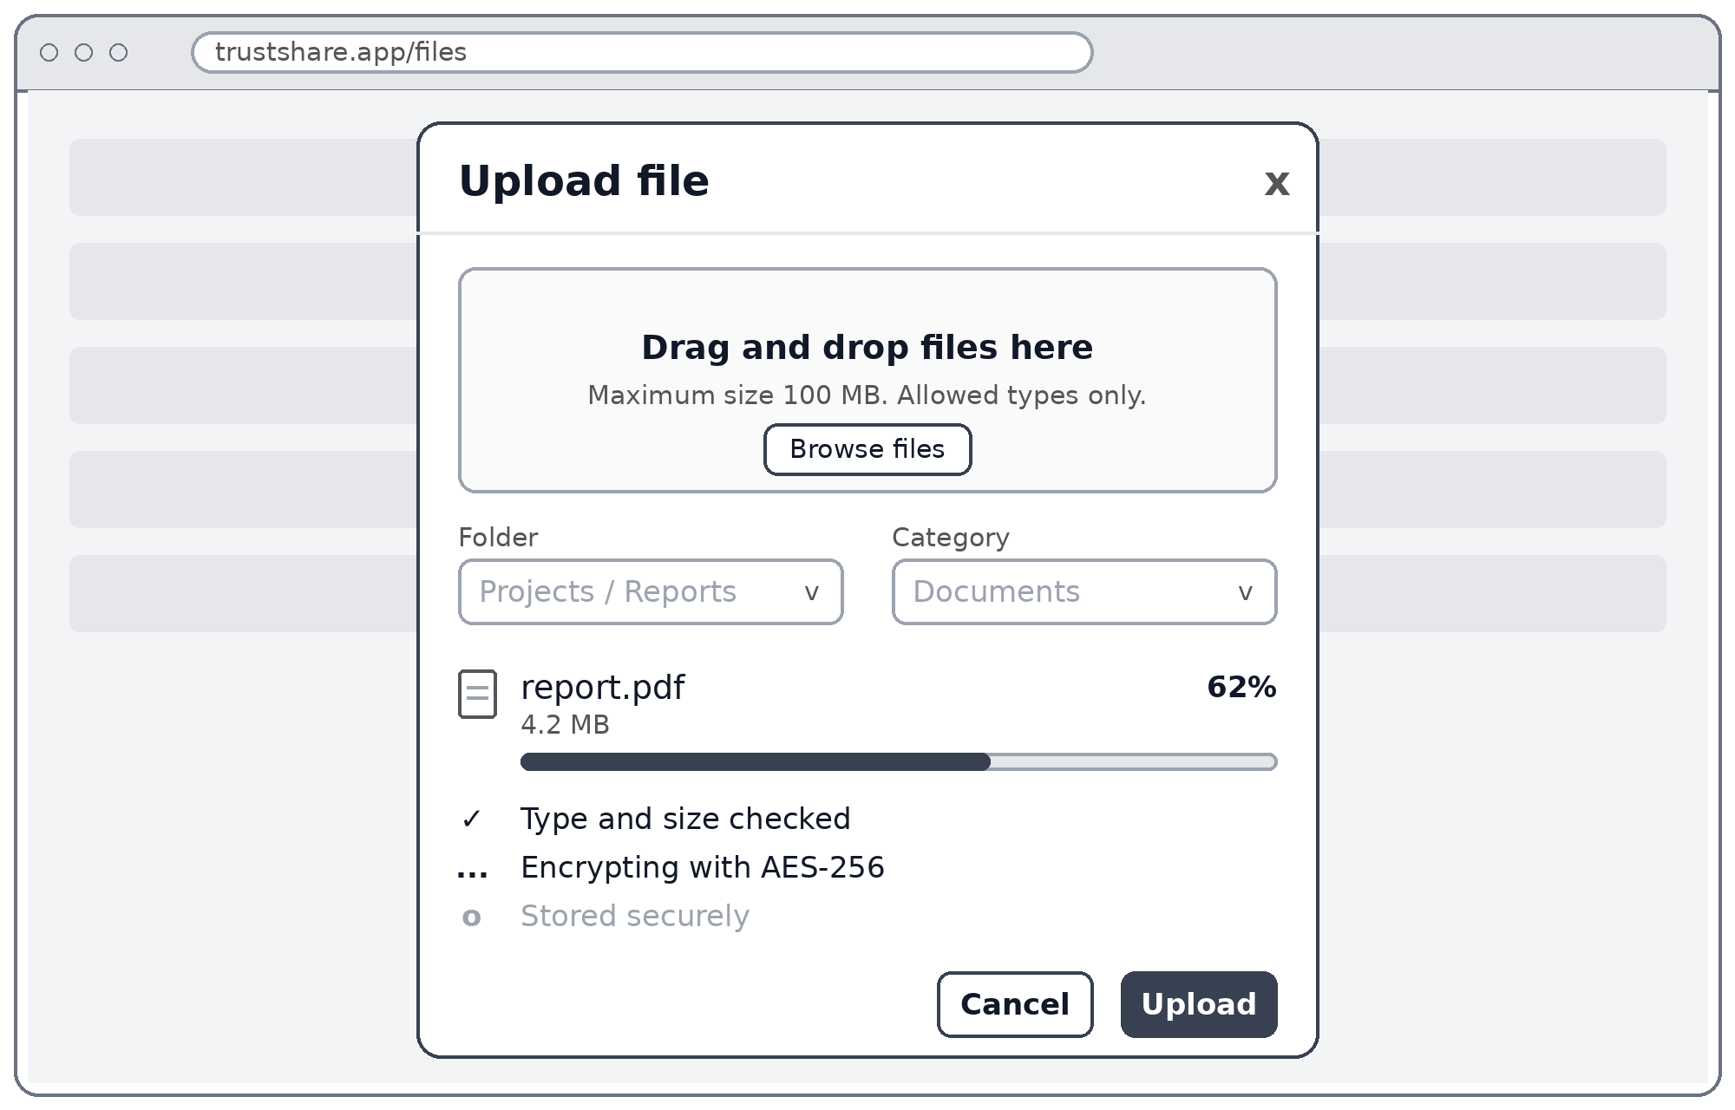
Figure 4: Upload dialog
Key elements
- Drop zone: drag and drop or browse, with the size and type limits stated.
- Destination: folder and category selectors.
- Progress: a progress bar and three status steps: checked, encrypting, stored.

3.4 Share dialog
Giving access to people and creating a temporary link. This maps to Workflow 3.
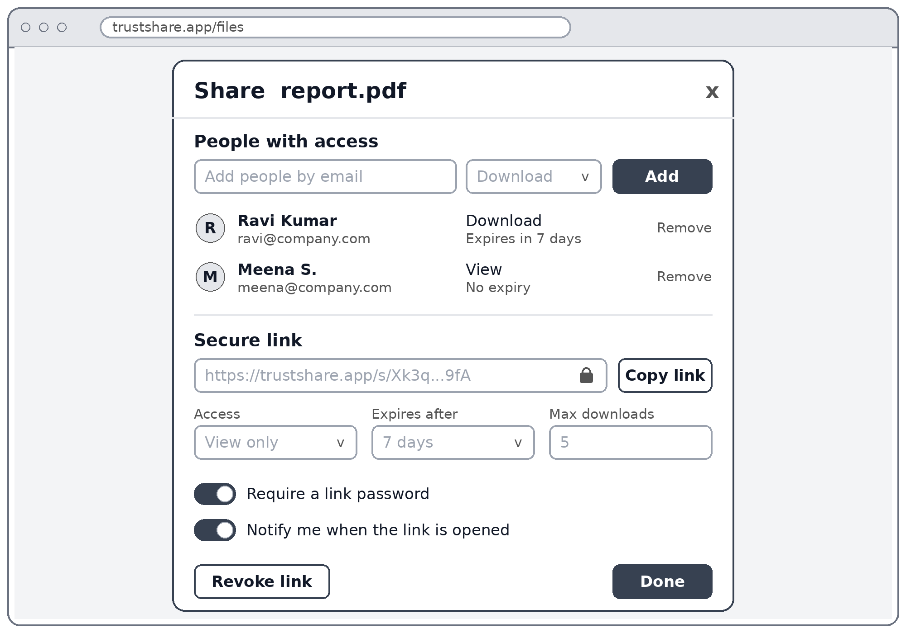
Figure 5: Share dialog
Key elements
- People: add by email, choose an access level, and remove access.
- Secure link: copy button, access level, expiry time and a download limit.
- Safety options: link password, an open-link alert, and a Revoke link button.

3.5 Shared link page (guest)
The page a recipient sees without an account, shown in its valid and expired states. This maps to Workflow 4.
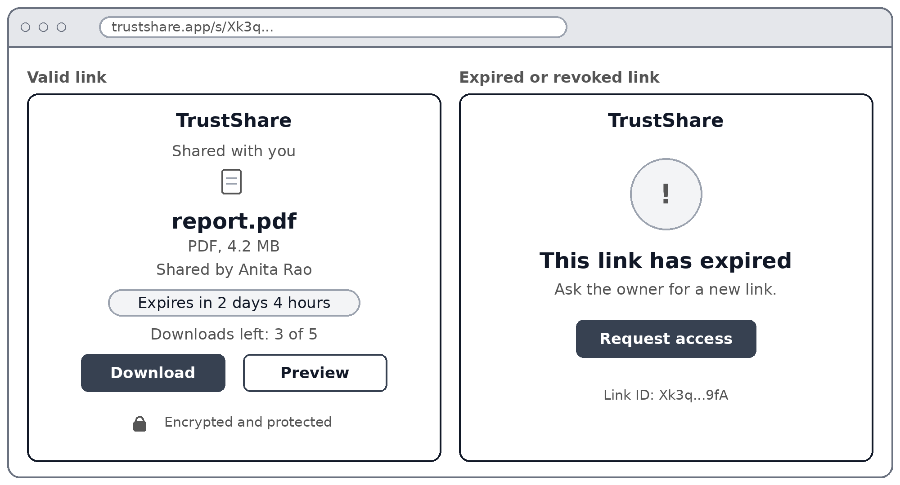
Figure 6: Shared link page (guest)
Key elements
- Valid link: file name, owner, expiry countdown, downloads left, and Download and Preview buttons.
- Expired or revoked link: a clear message and a Request access button.

3.6 File details
Everything about one file, including versions and activity.
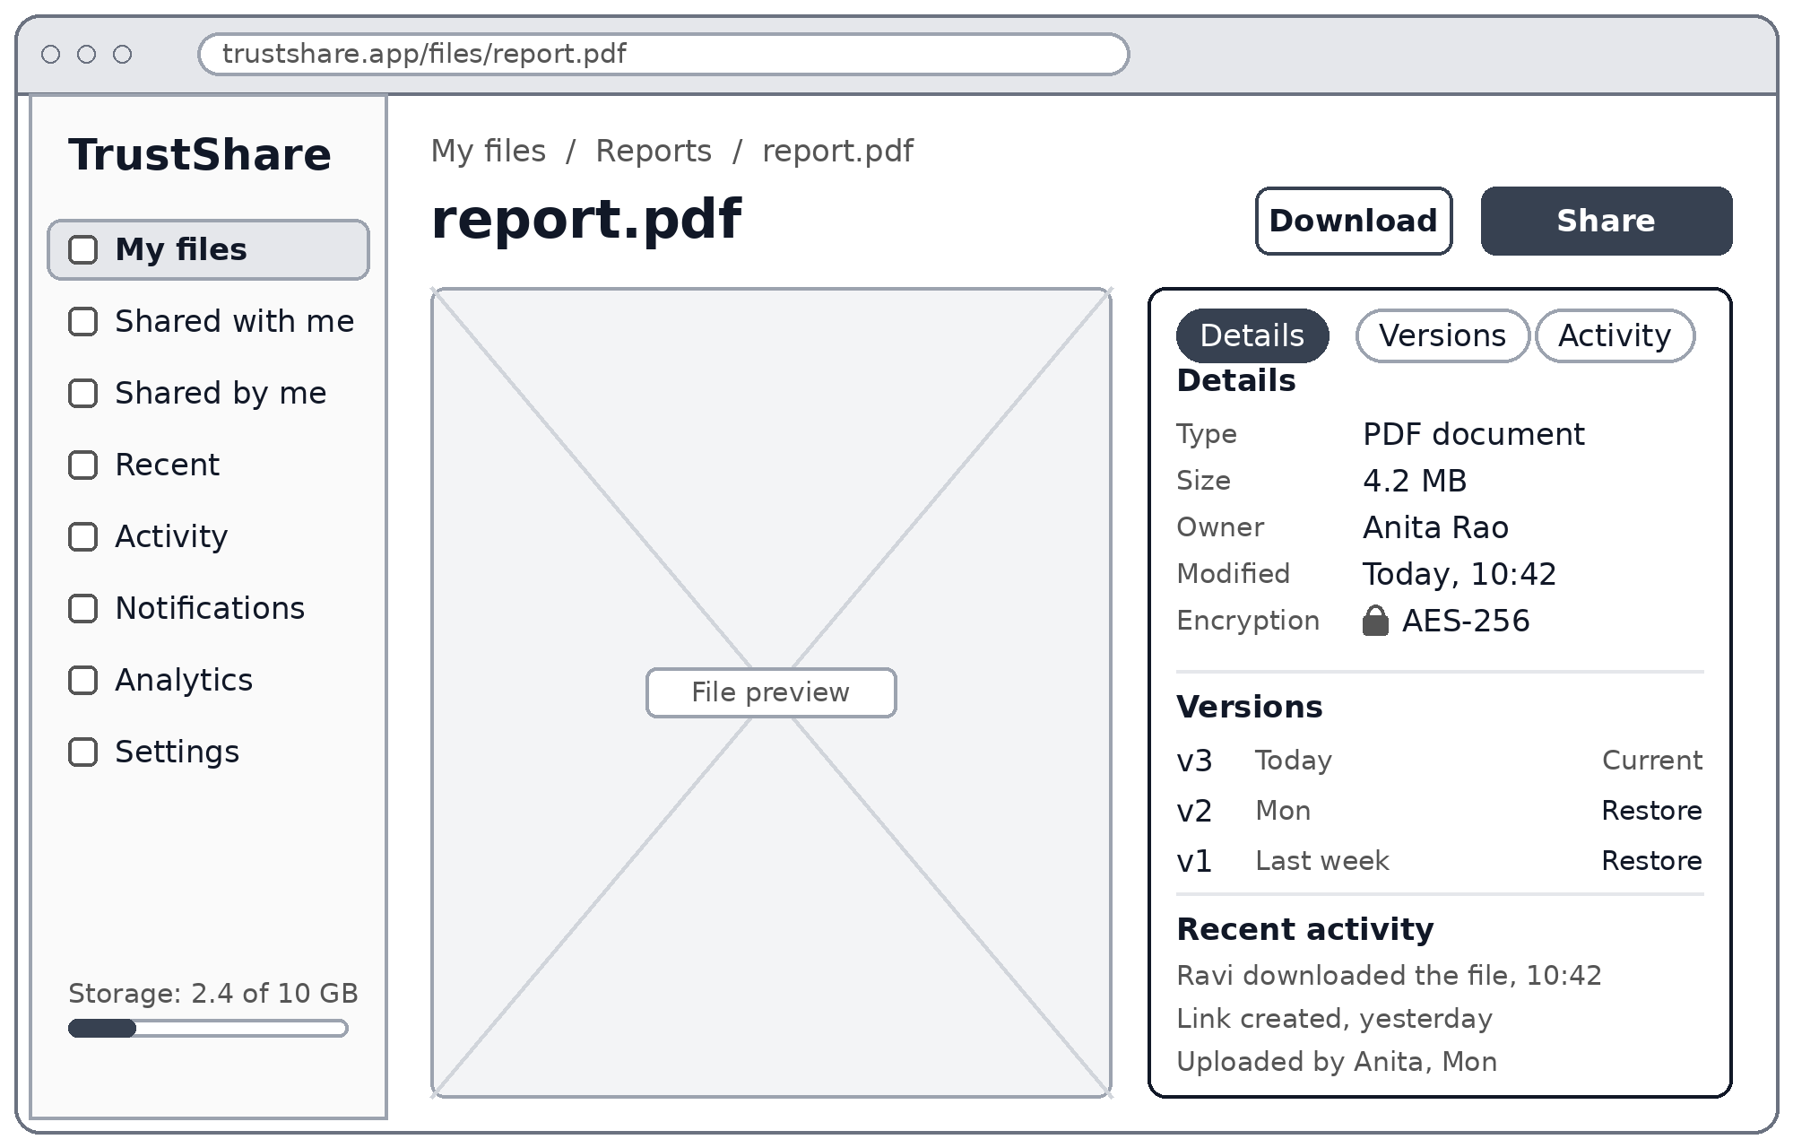
Figure 7: File details
Key elements
- Preview: a viewer area with Download and Share buttons.
- Details: type, size, owner, last change and the AES-256 encryption status.
- Versions: version history with a Restore option.
- Activity: recent downloads, link creation and uploads.

3.7 Notifications and security settings
Alerts for sharing, access and security events, plus account protection settings. This maps to Workflows 5 and 6.
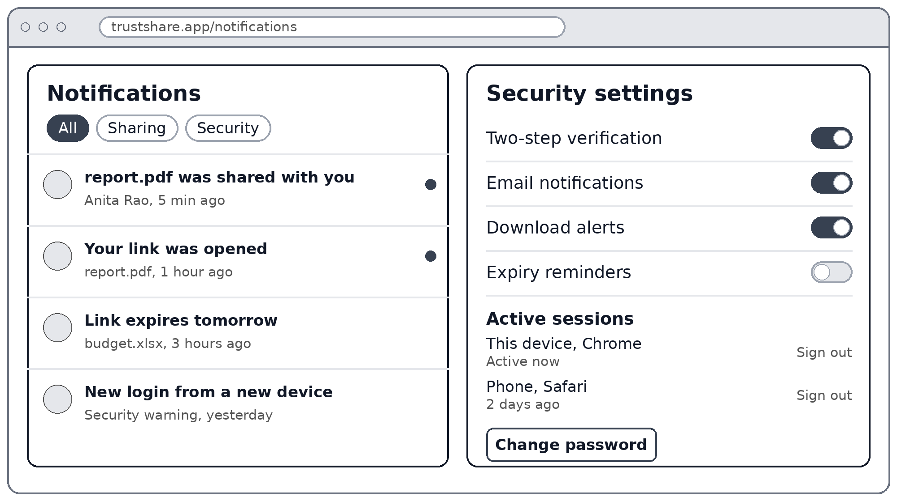
Figure 8: Notifications and security settings
Key elements
- Notifications: filter by All, Sharing or Security, with unread markers.
- Settings: toggles for two-step verification, email notifications, download alerts and expiry reminders.
- Sessions: list of signed-in devices with Sign out, and a Change password button.

3.8 Analytics dashboard
Storage, file activity and security figures for a user.
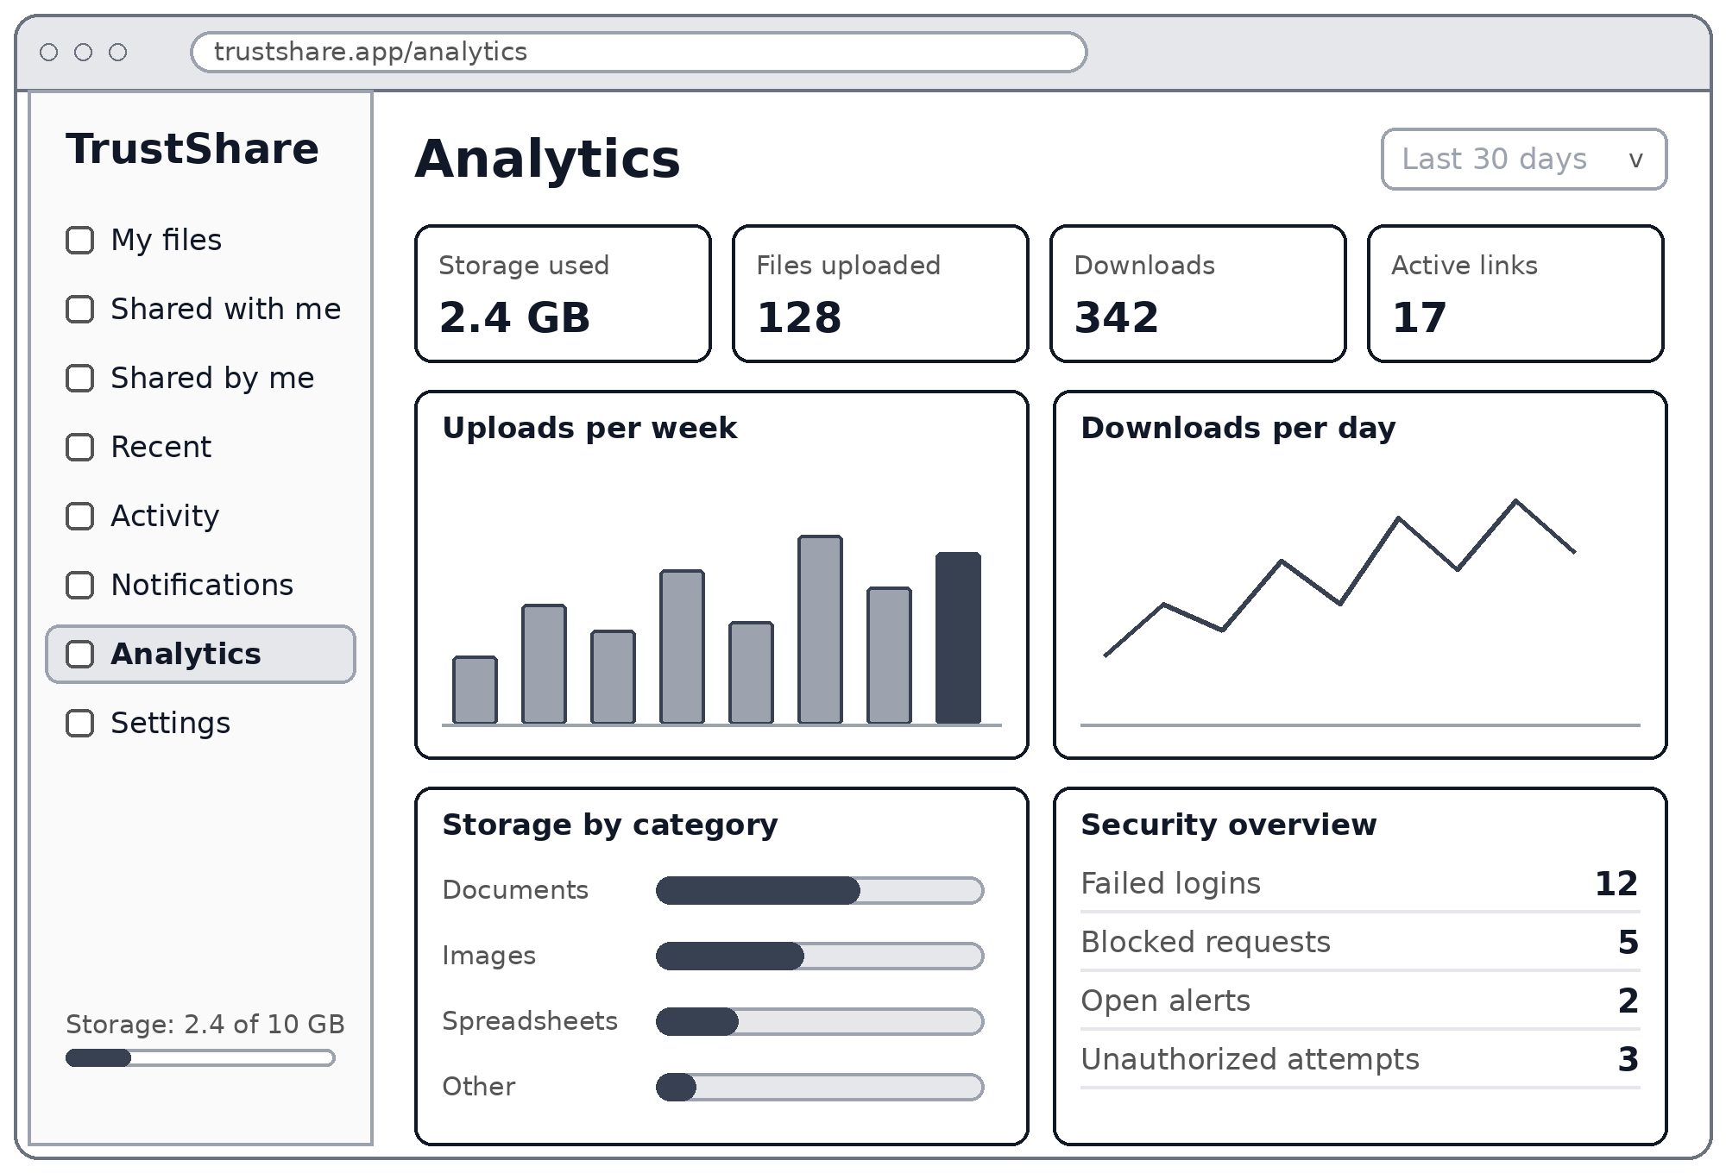
Figure 9: Analytics dashboard
Key elements
- Summary cards: storage used, files uploaded, downloads and active links.
- Charts: uploads per week, downloads per day, and storage by category.
- Security overview: failed logins, blocked requests, open alerts and unauthorized attempts.

3.9 Admin dashboard
The admin view of users, security and system health.
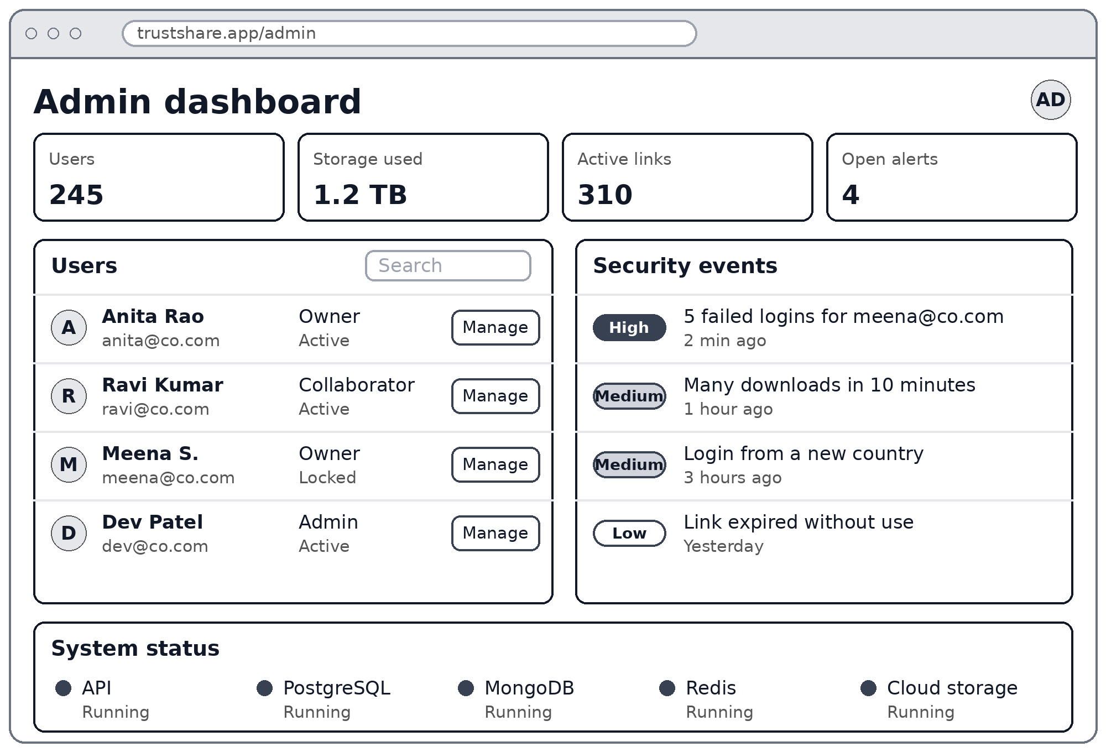
Figure 10: Admin dashboard
Key elements
- Summary cards: users, storage, active links and open alerts.
- Users: search, role and status, and a Manage button for each account.
- Security events: severity levels (High, Medium, Low) with time stamps.
- System status: health of the API, PostgreSQL, MongoDB, Redis and cloud storage.

4. Workflow Planning

4.1 User Journeys
The diagram follows the three types of user through the screens above. Shaded boxes mark steps where the system acts or sends an alert.
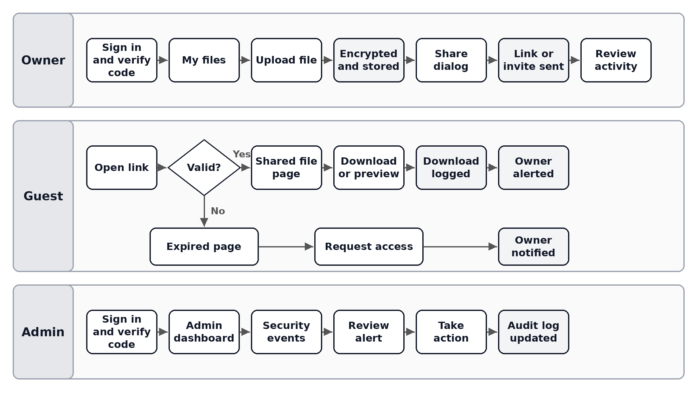
Figure 11: User journeys for owners, guests and admins

4.2 Screens and Backend Endpoints
Each screen calls the backend modules from Task 2. The endpoint names are proposed and can change during development.
- Authentication screens: POST /auth/register, /auth/login, /auth/mfa/verify, /auth/forgot-password.
- My files: GET /files, GET /folders, with search and category filters.
- Upload: POST /files/upload (validate, encrypt, store, then log).
- Share dialog: POST /shares, POST /links, DELETE /links/{id}.
- Shared link page: GET /s/{token} and GET /s/{token}/download.
- File details: GET /files/{id}, /files/{id}/versions and /files/{id}/activity.
- Notifications and settings: GET /notifications, PATCH /settings/security.
- Analytics: GET /analytics/files and /analytics/security.
- Admin: GET /admin/users, /admin/security-events and /admin/system.

4.3 Two-Week Plan
The plan follows the eight Milestone 1 tasks. The day ranges are proposed and assume ten working days.
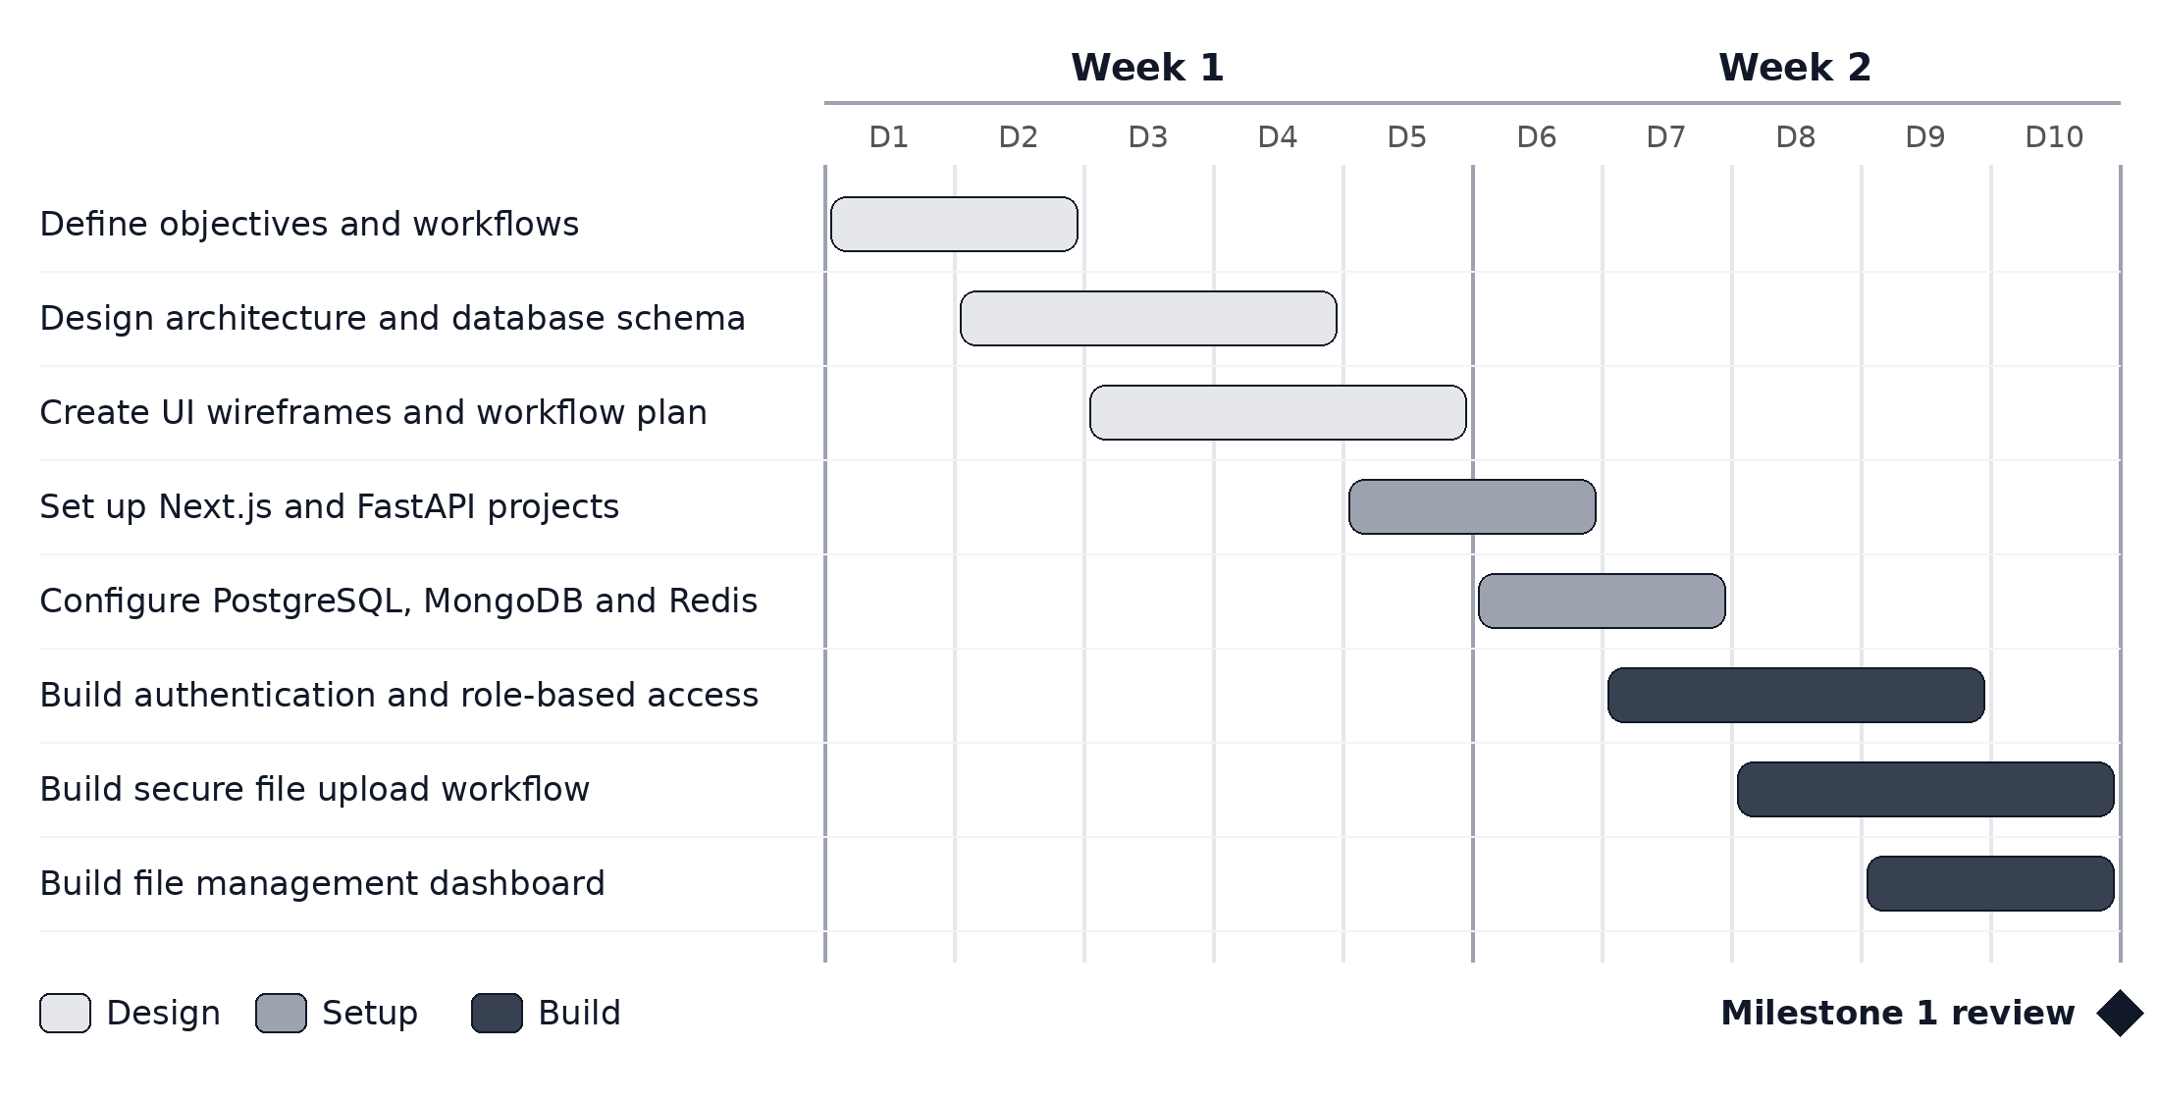
Figure 12: Weeks 1 and 2 plan, ending with the Milestone 1 review

4.4 Screen States to Build
- Loading: skeleton rows while files and analytics load.
- Empty: a friendly message and an Upload button when a folder has no files.
- Error: upload failed, file type not allowed, or file too large.
- Access denied: shown when a user opens a file they have no permission for.
- Expired or revoked link: the guest page in its expired state.
- Session timeout: redirect to sign in, then return to the same screen.

