PolicyGPT
Government Policy & Public Scheme Intelligence Platform
UI Wireframes — Milestone 1
Low-fidelity screen layouts for review before implementation
Screens included:
1. Login Page
2. Registration Page
3. Citizen Dashboard
4. Government Dashboard
5. Policy Search Page
6. Policy Details Page
7. Scheme Details Page
8. Eligibility Checker
9. Reports Dashboard
10. Notification Screen

1. Login Page
Secure entry point for all user roles (Citizen, Government Official, Researcher, Organization, Guest). Supports email/mobile login, password recovery, and SSO/OAuth2 sign-in.
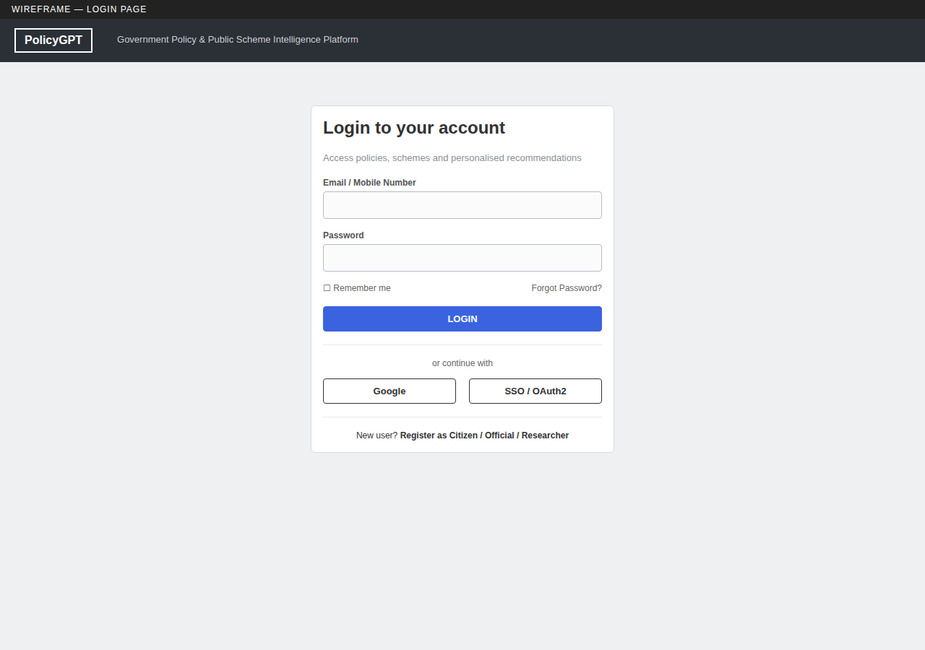

2. Registration Page
New account creation with role selection, personal details, location, and terms acceptance — feeds directly into Role-Based Access Control.
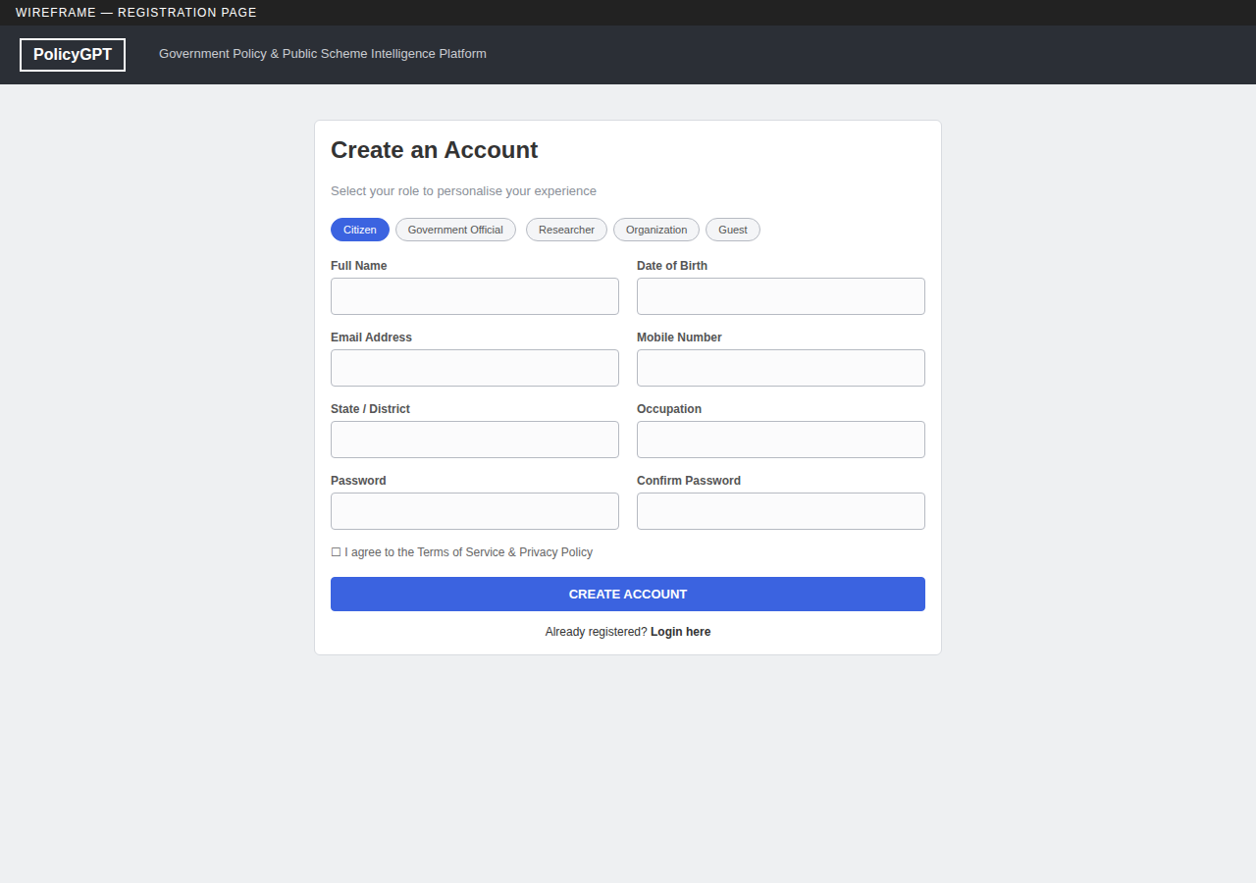

3. Citizen Dashboard
Personalised home screen showing saved policies, eligible schemes, recent notifications, application status and search history.
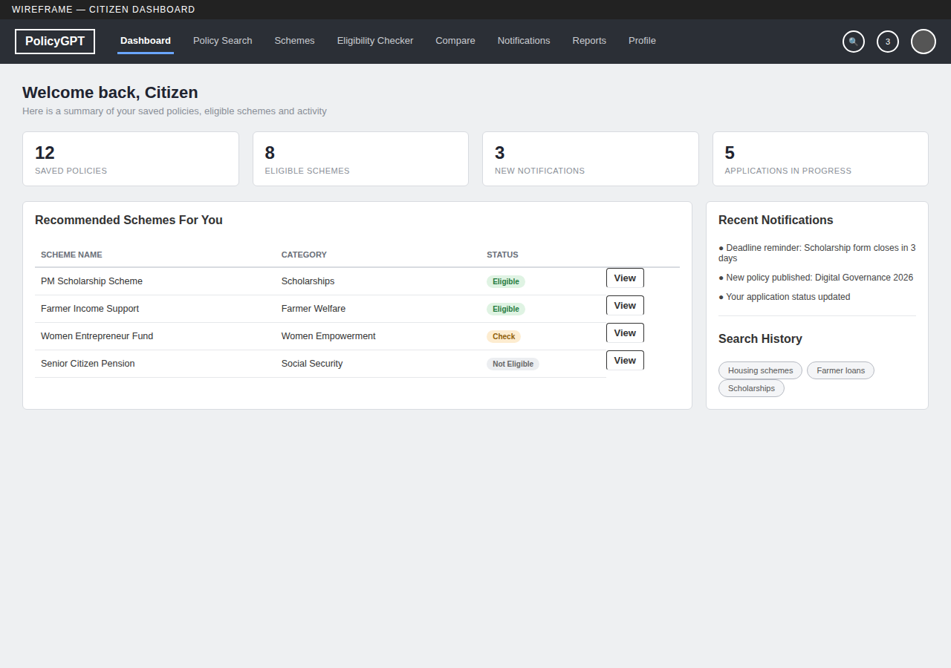

4. Government Dashboard
Department-facing workspace with policy/scheme management shortcuts, usage analytics, approvals queue and audit visibility.
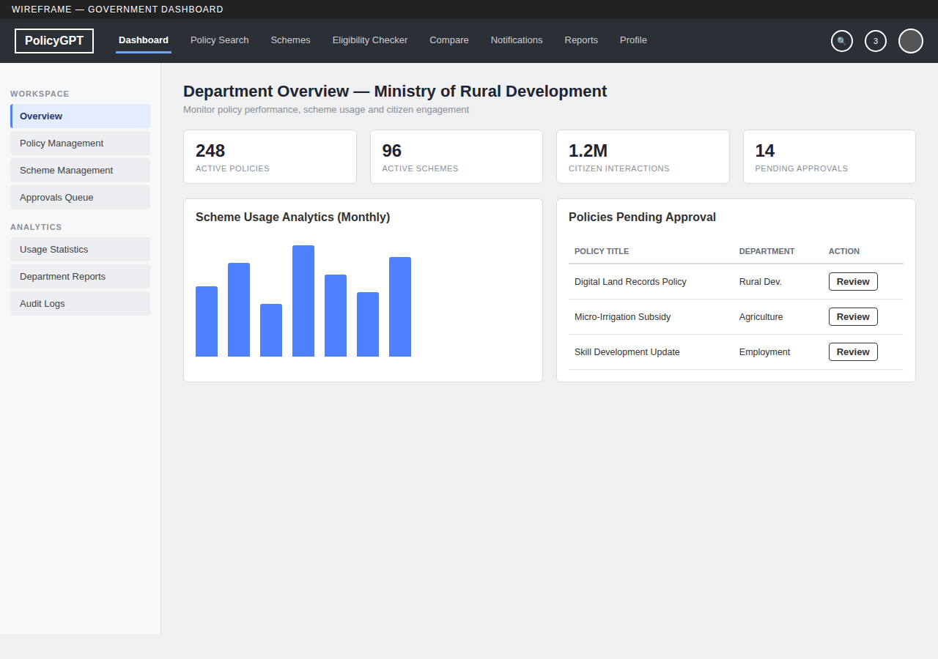

5. Policy Search Page
Central discovery screen with keyword search, category chips and advanced filters (State, Ministry, Department, Date, Status).
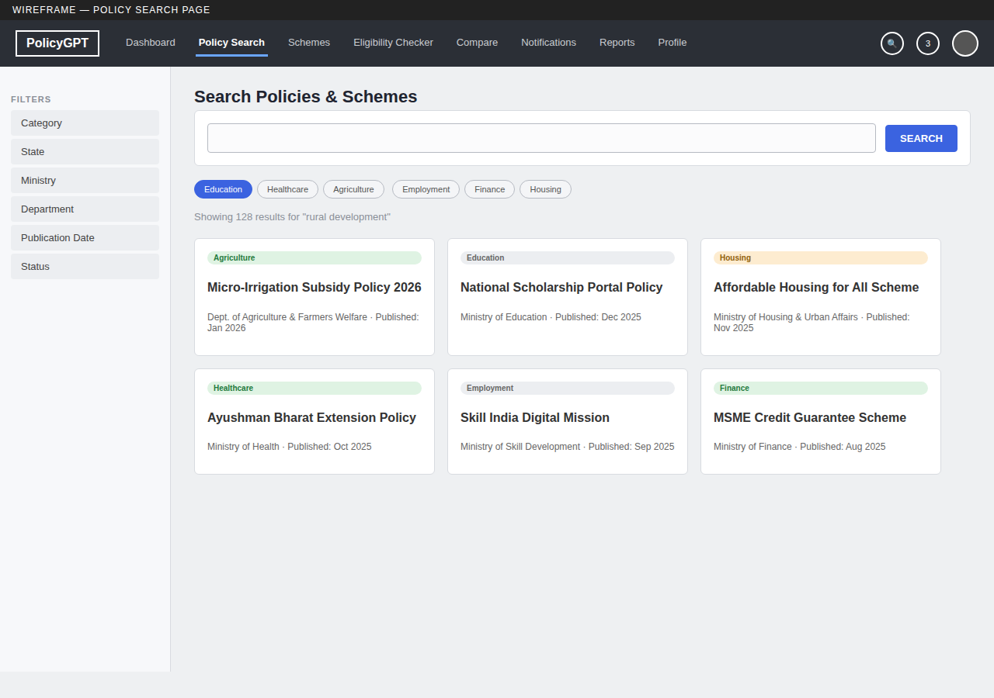

6. Policy Details Page
Full policy record with overview, eligibility, quick actions (check eligibility, save, compare, download) and metadata panel.
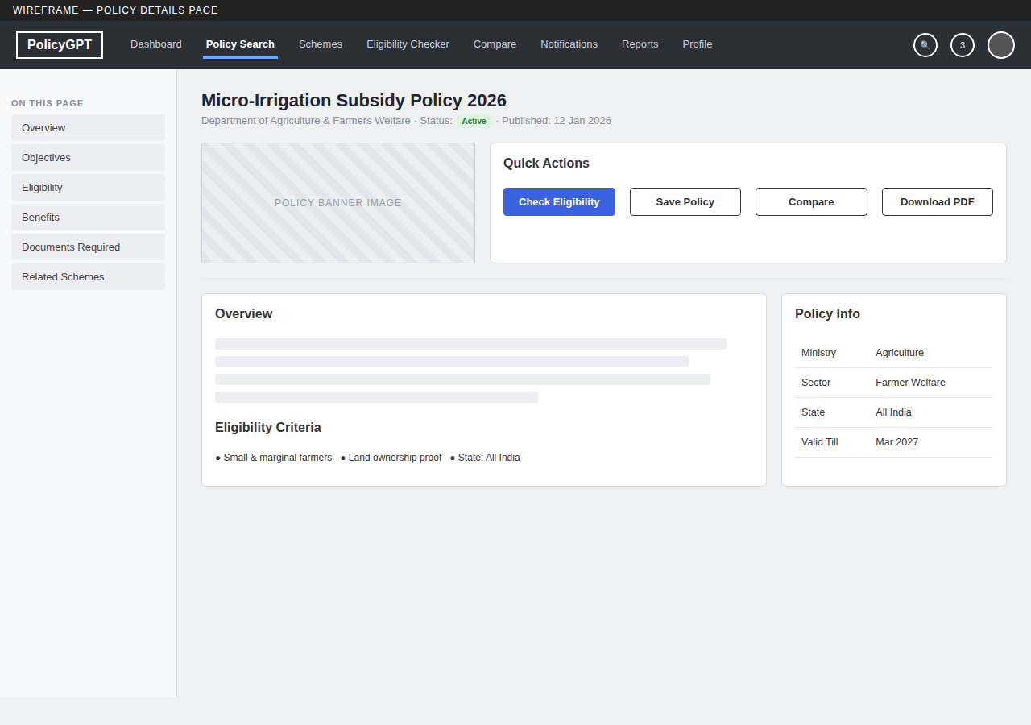

7. Scheme Details Page
Scheme-specific view showing benefit amount, eligibility parameters, step-by-step application process and a direct apply action.
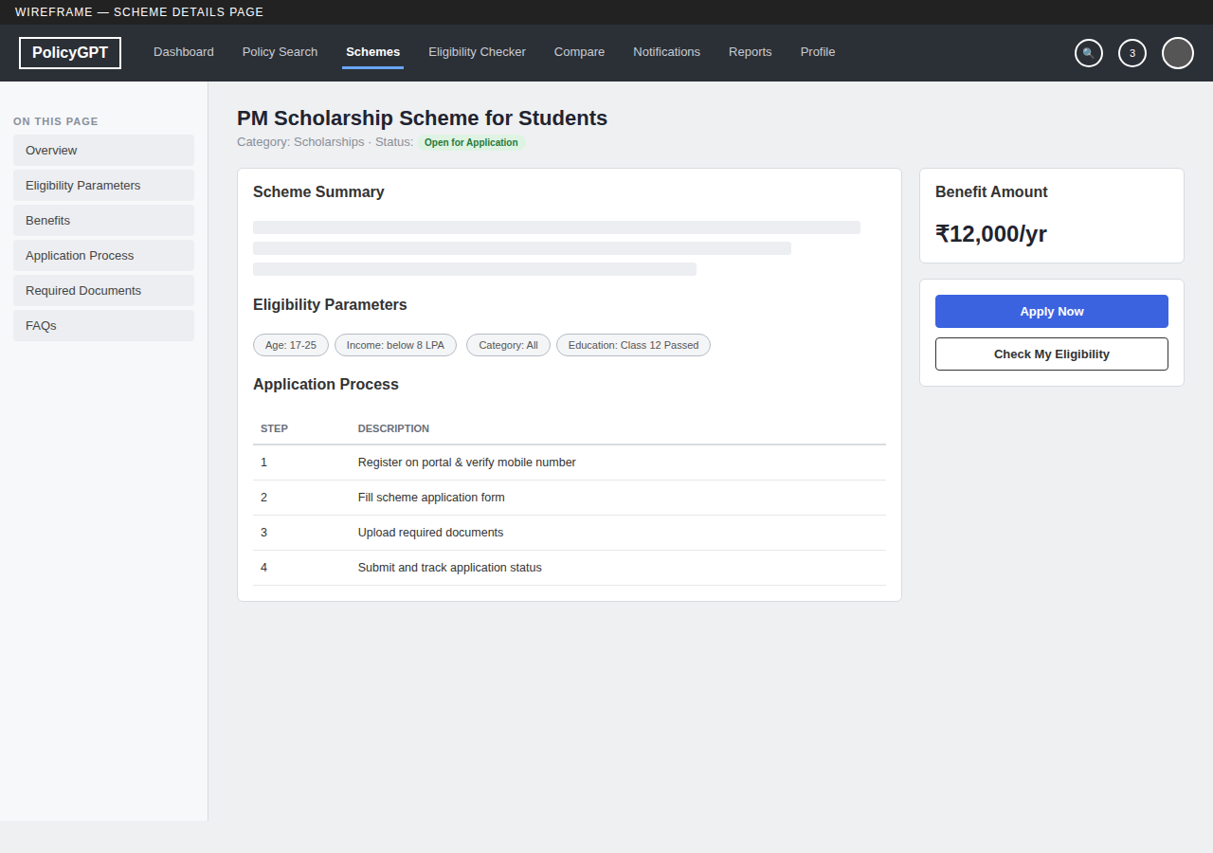

8. Eligibility Checker
Profile-driven form (age, income, occupation, education, location, category, disability) that returns a matched eligibility summary.
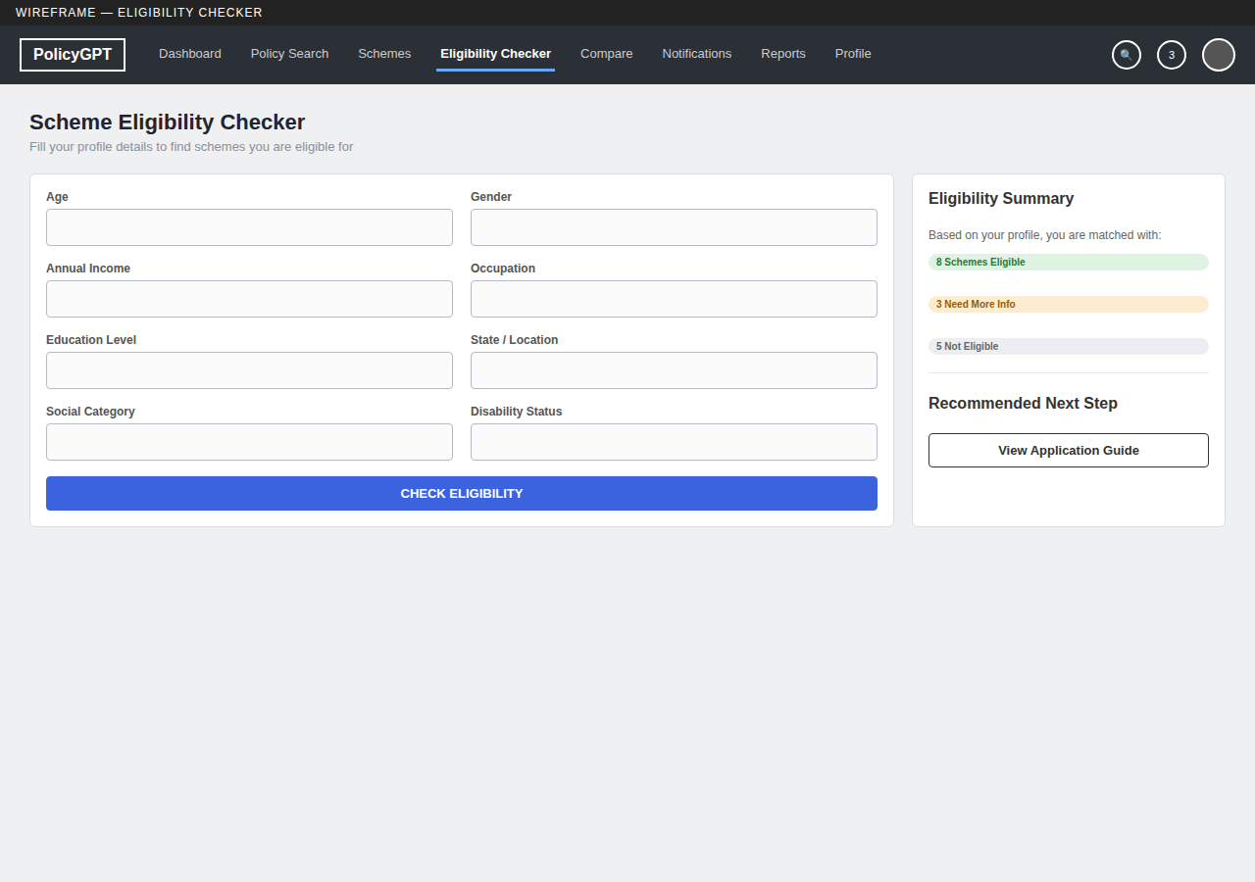

9. Reports Dashboard
Report generation and export screen with filters, engagement trend charts, category breakdown and a downloadable report log.
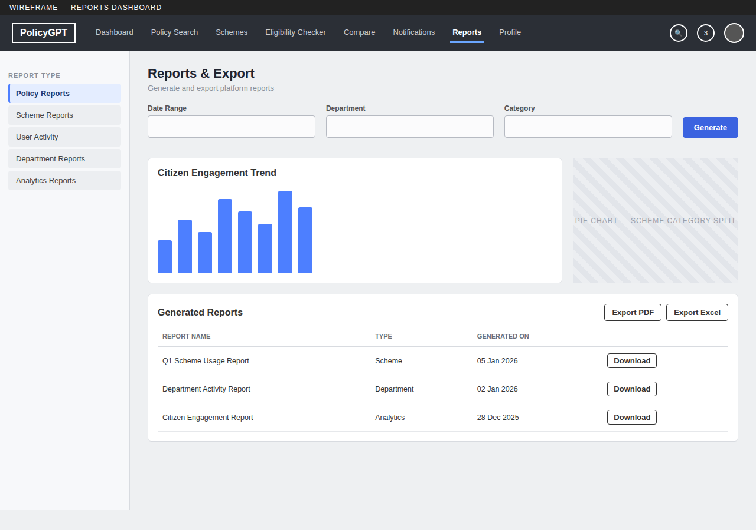

10. Notification Screen
Unified notification centre for policy alerts, scheme updates, deadline reminders and application status changes.
