PCB Defect Detection and Classification Application

1. Introduction
Printed Circuit Boards (PCBs) are essential components in modern electronics. Ensuring defect-free production is critical for reliability. This project develops a deep-learning-based PCB defect detection system using YOLOv8 and YOLOv11 models. The dataset includes six defect types: missing hole, mouse bite, open circuit, short, spur, and spurious copper.

2. Project Objectives
- Build a complete PCB defect detection system.
- Preprocess images using subtraction and mask generation.
- Train and evaluate YOLO models.
- Develop frontend/backend for real-time inference.
- Document challenges, solutions, and industry applications.

3. Milestone-Based Work Breakdown
Milestone 1: Dataset Preparation and Image Processing

Module 1: Dataset Setup and Annotation Conversion

Tasks Performed
- Collected all XML annotation files from the original DeepPCB dataset and scanned all defect folders to locate corresponding images.
- Created a complete YOLO-compatible directory structure, including separate train/validation image and label folders.
- Parsed Pascal VOC XML annotations, extracted bounding boxes and class names, and converted them to YOLO format (class ID, normalized coordinates).
- Implemented automated matching between XML files and images to prevent missing or mismatched annotations.
- Randomized the dataset and applied an 80/20 split for training and validation.

Deliverables
- A fully structured YOLO dataset (pcb_yolo/) containing images and labels for both train and validation sets.
- Converted YOLO text annotation files for all six defect classes.
- A reproducible dataset preparation script that automates directory creation, annotation parsing, and image copying.

Evaluation Outcome
- All valid annotations were accurately converted and aligned with their corresponding images.
- The final dataset maintained class consistency, proper normalization, and correct formatting for YOLOv8 and YOLOv11 training.
- The resulting dataset was clean, consistent, and ready for downstream model training.

Module 2: ROI Preparation Through Annotation Conversion

Tasks Performed

Used bounding box information to define Regions of Interest (ROIs).

Normalized and validated bounding box coordinates for model compatibility.

Ensured correct class-ID mapping for all defect types:

Missing hole

Mouse bite

Open circuit

Short

Spur

Spurious copper

Performed integrity checks to verify annotation-image alignment.

Deliverables

Defect-specific YOLO label files for training and validation.

A consistent ROI-based annotation pipeline.

Evaluation Outcome

High-quality ROI extraction contributed to improved model convergence.

Annotation precision supported accurate object detection performance.

Milestone 2: Model Training and Evaluation
Module 3: Training YOLO Models
Multiple models were trained to compare performance.
Model 1: YOLOv8s
model = YOLO("yolov8s.pt")
model.train(data="pcb_yolo/data.yaml", epochs=50, imgsz=640, batch=8)
Graphs and Charts of YOLOv8s model:
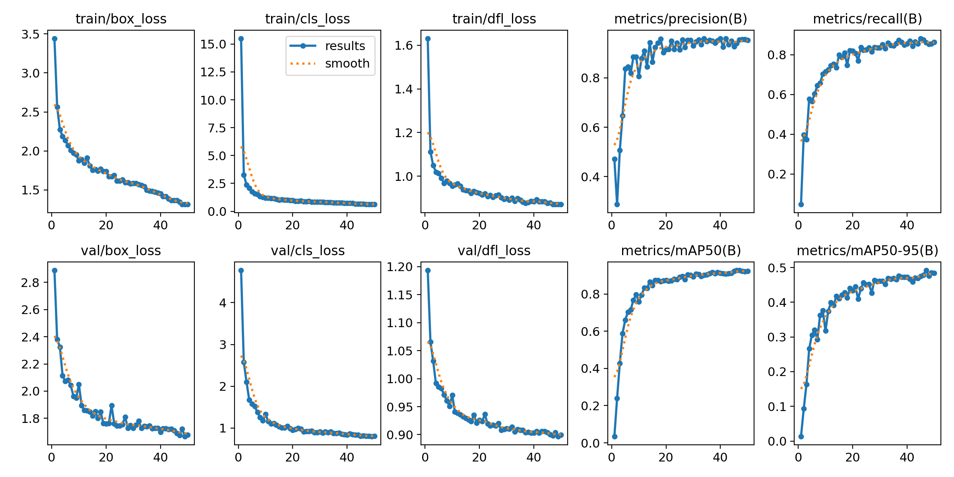
Purpose
A lightweight baseline for PCB detection.
Model 2: YOLOv8m
model = YOLO("yolov8m.pt")
model.train(epochs=100, optimizer="AdamW", cos_lr=True, patience=20)
Graphs and Charts of YOLOv8s model:
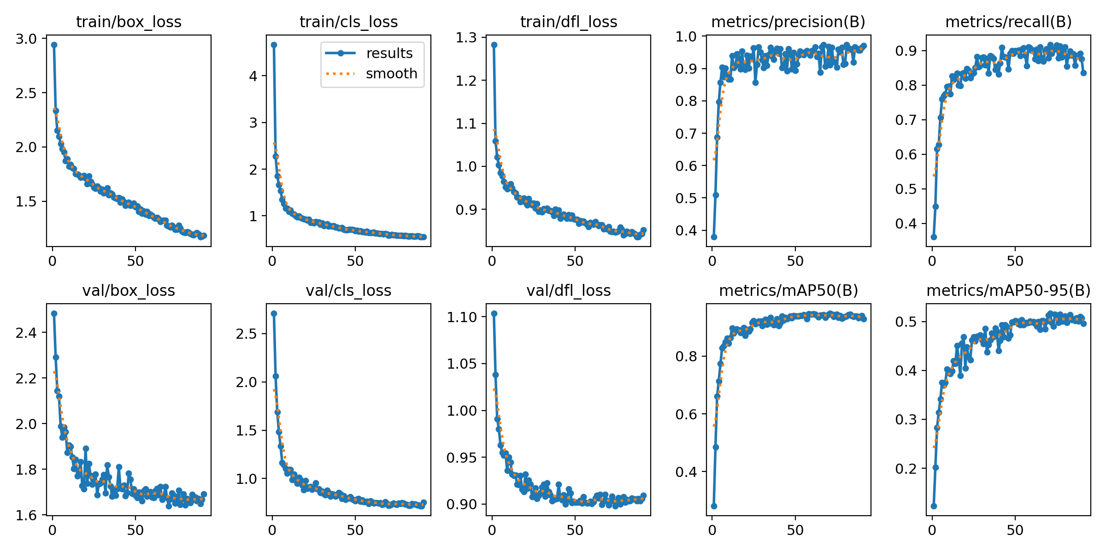
Purpose
Medium model with stronger accuracy; used more advanced training settings.
Model 3: YOLOv8 Freeze → Finetune Strategy
Two-phase training:
Phase 1: Freeze backbone
Fine for feature extraction.
Resultant Graph during freezing phase:
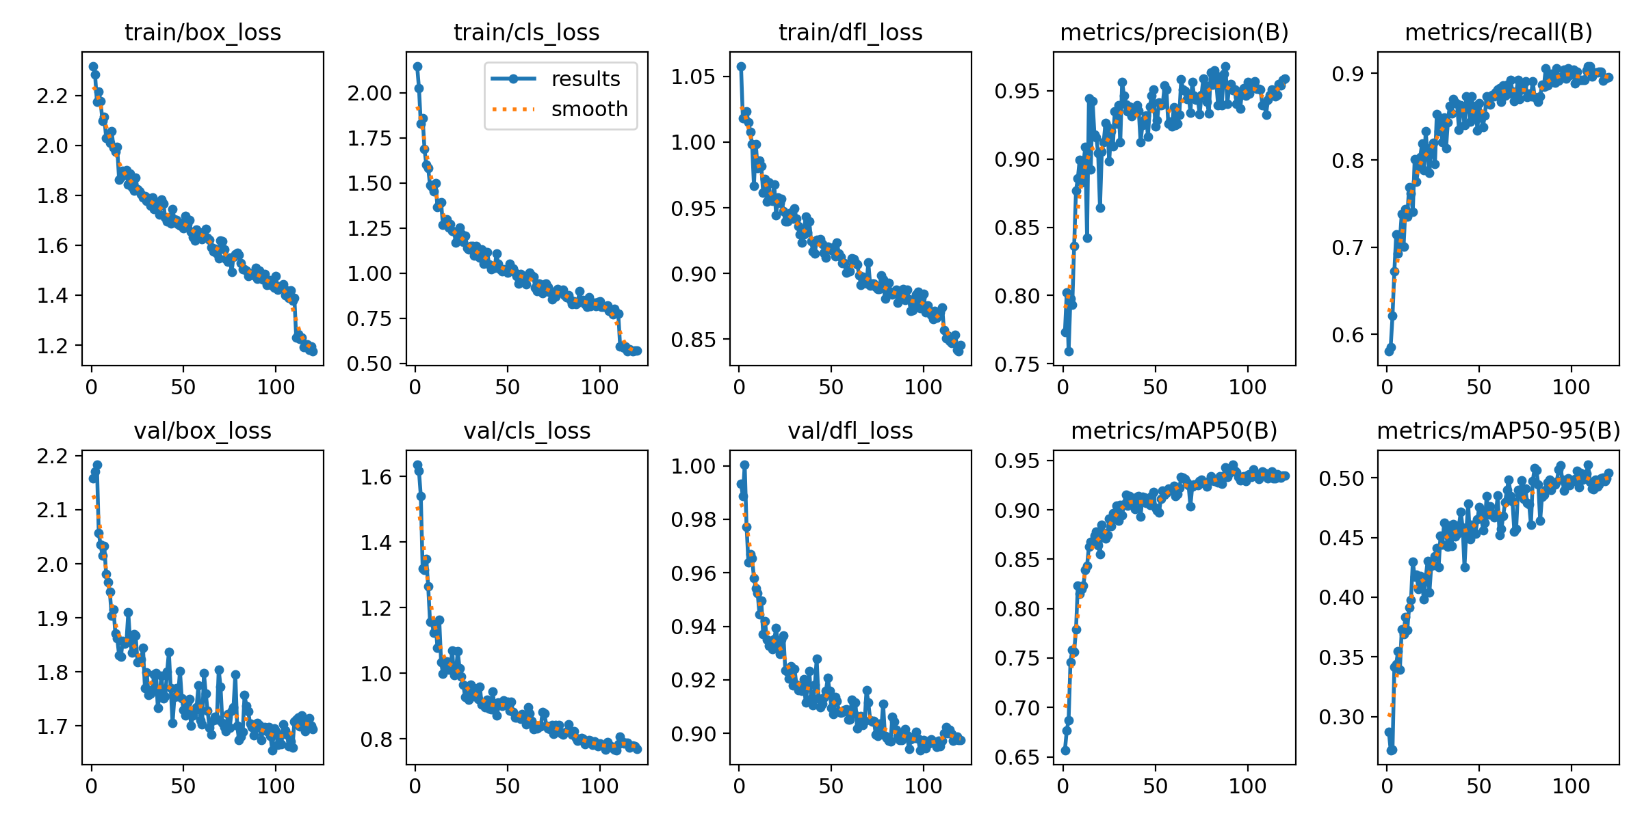
Phase 2: Finetune entire network
Used AdamW, reduced batch size, and PCB-safe augmentations.
Resultant Graph during finetunning phase:
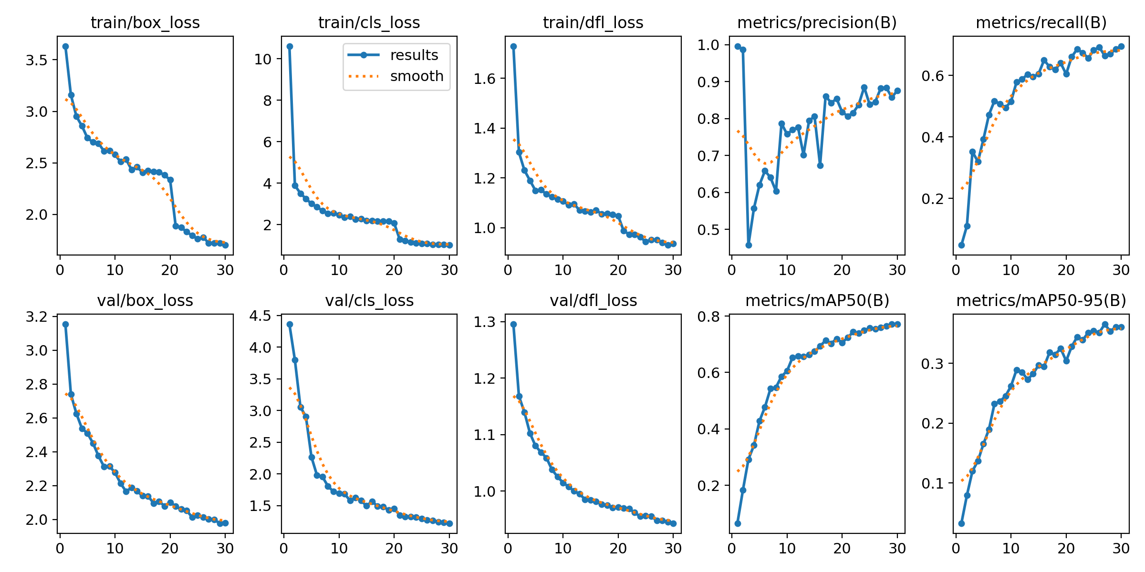
Model 4: YOLOv11s and Model 5: YOLOv11m
YOLOv11 is the newest YOLO architecture offering higher accuracy and stability.
model = YOLO("yolo11m.pt")
model.train(epochs=100, optimizer="AdamW", cos_lr=True, amp=True)
Yolo11s Matrix graphs:
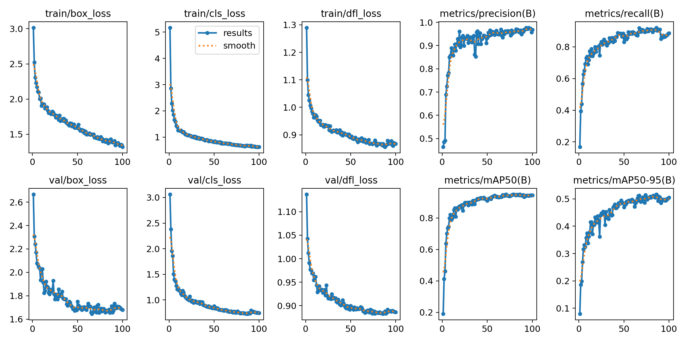
Yolo11m Matrix graphs:
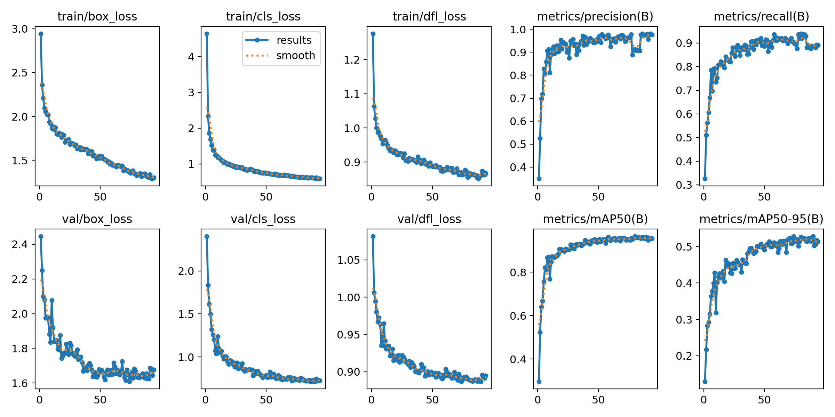
These models were tested with mild augmentations because PCB images are sensitive—too much deformation can distort defect geometry.

Module 4: Evaluation and Prediction Testing
Each model was evaluated using:
- Precision
- Recall
- mAP50
- mAP50-95
- Validation losses
- Visual inspection of predictions on unseen images
Final Metrics Summary
Model | mAP50 | mAP50-95
YOLOv8s | 0.92399 | 0.48410
YOLOv8m | 0.92979 | 0.49594
YOLOv8 Freeze-Finetune | 0.93454 | 0.50423
YOLOv11s | 0.94464 | 0.50462
YOLOv11m | 0.96510 | 0.51379

Conclusion from Evaluation
YOLOv11m is the overall best-performing model across all metrics. It outperformed every YOLOv8 variant, including the fine-tuned model.
Milestone 3: PCB vs Non-PCB Image Classification
To improve system robustness, a binary image classification model was introduced before defect detection.
Purpose of the Classifier
- Prevent false detections on non-PCB images.
- Reduce unnecessary computation on invalid inputs.
- Act as a pre-filter before running defect detection.
Model Details
- Task: Binary classification (PCB / Non-PCB)
- Architecture: YOLO-based image classifier
- Input: Raw uploaded image
- Output: PCB confidence score
Integration Strategy
- Images with confidence below a defined PCB threshold are rejected.
- Only verified PCB images proceed to YOLO defect detection.
- This improves accuracy and system reliability in real-world usage.

Milestone 3: Frontend and Backend Integration
Backend Architecture
- Developed using FastAPI for high-performance asynchronous inference.
- Modular service structure:
  - Image preprocessing
  - Classifier inference
  - Defect detection
  - Metadata generation
  - PDF and JSON report creation
- Static file handling for annotated images and downloadable reports.
- ZIP packaging of all outputs per inference session.
Frontend Architecture
- Initially implemented using Gradio for rapid prototyping and evaluation.
- Later extended to a custom web-based frontend using HTML, CSS, and JavaScript.
- Key features:
  - Multi-image upload
  - Real-time inference triggering
  - Interactive results table
  - Detailed per-image analysis page
  - Bar and pie chart visualizations
  - PDF, JSON, and ZIP report downloads
- State persistence implemented to preserve results across page navigation.
System Workflow
- User uploads images via frontend.
- PCB vs Non-PCB classifier validates inputs.
- YOLOv11m performs defect detection.
- Annotated images and metadata are generated.
- Reports (PDF, JSON, ZIP) are made available for download.
- Results are visualized interactively in the UI.
UI Graphics Image:
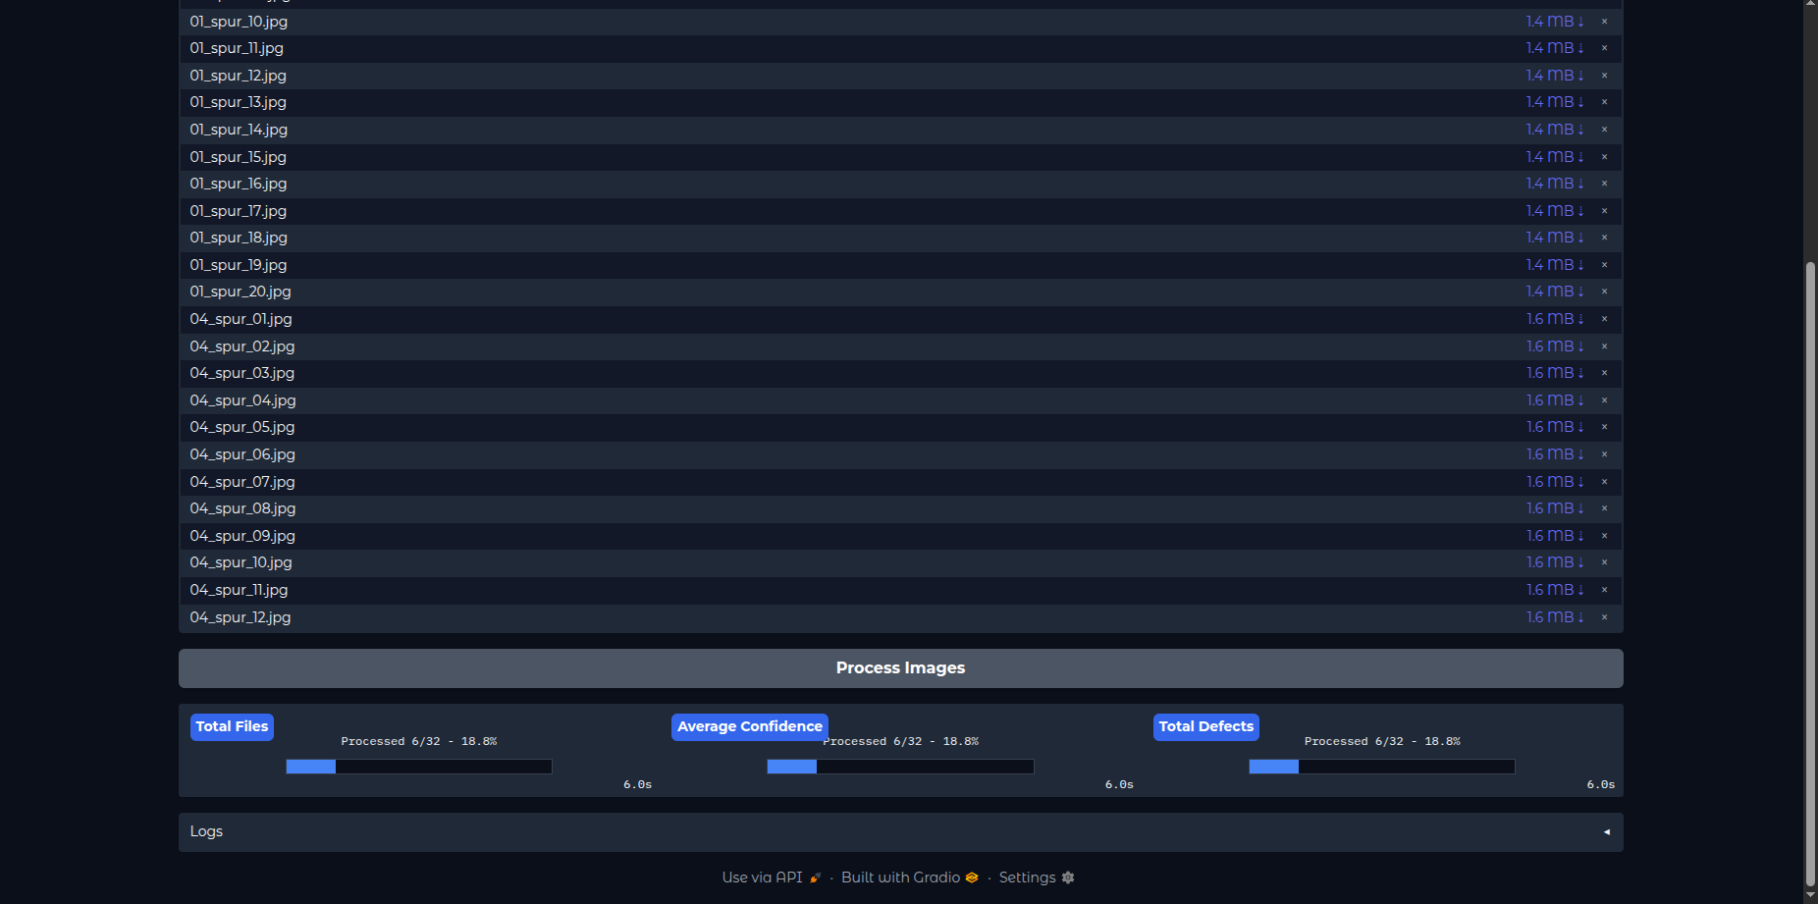
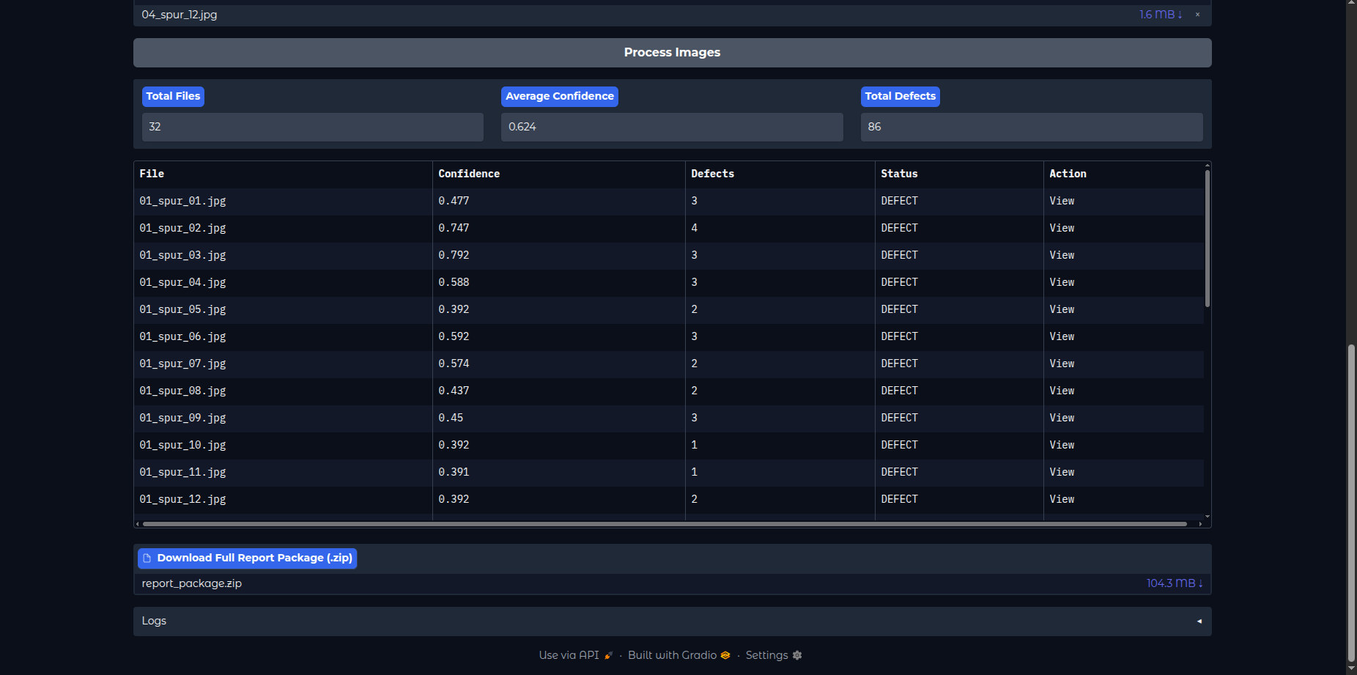
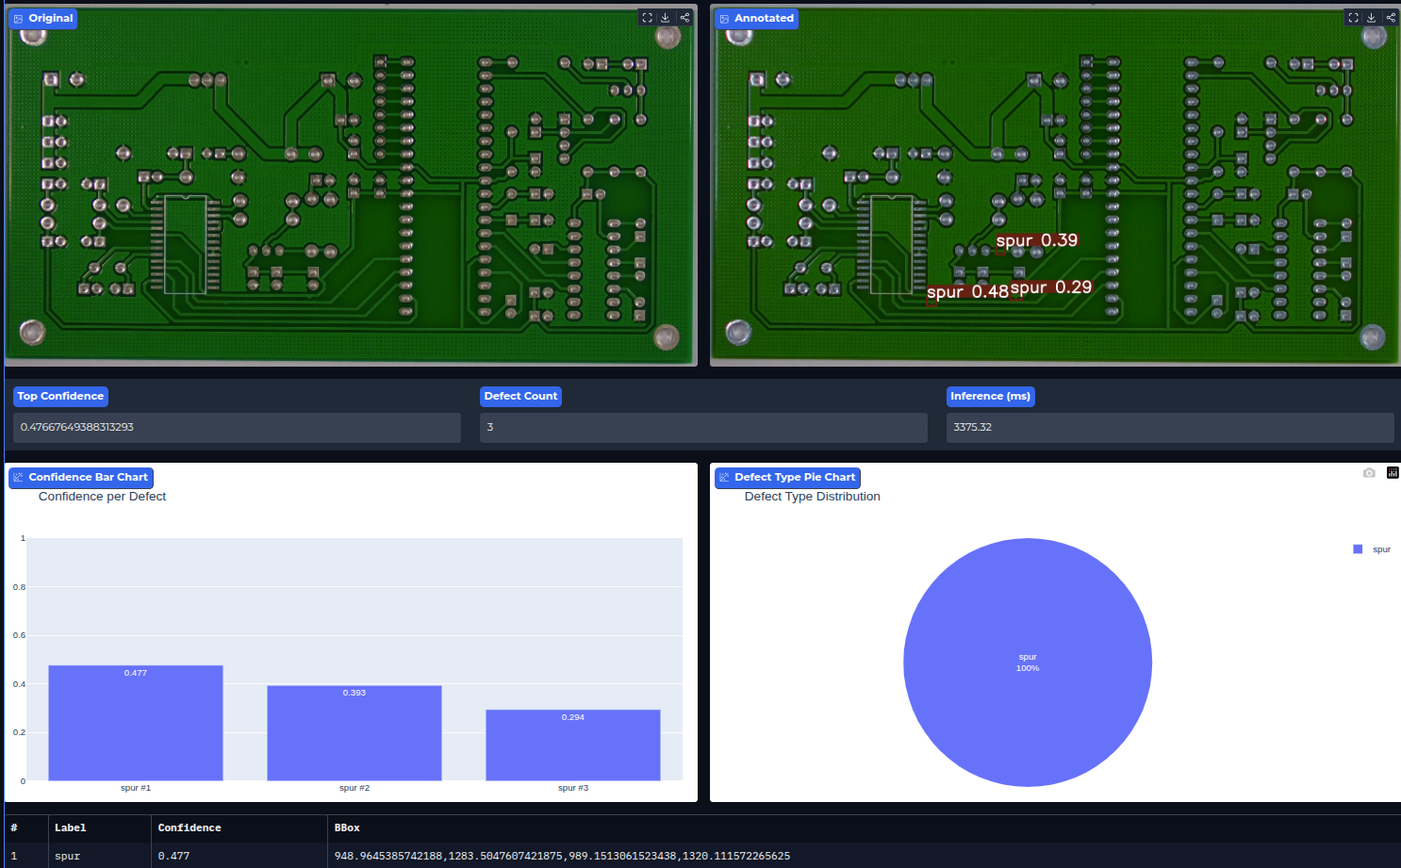
4. Challenges Faced and Solutions

Challenge | Explanation | Solution
Dataset alignment issues | Template and test images were slightly misaligned | Applied feature-based alignment + resizing
Noise in subtraction outputs | PCB images contain reflections, solder marks | Used Gaussian blur + morphological filters
Overfitting in early YOLOv8 training | mAP stagnated after 30 epochs | Introduced early stopping, cosine LR, AdamW
Limited GPU memory (RTX 4050 6GB) | YOLOv8m/YOLOv11m training consumed VRAM | Reduced batch size, enabled AMP
False positives in small defects | Spur and short often confused | Improved augmentations and class balancing

5. Potential Applications
- Automated PCB inspection
- Robotics-based QC systems
- Assembly-line defect filtering
- Mobile inspection tools
- Predictive maintenance

6. Industry Impact
AI-driven PCB inspection improves quality assurance, reduces manual labor, speeds up production, lowers costs, and increases accuracy and consistency.

7. Final Results Summary
After evaluating all models:
- YOLOv11m achieved the highest accuracy
- Fine-tuned YOLOv8 outperformed default YOLOv8 models
- YOLOv11 architecture showed significant improvement over YOLOv8
- The complete system (data → model → UI → backend) is production-ready

8. Conclusion
This project successfully implemented a complete PCB defect detection system using modern YOLO architectures. With further improvements like pruning and quantization, the solution can be deployed in real manufacturing environments.

