CLIPMIND AI
MILESTONE 2 DOCUMENTATION
Transcript Generation and AI Summarization

Prepared by: Sneha Singh
Project: ClipMind AI - Video Summarization & KeyMoments Detection Platform

1. Introduction
ClipMind AI is a web application designed to help users understand video content more efficiently. This module focuses on converting video speech into readable text and generating short and detailed summaries from the transcript. This document describes the workflow and the features visible in the supplied screenshots.

2. Objectives
- Extract audio from an uploaded video for speech processing.
- Generate a text transcript from the video's speech.
- Present the generated transcript on a dedicated Transcript page.
- Create a short summary for a quick overview and a detailed summary with more of the video's content.
- Display detailed-summary sections with timestamps so users can locate parts of the video.
- Show completion status for transcript and summary generation.

3. Technology Stack
Technology | Purpose
React.js + Vite | Frontend pages and user interface.
Python + FastAPI | Backend API endpoints and processing workflow.
FFmpeg | Video/audio handling and audio extraction where required.
Whisper | Speech-to-text transcription.
Hugging Face Transformers (BART) | Text summarization from the transcript.
SQLite | Application data storage.

4. Module Workflow
Video Upload → Audio Extraction → Speech-to-Text → Transcript → AI Summarization → Short & Detailed Summary
The backend processes the uploaded video's audio, produces transcript text, and makes the transcript available to the frontend. The summarization step uses transcript text to create the summary content displayed on the Summary page.

5. Transcript Generation
The Transcript page displays the heading “Generated Transcript” and explains that the transcript is generated from the video audio. The screenshot shows readable transcript text, a “View Summary” button, and a “Transcript completed” status message. This confirms that transcript text was available in the interface for the example video shown.
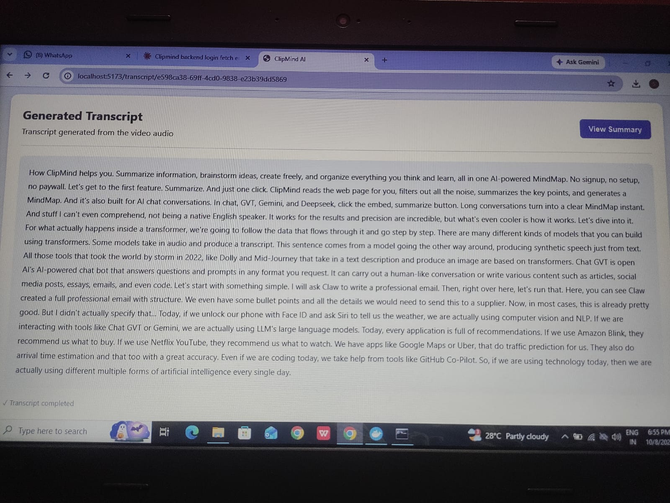
Figure 1. Generated Transcript page in ClipMind AI.

Transcript page features visible
- Displays generated transcript as readable text.
- Provides a “View Summary” navigation action.
- Shows a completed status for transcript generation.

6. AI Summarization
The Summary page presents two output formats: Short Summary and Detailed Summary. The short summary gives a quick overview, while the detailed summary presents more of the transcript in timestamped sections.
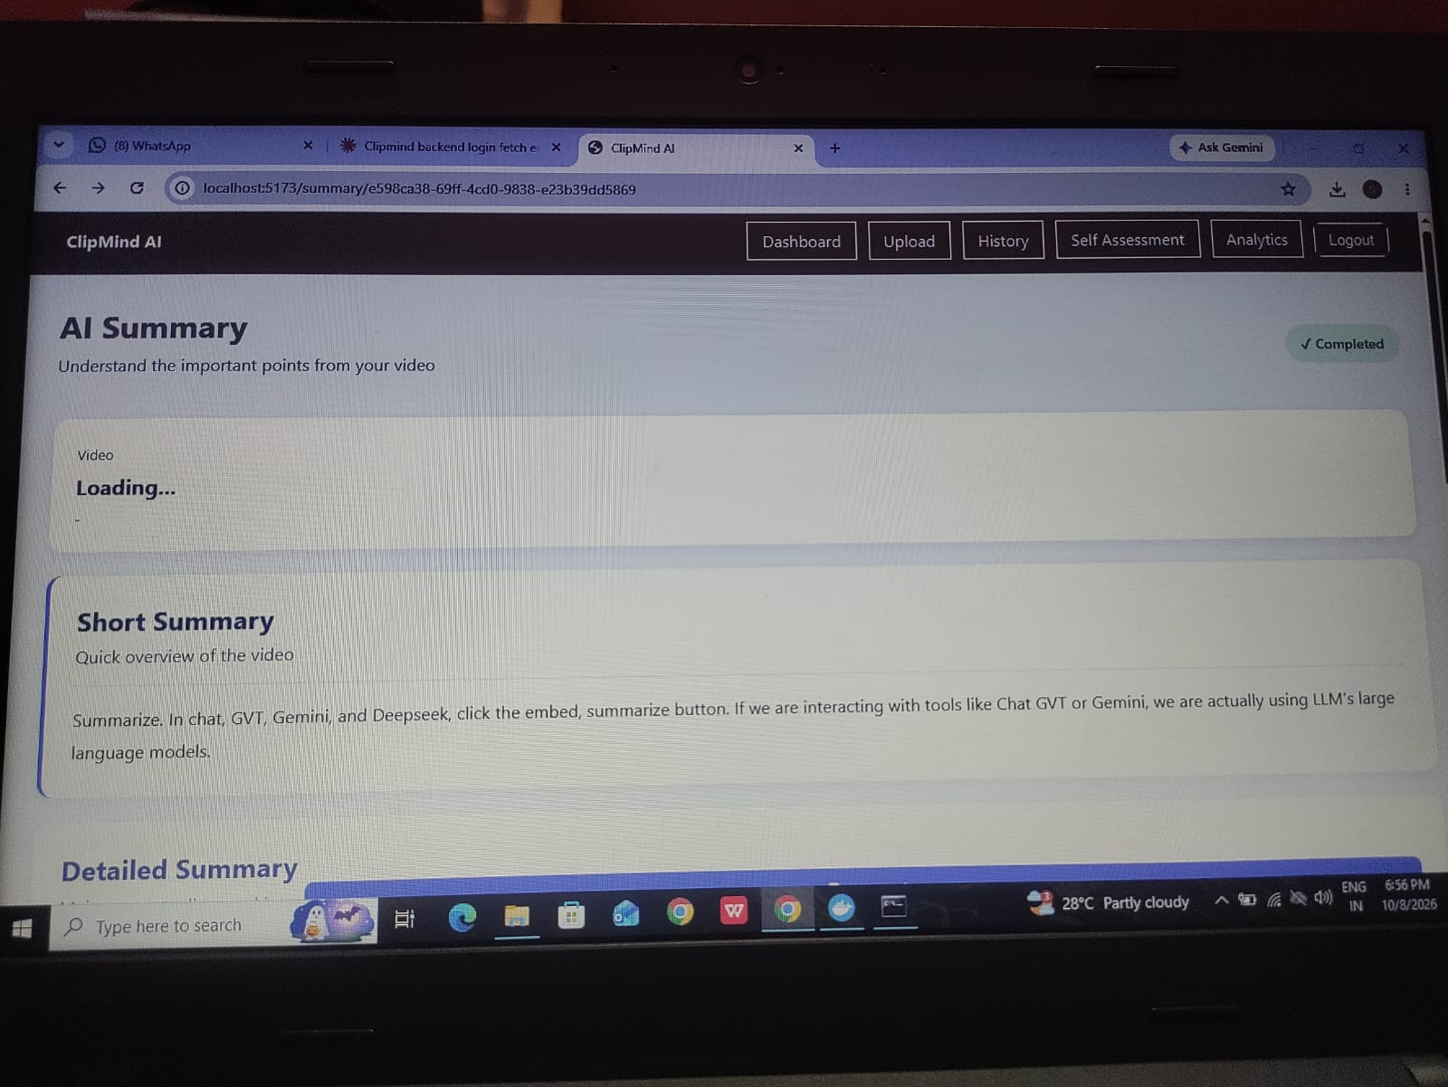
Figure 2. Summary page showing the Short Summary section and completed status.
The screenshot shows a completed status and short summary text. The video-information card displays “Loading...” in this captured state; therefore, this document does not claim that the video title/details had fully loaded in the screenshot.
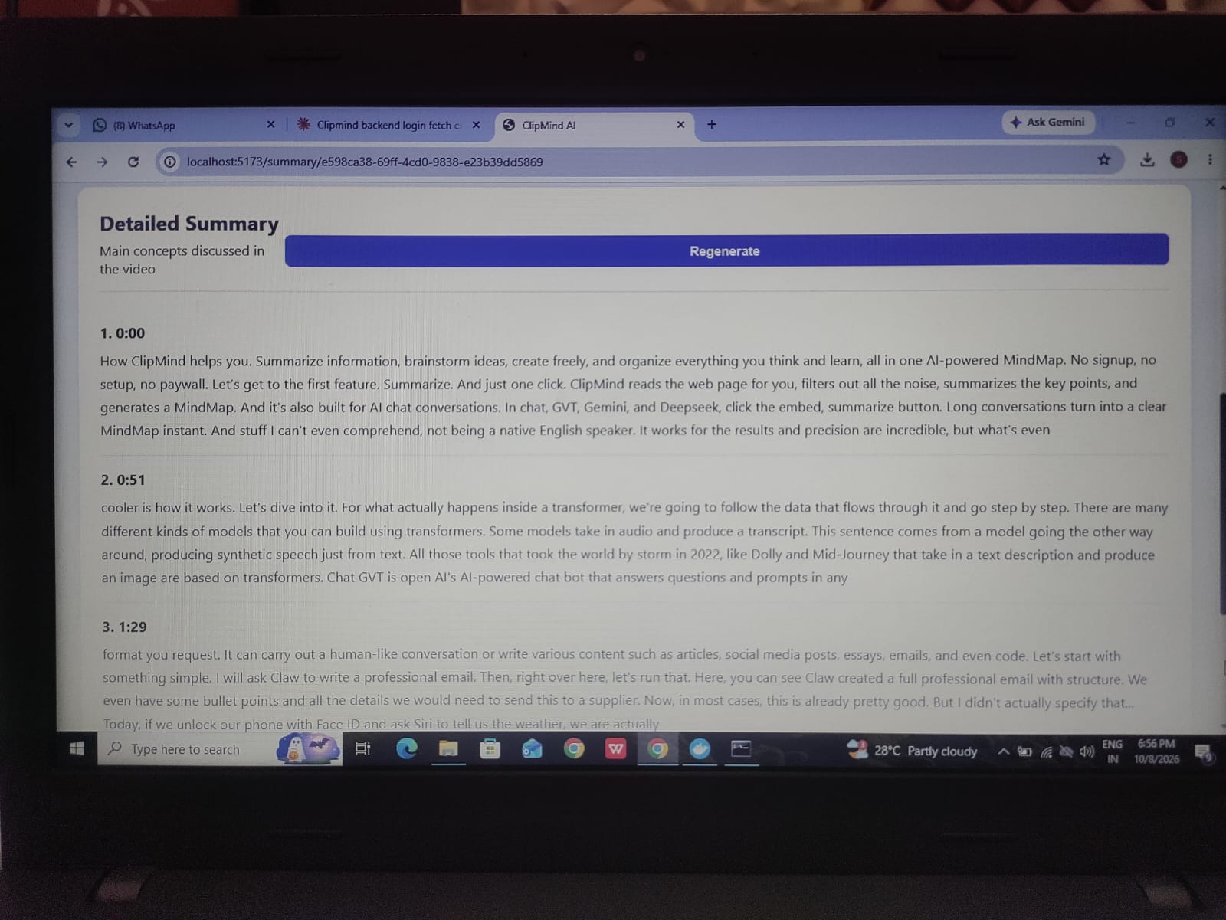
Figure 3. Detailed Summary with timestamped sections and a Regenerate control.

Summary page features visible
- Displays a short summary for a quick overview.
- Displays detailed-summary sections with timestamps such as 0:00, 0:51, and 1:29.
- Provides a “Regenerate” control for the detailed summary.
- Shows summary status as completed in the captured page.

8. Testing and Observations
The following checks are supported by the screenshots supplied for this documentation. Other checks should only be marked as passed after they have been run.
Test | Observed result | Evidence
Open Transcript page | Transcript text displayed; status reads “Transcript completed”. | Figure 1
Open Summary page | Short summary displayed; status reads “Completed”. | Figure 2
View Detailed Summary | Timestamped sections displayed; “Regenerate” control visible. | Figure 3

9. Scope and Limitations
- The screenshots demonstrate the display of transcript and summary content for the shown video.
- The video information card still shows “Loading...” in Figure 2, so this captured state does not verify that metadata loading completed.
- The screenshots do not independently verify transcript editing, detailed failure recovery, duplicate-job prevention, or access-control behavior; these are not claimed as tested here.

10. Conclusion
Module 2 demonstrates the core transcript and summarization flow in ClipMind AI. The supplied screenshots show generated transcript text, a short summary, a detailed summary with timestamps, and completion indicators. These outputs help users review key information from a video without watching the entire content again.

11. Before GitHub Submission
- Confirm the technology names match the final code and project requirements.
- Check that screenshots are from the latest working version.
- Use cleaner screenshots if possible, with unrelated browser tabs and taskbar cropped out.
- Save the final document in the repository's documentation folder.

