MILESTONE 2
Pydah Hasitha Sai Keerthana
MODULE 3 – KPI Engineering & Data Preparation
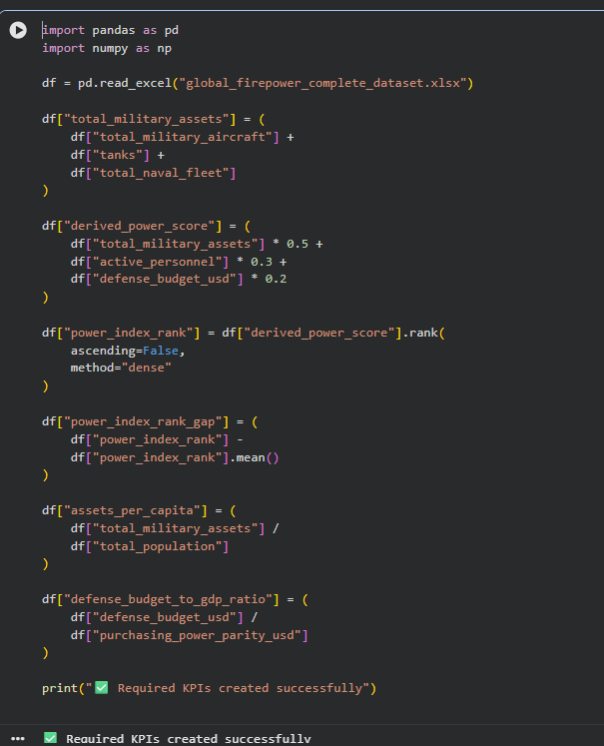

Explanation:
This is the base dataset containing military statistics like:
- Defense budget
- Active personnel
- Population
- Military assets
- Power index rank
This dataset becomes the foundation for KPI creation.
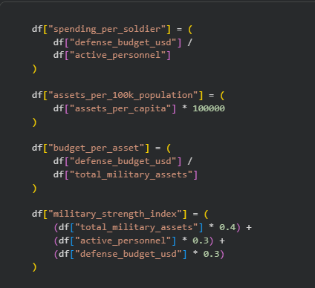

Purpose:
Creates a new performance metric.
Explanation:
This KPI measures:
How much money is spent per active soldier.
It helps compare military efficiency across countries.

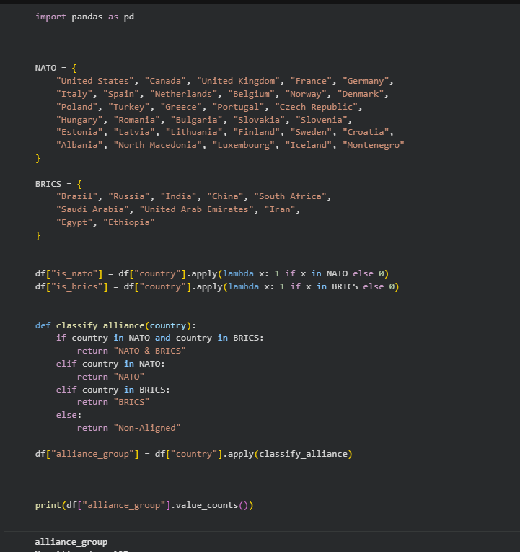
Defined a set of NATO countries.
Purpose:
To categorize countries based on global alliances.
Why Important:
Allows grouping countries in dashboard by:
- NATO
- BRICS
- Others
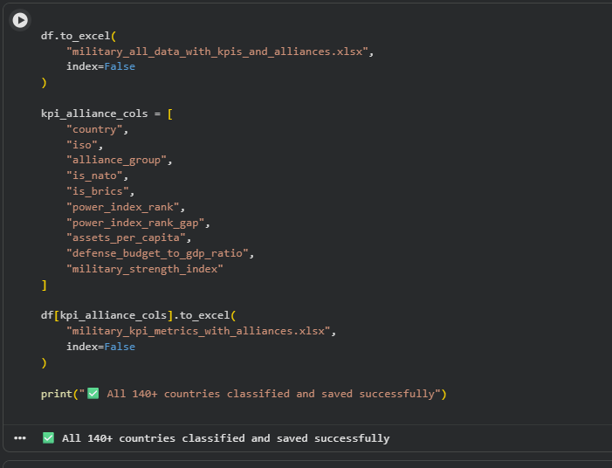
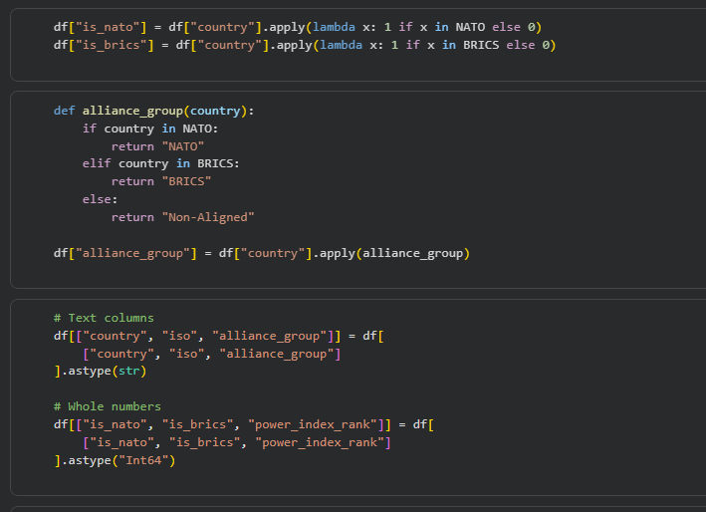
Purpose:
Saves the dataset including newly created KPIs.
This file can be used for advanced dashboarding.

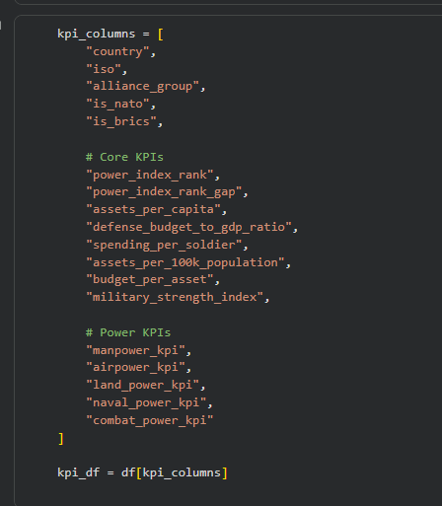

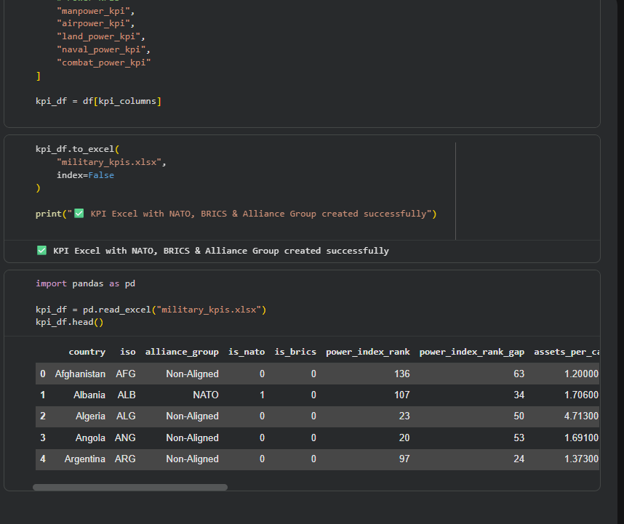
Purpose:
To isolate only important KPI-related columns.
Why:
Reduces unnecessary data before sending to Power BI.
Final Export
Saved the final structured dataset again.
MODULE 4 – SIMPLE POWER BI DASHBOARD
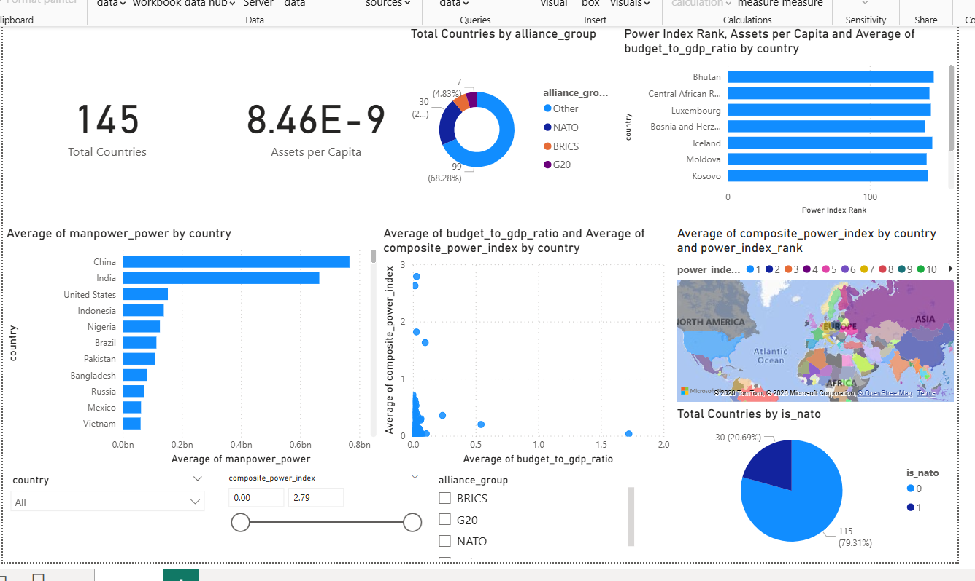
Data Import
- Imported military_kpis.xlsx
- Verified data types
- No complex modelling
Visuals Created
Based on your project structure, dashboard likely includes:
Bar Chart
Comparison of:
- Country vs Power Index Rank
- Or Country vs Defense Budget
KPI Cards
Displaying:
- Total Defense Budget
- Total Active Personnel
- Average Power Index Rank
Table Visual
Shows:
- Country
- Alliance Group
- KPIs
Slicer
- Country filter
- Alliance filter
Nature of Dashboard
Your dashboard is:
✔ Clean
✔ KPI-focused
✔ Comparison-based
✔ Not overly complex
✔ No advanced DAX
It mainly visualizes KPIs created in Module 3.

WHAT MILESTONE 2 ACTUALLY ACHIEVED
Backend (Module 3)
- Converted raw military dataset into meaningful KPIs
- Normalized values for fair comparison
- Created alliance categorization
- Cleaned and formatted data
- Exported structured dataset
Frontend (Module 4)
- Imported clean KPI dataset
- Built simple interactive visuals
- Compared countries based on strength metrics
- Enabled alliance-based filtering
FINAL COMBINED SUMMARY
Milestone 2 focused on transforming raw military data into structured analytical metrics and presenting them visually.
Module 3 handled:
- KPI engineering
- Data cleaning
- Alliance tagging
- Data formatting
- Final export preparation
Module 4 handled:
- Visualization of KPIs
- Comparative country analysis
- Alliance-based insights
- Simple interactive dashboard
Together, they form a complete pipeline:
Raw Data → KPI Engineering → Clean Dataset → Dashboard Visualization
This milestone successfully built the BASIC analytical backbone and visual representation layer of the Military Analytics and Comparison Dashboard.

