☀️ 🌬️
Solar & Wind Deployment
Intelligence Platform
Project Documentation & Development Review
Prepared for project review
Covers: system architecture · end-to-end workflow · prediction & scoring logic ·
database design · module completion status · roadmap

1. Project Overview
The Solar & Wind Deployment Intelligence Platform is an AI-assisted system that helps renewable energy planners identify the best locations for solar and wind projects. A user creates a project, registers candidate sites by coordinates, and the system automatically evaluates each site's solar potential, wind potential, environmental suitability, and financial feasibility — then ranks sites so planners can see, at a glance, where to invest.
This document walks through what has been built so far: the architecture, the full data flow, every calculation used, the database design, and an honest status of what remains to be implemented.

2. System Architecture
The platform is built as three independent layers, each running in its own Docker container, networked together. This mirrors how production systems are deployed — each layer can be scaled, updated, or replaced without touching the others.
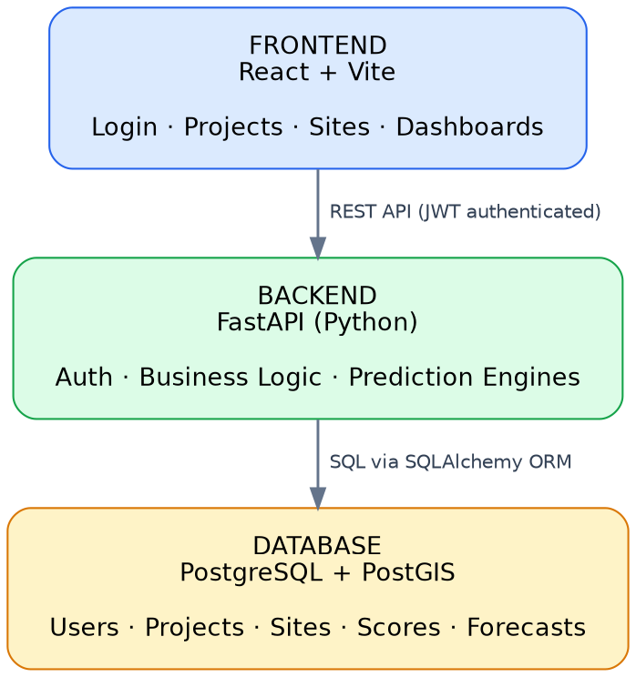
Figure 1 — Three-tier architecture: Frontend, Backend, Database
Layer | Technology | Responsibility
Frontend | React + Vite | Forms, dashboards, charts — what the user sees & clicks
Backend | Python + FastAPI | Business logic, calculations, API endpoints, authentication
Database | PostgreSQL + PostGIS | Persists users, projects, sites, and every computed result

3. End-to-End User Flow
This is the journey a user takes from opening the app to seeing a ranked list of the best deployment sites.
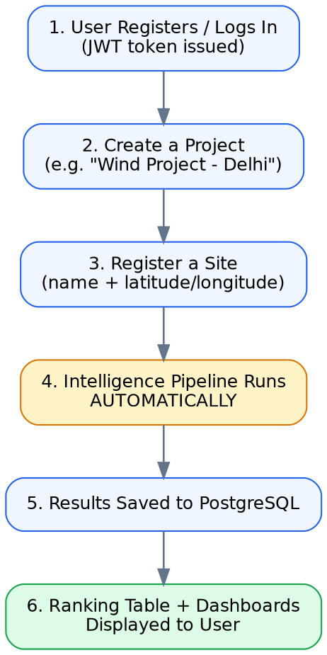
Figure 2 — User journey from login to ranked results
The key thing to note: step 4 — the intelligence pipeline — runs automatically the moment a site is registered. There is no separate "analyze" button; registering a site and analyzing it are the same action.

4. The Intelligence Pipeline (Core Logic)
When a site is registered, five calculation engines run in sequence, each feeding the next. This is the heart of the platform.
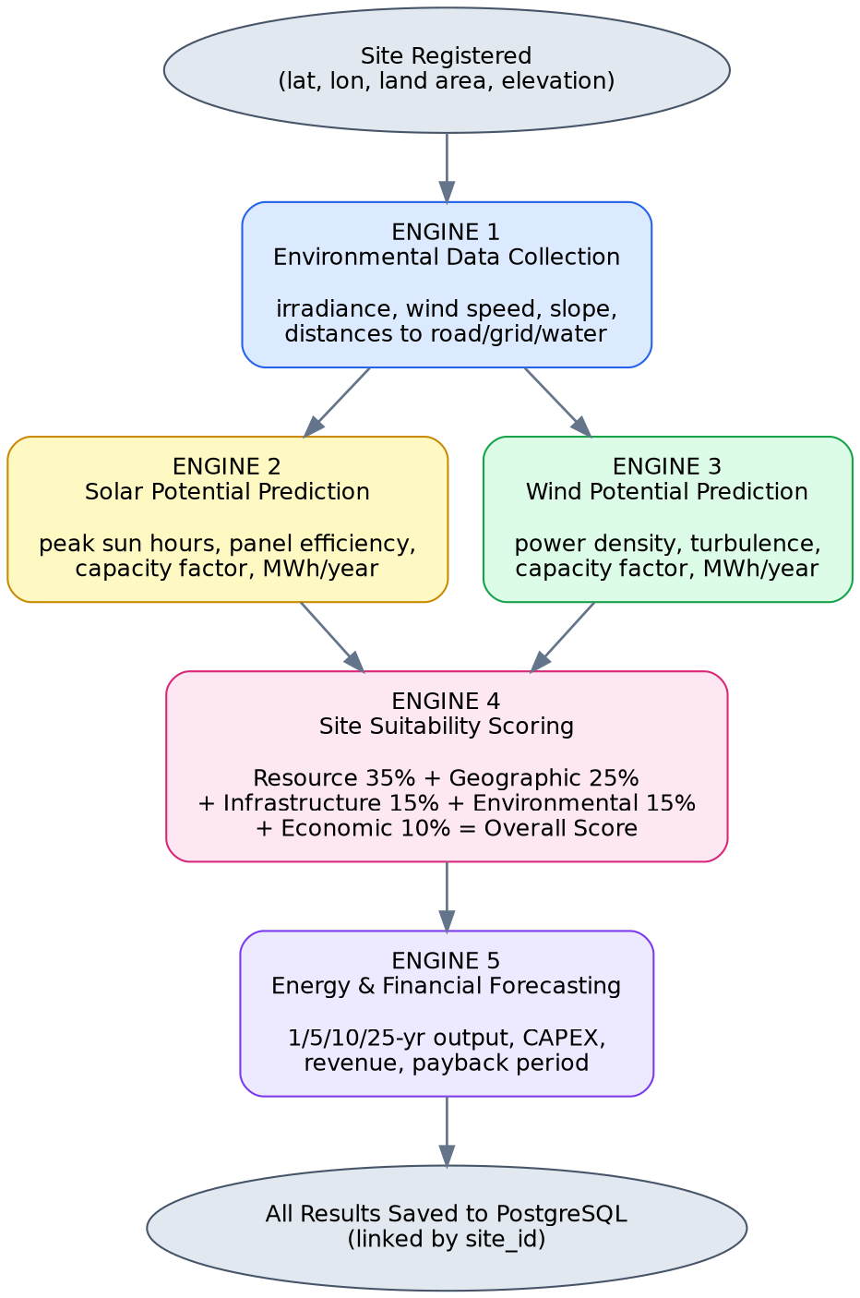
Figure 3 — The five-engine intelligence pipeline

4.1 Engine 1 — Environmental Data Collection
Purpose: gather the raw inputs every other calculation depends on.
Current implementation: a deterministic formula seeded by the site's coordinates, simulating what live APIs would return.
lat_factor = cos(min(|latitude|, 65°))
irradiance = 3.0 + (lat_factor × 4.0) + small variation
temperature = 30 − (|latitude| × 0.5) + small variation
Also generated: wind speed & direction, rainfall, cloud cover, land slope, vegetation index (NDVI), and distances to road / transmission line / substation / urban area / water body, plus whether the site sits in a protected zone.
Planned real sources: NASA POWER (solar irradiance) · Global Wind Atlas (wind speed) · NASA SRTM (elevation/terrain) · OpenStreetMap (infrastructure distances) · Copernicus Sentinel Hub (satellite land cover).

4.2 Engine 2 — Solar Potential Prediction
peak_sun_hours = solar_irradiance (kWh/m²/day)
panel_efficiency = 21.0% − temp_derate − slope_derate
performance_ratio = 0.85 − (cloud_cover/1000) − (shading_loss/200)
capacity_factor = (peak_sun_hours / 24) × performance_ratio × 100
expected_output_MWh = capacity_MW × 1000 × (capacity_factor/100) × 8760 / 1000
Example (5 hectares, irradiance 5.2 kWh/m²/day) → capacity factor ≈ 18.4%, expected output ≈ 4,029 MWh/year.

4.3 Engine 3 — Wind Potential Prediction
power_density = 0.5 × air_density(1.225) × wind_speed³
capacity_factor: banded by wind speed (see table below)
expected_output_MWh = capacity_MW × 1000 × (capacity_factor/100) × 8760 / 1000

Wind Speed | Suitability | Capacity Factor Formula
< 3 m/s | Unsuitable | min(v × 2, 8)%
3 – 5.5 m/s | Marginal | 15 + (v−3)×5 %
5.5 – 7.5 m/s | Suitable | 28 + (v−5.5)×6 %
> 7.5 m/s | Highly Suitable | min(40 + (v−7.5)×4, 55)%

4.4 Engine 4 — Site Suitability Scoring
This is the platform's central formula — it combines every prior calculation into one comparable score per site.
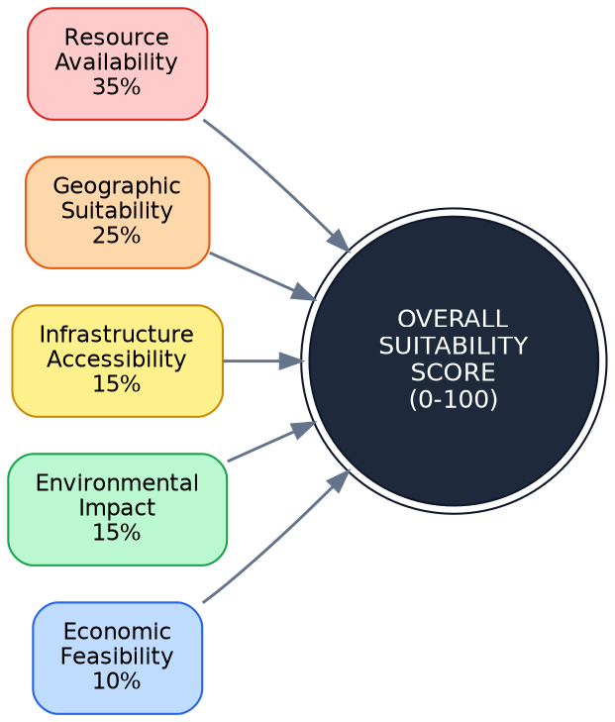
Figure 4 — Weighted suitability score composition
Overall Score = Resource(35%) + Geographic(25%) + Infrastructure(15%)
+ Environmental(15%) + Economic(10%)

- Resource Score (35%) — best of solar or wind capacity factor × 2.6
- Geographic Score (25%) — penalizes steep slope and dense vegetation
- Infrastructure Score (15%) — penalizes distance from roads/grid/substation
- Environmental Score (15%) — penalizes protected zones and water proximity
- Economic Score (10%) — rewards usable land area, penalizes cloud-cover variability

Score Range | Category
≥ 85 | Excellent
70 – 84 | Highly Suitable
50 – 69 | Moderately Suitable
30 – 49 | Low Suitability
< 30 | Unsuitable

4.5 Engine 5 — Energy & Financial Forecasting
output_at_year_N = year1_output × (1 − degradation)^(N−1)
Solar degradation: 0.5%/yr Wind degradation: 0.3%/yr
CAPEX: Solar $850,000/MW · Wind $1,300,000/MW
Annual revenue = year1_output_MWh × $55/MWh
Payback period = CAPEX / annual_revenue
Projects Year 1, 5, 10, and 25 output, plus a rough investment feasibility check for the planner.

5. Database Design
All five engines' outputs are persisted to PostgreSQL, each result table linked back to its site via a site_id foreign key. This makes every number on screen independently verifiable with a direct SQL query — proof the platform is a real, working system and not a static mockup.
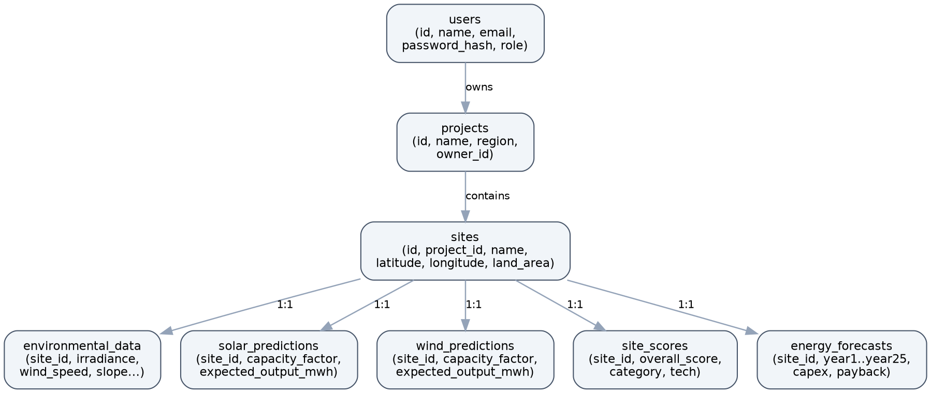
Figure 5 — Database schema and relationships

6. Module Completion Status
Status against the original 14-module specification:
Module | Status | Notes
1. User Authentication & Role-Based Access | Done | JWT login/register, 4 roles
2. Project & Site Management | Done | Create/list/delete projects & sites
3. Environmental Data Collection | Partial | Pipeline works; data is simulated, not live APIs yet
4. Geographic Intelligence | Partial | Simulated distances to roads/grid
5. Solar Potential Prediction | Done | Physics formulas, not trained ML
6. Wind Potential Prediction | Done | Physics formulas, not trained ML
7. Site Suitability Analysis | Done | Exact weighted formula implemented
8. Energy Forecasting | Done | 1/5/10/25-year projections
9. Deployment Optimization | Partial | Per-site recommendation only, no portfolio optimization
10. Site Scoring & Ranking | Done | Ranking table sorts by score
11. Dashboard & Analytics | Partial | Basic charts; role-specific dashboards not separated
12. Notification & Alert System | Not started | —
13. Reports & Export System | Partial | Data generated as JSON; PDF/Excel export not built
14. Final Integration & Docker Deployment | Done | docker-compose with PostgreSQL + PostGIS

7. What's Still To Be Implemented

Priority 1 — Foundational
- Live environmental/GIS data integration (currently simulated) — NASA POWER, Global Wind Atlas, NASA SRTM, OpenStreetMap, Copernicus Sentinel Hub
- Trained ML prediction models (currently physics-based formulas) — XGBoost / Random Forest / LightGBM / TensorFlow trained on historical generation data

Priority 2 — Core Feature Gaps
- GIS map visualization (Leaflet / Mapbox) — coordinates are ready, no map UI yet
- Satellite imagery display (Sentinel Hub integration)
- Multi-site portfolio optimization (currently scores sites individually)
- Downloadable PDF / Excel reports (data exists as JSON only today)

Priority 3 — Supporting Features
- Notification & alert system (weather, risk, forecast update alerts)
- Side-by-side site comparison view
- Role-specific dashboards (Planner / GIS Analyst / Project Manager / Admin views)
- Admin panel (user management, platform analytics, data source management)
- OAuth2 social login (currently email/password JWT only)

Priority 4 — Polish & Production-Readiness
- Deeper financial modeling (financing terms, tax incentives, regional pricing)
- Automated testing suite (unit, integration, security, performance)
- Centralized monitoring & logging

8. Recommended Next Step
Real environmental data integration should come first — every other number in the system, including any future trained ML model, depends on having real inputs. Improving dashboards or reports on top of simulated data adds polish but not real accuracy; fixing the data foundation does.

