DV - Optimizing IT Support Team Performance Using Analytics ( Supportlytics)

Milestone 1: Week 1 and 2.
About the Dataset:
The “customer_support_tickets.csv” dataset represents customer support ticket records, where each row corresponds to a single support ticket submitted by a customer (Dataset chosen from Kaggle).
The dataset contains 16 attributes including:
- Ticket identifiers
- Ticket properties
- Time-related support metrics
- Customer demographics
- Support interaction fields
- Customer satisfaction outcomes (but empty in current state)

Category | Columns | Purpose
Ticket Metadata | Ticket ID | Unique ticket tracking
Ticket Classification | Ticket Type, Ticket Priority | Support workload & urgency
Ticket Status | Ticket Status | Track closure vs backlog
Time Metrics | First Response Time, Time to Resolution | Performance & SLA analysis
Support Channel | Ticket Channel | Channel efficiency analysis
Customer Info | Customer Name, Customer Age, Customer Gender, Customer Email | Demographic analysis (optional)
Interaction Text | Ticket Subject, Ticket Description | Issue category extraction (optional)
Purchase Info | Product Purchased, Date of Purchase | Product-specific issue analysis
Outcome | Customer Satisfaction Rating | Performance outcome (but empty)

Total rows: 8469 Total features: 18.
Keep for KPIs:
- Ticket Priority
- Ticket Status
- Ticket Type
- Time fields

Drop/flag:
- Empty satisfaction field
- Empty channel field

Keep optional:
- Customer demographics
- Product field

(D) Weak Columns (Should Drop or Flag)
Column | Issue
Customer Satisfaction Rating | All missing (0 count)
Ticket Channel | Empty / NaN
Resolution (text) | Unstructured & unclear meaning
block KPIs and confuse final module.
- Core Performance Columns (MUST KEEP)
Column | Purpose
Ticket ID | Unique ticket identifier
Ticket Type | Classifies issue type
Ticket Priority | Urgency (High/Med/Low)
Ticket Status | Closed/Open/Resolved
First Response Time | Response efficiency KPI
Time to Resolution | Resolution efficiency KPI

(B) Useful for Insights (Recommended Keep)
Column | Purpose
Ticket Subject | For categorization & frequent issues
Ticket Description | For NLP / clustering / patterns
Product Purchased | Product-based problem insights
Date of Purchase | Context or trend analysis

(C) Customer Demographics (Optional Keep)
Column | Purpose
Customer Name | Identity → Not useful analytically
Customer Email | PII → Ethical drop
Customer Age | Could link demographics → performance
Customer Gender | Customer segmentation insights
Drop Name & Email (PII, no analytical value)

Feature Engineering
Fix: Correct KPI Computation
Milestone 2: Week 3.
Ticket Type → Bar chart
Priority → Bar chart
Resolution Category → Pie chart
Unresolved → Pie chart / bar
Resolution Time → Box / Histogram
Priority vs Resolution → Box plot
🔷 MODULE-3 — PART 5: Insights Extraction
After visualizations, write insights like:
✔ Workload Insights
- Technical issues are X%
- Priority distribution skewed toward Critical/High
- Backlog rate = Y%
✔ Performance Insights
- Avg resolution time = X hours
- Fast = A%, Medium = B%, Slow = C%
- Critical tickets take longest handling time
✔ Backlog Insights
- Unresolved = X%
- Pending customer response = Y%
These insights will feed Module-4 (Optimization).
Based on your dataset insights, main issues are:
Problem 1 — High Backlog
Unresolved = 67.3%
Impact:
→ high customer dissatisfaction
→ SLA breach risk
→ increased operational load

Problem 2 — Slow Ticket Category Dominates
Slow ≈ ~67%
Impact:
→ bottleneck in ticket lifecycle
→ delayed closure
→ priority inefficiency

Problem 3 — Balanced Priority Load
All priority types ~25% each
Insight:
→ workload allocation must be dynamic, not fixed

Problem 4 — Diverse Ticket Types
5 major categories ~20% each
Impact:
→ requires multi-skill support
→ need domain-based routing
Milestone-3 (Weeks 5–6) — Performance Intelligence
Focus: Deep operational insights
Module-5
- Resolution KPIs
- Priority vs performance
- Request / Incident / Problem analysis
- Unresolved ticket analysis
- Time trends
Module-6
- Geographic performance comparison
- Cluster impact analysis
- Size vs performance relationship
- Final operational recommendations
Outcome: Evidence-based performance diagnosis
Final Step: Turn analysis into decision system
FINAL MILESTONE — Weeks 7 & 8
Final Dashboard:

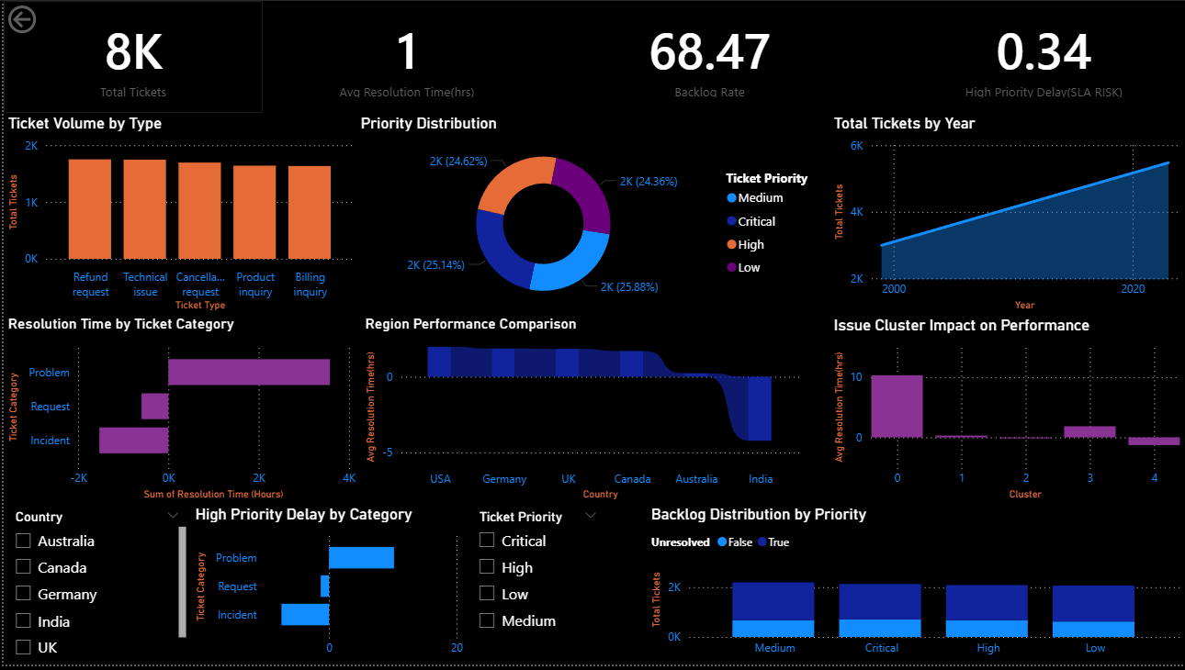

Final Overall Conclusion (Very Important — Memorize)
The dashboard converts raw support ticket data into operational intelligence.
It identifies workload patterns, performance bottlenecks, and high-impact issues, enabling management to prioritize automation, optimize staffing, and improve customer satisfaction.

