PPE Detection using YOLOv8 K. Lakshmi Pravallika

Milestone 2 – Model Training and Evaluation Report

Introduction

Construction sites are high-risk environments where workers are exposed to hazards such as heavy machinery, falling objects, and unsafe working conditions. To reduce the risk of accidents, workers are required to wear Personal Protective Equipment (PPE) such as helmets, safety vests, and masks. Monitoring whether workers follow these safety rules is important but manual supervision can be difficult and time-consuming. With the advancement of artificial intelligence and computer vision, automated systems can be used to detect PPE compliance efficiently. Computer vision models can analyze images or video frames and identify objects in real time. In this project, the YOLOv8 object detection model was used to automatically detect PPE items on construction sites. The model was trained to recognize objects such as hardhats, masks, safety vests, machinery, vehicles, and cones. This automated detection system can help improve construction site safety by identifying safety violations quickly and accurately.

2. Dataset Description

The dataset used in this project contains annotated images of construction site environments for detecting Personal Protective Equipment (PPE). The images include workers wearing or not wearing safety equipment along with other objects commonly found on construction sites. Each image in the dataset is labeled using bounding boxes that identify different PPE classes.
The dataset follows the YOLO annotation format where each image has a corresponding label file containing the class ID and normalized bounding box coordinates. These annotations allow the YOLOv8 model to learn how to detect different safety-related objects.
Dataset Details
- Total number of images: 2599
- Number of classes: 10
- Classes: Hardhat, Mask, NO-Hardhat, NO-Mask, Safety Vest, NO-Safety Vest, Person, Machinery, Vehicle, Cone
- Dataset source: PPE Detection Dataset (construction safety images with annotations)
Dataset Structure
The dataset is organized according to the YOLOv8 directory format, separating images and labels into training, validation, and testing folders.
dataset/
├── images
│ ├── train
│ ├── val
│ └── test
│
├── labels
│ ├── train
│ ├── val
│ └── test
│
└── data.yaml
3.Model Training Configuration

- Framework used: YOLOv8 (Ultralytics)
- Programming language: Python
- Hardware used: Google Colab Tesla T4 GPU (training), Local CPU (testing)
- Base models used: YOLOv8n and YOLOv8s
- Image sizes used: 640 × 640 and 800 × 800
- Number of epochs: 50 epochs (baseline), 100 epochs (experiment)

4. Training Experiments
Experiment 1 – Increased Epochs
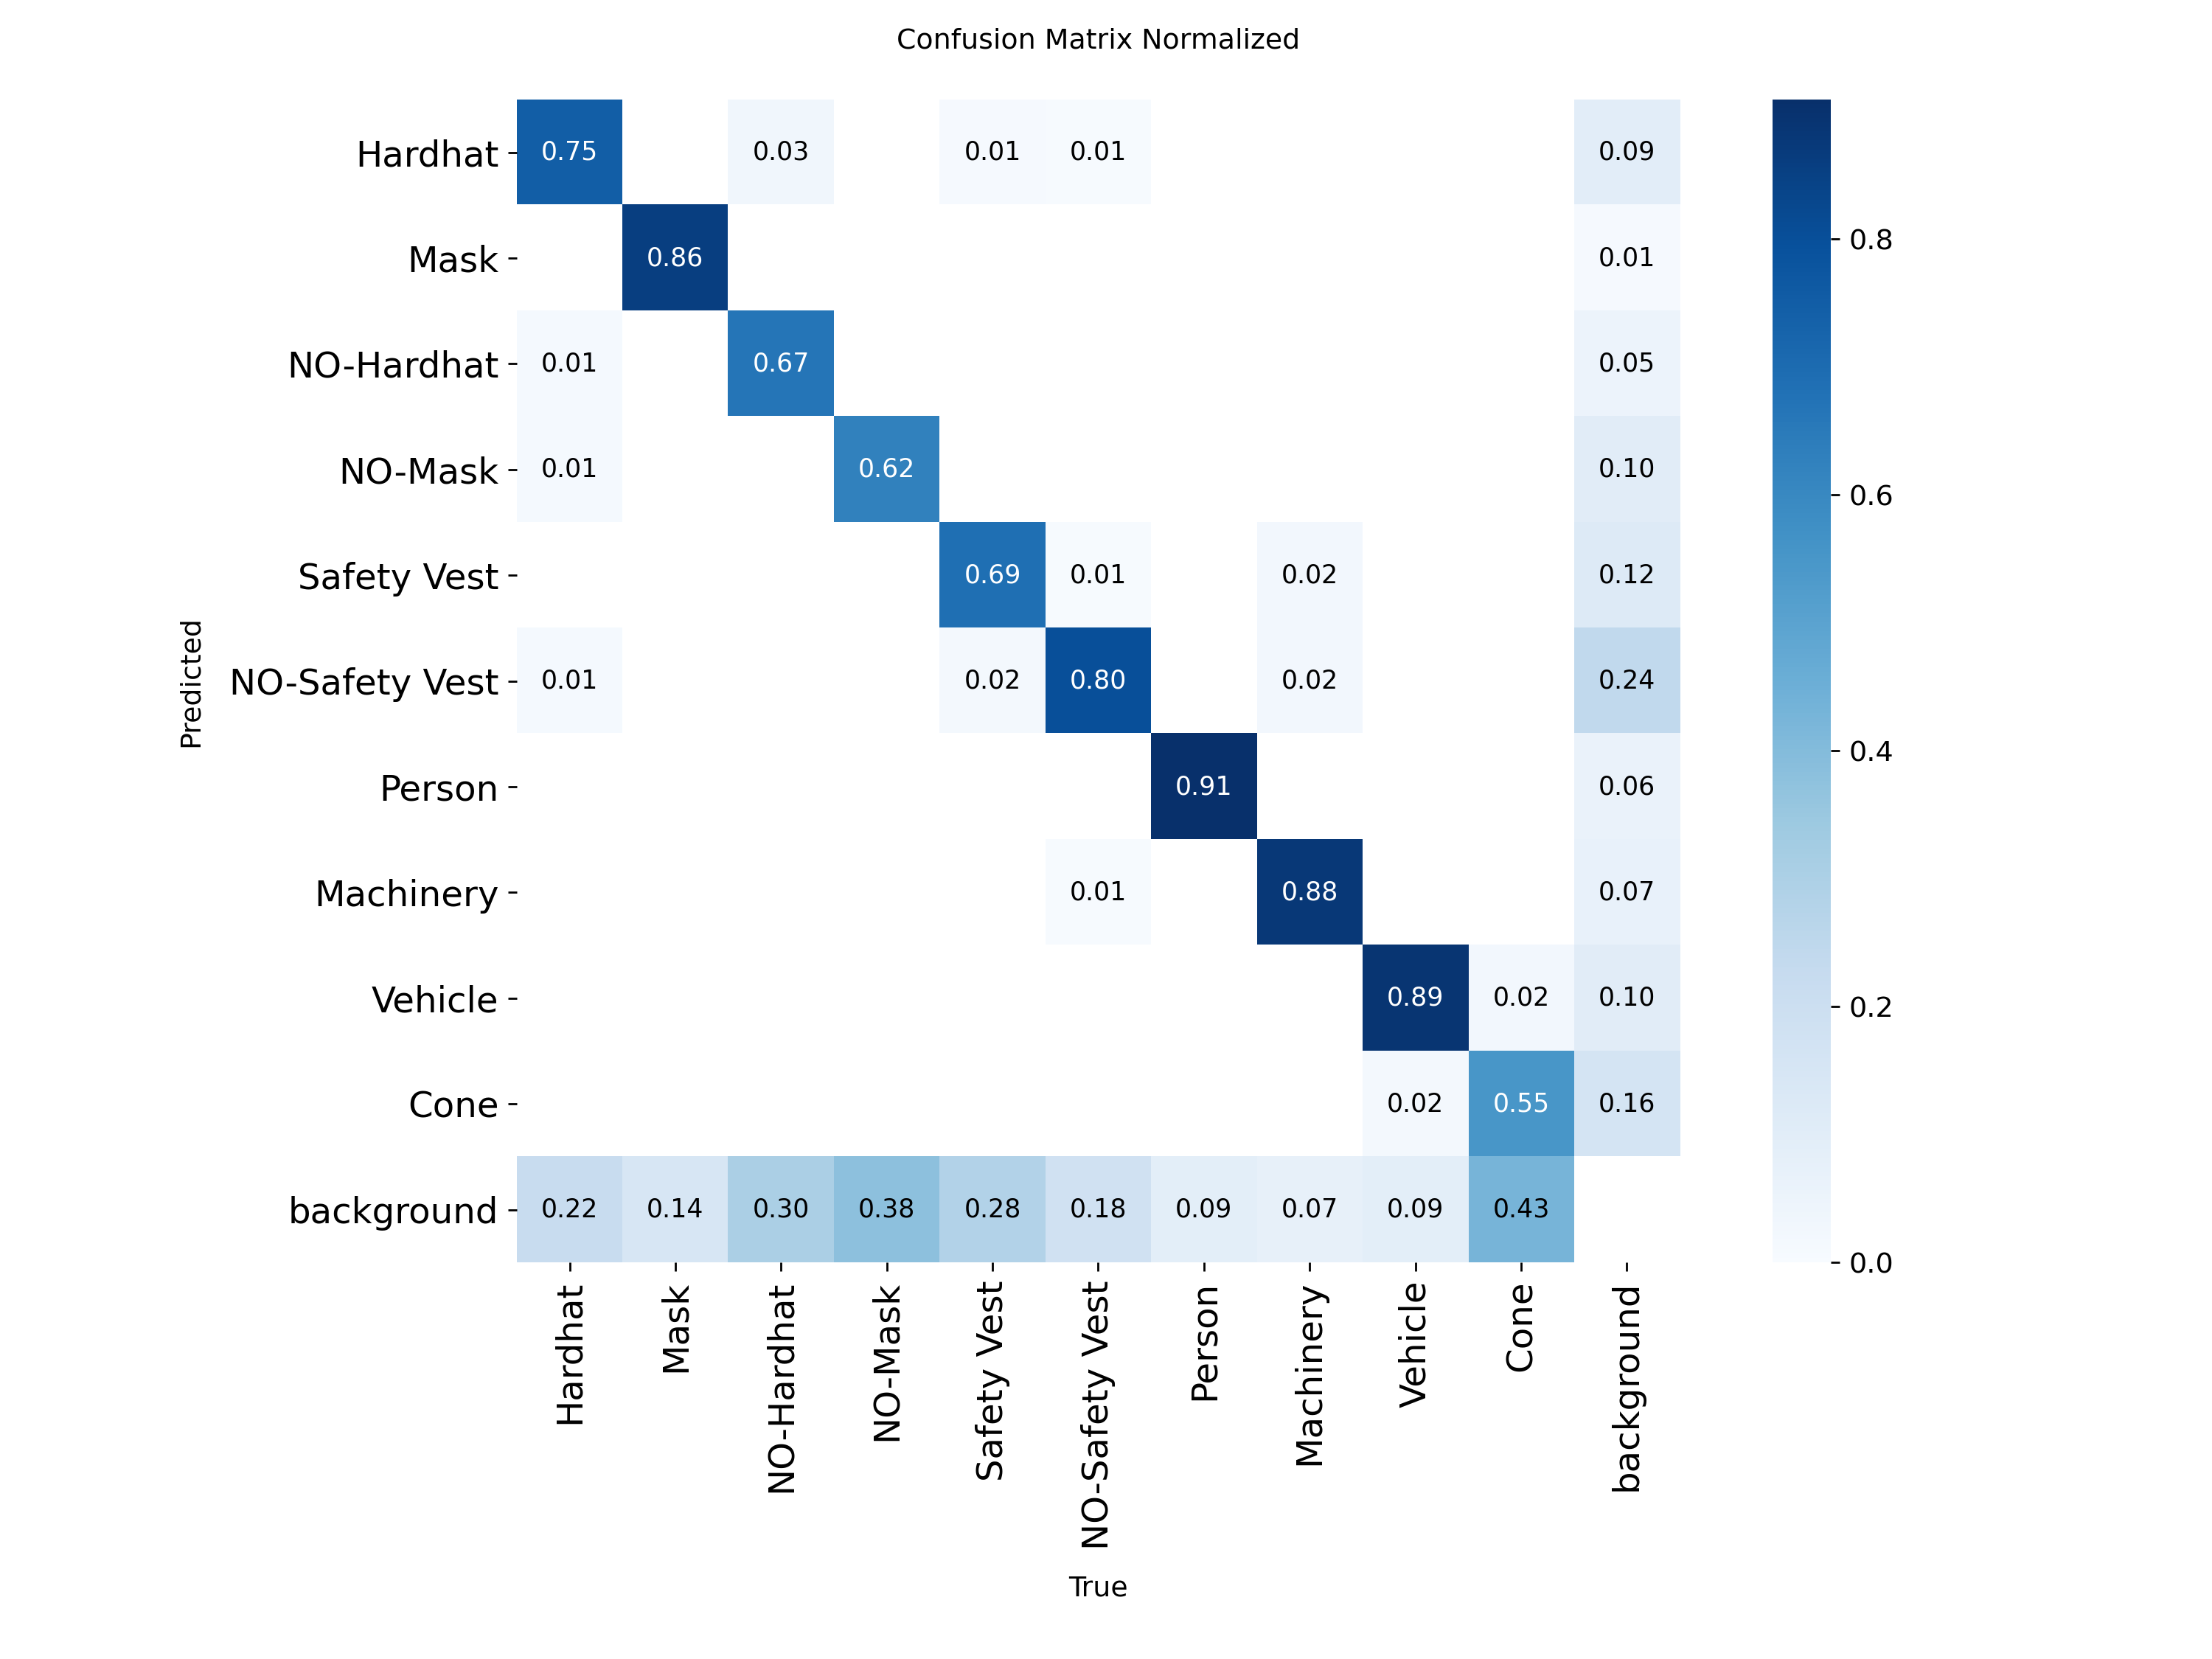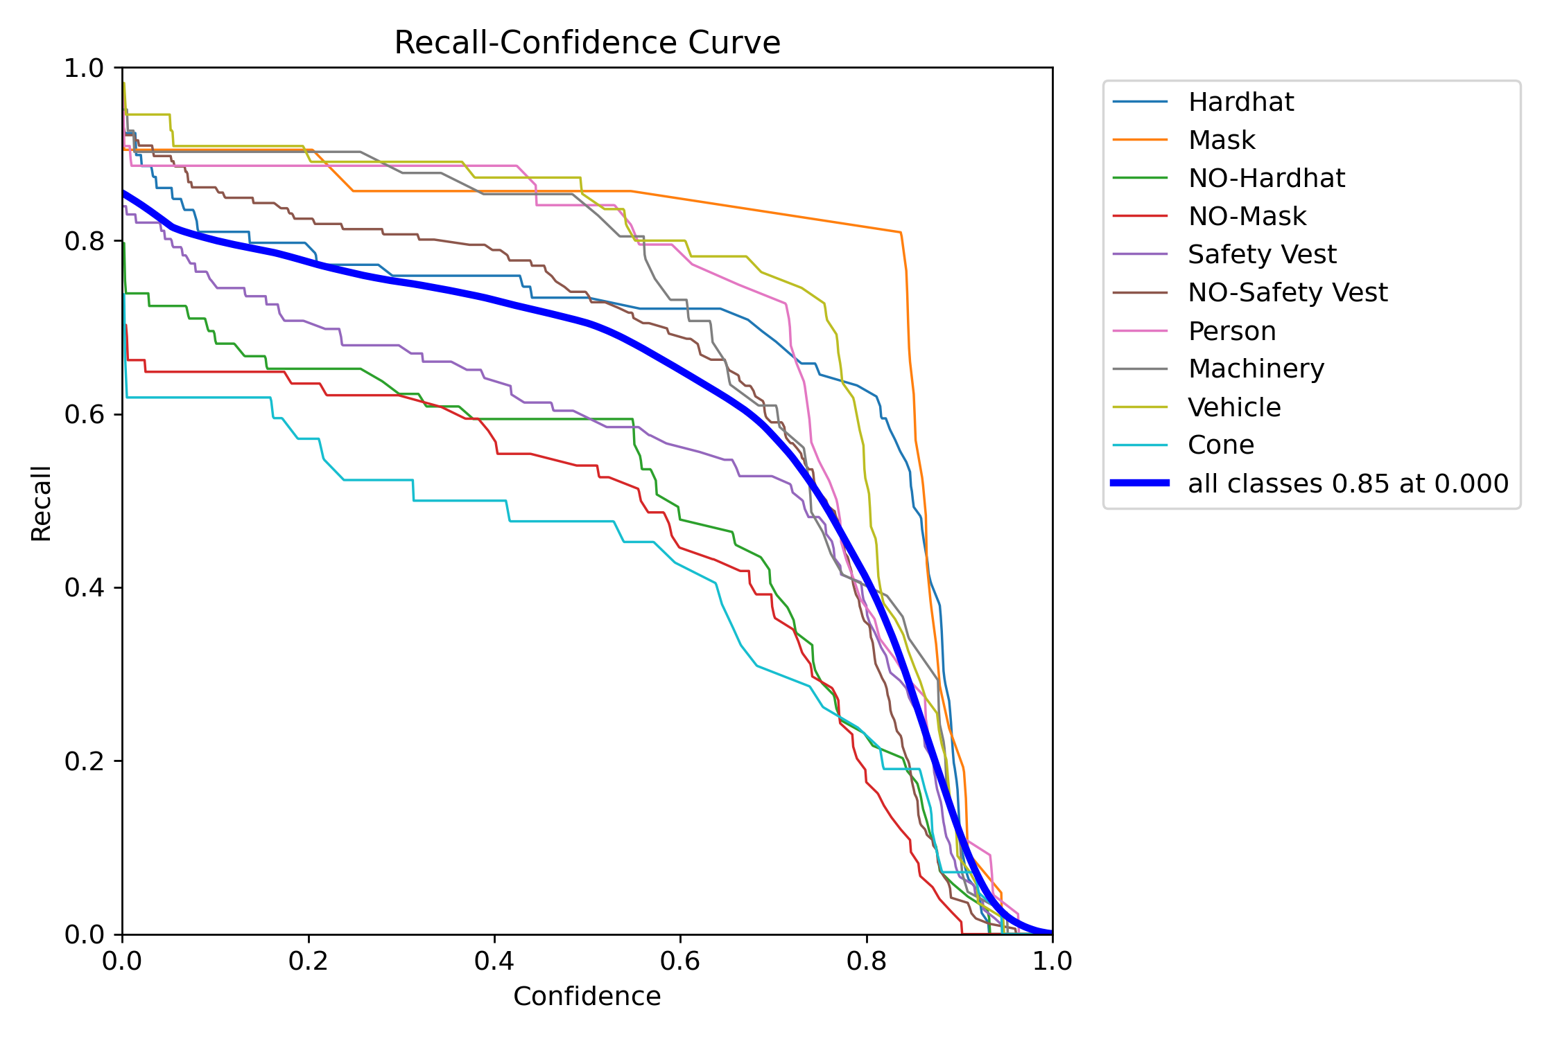
Confusion matrix BoxR_curve

Experiment 2 – Increased Image Size (800)
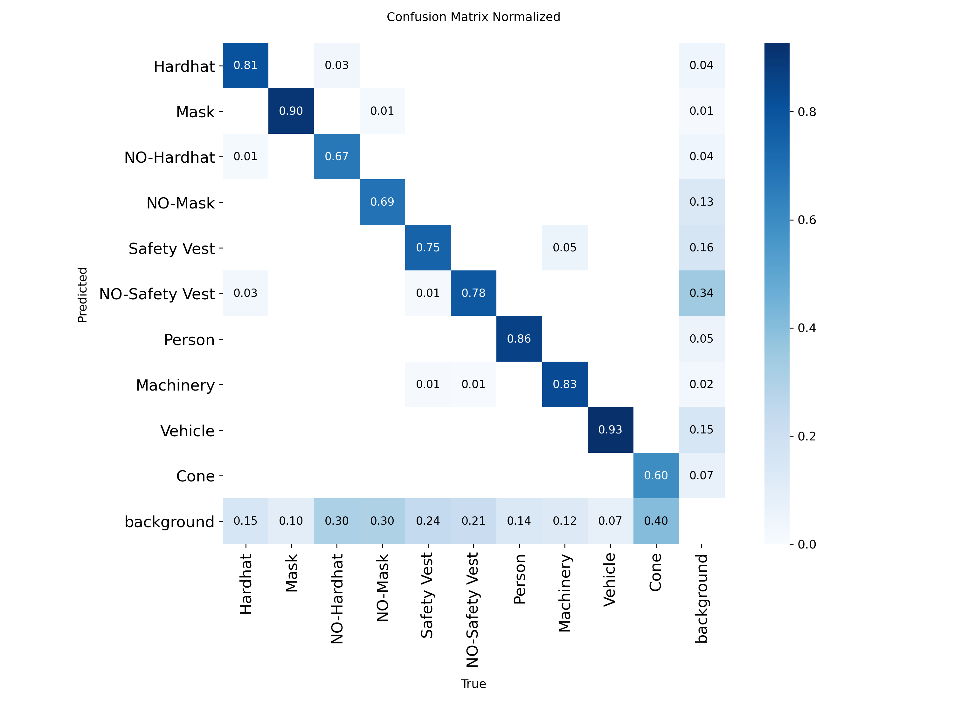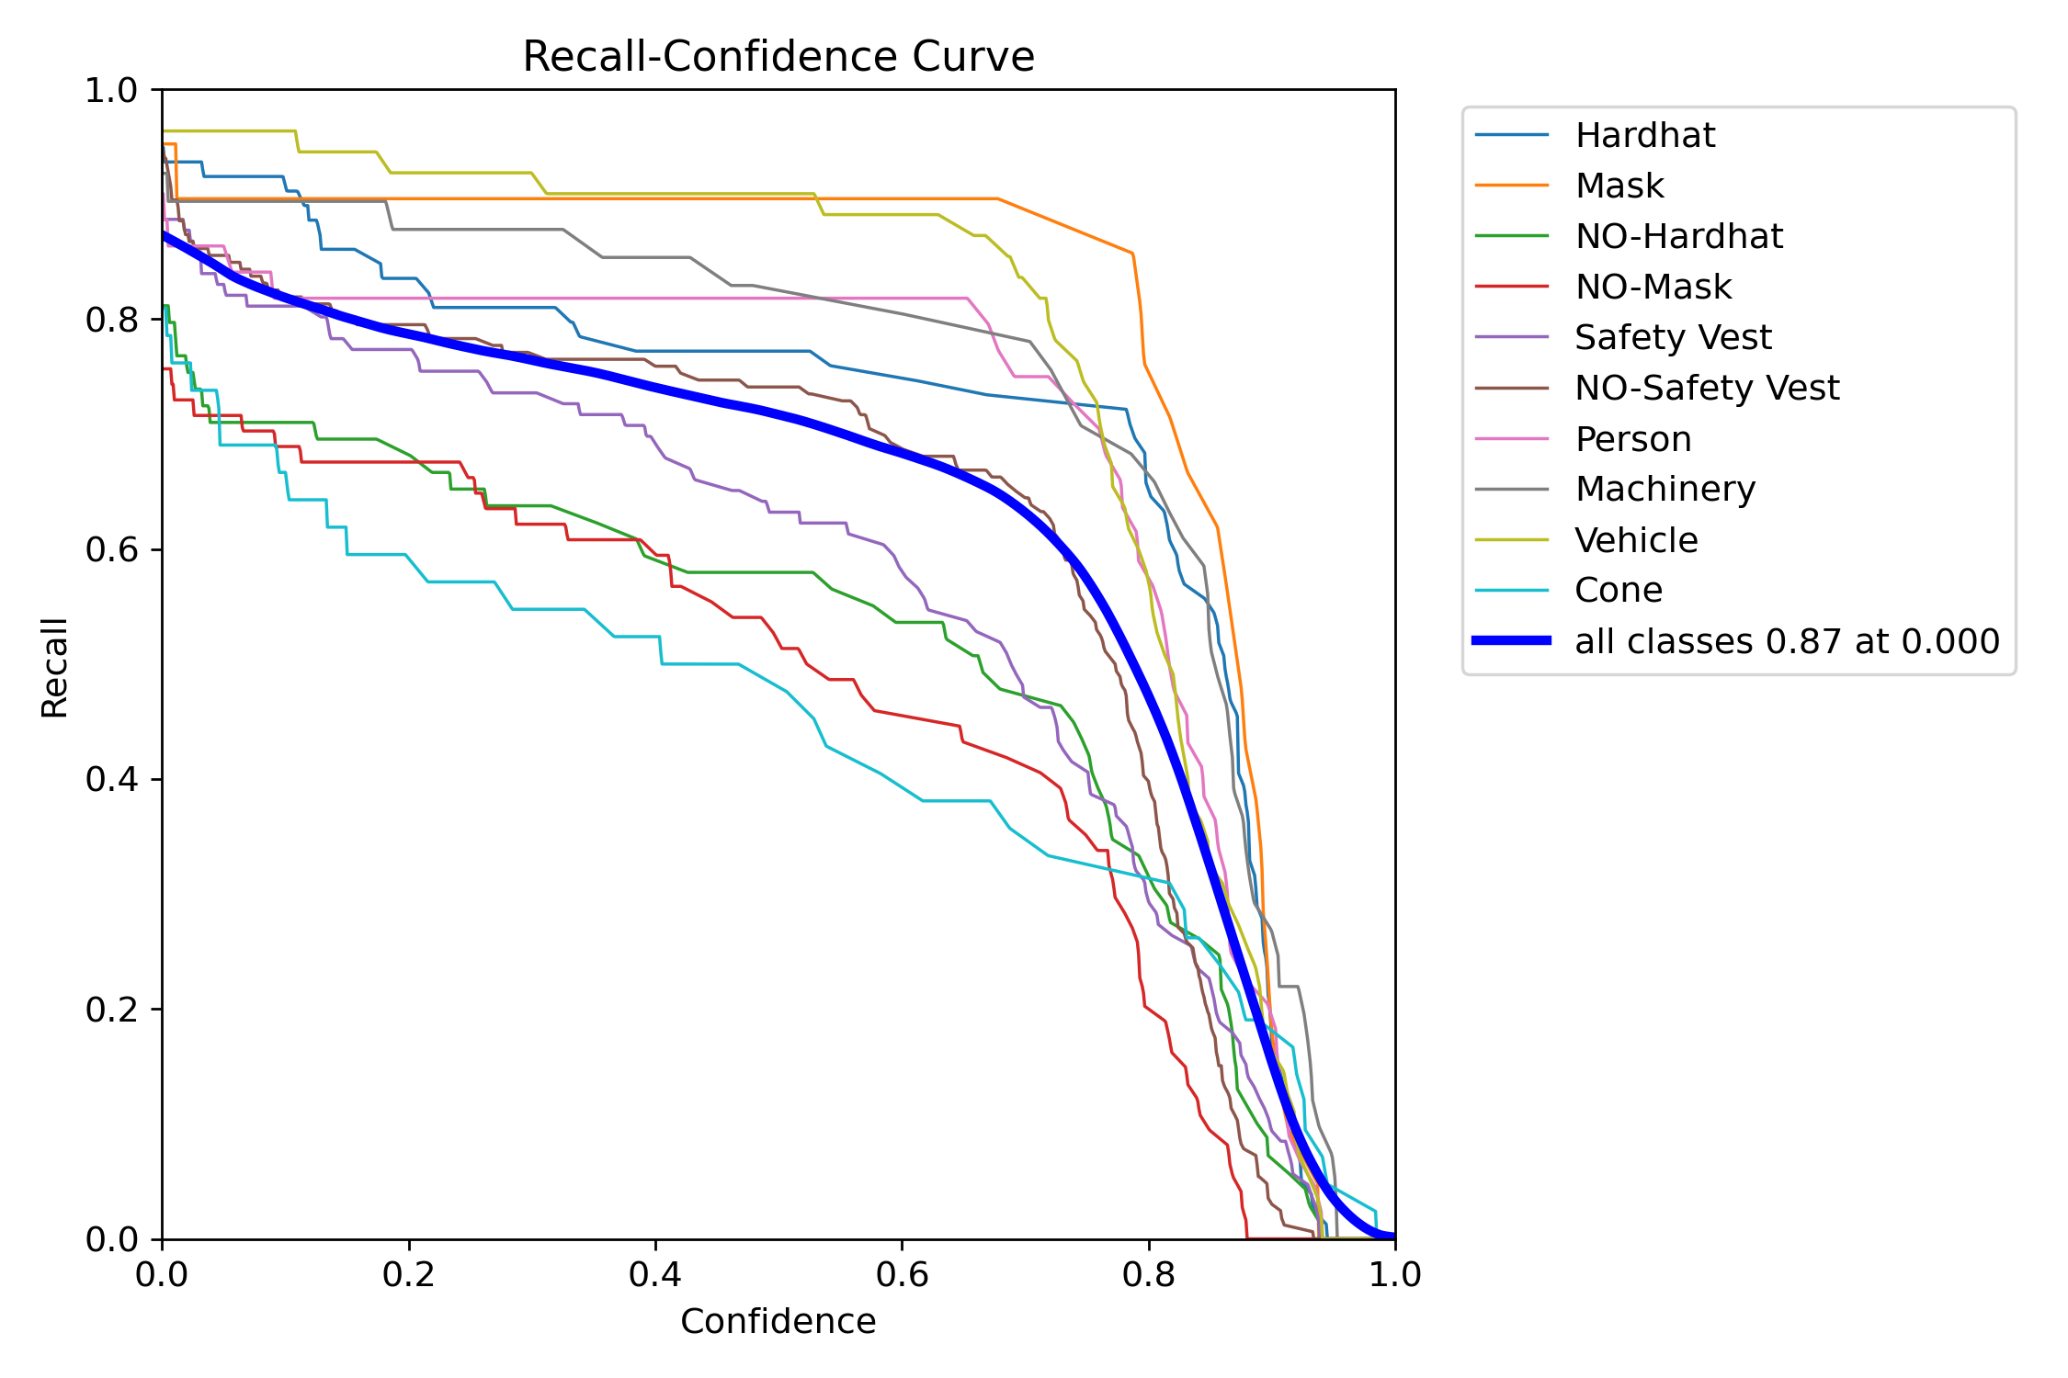
Confusion Matrix BoxR_curve
Experiment 3 – Larger Model (YOLOv8s)
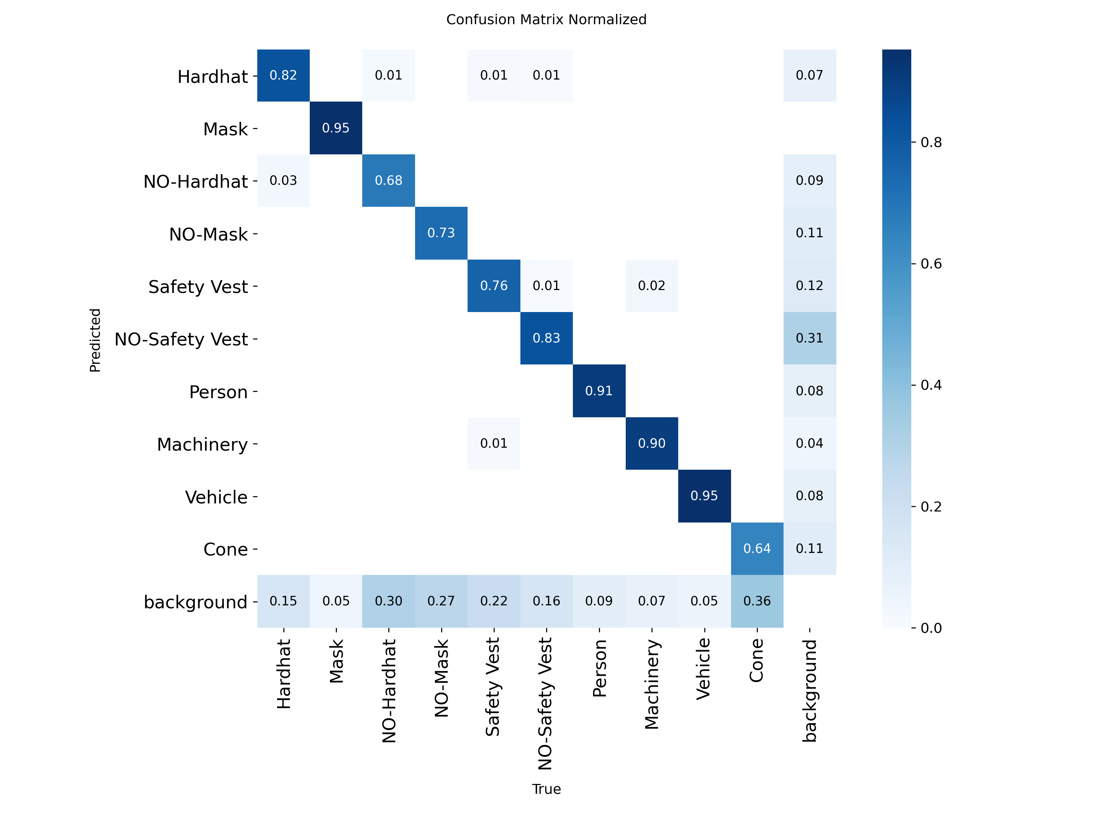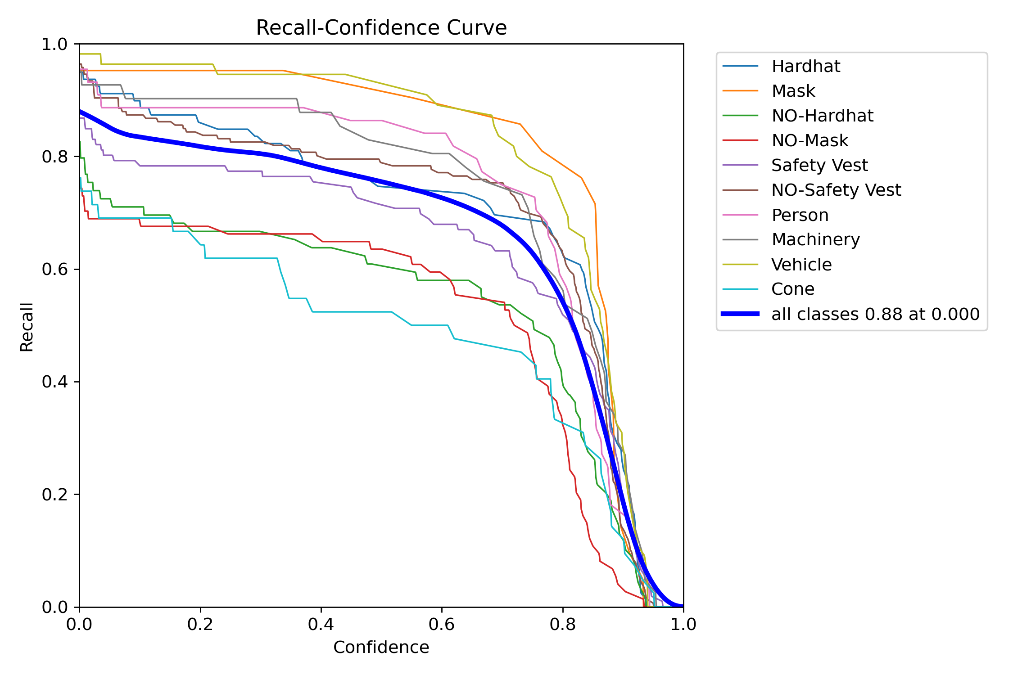

Confusion matrix BoxR_curve

5. Performance Metrics
Best.pt: Trained with 5o epochs and image size:640
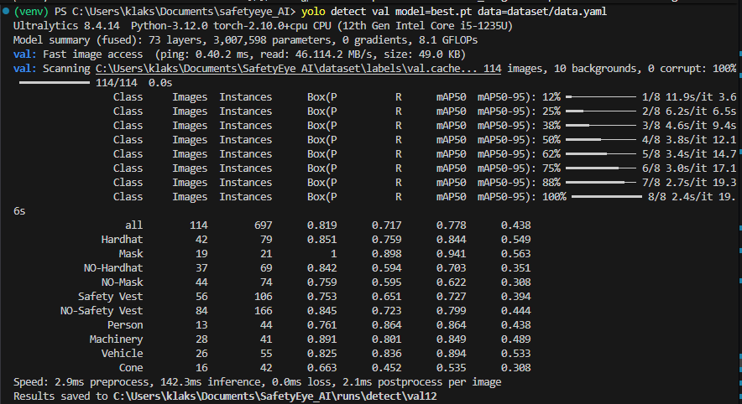
Best_epoch100: Trained with 100 epochs and img_size:640
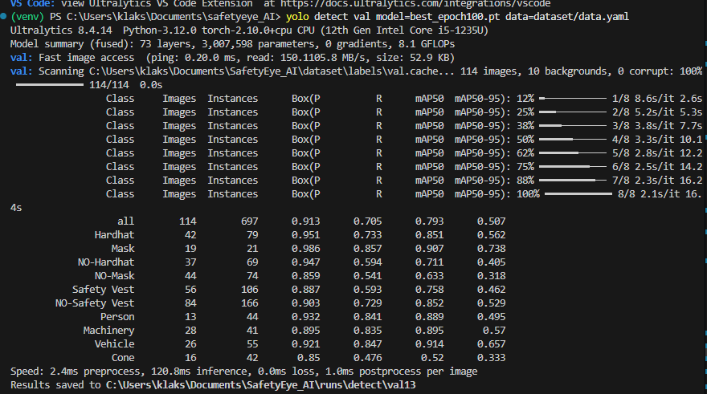
Best_img800.pt: Trained with 50 epochs and img_size=800
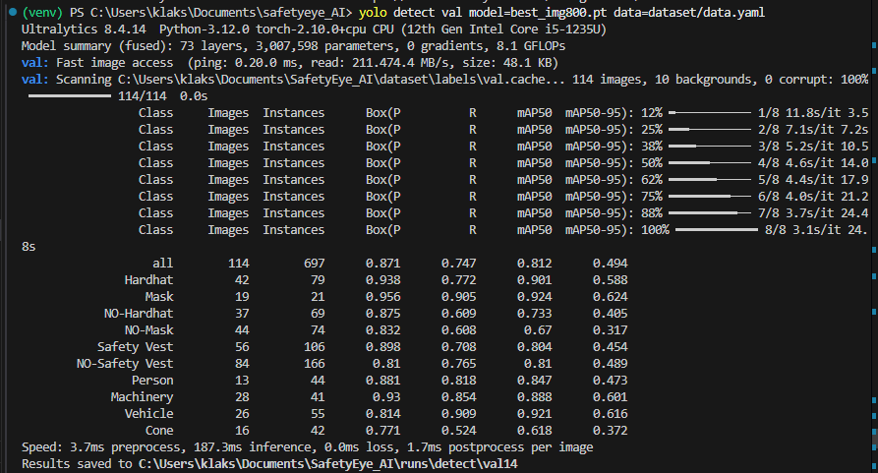
Best_largemodel.pt: Trained with 50 epochs and model = yolov8s.pt
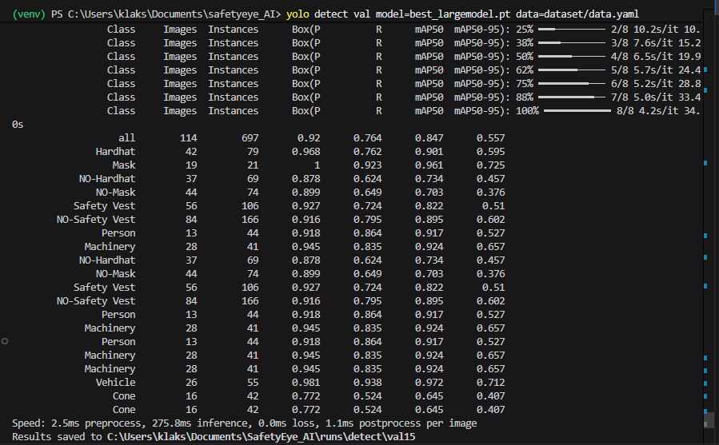

6. Experiment Comparison Table
Experiment | Model | Epochs | Image Size | Precision | Recall | mAP@0.5
Baseline | YOLOv8n | 50 | 640 | 0.819 | 0.717 | 0.778
Exp 1 | YOLOv8n | 100 | 640 | 0.913 | 0.705 | 0.793
Exp 2 | YOLOv8n | 50 | 800 | 0.871 | 0.747 | 0.812
Exp 3 | YOLOv8s | 50 | 640 | 0.920 | 0.764 | 0.847

7. Sample Predictions
prediction images generated by the best model.
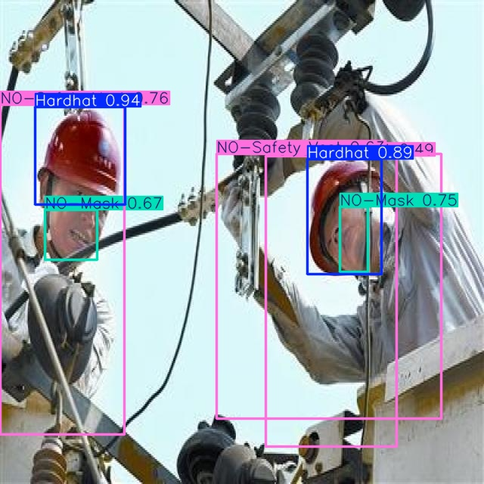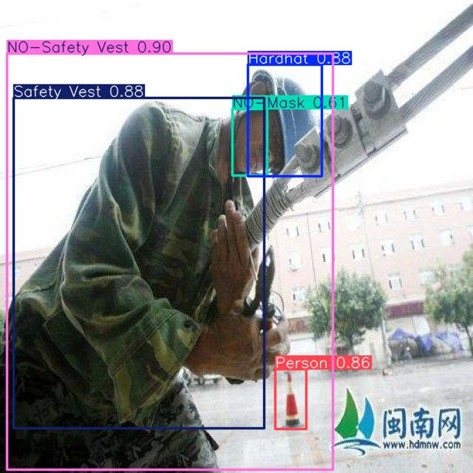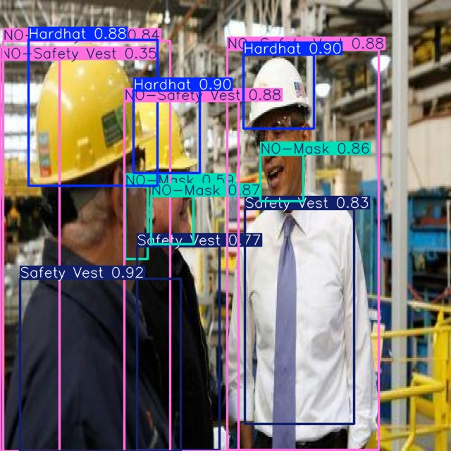

8. Conclusion
- The YOLOv8s model was the best performing model among the experiments conducted.
- The model achieved a mAP@0.5 score of 0.847, showing strong performance in detecting PPE items.
- Automated PPE detection systems can help improve construction site safety by monitoring worker compliance with protective equipment rules.
- Future improvements include increasing dataset size, applying data augmentation, and training larger models for better accuracy.

