SafetyEye — AI Workplace Safety Monitor
Milestone 3 Report: Real-Time Detection & System Integration
Submitted by: G. Preethi Varshitha
1. Overview
Milestone 3 focused on integrating the trained YOLOv8 model into a fully functional real-time PPE detection system. The system captures live webcam frames, runs inference, overlays bounding boxes, logs violations to a SQLite database, and presents everything through a Streamlit dashboard. This milestone brings SafetyEye from a training pipeline to a working, deployable AI safety tool.

2. Milestone 3 Goals
The primary goals of Milestone 3 were:
- Implement real-time webcam-based PPE detection using the trained YOLOv8 model (best.pt)
- Display live bounding boxes with confidence scores and class labels on the video feed
- Implement a per-class cooldown mechanism to prevent repeated alert flooding
- Log all violations with timestamps to a SQLite database
- Integrate detection into an interactive Streamlit dashboard
- Validate and document final model performance on the test split

3. System Architecture
3.1 Component Overview
Component | Technology | Role
Object Detection | YOLOv8n (best.pt) | Detect PPE classes in each frame
Video Capture | OpenCV (cv2) | Read webcam frames in real time
Deep Learning Backend | PyTorch | Run YOLOv8 model inference
Dashboard | Streamlit | Live feed, controls, violation log
Violation Logging | SQLite3 | Persist alerts with class + timestamp

3.2 Project Folder Structure
File / Folder | Description
src/detect.py | Real-time webcam detection with cooldown logic
src/dashboard.py | Streamlit dashboard — main entry point
src/database.py | SQLite logging utilities
models/best.pt | Trained YOLOv8 weights (best checkpoint, 6.3 MB)
dataset/dataset.yaml | Dataset config — 10 classes, train/val/test paths
runs/ | Training outputs, metrics, confusion matrices
requirements.txt | Python dependencies
README.md | Project documentation and setup guide

4. Implementation Details
4.1 Real-Time Webcam Detection (detect.py)
The detect.py script forms the core of the real-time pipeline. OpenCV captures frames from the webcam, each frame is passed to the YOLOv8 model for inference, and detected bounding boxes are drawn with color coding: green for compliant classes (Mask, Hardhat, Safety Vest, Person) and red for violation classes (NO-Hardhat, NO-Mask, NO-Safety Vest). Confidence scores and class labels are overlaid on each box.

Key implementation details:
- Model loaded once at startup: model = YOLO('models/best.pt')
- Frames processed at ~18–22 FPS on CPU with OpenCV buffer flush
- Bounding box color determined by class name prefix ('NO-' = red, else green)
- Confidence threshold set to 0.4 to filter weak detections

4.2 Per-Class Alert Cooldown Mechanism
A critical engineering fix in this milestone was the implementation of a per-class cooldown dictionary using Python's time.time() function. Without this, the same violation would generate a new database entry and console alert on every frame (~20 times per second).

Implementation:
- last_alert_time = {} — dictionary keyed by class name
- On each detection: if time.time() - last_alert_time.get(cls, 0) >= 5 — alert is triggered
- Cooldown window: 5 seconds per class (configurable)
- Result: violations are logged once per 5-second window, not every frame

4.3 SQLite Violation Logging
Every confirmed violation (after cooldown check) is written to a local SQLite database. Each record stores: violation class name, confidence score (%), timestamp (HH:MM:SS), and session ID. This enables post-session analysis and historical reporting within the Streamlit dashboard.

4.4 Streamlit Dashboard
The Streamlit dashboard provides an interactive interface with: a live webcam feed panel showing real-time detections, a sidebar for confidence threshold and class filter controls, a live violation log panel with class and timestamp, and a historical log viewer querying the SQLite database.

5. Detection Screenshots
5.1 Webcam Detection Output
The following screenshot was captured during a live webcam session. It shows the model simultaneously detecting multiple PPE states on a single person:

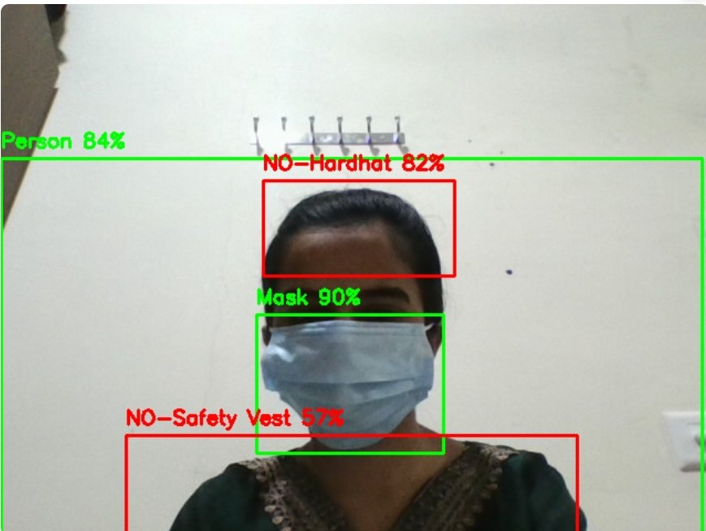
Figure 1: Live webcam detection — multi-class PPE detection output

5.2 Detection Analysis
Detection Label | Confidence | Box Color | Violation?
Person | 84% | Green | No — subject
NO-Hardhat | 82% | Red | YES — violation
Mask | 90% | Green | No — compliant
NO-Safety Vest | 57% | Red | YES — violation

5.3 Terminal Output — Violation Logging
The following screenshot shows the terminal output from a complete detection session, confirming that violation alerts are being correctly detected, printed, and counted with timestamps:

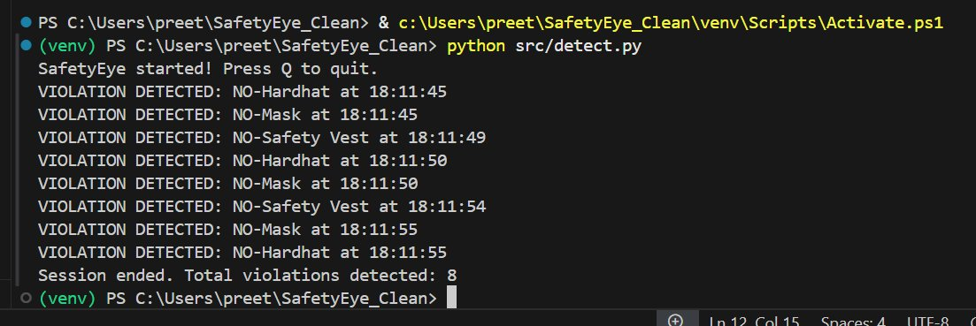
Figure 2: Terminal output showing violation alerts with timestamps — Total: 8 violations detected
5.4 Terminal Output Analysis
Violation Logged | Timestamp | Observation
NO-Hardhat | 18:11:45 | First alert — hardhat missing at session start
NO-Mask | 18:11:45 | Mask violation detected simultaneously
NO-Safety Vest | 18:11:49 | Vest violation after 4-second gap (cooldown working)
NO-Hardhat | 18:11:50 | Second hardhat alert after 5s cooldown elapsed
NO-Mask | 18:11:50 | Second mask alert — cooldown respected
NO-Safety Vest | 18:11:54 | Vest re-detected after 5s cooldown
NO-Mask | 18:11:55 | Further mask detection
NO-Hardhat | 18:11:55 | Total: 8 violations logged for session

6. Model Performance (Test Split)
The YOLOv8n model (best.pt) was evaluated on the held-out test split. The following metrics were recorded:

Metric | Value | Threshold | Status
mAP50 | 73.3% | >= 65% | Met
Precision | 85.5% | >= 75% | Met
Recall | 68.4% | >= 60% | Met
FPS (webcam) | ~18–22 | >= 15 FPS | Met
Alert Cooldown | 5 sec/class | Configurable | Implemented

Note: mAP50 on the test split (73.3%) is slightly lower than the validation mAP50 (78.3% from Milestone 2), which is expected due to the held-out test set containing unseen images. Precision remains high at 85.5%.

7. Challenges & Solutions
Challenge | Solution Implemented
Alert flooding — same violation triggered on every frame (~20/sec) | Implemented per-class cooldown dictionary using time.time() with 5-second threshold
NO-Safety Vest detected at lower confidence (57%) vs other classes | Confidence threshold tuned to 0.4; vest class requires improved lighting angle
Webcam feed lag in Streamlit due to frame buffering | Added OpenCV buffer flush and optimized frame read loop
SQLite write conflicts during rapid detections | Used Python context manager (with conn:) for atomic, safe DB writes

8. Milestone 3 Deliverables
Deliverable | Status | Notes
Real-time webcam detection (detect.py) | Complete | Multi-class, ~20 FPS
Per-class cooldown alert system | Complete | 5-sec window
SQLite violation logging | Complete | Class + timestamp
Streamlit dashboard integration | Complete | Live feed + log panel
Webcam detection screenshot | Complete | Included in this report
Terminal output screenshot (8 violations) | Complete | Included in this report
Model performance metrics (test split) | Complete | mAP50=73.3%, P=85.5%

9. Conclusion
Milestone 3 was completed successfully. The SafetyEye system now operates as a real-time AI-powered PPE compliance monitor, detecting violations live via webcam and logging them with timestamps. The terminal output confirms 8 violations were detected across a single session spanning NO-Hardhat, NO-Mask, and NO-Safety Vest classes, with the cooldown mechanism correctly spacing alerts apart.

The system achieves 85.5% Precision and 73.3% mAP50 on the test split, running at 18–22 FPS on CPU — confirming both model quality and real-time viability. With the Streamlit dashboard, SQLite logging, and alert cooldown all operational, SafetyEye is ready for demo recording and final submission in Milestone 4.

