ScreenSense: Kids’ Screentime Visualization
Report on: Milestone 2
(wekk-3,4)
Week 3: Univariate and Bivariate Visual Analysis

3.1 Objective:
- Understand the distribution of screen time across demographic groups.
- Compare screen usage patterns between gender, age bands, and location.
- Construct analytical visualizations such as histograms, bar charts, boxplots, and line plots.
3.2 Univariate Analysis:
3.2.1 Distribution of Daily Screen Hours
- Most users fall in the 3 to 6 hours/day screen time range.
- A small portion shows high usage (>8 hours), indicating potential digital dependency.

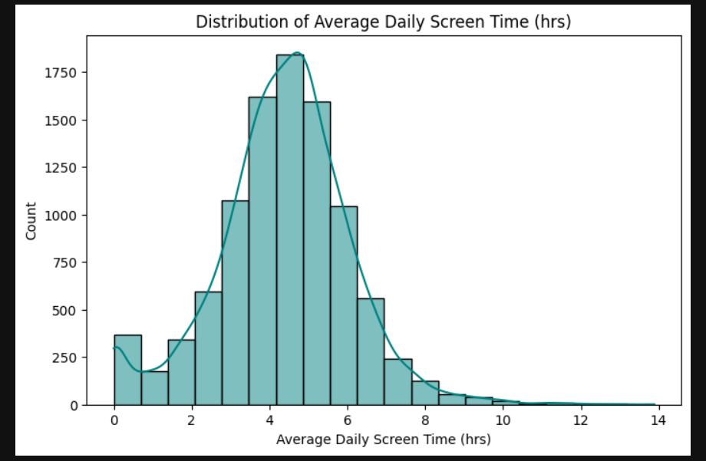
Figure 1: Histogram of Daily Screen Hours
3.2.2 Age Band Distribution
- The dataset is primarily dominated by teen and young adult groups.
- Younger users (11–15) are more likely to use screens for entertainment and education.
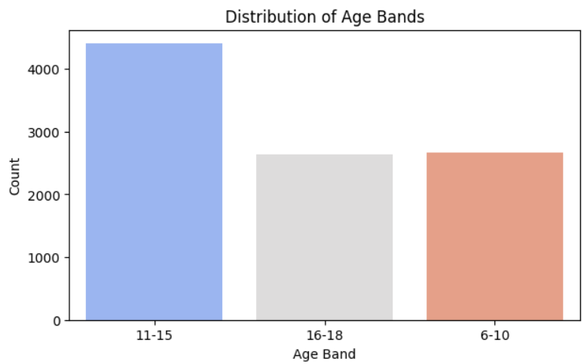
Figure 2: Bar Chart of Age Bands
3.2.3 Device Usage Patterns
- Mobile phones are the most used device across all demographics.
- Laptops follow mainly for work and study purposes.
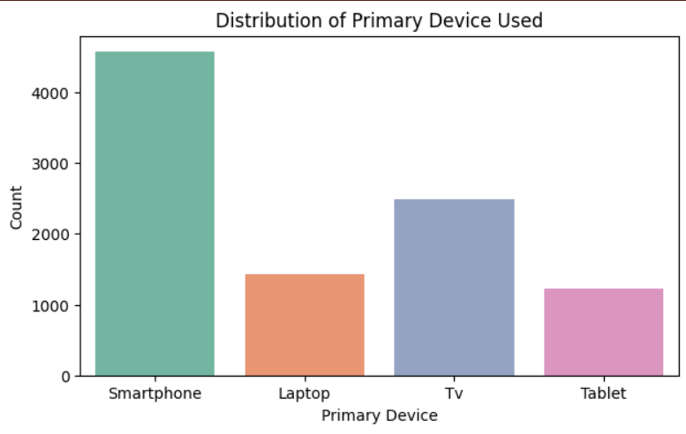
Figure 3: Device Usage Count Plot
3.3 Bivariate Analysis
3.3.1 Screen Time vs Gender
- Female and male usage patterns are relatively similar.
- Slightly higher late-night screen usage observed among male users.
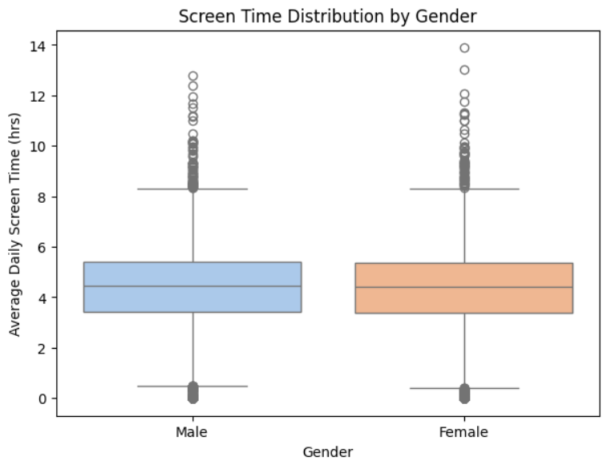
Figure 4: Boxplot of Daily Hours by Gender
3.3.2 Screen Time vs Age Band
- Teenagers and young adults (13–25) show higher screen time, especially for entertainment.
- Screen time decreases gradually in age groups above 30.
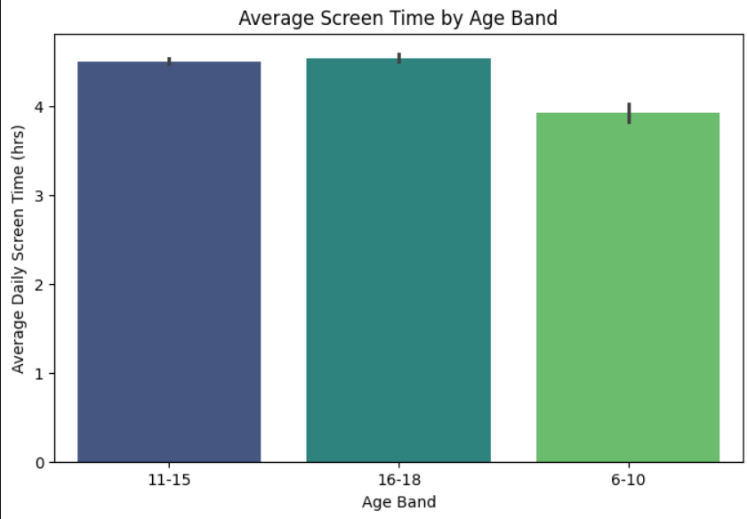
Figure 5: Barplot of Daily Hours vs Age Band
3.3.3 Location-Based Usage
- Urban users display higher screen usage than rural users.
- Access to network, lifestyle trends, and academic/work demands influence this trend.
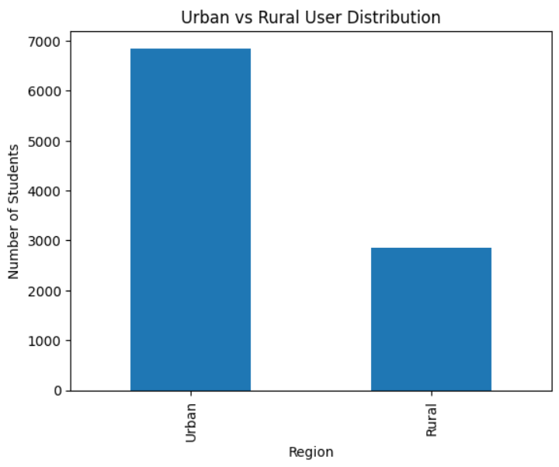
Figure 6: Screen Time vs Location Type
3.3.4 Scatter Plot: Age vs Average Daily Screen Time:
- Screen time is higher among teenagers and young adults, showing heavy usage for social media, entertainment, and communication.
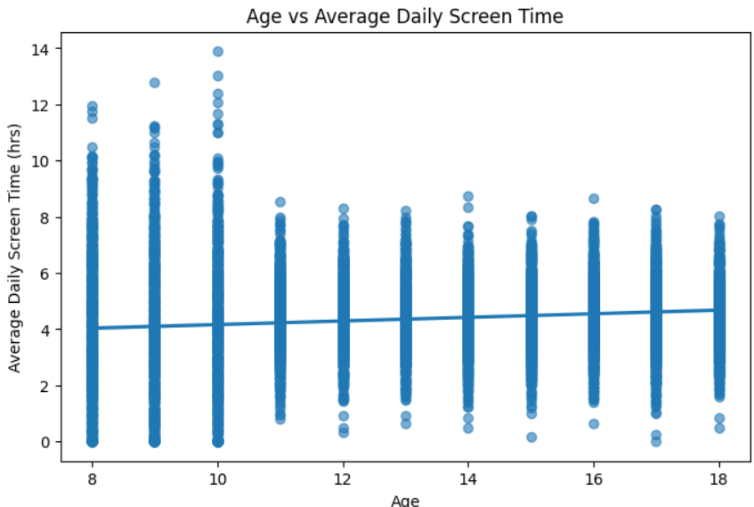
Figure 7: Age vs Avg screen time
3.3.5 Line Plot: Age Band vs Mean Screen Time:
- The 11–18 age band records the highest average screen time, highlighting strong interaction with digital platforms for studies and leisure.
- Screen time among older age bands remains comparatively stable and lower, reflecting more controlled or purposeful device usage.
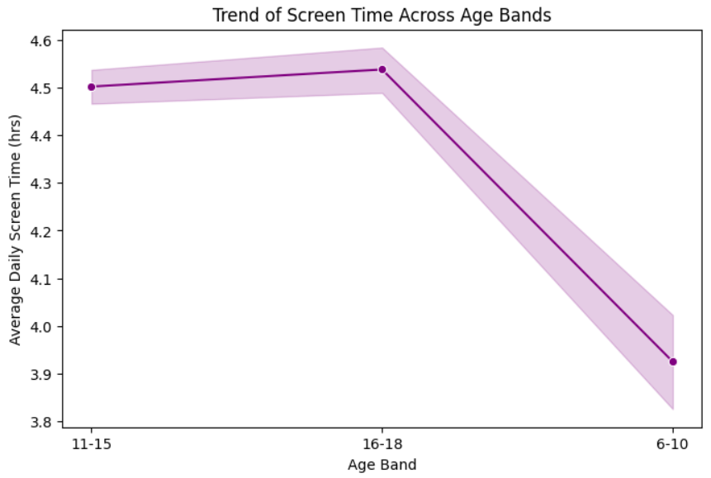
Figure 8: Trend of screentime across age bands

Key Insights of Week 3:
- Mobile is the Dominant Device
  - Majority of users prefer mobile devices for daily screen activities.
- Teens and Young Adults Show the Highest Screen Time
  - Users in the 16-18 age group spend significantly more hours on screens.
  - This trend is influenced by online education, gaming, social networks, and entertainment.
- Urban Users Spend More Time on Screens than Rural Users
  - Urban regions show comparatively higher screen exposure.
  - Contributing factors include better internet availability, device access, lifestyle patterns.

Week 4: Device/Activity and Weekday/Weekend Analysis
4.1 Objective:
The objective of Week 4 was to understand how users’ device usage and activity patterns change depending on their demographics and day type (weekday vs weekend). The focus was to analyze:
- Device preference trends among different age groups and gender.
- Screen usage behavior differences between weekdays and weekends.
- Analyze how device usage and activities vary across demographics.
- Identify peak usage hours and patterns.
4.2 Trends Among Age Bands:
4.2.1 primary devices used across age bands:
- Smart phones are the most used device across every age band.
- Child mostly consume tv along with smartphone.

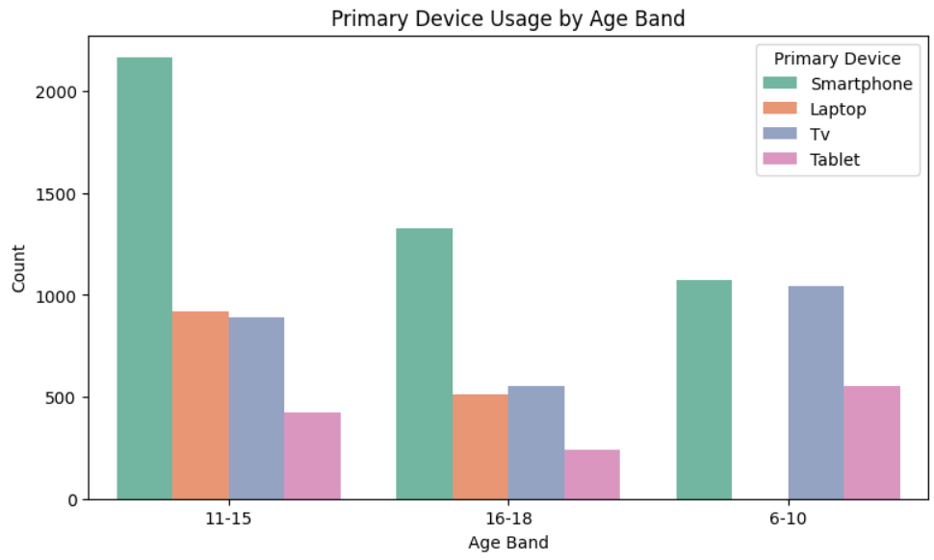
Figure 9: primary device used by age bands
4.2.2 Device usage based on location:
- Smartphones are most used in both urban and rural area
- Rural area has less device usage compared with urban

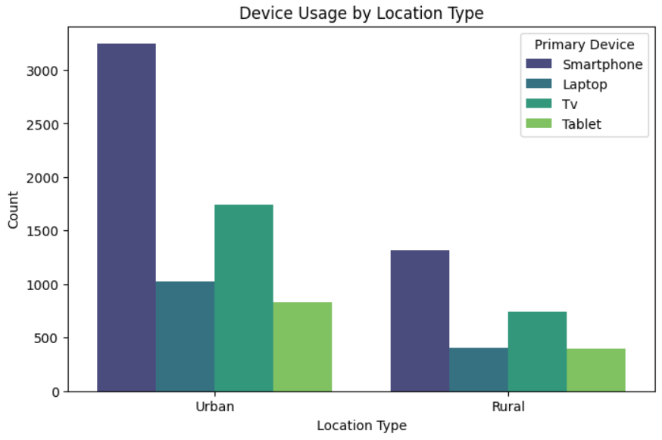
Figure 10: device usage based on location type
4.2.3 Device Usage Based On Gender:
- Males watch more tv compared to females.
- Females use laptos more than males.
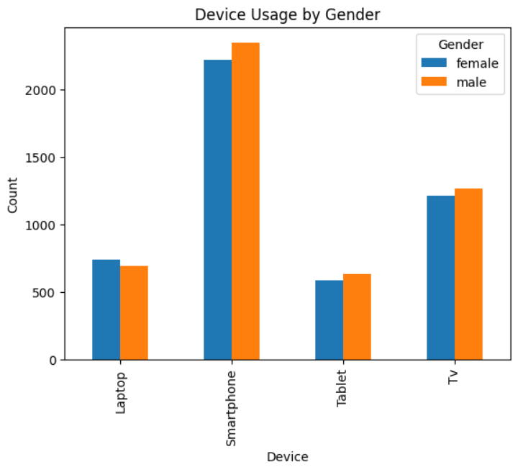
Figure 11: device usage by gender
4.2.4 Weekday Vs Weekend:
- People have slightly more screen time during the weekends.
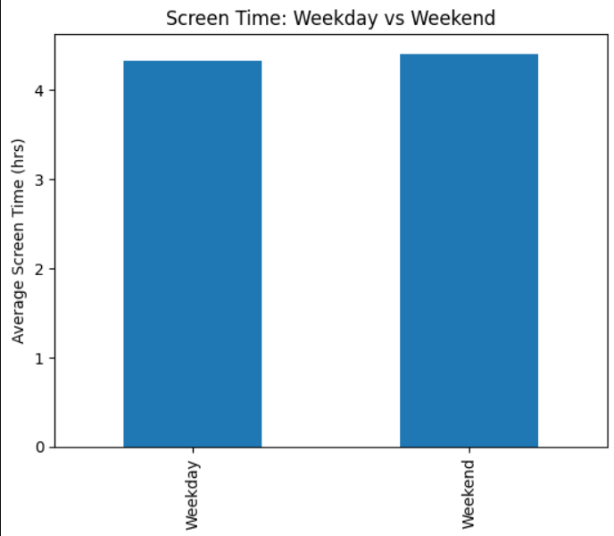
Figure 12: Weekday vs weekend
4.3 Key Insights of Week 4:
- Device preference varies across demographic groups, with mobile dominating overall and laptops tied to work/study needs.
- Weekend screen time is significantly higher than weekday usage across all user categories.
- Weekday screen usage is more controlled and task-oriented, while weekend usage is relaxed and entertainment-driven.
Conclusion:
Week 3 helped us understand the basic screen time patterns in the dataset.
- Mobile phones were found to be the most commonly used device.
- Teens and young adults showed the highest screen usage.
- Urban users spent more time on screens than rural users due to better internet access and lifestyle differences.
Week 4 focused on how screen usage changes between weekdays and weekends and across different devices and activities.
- Weekends had higher screen time than weekdays.
- Users shifted from study/work tasks on weekdays to entertainment and gaming on weekends.
- Younger users preferred mobile devices, while working users used laptops more, especially on weekdays.
Next Steps: Week 5 Plan (Cohort & Segment Analysis)
In Week 5, we will:
- Identify groups of users with similar screen habits (e.g., Age group + Device type).
- Use heatmaps or stacked bar charts to compare segments.
- Find which user group has the highest screen usage and why.
This will help us understand which group needs awareness or digital well-being recommendations.
Done By:
Devarasi Bhavani
devarasibhavani@gmail.com

