Kshiti Gambhir
FINAL PROJECT REPORT
Milestone 4
1. Introduction
The increasing availability of digital devices has resulted in significant growth in screen exposure among children. Understanding how children use screen along with associated risk is important for parents, educators, and policymakers.
This project, ScreenSense, analyzes kids’ screentime behaviour using data visualization techniques, exploring patterns across age, gender, device types, activity types, and health impacts.
The final outcome is an interactive Power BI dashboard that presents insights in a clear, accessible format.

2. Dataset Description
The dataset used in this project is the Indian Kids Screentime 2025 dataset (Kaggle). Key columns include:
Demographics
- Age – Child’s age
- Gender – Male/Female
- Urban_or_Rural – Location type
Screentime Information
- Avg_Daily_Screen_Time_hr – Average daily screentime
- Primary_Device – Smartphone, Tablet, Laptop, TV, etc.
- Activity_Type – Educational / Recreational (derived)
- Dominant Activity – Which type dominates
Derived Features
- Age_Band – 0–5, 6–12, 13–17, 18+
- Day_Type – Weekday / Weekend
- Activity_Type – Classified using the Educational/Recreational ratio
Health Effects
- Health_Impacts – Eye Strain, Poor Sleep, Anxiety, etc.

3. Methodology
Week 5: Cohort & Segment Analysis
- Created age and gender cohorts
- Analyzed device preference by demographic
- Compared screentime across segments
- Built first set of visuals: bar charts, donut charts, matrix
Week 6: Habit & Behaviour Patterns
- Since no date column existed, weekday/weekend behaviour was analyzed
- Urban vs Rural usage habits
- Health impact comparison by segments
- Added stacked visuals and comparison charts
Week 7: Final Dashboard Development
- Designed a clean, color-coordinated dashboard in Power BI
- Added slicers for Age Band, Gender, Urban/Rural
- Positioned KPI cards for quick insights
- Added treemap for health impacts
- Ensured consistent formatting, labels, and alignment
Week 8: Documentation & Presentation
- Created final written report
- Prepared a dashboard walkthrough
- Summarized insights and recommendations

4. Dashboard
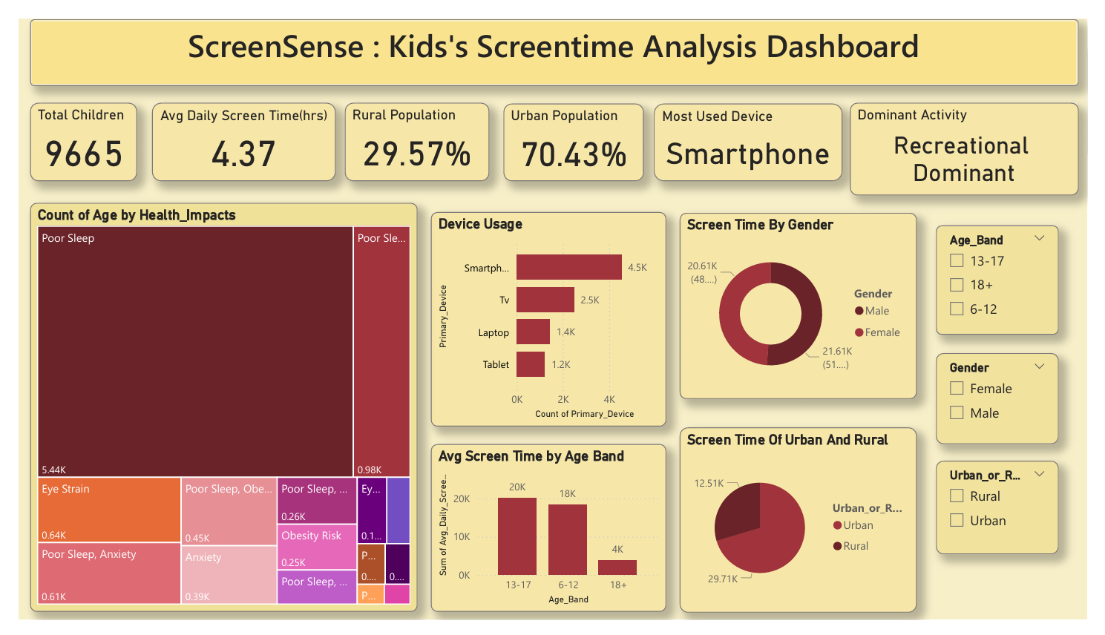
5. Key Insights
- Urban children demonstrate significantly higher screentime than rural children.
- Urban kids also report more adverse health effects, indicating higher exposure.
- Teenagers (13–17 years) have the highest average daily screentime.
- Screen dependency increases with age.
- Smartphones are the most widely used device among kids.
- They are portable, personal, and easily accessible.
- Recreational activities dominate the screentime usage.
- Entertainment is used far more than educational content.
- Poor Sleep and Eye Strain are the most common health impacts.

