Kshiti Gambhir
Milestone 1
Week 1: Project Initialization and Dataset Setup
Goals and Workflow
The goal of this project is to analyze children’s screen time behavior and identify how factors like age, gender, device type, and location (urban/rural) influence overall screen usage and its health impact.
The workflow for Week 1 includes:
- Defining analysis goals and identifying useful columns.
- Loading the dataset and exploring its structure.
- Checking for missing values, data types, and overall dataset quality.
- Documenting key observations and assumptions for future preprocessing.

Dataset Overview
Dataset Columns:
['Age', 'Gender', 'Avg_Daily_Screen_Time_hr', 'Primary_Device', 'Exceeded_Recommended_Limit', 'Educational_to_Recreational_Ratio', 'Health_Impacts', 'Urban_or_Rural']

Exploring Dataset
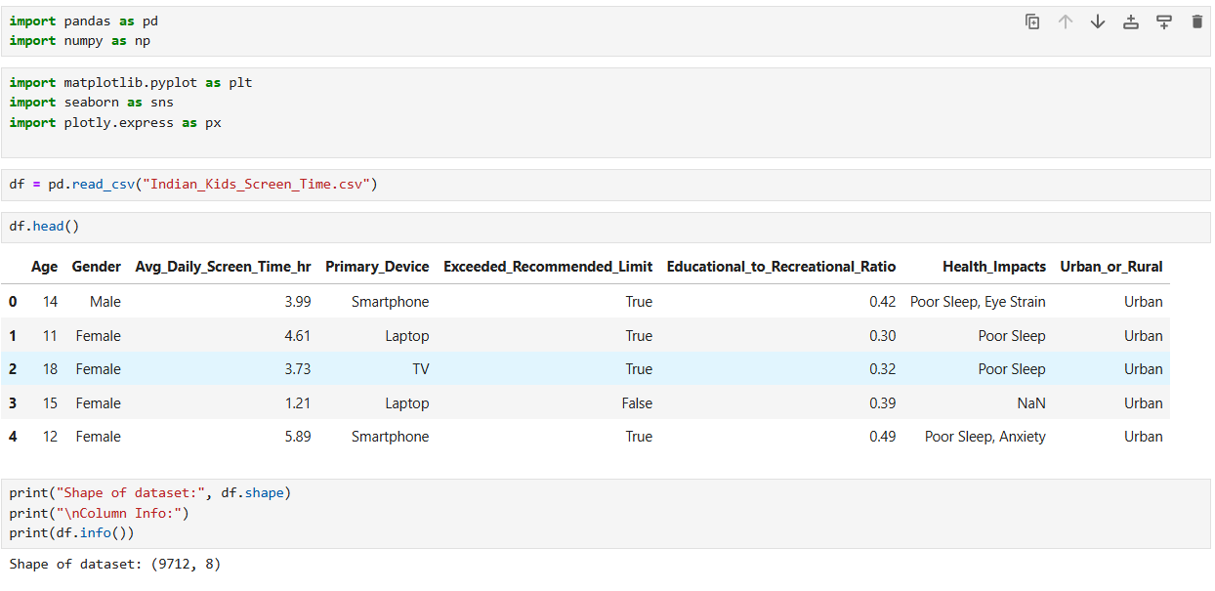

Week 2: Preprocessing and Feature Engineering
Data Prep
Before we could analyze anything, we had to clean the data. Here’s what we did:
- Filled in Blanks: Some columns had missing info. We filled empty spots for Age and screen time with the median value. For text fields like Gender, we used the most common entry (mode).
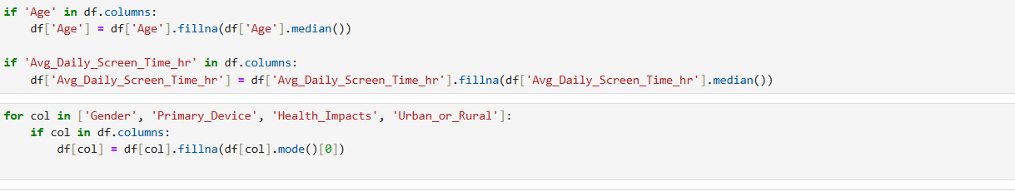

- Removed Duplicates: We deleted any rows that were exact copies to avoid counting the same data twice.

- Fixed Typos: We standardized the text in columns like Gender to make sure "male" and "Male" were treated as the same thing.


- Removed Unrealistic Data: We dropped any entries where screen time was over 15 hours a day, assuming these were errors.

Initial Observations:
- Dataset size: 9712 rows, 8 columns
- Missing values detected in Age and Avg_Daily_Screen_Time_hr
- Minor categorical inconsistencies like “male” and “Male” or “urban” and “Urban”
- No date/time fields present
OUTCOMES:
After cleaning, we created four charts to see what was going on.
1. No Real Difference Between Genders
Boys and girls have almost identical screen time habits. Both groups average a little over 4 hours per day. Gender doesn't seem to be a factor.
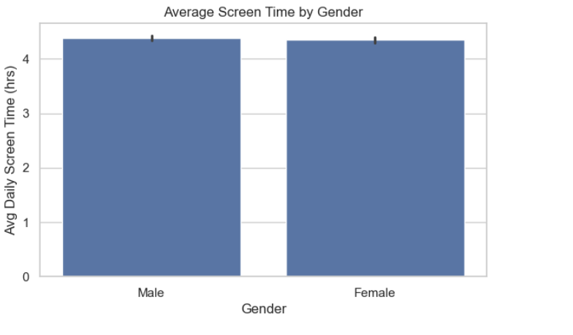
2. Smartphones are most used one
The smartphone is the #1 primary device by a long shot. More than 4,000 kids in the study use it as their main device, far outpacing TVs, laptops, and tablets.
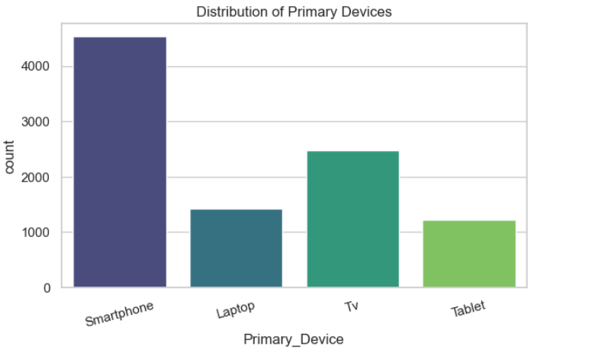

3. Urban vs. Rural Doesn't Matter
It doesn't matter if a kid lives in a city or the countryside—their screen time is basically the same. The median for both groups is around 4 hours, and the overall data spread is nearly identical.
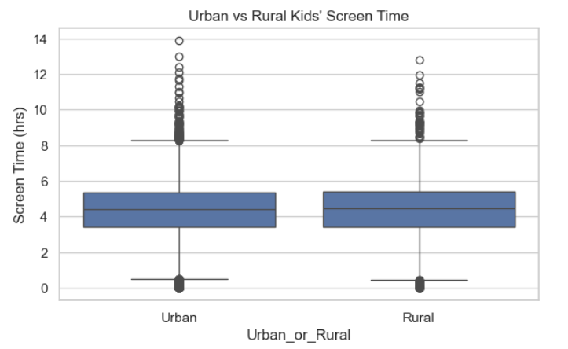

4. Clear Links Between Age, Time, and Content
The correlation heatmap showed us two common-sense patterns:
- A moderate positive link (0.66) between Avg_Daily_Screen_Time_hr and Exceeded_Recommended_Limit. Basically, the more time kids spend on screens, the more likely they are to go over the recommended limit. No surprises there.
- A moderate negative link (-0.49) between Age and Educational_to_Recreational_Ratio. This suggests that as kids get older, they use their screen time more for fun than for learning.
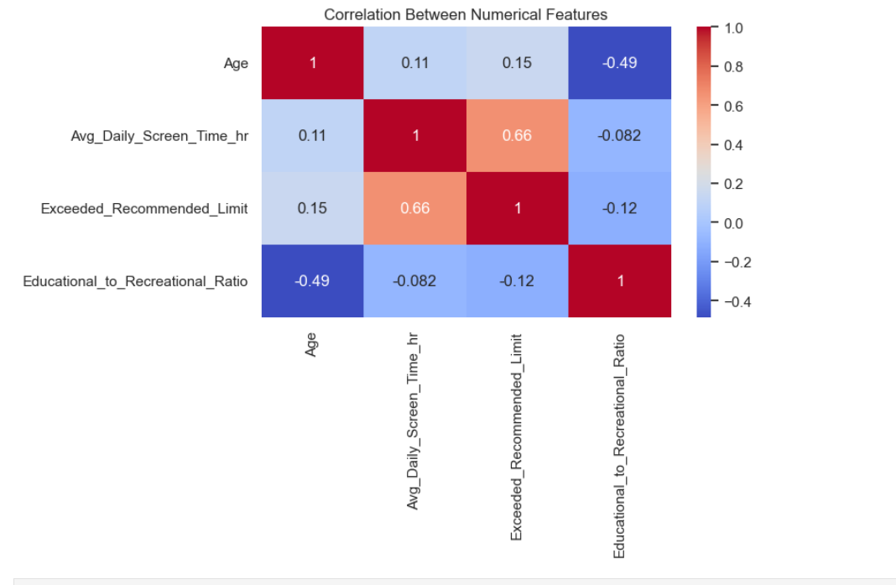
Week 1 Summary
The initial look shows some clear trends: screen time is consistent across genders and locations, and smartphones are the go-to device. The data is now clean and ready for a deeper dive next week.

