ScreenSense: Kids’ Screentime Visualization

WEEK -1 REPORT: Project Initialization & Dataset Setup
Main Objective :
The purpose of this week is to initialize the project by:
- Downloading the dataset from Kaggle.
- Exploring and understating the dataset.
- Identifying missing or inconsistent data.
- Recording assumptions and observations for further preprocessing.
Description:
The dataset contains information about children’s daily screen usage patterns across India. It includes attributes such as:
- Age
- Gender
- Location (Urban/Rural)
- Device Type
- Activity Category
- Weekday and Weekend Screentime
- App Usage Patterns
Data Quality Review
After performing initial exploration using df.info(), df.describe(), and df.isnull().sum(), several data quality issues were identified in the dataset. These issues must be addressed in the next phase (Week 2: Data Cleaning).
Libraries Used:
import pandas as pd
import matplotlib.pyplot as plt
import seaborn as sns

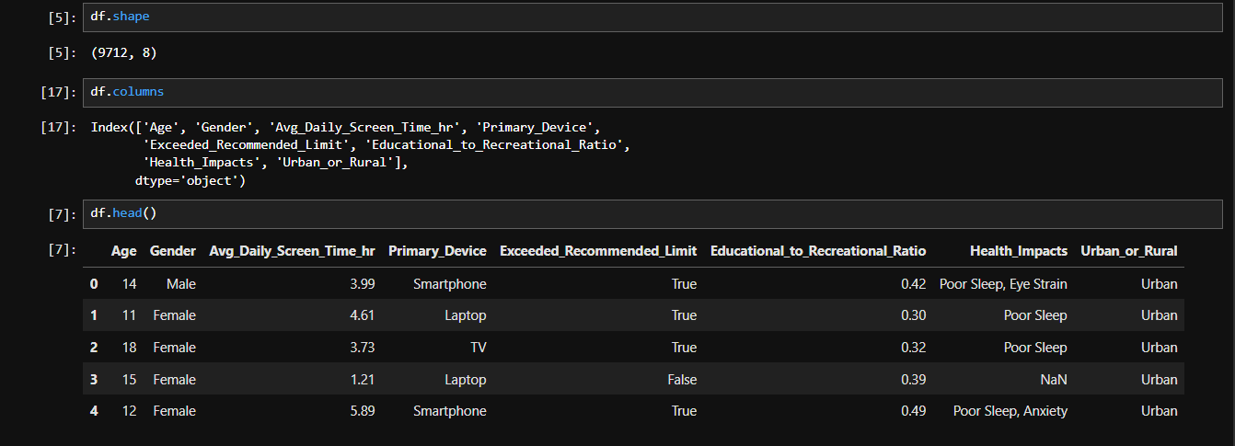
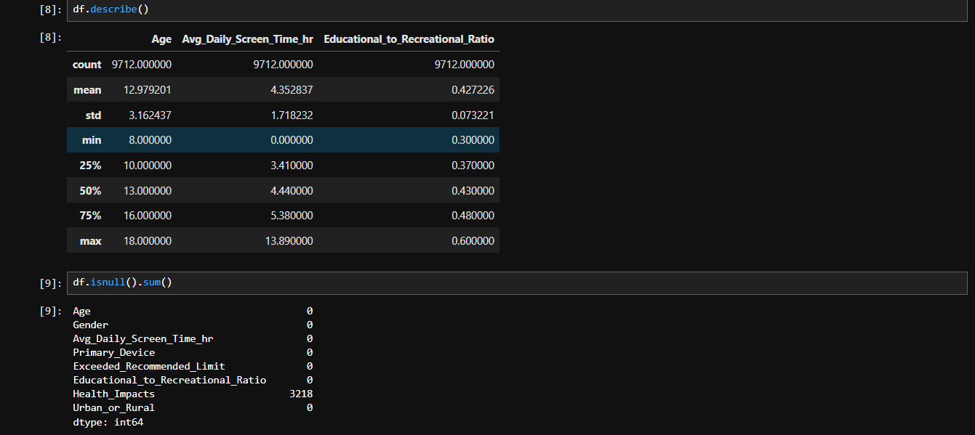
>Datatypes inside the dataset:
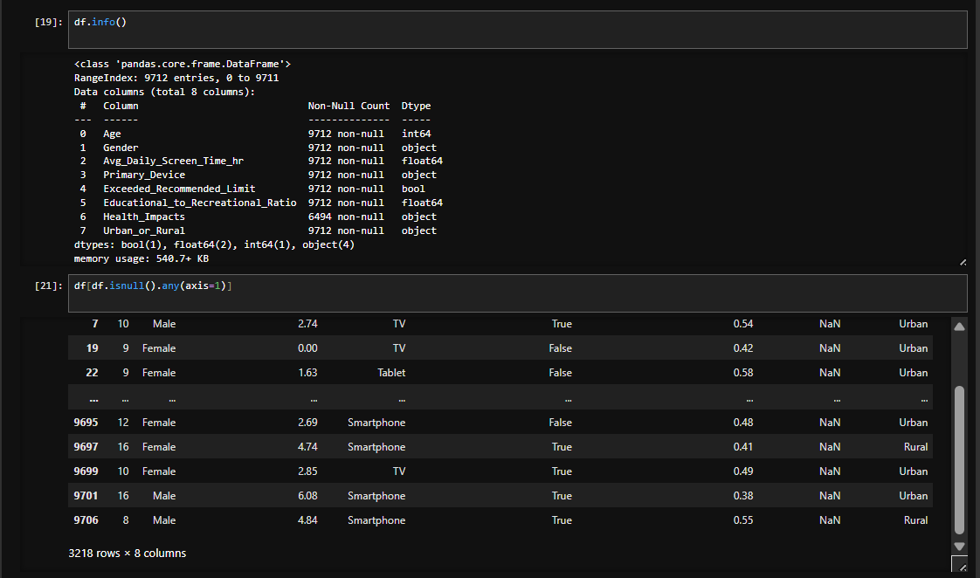

>Heat Map for Missing Values:
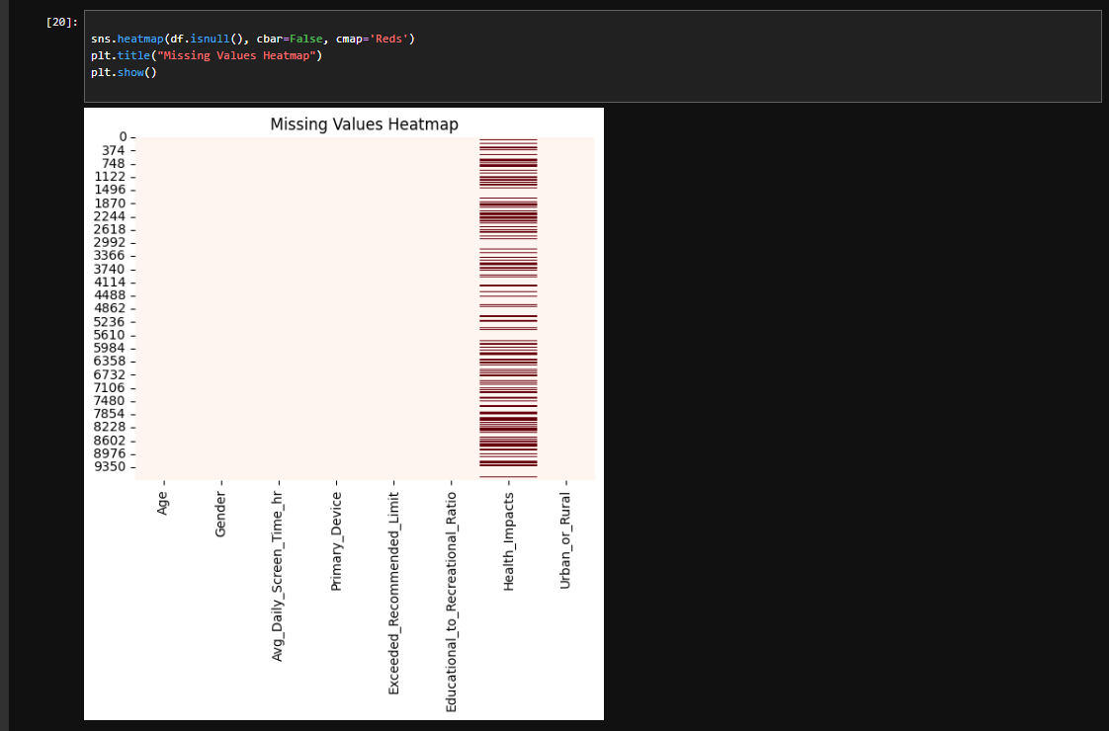

Conclusion:
- Dataset is mostly complete and reliable.
- Contains a few missing and inconsistent entries, which can be corrected using imputation and normalization.
- Data is ready for cleaning and exploratory analysis in Week 2.
Done by:
Devarasi Bhavani
devarasibhavani@gmail.com

