Kshiti Gambhir
Milestone 2
Week 3: Univariate and Bivariate Visual Analysis
Goals and Workflow
The goal for Week 3 was to perform visual analysis of the cleaned children’s screen-time dataset to uncover demographic and behavioral patterns. The focus was on distributions of daily hours, device preferences, and relationships between age, gender, and location.
Workflow for Week 3 included:
- Visualize device usage patterns by gender.
- Examine screen-time distributions by age bands.
- Compare screen-time across gender, age band, and location type.
- Build multiple visualizations (bar charts, boxplots, histograms) to summarize behavioral differences.
Dataset Overview
Dataset Columns:
- Age
- Gender
- Avg_Daily_Screen_Time_hr
- Primary_Device
- Urban_or_Rural
- Exceeded_Recommended_Limit
- Educational_to_Recreational_Ratio

Visual Analyses
  - Device Usage by Gender
- A count plot compared the number of users by device type (Smartphone, Laptop, Tablet, TV) across genders.
- Smartphones were the most common for both, but males showed a slightly higher smartphone preference.
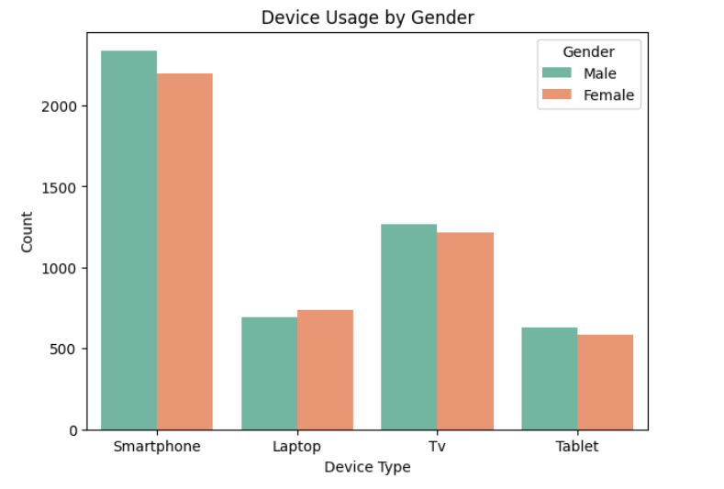
Interpretation: Both genders favor smartphones; small differences arise from recreational usage preferences.

  - Activity Type by Gender
  - Count plot showed how Educational vs Recreational activities vary by gender.
  - Both males and females predominantly engage in Recreational activities, but females maintain a slightly higher educational ratio.
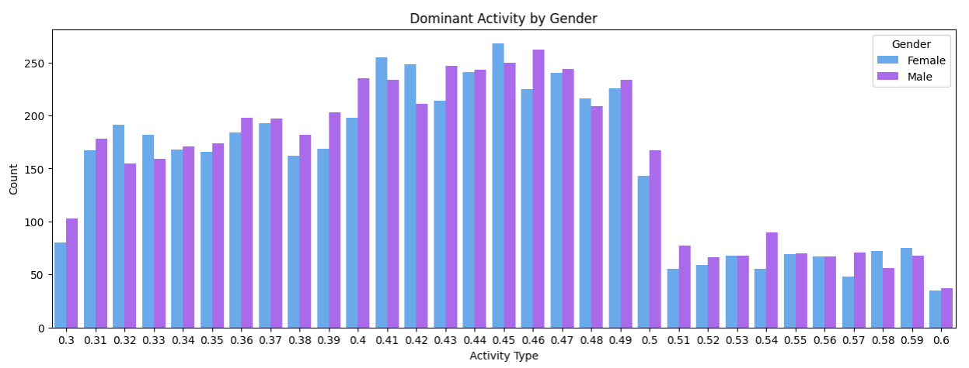
Interpretation: Screen time across genders is balanced, but males lean marginally more toward entertainment-focused use.

  - Weekday vs Weekend Screen-Time Distribution
- Boxplot comparison between weekday and weekend screen time.
- Median screen time increases noticeably on weekends for all users.
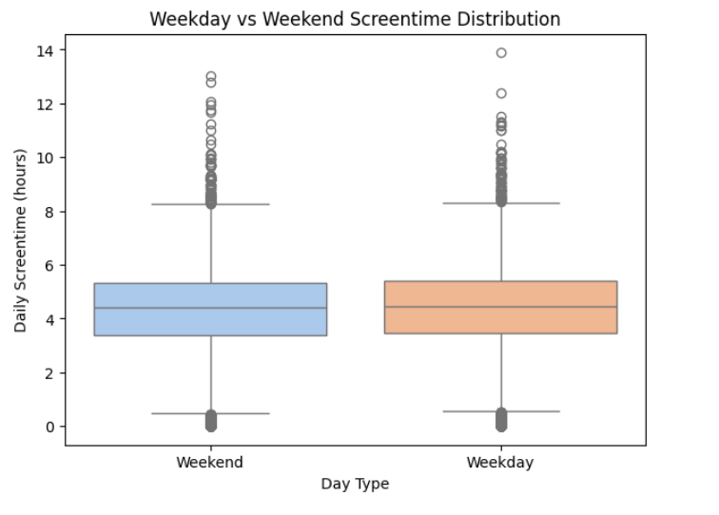
Interpretation: Weekend leisure hours drive longer and less structured screen sessions.
  - Average Screen-Time by Day Type and Age Band
  - Grouped bar chart displayed average hours for each age band split by weekday/weekend.
  - Teens and young adults have the steepest rise in weekend usage, exceeding 6 hours/day on average.
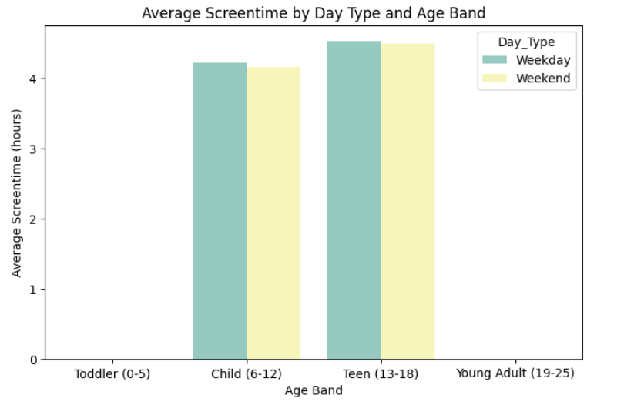
Interpretation: The age factor amplifies weekend overuse older users spend significantly more time online during breaks.
  - Activity Category Comparison: Weekday vs Weekend
- Count plot of Activity_Type (Educational vs Recreational) for both day types.
- On weekdays: Balanced mix leaning toward educational usage.
- On weekends: Strong dominance of Recreational activity across all demographics.
Interpretation: Purpose of screen-time shifts depending on the day — from learning to leisure.
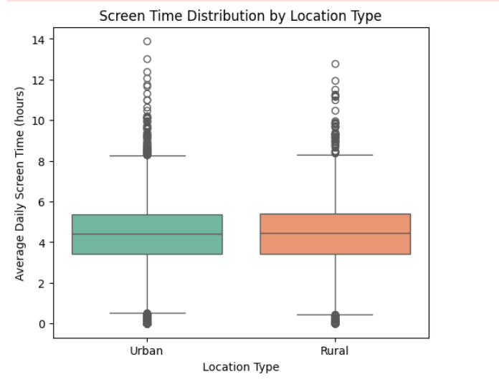
  - Average Screen-Time by Age Band and Device Type (Heatmap)
Pivot table aggregated average hours for each combination of Age_Band × Primary_Device.
Heatmap clearly showed:
1Teens + Smartphones/Laptops → highest average usage
    - Children + Tablets → moderate use
    - Toddlers → minimal screen-time exposure
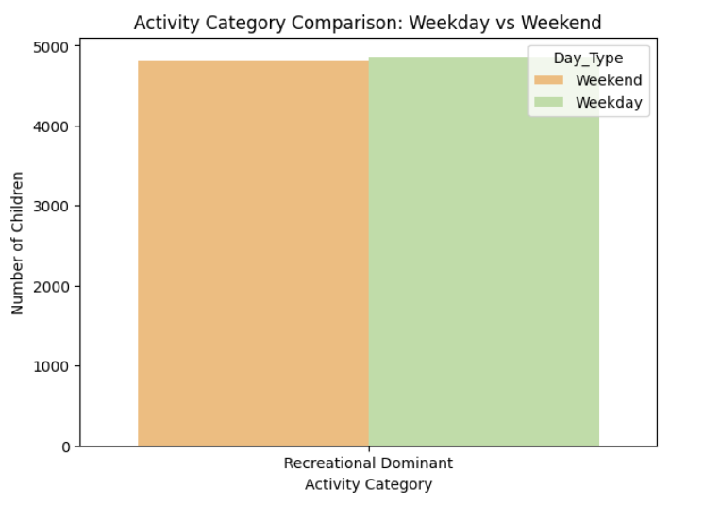
Interpretation: Device type strongly correlates with age; personal portable devices dominate as children grow older.
  - Average Screen-Time by Age Band and Device Type (Heatmap)
- Pivot table aggregated average hours for each combination of Age_Band × Primary_Device.
- Heatmap clearly showed:
  - Teens + Smartphones/Laptops → highest average usage
  - Children + Tablets → moderate use
  - Toddlers → minimal screen-time exposure
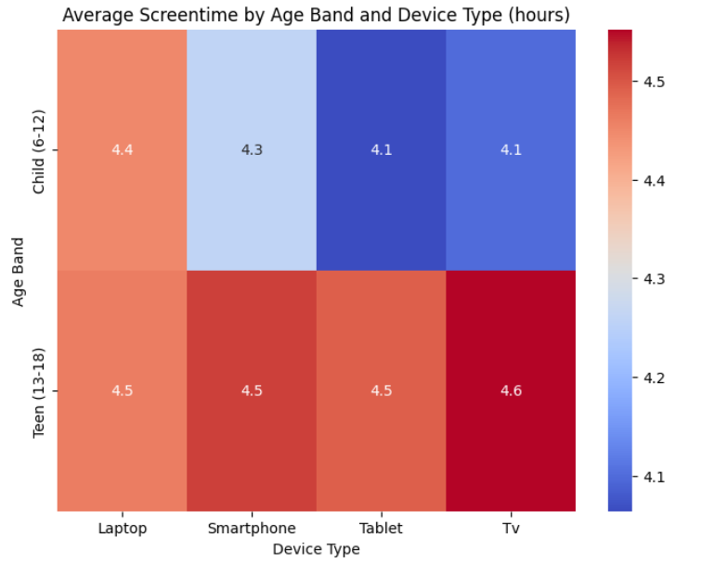
Interpretation: Device type strongly correlates with age; personal portable devices dominate as children grow older.
8. Peak Usage Cohorts (Age Band × Gender)
- Bar chart compared mean screen time by gender within each age band.
- Teen males recorded the highest daily averages, exceeding 6 hours/day.
- Gender gap was minimal in younger bands but widened with age. 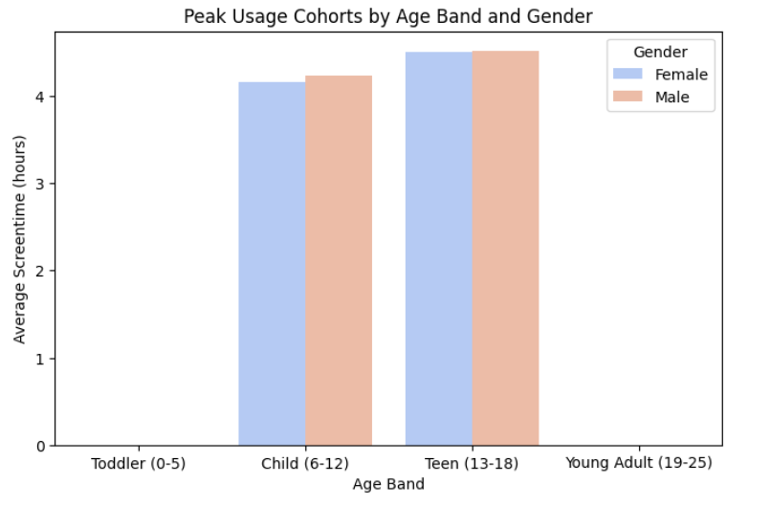
Interpretation: Adolescent males emerge as the key high-usage cohort a potential focus group for digital wellbeing programs.
Week 4: Preprocessing and Feature Engineering

Goals and Workflow
The objective for Week 4 was to perform multi-dimensional cohort analysis to identify how age, gender, location, and device type jointly influence daily screen-time usage.
The week’s focus was on uncovering behavioral clusters, device trends, and demographic interactions that lead to higher screen exposure.
Workflow:
- Build pivot tables and heatmaps for Age Band × Device, Age Band × Gender, and Location × Device combinations.
- Analyze the average screen-time across demographic cohorts.
- Identify top five high-usage groups from combined metrics.
- Generate interactive and comparative visuals to explain correlations clearly.

Analyses and Visuals
- Average Screen Time by Age Band and Device Type
  - Created a pivot table to measure average screen time across device types for each age group.
  - Heatmap revealed that Teenagers using Smartphones or Laptops had the highest screen-time values.
  - Younger groups like children showed moderate usage (mostly tablets).
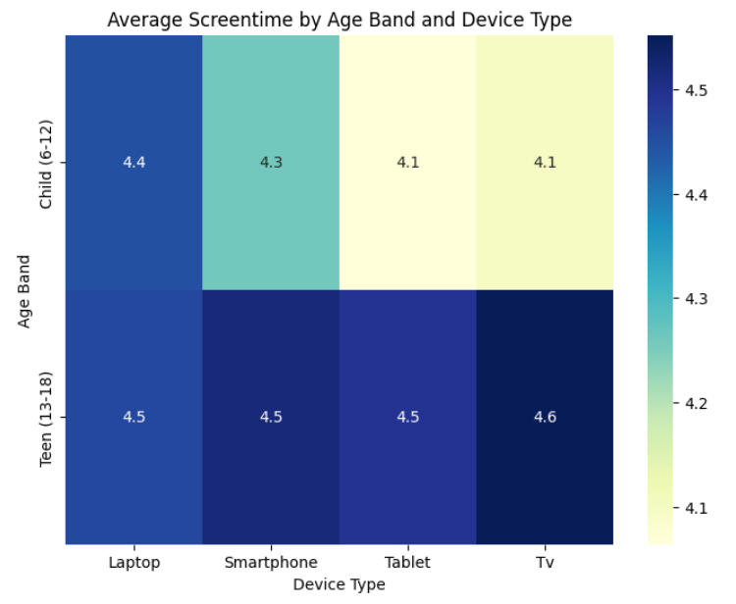
Interpretation: Device preference evolves with age — handheld and personal devices dominate in teenage years.

- Average Screen Time by Age Band and Gender
  - Generated a pivot table visualized as a heatmap comparing male vs female users.
  - Results showed that both genders exhibit similar screen-time trends, with males slightly higher across all age bands.
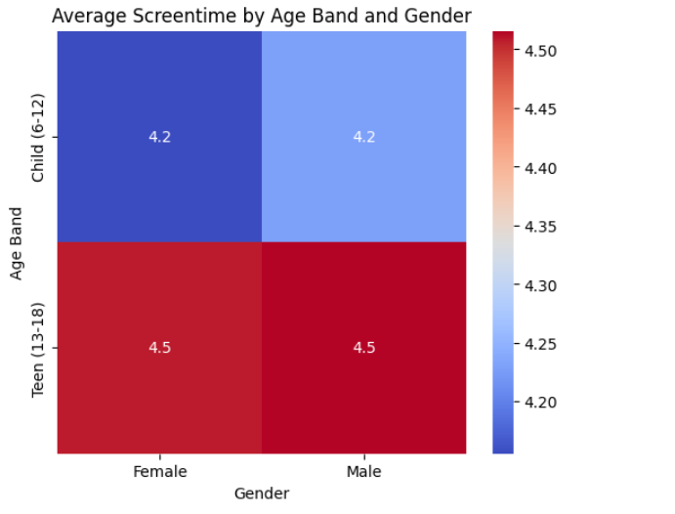
Interpretation: Gender plays a secondary role, but adolescent males tend to use devices more heavily, aligning with recreational content usage patterns.

- Average Screen Time by Location and Device Type
  - Built a stacked bar chart comparing Urban vs Rural device-wise screen time.
  - Smartphones and Laptops are dominant in both segments, though urban areas show slightly higher laptop usage.
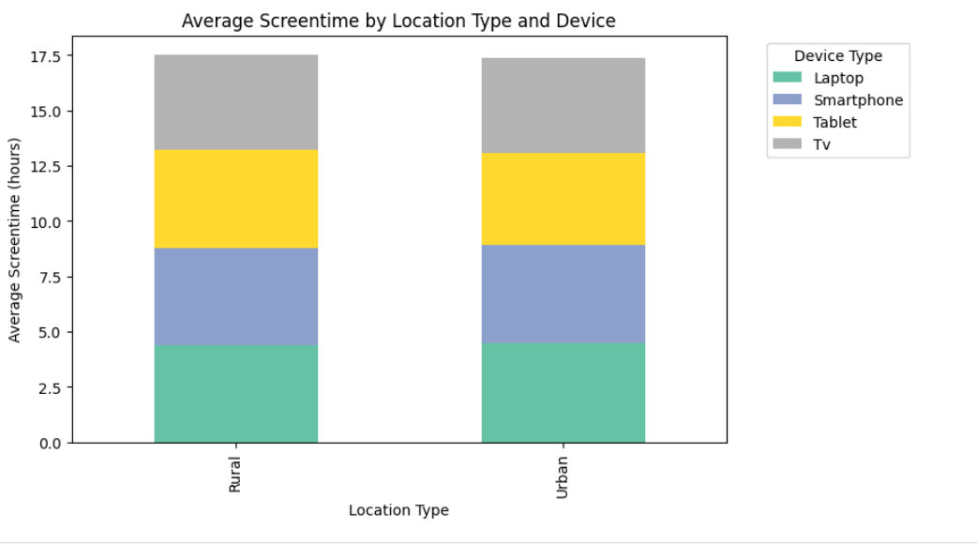
Interpretation: The device distribution pattern is nearly uniform, indicating strong digital access even in rural regions.

- Average Screen Time by Age Band and Location Type
  - Heatmap visualization for Age_Band × Urban_or_Rural.
  - Similar usage across both locations, with the Teen (13–18) age group leading in screen time.
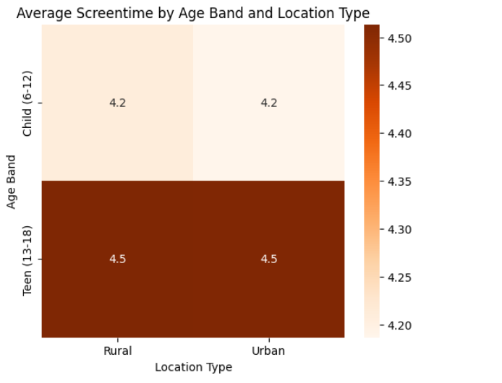
Interpretation: Age-based behavior outweighs location-based differences; urbanization has little effect on total usage.
- Top 5 High-Usage Cohorts
  - Grouped data by Age Band, Primary Device, and Gender to identify the five highest average screen-time combinations.
  - Top results revealed:
    - Teen Males – Smartphones
    - Teen Females – Laptops
    - Young Adults – Smartphones
    - Teen Males – Tablets
    - Child Males – Tablets (moderate but consistent use) 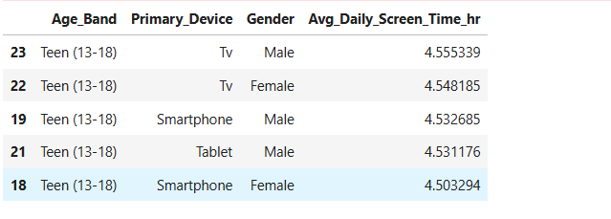
Interpretation: Teenagers are the consistent top cohort across devices, reaffirming them as the high-risk user group for prolonged screen exposure.

