Kshiti Gambhir
Milestone 3
Week 5 :Cohort And Segment Analysis
1. Top 10 cohorts by screen time
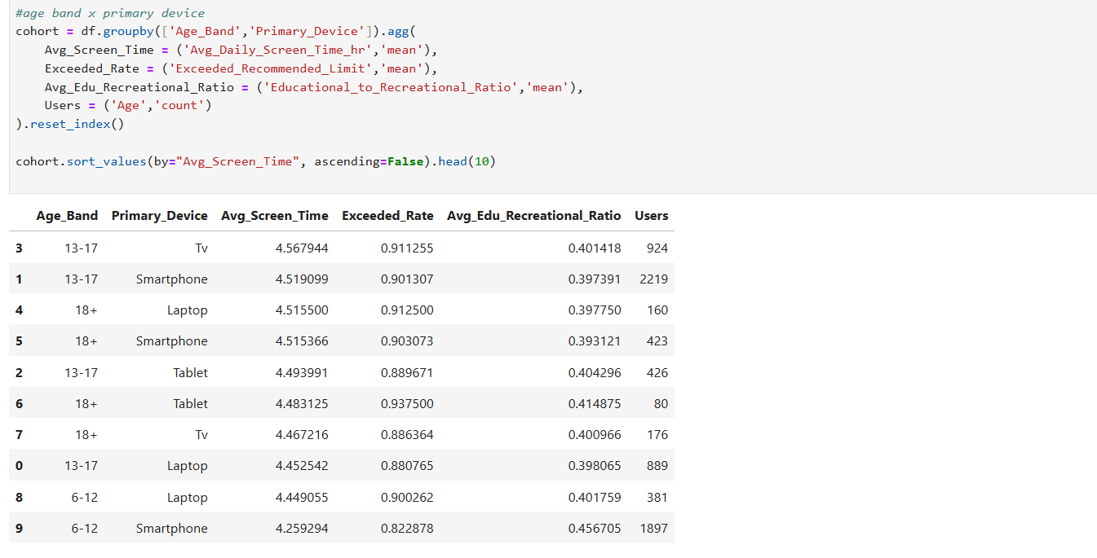

2. Most risky cohorts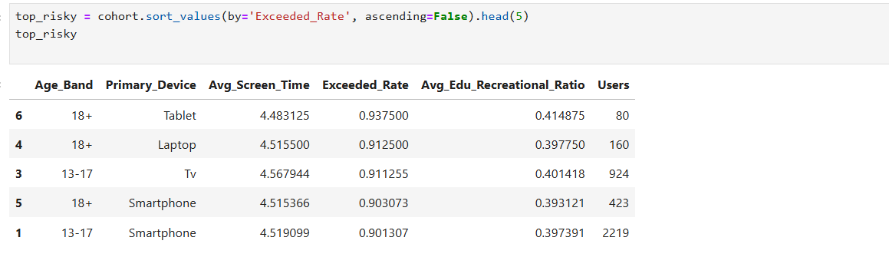

3. Heatmap – Age Band vs Exceeded Limit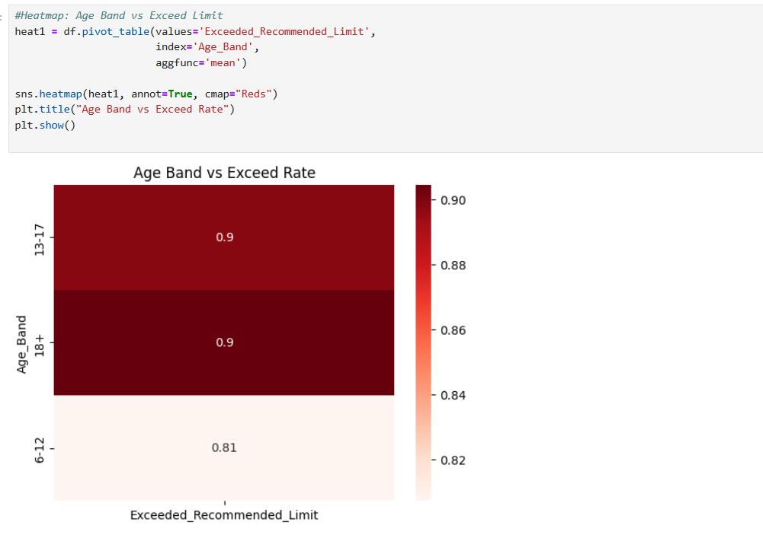
4. Heatmap – Urban vs Rural screen time
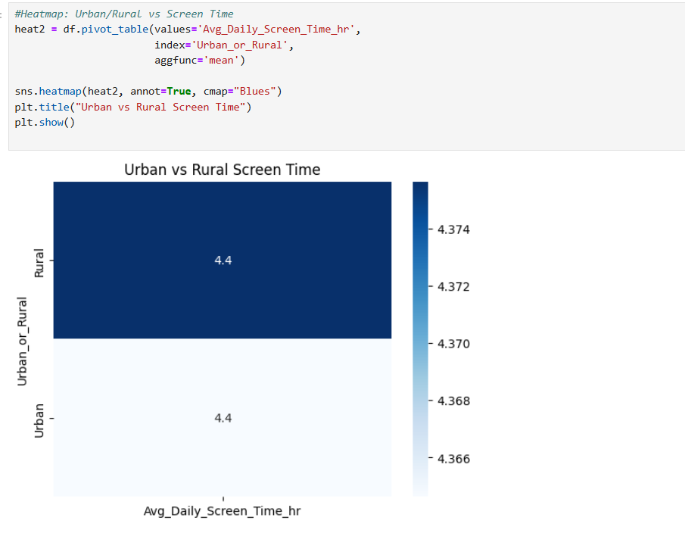

5.Gender vs Activity (stacked bar)
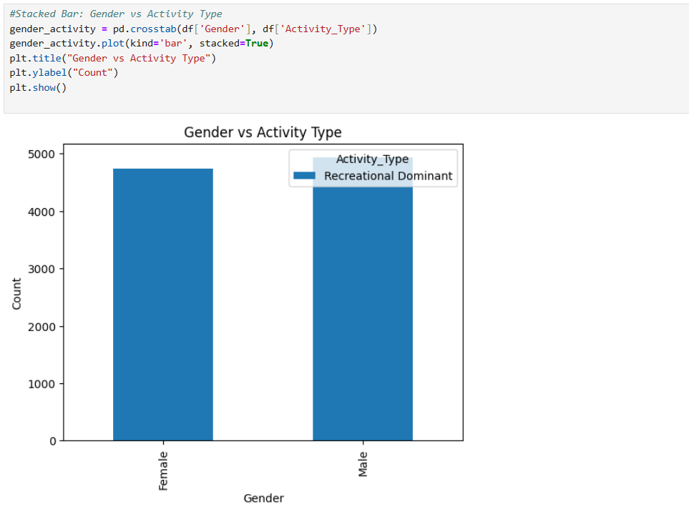
6. Device vs Health Impacts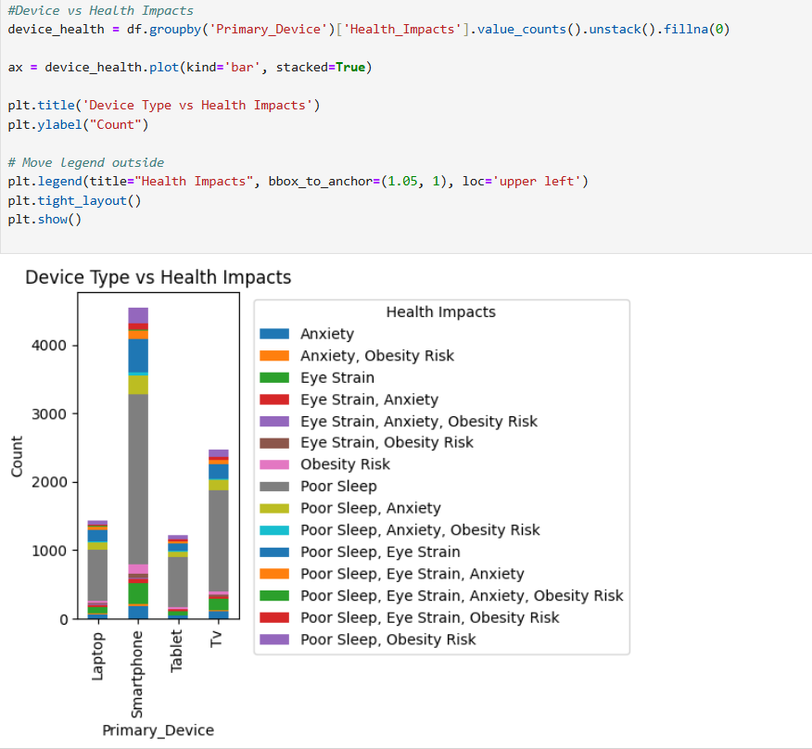
Week 6 : Seasonal and Habit Patterns
1. Screen Time: Weekday vs Weekend
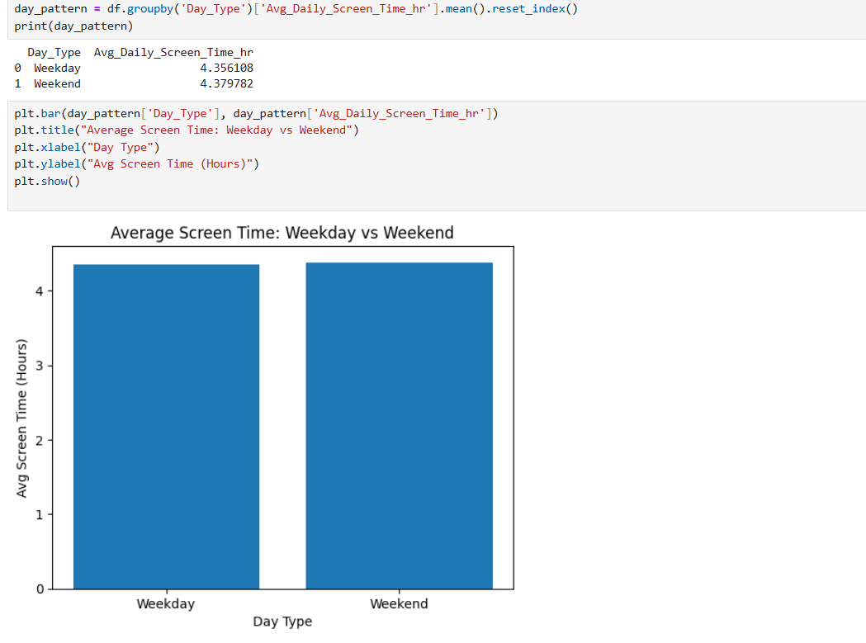
2. Activity Type Pattern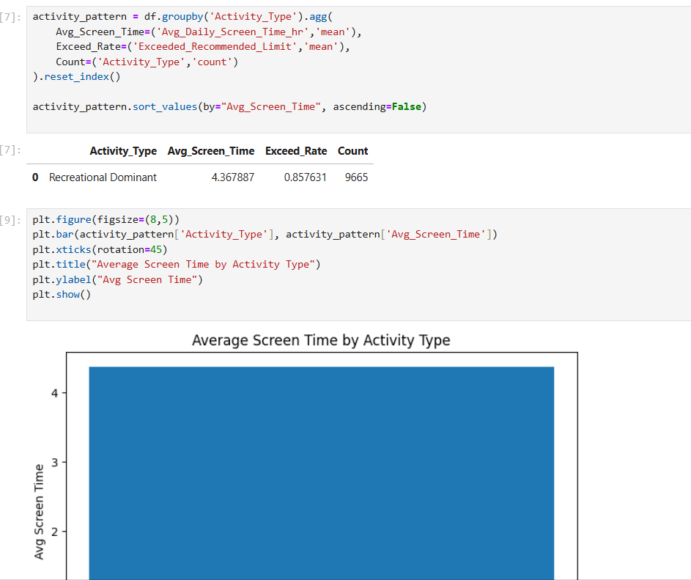

3. Habit Pattern by Age Group
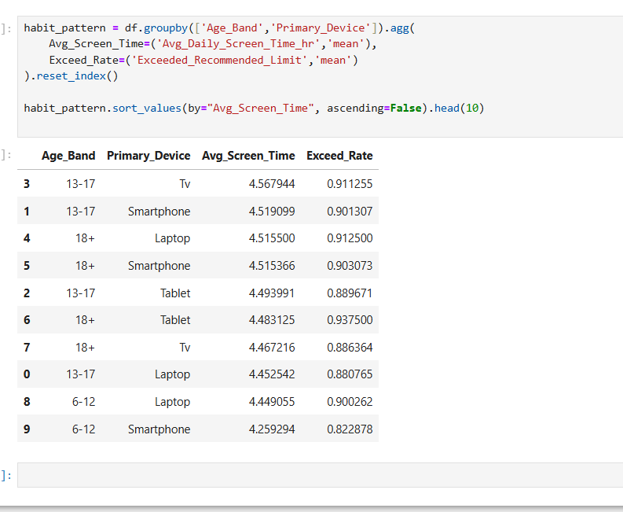

Power Bi Visuals
Week 5
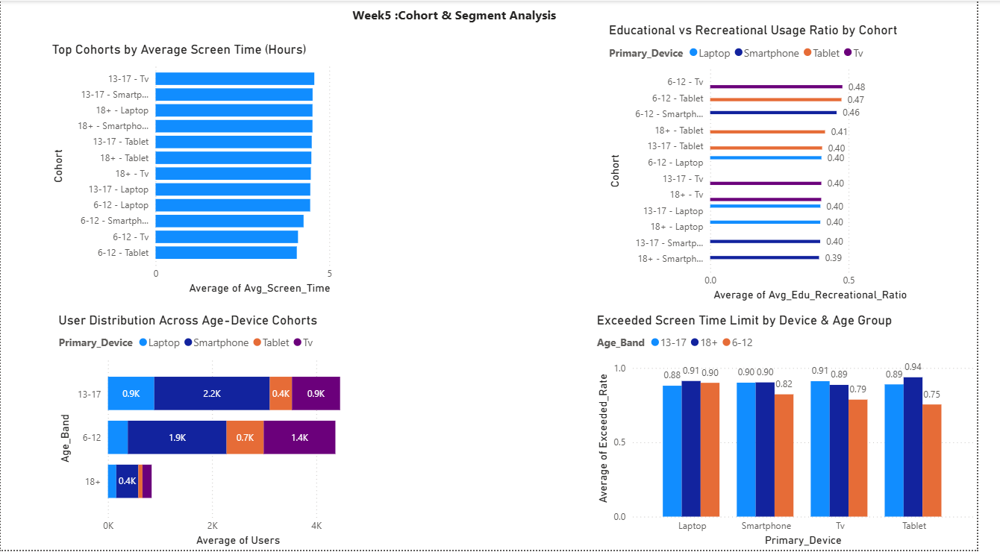

Week 6
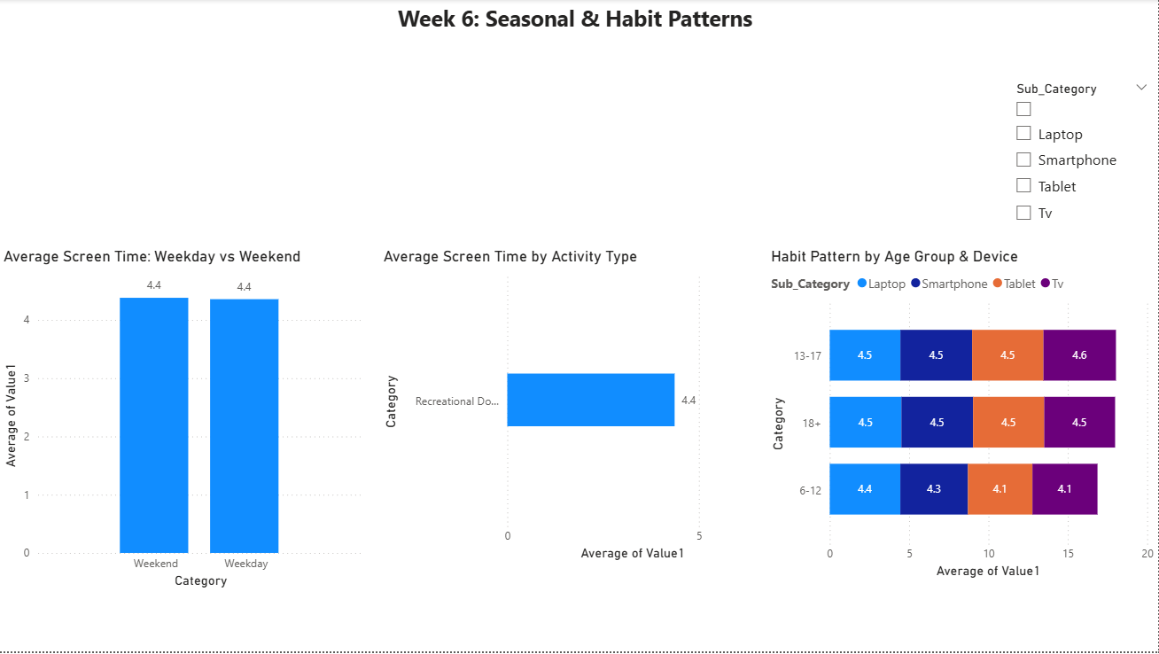

Results:
Teenagers (13–17) and adults (18+) have the highest average screen time across devices.
Smartphones and TVs are the most overused devices in all age groups.
Adults using tablets show the highest exceedance rate (≈93%), making them the most vulnerable cohort.
Children (6–12) show comparatively better control over screen usage.
Urban and rural screen time is almost equal, indicating wide digital penetration.
Screen usage is strongly recreational dominant rather than educational.
Weekend screen time is slightly higher than weekday usage.
Excessive screen use is linked to poor sleep, eye strain, and anxiety.

