ScreenSense: Kids' Screentime Visualization Project

Week 3 Submission
Student Name: Afzal Hussain S
Department: Data Analytics Intern at Infosys Springboard
Mentor: Sirisha
Project Timeline: 8 Weeks
Submission Date: 31-10-2025
Review Session: Thursday/Friday Review

Project Overview
Analyze kids' screentime patterns to uncover trends by age, gender, location type (urban/rural), device type, and health impacts using data visualization in Power BI. Week 3 focuses on creating univariate and bivariate visualizations to reveal patterns and relationships in the data.

Dataset Status
Source: Kaggle — Indian Kids Screentime 2025
Current Rows: 9,712 (complete dataset)
Current Columns: 20
Power BI Project: "ScreenSense: Kids Digital Behavior Analysis"
Dashboard Pages: 2 (Univariate Analysis + Bivariate Analysis)

Week 3: Data Refinement Decision
Important Change in Week 3:
During Week 3 preparation for visualization, a data accuracy issue was identified through peer consultation.
Issue Identified:
In earlier weeks, 226 entries with 0 hours screen time had been filtered from the dataset. Upon review, this was found to create statistical bias:
• Excluding zero values artificially inflates average calculations
• Children with 0 screen time exist across all age groups (including ages 17-18)
• These represent valid scenarios: controlled access, no device ownership, parental restrictions
• Statistical formulas require complete datasets for accuracy
Action Taken in Week 3:
• Removed the filter in Power Query Editor
• Restored all 226 zero-value entries
• Dataset now contains complete 9,712 rows
• Zero screen time categorized as "Low (Healthy)" in Screen_Time_Category
• All Week 3 visualizations use the complete, unfiltered dataset
Result:
More accurate population representation and statistically sound calculations for all Week 3 analysis.
Note: Week 1 and Week 2 documents remain unchanged as submitted to GitHub. Final project documentation will reflect the complete 9,712-row dataset used from Week 3 onwards.

WEEK 3: UNIVARIATE AND BIVARIATE VISUAL ANALYSIS

Week 3 Objectives
- ✅ Create univariate visualizations (single variable distributions)
- ✅ Create bivariate visualizations (comparative analysis)
- ✅ Implement interactive slicers for filtering
- ✅ Apply custom theme for consistent branding
- ✅ Generate insights from visual patterns
- ✅ Prepare 2 dashboard pages for stakeholder presentation

Understanding Analysis Types

What is Univariate Analysis?
Definition: Univariate analysis examines the distribution of a single variable in isolation.
Purpose in This Project:
• Understand the composition of each demographic or behavioral factor
• Identify dominant categories or patterns
• Establish baseline understanding before comparative analysis
Examples:
• How many children are in each screen time risk category?
• What is the age group distribution?
• Which devices are most commonly used?

What is Bivariate Analysis?
Definition: Bivariate analysis examines relationships between two variables to uncover patterns.
Purpose in This Project:
• Reveal hidden relationships between demographics and behaviors
• Identify which groups are at higher risk
• Enable targeted intervention strategies
Examples:
• Do Young Adults have more excessive screen time than Children?
• Are males or females more likely to exceed limits?
• Do urban children prefer different devices than rural children?

PAGE 1: UNIVARIATE ANALYSIS

Single Variable Distributions
Objective: Display distribution of key variables to understand overall patterns
Layout: 4 primary charts + 3 interactive slicers
Theme: Custom blue/purple gradient theme

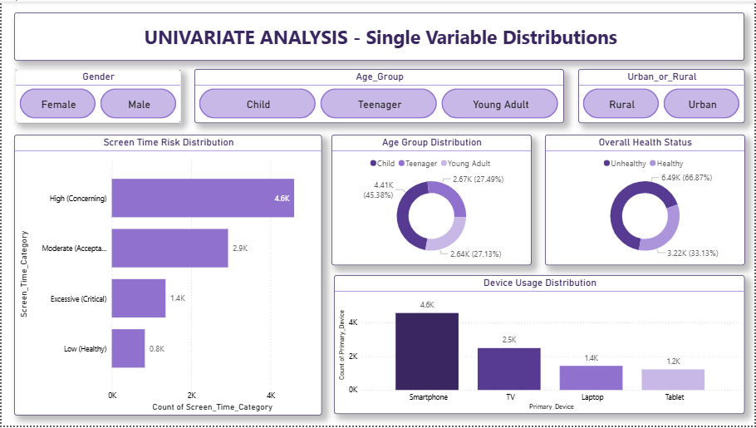
____________________________________________________________________________________________________

Chart 1: Screen Time Risk Distribution
Visual Type: Clustered Bar Chart
Configuration: Screen_Time_Category on Y-axis, Count on Values
Sort: Descending by count
Key Insights:
• High (Concerning): 4,600 children (47.4%) - Largest category
• Moderate (Acceptable): 2,900 children (29.9%)
• Excessive (Critical): 1,400 children (14.4%)
• Low (Healthy): 800 children (8.2%) - Includes restored 226 zero values
Stakeholder Implication:
61.8% of children in concerning categories - urgent intervention needed.

Chart 2: Age Group Distribution
Visual Type: Donut Chart
Configuration: Age_Group in Legend, Count in Values
Data Labels: Category name and percentage
Key Insights:
• Child (8-12 years): 4,410 (45.4%)
• Teenager (13-15 years): 2,670 (27.5%)
• Young Adult (16-18 years): 2,632 (27.1%)
Stakeholder Implication:
Balanced distribution enables robust comparative analysis.

Chart 3: Device Usage Distribution
Visual Type: Stacked Column Chart
Configuration: Primary_Device on X-axis, Count on Y-axis
Key Insights:
• Smartphone: 4,600 (47.4%) - Dominant device
• TV: 2,500 (25.7%)
• Laptop: 1,400 (14.4%)
• Tablet: 1,200 (12.4%)
Stakeholder Implication:
Smartphone dominance suggests mobile-first intervention strategies.

Chart 4: Overall Health Status
Visual Type: Donut Chart
Configuration: Health_Status in Legend, Count in Values
Colors: Green for Healthy, Red for Unhealthy
Key Insights:
• Unhealthy: 6,490 (66.9%) - Two-thirds affected
• Healthy: 3,222 (33.1%)
Stakeholder Implication:
Public health crisis - majority showing health impacts.

Interactive Slicers (Page 1)
Three button-style slicers added:
1. Gender (Female/Male)
2. Age_Group (Child/Teenager/Young Adult)
3. Urban_or_Rural (Rural/Urban)
All slicers cross-filter all charts on the page.

PAGE 2: BIVARIATE ANALYSIS

Comparative Patterns
Objective: Reveal relationships between variables to identify risk patterns
Layout: 4 comparison charts + 3 interactive slicers
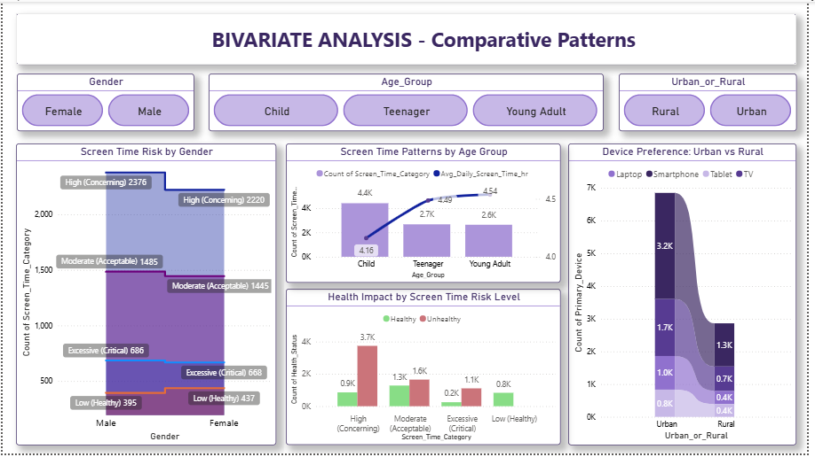
____________________________________________________________________________________________________

Chart 5: Screen Time Patterns by Age Group
Visual Type: Line and Clustered Column Chart (Combo)
Configuration: Age_Group on X-axis, Screen_Time_Category count on Column Y-axis, Avg hours on Line Y-axis
Key Insights:
• Young Adults show highest average screen time (line trend)
• High category increases with age
• Clear correlation: Age ↑ = Screen time ↑
Stakeholder Implication:
Intensify programs for 16-18 age group.

Chart 6: Screen Time Risk by Gender
Visual Type: Area Chart
Configuration: Gender on X-axis, Screen_Time_Category stacked in Legend, Count on Y-axis
Key Insights:
• Males: Excessive = 686, High = 2,376
• Females: Excessive = 668, High = 2,220
• Males slightly higher in concerning categories
Stakeholder Implication:
Both genders require attention, minimal difference.

Chart 7: Device Preference: Urban vs Rural
Visual Type: Ribbon Chart
Configuration: Urban_or_Rural on Y-axis, Primary_Device in Legend, Count in Values
Key Insights:
• Urban: Higher smartphone and laptop usage
• Rural: More TV usage
• Clear digital divide in device access
Stakeholder Implication:
Location-specific interventions: parental apps (urban), TV time management (rural).

Chart 8: Health Impact by Screen Time Risk Level
Visual Type: Clustered Column Chart
Configuration: Screen_Time_Category on X-axis, Health_Status in Legend, Count on Y-axis
Colors: Green for Healthy, Red for Unhealthy
Key Insights:
• Strong correlation: Higher screen time → More unhealthy
• Excessive category: Predominantly unhealthy
• Clear cause-effect relationship
Stakeholder Implication:
Direct evidence supporting screen time reduction programs.

Interactive Slicers (Page 2)
Same three button-style slicers as Page 1:
1. Gender, 2. Age_Group, 3. Urban_or_Rural
All working correctly and cross-filtering all charts.

Design and Theme
Custom Theme: Blue/purple gradient palette
Rationale: Conveys technology, trust, and wellness. Professional appearance for stakeholders.
Accessibility: High contrast, clear labels, green/red health coding.

Week 3 Achievements
- ✅ Created 8 professional visualizations across 2 pages
- ✅ Implemented 4 univariate + 4 bivariate charts
- ✅ Added 6 interactive slicers (3 per page)
- ✅ Applied custom theme consistently
- ✅ Restored complete dataset (9,712 rows) for accuracy
- ✅ Generated actionable insights for stakeholders
- ✅ Demonstrated advanced chart types (ribbon, combo, area)
- ✅ Created stakeholder-ready dashboard

Technical Skills Demonstrated
- • Multiple Power BI chart type configuration
- • Univariate and bivariate analysis implementation
- • Interactive slicer setup and cross-filtering
- • Custom theme design and application
- • Color psychology (green/red for health)
- • Data label optimization
- • Visual hierarchy and layout design
- • Insight generation from patterns

Key Insights for Stakeholders
1. URGENT: 61.8% in High/Excessive categories
2. HEALTH CRISIS: 66.9% showing health impacts
3. AGE FACTOR: Screen time increases with age
4. DEVICE: Smartphones dominant (47%)
5. LOCATION: Urban-rural digital divide exists
6. CORRELATION: High screen time = Poor health
7. GENDER: Both genders similarly affected

Recommended Actions
- • Launch awareness campaigns for 61.8% in risk categories
- • Target 16-18 age group with intensive programs
- • Promote smartphone parental control apps
- • Urban: Focus on mobile device management
- • Rural: Implement TV time limits
- • Address 66.9% unhealthy through wellness programs
- • Establish screen time guidelines for both genders

Preparation for Week 4
Next Phase: Device/Activity Analysis
Planned:
• Device mix analysis
• Activity category distributions
• Mobile vs Large Screen comparison
• Health impacts by device
Note: Dataset lacks date fields - Week 4 will focus on device/activity patterns instead of weekday/weekend analysis.

Week 3 Deliverables
- ✅ 2 Dashboard Pages with 8 visualizations
- ✅ 6 Interactive slicers
- ✅ Custom theme applied
- ✅ Complete dataset (9,712 rows)
- ✅ Data refinement documented
- ✅ Stakeholder insights generated
- ✅ Dashboard images in PDF

Week 3 Summary
Time Invested: 9 hours
Visualizations: 8 charts
Interactive Elements: 6 slicers
Data Refinement: Restored 226 entries for accuracy
Status: Ready for Week 4
Week 3 delivered comprehensive visual analysis revealing critical patterns. Dashboard ready for stakeholder presentation with clear narratives and actionable insights.

