ScreenSense: Kids’ Screentime Visualization

WEEK -2 REPORT: Preprocessing and Feature Engineering

Main Objective:
The goal of Week 2 was to prepare the raw dataset for analysis and modeling by:
- Handling missing and inconsistent data,
- Creating new meaningful features,
- Formatting and standardizing data,
- Saving a reusable, clean dataset with proper documentation.
This ensures that the dataset is structured, consistent, and information-rich before applying any machine learning or visualization techniques.
Step 1: Handling Missing Values
Why it is needs to be done:
Real-world data often has missing or incomplete values due to user error, data corruption, or collection gaps. These missing values can mislead your analysis or reduce model accuracy.
What We Did:
- Detected missing values using df.isnull().sum().
- Handled them differently based on data type:
  - For numeric columns (like Age or Avg_Daily_Screen_Time_hr), filled missing values with the median, since it’s less sensitive to outliers.
  - For categorical columns (like Gender, Urban_or_Rural, Primary_Device), filled missing values with the mode (most frequent category).
Code:
for col in df.select_dtypes(include=['int64', 'float64']).columns:
df[col] = df[col].fillna(df[col].median())

for col in df.select_dtypes(include=['object']).columns:
df[col] = df[col].fillna(df[col].mode()[0])
- No missing values remained, ensuring data completeness for every record.

Step 2: Fixing Inconsistent Categories
Why it is needed to be done:
Categorical data can have inconsistencies such as extra spaces, case differences, or abbreviations (e.g., “Male”, “male ”, “M”). These inconsistencies can create multiple unintended categories.
What We Did:
- Standardized Gender values to lowercase and replaced abbreviations (M → Male, F → Female).
- Cleaned Urban_or_Rural entries to have consistent title case (“Urban” or “Rural”).
Code:
df['Gender'] = df['Gender'].str.strip().str.lower()
df['Gender'] = df['Gender'].replace({
'm': 'male', 'f': 'female', 'man': 'male', 'woman': 'female'
})
df['Urban_or_Rural'] = df['Urban_or_Rural'].str.strip().str.title()
- All text categories are standardized and consistent, preventing misclassification during analysis.
Step 3: Feature Engineering (Creating New Fields)
Feature engineering transforms existing data into more informative features to help uncover deeper insights and improve model performance.
(a) Screen Time Bands:
Why it needed to be done:
Continuous data like daily screen time can be difficult to analyze directly. By grouping into bands, we can easily see patterns by category (e.g., low vs. extreme users).
What We Did:
Divided Avg_Daily_Screen_Time_hr into five levels:
- Low (<2 hr)
- Moderate (2–4 hr)
- High (4–6 hr)
- Very High (6–8 hr)
- Extreme (>8 hr)
- Added a new categorical feature ScreenTime_Band for easier analysis of user behavior.
(b) Device Flags — Identifying Device Type:
Why it is needed to be done:
Device usage patterns can indicate user behavior — for example, mobile users might have different screen-time habits compared to desktop users.
What We Did:
- Cleaned Primary_Device column text.
- Created Boolean (True/False) flags:
  - Is_Mobile_User
  - Is_Desktop_User
Code:
df['Primary_Device'] = df['Primary_Device'].str.strip().str.title()
df['Is_Mobile_User'] = df['Primary_Device'].str.contains('Mobile', case=False)
df['Is_Desktop_User'] = df['Primary_Device'].str.contains('Desktop', case=False)
- Now the dataset indicates which users primarily use mobile or desktop devices.

(c) Exceeded Recommended Screen Limit

Why it is needed to be done:

We want a binary variable that clearly indicates whether users exceed healthy screen limits.

What We Did:

Converted Yes/No or Y/N responses into numeric binary values (1 = Yes, 0 = No).

Code:
df['Exceeded_Recommended_Limit'] = df['Exceeded_Recommended_Limit'].replace({
'Yes': 1, 'No': 0, 'Y': 1, 'N': 0
})
- Simplified categorical responses into numeric format, which is model-friendly.
(d) Educational Screen Time Share:

Why it is needed to be done:

The ratio of educational to recreational screen time helps measure productivity and screen-time quality.

What We Did:

Derived a new column Educational_Share_% using the existing ratio feature.

Code:
df['Educational_Share_%'] = df['Educational_to_Recreational_Ratio'] / (
1 + df['Educational_to_Recreational_Ratio']) * 100

- Added a new quantitative feature representing the share of educational screen time.

Step 4: Save Preprocessed Data:

Saved the processed dataset for reuse and consistency across future tasks (Week 3 onward).
Week 3 – Univariate & Bivariate Visual Analysis (Preview)
Objectives:
Perform exploratory visual analysis to discover relationships and insights.
Planned Tasks:
- Analyze distributions of :
  - Avg_Daily_Screen_Time_hr
  - Age_Band
  - Primary_Device
- Compare screen time across :
  - Gender
  - Age_Band
  - Urban_or_Rural
- Create visuals using:
  - Bar charts for categorical comparisons
  - Histograms for numeric distributions
  - Boxplots for variability and outliers
  - Line plots for trend tracking
Conclusion
In Week 2, we successfully transformed raw and inconsistent data into a structured, reliable dataset ready for analysis.
The preprocessing phase involved identifying and addressing missing values, standardizing categorical entries, and engineering meaningful features such as Age Bands, Screen Time Categories, and Exceeded Recommended Limit.
These steps ensured that the dataset is:
- Accurate: Missing and incorrect entries were corrected.
- Consistent: Categories were standardized for reliable grouping and comparison.
- Insight-Ready: Derived features enable richer visual and statistical exploration.

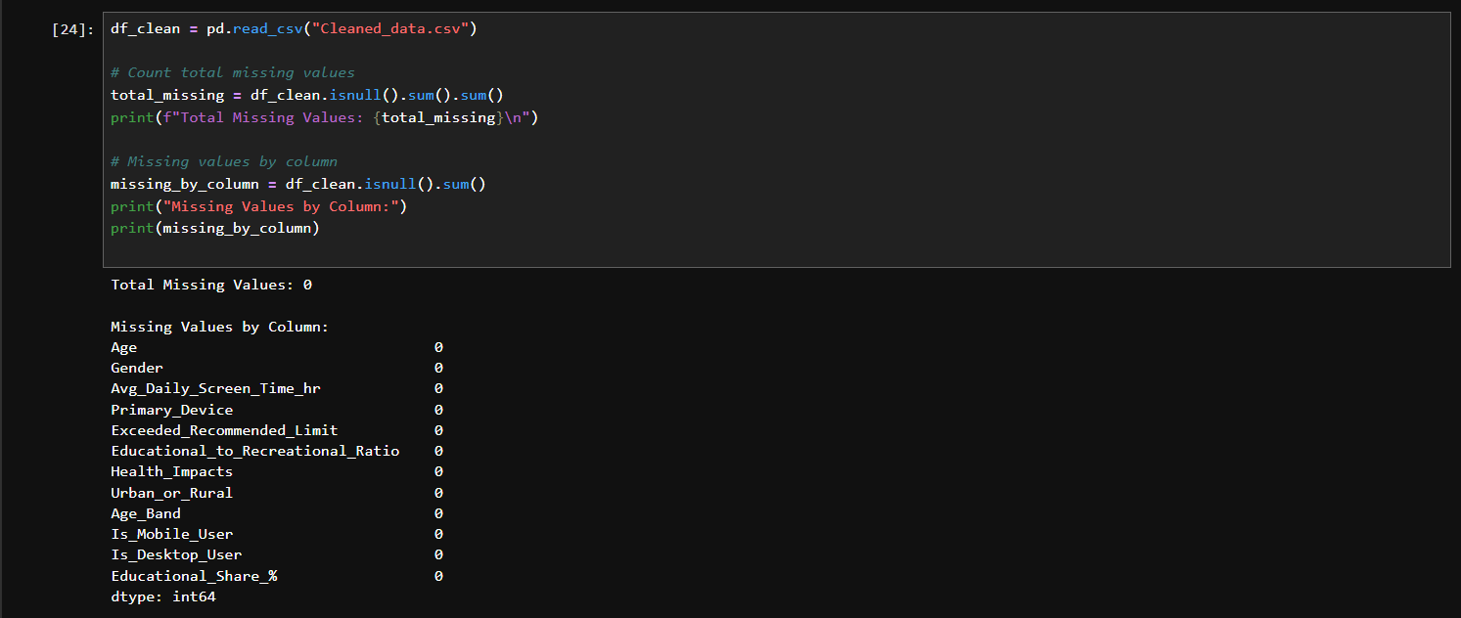
The resulting cleaned dataset (Cleaned_data.csv) provides a strong foundation for Week 3’s visual analysis. With preprocessing completed, the next phase will focus on univariate and bivariate analysis to uncover trends, behavioral patterns, and relationships between screen time, age, gender, and living environments.
Done By:
Name : Devarasi Bhavani
Email Id : devarasibhavani@gmail.com

