**Gather functional integration requirements (voice input → intent mapping)**

The objective of this task is to capture and define the functional requirements needed for integrating the legacy IVR with Conversational AI platforms (ACS/BAP). Specifically, the focus is on enabling voice-based user inputs, mapping them to appropriate intents, and routing them to the correct IVR workflows.

Traditional IVRs operate primarily on DTMF (Dual Tone Multi Frequency) inputs, requiring users to press numbers for specific actions. However, modern users expect natural voice interactions.

Example: Instead of pressing “1” for balance enquiry, a caller should be able to say “Check my balance”.

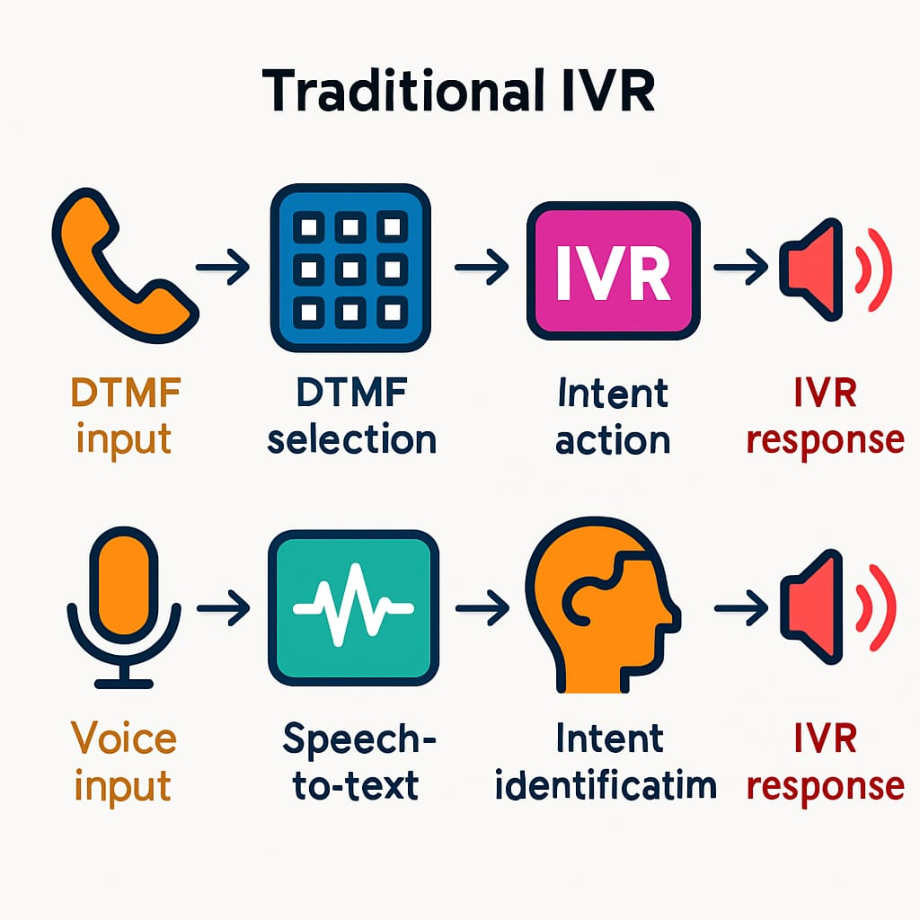This requires capturing voice input, converting it into text, identifying the intent behind it, and mapping that intent to an existing IVR function.

**Scope:**

This task covers the functional integration layer between:

Caller voice input → Captured and processed via ACS/BAP.

AI/NLP module → Recognizes the intent.

Legacy IVR workflows → Executes the mapped function (e.g., balance enquiry, fund transfer).

The Conversational AI platform (ACS/BAP) processes the speech and converts it into text (speech-to-text). Then NLP (Natural Language Processing) identifies the intent. That intent must be mapped to the correct legacy IVR flow.

**Methodology:**

1.Voice Input Capture

* Caller speaks (e.g., “I want to check my balance”).
* System uses Automatic Speech Recognition (ASR) to convert speech → text.

2.Intent Recognition (NLP Layer)

* The text is processed by Natural Language Processing (NLP).
* Example: “I want to check my balance” → Intent = Check_Balance.

3.Mapping to Legacy IVR

* The recognized intent is mapped to the corresponding legacy IVR action.
* Example: Instead of pressing “1”, the spoken request is mapped to the Balance Enquiry module.

4.Response Delivery

* The system fetches the response from the legacy backend (e.g., balance = ₹10,000).
* Text-to-Speech (TTS) converts it into a natural voice response:
* “Your account balance is ten thousand rupees.”

**Example:**

User Voice Input: "I want to check my balance"

↓

Speech-to-Text: "I want to check my balance"

↓

NLP Intent Detection: Check Balance

↓

Mapped to Legacy IVR Action: Route call to Balance Enquiry module

↓

System Response: "Your account balance is ₹10,000."

**Advantages:**

* **User-friendly**: Callers interact naturally, reducing frustration.
* **Faster navigation:** No need to remember menu numbers.
* **Reusability**: Existing IVR flows are reused, minimizing cost.
* **Personalization**: Can provide customized responses based on user history.
* **Future-ready:** Easily integrates with chatbots, WhatsApp bots, Alexa, etc.

**Difficulties in modern IVR:**

* Speech Recognition Accuracy
* Implementation Complexity
* Cost of Deployment
* Multilingual Support
* Latency (Response Delay)
* Security & Privacy
* Customer Trust