SwipeX – AI Recommendation

1. Simple Explanation

The AI Recommendation system suggests suitable jobs by comparing the candidate’s profile, resume, skills, experience, and preferred role with job requirements. When enough swipe history is available, the system can also use previous Like and Reject actions.

2. Workflow
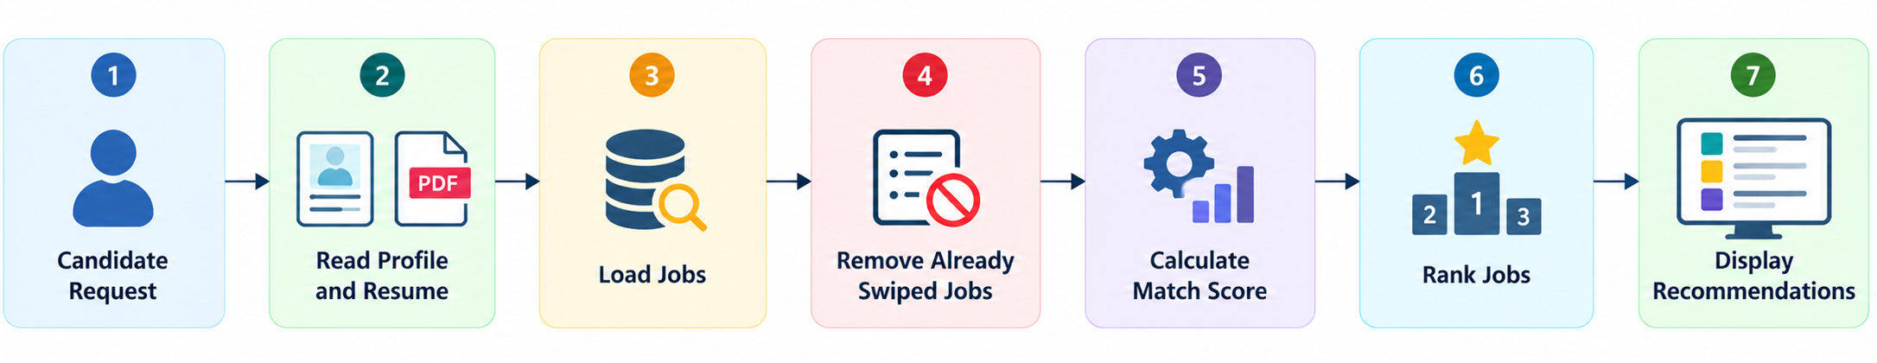

3. Main Steps

- The candidate opens the AI Recommendation page.
- The system reads the candidate’s profile and resume.
- The system compares candidate information with available jobs.
- Jobs already liked or rejected are removed from the recommendation list.
- A score is calculated using skills, experience, and role relevance.
- After more than 10 swipes, previous swipe behavior can also be considered.
- Jobs are ranked and displayed according to their scores.

4. Mathematical Formula

For candidates with 10 or fewer swipes:
R = (P × 0.70) + (E × 0.20) + (L × 0.10)
For candidates with more than 10 swipes:
R = (P × 0.40) + (B × 0.30) + (E × 0.20) + (L × 0.10)

Symbol | Meaning
P | Profile/Resume Skill Match
B | Swipe Behavior Fit
E | Experience Match
L | Role Relevance
R | Final Recommendation Score

5. Result

The system ranks suitable jobs from the highest score to the lowest score and displays them to the candidate. The recommendation score helps the candidate discover jobs that match their background and preferences.

