SwipeX – ATS Score

1. Simple Explanation
The ATS Score system checks how closely a candidate’s resume and profile match a selected job. It compares skills, experience, semantic similarity, and education, then produces a score out of 100.

2. Workflow

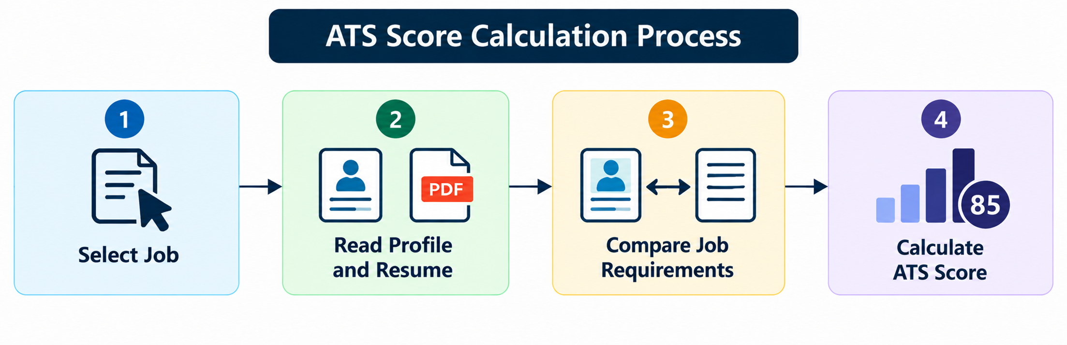

3. Main Steps

- The candidate selects a job for ATS analysis.
- The system reads the candidate’s profile and resume.
- The system checks the job’s skills, experience, education, and description.
- The candidate’s information is compared with the job requirements.
- Each component receives a score.
- The component scores are combined using fixed weights.
- The final ATS score and score details are displayed.

4. Mathematical Formula
ATS = (S × 0.50) + (E × 0.20) + (M × 0.20) + (D × 0.10)
Symbol | Meaning | Weight
S | Skills Match | 50%
E | Experience Match | 20%
M | Semantic Similarity | 20%
D | Education Match | 10%

5. Simple Example
If the component scores are Skills = 80, Experience = 90, Semantic Similarity = 70, and Education = 100:
ATS = (80 × 0.50) + (90 × 0.20) + (70 × 0.20) + (100 × 0.10)
ATS = 40 + 18 + 14 + 10 = 82
Final ATS Score = 82/100

6. Result

The ATS score helps the candidate understand how well their profile and resume match a selected job. It is an estimated matching score and does not guarantee selection by an employer.

