Swipe-Based Intelligent Job Discovery and Career Assistance Platform
Document basis: Current project source code in job-discovery-platform(8).zip, together with the supplied explanation and previous documentation files.

1. Project Overview

SwipeX is a full-stack job discovery platform that helps candidates discover active job opportunities, maintain a professional profile, upload resumes, receive profile/resume-based recommendations, calculate ATS scores, interact with jobs through like/reject actions, manage saved jobs, and review swipe history. The current implementation combines rule-based matching, semantic similarity, and optional machine-learning personalization.

2. Project Objectives
- Simplify job discovery through a dedicated Discover page and recommendation dashboard.
- Allow candidates to register, log in, and maintain profile information.
- Support PDF and DOCX resume upload, text extraction, cleaning, and skill extraction.
- Calculate an ATS score using skills, experience, semantic similarity, and education.
- Recommend jobs from the active unswiped job pool.
- Use swipe history for personalization after the configured threshold.
- Allow candidates to like, reject, save, and review jobs.
- Provide a scalable foundation for future recruiter-side functionality.

3. Technology Stack

Frontend
- React.js
- JavaScript / JSX
- Vite
- React Router
- Axios
- CSS
Backend
- Python
- FastAPI
- SQLAlchemy
- Pydantic
- Uvicorn

Database
- PostgreSQL

Machine Learning / NLP
- joblib swipe classifier
- semantic embeddings when available
- word-overlap fallback
- spaCy PhraseMatcher when available
- optional Groq LLM integration

Data
- naukri_jobs.csv imported job dataset

4. System Architecture

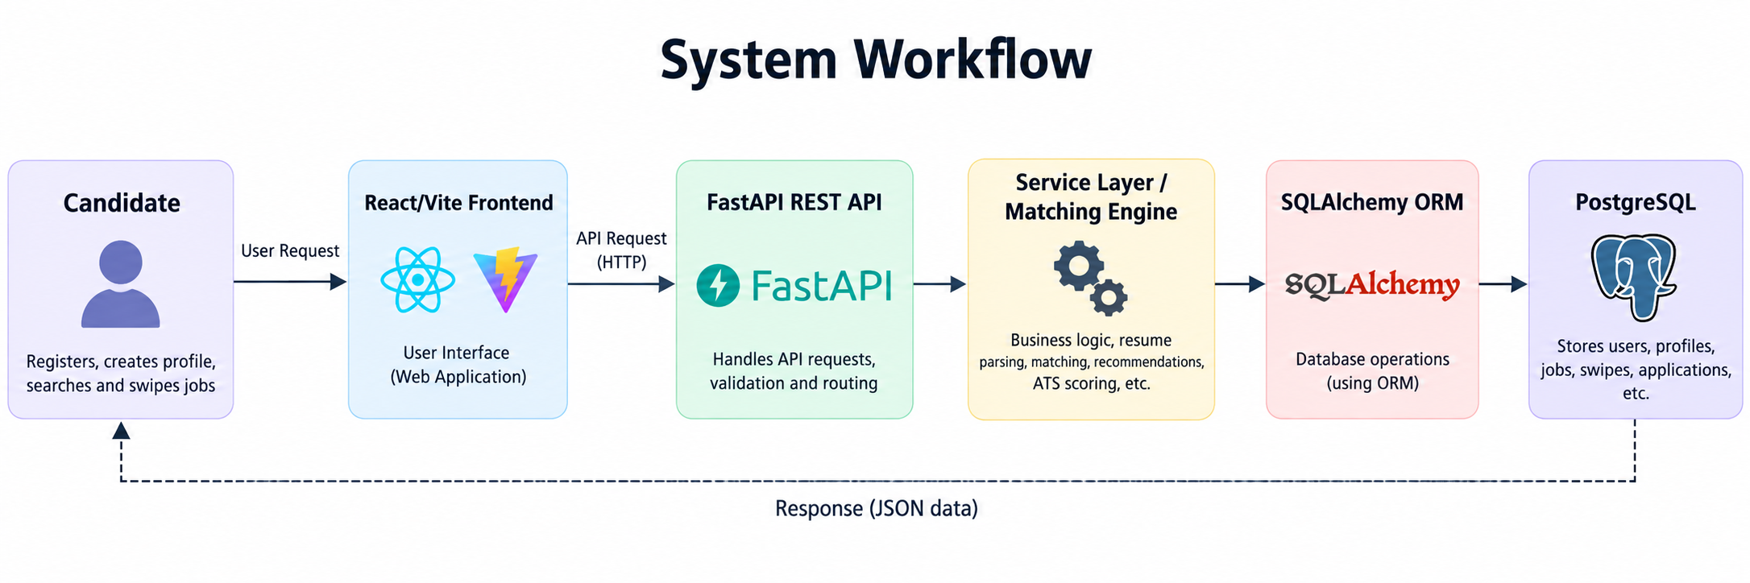
Supporting services include resume parsing, skill normalization, semantic similarity, ATS scoring, recommendation ranking, swipe persistence, and saved-job management.

5. Main User Workflow

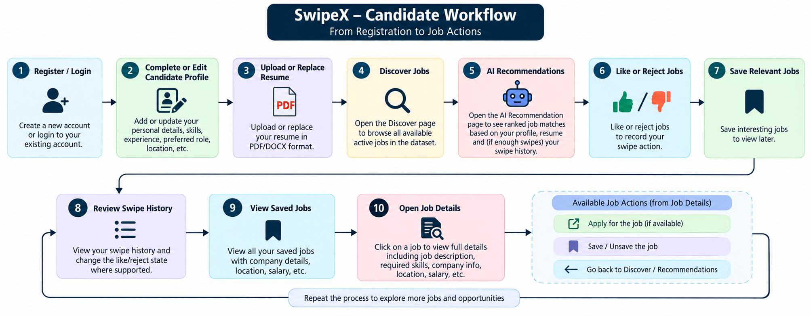

1. Register / Login
2. Complete or edit candidate profile
3. Upload or replace PDF/DOCX resume
4. Open Discover to browse active jobs
5. Open AI Recommendations for ranked matches
6. Like or reject jobs / record swipe action
7. Save relevant jobs
8. Review Swipe History and change like/reject state where supported
9. View Saved Jobs
10. Open job details and proceed with available job actions

6. Implemented Functional Modules

Authentication
Candidate registration, login, authentication token handling, role information, and protected routes.

Candidate Profile
Headline, bio, location, education, skills, experience years, preferred role, preferred location, and expected salary.

Resume Management
PDF and DOCX text extraction, resume text cleaning, skill extraction through a predefined vocabulary, normalization, extracted skills/experience/education fields, and primary resume handling.

Discover Jobs
Lists active jobs from the imported dataset and supports job browsing, details, filtering/search behavior, and like/reject interaction.

AI Recommendations
Checks profile/resume availability, excludes previously swiped jobs, scores eligible jobs, applies a minimum match threshold, ranks results, and enriches returned jobs with tags and score breakdowns.

ATS Scoring
Produces a 0–100 score and diagnostic breakdown including skills, experience, semantic similarity, education, required skills, preferred skills, and missing skills.

Swipe System
Stores like/reject actions in job_swipes, preserves the match score at swipe time when available, updates existing actions, and invalidates recommendation cache.

Saved Jobs
Stores saved jobs separately and supports saved-job listing and management.

Swipe History
Shows prior actions with job information, action, score, and timestamp; the frontend also supports changing the action through the available interface.

7. Resume Parsing and Skill Extraction

The current parser supports PDF extraction through pypdf and DOCX extraction through python-docx. Extracted text is cleaned by reducing repeated spaces and excessive blank lines. Skills are detected using a common skill vocabulary and aliases. When spaCy and its language model are available, PhraseMatcher is used; otherwise, a word-boundary regular-expression fallback is used. Optional Groq-based extraction can add explicit professional or technical skills when GROQ_API_KEY is configured. Detected skills are normalized before storage.

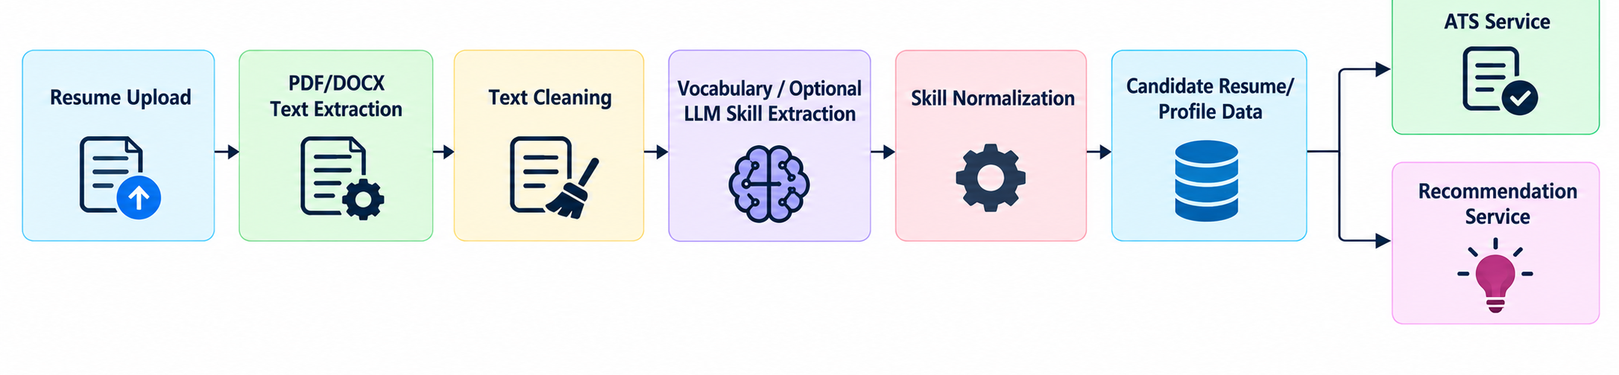

8. AI Recommendation Logic

- The system evaluates the eligible active-job pool and removes jobs already swiped on by the candidate.
- A minimum match score of 40 is applied before recommendation results are returned.
- The scoring stage evaluates skills, experience, and role relevance; semantic and ML work is bounded to a limited set of top rule-matched candidates for performance.
- The recommendation endpoint supports a configurable result limit, capped at 30, and optional server-side search across title, company, skills, and location.
- A short-lived recommendation cache is used and invalidated when profile, resume, or swipe data changes.

9. ATS Score Calculation

The ATS score is calculated on a 0–100 scale using the following weights:
Component | Weight | Implementation detail
Skills Match | 50% | Combined required and preferred skill scores; required skills have 70% of the skill component and preferred skills 30%.
Experience Match | 20% | Compares candidate experience with the job experience requirement/range.
Semantic Similarity | 20% | Uses embedding cosine similarity when available; otherwise uses shared word-overlap similarity.
Education Match | 10% | Best-effort comparison against degree-related keywords in the job description; missing structured education requirements are not automatically treated as failure.

Overall formula: ATS = (Skills × 0.50) + (Experience × 0.20) + (Semantic × 0.20) + (Education × 0.10)

10. Personalization Logic

The configured threshold is strictly more than 10 swipes. Therefore, candidates with 0–10 swipes use profile/resume-based recommendations, while candidates with 11 or more swipes can use the trained swipe classifier and Like/Reject history for personalization. Both like and reject actions count toward the threshold. If the model is missing, corrupted, or incompatible, the application falls back to profile/resume-based scoring rather than preventing the API from starting.

11. Recommendation Weights

Component | Weight
Profile / Resume-based score | 40%
Swipe behavior personalization | 30%
Experience component | 20%
Role relevance component | 10%

The profile/resume-based recommendation layer uses skill matching as the main component, with experience and role relevance contributing to the ranking. The swipe behavior component is used when personalization is ready.

12. Database Design
- users – identity, email, password hash, role, phone, verification state, and timestamps.
- candidate_profiles – candidate profile and preference information.
- resumes – uploaded file metadata, extracted text, extracted skills, extracted experience, extracted education, and primary status.
- jobs – job title, company, description, location, employment type, experience requirement, salary, skills, company type, preferred skills, status, and creation date.
- job_swipes – candidate/job action, match score at the time of action, and timestamp.
- saved_jobs – candidate saved-job relationships.

13. API Areas
- /api/auth/...
- /api/candidate/...
- /api/resume/...
- /api/jobs/...
- /api/recommendations/...
- /api/swipes
- /api/swipes/history
- /api/saved-jobs/...
- /api/ats/...
Exact endpoint parameters and response structures should be taken from the FastAPI route files when integrating external clients.

14. Dataset Integration
The current backend contains naukri_jobs.csv as the imported job dataset. The import script is responsible for loading job records into PostgreSQL. Skill cleaning and normalization are applied before matching. The recommendation implementation is designed to evaluate the complete eligible active-job pool before applying the final result limit, while bounding expensive semantic/ML enrichment for performance.

15. Performance and Reliability Features
- Adaptive semantic candidate limits based on the number of eligible jobs.
- Recommendation cache with a five-minute TTL and a bounded maximum size.
- Cache invalidation after profile, resume, or swipe changes.
- Graceful fallback when spaCy, embedding models, Groq, or the swipe classifier are unavailable.
- Search and filtering before final slicing and enrichment.

16. Testing Areas
- Registration and login
- Protected route behavior
- Profile creation and editing
- Resume upload for PDF and DOCX
- Resume replacement and extraction
- Skill normalization
- ATS score calculation and score breakdown
- Recommendation exclusion of previously swiped jobs
- Recommendation threshold and personalization behavior
- Like/reject recording and update
- Swipe history retrieval
- Saved job operations
- Dataset import and job skill cleanup
- Matching smoke tests in backend/tests

17. Current Implementation Notes
The current source includes candidate-facing discovery, ATS, recommendation, swipe, resume, profile, and saved-job functionality. Recruiter-side job creation and management should be described as future work unless separately enabled and verified in the deployed application. Optional AI/ML components depend on their model files, Python packages, and environment variables.

18. Future Enhancements
- Recruiter dashboard and job posting workflow
- More structured job education and preferred-skill fields
- Improved semantic models and multilingual resume support
- Recommendation explanations and user feedback controls
- Notifications and application tracking expansion
- Monitoring, analytics, and model evaluation dashboards
- Automated integration and end-to-end tests

19. Conclusion
SwipeX combines a modern React frontend with a FastAPI backend and PostgreSQL database to support practical job discovery. Its current design integrates resume parsing, normalized skill extraction, ATS scoring, rule-based matching, semantic similarity, and optional swipe-history personalization. The architecture is modular and can be extended with recruiter functionality, improved models, and additional career assistance features.

