1. Project Understanding & Objectives

1.1 Project Understanding
MediStock is a web-based Medical Inventory Management System developed to help pharmacies, hospitals, and healthcare organizations manage medicines efficiently. It allows users to track medicine stock, monitor expiry dates, manage suppliers, and generate inventory reports. The system uses React.js, Spring Boot, and MySQL/PostgreSQL with secure JWT authentication.

Objectives
- Manage medicine inventory digitally.
- Track stock and expiry dates.
- Manage suppliers and purchases.
- Generate inventory reports.
- Provide secure role-based access.
- Improve inventory accuracy and efficiency.

Scope
The system includes:
- User Authentication
- Medicine Management
- Inventory Management
- Supplier Management
- Purchase Management
- Stock & Expiry Tracking
- Reports & Analytics
- Notifications

2. Problem Statement
Many pharmacies still manage medicine inventory manually, which can lead to stock errors, expired medicines, delayed updates, and difficulty in maintaining supplier records.
MediStock solves these problems by providing a centralized inventory management system with real-time stock updates, expiry monitoring, supplier management, automated notifications, and reporting. This improves efficiency, reduces manual work, and helps maintain accurate inventory records.

3. User Roles & Permissions
The MediStock system follows Role-Based Access Control (RBAC) to ensure secure and authorized access to system features. Each user is assigned a specific role with predefined permissions.
Role | Permissions
Admin | Manage users, medicines, suppliers, inventory, reports, notifications, and system settings.
Pharmacist | Add, update, and manage medicines, inventory, suppliers, purchases, and expiry records.
Staff | View medicine inventory, stock details, notifications, and reports as permitted.

4. Functional Requirements
Functional requirements describe the core features that the MediStock system provides.

4.1 User Authentication
- Secure login using JWT.
- Role-based access (Admin, Pharmacist, Staff).
- Password reset and user profile management.

4.2 Medicine Management
- Add, update, delete, and view medicines.
- Manage medicine categories and batches.
- Store medicine details such as name, batch number, expiry date, quantity, and price.

4.3 Inventory Management
- Monitor medicine stock in real time.
- Update stock after purchases.
- Maintain inventory history.

4.4 Supplier Management
- Add and manage supplier details.
- Maintain supplier contact information.
- Track supplier purchase history.

4.5 Stock Monitoring
- Monitor available stock.
- Generate low-stock and out-of-stock alerts.
- Track inventory movements.

4.6 Expiry Tracking
- Monitor medicine expiry dates.
- Identify near-expiry and expired medicines.
- Generate expiry notifications.

4.7 Search & Filter
- Search medicines by:
  - Name
  - Category
  - Supplier
  - Batch Number
  - Expiry Date
  - Stock Status

4.8 Dashboard & Analytics
- Display inventory overview.
- Show low-stock and expiring medicines.
- Provide supplier and inventory analytics.

4.9 Notifications
- Low-stock alerts.
- Expiry reminders.
- Purchase notifications.
- Email and push notifications.

4.10 Reports
- Generate inventory reports.
- Export reports in PDF and Excel formats.
- View purchase and expiry reports.

5. Non-Functional Requirements
Non-functional requirements define the quality attributes of the MediStock system.

5.1 Performance
- Fast response for all user requests.
- Efficient handling of medicine inventory and reports.

5.2 Security
- Secure user authentication using JWT.
- Role-based access for Admin, Pharmacist, and Staff.
- Protect user and inventory data.

5.3 Reliability
- Ensure accurate and consistent inventory records.
- Prevent data loss during system operations.

5.4 Scalability
- Support increasing numbers of users and medicines.
- Allow future feature enhancements.

5.5 Availability
- System should be available whenever required.
- Provide uninterrupted access to users.

5.6 Usability
- Simple, user-friendly, and responsive interface.
- Easy navigation for all users.

5.7 Maintainability
- Modular code structure for easy updates.
- Easy debugging and maintenance.

5.8 Compatibility
- Compatible with modern web browsers.
- Accessible on desktop and mobile devices.

5.9 Backup & Recovery
- Regular database backups.
- Restore data in case of failure.

5.10 Error Handling
- Display meaningful error messages.
- Validate user input before processing.

6. System Workflow
The MediStock system follows the workflow below to manage medicine inventory efficiently.
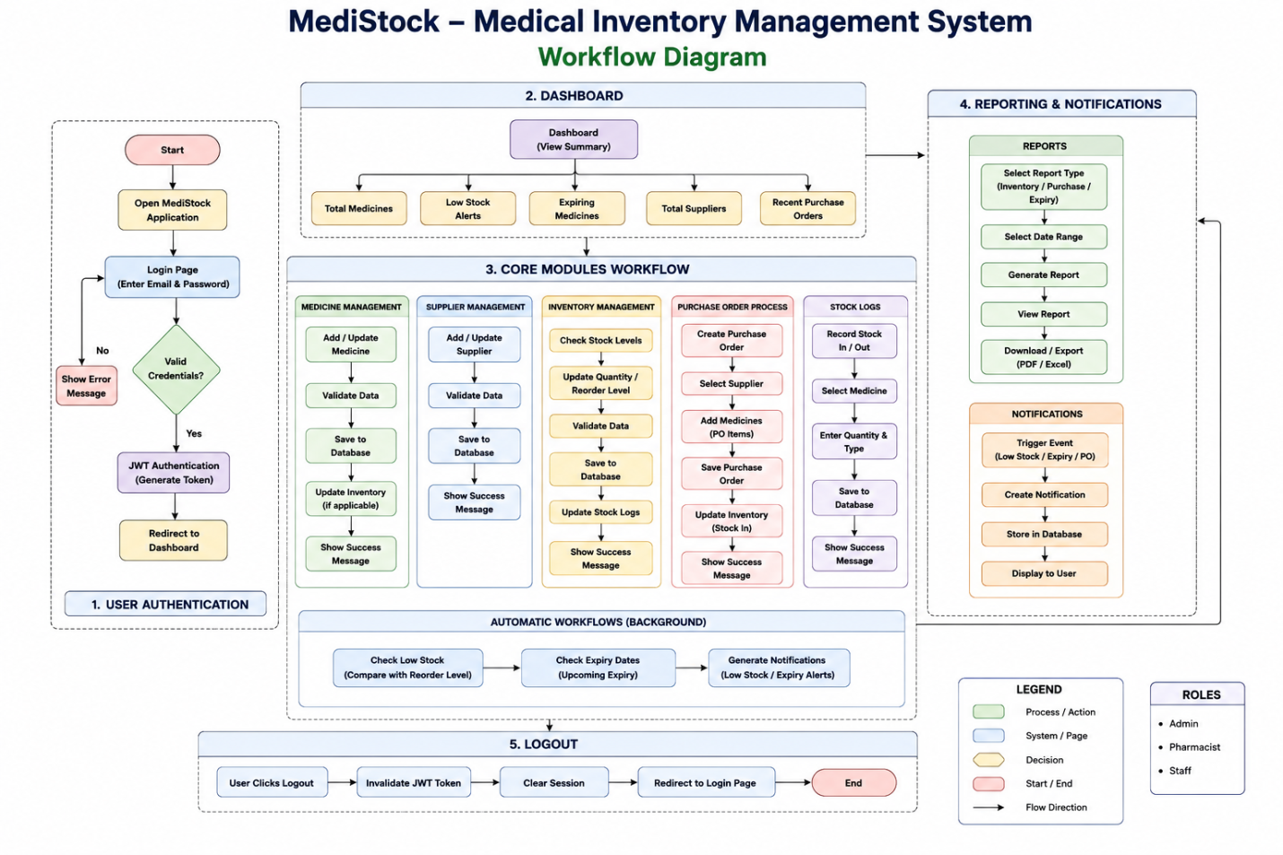 Workflow Explanation
- User Login – The user logs in using valid credentials (Admin, Pharmacist, or Staff).
- Authentication – The system verifies the login details and grants access to the dashboard.
- Dashboard – The dashboard displays an overview of medicines, inventory, suppliers, and notifications.
- Medicine Management – Users can add, update, delete, and search medicine records.
- Supplier Management – Users can manage supplier information and purchase details.
- Inventory Management – The system updates stock levels, tracks inventory, and records stock movements.
- Purchase Orders – Purchase orders are created for suppliers, and inventory is updated after successful purchases.
- Stock & Expiry Monitoring – The system continuously checks stock levels and medicine expiry dates.
- Notifications & Reports – Low-stock alerts, expiry reminders, and inventory reports are generated automatically.
- Logout – The user logs out, and the session is securely terminated.

7. System Architecture
The MediStock application follows a Three-Tier Architecture, separating the presentation, business logic, and database layers.

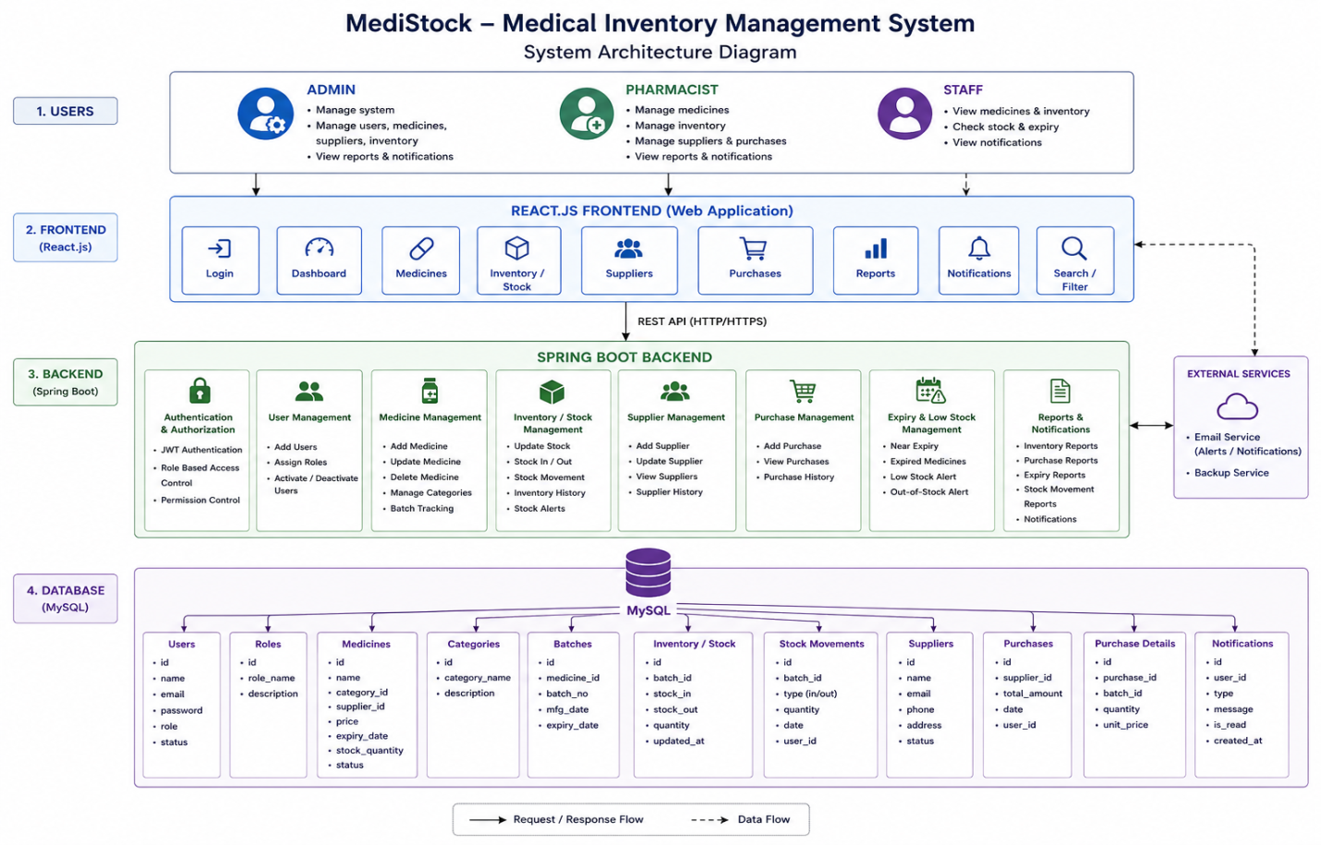

Layer | Description
Presentation Layer | React.js frontend for user interaction.
Business Layer | Spring Boot backend processes requests, validates data, and provides REST APIs.
Database Layer | MySQL stores all application data such as users, medicines, suppliers, inventory, and purchases.
Security Layer | Spring Security with JWT for authentication and authorization.

8.Database Design
Table Name | Description
Roles | Stores user roles such as Admin, Pharmacist, and Staff.
Users | Stores user login credentials and personal details.
Categories | Stores medicine categories such as Tablets, Syrups, etc.
Suppliers | Stores supplier information including contact details.
Medicines | Stores medicine details such as name, batch number, price, and expiry date.
Inventory | Maintains available stock quantity and reorder level for each medicine.
Purchase Orders | Stores purchase orders created for suppliers.
Purchase Order Items | Stores medicines included in each purchase order with quantity and price.
Stock Logs | Records all stock transactions (stock in, stock out, adjustments).
Expiry Tracking | Tracks medicine expiry dates and expiry alerts.
Notifications | Stores system notifications such as low stock and expiry alerts.
Reports | Stores information about generated inventory and purchase reports.

Database Relationships
- One Role can have many Users.
- One Category can have many Medicines.
- One Supplier can supply many Medicines.
- One Medicine has one Inventory record.
- One Purchase Order contains many Purchase Order Items.
- One Medicine can appear in many Purchase Order Items.
- One Inventory record can have many Stock Logs.
- One Medicine can have many Expiry Tracking records.
- One User can receive many Notifications.
- One User can generate many Reports.
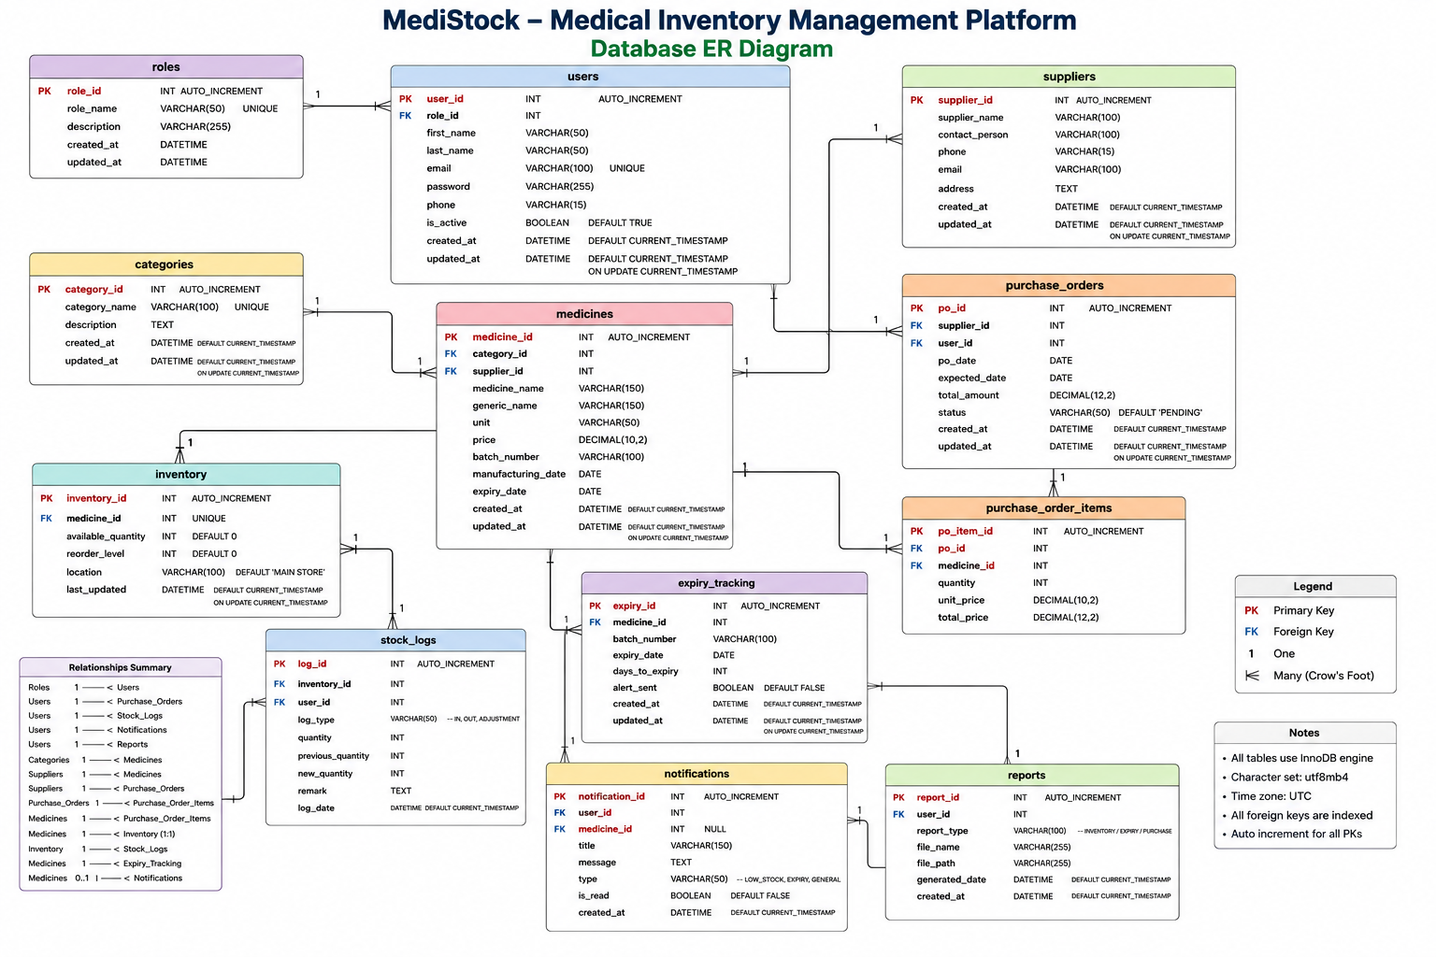

9.UI Wireframes
The MediStock application provides a simple and user-friendly interface for different user roles.
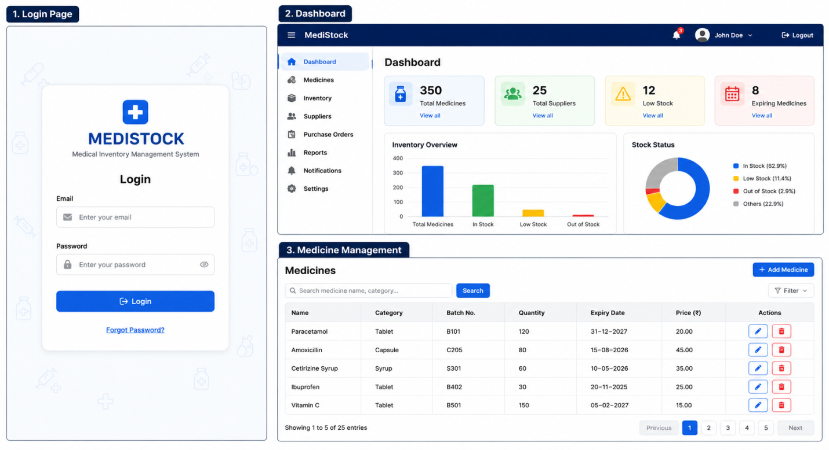
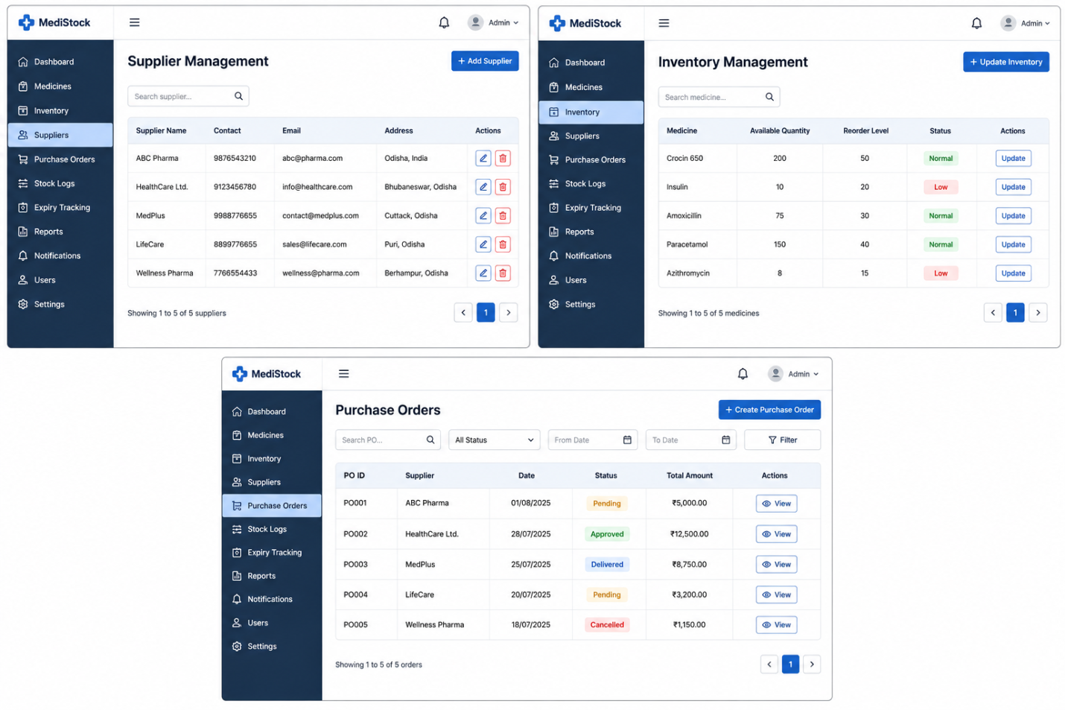
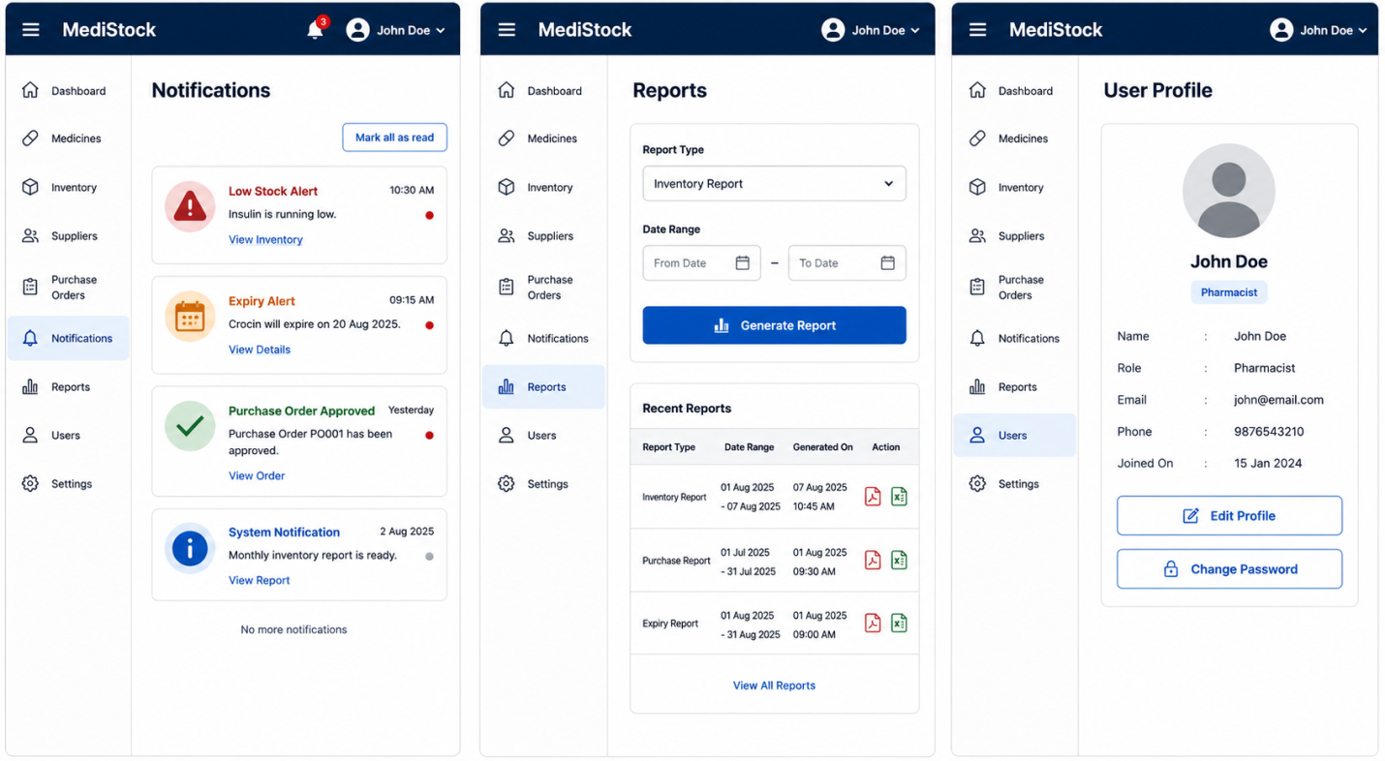
Screen | Description
Login Page | Allows users to securely log in using their email and password. Only authenticated users can access the system.
Dashboard | Displays an overview of inventory statistics, including total medicines, suppliers, low-stock items, and expiring medicines through charts and summary cards.
Medicine Management | Enables users to add, update, delete, search, and manage medicine records, including category, quantity, batch number, expiry date, and price.
Supplier Management | Allows users to manage supplier details such as supplier name, contact number, email, and address.
Inventory Management | Displays current medicine stock, available quantity, reorder level, and stock status. Users can update inventory when required.
Purchase Orders | Allows users to create, view, and manage purchase orders placed with suppliers. It records supplier details, order status, and total purchase amount.
Notifications | Displays important alerts such as low stock, medicine expiry, purchase approvals, and other system notifications.
Reports | Enables users to generate and download inventory, purchase, and expiry reports based on a selected date range.
User Profile | Allows users to view and update their personal information and change their account password securely.

