Infosys Springboard Virtual Internship 6.0

Documentation on
EnviroScan Elite Pro: Advanced AI Pollution Analytics

An advanced data-driven platform that analyzes air quality data using machine learning techniques to identify pollution sources, detect anomalies, visualize environmental trends, and generate actionable insights for effective environmental monitoring and decision-making.

Submitted by

NAME: ANABATHULA SAITEJAS
MENTOR: DUNGALA HARIKA
BATCH: 13

INDEX

S.no | Chapter | Page no
1 | Abstract | 1
2 | Introduction | 2
3 | Problem Statement | 5
4 | Objectives | 7
5 | Dataset Description | 9
6 | Data Preprocessing | 13
7 | Exploratory Data Analysis | 16
8 | Source Labeling Methodology | 19
9 | Model Development | 23
10 | Model Evaluation | 26
11 | Geospatial Visualization | 29
12 | Dashboard Implementation | 32
13 | Results and Outputs | 36
14 | Limitations | 52
15 | Future Enhancements | 55

1.ABSTRACT
Air pollution has emerged as one of the most critical environmental challenges in rapidly urbanizing regions, significantly affecting public health, climate stability, and overall quality of life. While conventional air quality monitoring systems provide real-time pollutant concentrations, they often fail to identify the underlying sources of pollution or deliver actionable insights for effective intervention. To address this limitation, the project “EnviroScan Elite Pro: Advanced AI Pollution Analytics” proposes an integrated, data-driven solution for intelligent environmental monitoring and analysis.
The system combines multiple open data sources to build a comprehensive environmental dataset. Air quality data is sourced from OpenAQ, meteorological parameters are integrated using OpenWeatherMap, and geospatial features such as proximity to roads and urban infrastructure are derived from OpenStreetMap.
Due to the absence of ground-truth labeled data for pollution sources, a rule-based labeling methodology is developed to simulate source categories such as vehicular, industrial, agricultural, burning, and natural emissions. These labels are generated using domain-informed thresholds and environmental patterns, allowing the application of supervised machine learning techniques. Models including Random Forest, Decision Tree, and XGBoost are trained on the processed dataset to predict probable pollution sources with associated confidence scores.
The project further incorporates extensive data preprocessing and feature engineering techniques, including handling missing values, removing inconsistencies, and constructing derived features such as time-based patterns and distance metrics. Model performance is evaluated using standard metrics such as accuracy, precision, recall, and F1-score to ensure robustness and reliability.
A key strength of the system lies in its advanced visualization capabilities. Interactive geospatial maps are developed to highlight pollution hotspots and high-risk zones, while analytical dashboards present trends, correlations, and comparative insights across cities. An anomaly detection engine based on machine learning identifies unusual pollution spikes and supports root cause analysis.
All functionalities are integrated into a user-friendly dashboard built using Streamlit, enabling users to upload datasets, perform real-time analysis, visualize patterns, and receive alerts through email and SMS when pollution levels exceed critical thresholds. The system also supports report generation for policy and decision-making purposes.

2.INTRODUCTION

Air pollution has become one of the most pressing environmental and public health challenges of the 21st century. Rapid urbanization, industrial expansion, increasing vehicular emissions, and unsustainable human activities have significantly contributed to the degradation of air quality across cities worldwide. According to global environmental studies, prolonged exposure to polluted air leads to severe respiratory diseases, cardiovascular disorders, and reduced life expectancy. In densely populated urban regions, the impact is even more pronounced, making effective monitoring and management of air quality a critical necessity.
Traditional air quality monitoring systems primarily focus on measuring pollutant concentrations such as particulate matter (PM2.5 and PM10), nitrogen dioxide (NO₂), sulfur dioxide (SO₂), carbon monoxide (CO), and ozone (O₃). While these systems provide valuable real-time data, they often lack deeper analytical capabilities. Specifically, they do not identify the underlying sources responsible for pollution, nor do they offer predictive insights or actionable recommendations. As a result, policymakers and environmental agencies face challenges in implementing targeted interventions, as the root causes of pollution remain unclear.
In recent years, the emergence of data science, machine learning, and geospatial technologies has opened new possibilities for addressing complex environmental problems. By leveraging these technologies, it is possible not only to monitor pollution levels but also to analyze patterns, predict sources, and generate meaningful insights for decision-making. However, integrating diverse datasets—such as air quality measurements, meteorological conditions, and spatial information—into a unified analytical framework remains a significant challenge.
The project “EnviroScan Elite Pro: Advanced AI Pollution Analytics” is developed to bridge this gap by providing an intelligent, end-to-end solution for environmental monitoring and analysis. The system integrates multi-source data, including air quality data from OpenAQ, weather data from OpenWeatherMap, and geospatial features derived from OpenStreetMap. This integration enables a comprehensive understanding of how various environmental and spatial factors influence pollution levels.

One of the major challenges in developing such a system is the lack of labeled datasets that explicitly identify pollution sources. Unlike traditional classification problems, where labeled data is readily available, environmental datasets rarely include ground-truth information about the origin of pollutants. To address this issue, the project adopts a rule-based labeling approach, where pollution sources are inferred based on domain knowledge, pollutant thresholds, and environmental conditions. These simulated labels are then used to train machine learning models capable of predicting probable pollution sources.
The system employs multiple machine learning algorithms, including Random Forest, Decision Tree, and XGBoost, to ensure accurate and robust predictions. These models are trained on carefully preprocessed data, incorporating feature engineering techniques such as time-based features, weather interactions, and distance-based spatial attributes. The use of ensemble and tree-based methods allows the system to capture complex, non-linear relationships between variables, thereby improving prediction performance.
Beyond predictive modeling, the project places strong emphasis on visualization and interpretability. Advanced geospatial visualization techniques are implemented to generate interactive heatmaps and identify pollution hotspots across different regions. These visualizations enable users to intuitively understand spatial patterns and high-risk zones. Additionally, exploratory data analysis provides insights into correlations between pollutants and meteorological parameters, helping to uncover hidden trends and relationships.
A significant component of the project is the development of an interactive dashboard using Streamlit. The dashboard serves as a centralized platform where users can upload datasets, perform analysis, visualize results, and obtain predictions in real time. It integrates multiple features such as city comparison, trend analysis, anomaly detection, and report generation. Furthermore, the system includes an alert mechanism that sends notifications via email and SMS when pollution levels exceed predefined thresholds, facilitating timely action.
The inclusion of an anomaly detection engine further enhances the system’s capabilities by identifying unusual pollution spikes that may indicate critical environmental events. By analyzing deviations from normal patterns, the system can assist in early detection of hazardous conditions and support proactive intervention strategies. Additionally, the platform generates automated reports summarizing key findings, pollution trends, and policy recommendations, making it useful for environmental agencies, urban planners, and researchers.

Despite its comprehensive design, the project acknowledges certain limitations. The reliance on rule-based labeling introduces assumptions that may not perfectly reflect real-world conditions. Moreover, the availability and quality of data can impact model performance and accuracy. However, the system is designed to be scalable and adaptable, allowing for future enhancements such as integration with real-time APIs, incorporation of satellite data, and use of advanced deep learning models.

3.PROBLEM STATEMENT

Air pollution has become one of the most critical environmental and public health challenges worldwide. Rapid urbanization, industrial growth, increasing vehicular emissions, and unregulated waste burning have significantly contributed to the deterioration of air quality. Although many cities continuously monitor air quality using parameters such as PM2.5, PM10, NO₂, SO₂, CO, and O₃, the available systems primarily focus on reporting pollution levels rather than providing deeper insights.
The major challenge lies in identifying the actual sources of pollution and understanding the underlying causes behind sudden spikes or consistently high pollution levels. Without accurate source identification, it becomes difficult for authorities and policymakers to take targeted actions.

Importance of Identifying Pollution Sources
Identifying pollution sources is essential for effective environmental management and policy formulation. Different sources such as vehicular emissions, industrial activities, agricultural burning, and natural factors contribute differently to pollution levels. A generalized approach to pollution control often leads to inefficient use of resources and limited impact.
Accurate source identification helps in:
- Implementing targeted control measures (e.g., traffic regulation, industrial emission control)
- Designing data-driven environmental policies
- Reducing health risks associated with prolonged exposure to pollutants
- Improving urban planning and sustainability strategies
- Enabling timely interventions during high pollution events
By understanding not just what the pollution levels are, but why they occur, more effective and long-term solutions can be developed.

Limitations of Existing Systems
Current air quality monitoring systems have several limitations:
- Lack of Source Attribution: Most systems only display AQI values without identifying the probable source of pollution.
- Limited Data Analysis: Existing platforms provide basic visualizations but lack advanced analytical capabilities such as anomaly detection and root cause analysis.
- No Predictive Intelligence: There is minimal use of machine learning to predict pollution sources or future trends.
- Poor Decision Support: Authorities do not receive actionable insights or recommendations based on data.
- Limited Interactivity: Many systems lack dynamic visualizations such as geospatial mapping, clustering, and multi-dimensional analysis.
- Absence of Automated Reporting: Generating detailed reports for analysis and policy-making is often manual and time-consuming.

4.OBJECTIVES

The primary objective of this project is to design and develop an advanced, AI-powered environmental monitoring system that not only analyzes air quality data but also provides meaningful insights for decision-making. The key goals of the project are as follows:
1. Pollution Source Prediction
- To accurately identify and classify the major sources of air pollution such as vehicular emissions, industrial activities, agricultural practices, biomass burning, and natural sources.
- To use machine learning models for predicting the dominant pollution source based on pollutant and meteorological data.
2. Air Quality Analysis
- To monitor and analyze key air pollutants including PM2.5, PM10, NO₂, SO₂, CO, and O₃.
- To compute Air Quality Index (AQI) levels and categorize them into standard health-based classifications.
3. Visualization of Pollution Patterns
- To present pollution data through interactive dashboards using graphs, charts, and 3D visualizations.
- To identify spatial and temporal pollution patterns such as peak hours, seasonal variations, and long-term trends.
4. Geospatial Intelligence and Hotspot Detection
- To map pollution levels across different locations using interactive maps.
- To detect high-risk zones and pollution hotspots using heatmaps, clustering, and marker-based visualization.
5. Real-Time Monitoring and Alerts
- To enable real-time analysis of environmental data.
- To generate instant alerts via email and SMS when pollution levels exceed critical thresholds.
6. Anomaly Detection and Root Cause Analysis
- To detect unusual spikes or abnormal pollution events using AI-based anomaly detection techniques.
- To analyze and identify possible causes behind sudden increases in pollution levels.
7. Multi-City Comparison and Analysis
- To compare pollution levels, sources, and trends across multiple cities.
- To support comparative decision-making for urban planning and policy formulation.
8. Policy Support and Decision Insights
- To provide data-driven insights and recommendations for policymakers and environmental authorities.
- To assist in designing effective pollution control strategies.
9. Automated Report Generation
- To generate structured reports (daily, weekly, anomaly-based, and summary reports) for easy interpretation and documentation.
- To facilitate sharing of environmental insights with stakeholders.

5.DATASET DESCRIPTION

The effectiveness of any data-driven system depends heavily on the quality and diversity of the dataset used. In this project, multiple reliable and real-time data sources have been integrated to build a comprehensive environmental dataset that captures both pollution levels and influencing factors.

5.1 Data Sources Used
To ensure accuracy and real-world applicability, the project combines data from the following sources:
- OpenAQ (Air Quality Data):
OpenAQ provides publicly accessible, real-time and historical air quality data collected from monitoring stations across various cities. It includes detailed measurements of major air pollutants.
- OpenWeatherMap (Meteorological Data):
Weather conditions play a crucial role in pollution dispersion and accumulation. OpenWeatherMap is used to collect environmental parameters such as temperature, humidity, and wind speed corresponding to the pollution data.
- OpenStreetMap / OSMnx (Geospatial Data):
Geospatial features are extracted using OpenStreetMap through OSMnx to understand the surrounding environment of monitoring locations. This includes proximity to roads, industrial areas, and other urban infrastructure.

5.2 Features Collected
The dataset includes a combination of pollution, meteorological, spatial, and temporal features to enable accurate analysis and prediction.

1. Pollutant Features
These represent the concentration levels of major air pollutants:
- PM2.5 (Fine particulate matter)
- PM10 (Coarse particulate matter)
- NO₂ (Nitrogen Dioxide)
- SO₂ (Sulfur Dioxide)
- CO (Carbon Monoxide)
- O₃ (Ozone)
These pollutants are critical indicators of air quality and are used to compute the Air Quality Index (AQI).

2. Weather Parameters
Meteorological factors significantly influence pollution behavior:
- Temperature (°C)
- Humidity (%)
- Wind Speed (m/s)
These parameters help in understanding pollutant dispersion, accumulation, and seasonal variations.

3. Distance-Based Features
To enhance source prediction accuracy, spatial features are included:
- Distance to nearest major road
- Distance to industrial zones
- Location coordinates
These features help in identifying the likely origin of pollution, such as vehicular or industrial sources.

4. Temporal Features
Time-based attributes are used to analyze patterns and trends:
- Year
- Month
- Day
- Hour
These features allow the system to detect peak pollution hours, seasonal effects, and daily variations.

5.3 Cities Selected
The dataset includes data from multiple cities to ensure diversity and scalability of the model. Cities are selected based on:
- Availability of continuous air quality data
- Geographic diversity
- Urban and semi-urban representation
This multi-city approach enables comparative analysis and improves the generalization capability of the model.

5.4 Time Range of Data
The dataset consists of historical as well as recent data collected over a defined time period. This includes:
- Continuous hourly or daily records
- Coverage across different seasons

- Inclusion of both normal and high-pollution periods
The time range ensures that the model captures both short-term fluctuations and long-term pollution trends, making predictions more reliable.

6.DATA PREPROCESSING

Data preprocessing is a critical step in the development of this system, as it ensures that the raw data collected from multiple sources is clean, consistent, and suitable for analysis and machine learning. The preprocessing pipeline was carefully designed to improve data quality and enhance model performance.

6.1 Handling Missing Values
Due to the integration of multiple real-world data sources, the dataset contained missing or incomplete values in several attributes. These were handled using the following approaches:
- Numerical Features:
Missing values in pollutant and meteorological parameters (e.g., PM2.5, NO₂, temperature) were handled using:
  - Mean or median imputation where appropriate
  - Default value replacement (e.g., 0) for features required by the model
- Categorical Features:
Missing categorical values such as city names or source labels were either:
  - Filled with a placeholder value (e.g., “Unknown”), or
  - Excluded if they were not critical for analysis
- Row Filtering:
Records with excessive missing values or critical missing fields (such as pollutant data or location coordinates) were removed to maintain dataset reliability.

6.2 Removing Duplicates
Duplicate records can negatively impact analysis and model training. To address this:
- Duplicate rows based on key attributes (timestamp, location, and pollutant values) were identified.
- Exact duplicates were removed to ensure that each record represents a unique observation.
- This step helped in avoiding bias and overrepresentation of certain data points.

6.3 Data Cleaning Steps
To maintain consistency and accuracy, several data cleaning operations were performed:
- Data Type Conversion:
All numerical columns were converted to appropriate numeric formats using safe parsing techniques.
- Outlier Handling:
Extreme or unrealistic values (e.g., negative pollutant concentrations) were identified and either corrected or removed.
- Column Standardization:
Column names were standardized for uniformity (e.g., consistent naming like “PM2.5”, “NO2”).
- Timestamp Formatting:
Date and time fields were converted into proper datetime format to enable time-based analysis.
- Unit Consistency:
Ensured that all pollutant values and meteorological parameters follow consistent units across the dataset.

6.4 Feature Engineering
To enhance the predictive capability of the model, several new features were derived from the existing data:

- Air Quality Index (AQI):
Computed based on pollutant concentrations to represent overall air quality in a single value.
- Time-Based Features:
  - Hour category (e.g., morning, afternoon, evening, night)
  - Weekend/weekday indicator
  - Peak pollution hour identification
- Geospatial Features:
- Distance to nearest road or pollution source
- Location-based clustering indicators
- Derived Indicators:
  - Health index (weighted pollutant impact)
  - Pollution severity classification
These engineered features help in improving model accuracy and enable deeper insights.

6.5 Normalization and Scaling
To ensure that all features contribute equally to the model:
- Numerical features were normalized or scaled where required, especially for machine learning algorithms sensitive to feature magnitude.
- Techniques such as:
  - Min-Max Scaling
  - Standardization (Z-score normalization)
were considered depending on the model requirements.
- In cases where tree-based models (e.g., Random Forest, XGBoost) were used, scaling was optional but still applied for consistency in visualization and analysis.

7.EXPLORATORY DATA ANALYSIS

Exploratory Data Analysis (EDA) was performed to understand the structure, distribution, and relationships within the dataset. This step plays a crucial role in identifying patterns, detecting anomalies, and guiding model development. Various statistical methods and visualizations were used to extract meaningful insights from the data.

7.1 Key Observations
- Dominance of Particulate Matter:
PM2.5 and PM10 were observed to be the most influential pollutants contributing to poor air quality across most cities.
- Variation Across Cities:
Significant differences in pollution levels were identified between cities, indicating the influence of local factors such as traffic density, industrial presence, and urban planning.
- Peak Pollution Periods:
Higher pollution levels were commonly observed during early morning and late evening hours, which correspond to peak traffic times and reduced atmospheric dispersion.
- Seasonal Influence:
Pollution levels showed variation across different months, with higher concentrations during colder periods, possibly due to temperature inversion and reduced wind flow.
- Presence of Extreme Values:
Certain records indicated very high pollutant concentrations, suggesting the occurrence of pollution spikes or abnormal events.

7.2 Important Visualizations
A variety of visual tools were used to better understand the data:
- Distribution Plots (Histograms):
Used to analyze the spread and skewness of pollutant concentrations, revealing that most pollutants follow a right-skewed distribution.
- Time Series Graphs:
Showed trends of pollutants over time, helping to identify peak hours, daily cycles, and long-term variations.
- Bar Charts and Pie Charts:
Used to visualize the distribution of predicted pollution sources and their proportions.
- Heatmaps:
Displayed correlation between different pollutants and meteorological factors.
- Geospatial Maps:
Heatmaps and marker-based maps were used to identify pollution hotspots and high-risk zones across different locations.
- 3D Visualizations:
Surface and scatter plots were used to explore multi-dimensional relationships between pollutants, time, and AQI.

7.3 Correlation Insights
Correlation analysis was performed to understand relationships between variables:
- Strong Positive Correlation:
  - PM2.5 and PM10 showed high correlation, indicating common sources such as dust and combustion.
- Moderate Correlation:
  - NO₂ and CO showed correlation with traffic-related emissions.
- Negative Correlation:
  - Wind speed showed a negative relationship with pollutant levels, indicating that higher wind speeds help disperse pollutants.
- Meteorological Influence:
  - Humidity and temperature showed varying degrees of influence on pollutant concentration depending on environmental conditions.
These insights helped in selecting relevant features for model training.

7.4 Patterns Discovered
- Urban Pollution Patterns:
Cities with higher traffic and industrial activity showed consistently elevated pollution levels.
- Time-Based Patterns:
  - Morning and evening peaks were linked to human activities.
  - Nighttime accumulation was observed due to reduced atmospheric mixing.
- Source-Based Patterns:
Certain pollutant combinations were strongly associated with specific sources:
  - High NO₂ and CO → Vehicular emissions
  - High SO₂ → Industrial sources
  - High PM levels → Dust or biomass burning
- Anomaly Patterns:
Sudden spikes in pollutant levels indicated unusual events such as fire incidents, industrial releases, or weather changes.

8.SOURCE LABELING METHODOLOGY

In the absence of publicly available datasets containing ground-truth labels for pollution sources, a rule-based labeling approach was adopted to generate approximate source categories. This methodology plays a crucial role in enabling supervised learning for pollution source prediction.

8.1 Need for Source Labeling
Most air quality datasets provide pollutant concentrations but do not specify the actual source of pollution (e.g., vehicular, industrial). Since supervised machine learning models require labeled data, it was necessary to assign source labels based on domain knowledge and observed pollutant patterns.

8.2 Rule-Based Labeling Logic
A deterministic rule-based system was designed to assign pollution sources based on combinations and dominance of specific pollutants. The logic is based on widely accepted environmental patterns:
- Vehicular Source:
  - High levels of NO₂ and CO
  - Moderate PM2.5 levels
  - Typically observed in urban traffic zones
- Industrial Source:
  - Elevated SO₂ and NO₂ concentrations
  - Often accompanied by moderate to high PM levels
- Agricultural Source:
  - High PM2.5 and PM10 levels
  - Occurs in regions with crop residue burning or dust movement
- Biomass / Burning Source:
  - Very high PM2.5 levels
  - Associated with sudden spikes indicating open burning or fire events
- Natural Source:
  - Moderate PM levels with low gaseous pollutants
  - Linked to dust storms, pollen, or natural environmental factors
Each data record was evaluated against these rules, and the most matching condition was used to assign a source label.

8.3 Threshold Values Used
Specific threshold values were defined to categorize pollutant levels:
- PM2.5:
  - Moderate: 50–100 µg/m³
  - High: >100 µg/m³
- NO₂:
  - High: >40 µg/m³
- SO₂:
  - High: >40 µg/m³
- CO:
  - Elevated: >1 mg/m³
These thresholds were chosen based on general environmental standards and observed data distributions. The values may vary slightly depending on regional guidelines but provide a reasonable basis for classification.

8.4 Assumptions Made
Several assumptions were considered while designing the labeling methodology:
- Pollutant concentration patterns can be used as proxies for identifying pollution sources.
- Each record is assumed to have one dominant source of pollution.
- External influencing factors such as meteorological variations are indirectly captured through pollutant behavior.
- Spatial features (such as proximity to roads) support but do not solely determine the source classification.

8.5 Limitations
This methodology has certain limitations that must be acknowledged:
- Lack of Ground Truth:
The labels are not based on actual verified source data but are simulated using heuristic rules.
- Over-Simplification:
Real-world pollution is often caused by multiple sources simultaneously, whereas the model assumes a single dominant source.
- Threshold Sensitivity:
The choice of threshold values may influence classification outcomes and may not be universally applicable.
- Regional Variations:
Pollution patterns may differ across regions, and a single rule set may not capture all local characteristics.
- Limited External Factors:
Factors such as wind direction, topography, and emission inventories are not explicitly considered in labeling.

8.6 Important Note
It is important to emphasize that the pollution source labels used in this project are simulated and not derived from ground-truth observations. They are generated using rule-based logic to enable model training and should be interpreted as approximate indicators rather than exact classifications.

9.MODEL DEVELOPMENT

The model development phase focuses on building a robust machine learning framework to predict the probable source of air pollution based on pollutant concentrations, meteorological conditions, and spatial features. Multiple algorithms were evaluated to achieve high accuracy and generalization.

9.1 Models Used
To ensure reliable performance, the following supervised machine learning models were implemented and compared:
- Random Forest Classifier:
  - An ensemble learning method based on multiple decision trees.
  - Handles non-linear relationships effectively and reduces overfitting through averaging.
  - Provides feature importance, making it useful for interpretability.
- Decision Tree Classifier:
  - A simple and interpretable model that splits data based on feature thresholds.
  - Useful for understanding decision boundaries and rule extraction.
  - Acts as a baseline model for comparison.
- XGBoost (Extreme Gradient Boosting):
  - An advanced boosting algorithm known for high performance and efficiency.
  - Handles complex patterns and interactions between features.
  - Incorporates regularization to prevent overfitting and improve generalization.
These models were selected due to their ability to handle structured tabular data and capture non-linear relationships in environmental datasets.

9.2 Feature Selection
Feature selection was carried out to improve model performance and reduce computational complexity. The following categories of features were used:
- Pollutant Features:
PM2.5, PM10, NO₂, SO₂, CO, O₃
- Meteorological Features:
Temperature, humidity, wind speed
- Spatial Features:
Latitude, longitude, distance to road
- Temporal Features:
Hour, day, month
Feature importance analysis (especially from Random Forest and XGBoost) was used to identify the most influential variables. Less relevant or redundant features were either removed or given lower priority.

9.3 Train-Test Split Approach
To evaluate model performance effectively, the dataset was divided into training and testing sets:
- Split Ratio:
Typically, 80% of the data was used for training and 20% for testing.
- Stratification:
Stratified sampling was applied (where applicable) to ensure that all pollution source classes were proportionally represented in both training and testing sets.
- Data Leakage Prevention:
Care was taken to ensure that no future or dependent information leaked into the training phase.
This approach ensures that the model is evaluated on unseen data, providing a realistic estimate of performance.

9.4 Hyperparameter Tuning Method
To optimize model performance, hyperparameter tuning was performed using systematic approaches:
- Grid Search / Random Search:
Different combinations of parameters were tested to identify the optimal configuration.
- Key Parameters Tuned:
  - Random Forest: Number of trees (n_estimators), maximum depth, minimum samples split
  - Decision Tree: Maximum depth, splitting criteria (Gini/Entropy)
  - XGBoost: Learning rate, number of estimators, maximum depth, subsampling ratio
- Cross-Validation:
K-fold cross-validation was used to ensure that the model performs consistently across different subsets of data.
- Evaluation Metric:
Accuracy and classification performance metrics were used to select the best model.

10.MODEL EVALUATION

Model evaluation is a crucial step to assess how effectively the trained machine learning models predict pollution sources. Various performance metrics were used to evaluate classification accuracy and reliability. These metrics provide a comprehensive understanding of the model’s strengths and limitations.

10.1 Evaluation Metrics Used
The following standard classification metrics were used:

1. Accuracy
- Accuracy measures the overall correctness of the model.
- It is defined as the ratio of correctly predicted observations to the total observations.
Accuracy=Correct Predictions / Total PredictionsAccuracy
- Observation:
The ensemble models (Random Forest and XGBoost) achieved high accuracy, indicating that the model correctly predicts pollution sources in most cases.

2. Precision
- Precision measures how many of the predicted positive instances are actually correct.
- It is especially important when false positives need to be minimized.
Precision=True Positives /( True Positives+False Positives)
- Observation:
High precision values indicate that when the model predicts a specific pollution source (e.g., industrial), it is usually correct.

3. Recall (Sensitivity)
- Recall measures the ability of the model to correctly identify all actual positive instances.
Recall=True Positives / (True Positives+False Negatives )
- Observation:
Good recall ensures that most pollution events belonging to a particular source are successfully detected.

4. F1-Score
- F1-score is the harmonic mean of precision and recall.
- It provides a balanced measure, especially when class distribution is uneven.
F1=2×(Precision×Recall) / (Precision+Recall )
- Observation:
A high F1-score indicates a good balance between precision and recall, making the model reliable across all classes.

5. Confusion Matrix
- A confusion matrix provides a detailed breakdown of:
  - True Positives (TP)
  - True Negatives (TN)
  - False Positives (FP)
  - False Negatives (FN)
- It helps visualize how well the model distinguishes between different pollution source categories.
- Observation:
  - Most predictions fall along the diagonal, indicating correct classifications.
  - Minor misclassifications occur between similar source categories (e.g., agricultural vs. natural sources).

10.2 Interpretation of Results
- High Overall Performance:
The model demonstrates strong predictive capability, especially with ensemble methods like Random Forest and XGBoost.
- Better Performance on Distinct Sources:
Pollution sources with clear pollutant signatures (e.g., industrial with high SO₂) are predicted with higher accuracy.
- Challenges in Overlapping Patterns:
Some sources share similar pollutant characteristics, leading to occasional misclassification.
- Balanced Model Behavior:
The combination of high precision and recall indicates that the model is neither overly biased nor missing significant patterns.

Model evaluation is a crucial step to assess how effectively the trained machine learning models predict pollution sources. Various performance metrics were used to evaluate classification accuracy and reliability. These metrics provide a comprehensive understanding of the model’s strengths and limitations.

11.GEOSPATIAL VISUALIZATION

Geospatial visualization plays a vital role in understanding the spatial distribution of air pollution and identifying high-risk areas. In this project, interactive mapping techniques were used to represent pollution data in a visually intuitive and user-friendly manner, enabling better analysis and decision-making.

11.1 Tools Used
The following tools and libraries were utilized for geospatial analysis and visualization:
- Folium:
  - A powerful Python library used to create interactive maps.
  - Supports layers, markers, heatmaps, and user interaction features such as zooming and tooltips.
  - Integrated with the application to display real-time pollution data on maps.
- GeoPandas (Optional Usage):
  - Used for handling geospatial data structures and performing spatial operations.
  - Facilitates analysis of geographic boundaries and location-based relationships.
- Additional Map Plugins:
  - HeatMap plugin for density visualization
  - MarkerCluster for grouping nearby data points
  - LayerControl for toggling different visualization modes

11.2 Heatmap Generation
Heatmaps were generated to represent the intensity of pollution across different geographic regions:
- Latitude and longitude coordinates were used as base inputs.
- Pollutant concentration (primarily PM2.5) was used as the weight parameter.
- Areas with higher pollution levels appear in warmer colors (red/yellow), while cleaner areas appear in cooler colors (blue/green).
- Adjustable parameters such as radius, blur, and opacity were used to enhance visualization clarity.
This approach helps in quickly identifying pollution hotspots and understanding spatial concentration patterns.

11.3 Marker Logic for Pollution Sources
Marker-based visualization was used to display detailed information at specific locations:
- Each monitoring point is represented by a marker on the map.
- Marker color is determined based on AQI levels:
  - Green → Good air quality
  - Orange → Moderate pollution
  - Red → Poor or hazardous conditions
- Additional information is displayed using popups and tooltips, including:
  - City name
  - AQI value and category
  - Pollutant concentrations (e.g., PM2.5)
  - Predicted pollution source
  - Model confidence level
  - Weather conditions (temperature, wind speed)
- Marker clustering is used to group nearby locations, improving map readability when handling large datasets.

11.4 High-Risk Zone Identification
The system identifies and highlights high-risk pollution zones using multiple approaches:

- Threshold-Based Identification:
Locations with AQI values exceeding critical levels (e.g., AQI > 300) are classified as high-risk zones.
- Color-Coding Strategy:
High-risk areas are visually emphasized using red or dark-colored markers.

- Clustering Techniques:
Dense clusters of high pollution readings indicate potential pollution hotspots.
- Multi-Layer Visualization:
Users can switch between different map layers such as heatmap, risk markers, and clustered views to gain deeper insights.
- Interactive Tools:
Additional map features such as drawing tools, distance measurement, and location tracking allow users to analyze specific regions in detail.

12.DASHBOARD IMPLEMENTATION

The project includes a fully interactive and feature-rich dashboard developed using Streamlit, designed to provide real-time environmental insights, AI-based predictions, and advanced visual analytics. The dashboard serves as the central interface for users to interact with the system, explore data, and generate actionable insights.

12.1 Streamlit Dashboard Features
The dashboard integrates multiple advanced features to deliver a complete environmental intelligence system:
- AI-Based Pollution Source Prediction:
Automatically predicts the dominant pollution source (Vehicular, Industrial, Agricultural, Burning, Natural) along with confidence scores.
- Real-Time Data Analysis:
Processes uploaded datasets instantly and generates insights without delay.
- Interactive Visualizations:
Includes dynamic charts such as bar graphs, pie charts, line charts, radar plots, and 3D visualizations.
- City Comparison Mode:
Allows users to compare multiple cities based on AQI, pollutant levels, and dominant sources.
- Geospatial Intelligence:
Provides multiple map visualization modes including heatmaps, risk markers, clustering, and multi-layer views.
- Anomaly Detection Engine:
Detects unusual pollution spikes using AI and highlights critical events.
- Automatic Root Cause Analysis:
Identifies possible reasons behind pollution trends using data-driven logic.
- Policy Recommendations:
Generates actionable suggestions for controlling pollution based on analysis.
- Export Functionality:
Allows downloading reports in multiple formats such as CSV and TXT.

12.2 User Inputs
The dashboard provides flexible input options to accommodate different user needs:
- CSV File Upload:
Users can upload their own environmental dataset containing pollutant and meteorological data.
- Manual Input (Optional):
Users can input individual data values for instant prediction and testing.
- City Selection:
Dropdown or multi-select options allow users to analyze specific cities or compare multiple locations.
- Feature Controls:
Options to enable or disable advanced features such as 3D visualizations, correlation analysis, and auto-refresh.

12.3 Prediction Display
The dashboard presents prediction results in a clear and informative manner:
- Predicted Pollution Source:
Displayed prominently along with category labels.
- Confidence Score:
Indicates the reliability of the prediction.
- AQI Value and Category:
Shows air quality status (Good, Moderate, Poor, etc.) with color-coded indicators.
- Health Impact Indicator:
Provides a simplified health index based on pollutant exposure.

- Key Statistics:
Includes average AQI, maximum AQI, dominant source, and anomaly counts.

12.4 Charts and Map Integration
The dashboard integrates multiple visualization components for comprehensive analysis:
Charts:
- Pollution Trends: Time-series graphs for pollutants
- Source Distribution: Pie charts showing contribution of each source
- City Comparison: Grouped bar charts and radar plots
- Correlation Heatmap: Shows relationships between pollutants and weather
- 3D Visualizations: Surface and scatter plots for multi-dimensional analysis
Maps:
- Heatmap Overlay: Displays pollution intensity across regions
- Risk Zone Markers: Highlights high AQI areas with color-coded markers
- Cluster Analysis: Groups nearby monitoring stations
- Multi-Layer View: Combines multiple visualization layers for deeper insights
Interactive map tools include:
- Drawing zones
- Distance measurement
- Location tracking
- Full-screen view

12.5 Alert System
An integrated alert system ensures timely notification of critical pollution events:
- Threshold-Based Alerts:
Alerts are triggered when AQI or pollutant levels exceed predefined limits.
- Email Notifications:
Users can receive alerts via email using SMTP configuration.
- SMS Alerts:
Integration with SMS API enables real-time mobile notifications.
- Anomaly Alerts:
Automatically generated when unusual pollution spikes are detected by the AI model.
- Alert History Tracking:
Maintains a record of triggered alerts for analysis and review.

13.RESULTS AND OUTPUTS

The developed system, EnviroScan Elite Pro, successfully delivers a comprehensive analysis of air pollution by integrating machine learning, geospatial intelligence, and interactive visualization. The outputs generated by the system are both analytical and visual, enabling users to clearly understand pollution patterns, sources, and risk levels across different cities.

The results demonstrate that the model is capable of:
- Accurately predicting dominant pollution sources
- Identifying high-risk pollution zones
- Detecting anomalies in pollution trends
- Providing actionable insights for environmental monitoring

13.1 Dashboard Output
The interactive Streamlit dashboard serves as the primary output interface of the system.
Key highlights observed:
- Real-time display of AQI levels and pollutant concentrations
- Clear identification of dominant pollution source with confidence score
- Dynamic filtering based on city, time, and dataset selection
- Summary statistics such as:
  - Average AQI
  - Maximum AQI
  - Health index
The dashboard ensures that even non-technical users can easily interpret complex environmental data.

13.2. Heatmap Visualization
The system generates geospatial heatmaps using latitude and longitude data.
Observed outcomes:
- High pollution zones are represented using red and yellow gradients
- Cleaner regions appear in green or blue shades
- Dense clusters of pollution indicate urban hotspots or industrial regions
These heatmaps provide a quick and intuitive understanding of spatial pollution distribution.

13.3 Charts and Graphical Outputs
Multiple visualizations were generated to analyze pollution trends:
a) Pollution Source Distribution (Pie Chart)
- Displays percentage contribution of different sources such as:
  - Vehicular
  - Industrial
  - Agricultural
  - Burning
  - Natural
- Helps in identifying the dominant contributor in a city
b) Time-based Analysis (Bar Charts)
- Shows variation of pollution sources across:
  - Hours of the day
  - Months

- Helps identify peak pollution periods

c) City Comparison Charts
- Enables comparison of multiple cities using:
  - AQI
  - PM2.5
  - NO₂ levels
- Radar charts highlight multi-pollutant exposure differences
d) 3D Visualizations
- Surface plots show PM2.5 variation across time (hour vs day)
- 3D scatter plots reveal relationships between pollutants
e) Correlation Heatmap
- Displays relationships between pollutants and weather parameters
- Helps in identifying:
  - Strong positive correlations (e.g., PM2.5 & PM10)
  - Environmental dependencies

13.4 Anomaly Detection Outputs
The system identifies unusual pollution spikes using an AI-based anomaly detection model.
Key outputs include:
- Total number of anomalies detected
- Severe pollution events (e.g., PM2.5 > 250 µg/m³)
- Timeline of pollution spikes
- Top 10 critical pollution events
Each anomaly is further enriched with:
- Severity classification
- Predicted root cause
- Source prediction confidence
This helps in early identification of critical environmental events.

13.5 Geospatial Risk Mapping
The map-based outputs include:
- Risk zone markers indicating AQI severity
- Cluster visualization of monitoring stations
- Multi-layer maps combining:
  - Heatmaps
  - Risk markers
  - Clusters
These outputs assist in:
- Urban planning
- Environmental monitoring
- Public awareness

13.6 Automated Reports
The system provides downloadable reports in multiple formats:
- Daily Report (CSV) – Aggregated daily pollution data
- Weekly Report (CSV) – Trend analysis over weeks
- Anomaly Report (CSV) – Detailed anomaly events
- Full Summary Report (TXT) – Comprehensive environmental assessment

These reports include:
- AQI statistics
- Pollutant averages
- Source distribution
- Policy recommendations

13.7 Key Outcomes Achieved
From the implementation of this system, the following outcomes were achieved:
- Accurate prediction of pollution sources using machine learning
- Effective visualization of pollution hotspots using geospatial tools
- Identification of temporal pollution trends and peak hours
- Detection of abnormal pollution spikes using AI
- Generation of data-driven insights and policy recommendations
- Development of a fully interactive and user-friendly dashboard

SCREENSHOTS
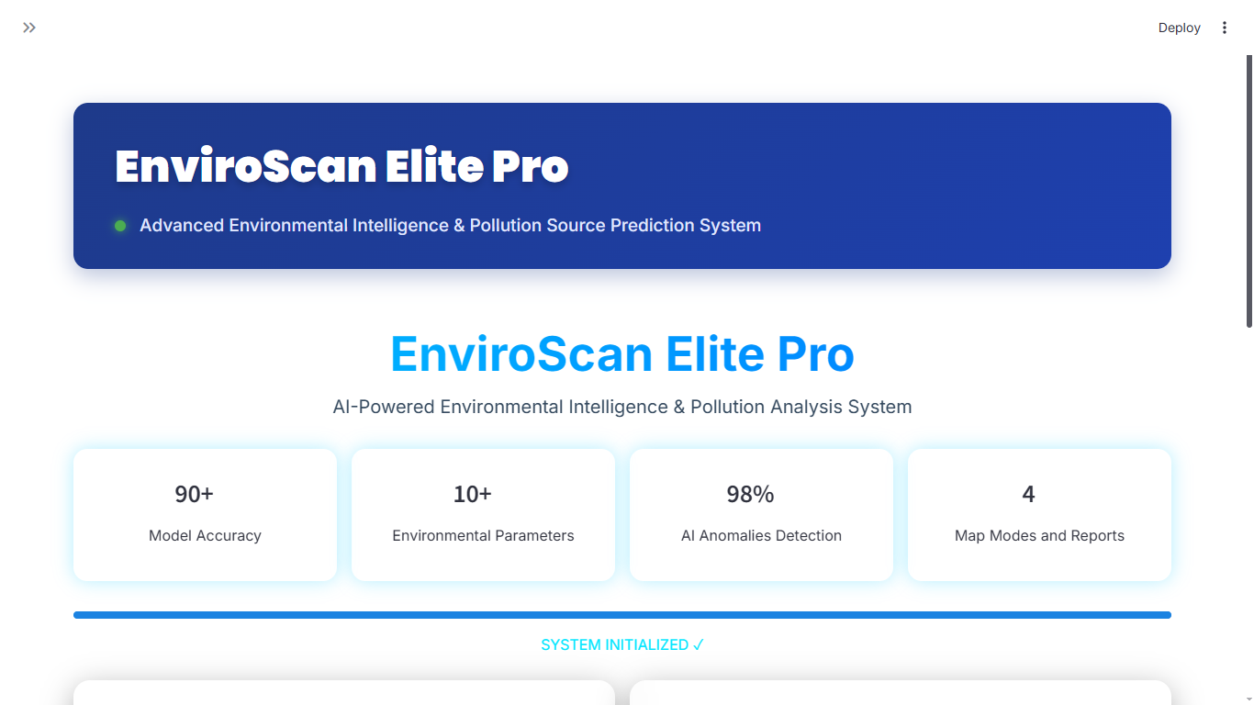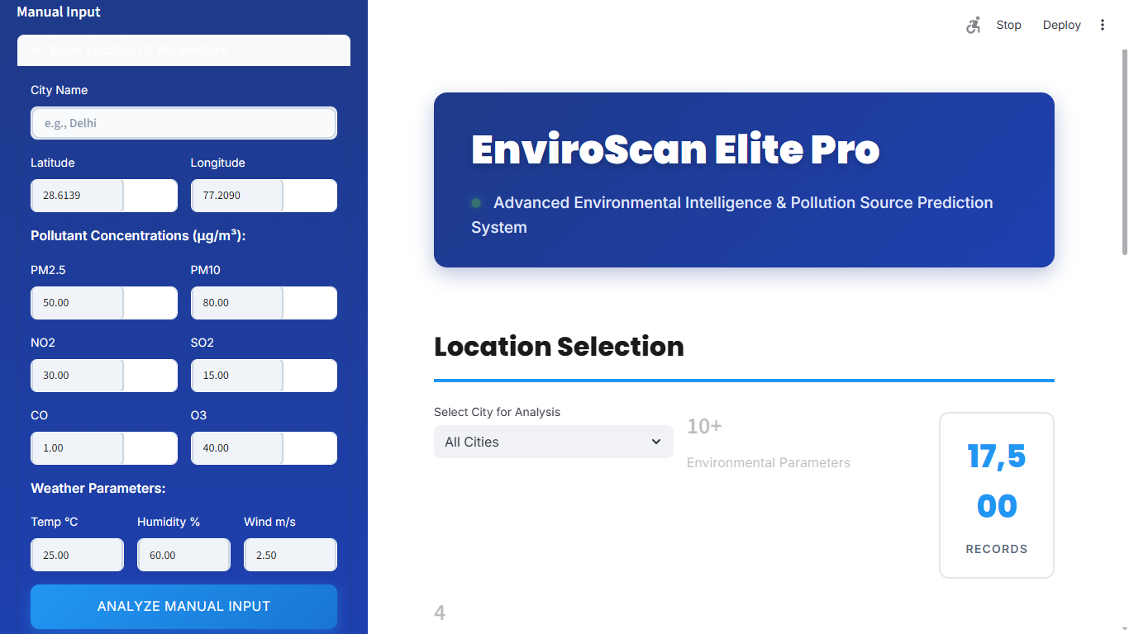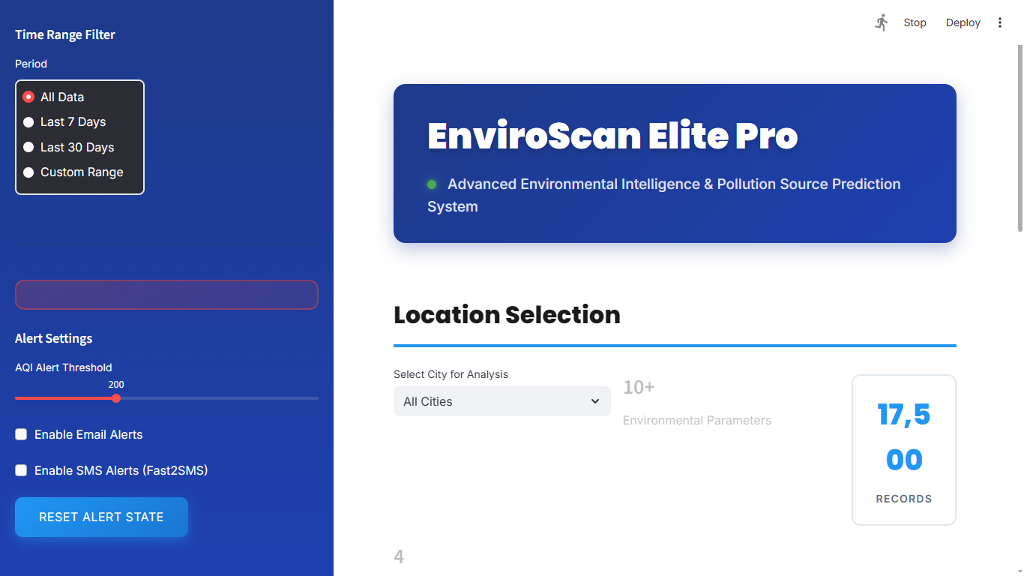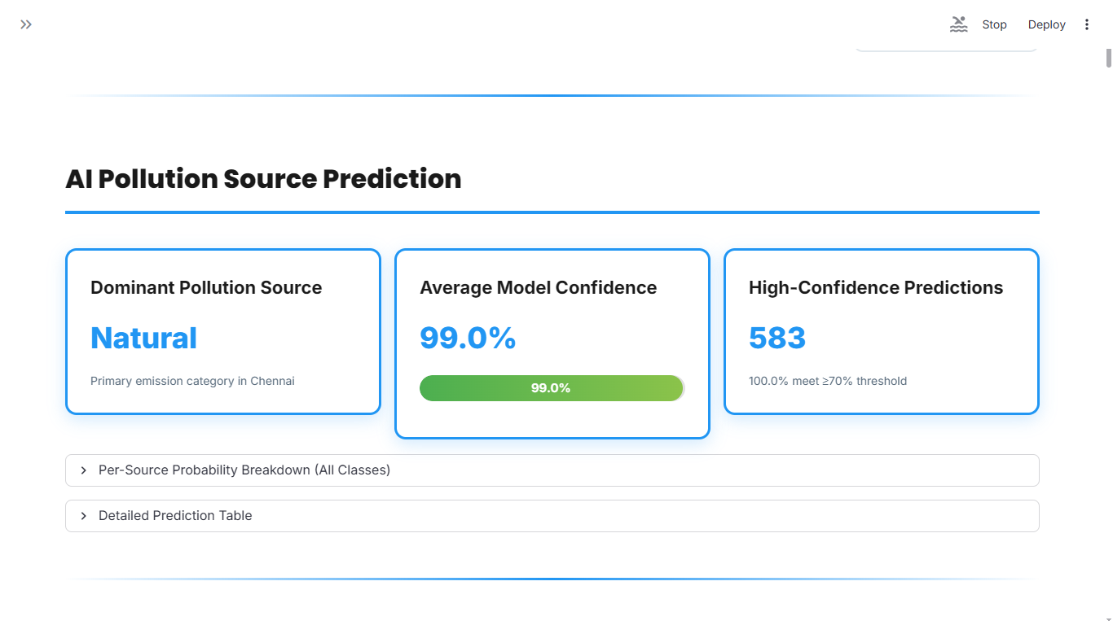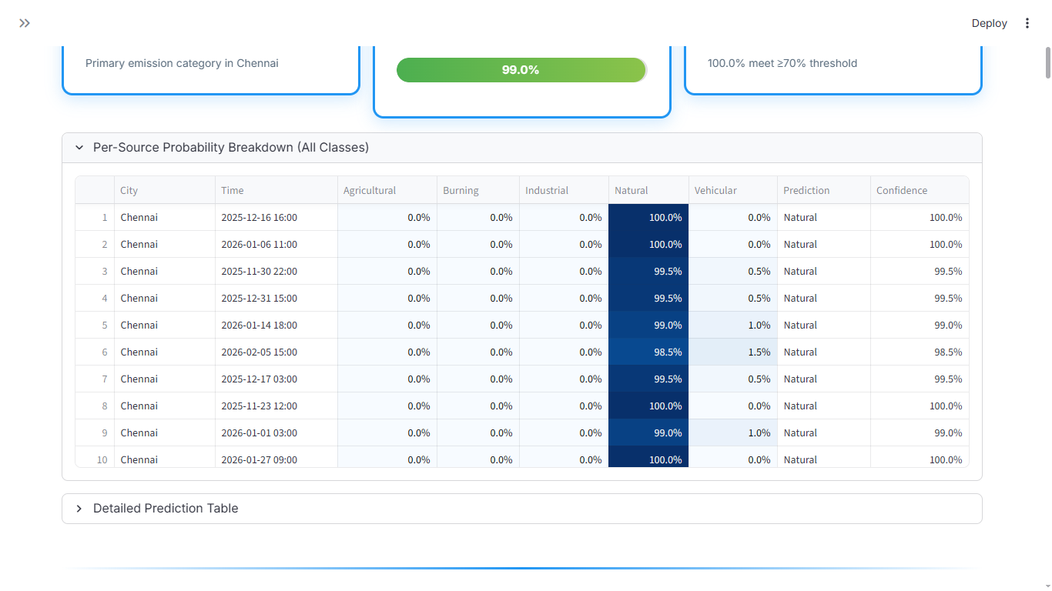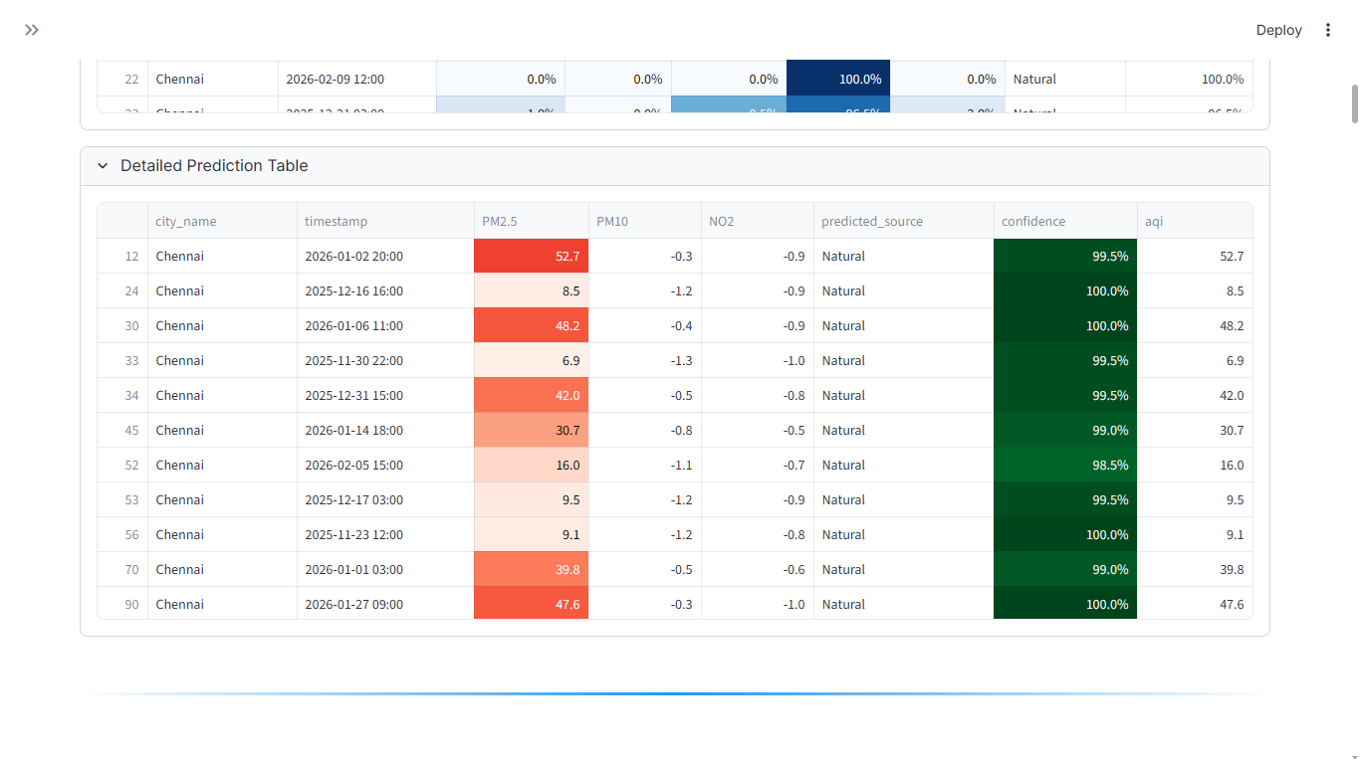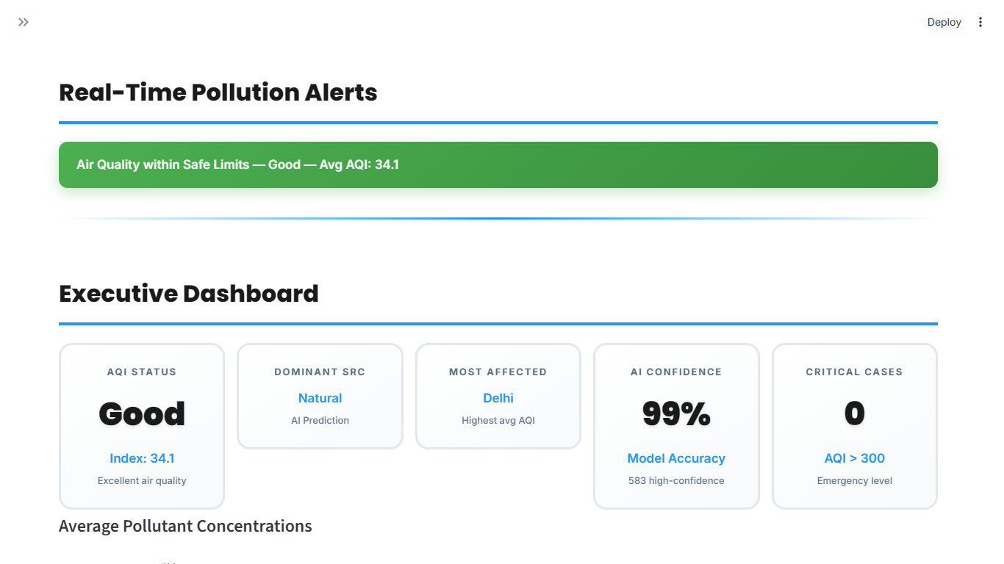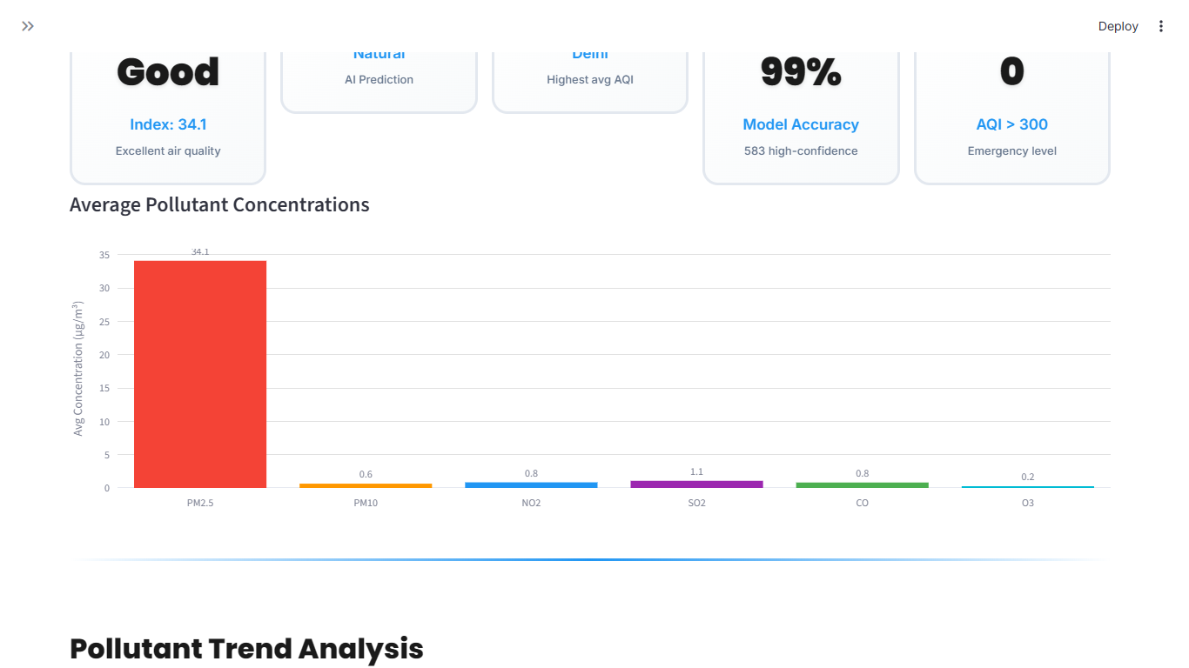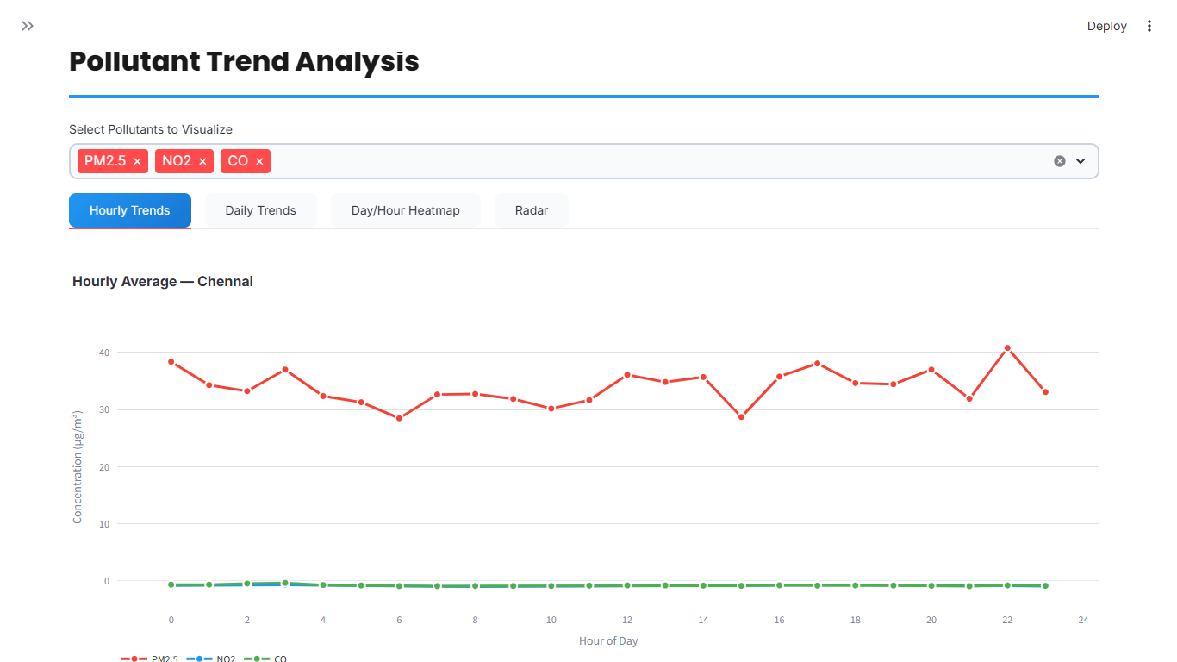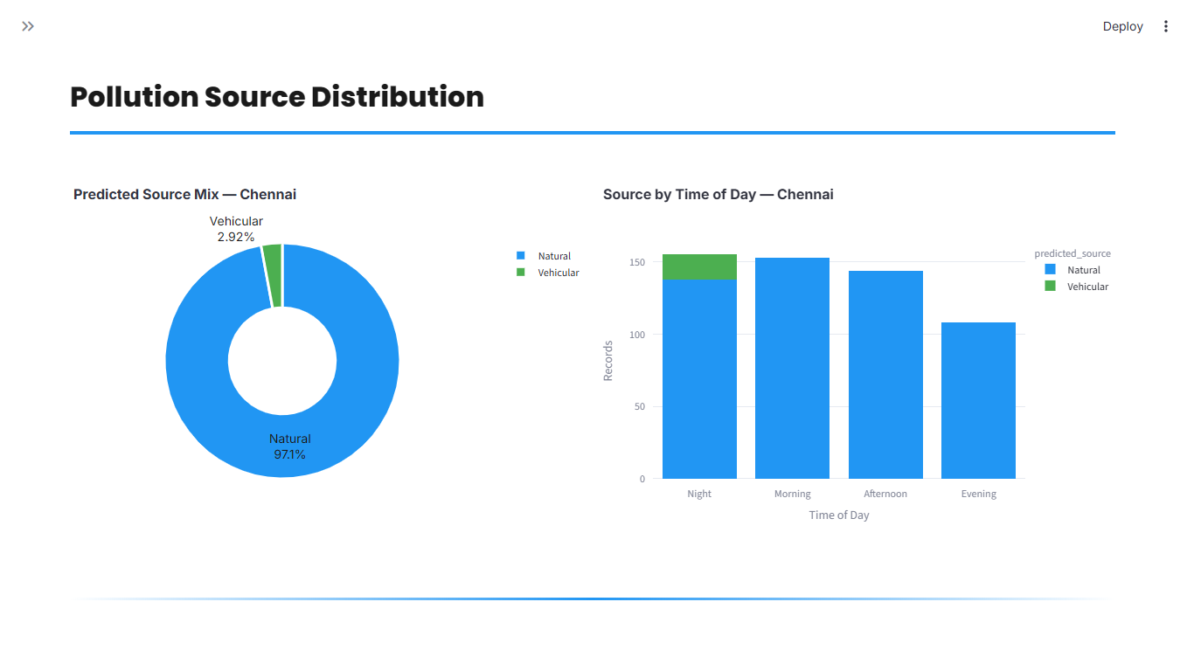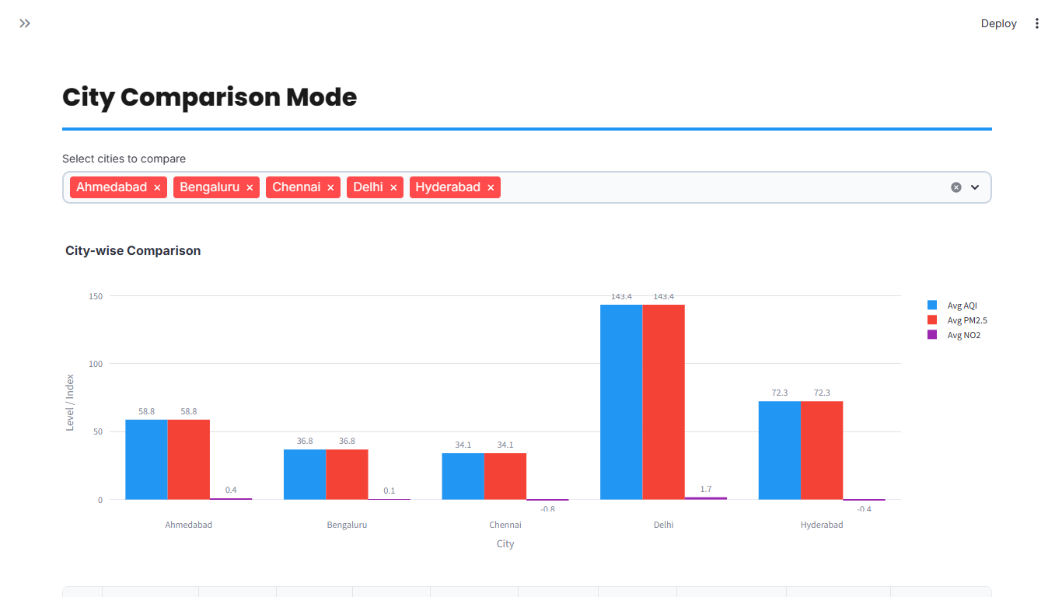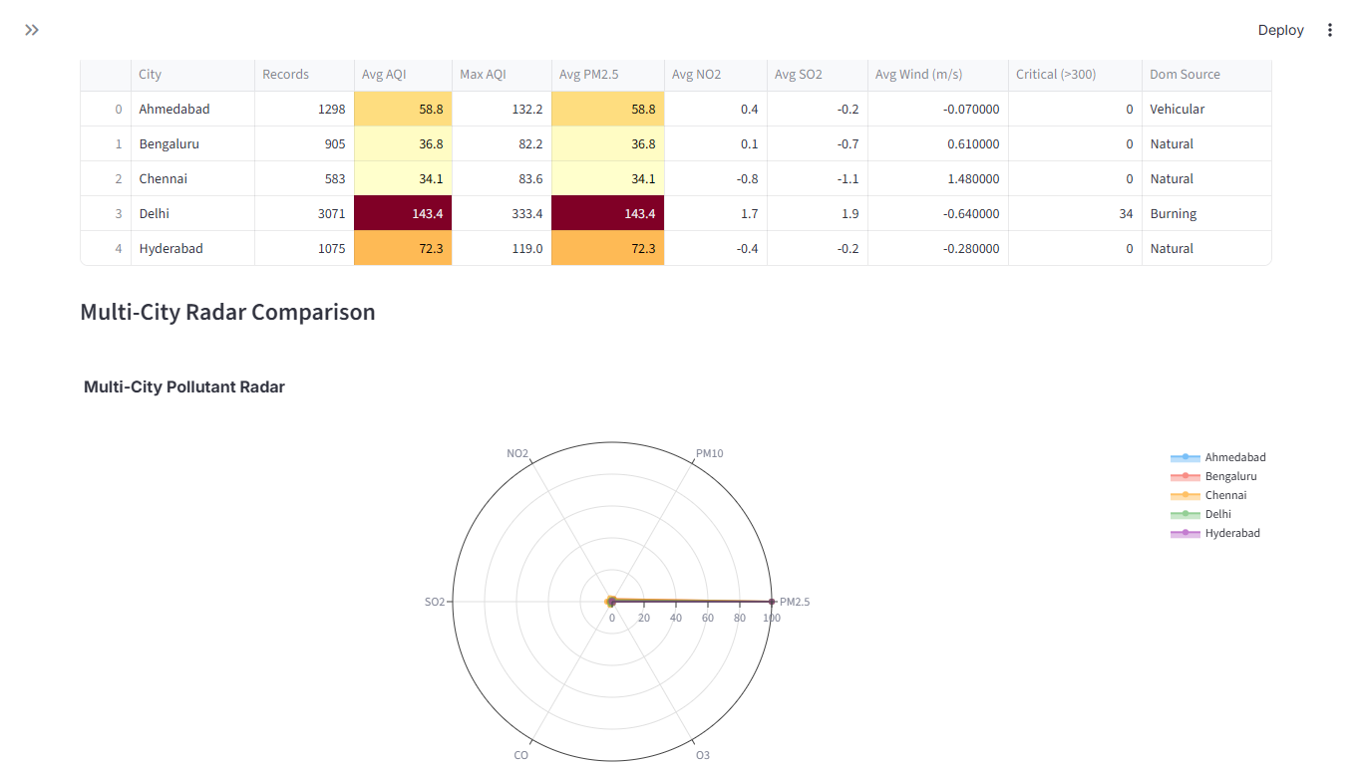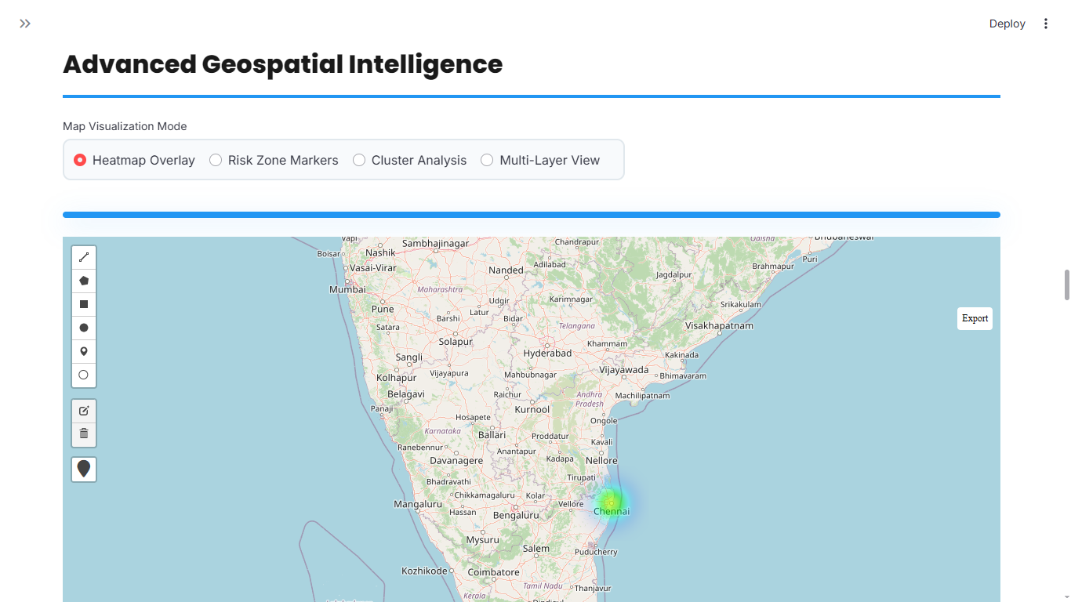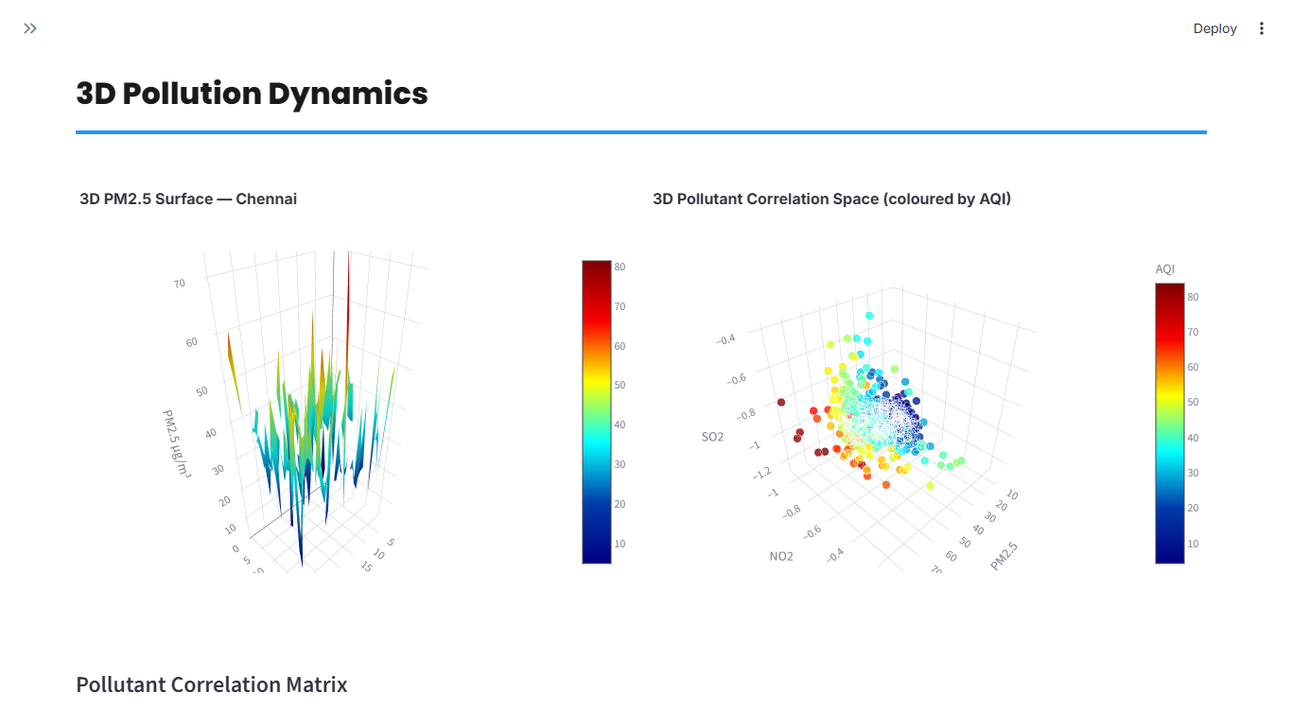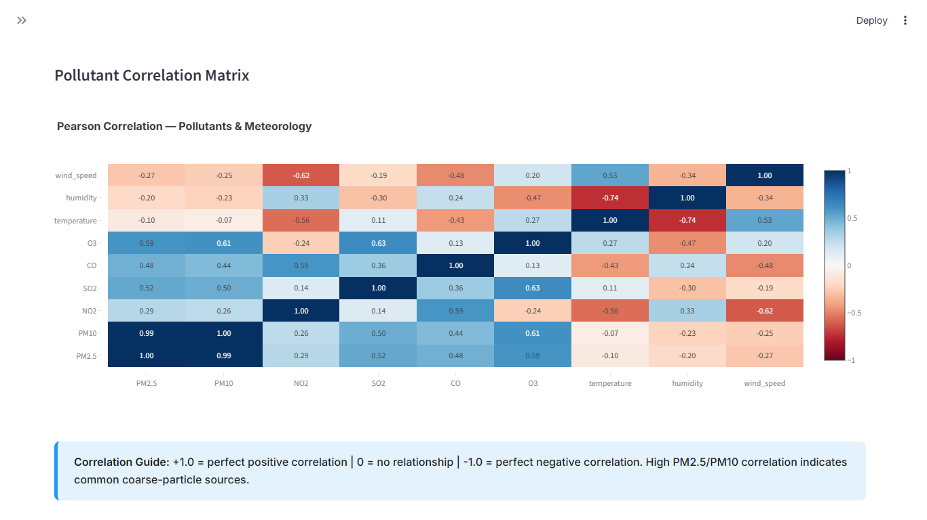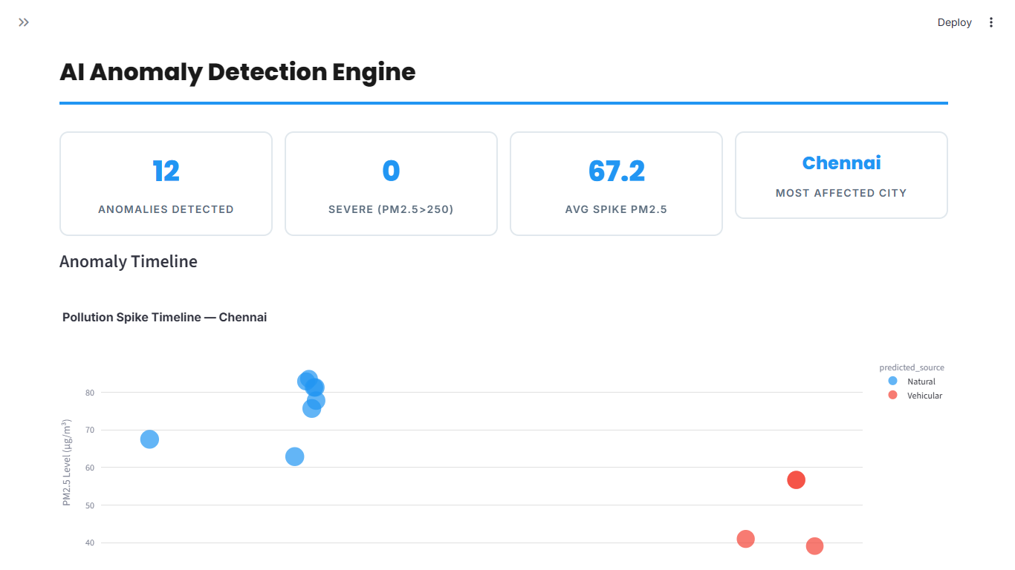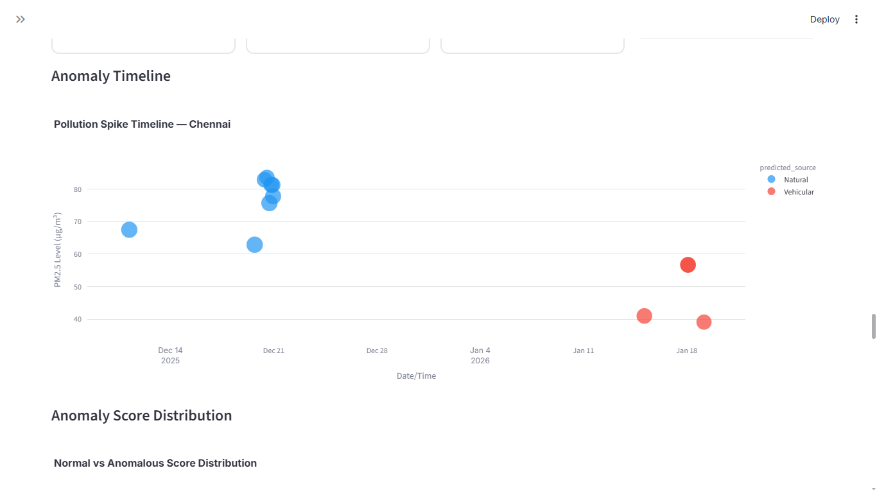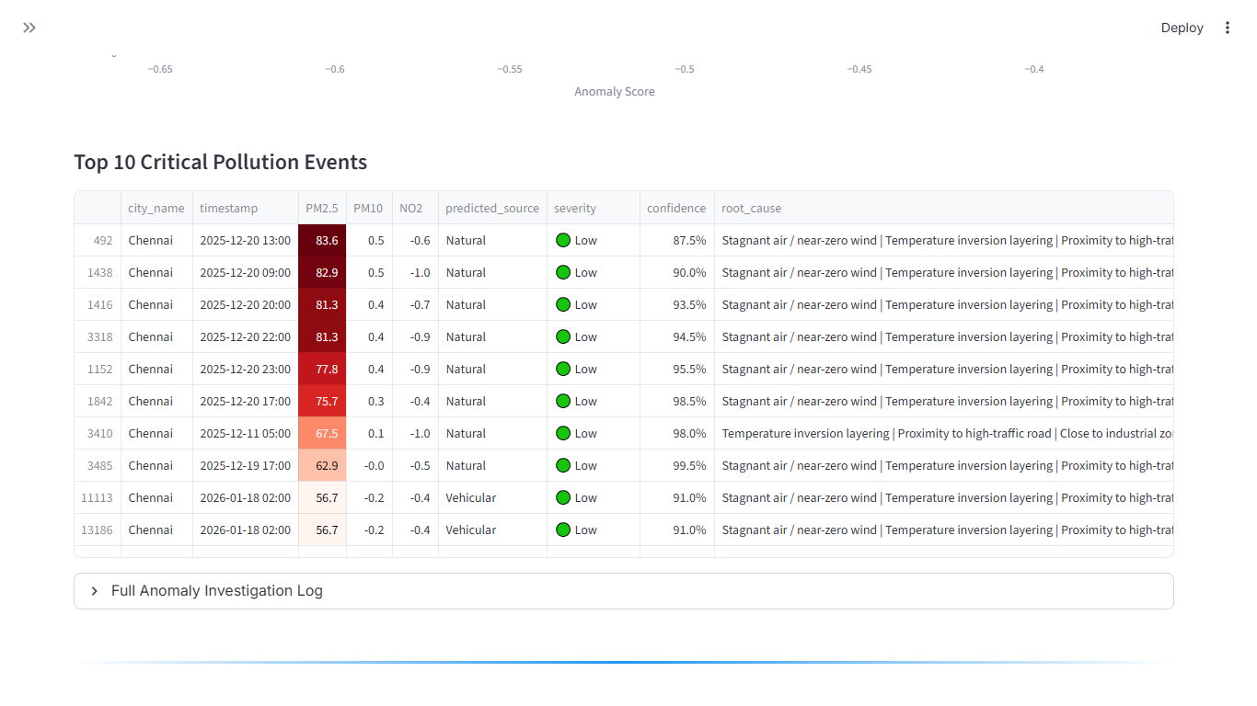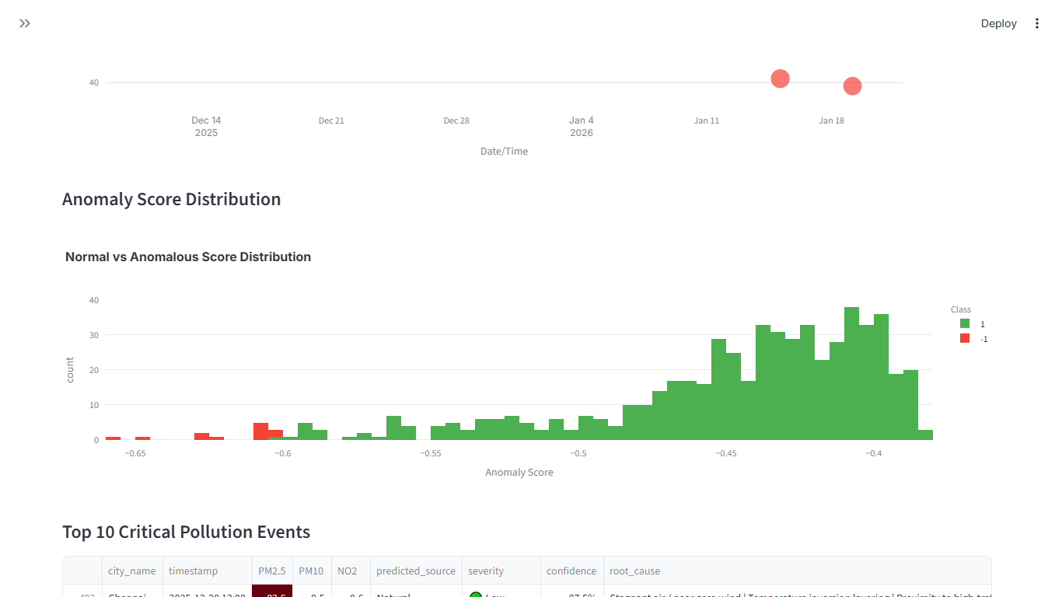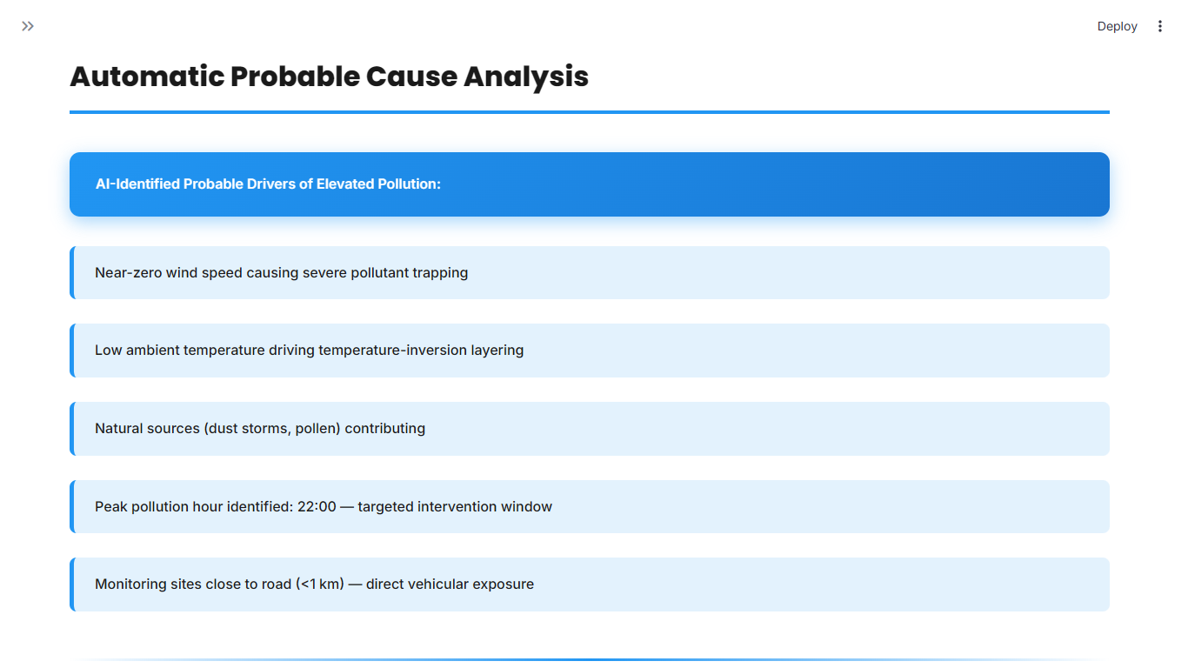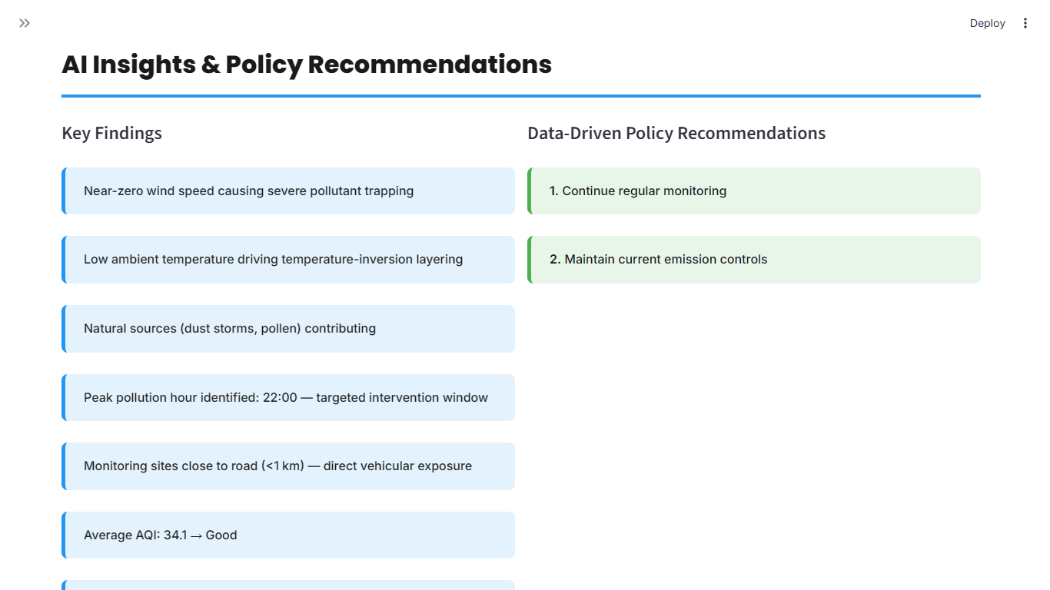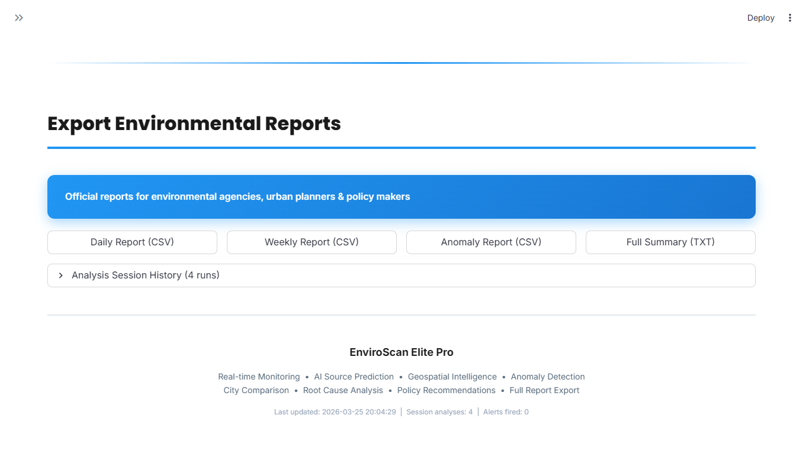

14.LIMITATIONS

Despite the successful implementation and comprehensive capabilities of the EnviroScan Elite Pro system, certain limitations exist that must be acknowledged. These limitations primarily arise from data availability, labeling methodology, and real-world constraints.

14.1 Limitations of Rule-Based Labeling
The pollution source labels used for model training were generated using a rule-based approach rather than actual verified data.
Key issues include:
- The rules are based on predefined thresholds and assumptions, which may not fully capture real-world complexities
- Pollution sources often overlap (e.g., vehicular + industrial), but the model assigns only a single dominant source
- Environmental conditions such as wind direction, atmospheric chemistry, and cross-regional pollution transport are not fully incorporated
As a result, the labeling process may introduce bias and simplification errors, affecting model learning.

14.2 Lack of Real-World Ground Truth
A major limitation of this project is the absence of verified ground truth data for pollution source classification.
- There is no publicly available dataset that directly maps pollution readings to exact sources
- The model is trained on simulated labels, not real measured source data
- This makes it difficult to validate whether the predicted source is 100% accurate in real-world scenarios
Therefore, the model predictions should be interpreted as probabilistic estimations rather than definitive conclusions.

14.3 Data Constraints
The performance and reliability of the system are also influenced by limitations in the dataset.
a) Data Availability
- Some regions and cities have limited or inconsistent data coverage
- Missing values in pollutant or weather data can impact model accuracy
b) Temporal Limitations
- The dataset may not cover long-term historical trends uniformly
- Seasonal variations may not be fully represented
c) Spatial Resolution
- Monitoring stations are not uniformly distributed, leading to uneven geographic representation
- Certain local pollution sources (e.g., small industries, local burning) may not be captured

14.4 Model Generalization Constraints
- The model is trained on specific datasets and may not generalize perfectly to new or unseen regions
- Differences in urban structure, industrial patterns, and climate can affect prediction reliability

14.5 Simplified Environmental Representation
- Complex atmospheric processes such as chemical reactions, dispersion dynamics, and inversion layers are not fully modeled
- The system relies on available features and does not simulate full environmental physics

14.6 Real-Time Dependency
- The accuracy of insights depends on the quality and timeliness of input data
- Delayed or outdated data may reduce the effectiveness of real-time monitoring and alerts

14.7 Interpretation Limitations
- The system provides data-driven insights, but it cannot replace expert environmental analysis
- Policy recommendations are indicative and should be validated by domain experts before implementation

15.FUTURE ENHANCEMENTS

The current implementation of EnviroScan Elite Pro provides a robust foundation for pollution analysis and source prediction. However, there are several opportunities to further enhance the system’s accuracy, scalability, and real-world applicability. The following improvements are proposed for future development:

15.1 Real-Time Data Integration
Currently, the system operates primarily on uploaded datasets. Future versions can integrate live data streams to enable real-time monitoring.
Enhancements include:
- Direct integration with APIs such as:
  - OpenAQ API for real-time pollution data
  - OpenWeatherMap API for live meteorological parameters
- Continuous data ingestion pipelines for instant analysis and alerts
- Automatic dashboard refresh for up-to-date insights
This would transform the system into a real-time environmental intelligence platform.

15.2 Advanced Machine Learning Models
The current system uses models such as Random Forest, Decision Tree, and XGBoost. Future improvements can include more advanced techniques.
Possible upgrades:
- Deep learning models such as:

  - Artificial Neural Networks (ANN)
  - Long Short-Term Memory (LSTM) for time-series forecasting
- Ensemble learning with hybrid models for improved accuracy

- Explainable AI (XAI) techniques to interpret model decisions
These enhancements can significantly improve prediction accuracy and reliability.

15.3 Integration of Satellite Data
To improve spatial coverage and accuracy, satellite-based data can be incorporated.
Enhancements include:
- Use of satellite datasets from sources like:
  - NASA (e.g., MODIS, Sentinel missions)
- Monitoring of:
  - Aerosol Optical Depth (AOD)
  - Large-scale pollution transport patterns
- Improved detection of regional pollution events such as dust storms or biomass burning
This would help overcome limitations related to ground station scarcity.

15.4 Enhanced Alert System
The current alert system supports email and SMS notifications. Future improvements can make alerts more intelligent and proactive.
Possible features:
- Multi-channel alerts:
  - Mobile app notifications
  - WhatsApp or Telegram integration
- Severity-based alert prioritization
- Predictive alerts based on forecasted pollution spikes
- Geo-fenced alerts for specific regions

This would ensure faster and more effective communication to users and authorities.

15.5 Improved Source Attribution Techniques
- Replace rule-based labeling with data-driven or hybrid labeling methods
- Incorporate domain-specific datasets for validated source identification
- Use chemical signature analysis and advanced feature engineering
This would improve the credibility and real-world applicability of source predictions.

15.6 Scalability and Cloud Deployment
- Deploy the system on cloud platforms (e.g., AWS, Azure, GCP)
- Enable handling of large-scale datasets and multiple cities simultaneously
- Implement distributed data processing for better performance
This would make the system suitable for nationwide or global deployment.

15.7 Mobile Application Development
- Develop a mobile application for easy access
- Provide user-friendly features such as:

  - Real-time AQI tracking
  - Personalized health recommendations
  - Location-based alerts
This would increase accessibility and user engagement.
15.8 Advanced Geospatial Analytics
- Integration with GIS tools for:
  - Detailed spatial analysis
  - Urban planning support
- Implementation of:
  - Pollution dispersion modeling
  - Route-based exposure analysis
This would enhance the system’s usefulness for urban planners and policymakers.

15.9 Health Impact Integration
- Incorporate health data to assess:
  - Respiratory risk levels
  - Long-term exposure effects
- Provide personalized health advisories based on AQI levels
This would make the system more people-centric and impactful.

15.10 Automated Policy Recommendation Engine
- Use AI to generate context-aware policy suggestions

- Recommend actions such as:
  - Traffic restrictions
  - Industrial regulation
  - Public health advisories
This would support data-driven decision-making for governance.

