TransferIQ – Football Player Market Value Prediction

Internship Report

Rohini S Nair

Infosys Springboard

January – March 2026 (8 weeks)
1. Abstract
This project focuses on predicting football player transfer market values using multi-source data, including player performance statistics, injury history, and social media sentiment. Machine learning and deep learning techniques, particularly Long Short-Term Memory (LSTM) networks, were utilized to capture time-series patterns in player data.
The project also involved feature engineering, sentiment analysis, and the development of an interactive Streamlit application. The final outcome includes a trained LSTM model, an ensemble model integrated with XGBoost, and a deployed dashboard capable of predicting player values while visualizing performance and sentiment trends.

2. Introduction
This project is situated in the domain of Artificial Intelligence and Machine Learning, specifically within sports analytics. Predicting player transfer values is a critical task for football clubs, scouts, and analysts, as it directly impacts financial planning and strategic decision-making.
By integrating performance data, injury records, and sentiment analysis, this project demonstrates how AI-driven approaches can enhance accuracy and provide deeper insights into player valuation in the football transfer market.

3. Objectives
- To develop an AI-based system for predicting football player transfer values
- To implement Natural Language Processing (NLP) techniques for sentiment analysis
- To design and train LSTM models for time-series forecasting
- To build an interactive and user-friendly application using Streamlit

4. Dataset Description
The project utilizes multiple datasets to capture different aspects of player valuation. These datasets were preprocessed, cleaned, and merged to form a unified dataset for model training.
- Player Performance Data: Includes statistics such as goals, assists, minutes played, and match performance metrics
- Market Value Data: Historical player market values sourced from platforms such as Transfermarkt
- Injury Data: Records of player injuries and recovery durations
- Sentiment Data: Extracted from textual sources and analyzed using VADER sentiment analysis
Data sources include publicly available datasets from Kaggle, Transfermarkt, and StatsBomb Open Data.

5. Methodology (Week-wise Breakdown)

Week 1 – Data Collection & Sentiment Analysis
- Collected player statistics and market value data
- Implemented VADER sentiment scoring (positive, negative, compound)
- Output: sentiment_data.csv, sentiment distribution plots
(Development for this stage was carried out using Google Colab)

Week 2 – Data Cleaning & Merging
- Removed missing values and corrected data types
- Merged datasets (performance, injury, sentiment, market value)
- Output: cleaned_merged_dataset.csv
(Development for this stage was carried out using Google Colab)

Week 3 – Feature Engineering & Visualization
- Created features such as goals_per90, assists_per90, injury impact metrics, sentiment features
- Developed Streamlit dashboard for visualization
- Output: Interactive dashboard with trends and comparisons

Week 4 – Data Preparation for Modeling
- Selected relevant features
- Applied normalization using MinMaxScaler
- Structured dataset for LSTM input
- Output: Model-ready dataset
Week 5 – LSTM Model Development
- Built LSTM model using TensorFlow/Keras
- Trained using train-test split
- Evaluated using MAE, RMSE, R²
- Output: lstm_player_value_model.keras, training loss curves

Week 6 – XGBoost & Ensemble
- Implemented XGBoost regression model
- Combined LSTM and XGBoost using ensemble approach
- Output: Ensemble predictions and evaluation metrics

Week 7 – Hyperparameter Tuning & Evaluation
- Tuned models using grid/random search
- Evaluated performance using RMSE, MAE, R²
- Selected best-performing model
- Output: Optimized model

Week 8 – Deployment & Reporting
- Resolved dependency issues (requirements.txt)
- Deployed application using Streamlit Cloud
- Uploaded project to GitHub repository
- Output: Final deployed application (Final.py), documentation, and presentation

6. Tools & Technologies Used
- Python
- Pandas
- NumPy
- scikit-learn
- TensorFlow/Keras (LSTM)
- XGBoost
- Streamlit
- Plotly
- Matplotlib
- Seaborn
- GitHub
Visual Studio Code (primary development environment)
Google Colab (used during initial stages for data processing and experimentation in Week 1 and Week 2)

7. Implementation
The implementation phase consisted of multiple components:
- Sentiment Analysis: Applied VADER to compute sentiment polarity scores
- Feature Engineering: Developed performance, injury, and sentiment-based features
- Model Development: Implemented Linear Regression (baseline), LSTM models, and XGBoost
- Ensemble Learning: Combined model outputs to improve prediction accuracy
- Application Development: Built an interactive Streamlit dashboard for visualization and prediction
Development Workflow: Initial stages including data processing and experimentation were performed using Google Colab, while complete model development, integration, and deployment were carried out using Visual Studio Code

8. Results
- Mean Absolute Error (MAE): Approximately 7.7M
- R² score improved significantly using the ensemble approach
- Training loss curves showed consistent convergence, indicating effective learning
- Successfully deployed a Streamlit application with the following features:
- Player and season selection
- Market value trend visualization
- Sentiment trend analysis
- Sentiment distribution insights
- AI-based value prediction
- Automated insights generation
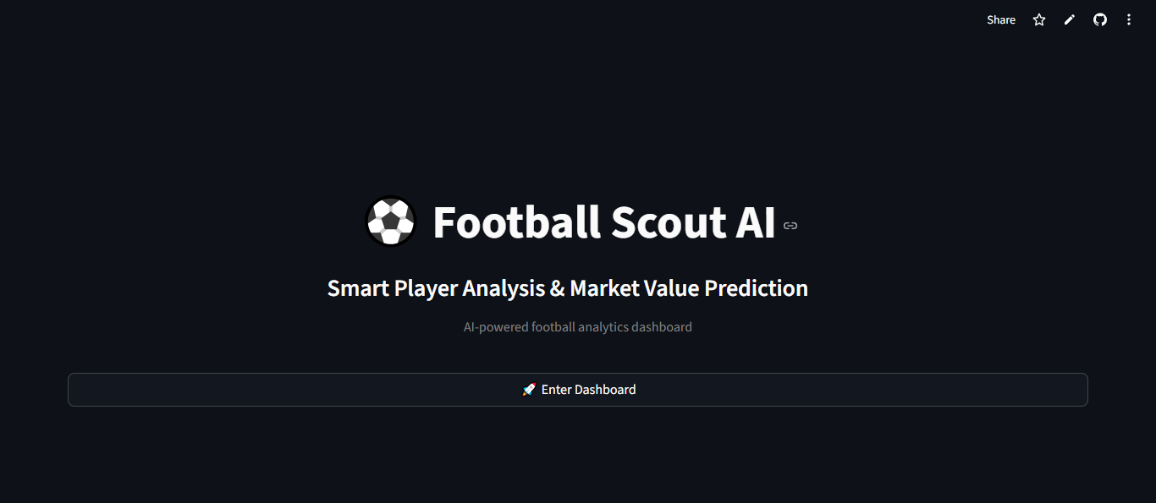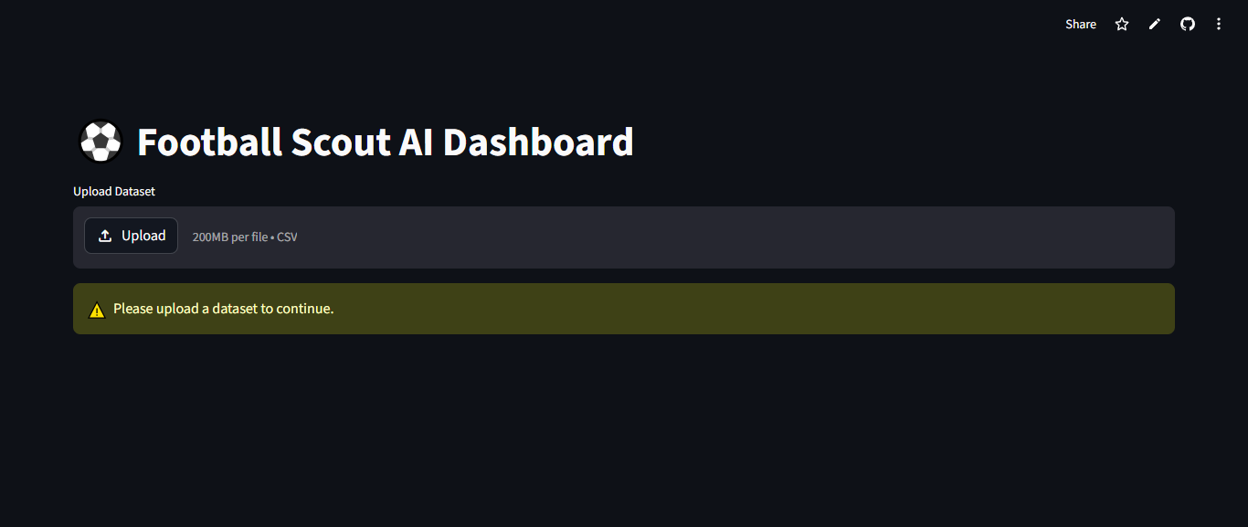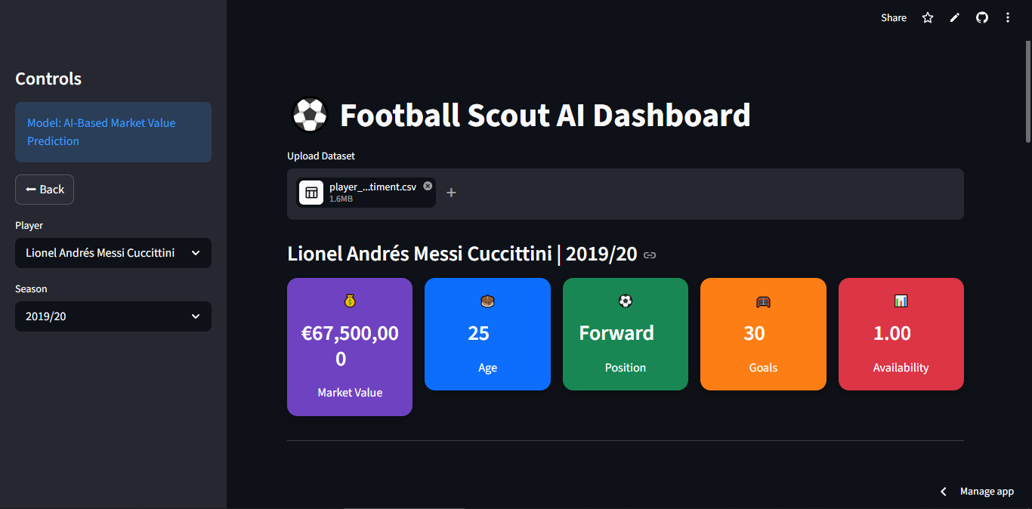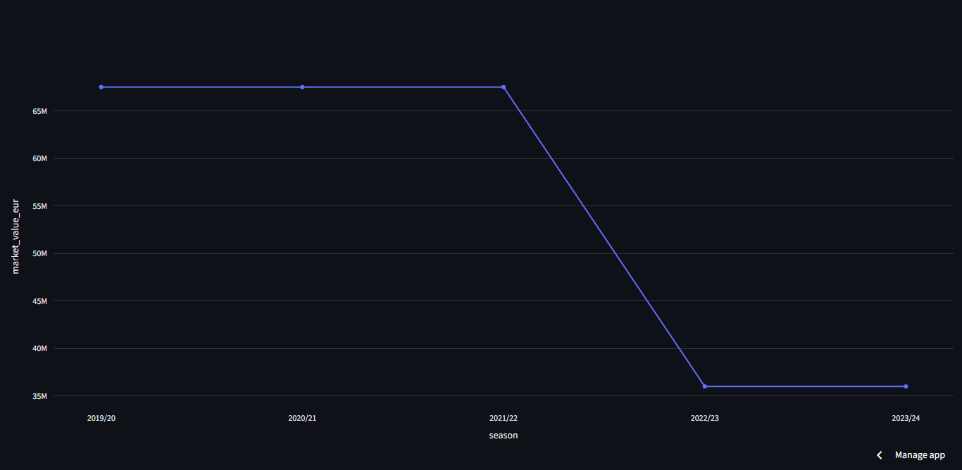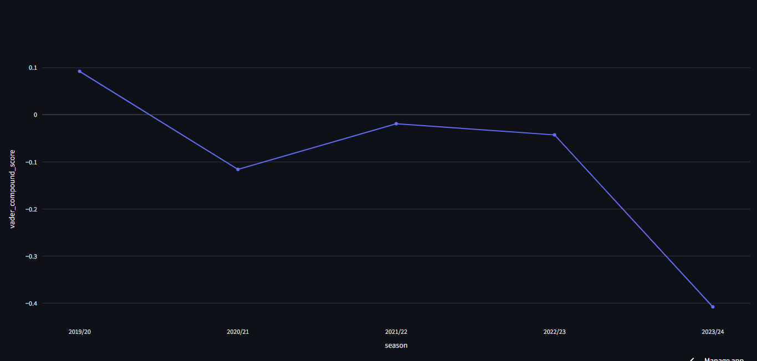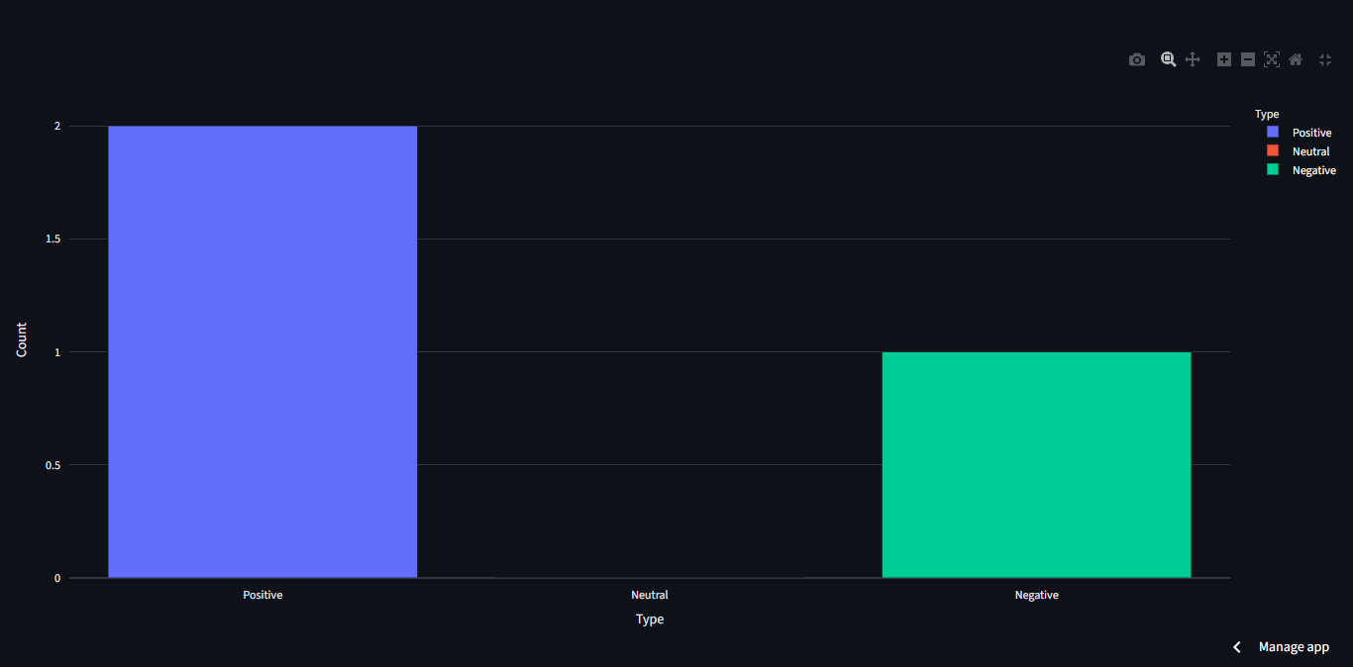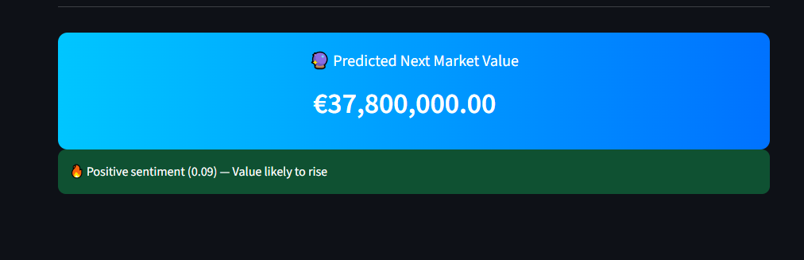

9. Challenges Faced

Problems:
- TensorFlow installation issues due to Python version mismatch
- Dataset merging and alignment complexities
- Plotly dependency errors during deployment

Solutions:
- Utilized Google Colab during initial stages to handle environment limitations and perform early experimentation, while continuing development primarily in Visual Studio Code
- Verified dataset structure prior to merging
- Resolved dependency issues through proper configuration of requirements.txt

10. Conclusion
This project successfully integrates performance data, injury records, and sentiment analysis to predict football player transfer values. Multiple machine learning models were implemented and evaluated, with ensemble learning delivering the best performance.
The deployment of the Streamlit application enhances usability, making the system interactive and practical for real-world applications.

11. Future Scope
- Incorporate additional features such as contract details and team performance metrics
- Enhance sentiment analysis using advanced NLP models (e.g., transformer-based architectures)
- Integrate real-time data through APIs
- Extend the framework to other sports analytics domains

12. References
- Kaggle Datasets
- Transfermarkt
- StatsBomb Open Data
- TensorFlow/Keras Documentation
- Streamlit Documentation

