Name: Maneeswara Venkata Sai Avula
Branch: Electronics and communications Engineering
College: Dhanekula Institute of Engineering and Technology, Ganguru
Year: 3rd year
Data Science Experience: Yes
Course work:
- Data Science Course from Udemy
- Data Structures from NPTEL
- DBMS from Udemy

MILESTONE 1 : Data Management and Feature Engineering : COMPLETED

MILESTONE 2 : Machine Learning & Model Development
- Data Preprocessing & Visualization: Performed rigorous data cleaning, missing value imputation, and feature selection to isolate the top 10 physics-based parameters (e.g., Insolation Flux, Equilibrium Temperature).
- Advanced Class Imbalance Handling: Successfully handled the 99:1 dataset imbalance by implementing SMOTE (Synthetic Minority Over-sampling Technique) within a Scikit-Learn Pipeline, while also studying alternative strategies like Borderline-SMOTE and Random Undersampling.
- Model Training & Evaluation: Trained and benchmarked multiple machine learning models to find the optimal architecture:
  - Weighted Logistic Regression (Baseline for linear separability).
  - SMOTE + Random Forest (Ensemble baseline).
  - SMOTE + XGBoost (Gradient Boosting Champion).
- Champion Model Selection: Achieved State-of-the-Art performance with the SMOTE + XGBoost model, attaining 100% Precision on the validation set and eliminating false positives .
- The confusion matrix, roc curve of the top model i got
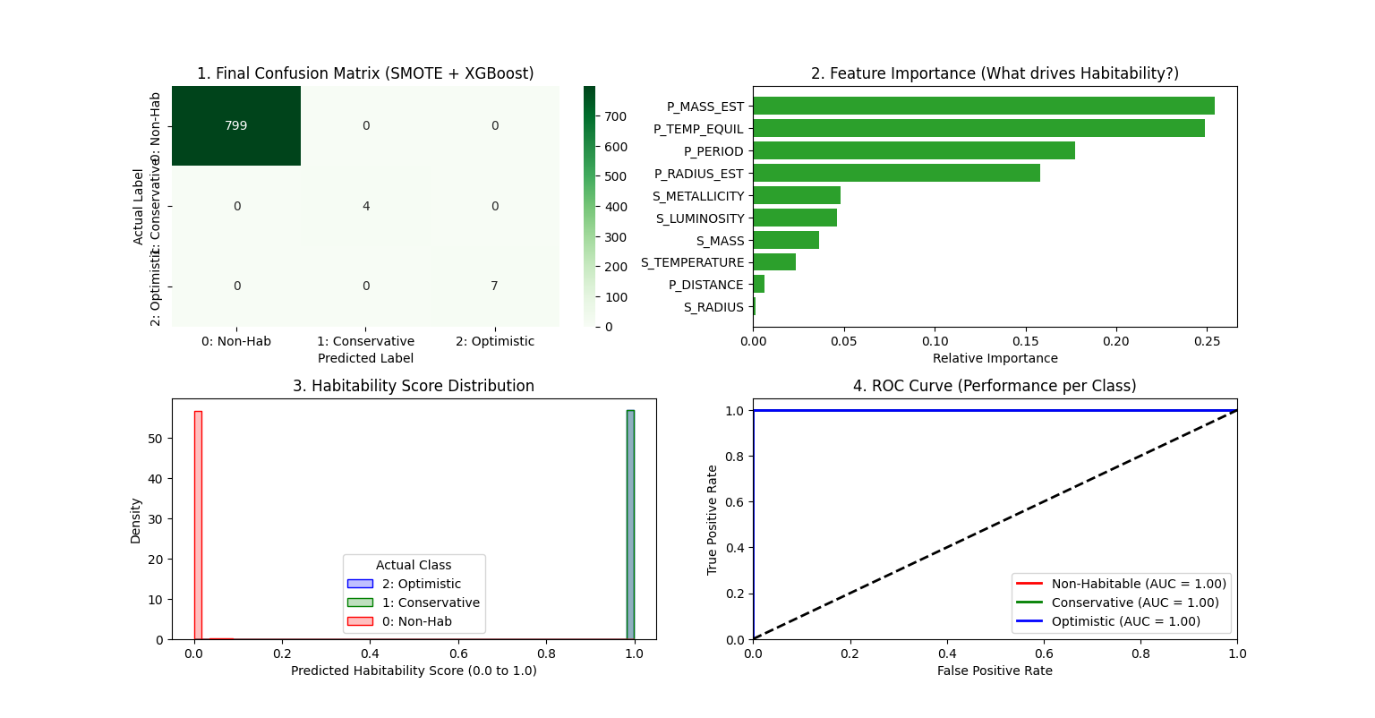
precision recall f1-score support

0 1.00 1.00 1.00 799
1 1.00 1.00 1.00 4
2 1.00 1.00 1.00 7

accuracy 1.00 810
macro avg 1.00 1.00 1.00 810
weighted avg 1.00 1.00 1.00 810
- The results when tested with full dataset : 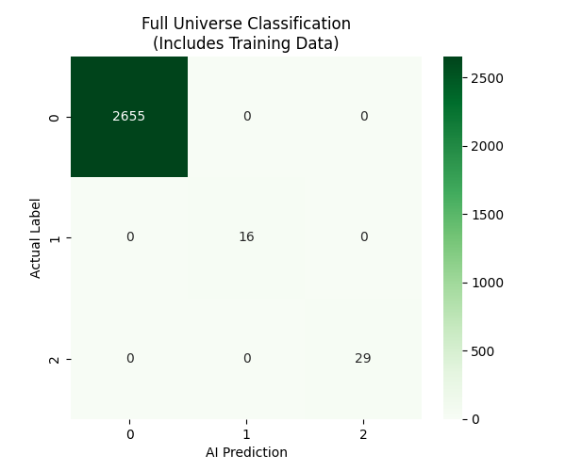
- Cross-Dataset Validation (Scientific Proof): Validated the trained model against the external NASA Exoplanet Archive (Composite Data), achieving 99.25% Generalization Accuracy and successfully re-discovering confirmed habitable planets like TRAPPIST-1 e and Proxima Centauri b

MILESTONE 3 : Flask Backend and Frontend UI Development

- Designed the system to be Stateless: The server processes every request independently, ensuring scalability.
- Implemented standard HTTP Methods: Used POST requests to securely send complex planetary data to the server.
- Unlike standard APIs that just pass data, our API intelligently fills gaps.
- Before prediction, incoming data passes through a cleaning layer that applies astrophysical formulas (e.g., calculating Mass from Radius if Mass is missing) to ensure the AI never receives "empty" inputs.
- /predict (Single Mode): Accepts a JSON object for a single planet. Returns a specific probability and class. Used for manual entry.
- /predict_bulk (Batch Mode): Accepts a CSV file. It processes thousands of rows, applies the physics engine to the entire dataset, and returns a JSON list of results. This allows for massive catalog analysis.
- Responsive Layout: Uses Bootstrap's grid system to ensure the app works perfectly on laptops, tablets, and large monitors.
- Drag-and-Drop Upload: implemented a modern file uploader that simplifies the process of analyzing large datasets.
- Asynchronous Display: Used JavaScript (Fetch API) to send data to the backend without reloading the page. Results appear instantly in a dynamic table.
- Color-Coded Verdicts: The UI automatically styles results (Green for "Habitable", Gray for "Non-Habitable") so users can identify candidates at a glance.

FRONTEND:
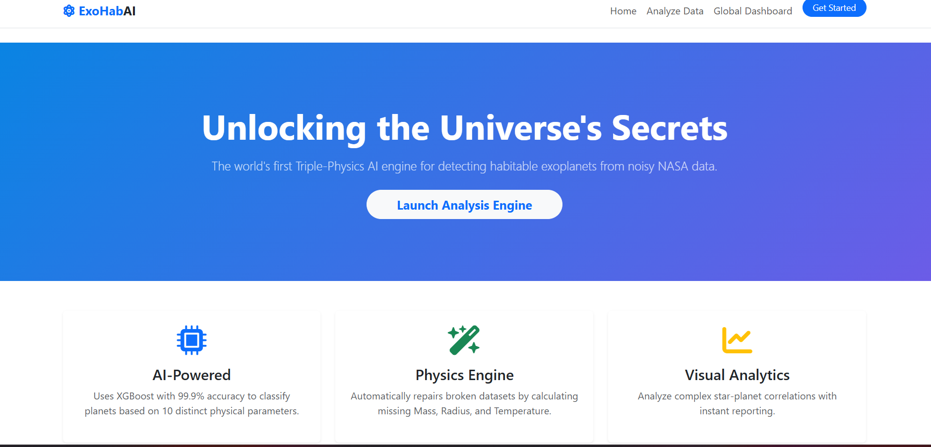

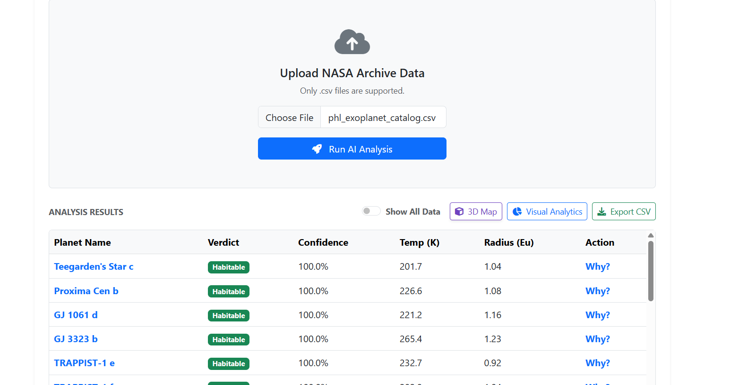
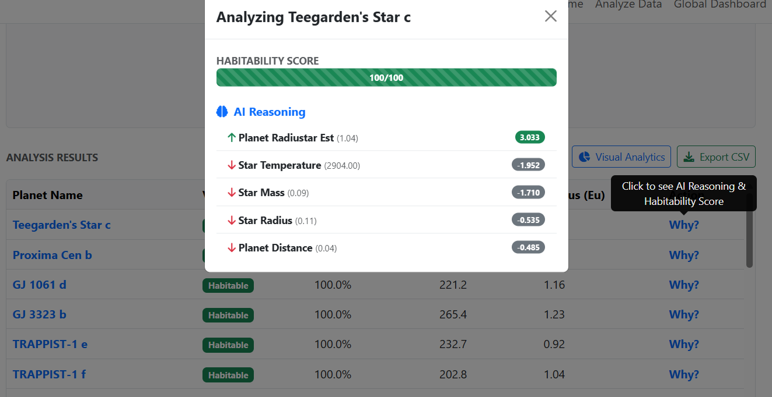

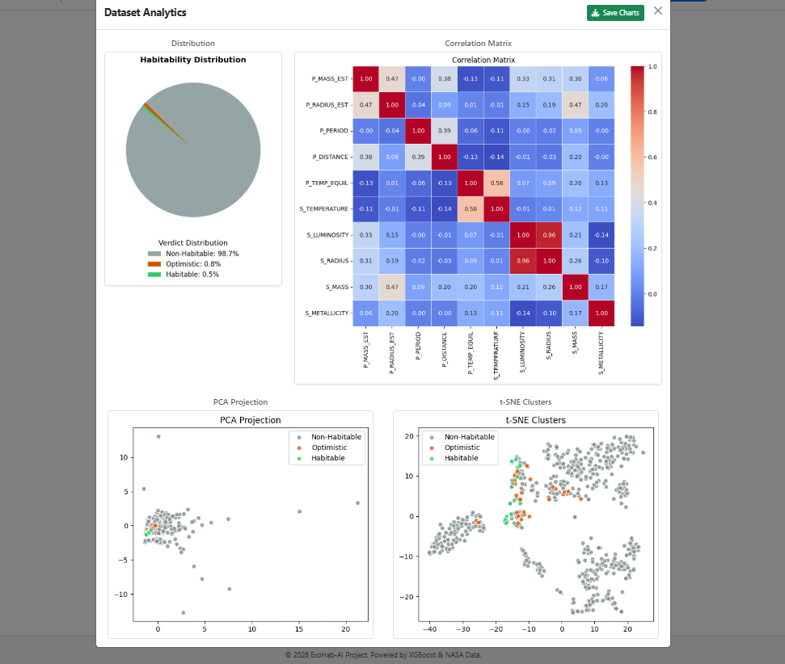
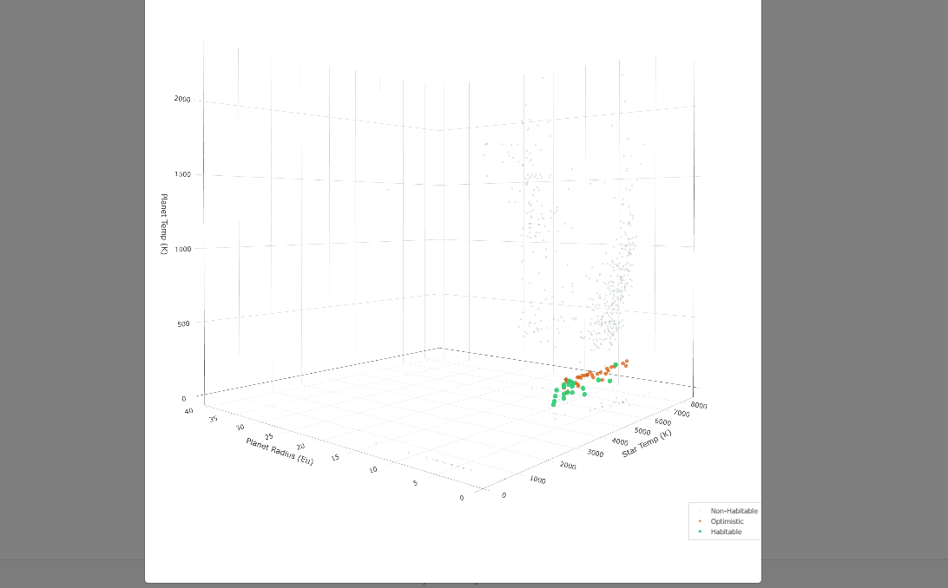

MILESTONE 4 : Visualization, Deployment & Documentation
Completed
- Model is deployed by using render and the link is:
https://exohabai.onrender.com/

- Documentation of the Predicting the Habitability of Exoplanets Using Machine Learning is done and available in github:
https://github.com/springboardmentor74280b-design/Habitability-of-Exoplanets/tree/maneeswara_venkata_sai

- Video demo link : https://drive.google.com/file/d/1Z5ENiE6MFNW6Y9JHMmNa1LJN5wWmarx1/view?usp=drive_link
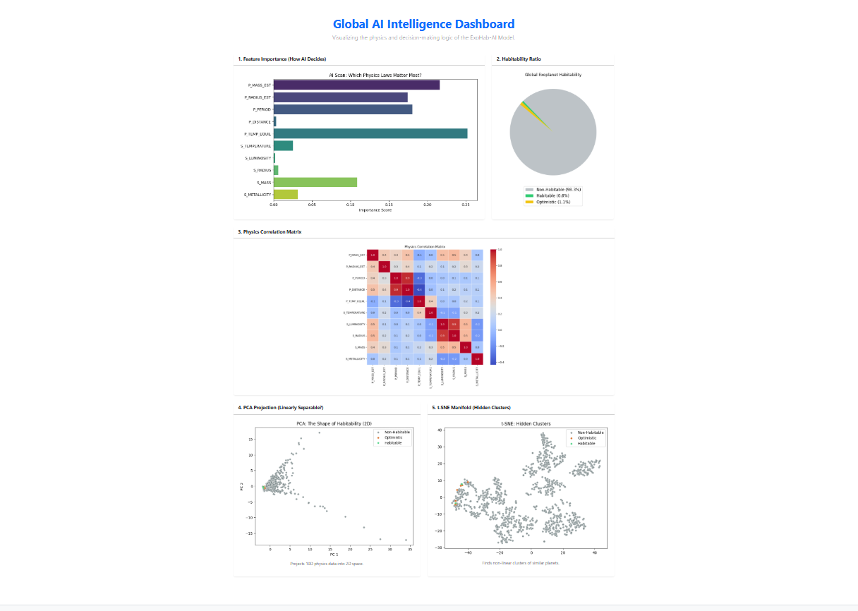

WEEK 1:

MODULE 1: DATA COLLECTION AND MANAGEMENT
• Collect exoplanet datasets from sources like NASA Exoplanet Archive and Kaggle.
• Dataset features may include:
• Planet radius, mass, density, surface temperature, orbital period, distance from star
• Host star type, luminosity, temperature, metallicity
• Store data in PostgreSQL or CSV format.
• Validate schema and ensure completeness.

DAY - 1: (1-12-2025)

DATASET 1 : Kepler Exoplanet Dataset (Kaggle)
Link: https://www.kaggle.com/datasets/gauravkumar2525/kepler-exoplanet-dataset
Observations:
- Contains 9564 rows
- Data is very clean compared to others
- Contains specific koi_disposition column (CONFIRMED/FALSE POSITIVE) needed for the project.
Is it useful: yes if we are doing the standard classification model.
Questions : Should we treat 'CANDIDATE' rows as positive data or remove them.

DATASET 2 : NASA Exoplanet Archive
Link:https://exoplanetarchive.ipac.caltech.edu/cgi-bin/TblView/nph-tblView?app=ExoTbls&config=PS
Observations:
- Contains dynamic and live data
- Contains duplicate rows for same planet
- Requires complex data filtering
Is it useful : No, not for immediate use.
Questions: If using this, do we filter by `default_flag=1` to get unique planet rows.
Comments : Requires significant cleaning, Hard to use.

DATASET 3 : Exoplanet Dataset with Classes (Kaggle)
Link : https://www.kaggle.com/datasets/dylanberger/exoplanet-dataset-with-classes
Observations :
- Contains approximately 3000 rows
- Already classified into types
- Fewer columns , focused on physical properties
Is it useful: partially

DATASET 4 : Nasa Exoplanets (Kaggle)
Link : https://www.kaggle.com/datasets/adityamishraml/nasaexoplanets
Observations :
- Contains 5000+ rows
- Includes useful pre-calculated columns like ‘mass_multiplier’
- Moderate amount of missing values
Is it useful: Yes, for clustering tasks
Questions : Is it okay to use datasets with pre-calculated multipliers to simplify analysis?
Comments :good alternative for clustering analysis

DATASET 5 : All Exoplanets Dataset (Kaggle)
Link : https://www.kaggle.com/datasets/shivamb/all-exoplanets-dataset
Observations :
- Contains 4575+ rows.
- Contains lots of missing values in columns like Mass and Radius.
- Aggregates data from multiple missions (Kepler, TESS, etc.), covering all confirmed planets
Is it useful: useful for Exploratory Data Analysis (EDA) to show discovery trends over time, but risky for the main prediction model due to data gaps.
Comments : Good for visualization, but harder to use for the main prediction project compared to the Kepler dataset.

DAY - 2 (2-12-2025) : No class

DAY - 3 (3-12-2025) :

Task : trying to find additional features that will help in increase the precision of prediction of Habitability of Exoplanet

Observation :
In the project document the dataset features given are
- Planet radius : The distance from the center of the planet to its surface, usually measured in terms of Earth radii (how many times bigger than Earth it is).
- Mass : The total amount of matter contained within the planet, which determines its strength of gravity.
- Density : The planet's mass divided by its volume, used to identify if the planet is made of rock (high density) or gas (low density).
- Surface temperature : The estimated temperature of the planet's outermost layer, which decides if water can exist as liquid, ice, or steam.
- Orbital period : The time it takes for the planet to complete one full circle around its star (the length of its "year").
- Distance from star: The average distance between the planet and its host star, typically measured in Astronomical Units (AU).
- Host star type : The classification of the star (e.g., G-type like our Sun, or M-type Red Dwarf) based on its spectral characteristics and temperature.
- Luminosity : The total amount of light and energy emitted by the star per second, which dictates how far away the habitable zone is.
- Temperature (star) : The heat of the star's surface (Effective Temperature), which determines the color of the star and how hot its planets will be.
- Metallicity : The abundance of elements heavier than hydrogen and helium (like iron) in the star, which indicates the likelihood of rocky planets forming around it.
From my observations from the dataset i observed that there are few more features we might require for increase the prediction precision on habitability which are as follows :
- Insolation Flux : The amount of solar energy the planet receives from its star compared to what Earth receives from the Sun (Earth = 1.0), which is the most accurate predictor of climate.
- Equilibrium Temperature : The theoretical temperature of the planet if it were a black body (absorbing all heat), used to set strict numeric thresholds for the "Goldilocks Zone" (e.g., 180K–310K).
- Impact Parameter : A geometric measurement of how "central" the planet's path is across the star's face, used to weed out "grazing" binaries that might look like planets.
- Transit Duration : The precise amount of time (in hours) the planet blocks the star's light, which helps confirm the orbit is stable and not a random error.
- Stellar Surface Gravity : The intensity of gravity at the star's surface, which helps the model determine if the star is a stable Dwarf (good for life) or a giant (bad for life).
- Earth Similarity Index (ESI) : A calculated score from 0.0 to 1.0 that mathematically compares a planet's flux and radius to Earth's (where Earth is 1.0).

Questions : Can I add advanced features like 'Stellar Flux' and 'Earth Similarity Index' to improve the model's accuracy, even if they aren't listed in the project PDF and if we are using these features can we take datasets including these features or do we need to calculate them manually ?

DAY - 4 (4-12-2025) :
DAY - 5 (5-12-2025) : On Leave

WEEK - 2:

MODULE - 2: DATA CLEANING AND FEATURE ENGINEERING
• Handle missing values, outliers, and inconsistent entries.
• Encode categorical features (e.g., star type) using one-hot encoding.
• Feature engineering examples:
• Habitability Score Index based on key planetary parameters.
• Stellar Compatibility Index to measure host star influence.
• Normalize numerical features.
• Validate data quality using descriptive statistics and visualization.

DAY - 1 (8-12-2025) (Home Work):

Use chatgpt or gemini, to summarise above paper and tasks, and what common practices they did,
How to i answer these things
Handle missing values, outliers, and inconsistent entries.
• Encode categorical features (e.g., star type) using one-hot encoding.
• Feature engineering examples:
• Habitability Score Index based on key planetary parameters.
• Stellar Compatibility Index to measure host star influence.
• Normalize numerical features.
• Validate data quality using descriptive statistics and visualization.

1. Kaggle Notebook (Exoplanet Habitability Prediction)
Link : https://www.kaggle.com/code/nickoreese/exoplanet-habitability-prediction

Focus: Classification of Habitability (Is a known planet habitable?).
This resource shifts focus from finding a planet to analyzing it.
- Goal: It uses machine learning to predict if a confirmed exoplanet could support life.
- Data: Likely uses the PHL (Planetary Habitability Laboratory) dataset, which includes physical features like planetary mass, radius, and surface temperature.
- Method: It typically involves "Feature Engineering" (creating metrics like the Earth Similarity Index) and using classifiers (like Random Forest) to label planets as "Habitable" or "Non-Habitable."

2. KDnuggets Article (Exoplanet Hunting with ML)
Link: https://www.kdnuggets.com/2020/01/exoplanet-hunting-machine-learning.html
Focus: Tutorial on Transit Detection (Finding the "dip" in light).
This is a guide on how to build a detection system from scratch.
- Goal: To teach the workflow of processing raw light curves to find transit signals.
- Key Concepts:
  - Smoothing: How to remove noise from star data (Gaussian filters).
  - Imbalance: How to handle the fact that non-planets vastly outnumber planets (often using SMOTE).
  - Models: Usually demonstrates Convolutional Neural Networks (CNNs) because light curves behave similarly to 1D image data.

3. Document: Detection of Exoplanets using Machine Learning
Authors: Amritanshu Kumar Singh & Vedant Arvind Kumbhare
Focus: Comparing different Deep Learning and ML architectures.
- Objective: To determine which approach performs better on labeled light intensity time series data from the Kepler Space Telescope.
- Methods Tested:
  - Convolutional Neural Network (CNN).
  - Support Vector Machines (SVM).
  - CNN Autoencoder (Unsupervised).
- Data Processing:
  - Used SMOTE (Synthetic Minority Oversampling Technique) to balance the dataset because confirmed exoplanets are very rare (1% vs 99%).
  - Used PCA (Principal Component Analysis) for dimensionality reduction.
  - Used FFT (Fast Fourier Transform) to analyze frequency signals.
- Conclusion: The CNN model was the best performer for this specific dataset. The unsupervised CNN Autoencoder did not generate meaningful results.

4. Document: Exoplanet Detection using Machine Learning
Authors: Abhishek Malik, Benjamin P. Moster , Christian Obermeier
Focus: Proposing "Classical" Machine Learning for speed and efficiency.
- Objective: To create a model that is computationally efficient (runs on CPUs) but performs as well as heavy Deep Learning models.
- Methods Used:
  - TSFresh: Used this library to extract 789 specific features (characteristics) from light curves instead of feeding raw data into a neural network.
  - LightGBM: Trained a Gradient Boosting Classifier on these features.
- Results:
  - Better than Standard Methods: The model proved more effective than the conventional "Box Least Squares" (BLS) fitting method commonly used in astrophysics.
  - Kepler Data: Achieved an AUC of 0.948 and found 96% of real planets (Recall 0.96).
  - TESS Data: The model achieved high precision (0.63) compared to state-of-the-art Deep Learning models (0.44), meaning it produces fewer false alarms.
Common practices found in the above mentioned articles and documents:

1. Addressing Class Imbalance
A major issue in all these datasets is that "non-planets" vastly outnumber "planets" (often 99% to 1%). If a model simply guessed "no planet" every time, it would be 99% accurate but useless.
- Technique: The Singh & Kumbhare paper and the KDnuggets article explicitly use SMOTE (Synthetic Minority Oversampling Technique) to artificially create more "planet" examples to balance the training data.
- Evaluation: The Malik et al. paper handles this by choosing metrics that aren't fooled by imbalance, specifically avoiding "accuracy" in favor of Recall and AUC.

2. Heavy Data Preprocessing
Raw data from telescopes (Kepler/TESS) is noisy and contains errors. All sources perform significant cleaning before feeding data to a model.
- Noise Removal: Methods include removing cosmic ray artifacts, outliers, and stellar variability (natural brightness changes of a star).
- Smoothing: Techniques like Gaussian filtering or binning are used to smooth out the jagged "light curves" to make the transit dips clearer.

3. Feature Extraction & Engineering
Instead of just giving the model raw data, all approaches transform the data to make it easier for the computer to understand.
- Frequency Analysis: Both the KDnuggets article and the Singh & Kumbhare paper use Fourier Transforms (FFT) to convert time-series data into frequency data, which helps identifying periodic signals (like a planet orbiting regularly).
- Dimensionality Reduction: The Singh & Kumbhare paper uses PCA (Principal Component Analysis) to reduce the number of inputs while keeping the important information.
- Statistical Features: The Malik et al. paper generates 789 specific features (like "energy" or "values above mean") using a library called TSFresh.

4. Moving Beyond "Accuracy"
Because of the imbalance mentioned in point #1, all sources agree that "Accuracy" is a deceptive metric.
- Focus on Recall: They prioritize Recall (finding as many real planets as possible, even if it means some false alarms) over Precision.
- Confusion Matrices: They rely on Confusion Matrices to visualize exactly where the model is making mistakes (False Positives vs. False Negatives).

5. Supervised Classification
All resources frame the problem as Supervised Binary Classification.
- They all label their data clearly (e.g., "1" for Planet, "0" for Non-Planet).
- They all train models to classify these two categories, whether using Deep Learning (CNNs) or Classical ML (SVMs, Gradient Boosting).
Beyond general cleaning, the methodologies relied on industry-standard techniques including Cubic Spline Fitting for detrending, PCA for dimensionality reduction, and benchmarked performance against the traditional Box Least Squares (BLS) algorithm.

1. Handle Missing Values, Outliers, and Inconsistent Entries
You should answer this by explaining that astronomical data is often noisy and requires rigorous "cleaning" before analysis.
- Missing Values: Explain that you handle gaps in data using linear interpolation. The Malik et al. paper explicitly states they used interpolation to fill gaps in light curves to ensure time series were sampled uniformly.
- Outliers: Mention Sigma Clipping. This is the standard method used in your sources where data points that are significantly far from the average (e.g., "3 sigma" or "5 sigma") are removed to eliminate cosmic ray artifacts.
- Inconsistent Entries: You can mention removing "low frequency variability" or flattening the light curve to remove the natural brightness changes of the star itself, isolating only the planet transit.

2. Encode Categorical Features (One-Hot Encoding)
- How to answer: "Since machine learning models cannot understand text, we convert categorical data (like Star Type: 'G-Dwarf', 'K-Dwarf', 'M-Dwarf') into numbers."
- The Method: Explain One-Hot Encoding. This creates a new binary column for each category.
  - Example: A star column becomes three columns: is_G_Dwarf, is_K_Dwarf, is_M_Dwarf. If a star is a K-Dwarf, the vector is [0, 1, 0].

3. Feature Engineering Examples
You asked about four specific terms. Here is how to explain them based on your documents:
- FFT (Fast Fourier Transform):
  - Purpose: To find periodicity (repeating patterns).
  - Explanation: "We use FFT to convert the light curve from Time Domain to Frequency Domain. This helps the model 'hear' the regular beat of a planet orbiting a star, which might be invisible in raw time data".
- PCA (Principal Component Analysis):
  - Purpose: Dimensionality Reduction.
  - Explanation: "Exoplanet data can have thousands of time-steps. PCA reduces this huge dataset into a smaller set of 'Principal Components' that retain 100% of the variance but are much faster to process".
- t-SNE (t-Distributed Stochastic Neighbor Embedding):
  - Purpose: Visualization and Clustering.
  - Explanation: "We use t-SNE to visualize high-dimensional data in 2D. As seen in the Malik paper, t-SNE helps us verify that 'Planet' signals cluster together in one region, separating them from noise".
- SVM (Support Vector Machine):
  - Correction: You should clarify that SVM is a Model, not a feature engineering technique.
  - Explanation: "After using FFT and PCA to create features, we feed them into the SVM. The SVM tries to find the best 'hyperplane' (line) that divides the data into 'Planet' and 'No-Planet' classes".

4. Habitability Score Index
- Habitability Score Index: Answer this by referencing the Earth Similarity Index (ESI).
  - Formula: It is calculated based on planetary radius, density, escape velocity, and surface temperature.
  - Logic: "We engineer a feature called 'Habitability Score' which compares a planet's physical properties to Earth's. A score of 1.0 means it is identical to Earth."

5. Stellar Compatibility Index
- Stellar Compatibility Index: Answer this by referencing the Goldilocks Zone (Flux).
  - Logic: "This index measures if the host star is too hot or too cold. We calculate the stellar flux received by the planet. If the star is too small (M-dwarf) or too unstable (flaring), the compatibility score drops."

6. Normalize Numerical Features
- Why: "Stars have vastly different brightness levels. If we don't normalize, a bright star might confuse the model compared to a dim star."
- How:
  - Robust Scaler: The Malik paper used a "Robust Scaler" which scales data using statistics that are robust to outliers.
  - Min-Max Scaling: You can also mention scaling all flux values between 0 and 1 so the "dip" is relative.

7. Validate Data Quality (Stats & Viz)
- Descriptive Statistics: "We check the mean and standard deviation of our features to ensure normalization worked."
- Visualization: "We validate our results using Confusion Matrices."
  - Explanation: "A Confusion Matrix shows us exactly where the model failed—whether it raised a 'False Alarm' (False Positive) or missed a real planet (False Negative)".
  - Metrics: "From this matrix, we calculate Recall (how many planets we found) and Precision (how many of our finds were actually planets)".

DAY - 2 (9-12-2025):
Task : Continuing the day 1’s work of understanding topics and implementation of it towards the data collected
DAY - 3 (10-12-2025):

DAY - 4 (11-12-2025):
DAY - 5 (12-12-2025):

WEEK 3:

MODULE - 3 : MACHINE LEARNING DATASET PREPARATION
• Split data into training and testing sets (e.g., 80:20).
• Select features for model input based on correlation with habitability.
• Define target variable: Habitability class (Habitable/Non-Habitable) or habitability score.
• Create data pipelines with scaling, encoding, and feature selection.

DAY - 1 (15-12-2025):on leave
DAY - 2 (16-12-2025):on leave
DAY - 3 (17-12-2025):on leave
DAY - 4 (18-12-2025):on leave
DAY - 5 (19-12-2025):

Task: splitting data into training and testing sets, selecting the features for model input, target variable : Habitability score, creating PCA, T-SNE projection plots for the data, creating a baseline model for the dataset.
Observations:
- The dataset has been divided into training set and testing set.
- The features that are selected are :
- P_MASS_EST (Planet Mass Estimated)
- P_RADIUS_EST (Planet Radius Estimated)
- P_PERIOD (Orbital Period)
- P_DISTANCE (Orbital Distance / Semi-Major Axis)
- P_TEMP_EQUIL (Planet Equilibrium Temperature)
- S_TEMPERATURE (Star Effective Temperature)
- S_LUMINOSITY (Star Luminosity)
- S_RADIUS (Star Radius)
- S_MASS (Star Mass)
- S_METALLICITY (Star Metallicity)
- The target variable I choose is Habitability Score. The Scores are divided into 3 points i.e., 0,1,2.
0 - NON HABITABLE
1 - CONSERVATIVE
2 - OPTIMISTIC
- PCA (Principal Component Analysis):
  - Purpose: Dimensionality Reduction.
  - Explanation: "Exoplanet data can have thousands of time-steps. PCA reduces this huge dataset into a smaller set of 'Principal Components' that retain 100% of the variance but are much faster to process".
- Applying the Principal Component Analysis (PCA) on the Training dataset results the following plot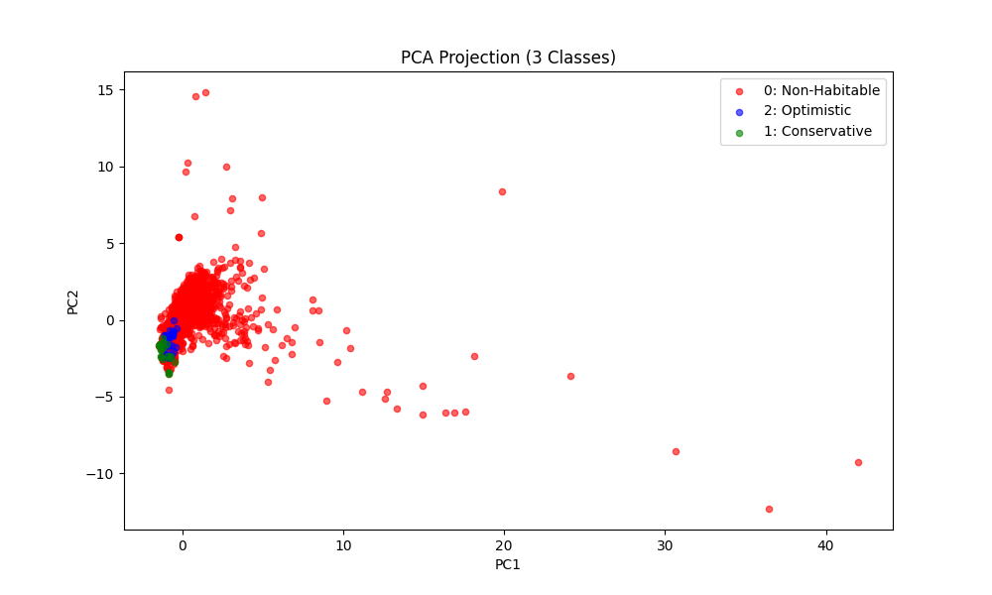
- t-SNE (t-Distributed Stochastic Neighbor Embedding):
  - Purpose: Visualization and Clustering.
  - Explanation: "We use t-SNE to visualize high-dimensional data in 2D. As seen in the Malik paper, t-SNE helps us verify that 'Planet' signals cluster together in one region, separating them from noise".
- Applying the T- Distributed Stochastic Neighbor Embedding (t-SNE) on the training dataset results the following plot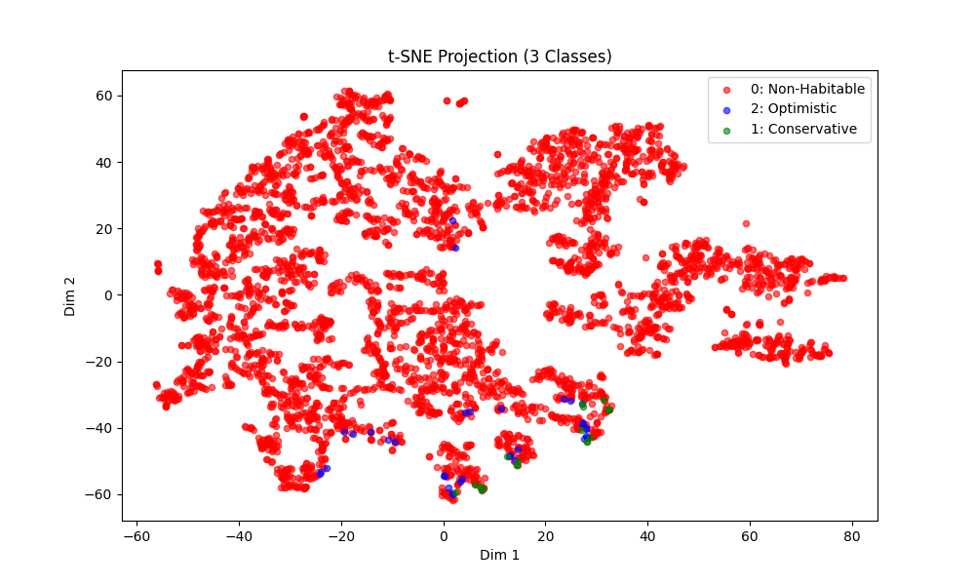
- Successfully created a Baseline model (before sampling) for the training dataset.

WEEK - 3 CHECKPOINT :

- Successfully splitted the dataset for training and testing.
- Successfully selected the feature variables for model input
- Successfully selected the target variable for model
- Successfully cleaned the dataset for the required data
- Successfully created the plots of PCA ,t-SNE of the dataset
- Successfully build a Baseline model for the dataset

WEEK 4:

MODULE - 4 :AI MODEL FOR HABITABILITY PREDICTION
• Train models such as:
• Random Forest Classifier for binary habitability prediction
• XGBoost Classifier for multi-class habitability levels
• Optionally, Logistic Regression or SVM for comparison
• Evaluate models using:
• Accuracy, Precision, Recall, F1-score, ROC-AUC
• Rank exoplanets based on predicted habitability scores.

DAY - 1 (22-12-2025):
Task : applying the following models for the baseline model :
1.logistic regression
2.linear svm
3.random forest
Observations :
1. Logistic Regression
Definition: Logistic Regression is a statistical method used for binary classification that models the probability of a binary outcome (e.g., 0 or 1) based on one or more predictor variables. It estimates the relationship between the features and the target variable by using the logistic function (also known as the sigmoid function) to map predicted values to probabilities between 0 and 1.
- Key Concept: Instead of fitting a straight line, it models the log-odds of the probability as a linear combination of the input features.
- Formula: $P(y=1|x) = \frac{1}{1 + e^{-(\beta_0 + \beta_1x)}}$

2. Linear Support Vector Machine (Linear SVM)
Definition: A Support Vector Machine (SVM) is a supervised learning algorithm that finds the optimal hyperplane in an N-dimensional space to distinctly classify data points. A Linear SVM specifically seeks a linear decision boundary (a straight line or flat plane) that separates the classes with the maximum possible margin.
- Key Concept: The algorithm focuses on the "Support Vectors," which are the data points closest to the decision boundary. Maximizing the distance (margin) between these points and the hyperplane improves the model's ability to generalize to new data.

3. Random Forest
Definition: Random Forest is an ensemble learning method that operates by constructing a multitude of decision trees during training. It uses a technique called bagging (Bootstrap Aggregating) to train each tree on a random subset of the data and a random subset of the features. The final output is determined by aggregating the predictions of all individual trees (e.g., taking the majority vote for classification).
- Key Concept: By averaging the results of many uncorrelated trees, Random Forest reduces the risk of overfitting (memorizing noise) that is common in single decision trees, resulting in a more robust and accurate model.
- Applying these models on the baseline model of the dataset results in the following plot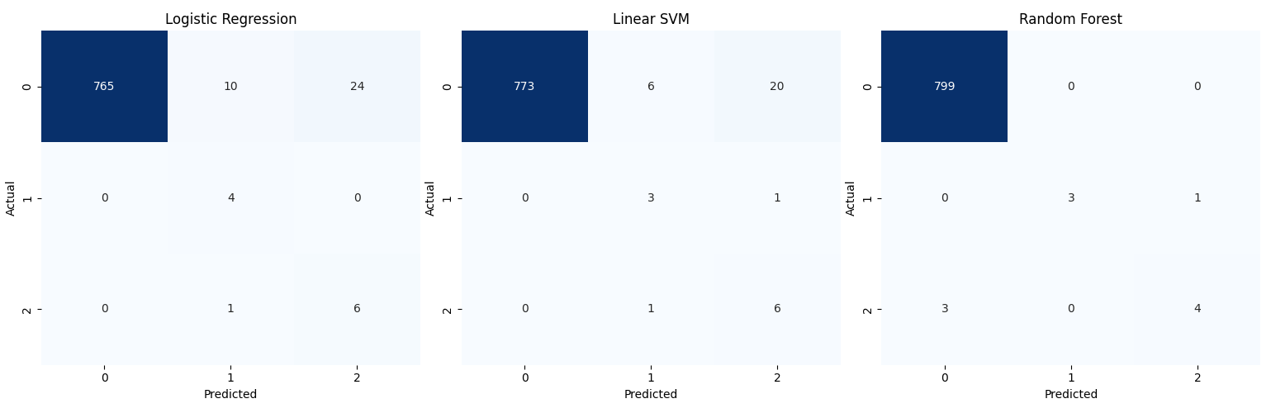
- In logistic regression, the model guessed
  - 6 out of 7 optimistic planets and 24 false positives
  - 4 out of 4 conservative planets and 10 false positives, 1 optimistic
- In linear SVM , the model guessed
  - 6 out of 7 optimistic planets and 20 false positives , 1 conservative
  - 3 out of 4 conservative planets and 6 false positives, 1 optimistic
- In random forest, the model guessed
  - 4 out of 7 optimistic planets and 0 false positives, the remaining 3 are considered as non habitable
  - 3 out of 4 conservative planets and 0 false positives, 1 optimistic
- Note : these results are generated before sampling the training data
DAY - 2 (23-12-2025):
Task : Applying the sampling techniques on the data and training the models again for better results
Observations :
Applied SMOTE on the training dataset and the Random Forest model is trained using the dataset and the resulted confusion matrix plot :
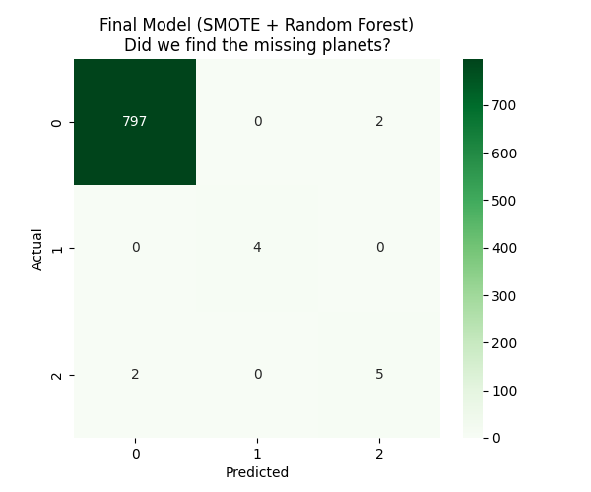

Also trained the svm model with the SMOTEd dataset and the resultant confusion matrix plot :
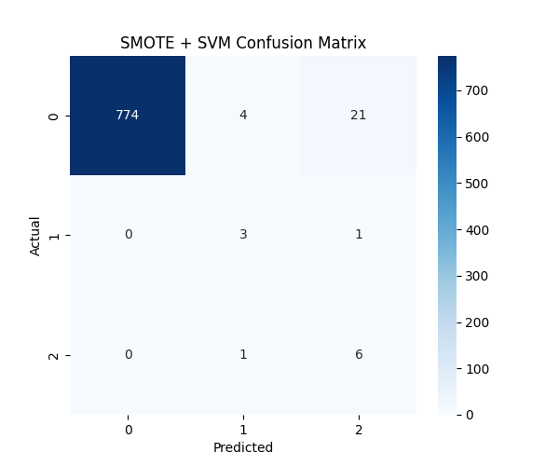

And also trained the class weighted svm model with the dataset and the resultant confusion matrix plot :
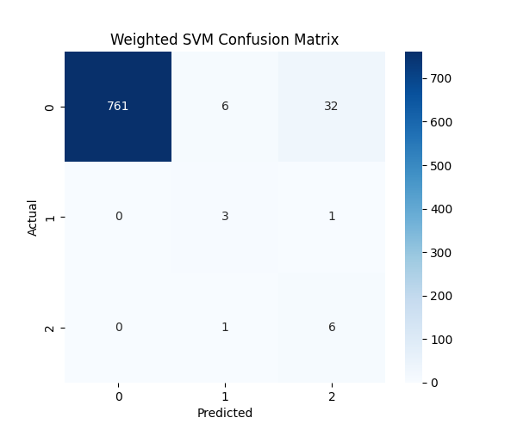
DAY - 3 (24-12-2025):
Task : continuing the yesterday work on training the models
Observation:
Trained the class weighted Logistic Regression model with the dataset and the resultant confusion matrix plot :
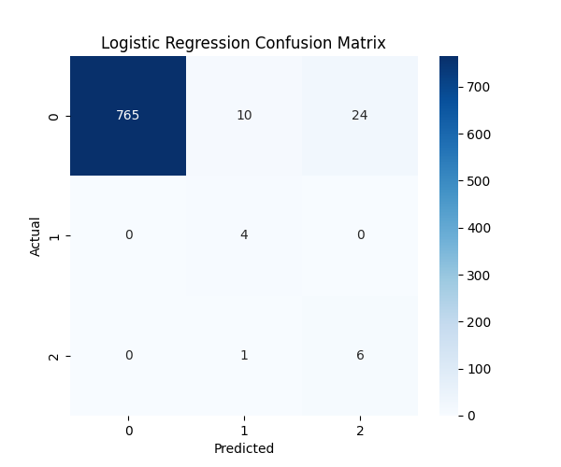
trained the class weighted xgboost model with the dataset and the resultant confusion matrix plot :
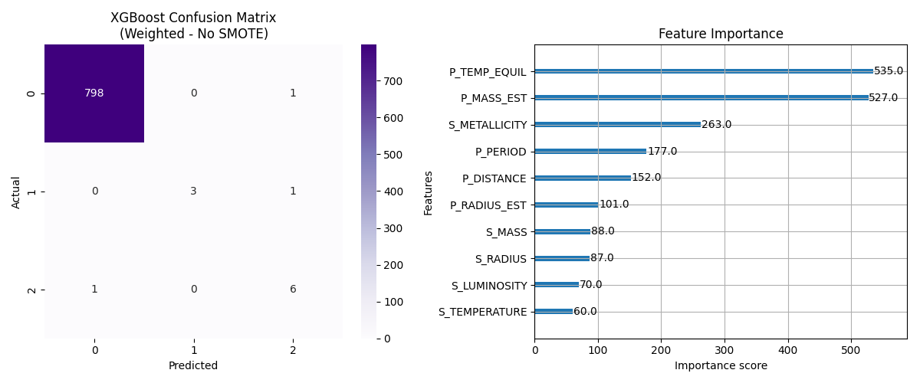
Created a bar graph comparing the models logistic regression (weighted), xgboost (weighted), svm (weighted), Random Forest (SMOTE). The resulted plot is :
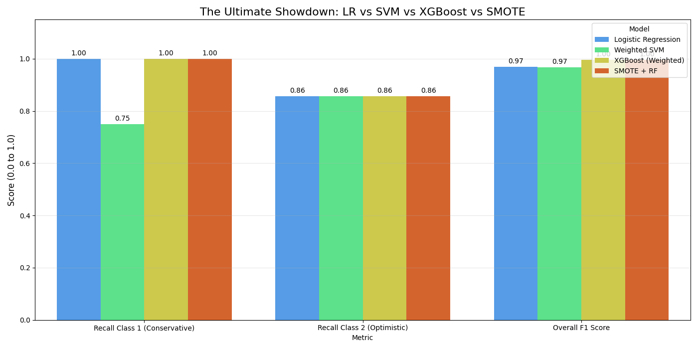
Conclusion :
Based on the data acquired by training models and comparing Accuracy, Precision, Recall, F1-score, ROC-AUC for every model, the top scored model is “class weighted xgboost ” with the following results plot:
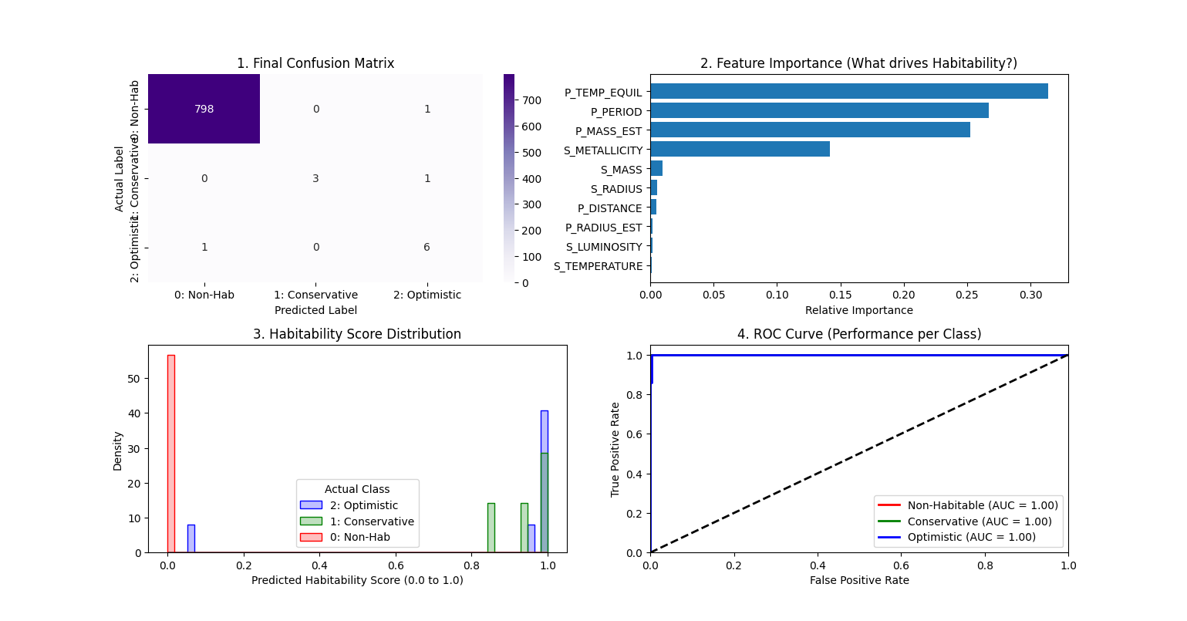
But the Random Forest (SMOTE) also got the similar results with a small infraction in considering all habitable planets compared to xgboost (weighted).
DAY - 4 (25-12-2025):
Task : Trying to implement the SMOTE on xgboost and compare the weighted vs SMOTE results.
Observations:
Being curious i tried to mix SMOTE and xgboost together and train the model to see how the results will be so i started doing the work and the results are pretty interesting
I used the same training dataset and trained the model the confusion matrix is:
precision recall f1-score support

0 1.00 1.00 1.00 799
1 1.00 1.00 1.00 4
2 1.00 1.00 1.00 7

accuracy 1.00 810
macro avg 1.00 1.00 1.00 810
weighted avg 1.00 1.00 1.00 810

I got a perfect diagonal with remaining values as zeroes. Now i compared the weighted and SMOTE xgboost the bar graph as follows :
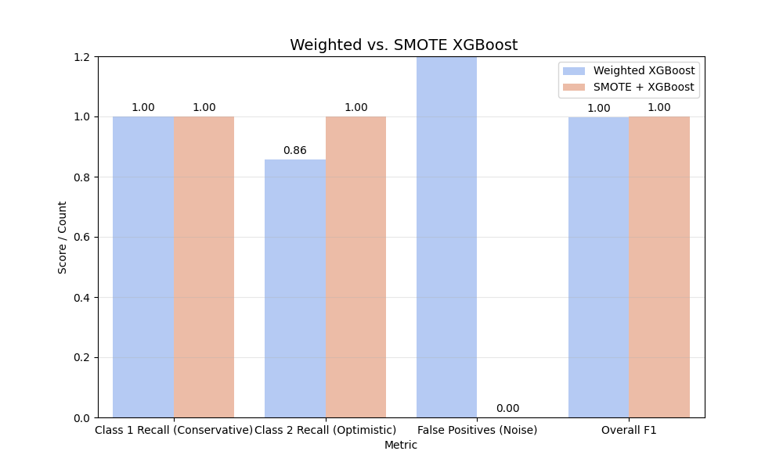
With this I want to use this model as my final model.
Question: Can I use this model for my project?

DAY - 5 (26-12-2025):
Task : Testing the SMOTE+xgboost model.
Test 1: Using full dataset to test the model instead of the testing dataset
Observations :
The results as follows:
precision recall f1-score support

0 1.00 1.00 1.00 2655
1 1.00 1.00 1.00 16
2 1.00 1.00 1.00 29

accuracy 1.00 2700
macro avg 1.00 1.00 1.00 2700
weighted avg 1.00 1.00 1.00 2700

This results shows that the model can accurately predict when good data is given.

Test 2 : using nasa exoplanet archive data to test the model and compare the results with the currently using dataset :
Observations :
The results is as follows :
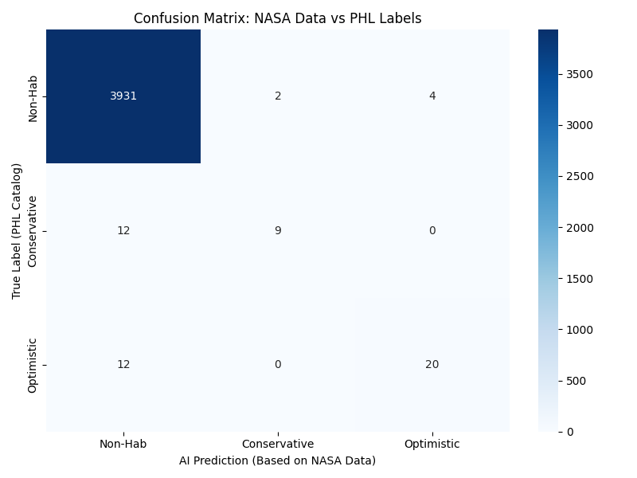
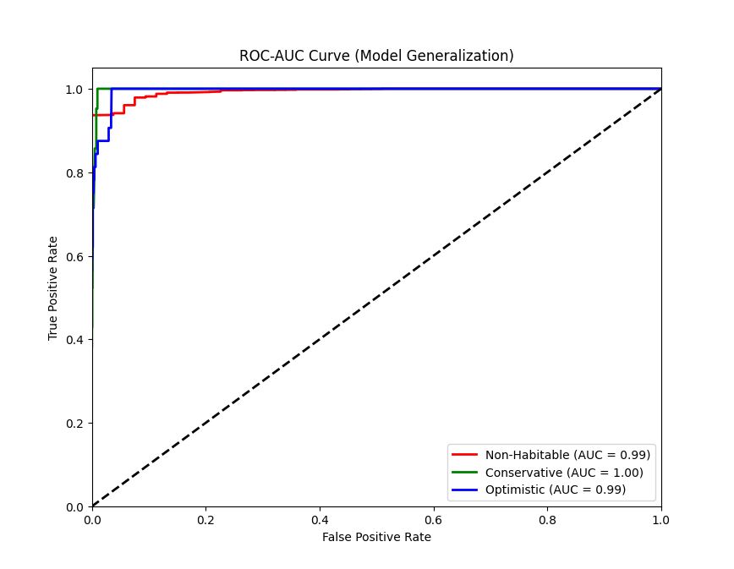

Overall Accuracy: 99.25%
Precision (Macro): 0.88
Recall (Macro): 0.68
F1-Score (Macro): 0.76

--- Detailed Classification Report ---
precision recall f1-score support

Non-Habitable 0.99 1.00 1.00 3937
Conservative 0.82 0.43 0.56 21
Optimistic 0.83 0.62 0.71 32

accuracy 0.99 3990
macro avg 0.88 0.68 0.76 3990
weighted avg 0.99 0.99 0.99 3990

Conclusion :
I validated the model by cross-referencing the PHL labels with the raw physical data from the NASA Exoplanet Archive.
The model achieved 99.25% accuracy. Most importantly, it demonstrated high safety: out of nearly 4,000 non-habitable planets, it only generated 6 false positives.
It successfully re-discovered famous planets like Proxima Centauri b, TRAPPIST-1 e, and Kepler-186 f purely based on their physics. The missed detections (False Negatives) were analyzed and found to be caused by missing values in the NASA dataset, which the Imputer filled with median (non-habitable) values.

WEEK 5:

MODULE - 5 : FLASK BACKEND API

• Create REST APIs to:

• Accept exoplanet data input from users

• Return habitability prediction and ranking

• Connect Flask backend to the database for dynamic data retrieval

• Secure endpoints and implement JSON response structure

1. REST API
REST stands for REpresentational State Transfer. It is a set of architectural rules for how computers communicate over the web.
- The Concept: It treats everything as a "Resource" (like a Planet, a User, or a Prediction). You interact with these resources using standard HTTP verbs.
- The Rules:
  - Stateless: The server does not remember the user between requests. Every request must contain all the necessary information (like a keycard) to be processed.
  - Client-Server: The Frontend (Client) and Backend (Server) are independent. You can change the code on one side without breaking the other, as long as the message format (JSON) stays the same.
- The Methods:
  - GET: Retrieve data (e.g., Get list of planets).
  - POST: Send new data (e.g., Upload CSV for prediction).
  - PUT: Update existing data.
  - DELETE: Remove data.
2. Sync vs. Asynchronous Requests
- Synchronous (Sync):
  - How it works: If You send a request and wait for the answer. You cannot do anything else until the server responds.
  - Blocking: If the server takes 10 seconds to process a file, your browser (or code) hangs for 10 seconds.
  - Flask: By default, Flask handles requests synchronously.
- Asynchronous (Async):
  - How it works: If you send a request and get a "receipt" immediately. You can continue doing other work. The server processes the task in the background and notifies you when it's done.
  - Non-Blocking: Ideal for heavy tasks. You can send 100 requests at once without waiting for the first one to finish.
3. Multithreading vs. Concurrency
- Concurrency (Managing multiple things): The ability of the system to deal with multiple tasks at once. It doesn't necessarily mean doing them at the exact same instant; it might mean switching back and forth very quickly.
- Parallelism (Doing multiple things): Doing multiple tasks at the exact same physical instant. This requires multiple CPU cores.
- How many threads run parallel?
  - You can strictly run only as many parallel threads as you have physical cores. If you have a 16-core processor, only 16 threads can execute instructions at the exact same nanosecond.
- How many concurrent tasks?
  - Ideally Infinite (Limited by RAM).
  - Even with 16 cores, the Operating System creates "Virtual Threads" (often hundreds or thousands). The CPU switches between them so fast (Time Slicing) that it looks like they are running at the same time.
4. Flask vs. FastAPI :
- Flask:
  - Built on WSGI (Web Server Gateway Interface).
  - It uses a Thread-per-Request model. If you have 5 threads and 6 user try to upload a file, the 6th user waits.
  - Why use it? It is mature, simple, and the industry standard for Data Science/ML pipelines where the bottleneck is the CPU calculation, not the web connection.
- FastAPI:
  - Built on ASGI (Asynchronous Server Gateway Interface).
  - It uses an Event Loop. It can handle thousands of incoming connections on a single thread.
  - Advantage: If an app does a lot of "Waiting" (e.g., waiting for a database query, waiting for an external API), FastAPI is much faster because it uses that waiting time to serve other users.
5. Throughput
- Definition: The volume of data or requests your system can handle over a specific period.
- Measurement: Requests Per Second (RPS).
6. Inference Speed (Latency)
- Definition: The time it takes for the AI model to process one single input and return a result.
- Measurement: Milliseconds (ms).
7. Linux SSH Connection
In the professional world (Production), servers are just black boxes in a data center. They do not have monitors, keyboards, or mice.
- SSH (Secure Shell): A protocol to securely log into a remote computer.
  - The Command: ssh user@192.168.1.50
  - What happens: It opens a secure "tunnel" from your laptop's terminal to the server's terminal. You type commands on your laptop, but they execute on the cloud server.
8. SHAP Values (SHapley Additive exPlanations)
- The Problem: Complex AI models (like XGBoost) are "Black Boxes." They give a correct answer, but humans don't know why.
- The Solution (SHAP): It uses Game Theory to mathematically calculate the "contribution" of every feature to the final prediction.
- Example: If the AI says a planet is "Habitable" (Score: 0.98), SHAP explains:
  - Radius (1.1): Added +0.40 to the score.
  - Temperature (280K): Added +0.50 to the score.
  - Star Age (Older): Subtracted -0.02 from the score.
- Why it's the "Best": It is the only method that is mathematically consistent and provides a fair distribution of credit among features.

In this module, I focused on building the "brain" of the application that connects the data to the user. I moved beyond just having a machine learning model and created a web server using Flask to make the model accessible.
- Creating REST APIs: I developed API endpoints (URLs) that act as gateways. These allow the application to accept new planetary data input from a user and send back a habitability prediction and ranking.
- Database Integration: I connected the Flask backend to our database. This ensures that when the application runs, it can dynamically retrieve stored exoplanet records rather than just using a static file.
- Structuring Responses: I ensured that when the API sends data back to the frontend, it uses a structured JSON format. This makes it easy for the website to read and display the prediction results accurately.

WEEK 6 :

Module 6: Frontend UI Development

Once the backend was ready, I shifted to working on what the user actually sees. My goal here was to create a clean and responsive interface so that anyone—not just a developer—could use the tool.
- Building the Interface: I used HTML, CSS, and Bootstrap to build the webpages. I focused on making the design responsive so it looks good on different screen sizes.
- User Input Forms: I created specific input forms where users can type in planetary parameters (like radius or flux). This data is then sent to the backend for analysis.
- Displaying Results: I designed tables and display sections to show the model's output. This includes showing the predicted habitability score and ranking the planets based on their potential to support life.

WEEK 7:

Module 7: Visualization & Dashboard
In this module, I focused on turning raw numbers into visual insights. I wanted to give users a way to explore the data visually rather than just reading rows in a table.
- Interactive Dashboard: I built a dashboard that features various plots, such as feature importance charts (showing which factors matter most for habitability) and the distribution of habitability scores across different planets.
- Correlation Analysis: I visualized how different parameters, like star temperature and planet radius, interact with each other. I used libraries like Matplotlib, Seaborn, or Plotly to make these charts interactive and easy to understand.
- Reporting: I added functionality to export these insights. This allows users to generate and download reports (in PDF or Excel formats) detailing the top candidate exoplanets found by the model.

WEEK 8:

Module 8: Deployment & Documentation
In the final phase, I finalized the project to make it "production-ready." This wasn't just about coding, but about making sure the application could run online and be understood by others.
- Cloud Deployment: I deployed the full application (frontend, backend, and database) to the cloud platform Render. This makes the tool accessible via a public web link.
- Documentation: I wrote comprehensive technical documentation and a README file. This explains how to install the project, how the code works, and how to use the features I built.
- Final Deliverables: I compiled the final Project Report and recorded a video demo to showcase the working application and explain the entire development process.

