TITLE
Organizational Knowledge Gap Intelligence Platform

Work done by:
SHINY P
TEAM – three
Batch number : 1
Internship duration : 8 weeks

PROJECT DOCUMENTATION (CONTRIBUTION)
AI Recommendation, Training Recommendation, Learning Path, Assessment, Learning Progress & Knowledge Sharing

TECHNOLOGY STACK:
- React.js
- Java
- Spring Boot
- Spring Data JPA
- Hibernate
- PostgreSQL/Supabase
- Gemini LLM
- Maven
- Intellij

Table of Contents
Contents
- Abstract
- System Requirements & Technology Stack
2.1 Introduction
  - Core Objectives
2.3 Key Outcome
3. System Requirements & Technology Stack
4. Architecture & Technical Design
  - System architecture
  - Entity-Relationship diagram
- Module-wise Detailed Implementation
  - AI Recommendation
  - Learning Path
  - Learning Progress
  - Knowledge Sharing & Mentorship
  - Assessment and survey module
- Testing, Validation & Code Quality
- Challenges & Future Enhancements
- Conclusion

CHAPTER 1
ABSTRACT

In modern organizations, employees possess different levels of expertise across technical and professional skills. Traditional learning management systems usually recommend identical training programs to all employees, regardless of their individual competency levels. This often results in inefficient training, slower skill development, and poor utilization of organizational knowledge. Page
The Organizational Knowledge Gap Intelligence Platform is designed to solve this problem by combining skill-gap analysis, intelligent course recommendations, AI-powered learning suggestions, structured learning paths, learning progress tracking, and mentorship support into a single integrated platform.
The platform is developed using React.js for the frontend and Spring Boot for the backend. Spring Data JPA and Hibernate handle database operations, while PostgreSQL/Supabase stores employee, skill, and learning data. The AI recommendation module integrates the Gemini Large Language Model (LLM) to generate personalized learning suggestions.
The implemented workflow enables employees to receive targeted recommendations, follow structured learning paths, monitor their learning progress, and participate in collaborative knowledge sharing, thereby supporting continuous organizational learning and workforce development.

CHAPTER 2
PROJECT OVERVIEW & OBJECTIVES

2.1 INTRODUCTION
Organizations today operate in rapidly changing technological environments where employee skills must continuously evolve. However, managers often struggle to identify which employees require training, while employees themselves may not know which skills they should prioritize.
The Organizational Knowledge Gap Intelligence Platform addresses these challenges by creating an intelligent system capable of:
- Identifying employee skill gaps.
- Recommending appropriate training.
- Generating AI-assisted learning suggestions.
- Tracking learning progress.
- Supporting collaborative knowledge sharing.
Instead of treating training as a one-time activity, the platform transforms it into a continuous learning ecosystem.
Problem Statement
Organizations face several challenges:
- Difficulty identifying employee competency gaps.
- Generic training programs.
- Lack of personalized learning.
- Poor visibility into learning progress.
- Limited knowledge sharing between employees.
This project solves these challenges through intelligent automation.

2.2 CORE OBJECTIVES
The objectives of this module are:
- Analyze employee skill gaps.
- Recommend suitable training courses.
- Generate personalized AI recommendations.
- Create structured learning paths.
- Track learning progress.
- Encourage knowledge sharing and mentorship.
- Improve organizational knowledge retention.
2.3 KEY OUTCOMES
Milestone | Outcome
Milestone 1 | React frontend completed
Milestone 2 | Spring Boot backend APIs developed
Milestone 3 | AI Recommendation, Learning modules implemented & Frontend-backend integration completed
Milestone 4 | Testing and deployment preparation

CHAPTER 3
SYSTEM REQUIREMENTS & TECHNOLOGY STACK

FRONTEND TECHNOLOGIES
Technology | Purpose
React.js | User Interface
JavaScript | Client-side logic
React Router | Navigation
Axios | REST API communication
Tailwind CSS | Styling
Chart.js | Charts
Recharts | Analytics
D3.js | Data visualization
Context API | State management

Why React?
React provides:
- Component-based architecture
- Dynamic rendering
- Faster UI updates
- Reusable components

BACKEND TECHNOLOGIES
Technology | Purpose
Java | Programming language
Spring Boot | Backend framework
Spring Data JPA | Database access
Hibernate | ORM
Spring Security | Authentication
Maven | Dependency management
Why Spring Boot?
Spring Boot simplifies:
- REST API creation
- Dependency injection
- Database integration
- Service organization
Database
The platform uses:
- PostgreSQL
- Supabase (managed PostgreSQL)
Database stores:
- Employees
- Skills
- Training courses
- Learning progress
- Knowledge articles
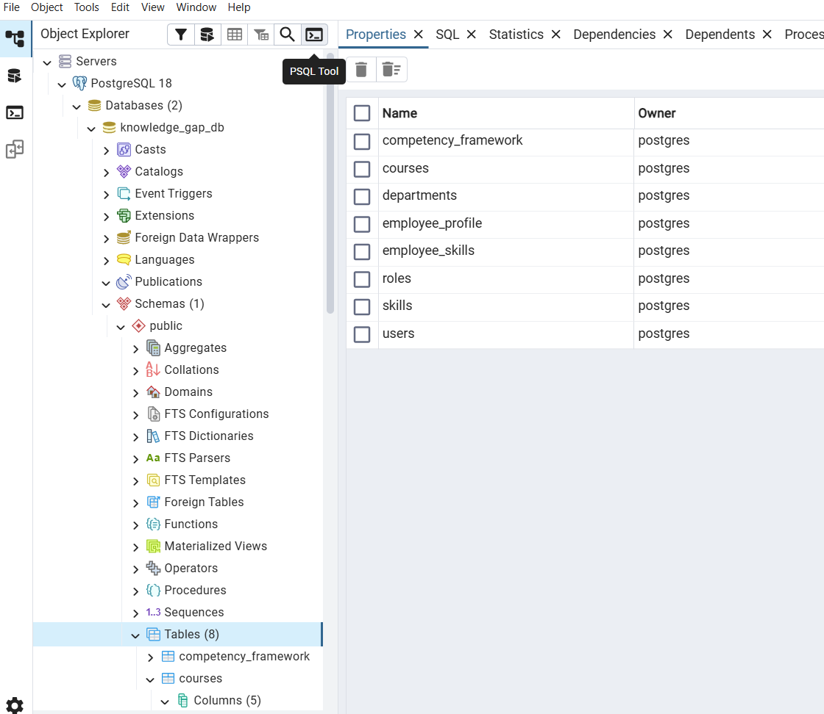
Fig 3.2: PostgreSQL

AI Integration
Current implementation:
- Gemini LLM
- Backend integration through GeminiServiceImpl
Purpose:
- Personalized recommendations
- Intelligent learning suggestions

CHAPTER 4
ARCHITECTURE & TECHNICAL DESIGN
4.1 System Architecture
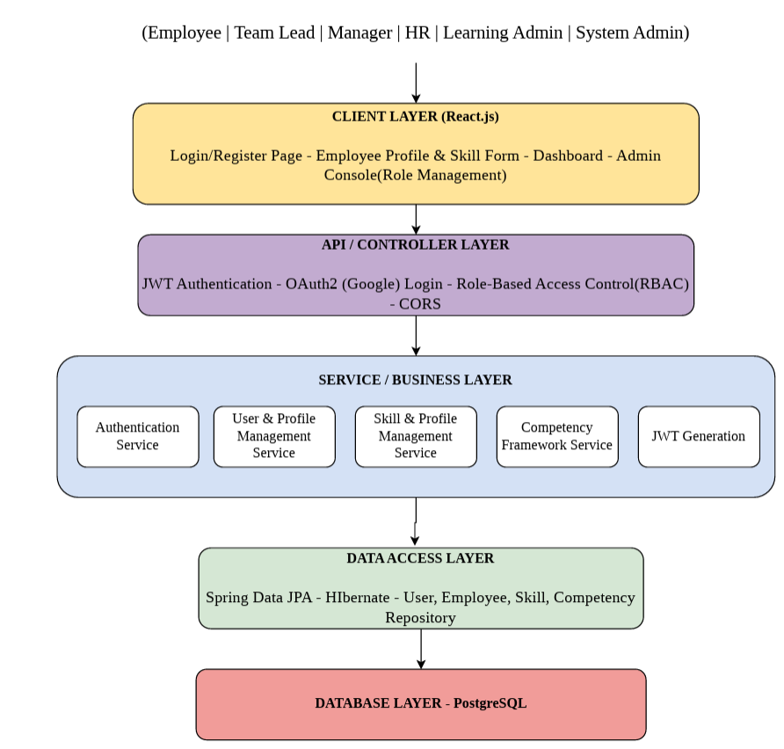
Architecture Explanation
The Organizational Knowledge Gap Intelligence Platform follows a layered architecture, where each layer has a specific responsibility. This separation improves maintainability, security, and scalability. The frontend communicates with the backend through REST APIs, the service layer processes business logic, and the database stores organizational data.
Architecture Layers
1. User Roles
The platform supports multiple organizational roles:
- Employee – Takes assessments, updates skills, views recommendations, and tracks learning progress.
- Team Lead – Monitors team skill gaps and employee progress.
- Manager – Reviews departmental performance and recommends training.
- HR – Manages employees, departments, and competency frameworks.
- Learning Admin – Creates courses, assessments, and learning paths.
- System Admin – Manages the overall platform configuration and user access.
These roles are protected using Role-Based Access Control (RBAC) implemented through Spring Security.
2. Client Layer (React.js)
The Client Layer is developed using React.js and provides the user interface.
Main components include:
- Login/Register Page
- Employee Profile
- Skill Form
- Dashboard
- Admin Console
The frontend communicates with the backend using Axios and REST APIs.
Technology Used
- React.js
- JavaScript
- React Router
- Axios
- Tailwind CSS
3. API / Controller Layer
The Controller Layer acts as the entry point for all client requests.
Main responsibilities:
- Receive HTTP requests.
- Validate incoming data.
- Authenticate users.
- Forward requests to the appropriate service.
Security features include:
- JWT Authentication
- OAuth2 Login (Google)
- Role-Based Access Control
- CORS Configuration
Example controllers:
- AuthController
- UserController
- RecommendationController
- AssessmentController
- LearningPathController
4. Service / Business Layer
This is the core processing layer of the application.
It contains the business logic for:
- Authentication
- User Management
- Skill Management
- Competency Framework
- AI Recommendations
- Learning Paths
- Assessments
Each service performs calculations, validations, and data processing before interacting with the database.
Example services:
Service | Purpose
Authentication Service | User login
User & Profile Service | Employee management
Skill & Profile Service | Skill management
Competency Framework Service | Required skill levels
JWT Service | Token generation
5. Data Access Layer
The Data Access Layer connects the application to the database.
It uses:
- Spring Data JPA
- Hibernate
Repositories perform CRUD operations without requiring manual SQL for most queries.
Example repositories:
- UserRepository
- SkillRepository
- EmployeeSkillRepository
- AssessmentRepository
Benefits:
- Faster development
- Automatic query generation
- Object-relational mapping
6. Database Layer
The platform uses PostgreSQL as its primary relational database.
It stores:
- Users
- Skills
- Employee Profiles
- Assessments
- Learning Progress
- Knowledge Articles
- Recommendations
Request Flow
A typical request follows this sequence:
- User logs in through React.
- Request reaches the Controller.
- Spring Security validates JWT.
- Service processes business logic.
- Repository accesses PostgreSQL.
- Response returns to React.

4.2 Entity Relationship Diagram
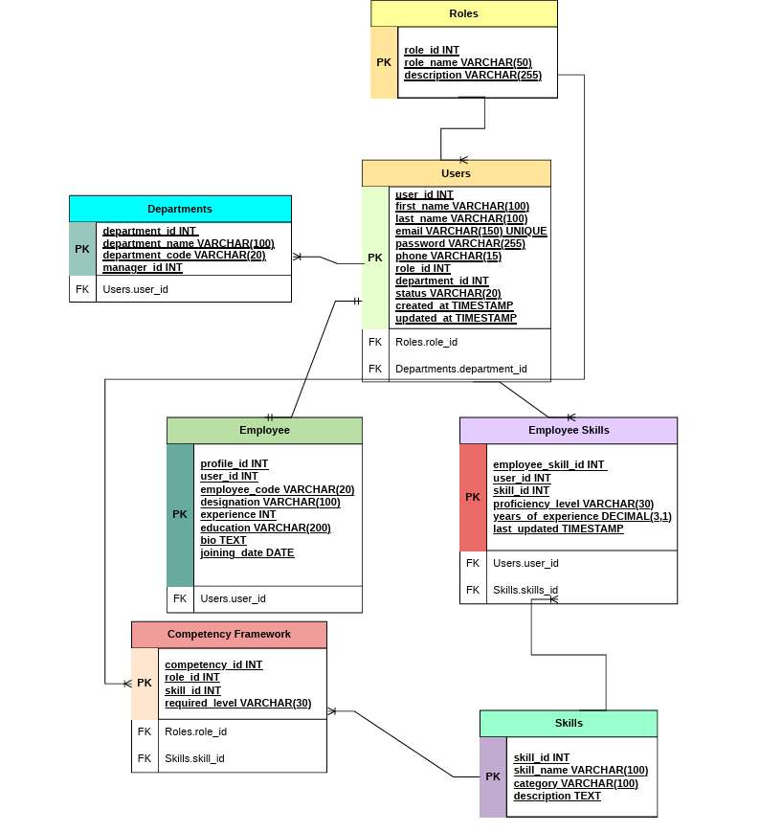
The ER Diagram represents the database structure of the Organizational Knowledge Gap Intelligence Platform.
The design is centered around the Users table, which connects employees, skills, departments, and competency frameworks.
1. Roles Table
The Roles table defines different user roles within the organization.
Field | Description
role_id | Primary Key
role_name | Employee, HR, Manager, Admin
description | Role description
Relationship
- One role can be assigned to many users.
Example:
The "Employee" role can belong to hundreds of users.
2. Users Table
This is the central table of the system.
Field | Description
user_id | Primary Key
first_name | Employee first name
last_name | Employee last name
email | Unique login email
password | Encrypted password
phone | Contact number
role_id | Foreign key
department_id | Foreign key
status | Active/Inactive
created_at | Creation timestamp
updated_at | Last update
Relationships
- Many users belong to one role.
- Many users belong to one department.
- One user has one employee profile.
- One user can have multiple skills.
3. Departments Table
Stores organizational departments.
Field | Description
department_id | Primary Key
department_name | Department name
department_code | Department code
manager_id | Department manager
Relationship
- One department contains many users.
Example:
- IT Department
- HR Department
- Finance Department
4. Employee Table
Stores additional employee-specific information.
Field | Description
profile_id | Primary Key
user_id | Foreign Key
employee_code | Company employee code
designation | Job title
experience | Years of experience
education | Qualification
bio | Employee profile
joining_date | Joining date
Relationship
- One user has one employee profile.
This separates login information from professional information.
5. Skills Table
Stores all available skills.
Field | Description
skill_id | Primary Key
skill_name | Skill name
category | Technical/Soft Skill
description | Skill description
Example skills:
- Java
- Spring Boot
- SQL
- Communication
6. Employee Skills Table
This table connects employees with their skills.
Field | Description
employee_skill_id | Primary Key
user_id | Foreign Key
skill_id | Foreign Key
proficiency_level | Beginner, Intermediate, Expert
years_of_experience | Experience
last_updated | Timestamp
This is a many-to-many relationship between Users and Skills.
7. Competency Framework Table
Defines the required skill level for each role.
Field | Description
competency_id | Primary Key
role_id | Foreign Key
skill_id | Foreign Key
required_level | Expected proficiency
This table is the foundation of the Gap Analysis Module.
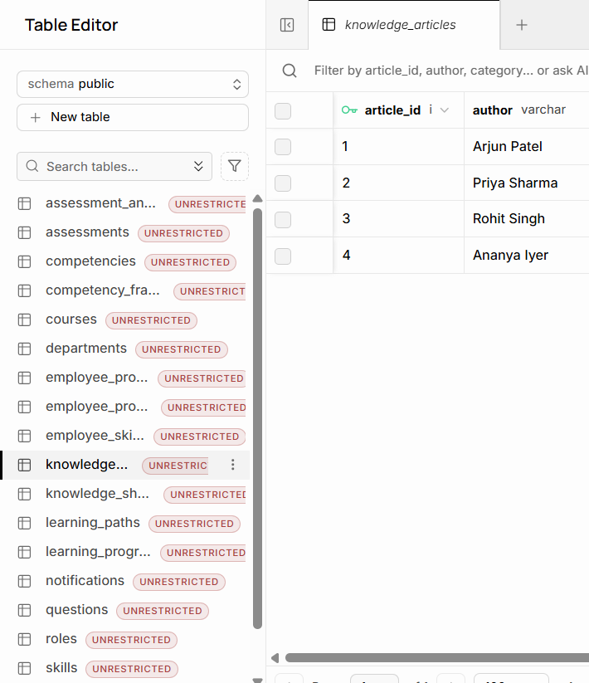

Fig 4.1: Supabase

CHAPTER 5
MODULE-WISE DETAILED IMPLEMENTATION

Purpose
This module recommends training courses based on employee skill gaps.
Unlike the AI module, this recommendation engine follows business logic.
Important Backend Files
RecommendationController.java
RecommendationServiceImpl.java
TrainingRecommendationController.java
TrainingRecommendationServiceImpl.java
TrainingCourseRepository.java
Core Algorithm
The recommendation engine follows this logic:
Java
List<GapAnalysisResponse> gaps =
gapAnalysisService.analyzeEmployee(userId);
if(gap.getGap()<=0)
continue;
trainingCourseRepository.findBySkillName(gap.getSkillName());
Algorithm Explanation
- Employee skill data is retrieved.
- Gap analysis identifies missing skills.
- Skills with Gap = 0 are ignored.
- Matching courses are fetched.
- Recommendations are returned.

5.1 AI RECOMMENDATION MODULE
Purpose
Generate personalized recommendations using Gemini.
Important Files
AIRecommendationController.java
AIRecommendationServiceImpl.java
GeminiServiceImpl.java
Workflow
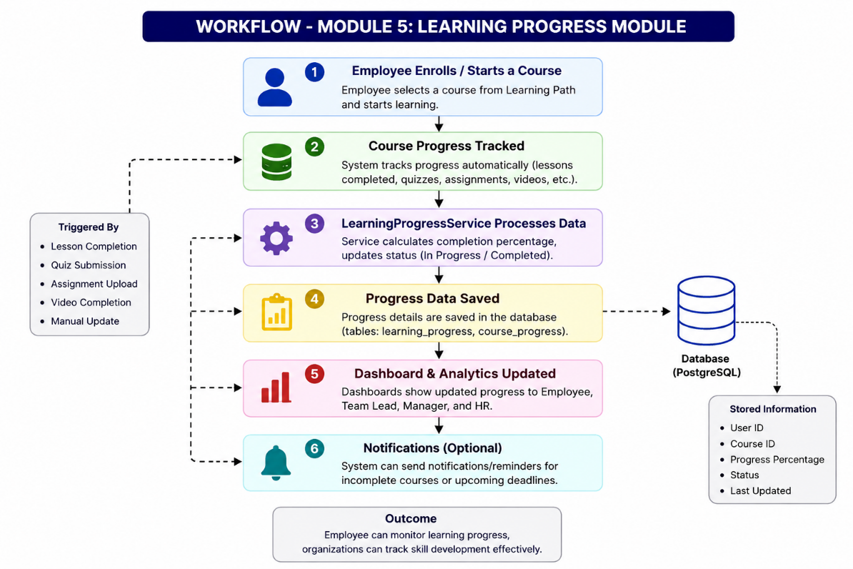

Gemini receives employee context and generates intelligent learning suggestions.
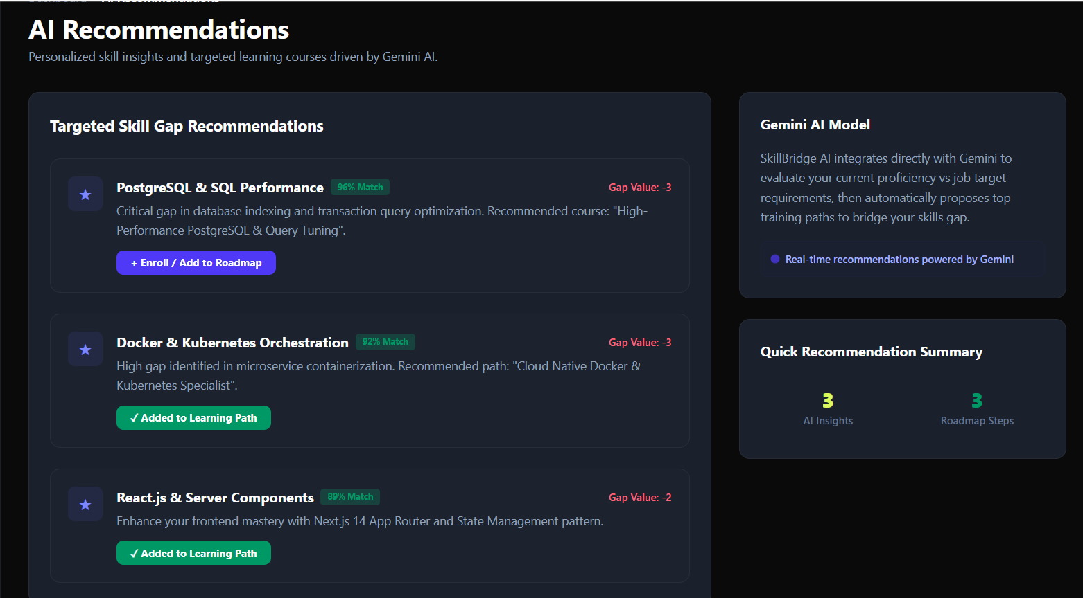
5.2 LEARNING PATH MODULE
Purpose
Convert recommendations into an organized learning journey.
Important Files
LearningPathController.java
LearningPathServiceImpl.java
LearningPathRepository.java
5.3 LEARNING PROGRESS MODULE
Purpose
Track employee learning completion.
Files
LearningProgressController.java
LearningProgressServiceImpl.java
LearningProgressRepository.java
Workflow
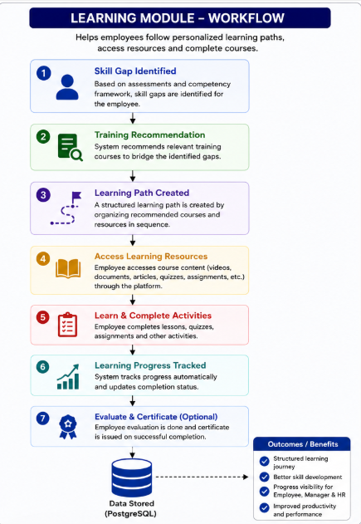
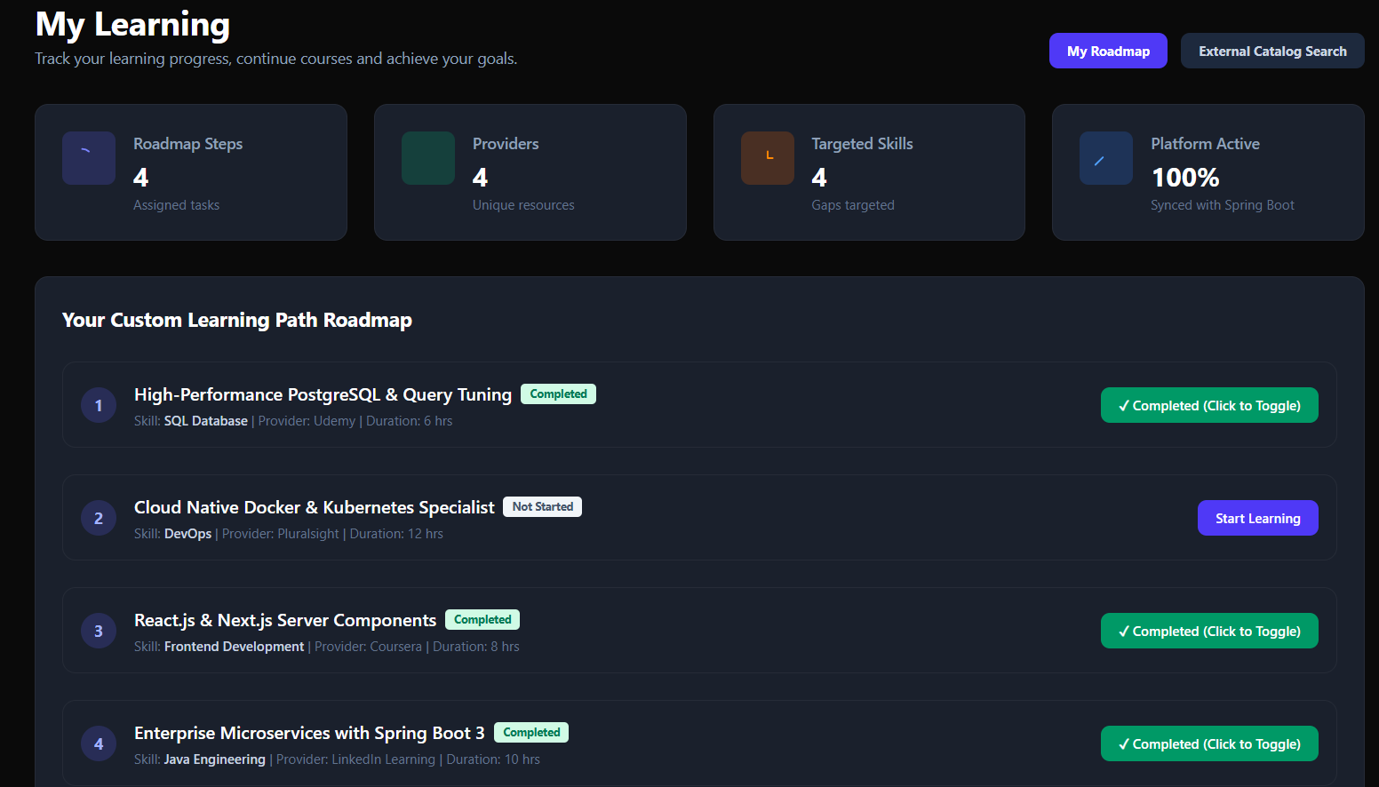

5.4 KNOWLEDGE SHARING & MENTORSHIP
Purpose
Support collaborative learning.

Files
KnowledgeSharingController.java
KnowledgeSharingServiceImpl.java
KnowledgeArticleController.java
KnowledgeArticleServiceImpl.java

Workflow
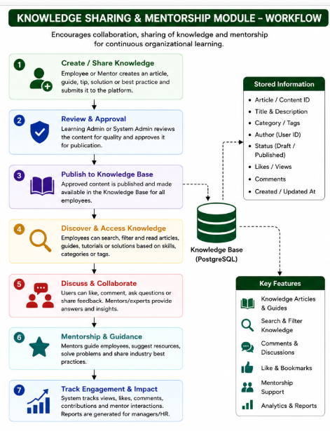
Employees can access shared knowledge and receive mentorship support.
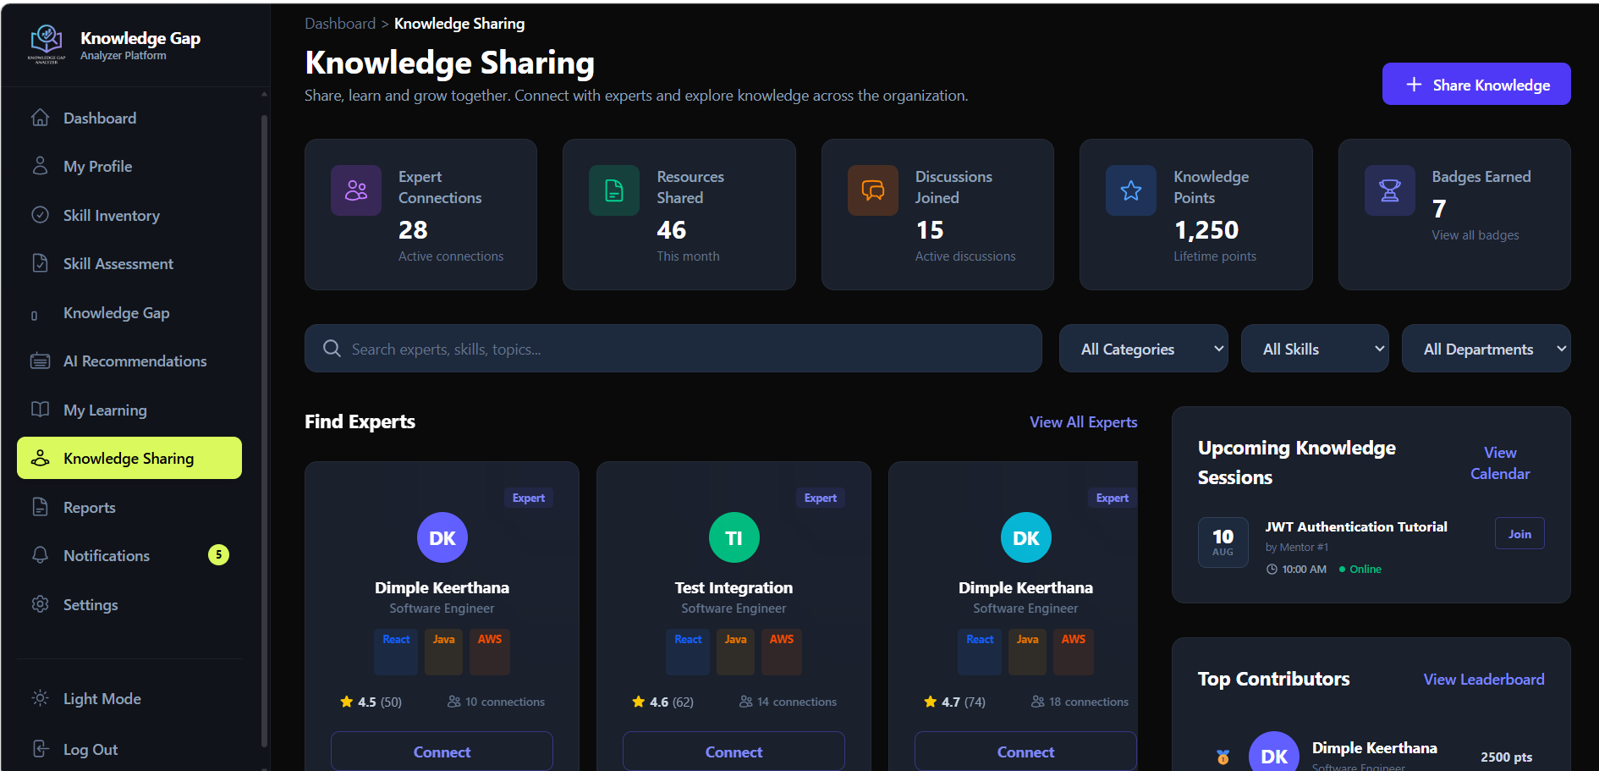
5.5 ASSESSMENT & SURVEY MODULE
Purpose
The Assessment & Survey Module evaluates an employee's knowledge through skill-based quizzes. It allows administrators or HR to create assessments, add multiple-choice questions, and evaluate employee performance. The module calculates scores automatically, determines whether the employee has passed or failed based on predefined passing marks, and stores the submitted answers for future analysis.
Unlike a simple quiz system, this module is integrated with the platform's learning ecosystem. The assessment results help identify knowledge gaps, which are later used by the Recommendation Engine and AI Recommendation Module to suggest suitable learning resources.
Objectives
- Create assessments for different skills and courses.
- Add multiple-choice questions with correct answers.
- Allow employees to attempt assessments.
- Automatically calculate scores.
- Validate that submitted questions belong to the selected assessment.
- Store employee responses for future analysis.
- Support personalized learning recommendations after assessment.
Backend Files Used
Controllers
AssessmentController.java
QuestionController.java
AssessmentAnswerController.java
Services
AssessmentService.java
AssessmentServiceImpl.java
AssessmentAnswerService.java
AssessmentAnswerServiceImpl.java
Entities
Assessment.java
Question.java
AssessmentAnswer.java
Repositories
AssessmentRepository.java
QuestionRepository.java
AssessmentAnswerRepository.java
Assessment Workflow
The assessment process follows this sequence.
Working
Step 1 – Assessment Creation
The administrator creates an assessment.
Example:
Field | Value
Assessment ID | 14
Course | React
Total Questions | 10
Passing Marks | 6

The assessment information is stored in the Assessment table.
Step 2 – Question Creation
Each assessment contains multiple questions.
Example JSON used in Postman:
JSON
{
"assessment": {
"assessmentId": 14
},
"questionText": "Which hook is used for state management?",
"optionA": "useRef",
"optionB": "useState",
"optionC": "useEffect",
"optionD": "useMemo",
"correctAnswer": "useState"
}
Each question stores:
- Question text
- Four options
- Correct answer
- Associated assessment
Relationship:
Assessment (1)
│
├── Question 1
├── Question 2
├── Question 3
└── Question N
Step 3 – Employee Attempts Assessment
The frontend requests assessment questions.
Example endpoint:
GET /api/questions/assessment/{assessmentId}
The backend returns only questions belonging to that assessment.
Step 4 – Employee Submits Answers
The frontend sends:
- User ID
- Assessment ID
- Selected answers
Example request:
JSON
{
"userId": 2,
"answers": [
{
"questionId": 45,
"selectedAnswer": "useState"
},
{
"questionId": 46,
"selectedAnswer": "useEffect"
}
]
}
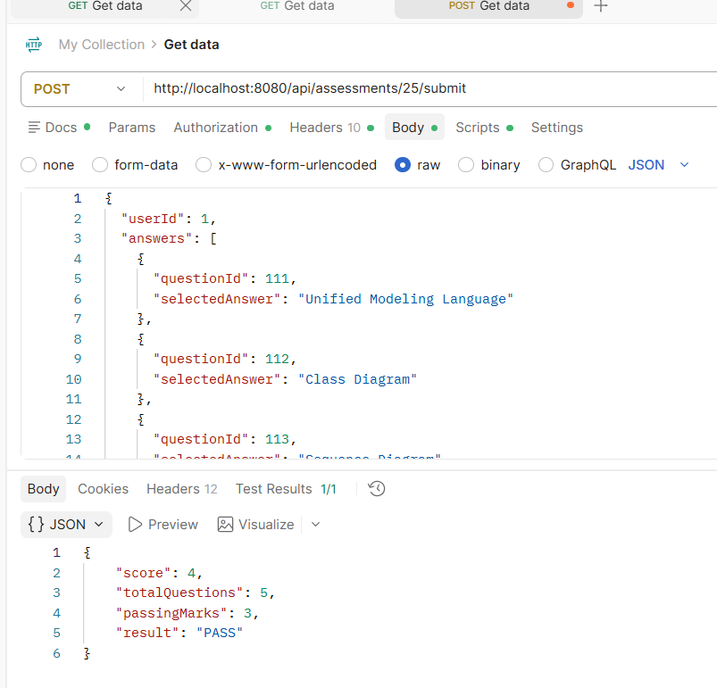
Assessment Validation
One important improvement implemented in your backend was question validation.
Earlier, a user could submit a correct question ID even with the wrong assessment ID.
Example problem:
Assessment ID = 24
Question belongs to Assessment 14
The submission still worked.
This was fixed inside AssessmentServiceImpl.
Validation added:
Java
if (!question.getAssessment().getAssessmentId().equals(assessmentId)) {
throw new RuntimeException(
"Question does not belong to this assessment."
);
}
Why this validation is important
It prevents:
- Cross-assessment submissions
- Invalid scoring
- Security loopholes
- Data inconsistency
Now every submitted question must belong to the selected assessment.
Score Calculation Logic
Inside AssessmentServiceImpl, each submitted answer is checked.
Logic:
Java
boolean correct =
question.getCorrectAnswer()
.equals(answerRequest.getSelectedAnswer());

if (correct) {
score++;
}
The system compares:
- Correct answer stored in database
- Employee's selected answer
Every correct answer increases the score.
Pass/Fail Decision
After evaluating all answers:
Java
if (score >= assessment.getPassingMarks()) {
response.setResult("PASS");
}
else {
response.setResult("FAIL");
}
Answer Storage
Every submitted answer is stored in the database.
Example entity fields:
Field | Purpose
User | Employee
Question | Attempted question
Selected answer | User response
IsCorrect | Evaluation result
This enables future analytics and learning recommendations.
Database Relationship
Relationships:
- One Assessment contains multiple Questions.
- One User submits multiple AssessmentAnswers.
- Each AssessmentAnswer references one Question.
APIs Used
Method | Endpoint | Purpose
POST | /api/assessments | Create assessment
GET | /api/assessments | View assessments
POST | /api/questions | Add question
GET | /api/questions/assessment/{id} | Get questions
POST | /api/assessments/{id}/submit | Submit assessment
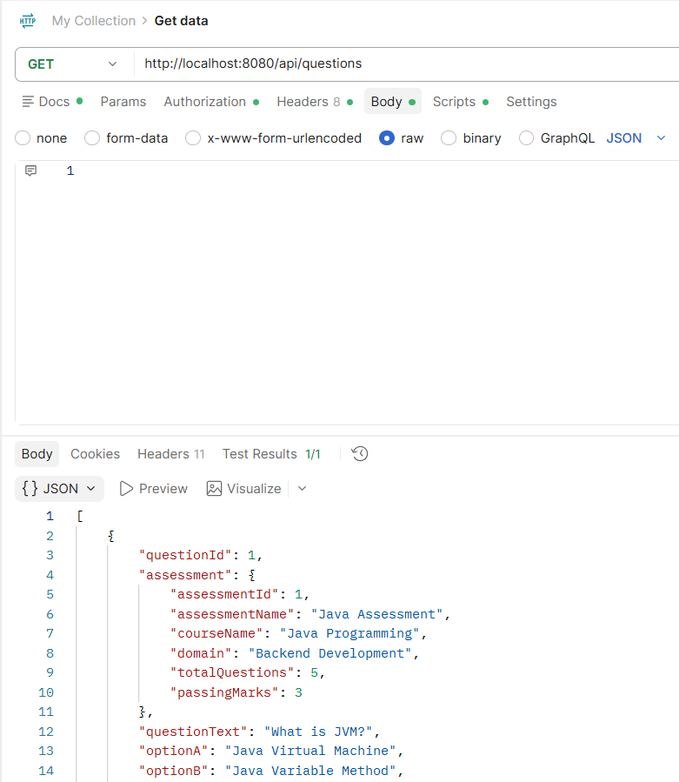
Testing & Validation
The Assessment Module was tested using Postman.
Test Cases
Test | Expected Result
Create Assessment | Success
Add Question | Success
Get Questions | Returns assessment questions
Submit Correct Answers | PASS
Submit Wrong Answers | FAIL
Wrong Assessment ID | Validation Error
Wrong Question ID | Question Not Found
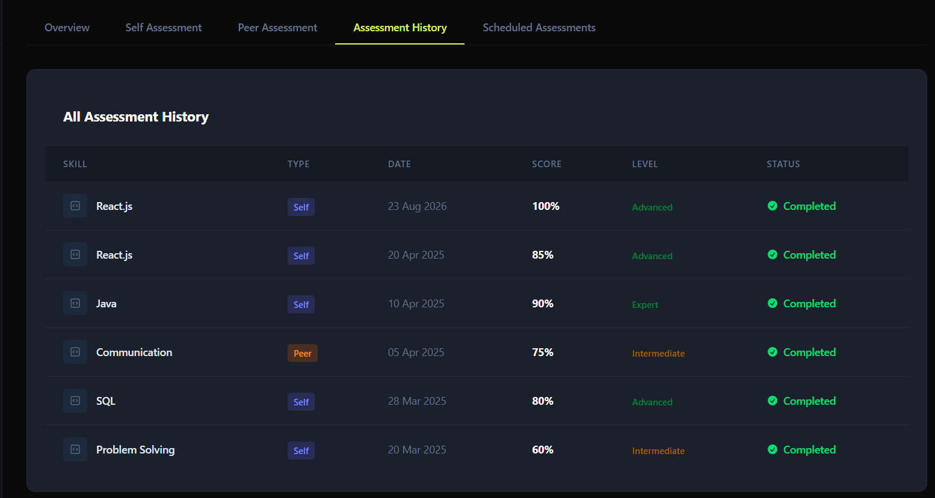

CHAPTER 6
TESTING, VALIDATION & CODE QUALITY
Unit Testing
Tools used:
- JUnit
- Mockito
API Testing
Postman verified:
- Recommendation API
- AI Recommendation API
- Learning Progress API
Validation included:
- Correct responses
- Error handling
- API functionality

CHAPTER 7
CHALLENGES & FUTURE ENHANCEMENTS
Challenges
- Integrating Gemini with backend services.
- Connecting gap analysis with recommendations.
- Separating AI recommendations from rule-based recommendations.
- Managing frontend-backend communication.
Future Enhancements
- Dynamic AI-generated learning paths.
- Intelligent mentor matching.
- Real-time recommendation updates.
- Advanced predictive learning analytics.

CONCLUSION
The AI Recommendation, Learning, and Mentorship module transforms the Organizational Knowledge Gap Intelligence Platform into an intelligent learning ecosystem. It combines skill-gap analysis, database-driven course recommendations, Gemini-powered AI suggestions, structured learning paths, learning progress tracking, and knowledge sharing to support continuous employee development. The implementation follows a scalable React + Spring Boot + JPA + PostgreSQL architecture and provides a strong foundation for future AI-driven organizational learning.

