EcoPackAI – AI-Powered Sustainable Packaging Recommendation System
Author: Nilesh Gawhale
Infosys Springboard Internship – Batch 11

1. Abstract
EcoPackAI is an AI-driven decision support system designed to recommend sustainable packaging materials based on product characteristics and sustainability priorities. The system integrates Machine Learning models for cost and CO₂ emission prediction, applies a weighted ranking framework, and provides an interactive dashboard for visualization.
The application is built using Flask (backend), HTML/Bootstrap (frontend), PostgreSQL (cloud database), and deployed using Render with production-ready configuration.
The project demonstrates the end-to-end lifecycle of an AI system: data processing, model training, backend integration, dashboard visualization, database logging, and cloud deployment.

2. Problem Statement
Sustainable packaging selection is a complex decision-making process involving trade-offs between:
- Cost
- Environmental impact (CO₂ emissions)
- Fragility requirements
- Shipping type
- Sustainability priority
Organizations often rely on static decision rules instead of data-driven approaches.
The objective of EcoPackAI is to:
- Predict packaging cost
- Predict CO₂ emission impact
- Rank materials dynamically
- Provide actionable recommendations
- Log usage data for analytics
3. System Architecture
3.1 High-Level Architecture
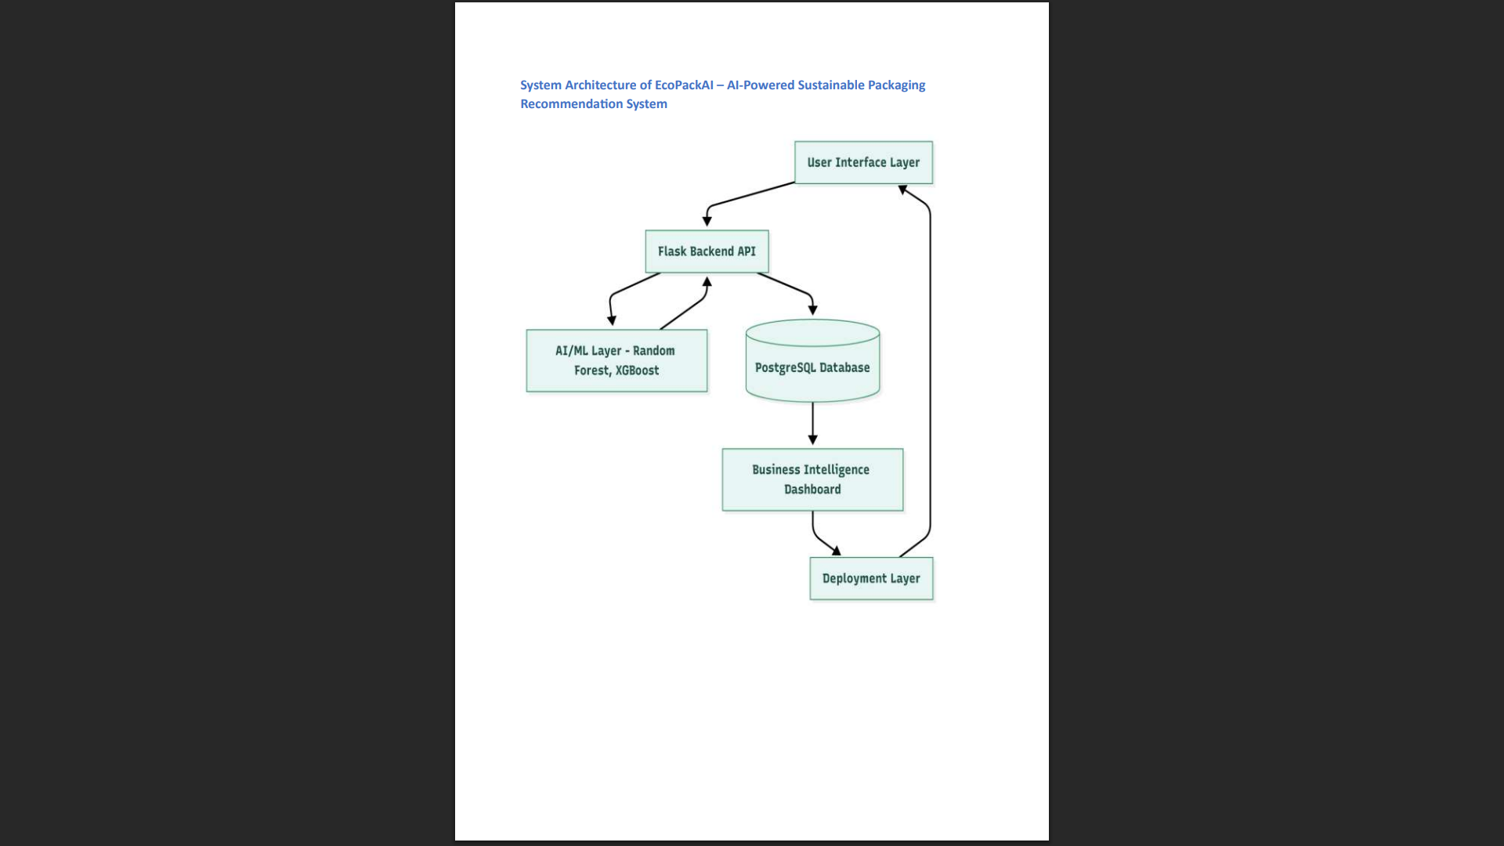
User (Browser)
→ Frontend (HTML + Bootstrap + JS)
→ Flask Backend
→ Feature Engineering
→ ML Models (Random Forest + XGBoost)
→ Ranking Engine
→ PostgreSQL (Cloud Logging)
→ Dashboard (Charts + Reports)
→ Export (Excel + PDF)

3.2 Component Description
Frontend
- Collects user inputs
- Displays recommendations
- Shows dashboard charts
- Provides export options
Backend (Flask)
- Handles API routes
- Loads ML models
- Generates predictions
- Applies ranking logic
- Logs usage to PostgreSQL
Machine Learning Layer
- Cost Prediction Model
- CO₂ Prediction Model
- Feature Scaling
Database Layer
- Cloud PostgreSQL
- Stores recommendation logs
- Tracks material usage frequency
4. Dataset Description
4.1 Dataset Name
EcoPackAI_materials.csv
4.2 Dataset Purpose
The dataset contains baseline packaging materials and their attributes, used for prediction and ranking.
4.3 Key Attributes
- Material Name
- Cost
- CO₂ Score
- Sustainability Score
- Weight-related metrics
4.4 Data Preprocessing
- Missing value handling
- Feature encoding
- Standardization using StandardScaler
- Feature vector creation based on user inputs
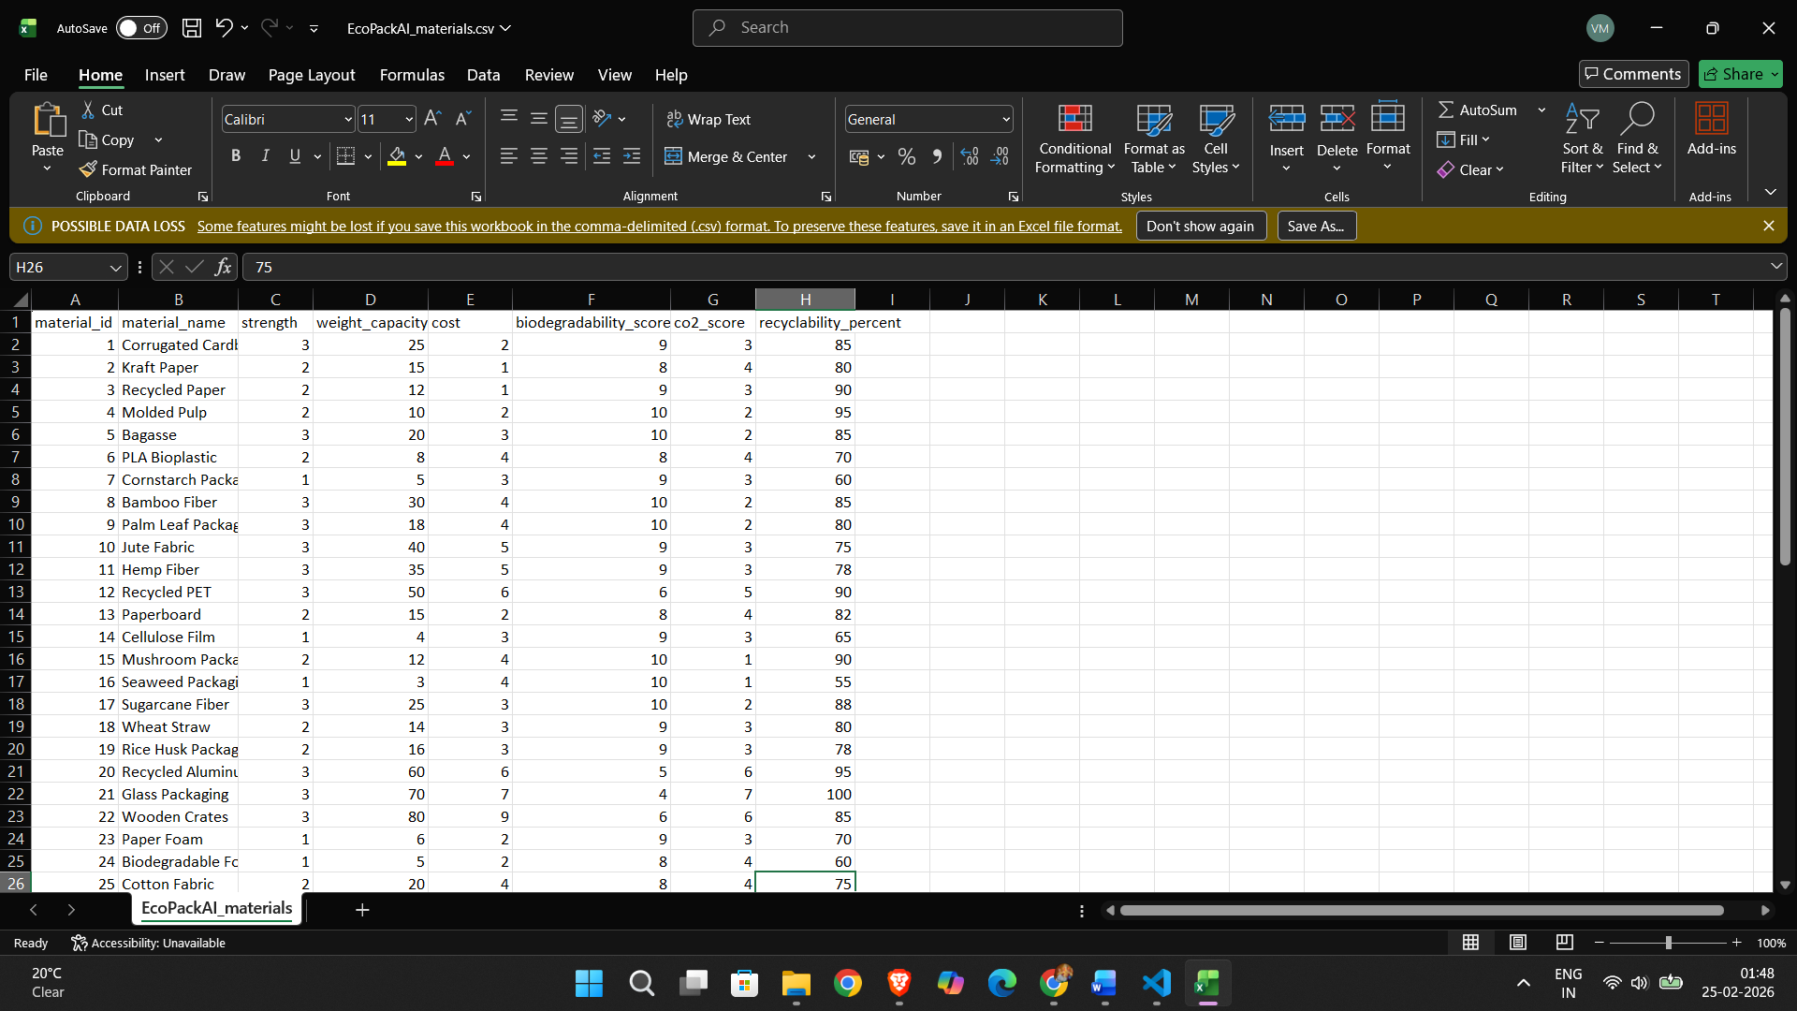
The dataset serves as the base reference for model prediction and ranking.
5. Machine Learning Model Design
5.1 Models Used
RandomForestRegressor
Used for cost prediction.
Reasons:
- Handles nonlinear relationships
- Strong performance on structured datasets
XGBoostRegressor
Used for CO₂ prediction.
Reasons:
- Gradient boosting optimization
- High predictive performance
StandardScaler
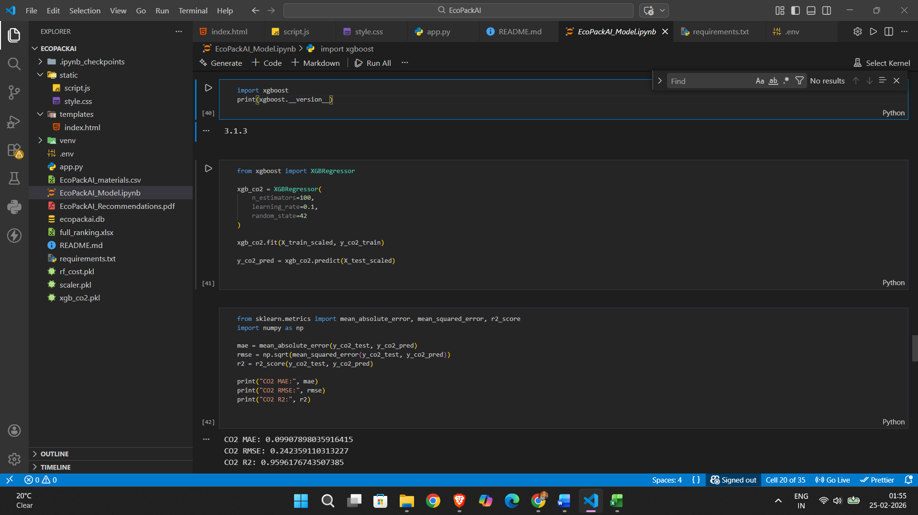
Used for feature normalization before model inference.

5.2 Prediction Workflow
- User selects input filters.
- Feature vector is generated.
- Features are scaled.
- Cost is predicted using Random Forest.
- CO₂ emission is predicted using XGBoost.
- Results are normalized.
- Ranking score is calculated.
6. Ranking Logic
The final material ranking is computed using a weighted scoring system.
Final Score =
(W₁ × Normalized Cost) + (W₂ × Normalized CO₂)
Where:
- W₁ and W₂ vary based on sustainability priority.
- Higher sustainability priority increases CO₂ weight.
- No negative CO₂ values are allowed (clipped to zero).
The system ensures:
- No equal ranking scores
- No uniform cost for all materials
- Consistent material ordering

7. Evaluation Metrics
Model performance was evaluated using:
- Mean Absolute Error (MAE)
- Root Mean Square Error (RMSE)
- R² Score
These metrics help measure:
- Prediction accuracy
- Error magnitude
- Model reliability
The models demonstrated stable performance suitable for deployment.

8. Dashboard Explanation
The dashboard provides:
8.1 Top 5 Recommendations
Displays best materials based on final ranking score.
8.2 Full Ranking Table
Shows all materials sorted by final score.

8.3 Visualizations
- Vertical Bar Chart – Cost comparison
- Horizontal Bar Chart – CO₂ comparison
- Line Chart – Material comparison trend
- Pie Chart – Sustainability distribution
Charts are rendered using Plotly for interactive visualization.

9. Database Integration (PostgreSQL)
9.1 Purpose
To log recommendation usage for analytics and tracking.
9.2 Implementation
- Cloud PostgreSQL database (Render)
- psycopg2 for connection
- Environment variable-based credentials
- No hardcoded passwords
Each recommendation request logs:
- Selected filters
- Top recommended material
- Timestamp

10. Security Implementation
- Environment variables for database credentials
- Debug mode disabled in production
- No exposed passwords in repository
- .gitignore prevents sensitive files from upload

11. Deployment Process
11.1 Local Setup
- Clone repository
- Install dependencies:
pip install -r requirements.txt
- Set .env file
- Run:
python app.py

11.2 Production Deployment
Platform: Render
Steps:
- Create Web Service
- Connect GitHub repository
- Add environment variables
- Configure gunicorn:
gunicorn app:app
- Deploy application
Live deployment ensures production-ready API and dashboard access.

12. Results
The system successfully:
- Predicts cost and CO₂ emissions
- Dynamically ranks materials
- Displays interactive dashboard
- Logs data to PostgreSQL
- Exports Excel and PDF reports
- Runs in cloud production environment
No 500 errors were observed after final deployment.
Ranking logic works consistently.
Charts load correctly.
Application is mobile responsive.
13. Future Enhancements
- Real-time carbon emission API integration
- User authentication system
- Role-based access control
- Scalable microservices architecture
- CI/CD automation
- Multi-dataset support

14. Conclusion

EcoPackAI demonstrates a complete AI-powered decision support system integrating machine learning, backend engineering, database logging, visualization, and cloud deployment.
The project successfully bridges theoretical ML concepts with real-world production deployment, showcasing practical AI system design and implementation.

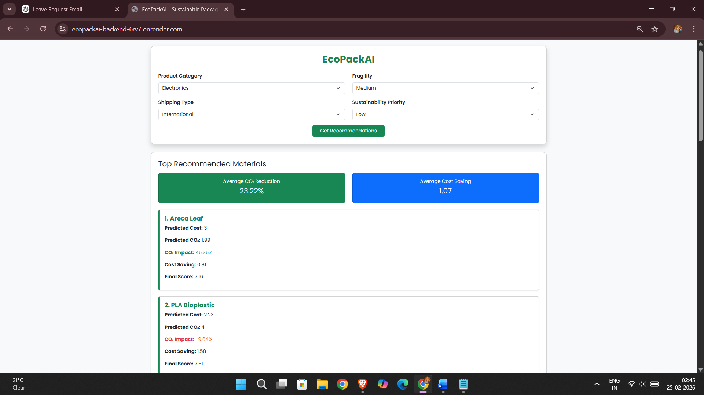
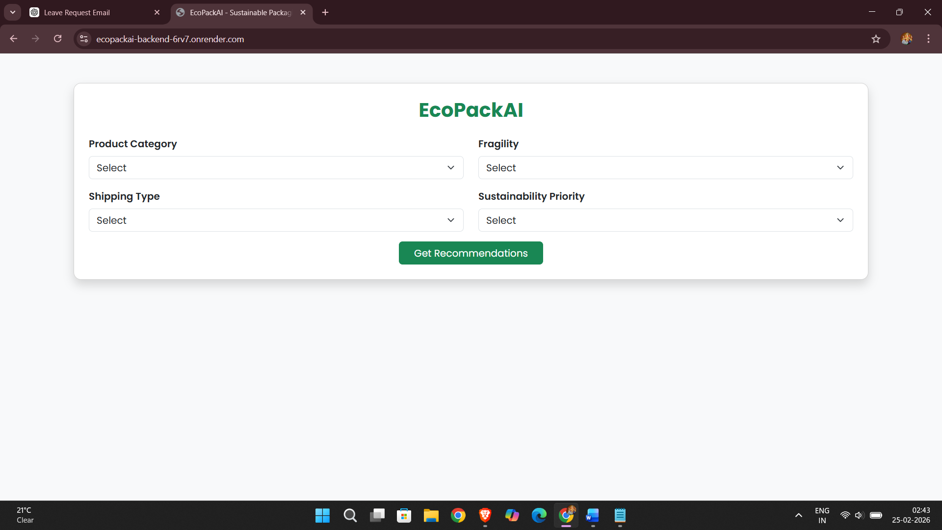
15. Screenshots Section
DashBoard – Filters & Summary Cards
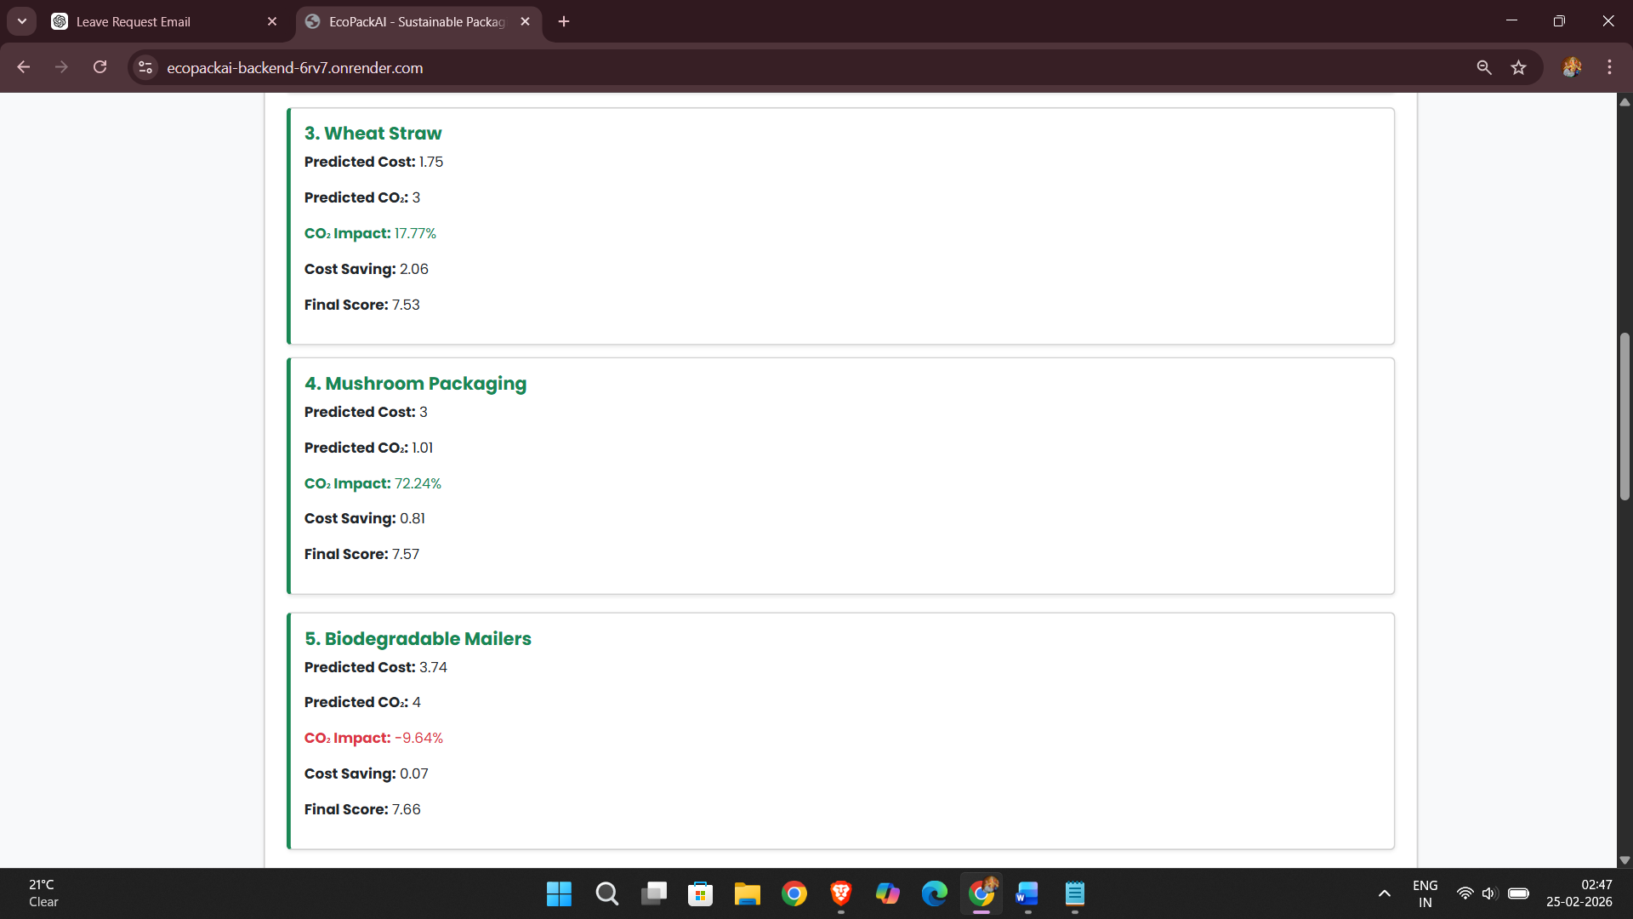
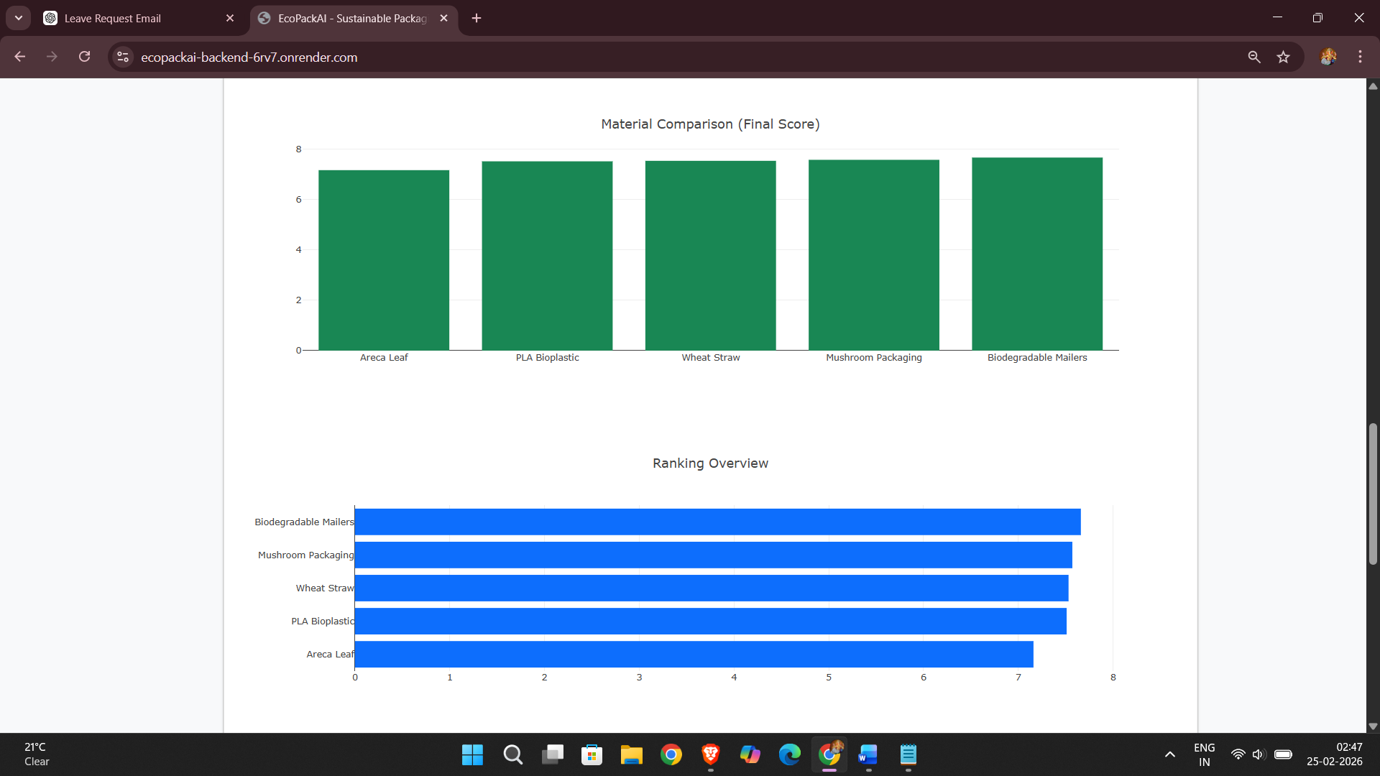
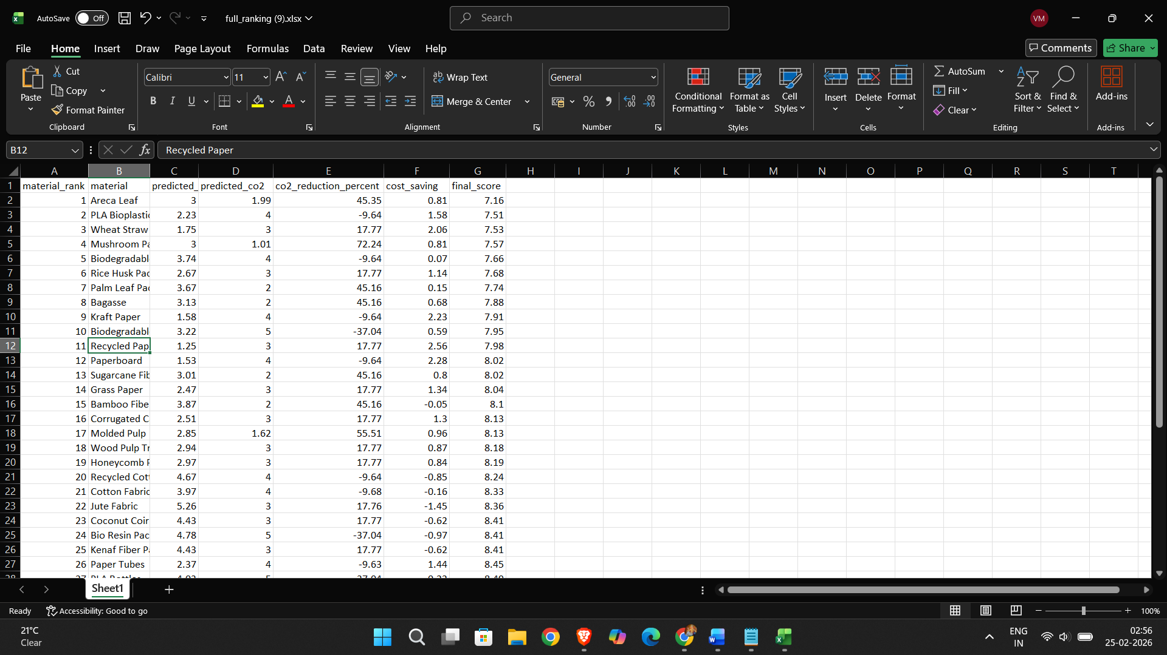
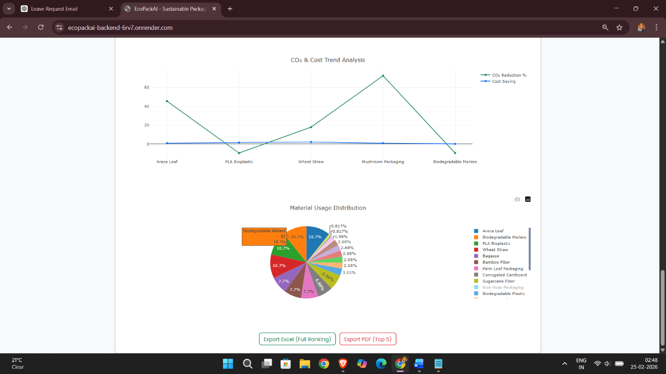
Materials Usage Pie -Chart & Exports Excels + P
Top 5 Recommendate Materials, Comparisons & Ranking Graphs
Materials Usage Pie -Chart & Exports Excels + PDF

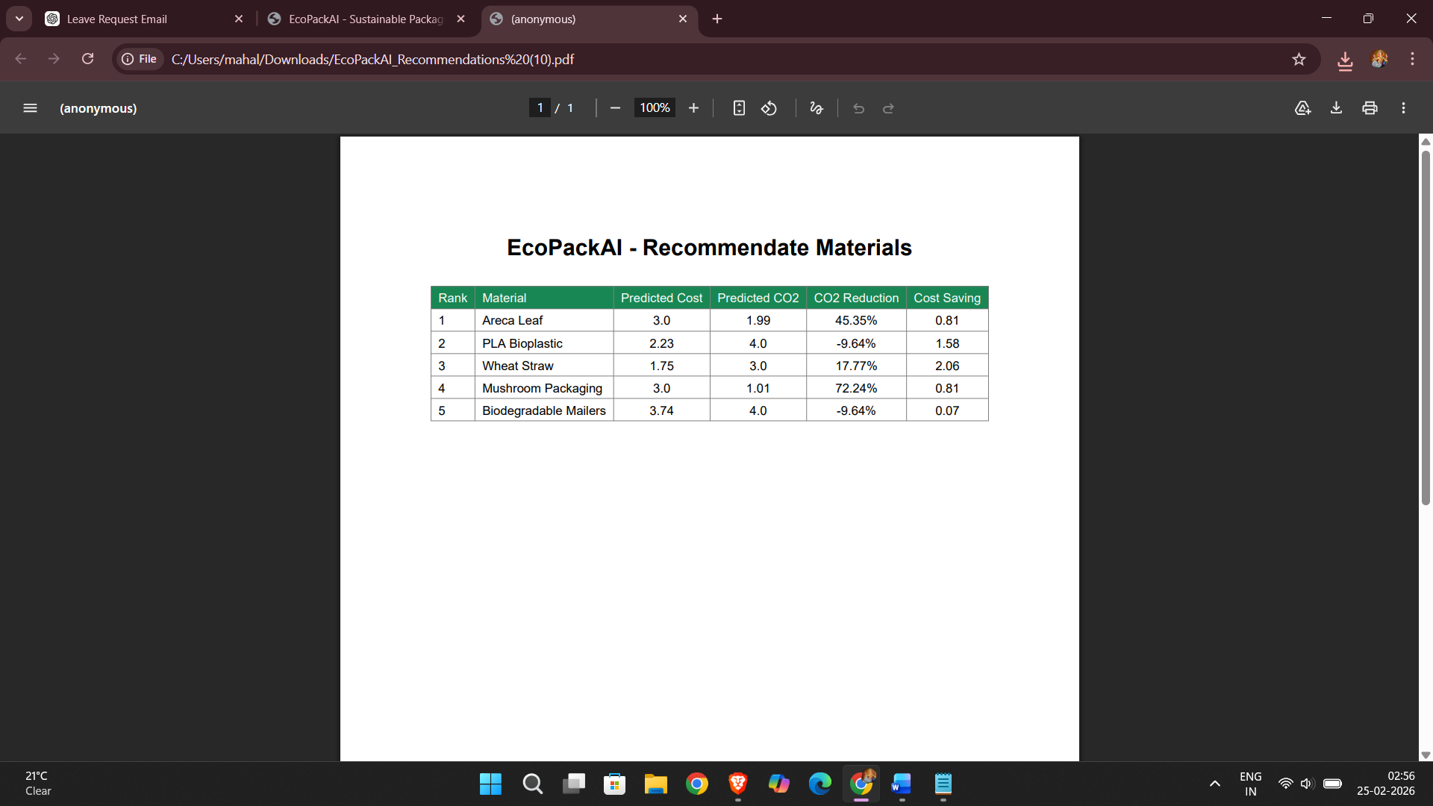
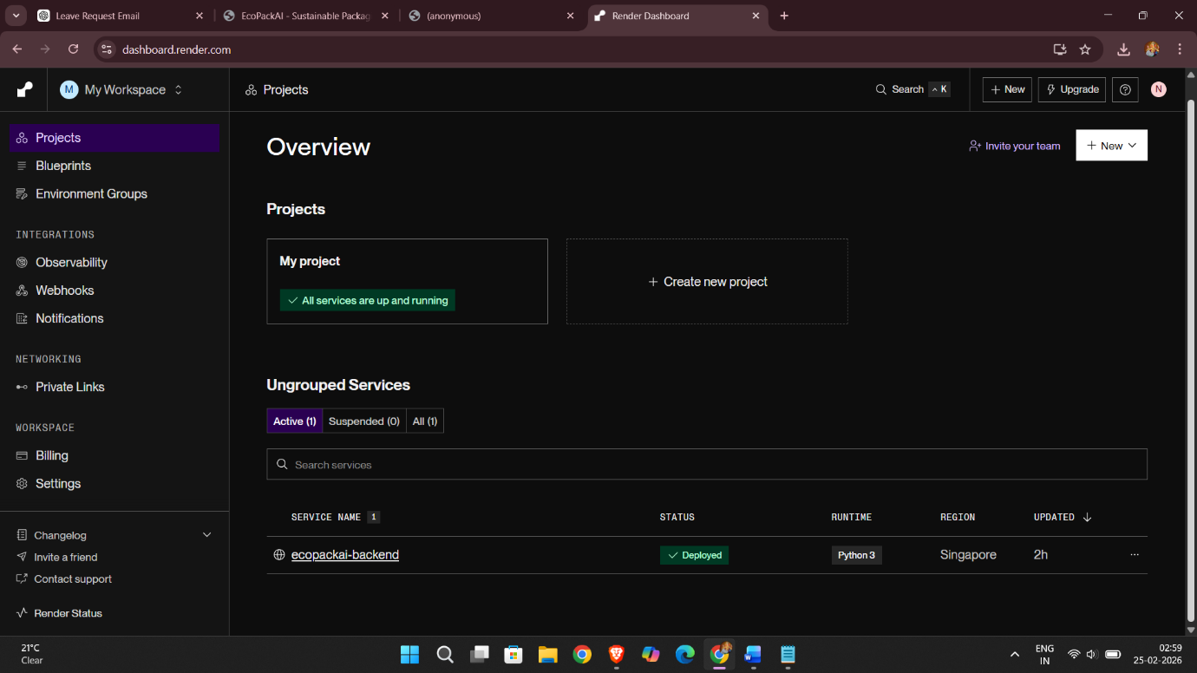
Deployment on Render
16. Repository & Deployment Details

GitHub Repository:
https://github.com/GPA-NileshGawhale/EcoPack-AI

Live Deployment (Render):

https://ecopackai-backend-6rv7.onrender.com

This project is deployed in a production environment using Flask, Gunicorn, PostgreSQL Cloud, and Render Web Services.

