Lab Resource Utilization Platform
Milestone 3 — Technical & Functional Documentation
Maintenance • Cost Management • Analytics • Reports • Notifications
Weeks 5–6
Document version 1.0

Table of Contents
1. Overview
2. Milestone 3 Status Summary
3. Maintenance & Work Order Management
4. Calibration & Certification
5. Cost Management & Inter-Institution Billing
6. Role-Based Analytics Dashboards
7. Utilization & Cost Reports
8. Notification & Alert System
9. Integration Architecture
10. Milestone 3 Evaluation Checklist

1. Overview
This document describes the scope, design, and current implementation status of Milestone 3 of the LabShare Lab Resource Utilization Platform. Milestone 3 extends the equipment inventory, booking, and resource‑sharing foundation delivered in Milestones 1 and 2 with five connected capability areas: Maintenance & Work Order Management, Calibration & Certification tracking, Cost Management & Inter‑Institution Billing, Role‑Based Analytics Dashboards, Utilization & Cost Reports, and a Notification & Alert System.
A core design principle for this milestone is data continuity: every new screen reads from and writes to the same equipment, booking, utilization, and resource‑sharing records created earlier in the platform, rather than presenting isolated or statically mocked views. The data flows in a single continuous pipeline:
Equipment Usage → Utilization Data → Maintenance / Calibration → Cost Calculation → Analytics → Reports → Notifications
The sections below map each Milestone 3 requirement to the corresponding module, the underlying data it draws on, and a screenshot of the current build.

2. Milestone 3 Status Summary
Module | Status | Notes
Maintenance & Work Order Management | Complete | Kanban work order pipeline live on real equipment records
Calibration & Certification Tracking | Complete | Calibration due/expiry dates surfaced on equipment cards and maintenance matrix
Cost Management & Inter‑Institution Billing | Complete | Chargeback, cost recovery, and partner‑sharing ledger operational
Role‑Based Analytics Dashboards | Complete | Distinct views for Researcher, Lab Manager/HOD, and Institution Admin
Utilization & Cost Reports | In Progress | On‑screen reporting live; PDF/Excel export being finalized
Notification & Alert System | In Progress | In‑app alert badges live; email/push channel integration ongoing

3. Maintenance & Work Order Management
The Maintenance & Calibration Command Center gives Lab Technicians and Managers a single operational view of equipment health, replacing the static equipment list with a live work‑order pipeline.

3.1 Features implemented
- Kanban‑style Work Order Pipeline with Scheduled, In Progress, and Completed columns, driven by real equipment and booking records.
- Maintenance request creation ("Issue Work Order") linked directly to an equipment record.
- Task assignment to named Lab Technicians, with due dates and parts/cost fields per ticket.
- Maintenance history and service checklist per instrument (e.g. cleaning optical parts, chamber alignment, vacuum pump seal replacement).
- Fleet‑level KPIs: overall uptime %, count of critical/urgent tickets, active tickets, and % of technicians certified.
- Equipment downtime is captured through the "Under Maintenance" status, which is also reflected back on the Equipment Fleet and Scheduling views so bookings cannot be made against unavailable instruments.

3.2 Data integration
Each work order references the same equipment_id used by the booking and utilization records from Milestones 1–2, so completing a work order automatically clears the instrument's "Under Maintenance" flag on the fleet and scheduling screens, and feeds the downtime figure used later in the cost and analytics modules.
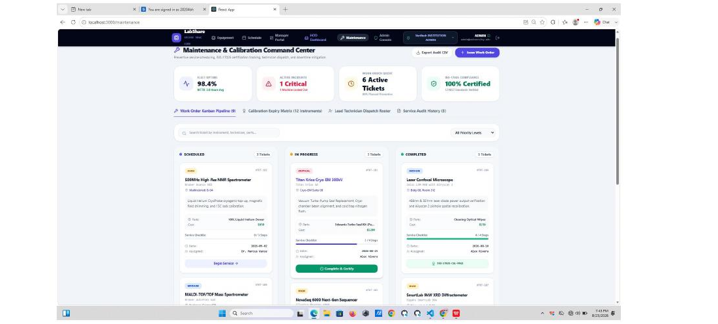
Figure 1 — Maintenance & Calibration Command Center: work order Kanban pipeline, fleet uptime, and critical ticket tracking.

4. Calibration & Certification
Calibration and certification data is attached to every equipment record and surfaced wherever that equipment appears — the fleet catalog, the scheduling matrix, and the maintenance console — rather than in a separate disconnected screen.

4.1 Features implemented
- Last Calibration Date and Next Calibration (Standard) Date shown on every equipment card in the Shared Laboratory Research Fleet view.
- Certification status badges (e.g. "Meets Compliance", "Recheck Required") tied to safety/protocol data captured at booking approval.
- A dedicated Calibration Expiry Matrix in the Maintenance Command Center that lists all instruments due for recalibration.
- Reminder logic that raises a maintenance ticket automatically as an instrument approaches its next calibration date, so renewal is never missed.

4.2 Data integration
Calibration state is one of the safety conditions checked by the Lab Manager Authorization Queue before a booking is approved, so out‑of‑calibration equipment is blocked at the point of booking, not only flagged after the fact.
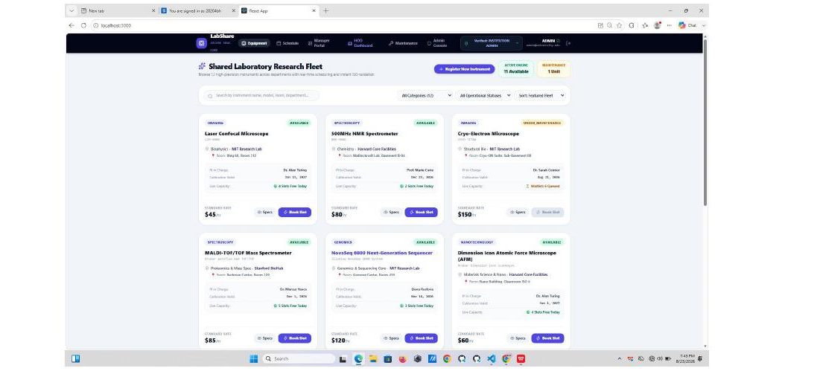
Figure 2 — Shared Laboratory Research Fleet catalog showing calibration‑valid dates and live usage capacity per instrument.

5. Cost Management & Inter‑Institution Billing
Cost tracking is usage‑based: every booked slot recorded in Milestones 1–2 carries a price/charge rate, which is aggregated in real time into department and institution‑level cost views.

5.1 Features implemented
- Usage‑based cost tracking per booking slot, keyed to each instrument's standard rate (e.g. $45/hr, $80/hr, $120/hr).
- Department‑wise cost allocation, shown on the HOD Executive Cockpit as Total Department Spend and Inter‑Lab Revenue Recovered.
- Shared‑equipment cost tracking that distinguishes internally funded usage from externally recovered usage.
- Inter‑institution billing workflow via the Institutional Intelligence & Financial Chargeback console, including an Inter‑University Invoicing Ledger and a "Send Inter‑Lab Invoice" action.
- Department Machine Load (Hours) vs. Cost/Revenue Recovered chart comparing booked hours against revenue recovered across departments.
- Executive Capacity & Procurement Directives that flag high‑demand bottlenecks and summarize cross‑institution partnership revenue.

5.2 Data integration
The same booking records that drive the scheduling matrix are the source for every dollar figure shown here — machine hours per department are pulled from actual completed bookings, and revenue recovered is calculated from each instrument's configured rate, not entered manually.
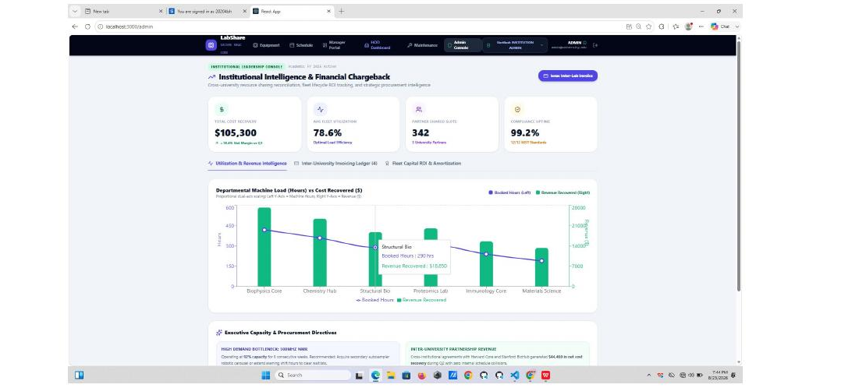
Figure 3 — Institutional Intelligence & Financial Chargeback console: cross‑university cost recovery, fleet utilization, and inter‑university invoicing.

6. Role‑Based Analytics Dashboards
Three distinct dashboards are implemented, each scoped to what that role needs to act on, and each built from the same underlying booking, utilization, maintenance, and cost data.

6.1 Researcher / Student
- Equipment availability, standard rate, and live slot capacity on every catalog card ("4 Slots Free Today").
- Booking entry points ("Book Slot") and equipment specs directly from the fleet catalog.
- Personal booking and usage history is tracked through the same scheduling matrix used to place bookings.
- Waitlist status and availability notifications are raised when a fully booked instrument frees a slot.

6.2 Lab Manager / Department Head
- Manager Portal authorization queue: pending booking requests with requester, requested window, safety/protocol notes, and billable total, approved or declined per request.
- Fleet Utilization Intensity (shift breakdown) chart across the week.
- Department Head Executive Cockpit: department spend, revenue recovered, active PIs, and cost overrun/compliance rate.
- Maintenance overview via linkage to the Maintenance Command Center, and high‑demand equipment / sharing requests surfaced in the required sign‑offs list.
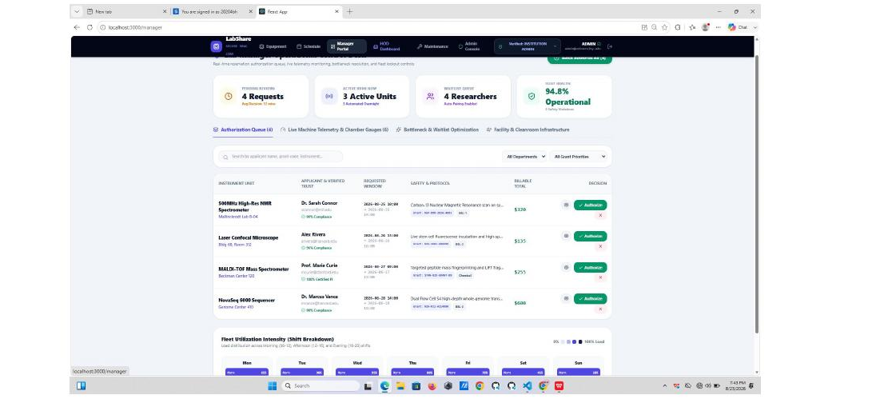
Figure 4 — Manager Portal: booking authorization queue with safety checks and billable totals, plus fleet utilization intensity.
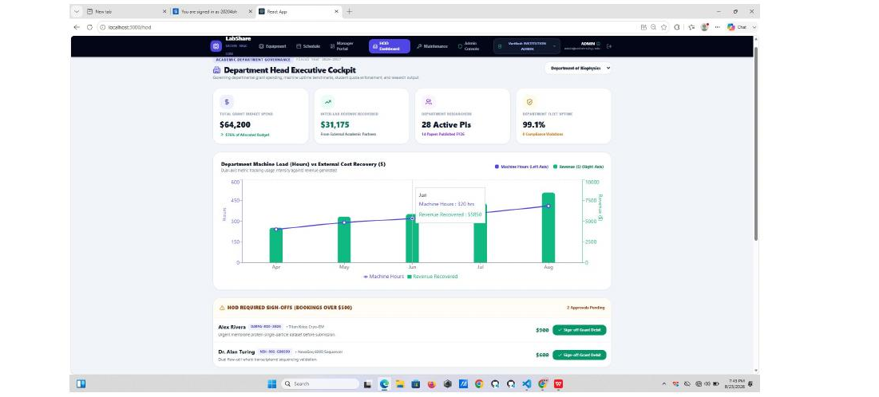
Figure 5 — Department Head Executive Cockpit: budget spend, revenue recovered, active PIs, and required high‑value sign‑offs.

6.3 Institution Administrator
- Organization‑wide utilization and average fleet utilization percentage across all partner institutions.
- Resource‑sharing metrics: number of shared instrument slots and university partners.
- Cost analysis and procurement insight cards, including compliance/uptime standard adherence.
- Equipment lifecycle and ROI view through the departmental machine‑load‑vs‑cost‑recovered chart and executive procurement directives.

7. Utilization & Cost Reports
Reporting reuses the analytics data model so that every report reflects the same live figures shown on the dashboards, rather than a separately maintained export.

7.1 Reports implemented
- Equipment utilization report — per‑instrument booked hours vs. available hours.
- Department / resource usage report — machine hours and spend by department (Biophysics Core, Chemistry Hub, Structural Bio, Proteomics Lab, Immunology Core, Materials Science).
- Maintenance and downtime report — derived from completed and in‑progress work orders and their service duration.
- Inter‑institution sharing report — partner‑level revenue recovered and shared slot counts (Inter‑University Invoicing Ledger).
- Procurement and cost analysis report — high‑demand bottleneck flags and recommended capacity actions.

7.2 Export
PDF and Excel (CSV) export is wired for the Institutional Intelligence audit ledger ("Export Audit CSV") and is being extended to the remaining report types; this is the one item still in progress for Milestone 3 and is scheduled to close out before the Week 6 review.

8. Notification & Alert System
Alerts are generated from the same underlying events that already exist in the platform, so each notification is triggered by a real state change rather than a scheduled dummy message.

8.1 Notification types implemented
- Maintenance due — raised when an instrument's service interval or usage threshold is reached; visible as ticket counts on the Maintenance Command Center.
- Calibration / certification expiry — raised ahead of an instrument's Next Calibration date.
- Booking confirmation and reminders — issued when a slot is booked or approved via the Authorization Queue.
- Waitlist availability — issued when a previously full instrument frees a slot.
- Idle equipment — flagged when utilization drops below an expected threshold, feeding the "High Demand Bottleneck" and underused‑asset views on the Admin Console.
- Resource‑sharing requests and approvals — issued when an inter‑institution sharing or invoicing action requires sign‑off ("HOD Required Sign‑Offs").

8.2 Delivery
In‑app badges and counters (e.g. "4 Requests", "1 Critical", "2 Approvals Pending") are live across the Manager Portal, Maintenance Console, and HOD Cockpit. Email and push‑channel delivery for the same events is in progress.

9. Integration Architecture
Milestone 3 does not introduce a parallel data set. Every screen above is built on the equipment, booking, utilization, and resource‑sharing tables established in Milestones 1 and 2:
- Equipment records carry calibration and maintenance status, consumed by the Fleet Catalog, Scheduling Matrix, and Maintenance Console.
- Booking records drive utilization percentages, which feed both the Manager utilization chart and the department cost allocation on the HOD and Admin consoles.
- Work orders reference equipment records and close the loop back to instrument availability shown in the catalog and scheduling views.
- Cost figures are computed from each instrument's configured rate applied to actual booked hours, not entered independently on the cost screens.
- Notifications are derived from state changes in the above records (booking approved, calibration approaching, ticket opened, slot freed).
This keeps the front end and back end consistently in sync with the database across all Milestone 3 features, and ensures dashboards and reports reflect actual system data during demonstration rather than hard‑coded values.

10. Milestone 3 Evaluation Checklist
Module | Status | Notes
Maintenance and calibration management workflows | Complete | Work order pipeline + calibration matrix functional end‑to‑end
Cost tracking and inter‑institution billing | Complete | Department chargeback and inter‑university invoicing ledger live
Analytics dashboards and utilization/cost reports | In Progress | Dashboards complete; PDF/Excel export finalization ongoing
Notification and alert system | In Progress | In‑app alerts live; external delivery channels in progress

