LAB RESOURCE UTILIZATION PLATFORM
Milestone 2 Documentation
Role-Based Dashboard Architecture & Feature Ownership
Prepared for: Riverside Institute of Technology | Version 2.0 (Post-Review) | Date: August 14, 2026

1. Purpose of This Document
This document specifies the finalized Milestone 2 architecture for the Lab Resource Utilization Platform. It responds to review feedback identifying that all Milestone 2 functionality was implemented under a single Lab Technician login rather than being distributed across the five defined user roles. It defines, for each of the six Milestone 2 tasks, which role owns the feature, which role supports it, and the specific dashboard changes required to bring the frontend in line with the project's role definitions and responsibilities.

2. Reviewer Feedback Summary
The following table summarizes the feedback received on the current build and the corresponding resolution applied to the dashboard architecture.
Area | Reviewer Feedback | Resolution
Dashboards | All six Milestone 2 features currently appear under the Lab Technician login only. | Features redistributed across five role-based dashboards per project role definitions.
Task 1 | Utilization should sit with the Lab Manager, not the Technician. | Moved to Lab Manager / Department Head; Technician retains operational status updates only.
Task 2 | Heatmap needs a clear idle equipment, idle duration, and utilization legend. | Added legend component and idle-duration column to the Lab Manager heatmap view.
Task 3 | Sharing needs Institution Administrator visibility and Approve/Reject actions. | Added Approve/Reject controls for Lab Manager; added network-wide sharing view for Institution Administrator.
Task 4 | Researcher should book; Lab Manager should approve. | Split into a Researcher booking flow and a Lab Manager approval queue, with statuses and double-booking prevention.
Task 5 | Needs organization-wide analytics for Institution Administrator and high-demand equipment tracking. | Added Institution Administrator analytics view and a high-demand equipment list for the Lab Manager.
Task 6 | Researcher needs Join Waitlist, My Waitlist, and notifications; Lab Manager needs management/optimization. | Split into Researcher waitlist tools and a Lab Manager waitlist/optimization view.

3. User Roles & Scope of Access
Five roles are defined in the platform. Each role has its own workspace, its own left-navigation menu, and its own top-level metrics. A user's role determines which decisions and data are visible to them; no role should see another role's decision-making tools by default.
Role | Scope of Access
Researcher / Student | Find available equipment; request and book time; track own bookings; join and monitor waitlists; receive availability notifications.
Lab Technician | Maintain accurate live instrument status; log maintenance and complete operational checks; flag issues. No booking-approval or analytics authority.
Lab Manager / Department Head | Own utilization tracking, idle detection, sharing approvals, booking approvals, demand analytics, and waitlist/booking optimization for their lab.
Institution Administrator | Organization-wide utilization and demand analytics; partner-network visibility; review and approve cross-institution sharing requests that exceed department scope.
System Admin | Platform configuration, access-role coverage, audit logs, and overall system health. Not part of Milestone 2 functional scope; unchanged.

4. Task-to-Role Ownership Matrix
This matrix is the single source of truth for where each Milestone 2 feature lives. “Primary Owner” is the role whose dashboard hosts the feature and who can take action on it. “Supporting Role(s)” can view or contribute to the feature but does not hold final decision authority.
Task | Feature | Primary Owner | Supporting Role(s) | Status
1 | Real-Time Equipment Utilization | Lab Manager / Department Head | Lab Technician (operational updates) | Reassigned
2 | Utilization Heatmap & Idle Detection | Lab Manager / Department Head | — | Reassigned
3 | Inter-Institution Resource Sharing | Lab Manager / Department Head | Institution Administrator (network-wide visibility) | Reassigned
4 | External Booking & Access Management | Researcher / Student (request) + Lab Manager (approval) | — | Split by action
5 | Utilization Rate & Demand Analysis | Lab Manager / Department Head | Institution Administrator (org-wide analytics) | Reassigned
6 | Waitlist Management & Booking Optimization | Researcher / Student (join/track) + Lab Manager (manage/optimize) | — | Split by action
Note: Tasks 4 and 6 are split by action rather than assigned to a single owner — the Researcher/Student initiates the request (booking or waitlist join), and the Lab Manager/Department Head owns the approval, management, and optimization of that request.

5. Dashboard Specifications by Role
The subsections below describe the finalized content of each role's dashboard, incorporating the reassignment described in Sections 2–4.

5.1 Researcher / Student Dashboard
Purpose: let researchers find equipment, book time, and track their own queue — no utilization, sharing, or approval tools.
Top-level metrics: Upcoming Bookings • Available Now • Waitlist Position

Task 4 — External Booking & Access Management (request side)
- Find Equipment: search and filter available instruments across institutions.
- Check real-time availability before submitting a request.
- Request / Book Equipment: submit a booking request for a specific time window.
- My Bookings: view booking status — Pending, Approved, Rejected, or Cancelled.
- Double-booking prevention: the booking form blocks selection of a time slot that overlaps an existing reservation on that instrument, and surfaces the conflict inline before submission.

Task 6 — Waitlist Management (researcher side)
- Join Waitlist: join the queue for a fully booked instrument directly from its availability page.
- My Waitlist: view current position and estimated wait for each queued instrument.
- Availability notifications: real-time alerts when a watched instrument frees up or a waitlist position improves.

5.2 Lab Technician Dashboard
Purpose: keep instrument status and maintenance data accurate so every other dashboard is trustworthy. No booking approvals, analytics, or sharing decisions.
Top-level metrics: Live Instruments • Maintenance Flags • Checks Due

Task 1 — Real-Time Equipment Utilization (operational support only)
- Update live instrument state (Available, In Use, Maintenance) as work happens on the bench.
- Log maintenance events and complete scheduled operational checks.
- Feed status changes into the Lab Manager's utilization and heatmap views — the Technician does not view utilization analytics or approve anything.

Role boundary (shown in-app)
- “Keep the network truthful”: the Technician's role card explicitly states that booking approvals and utilization decisions stay with the Lab Manager, to prevent scope creep back into this dashboard.

5.3 Lab Manager / Department Head Dashboard
Purpose: the primary decision-making dashboard for Milestone 2. Owns utilization, idle detection, sharing approvals, booking approvals, demand analytics, and waitlist optimization for the department.
Top-level metrics: Network Utilization • Pending Decisions • Idle Equipment

Task 1 — Real-Time Equipment Utilization
- Live status feed for every instrument in the department, sourced from Lab Technician updates.
- Utilization percentage with week-over-week trend.

Task 2 — Utilization Heatmap & Idle Detection
- Heatmap of usage by instrument and time block.
- Idle equipment list with idle duration per instrument (e.g. “Over 3h threshold”).
- Utilization legend clarifying the color/intensity scale (e.g. Idle / Low / Moderate / High utilization bands) so the heatmap is self-explanatory without cross-referencing another screen.

Task 3 — Inter-Institution Resource Sharing
- Incoming and outgoing sharing requests for department equipment.
- Approve / Reject actions on each incoming request, with the decision reflected immediately in the requesting institution's view.
- Sharing history and active partner agreements relevant to the department.

Task 4 — External Booking & Access Management (approval side)
- Booking approvals queue: Approve / Reject each pending request, with requester, instrument, and time window shown.
- Booking status shown to the Manager mirrors the Researcher's view (Pending, Approved, Rejected, Cancelled) so both sides stay in sync.
- Double-booking prevention enforced at approval time as a second safeguard: approving a request that now conflicts with another approved booking is blocked with an explicit warning.

Task 5 — Utilization Rate & Demand Analysis
- Department-level utilization rate over time, with trend indicators.
- High-demand / frequently requested equipment list, ranked by request volume, to inform purchasing and scheduling decisions.

Task 6 — Waitlist Management & Booking Optimization (manager side)
- Waitlist management view across all department instruments, with the ability to reorder, notify, or convert a waitlist entry into a booking.
- Optimization suggestions (e.g. expanding evening access for a high-utilization instrument) surfaced from utilization and demand signals.

5.4 Institution Administrator Dashboard
Purpose: organization-wide visibility across all departments and partner institutions. Broader read/approve scope than a single Lab Manager, without department-level operational detail.
Top-level metrics: Network Utilization • Partner Institutions • Sharing Requests

Task 3 — Inter-Institution Resource Sharing (network visibility)
- Network-wide view of sharing requests across all departments and partner institutions.
- Approve / Reject authority on cross-institution requests that exceed a single Lab Manager's scope.
- Partner network health, including active agreements per partner institution.

Task 5 — Utilization Rate & Demand Analysis (organization-wide)
- Organization analytics rolling up utilization across every institution in the network, not just one department.
- Per-institution utilization comparison to identify institutions that are over- or under-utilizing shared resources.

5.5 System Admin Dashboard
Purpose: platform configuration, access coverage, and system health. Out of scope for Milestone 2 features and left unchanged by this revision.
Top-level metrics: Network Health • Active Users • Audit Events

Existing scope (unchanged)
- Access model / role coverage across the network.
- System status for booking service, permission sync, and audit retention.
- Configuration and audit log review.

6. New Functional Requirements Introduced by This Review
The following capabilities did not exist in the prior build and are now required as part of Milestone 2:
Sharing approvals
- Approve / Reject controls on the Lab Manager dashboard for incoming inter-institution sharing requests.
- Escalated Approve / Reject view on the Institution Administrator dashboard for network-wide requests.

Booking statuses & double-booking prevention
- Standard status set across Researcher and Lab Manager views: Pending, Approved, Rejected, Cancelled.
- Conflict check at request time (Researcher) and again at approval time (Lab Manager), blocking any overlapping time window on the same instrument.

Idle detection legend
- Idle equipment list showing idle duration per instrument.
- Visible legend explaining the heatmap's utilization color scale.

High-demand equipment tracking
- Ranked list of frequently requested equipment on the Lab Manager dashboard, driven by request volume.

Waitlist split by role
- Researcher: Join Waitlist, My Waitlist, and availability notifications.
- Lab Manager: waitlist management and booking optimization across the department.

7. Implementation Notes & Next Steps
- Rebuild navigation so each role's login lands on its own workspace; remove Milestone 2 feature access from the Lab Technician menu beyond live status and maintenance logging.
- Reuse the existing “Inspect a Role” switcher only for internal QA — it should not be presented as a normal end-user control in production.
- Wire Approve/Reject actions on both the Lab Manager and Institution Administrator dashboards to the same underlying sharing/booking request objects so status stays consistent across roles.
- Add the utilization legend and idle-duration column to the heatmap component before Milestone 2 sign-off.
- Confirm double-booking prevention logic is enforced server-side, not only in the request-form UI, since approvals can also create conflicts.
- Circulate this document for sign-off, then update the six task tickets to reference the finalized owning dashboard before development resumes.

Appendix A: Current Frontend Screens (As Reviewed)
The screens below are the current build referenced in the review. They are included here for traceability between the feedback in Section 2 and the finalized ownership in Sections 4–5.

A.1 — Secure Sign-In / Choose Your Workspace
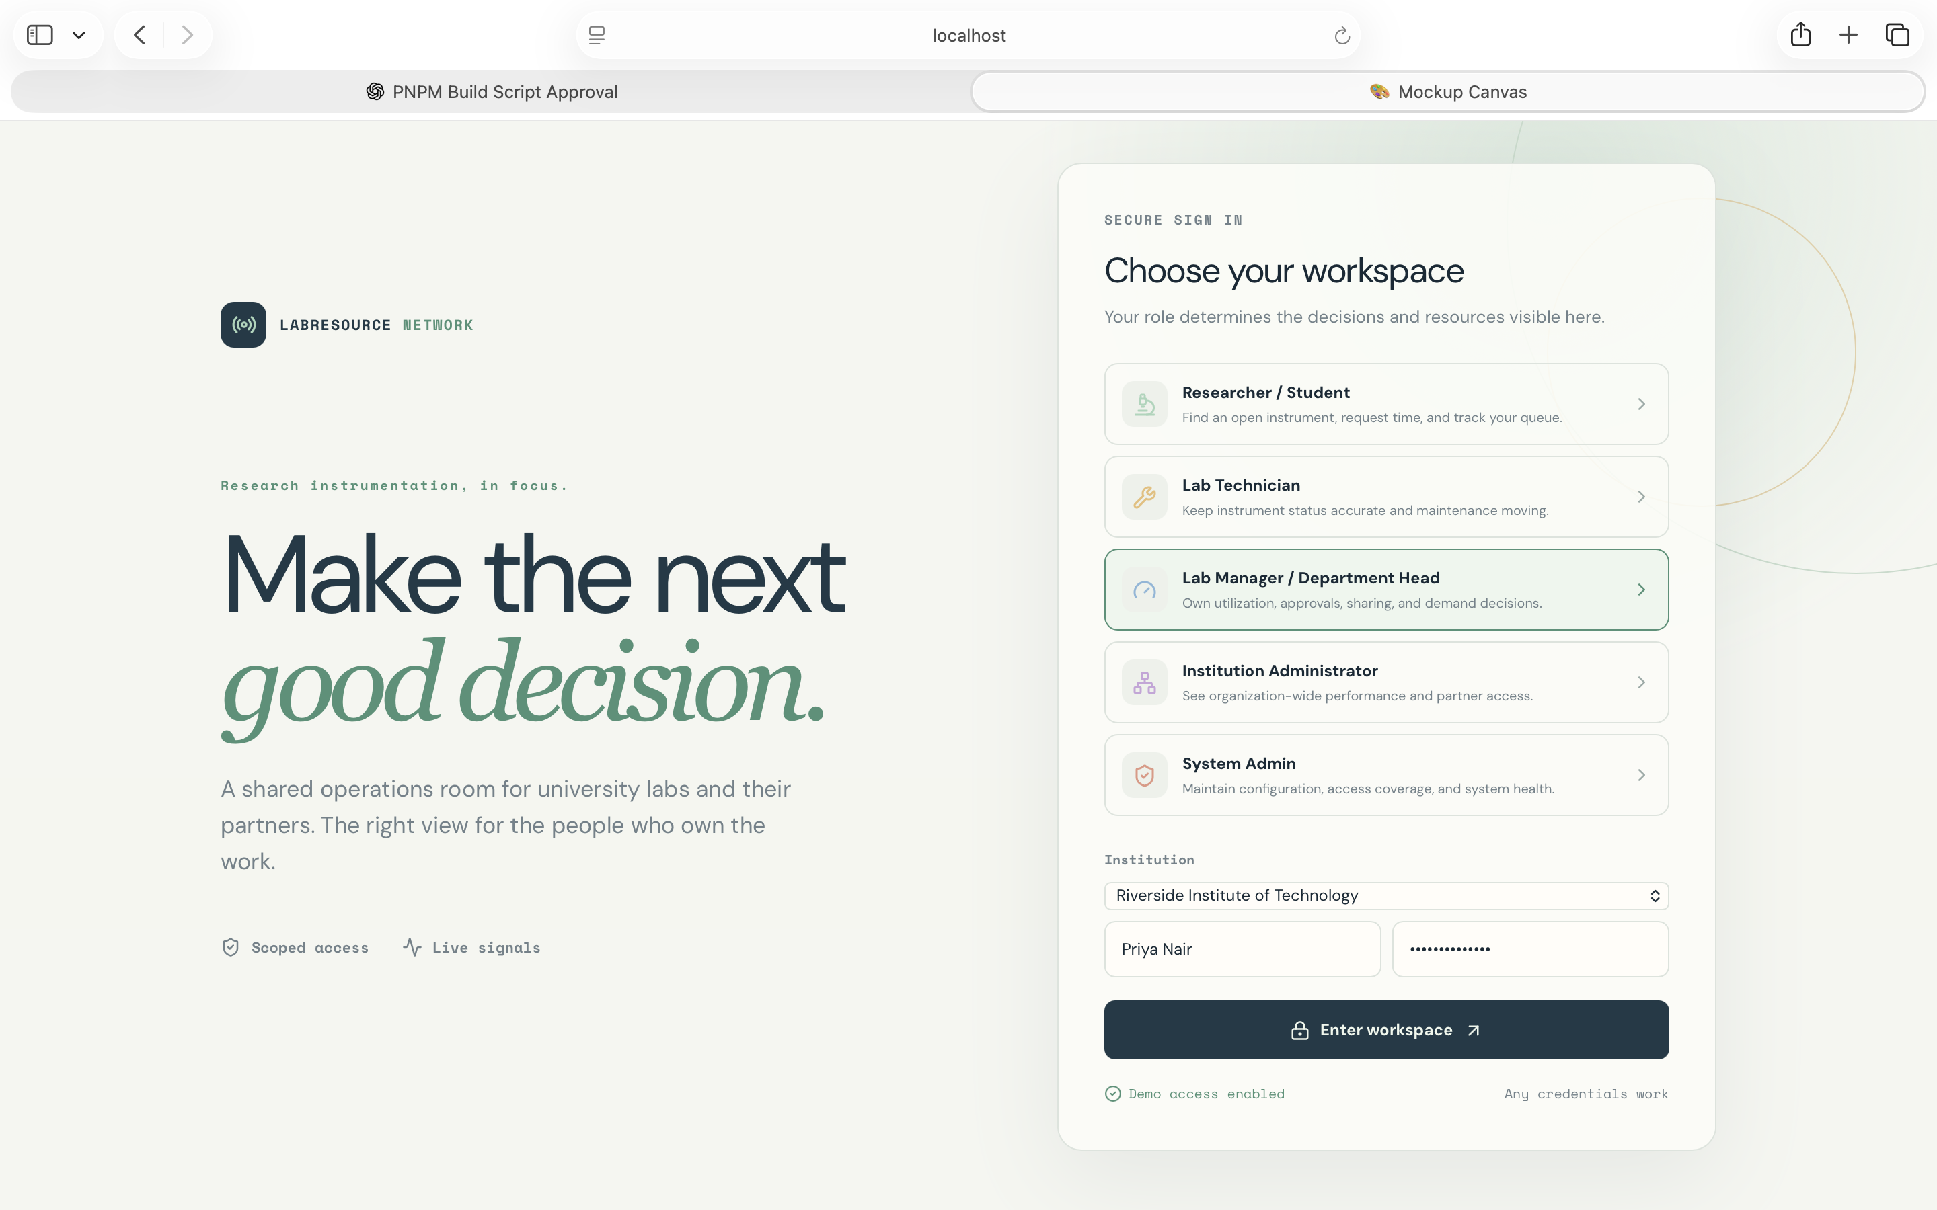
Role-selection screen used to enter the demo. Each role listed here (Researcher/Student, Lab Technician, Lab Manager/Department Head, Institution Administrator, System Admin) should route to its own dashboard as specified in Section 5.

A.2 — Researcher / Student Login (Current State)
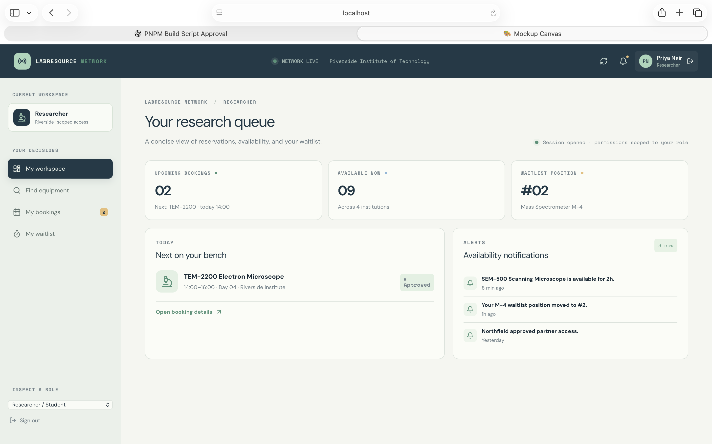
Current “Your research queue” view. Booking and waitlist tools are present; per Section 5.1 this dashboard should not surface utilization, sharing, or approval features.

A.3 — Lab Technician Login (Current State)
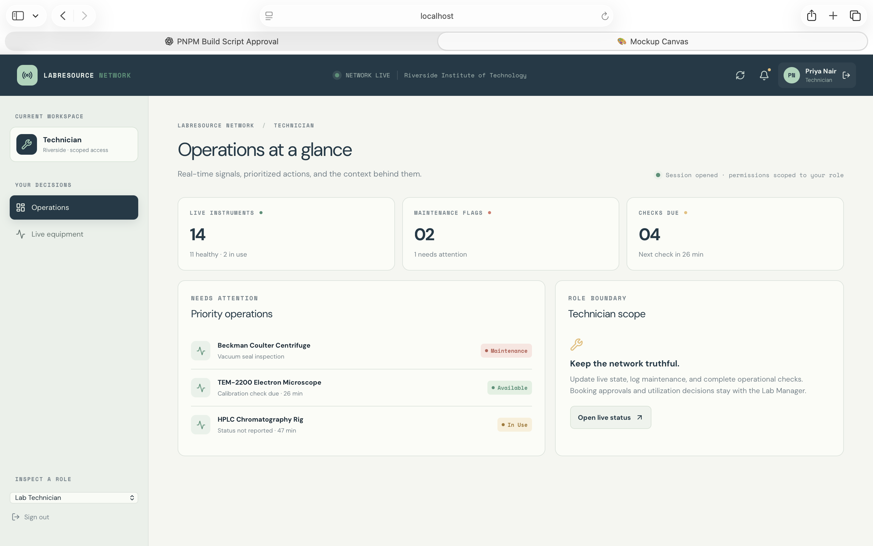
Current “Operations at a glance” view. This is where all six Milestone 2 features were previously surfaced; per Section 5.2 this dashboard should be limited to live status and maintenance logging only.

A.4 — Lab Manager / Department Head Login (Current State)
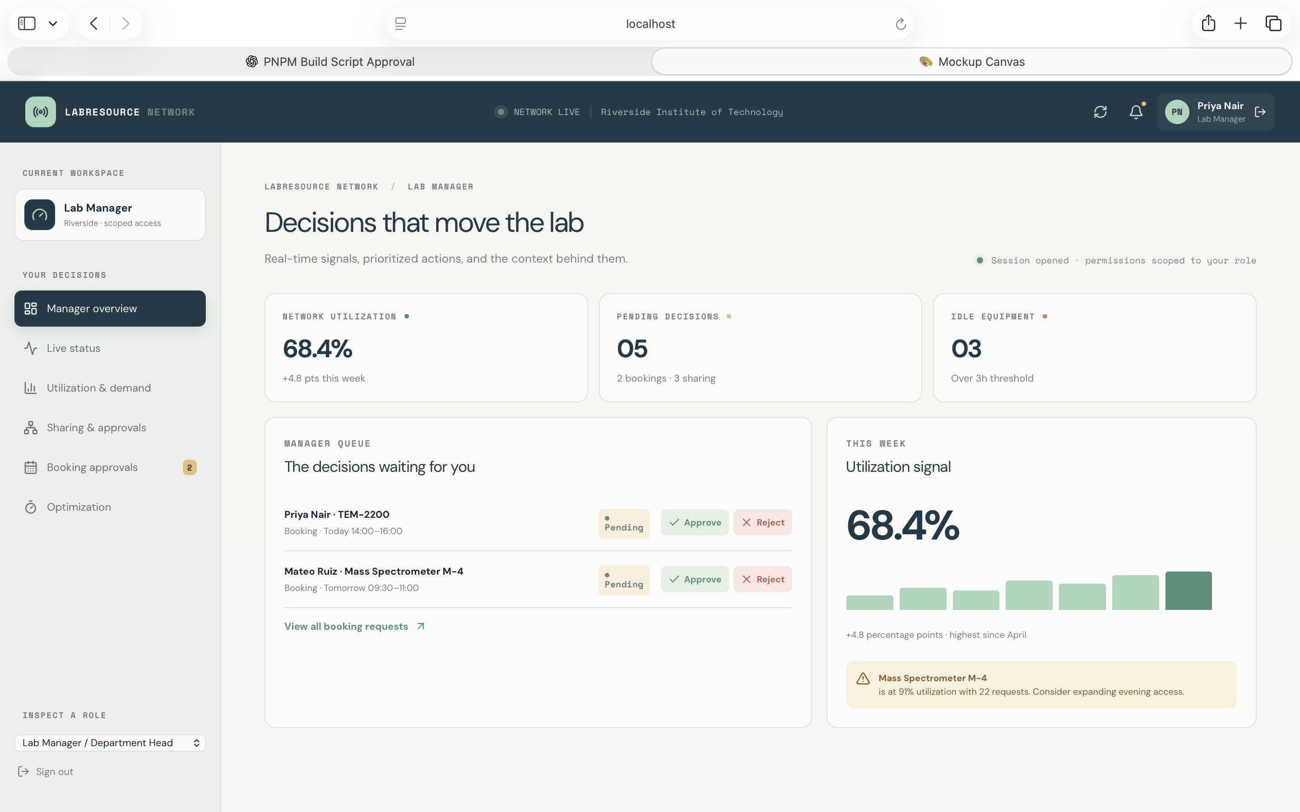
Current “Decisions that move the lab” view. Per Section 5.3, this dashboard is the primary owner of Tasks 1, 2, 3, 4 (approval side), 5, and 6 (manager side); Approve/Reject and idle-duration/legend details still need to be added.

A.5 — Institution Administrator Login (Current State)
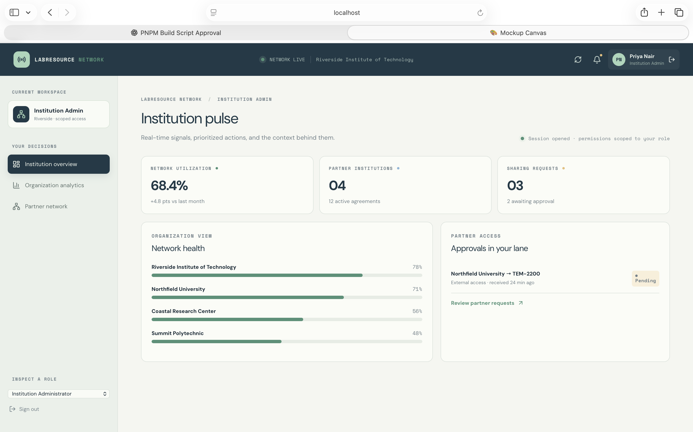
Current “Institution pulse” view. Per Section 5.4, this dashboard should carry network-wide sharing visibility and organization-wide utilization/demand analytics.

A.6 — System Admin Login (Current State)
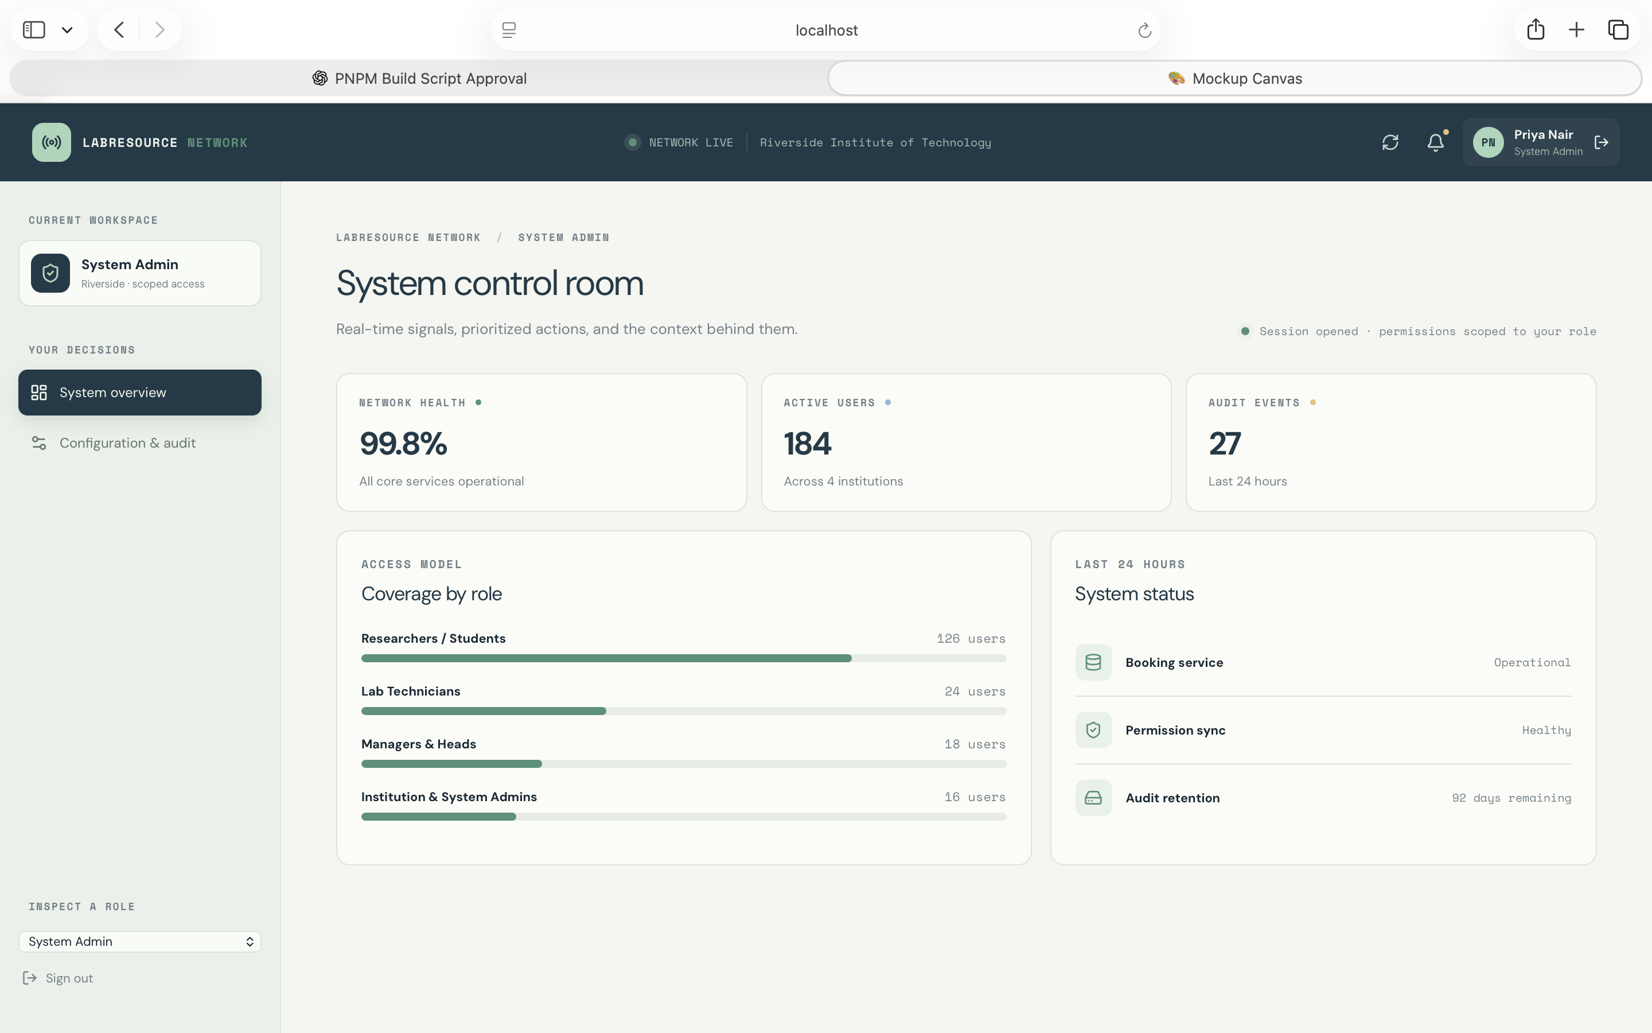
Current “System control room” view. Out of scope for Milestone 2 features; unchanged per Section 5.5.

