Clause-AI
Multi-Agent Contract Analyzer
PROJECT REPORT

Abstract
ClauseAI is an advanced AI-powered system designed to automate the analysis of legal contracts using a multi-agent Large Language Model (LLM) architecture. In traditional workflows, reviewing legal documents is a time-consuming and error-prone process that requires domain expertise and significant manual effort. ClauseAI addresses this challenge by intelligently processing contract documents, extracting key clauses, identifying potential risks, and generating structured, easy-to-understand reports.
The system leverages Natural Language Processing (NLP), vector embeddings, and semantic search techniques to understand the context and meaning of contractual text. By integrating with a vector database such as Pinecone, ClauseAI enables efficient storage and retrieval of document embeddings, allowing for faster and more accurate analysis. The multi-agent pipeline ensures that different aspects of the contract, such as clause extraction, risk detection, and summarization, are handled independently yet cohesively.
ClauseAI provides a user-friendly interface built with Streamlit, where users can upload contracts and receive detailed insights in real time. The system not only highlights missing or ambiguous clauses but also suggests improvements, making it highly useful for legal professionals, businesses, and individuals. Overall, ClauseAI enhances productivity, reduces human error, and introduces scalability into legal document analysis through intelligent automation

Introduction
In today’s digital era, legal documentation plays a critical role in business operations, agreements, and compliance. Contracts form the backbone of legal relationships, defining obligations, rights, and responsibilities between parties. However, analyzing these documents manually is a complex and time-intensive process that requires expertise in legal terminology and interpretation.
With the rapid advancement of Artificial Intelligence and Machine Learning, there is a growing opportunity to automate such repetitive and knowledge-intensive tasks. ClauseAI is developed as a solution to simplify and accelerate contract analysis by leveraging AI-driven techniques. The system is capable of understanding unstructured legal text, identifying key clauses, and generating meaningful insights without requiring constant human intervention.
ClauseAI combines multiple technologies, including Natural Language Processing, vector databases, and large language models, to create an intelligent pipeline for document analysis. The system not only improves efficiency but also ensures consistency and accuracy in identifying risks and missing clauses. By transforming complex legal documents into structured outputs, ClauseAI makes legal analysis more accessible to both professionals and non-experts.
This project demonstrates how AI can be applied in real-world scenarios to solve practical problems, particularly in the legal domain. It highlights the integration of modern technologies to build a scalable, efficient, and intelligent contract analysis system.
Background of the Problem
Legal contracts are inherently complex documents that contain dense language, technical terminology, and intricate clause structures. Traditionally, reviewing these contracts requires skilled legal professionals who must carefully read and interpret each section to identify key terms, obligations, and potential risks. This process is not only time-consuming but also prone to human error, especially when dealing with large volumes of documents.
In many organizations, contract analysis is a repetitive task that consumes significant resources. Manual review can lead to inconsistencies, overlooked clauses, and delays in decision-making. Additionally, small businesses and individuals may not always have access to legal expertise, making it difficult for them to fully understand the implications of contractual agreements.
Another major challenge is the lack of standardization in contracts. Different documents may use varied formats, terminologies, and structures, making automated processing difficult using traditional rule-based systems. This creates a need for intelligent systems that can understand context and semantics rather than relying solely on predefined rules.
With the increasing volume of digital documents and the demand for faster processing, there is a strong need for automated solutions that can efficiently analyze contracts while maintaining accuracy and reliability. This forms the foundation for developing systems like ClauseAI.
Need for Automated Contract Analysis
The growing complexity and volume of legal documents have made manual contract analysis increasingly inefficient. Organizations often deal with hundreds or thousands of contracts, each requiring careful review to ensure compliance, identify risks, and extract relevant information. Manual processing in such scenarios leads to delays, increased operational costs, and potential errors.
Automated contract analysis addresses these challenges by leveraging Artificial Intelligence to process documents quickly and accurately. AI-based systems can analyze large volumes of text in a fraction of the time required by humans, enabling faster decision-making and improved productivity. Additionally, automation ensures consistency in analysis, reducing the chances of missing critical clauses or misinterpreting information.
Another important need is accessibility. Not all users have legal expertise, and understanding complex contracts can be difficult for non-professionals. Automated systems can simplify this process by providing clear summaries, highlighting key points, and identifying potential risks in an understandable manner.
Furthermore, automation enables scalability. As businesses grow, the number of contracts increases, making manual review impractical. AI-driven systems like ClauseAI can scale efficiently to handle large datasets while maintaining performance. This makes automated contract analysis an essential solution in modern legal and business environments.
Overview of ClauseAI
ClauseAI is an intelligent contract analysis system that utilizes a multi-agent AI architecture to process and analyze legal documents. The system is designed to handle unstructured text inputs, extract meaningful information, and generate structured outputs in the form of reports. It integrates various components such as document loaders, text chunking modules, embedding models, and vector databases to create a seamless analysis pipeline.
The core functionality of ClauseAI involves breaking down contracts into smaller chunks, converting them into vector embeddings, and storing them in a vector database like Pinecone. This allows the system to perform semantic search and retrieve relevant information efficiently. Large Language Models are then used to analyze the extracted data, identify key clauses, detect risks, and generate summaries.
The system features a user-friendly interface built using Streamlit, enabling users to upload documents and view analysis results in real time. It also includes visualization components such as charts and performance metrics, making the output more interactive and informative.
ClauseAI follows a modular design, where each component performs a specific function, ensuring flexibility and scalability. The multi-agent approach allows different tasks such as clause extraction, risk analysis, and report generation to be handled independently, improving overall efficiency.
Overall, ClauseAI represents a modern approach to legal document analysis by combining AI, data processing, and user-centric design to deliver accurate and actionable insights.

Problem Statement
Legal contract analysis is a critical yet complex task that requires careful examination of clauses, terms, and conditions to identify obligations, risks, and compliance requirements. Traditionally, this process is performed manually by legal professionals, which is time-consuming, expensive, and prone to human error. With the increasing volume of contracts in businesses and organizations, manual analysis becomes inefficient and difficult to scale.
Another major issue is the lack of accessibility for individuals or small organizations who may not have legal expertise. Understanding complex legal language and identifying potential risks in contracts can be challenging, leading to poor decision-making or legal complications. Additionally, contracts often vary in structure and format, making it difficult to apply traditional rule-based automation techniques effectively.
There is also a need for faster turnaround times in reviewing contracts, especially in dynamic business environments where decisions must be made quickly. Manual methods cannot meet these demands efficiently. Therefore, the problem lies in developing an intelligent, scalable, and accurate system that can automate contract analysis, extract key information, detect risks, and present results in a structured and user-friendly manner.

Objectives of the Project
The primary objective of the ClauseAI project is to design and develop an intelligent system that automates the process of legal contract analysis using advanced AI techniques. The system aims to reduce manual effort, improve accuracy, and provide faster insights into contract documents.
Key Objectives:
- To develop an AI-based system capable of analyzing legal contracts automatically
- To extract important clauses such as payment terms, termination clauses, and obligations
- To identify potential risks and missing clauses in contracts
- To generate structured and easy-to-understand reports
- To integrate vector databases (Pinecone) for efficient storage and retrieval
- To implement a multi-agent pipeline for modular and scalable processing
- To provide a user-friendly interface for uploading and analyzing documents
- To ensure high accuracy and consistency in contract analysis
The project also aims to demonstrate the practical application of Artificial Intelligence in solving real-world problems in the legal domain.

Scope of the Project
The scope of ClauseAI focuses on automating the analysis of legal contracts using AI technologies. The system is designed to handle digital contract documents, extract relevant information, and provide meaningful insights to users. It covers various aspects of contract analysis, including clause identification, risk detection, and report generation.
ClauseAI is primarily intended for use by legal professionals, businesses, and individuals who need to analyze contracts efficiently. It supports documents in standard formats such as PDF and Word files and processes them using Natural Language Processing techniques. The system is scalable and can handle multiple documents, making it suitable for both small-scale and enterprise-level applications.
However, the scope of the project is limited to contract analysis and does not include full legal decision-making or legal advice. The system provides recommendations and insights but does not replace professional legal consultation. Additionally, the accuracy of the system depends on the quality of input data and the effectiveness of the AI models used.
Overall, ClauseAI aims to enhance productivity and simplify contract analysis while maintaining a balance between automation and user control.

Literature Survey
The development of automated contract analysis systems is based on advancements in Natural Language Processing (NLP), Machine Learning, and Artificial Intelligence. Several research studies and tools have explored the use of AI for processing legal documents and extracting meaningful information.
Early approaches to contract analysis relied on rule-based systems, where predefined rules were used to identify specific patterns in text. However, these systems lacked flexibility and struggled to handle variations in language and structure. With the introduction of Machine Learning, models began to learn patterns from data, improving accuracy and adaptability.
Recent advancements in Large Language Models (LLMs), such as transformer-based architectures, have significantly improved the ability to understand and process natural language. These models can capture context, semantics, and relationships within text, making them highly effective for tasks like summarization, classification, and information extraction.
Vector databases like Pinecone have also played a crucial role in enabling semantic search by storing text embeddings. This allows systems to retrieve relevant information based on meaning rather than exact keyword matches. Multi-agent systems further enhance performance by dividing tasks into smaller components, improving efficiency and scalability.
The ClauseAI project builds upon these advancements by integrating NLP, LLMs, and vector databases into a unified system for automated contract analysis.

Existing Systems
Several tools and systems currently exist for legal document analysis, ranging from traditional software to AI-powered platforms. These systems aim to assist legal professionals in reviewing contracts and extracting relevant information.
Examples of Existing Systems:
- Manual Review Systems: Traditional approach where lawyers analyze contracts manually
- Rule-Based Systems: Use predefined patterns to identify clauses
- Legal Tech Platforms: Tools like Kira Systems, Luminance, and LawGeex
- Document Management Systems: Store and organize contracts but offer limited analysis
- Basic NLP Tools: Perform keyword extraction and simple text analysis
These systems provide some level of automation but often lack the ability to fully understand context and semantics. While AI-based platforms have improved performance, they may still be expensive, complex, or limited in customization.

Limitations of Existing Systems
Despite the availability of various tools, existing systems for contract analysis have several limitations that affect their effectiveness and usability.
Key Limitations:
- High Dependency on Manual Effort
- Limited Understanding of Context and Semantics
- Inability to Handle Diverse Contract Formats
- High Cost of Advanced Legal AI Tools
- Lack of Customization for Specific Use Cases
- Difficulty in Identifying Implicit Risks
- Limited Scalability in Traditional Systems
- Poor User Accessibility for Non-Experts
Most existing systems either rely heavily on predefined rules or require expensive subscriptions. They may not provide accurate results when dealing with complex or non-standard contracts, making them less reliable in real-world scenarios.

Need for Proposed System
The limitations of existing systems highlight the need for a more advanced and intelligent solution for contract analysis. The proposed system, ClauseAI, aims to address these challenges by leveraging modern AI technologies.
ClauseAI provides a scalable and automated approach to analyzing contracts, reducing the dependency on manual review. By using Large Language Models and vector databases, the system can understand the context and meaning of text, enabling more accurate extraction of information and identification of risks.
The proposed system is designed to be cost-effective and accessible, making it suitable for a wide range of users, including individuals and small businesses. Its modular architecture allows for easy customization and scalability, ensuring that it can adapt to different requirements and use cases.
Additionally, ClauseAI enhances user experience by providing a simple and interactive interface, enabling users to upload documents and receive insights instantly. The system not only improves efficiency but also ensures consistency and reliability in contract analysis.
Overall, the proposed system bridges the gap between traditional methods and modern AI-driven solutions, offering a more effective and practical approach to legal document analysis.

Proposed System (ClauseAI Architecture)

The proposed system, ClauseAI, is an advanced AI-powered contract analysis platform designed to automate the process of understanding, evaluating, and summarizing legal documents. Unlike traditional systems that rely heavily on manual review, ClauseAI uses a multi-agent architecture powered by Large Language Models (LLMs) to perform parallel analysis of contracts.

The architecture is built using modern AI technologies such as LangGraph for orchestration, Groq LLM for fast inference, and Pinecone for vector storage. The system processes contracts in multiple stages, including text extraction, semantic embedding, intelligent retrieval, and multi-agent evaluation. Each stage is optimized for scalability, speed, and accuracy.

ClauseAI follows a modular design where each component performs a specific function. This ensures flexibility, easy debugging, and future scalability. The architecture is capable of handling large documents and performing complex reasoning tasks such as clause comparison, risk detection, and compliance validation.

The system leverages vector databases to store embeddings of contract text, allowing efficient semantic search and retrieval. This enables agents to access relevant context while performing analysis. Additionally, the integration of a Streamlit-based UI provides an interactive and user-friendly interface for uploading documents, viewing analysis, and downloading reports.

Overall, the proposed system transforms traditional contract review into an automated, intelligent, and scalable process, reducing manual effort while improving accuracy and efficiency.

System Architecture
ClauseAI follows a modular and scalable architecture designed to automate legal contract analysis efficiently. The system integrates document processing, embedding generation, vector storage, multi-agent analysis, and report generation into a unified workflow.
The architecture is divided into multiple logical layers to ensure maintainability and scalability.
User Upload
↓
Text Extraction
↓
Chunking
↓
Embeddings
↓
Pinecone Vector DB
↓
Multi-Agent Analysis
↓
Report Generation
13.2 Architecture Layers
1️⃣ Presentation Layer (User Interface)
- Built using Streamlit
- Allows users to upload contract documents
- Displays analysis results
- Provides download options (Markdown, JSON, ZIP)
- Shows visualization dashboards
This layer ensures ease of use and interactive experience.

2️⃣ Processing Layer
This layer handles document parsing and preprocessing:
- Extracts text from PDF and DOCX files
- Cleans and normalizes text
- Splits text into meaningful chunks
- Prepares text for embedding generation
Chunking is necessary because LLMs have token limits and cannot process very large documents directly.

3️⃣ Embedding & Vector Layer
- Uses Sentence Transformers / HuggingFace embeddings
- Converts text chunks into numerical vector representations
- Stores embeddings in Pinecone vector database
This enables:
- Semantic search
- Context-aware retrieval
- Efficient contract memory storage
Multi-Agent Design
The core strength of ClauseAI lies in its multi-agent design, where multiple specialized AI agents work collaboratively to analyze different aspects of a contract.
Each agent is designed with a specific role:
- Compliance Agent → Checks whether the contract adheres to legal standards and regulatory requirements
- Finance Agent → Analyzes payment terms, penalties, and financial risks
- Legal Agent → Evaluates legal clauses such as liabilities, obligations, and termination conditions
- Operations Agent → Focuses on operational feasibility, timelines, and responsibilities
Instead of relying on a single model, the system distributes tasks across these agents, enabling parallel processing. This significantly improves both speed and accuracy, as each agent provides domain-specific insights.
The agents are orchestrated using LangGraph, which manages the flow of information between them. This ensures that each agent receives relevant context and contributes effectively to the final output.
The multi-agent approach also enhances modularity and scalability. New agents can be added in the future for specialized tasks such as compliance auditing, contract comparison, or risk scoring.
Furthermore, the agents can interact dynamically with user inputs, allowing customization of analysis. This creates a more flexible and intelligent system compared to traditional single-model approaches.
Overall, the multi-agent design enables ClauseAI to simulate a team of experts working together, making contract analysis more comprehensive and reliable.

Workflow Description
The workflow of ClauseAI follows a structured pipeline that ensures efficient processing and accurate analysis of contracts.
Step 1: Document Upload
The user uploads a contract file (PDF/DOCX) through the Streamlit interface. The system validates the file format and prepares it for processing.
Step 2: Text Extraction
The uploaded document is parsed using specialized libraries to extract raw text. This step ensures that all relevant information is captured from the document.
Step 3: Text Chunking
The extracted text is divided into smaller chunks. This improves processing efficiency and allows better handling of large documents.
Step 4: Embedding Generation
Each chunk is converted into a vector representation using embedding models. These embeddings capture the semantic meaning of the text.
Step 5: Vector Storage
The embeddings are stored in the Pinecone vector database. This enables fast retrieval of relevant information during analysis.
Step 6: Multi-Agent Analysis
The system activates multiple agents simultaneously. Each agent retrieves relevant chunks from the vector database and performs specialized analysis.
Step 7: Result Aggregation
Outputs from all agents are combined into a unified structure. This step ensures consistency and completeness of analysis.
Step 8: Report Generation
The system generates a structured report containing:
- Clause summaries
- Risk identification
- Recommendations
Step 9: User Interaction & Feedback
Users can interact with the system, provide feedback, and re-run analysis for improved results.
Methodology
The methodology of ClauseAI follows a structured and systematic approach to transform raw legal documents into actionable insights using artificial intelligence. The process begins with data acquisition, where users upload contracts in formats such as PDF or DOCX. The system then performs preprocessing, including text extraction and cleaning, to ensure that the data is in a usable format.
After preprocessing, the document is segmented into smaller chunks to improve processing efficiency. These chunks are then converted into vector embeddings using transformer-based models, enabling semantic understanding of the text. The embeddings are stored in a vector database (Pinecone), allowing efficient retrieval during analysis.
The core methodology lies in the multi-agent LLM pipeline, where multiple specialized agents analyze the contract simultaneously. Each agent processes relevant chunks and generates insights based on its domain expertise. The outputs are then aggregated and structured into a final report.
This methodology ensures:
- High scalability for large documents
- Improved accuracy through specialization
- Faster processing using parallel execution
- Better user interaction with iterative feedback
Data Flow
The data flow in ClauseAI represents how information moves through the system from input to output.
Initially, the user uploads a contract through the interface. The file is passed to the document loader, which extracts text and sends it to the preprocessing module. After cleaning and chunking, the text is forwarded to the embedding module.
The embedding module converts text into vectors and stores them in Pinecone. When analysis is triggered, the system retrieves relevant vectors and passes them to different agents. Each agent processes the data independently and produces results.
Finally, the outputs are combined and sent to the report generator, which formats the results into a structured report displayed to the user.
Key Points
- Input → Processing → Storage → Analysis → Output
- Uses vector-based retrieval for efficiency
- Supports parallel data processing

Processing Pipeline
The processing pipeline is the backbone of ClauseAI, ensuring smooth execution of all tasks.
Pipeline Stages:
- Input Stage – Contract upload
- Preprocessing Stage – Text extraction and cleaning
- Chunking Stage – Splitting text into segments
- Embedding Stage – Converting text into vectors
- Storage Stage – Saving embeddings in Pinecone
- Analysis Stage – Multi-agent processing
- Output Stage – Report generation
Each stage is independent yet interconnected, allowing modular development and debugging. The pipeline ensures efficient handling of large datasets and reduces latency during analysis.

AI Model Integration
ClauseAI integrates advanced AI models to perform intelligent contract analysis. The system primarily uses Large Language Models (LLMs) provided by Groq (LLaMA models) for fast and efficient inference.
The integration is done through a modular approach:
- The LLM is connected via API
- Prompts are dynamically generated for each agent
- Context is retrieved from Pinecone before sending to the model
The models are responsible for:
- Understanding legal language
- Extracting clauses
- Identifying risks
- Generating summaries
This integration ensures that the system can perform human-like reasoning while maintaining high speed and scalability.

System Design
The system design of ClauseAI follows a modular and layered architecture, ensuring flexibility and scalability.
Design Layers:
- Presentation Layer → Streamlit UI
- Application Layer → Business logic and orchestration
- AI Layer → LLM and agent processing
- Data Layer → Pinecone vector database
Each layer communicates with others through well-defined interfaces. This separation of concerns makes the system easy to maintain and extend.
Architecture Diagram
User Upload
↓
Text Extraction
↓
Chunking
↓
Embeddings
↓
Pinecone Vector DB
↓
Multi-Agent LLM Processing
↓
Report Generation
↓
Streamlit UI

Module Description
ClauseAI is divided into multiple modules, each responsible for a specific function.
1. Document Loader Module
- Extracts text from PDF/DOCX
- Handles file validation
2. Chunking Module
- Splits text into smaller parts
- Improves processing efficiency
3. Embedding Module
- Converts text into vectors
- Uses transformer models
4. Vector Store Module
- Stores embeddings in Pinecone
- Enables semantic retrieval
5. Agent Module
- Contains multiple AI agents
- Performs domain-specific analysis
6. Report Module
- Generates structured output
- Provides summaries and recommendations

Flowcharts
Start
↓
Upload Contract
↓
Extract Text
↓
Chunk Data
↓
Generate Embeddings
↓
Store in Pinecone
↓
Run AI Agents
↓
Generate Report
↓
End

Technologies Used
ClauseAI uses a combination of modern technologies for efficient performance.
Key Technologies
- Artificial Intelligence (LLMs)
- Vector Databases
- Cloud-based APIs
- Web-based UI
These technologies enable automation, scalability, and high performance.

Programming Languages
The system is primarily developed using:
- Python → Core backend and AI logic
- JavaScript (optional) → For frontend enhancements
Python is chosen due to its strong ecosystem for AI, data processing, and rapid development.

Frameworks & Tools
ClauseAI utilizes several frameworks and tools:
- Streamlit → User Interface
- LangGraph → Multi-agent orchestration
- Pinecone → Vector database
- Groq API → LLM inference
- Git & GitHub → Version control
These tools help in building a scalable and production-ready system.

Libraries
The system relies on various Python libraries:
Core Libraries
- streamlit → UI development
- pandas → Data handling
- numpy → Numerical operations
AI & NLP Libraries
- transformers → Embeddings and models
- langchain / langgraph → Agent workflows
Document Processing
- PyPDF → PDF parsing
- python-docx → DOCX handling
Other Utilities
- dotenv → Environment variables
- plotly → Visualization
Implementation
The implementation of ClauseAI focuses on integrating multiple technologies into a unified system capable of performing intelligent contract analysis. The system is developed using a modular architecture where each component is designed and implemented independently, ensuring scalability and maintainability.
The frontend is built using Streamlit for rapid UI development, while the backend logic is implemented in Python, handling document processing, AI inference, and data management. The system integrates with Pinecone as a vector database to store embeddings and retrieve relevant information efficiently.
The implementation ensures:
- Seamless interaction between UI and backend
- Efficient processing of large documents
- Scalable architecture for real-world deployment
- Modular codebase for easy updates

Frontend (Streamlit UI)
The frontend of ClauseAI is developed using Streamlit, which provides an interactive and user-friendly interface.
The UI allows users to:
- Upload contract files (PDF/DOCX)
- View extracted text
- Trigger contract analysis
- Interact with AI agents
- Download reports
Streamlit enables rapid prototyping and clean design using minimal code. The UI is structured into tabs for better usability, such as:
- Upload Section
- Analysis Section
- Results Dashboard
- Report Download
This ensures a smooth and intuitive user experience.

Backend (FastAPI / Python Logic)
The backend is responsible for handling all core operations of the system. It is implemented using Python, with optional support for FastAPI to expose APIs.
Responsibilities:
- Document processing
- Data transformation
- AI model interaction
- Multi-agent orchestration
- Report generation
The backend ensures efficient handling of requests and maintains communication between different modules.

Vector Database (Pinecone)
Pinecone is used as the vector database to store and retrieve embeddings generated from contract text.
Key Features:
- High-speed similarity search
- Scalable storage
- Namespace-based organization
Each contract is stored in a separate namespace, allowing efficient querying and isolation of data. This enables fast retrieval of relevant chunks during AI analysis.

Integration
The system integrates multiple components seamlessly:
- Frontend ↔ Backend (user interaction)
- Backend ↔ Pinecone (data storage & retrieval)
- Backend ↔ LLM APIs (AI processing)
Integration is achieved through API calls and modular function design. This ensures smooth data flow across the system.
Modules Description
The system is divided into functional modules to handle specific tasks efficiently.

Document Loader
This module extracts text from uploaded documents.
Functions:
- Reads PDF/DOCX files
- Converts content into plain text
- Handles errors and invalid formats

Chunking Module
This module splits large text into smaller chunks.
Purpose:
- Improve processing efficiency
- Enable better embedding generation

Embedding Module
This module converts text into vector representations.
Key Role:
- Enables semantic understanding
- Supports similarity search

LLM Processing
This module uses Large Language Models to analyze the contract.
Tasks:
- Clause extraction
- Risk detection
- Summary generation

Risk Analyzer
The risk analyzer identifies potential risks in contracts.
Examples:
- Missing clauses
- Ambiguous terms
- Financial risks

Report Generator
This module generates structured outputs.
Outputs:
- Markdown report
- JSON data
- Downloadable files

Results and Outputs
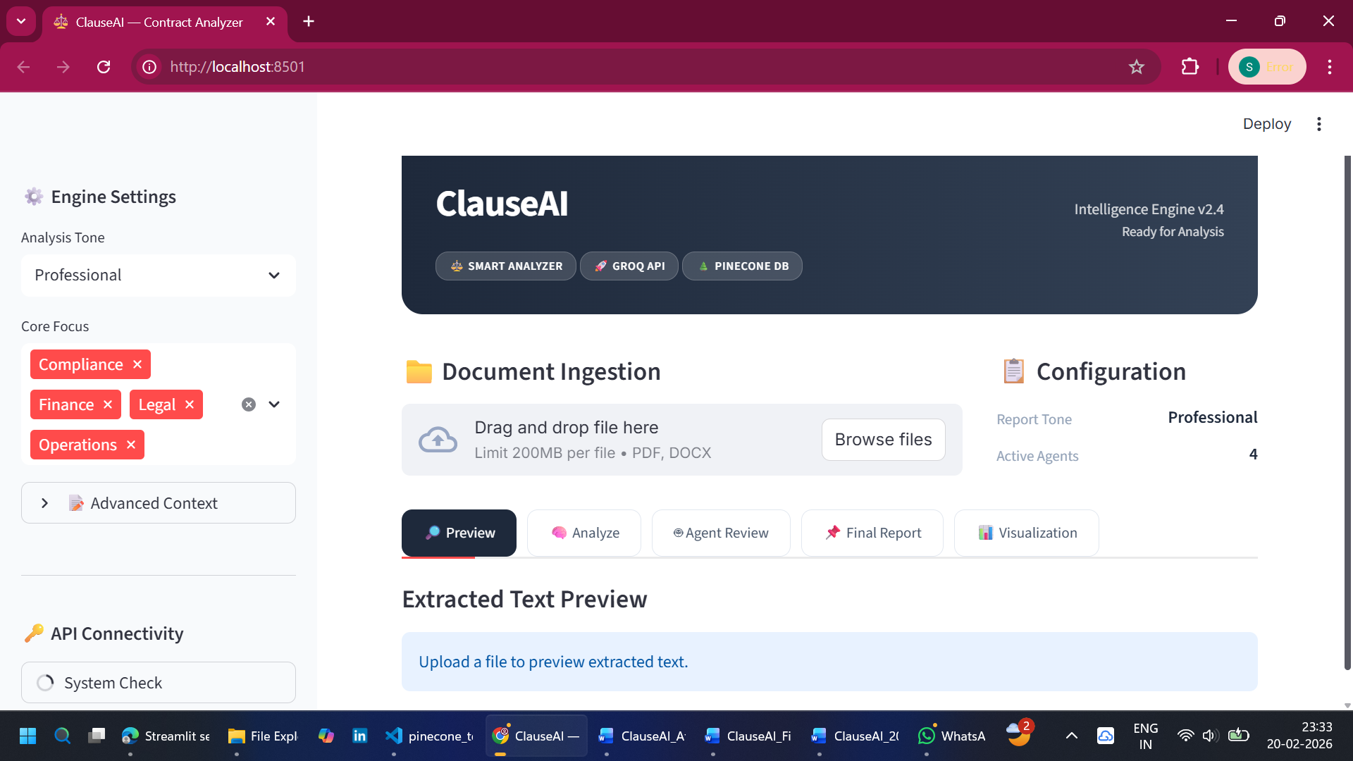
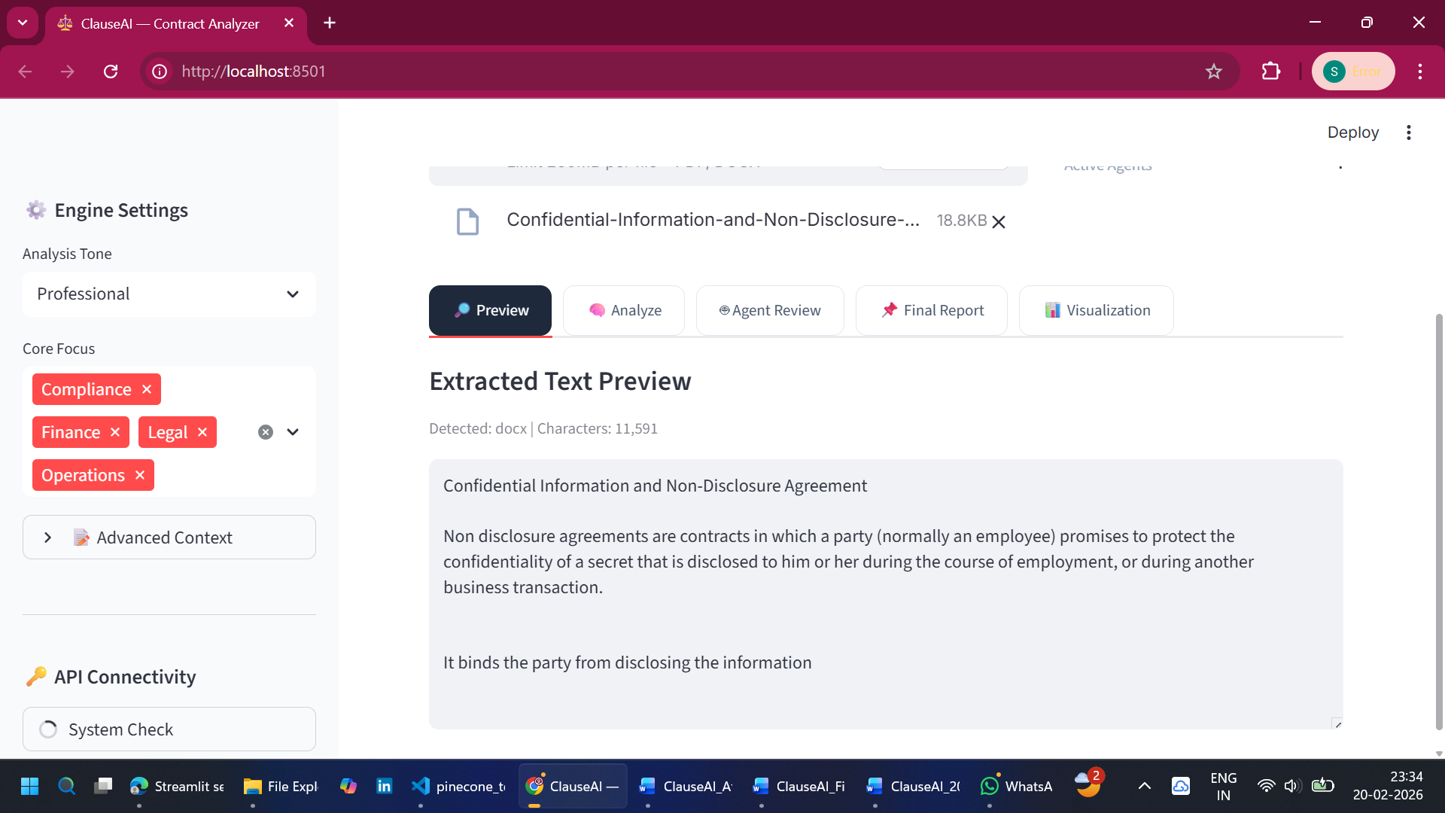

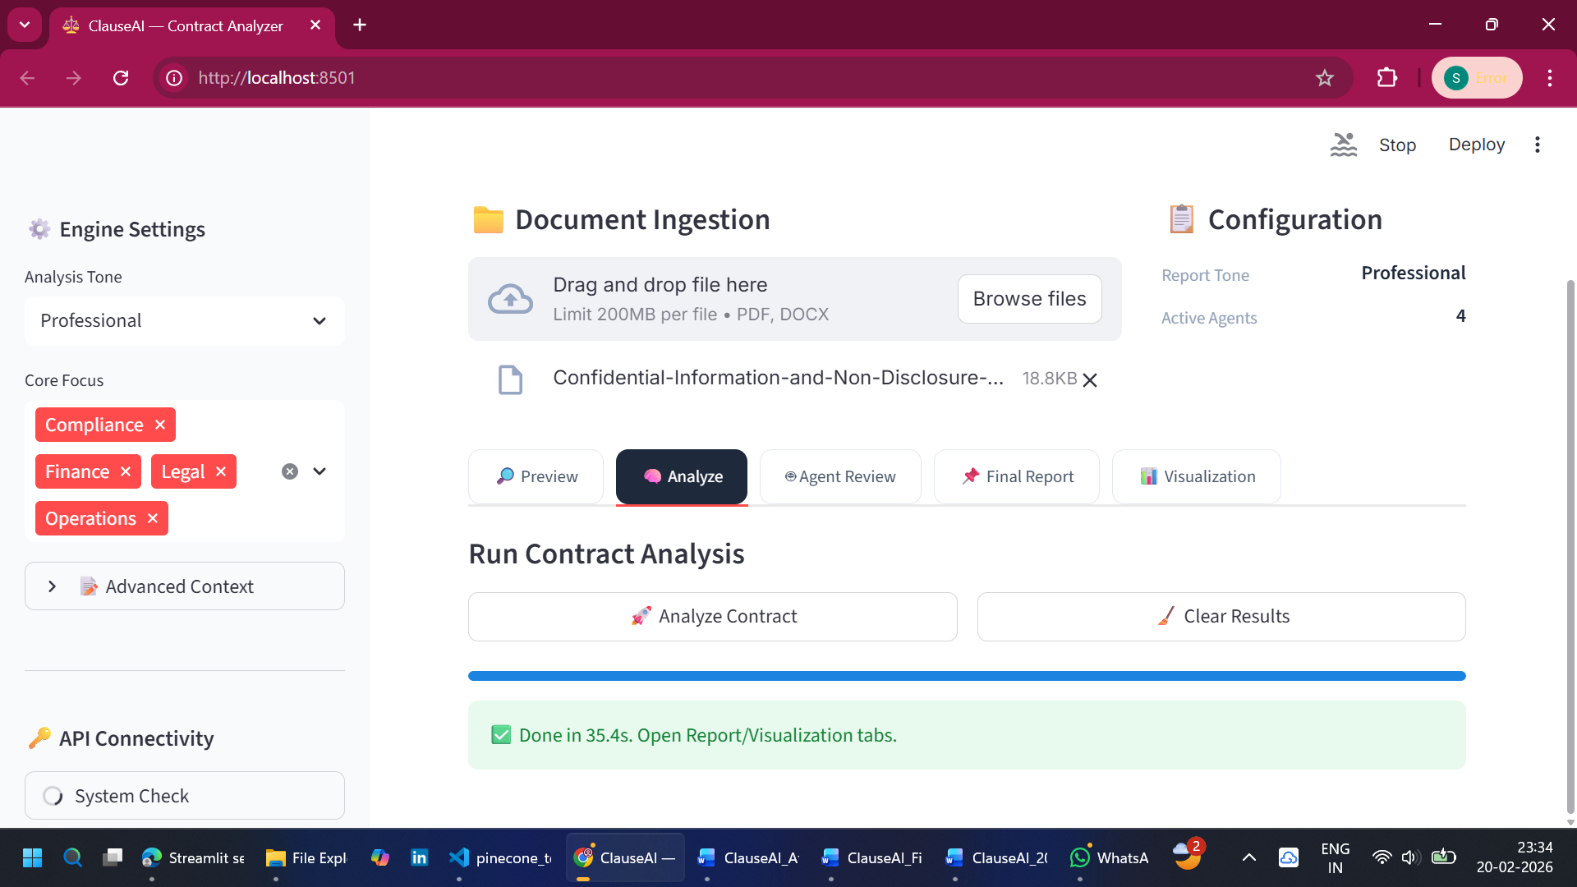

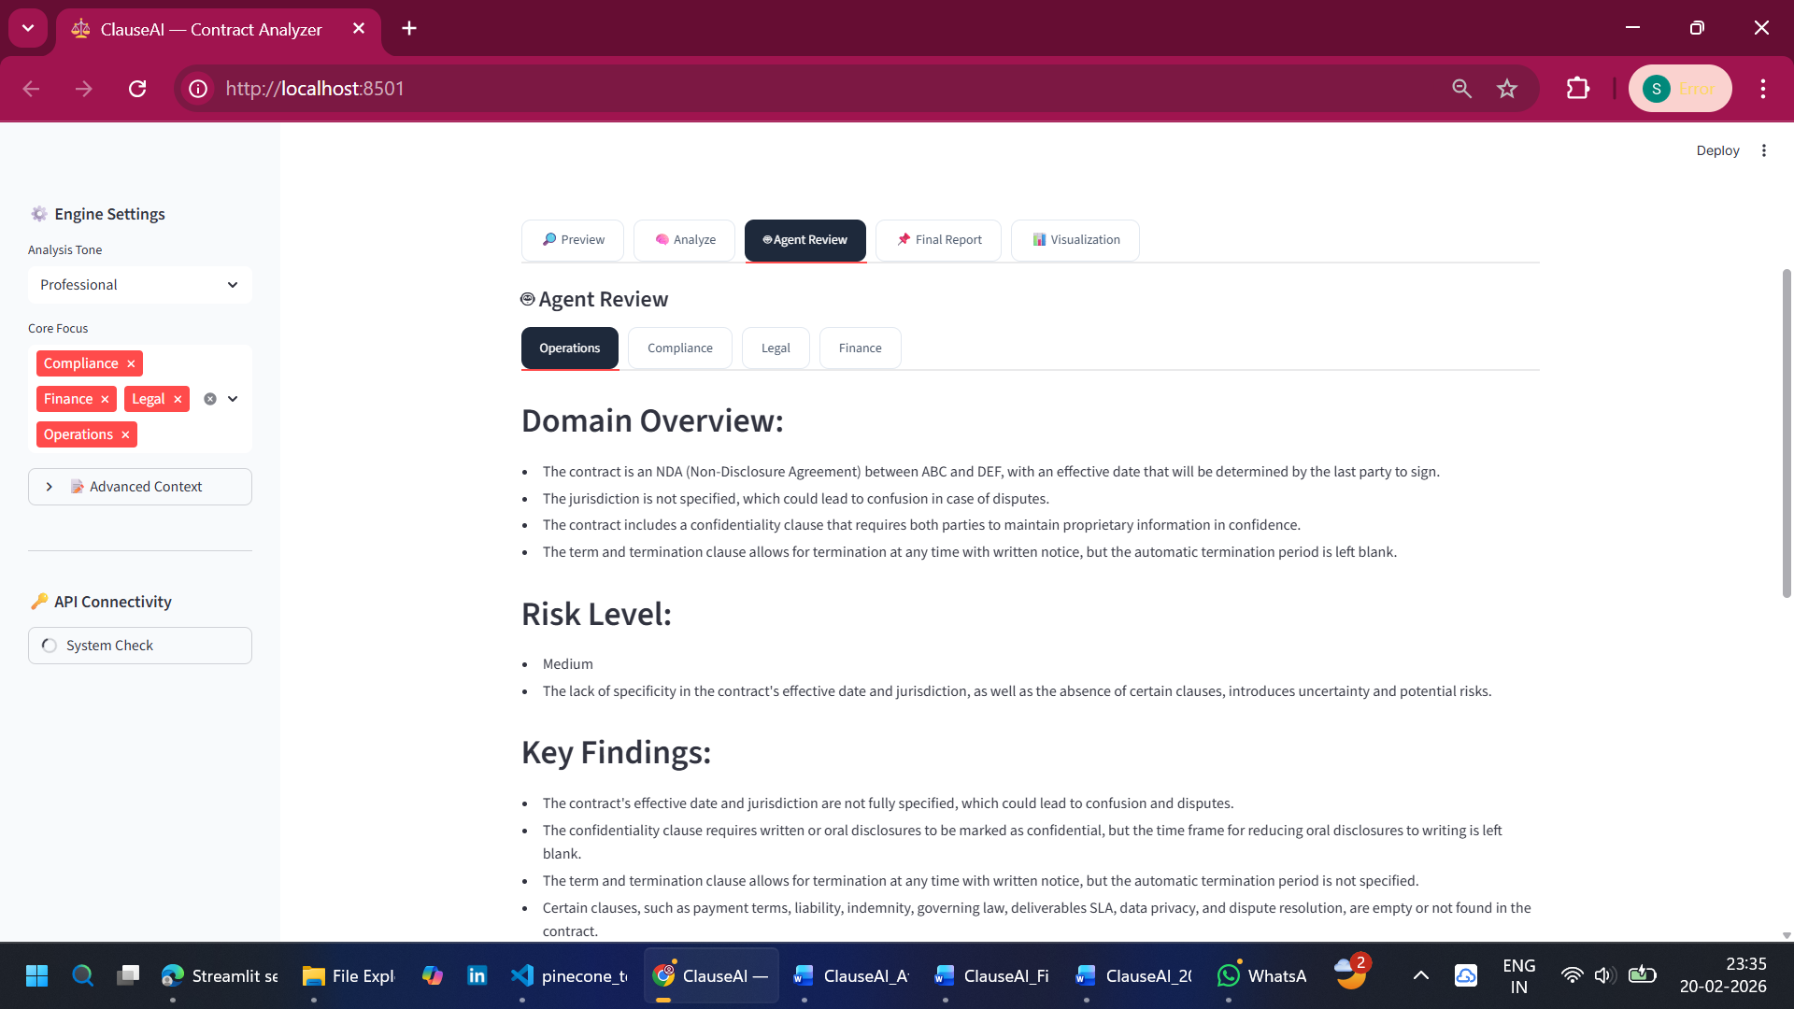

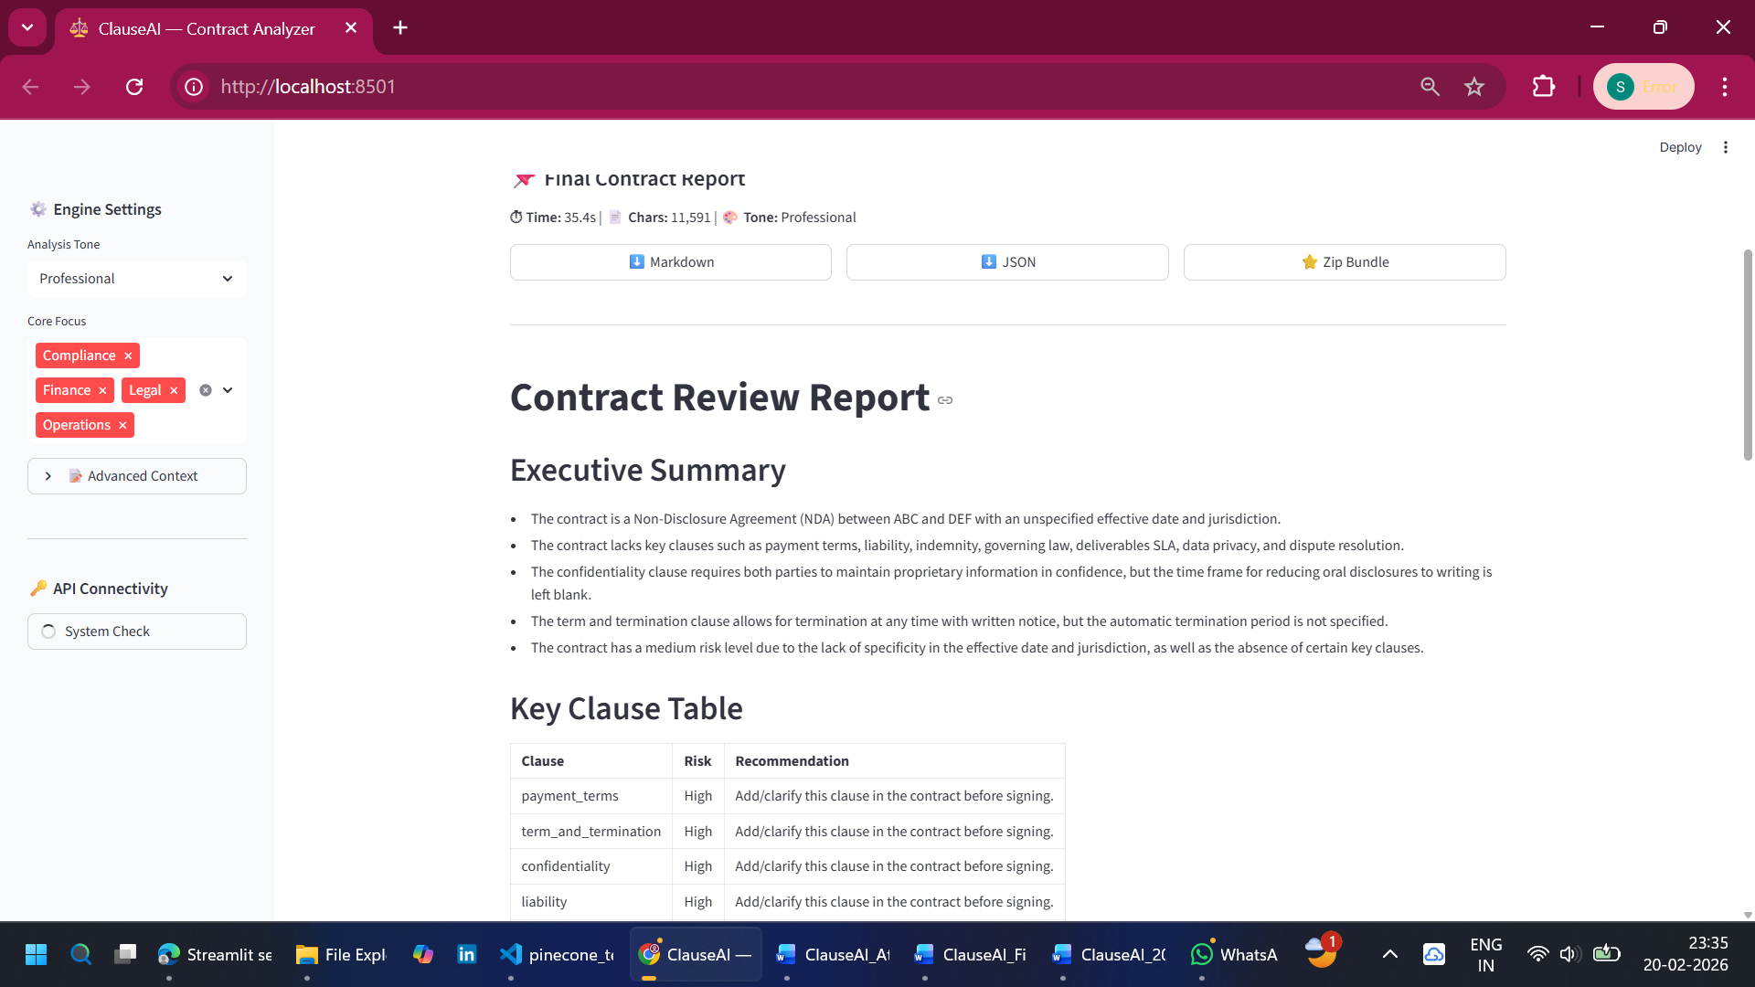

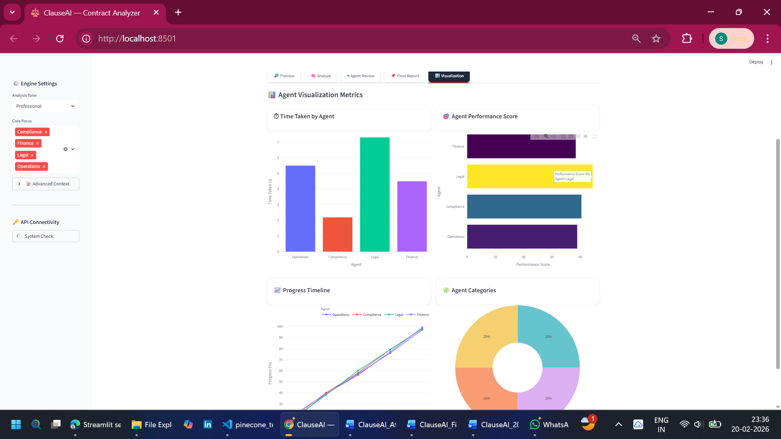

Advantages of the System
- Automates contract analysis
- Saves time and effort
- Improves accuracy
- Scalable and efficient
- User-friendly interface

Limitations of the System
- Depends on API availability
- May require internet connection
- Limited understanding of highly complex legal language
- Processing time increases with document size

Applications
ClauseAI can be used in various domains:
- Legal firms
- Corporate contract management
- Financial institutions
- Startups and enterprises

Future Enhancements
- Clause comparison feature
- Real-time collaboration
- Multi-language support
- Cloud deployment
- AI-based redlining

Conclusion
ClauseAI successfully demonstrates the application of artificial intelligence in automating legal contract analysis. By leveraging multi-agent systems, vector databases, and LLMs, the system provides accurate and efficient insights into complex legal documents.
The project highlights the potential of AI in transforming traditional workflows and improving productivity in legal and business environments.

References / Bibliography
- Pinecone Documentation
- Streamlit Documentation
- LangChain / LangGraph Documentation
- Groq API Documentation
- Research papers on NLP and LLMs
- Python Official Documentation

