SMARTHIRE
AI-POWERED MOCK INTERVIEW &
CANDIDATE ASSESSMENT PLATFORM
USER MANUAL • VERSION 1.0 • 2026
Practice. Perform. Improve. Get Hired.
A concise guide for candidates, recruiters, and administrators.

About SmartHire AI
SmartHire AI is an AI-assisted mock interview and candidate assessment platform designed to simulate interview experiences, analyze available interview evidence, generate performance feedback, and support recruiter review while respecting candidate privacy.
CANDIDATE  Practice interviews  and understand  performance. | RECRUITER  Review candidates  and support  selection. | ADMIN  Monitor users,  interviews, and  platform activity.
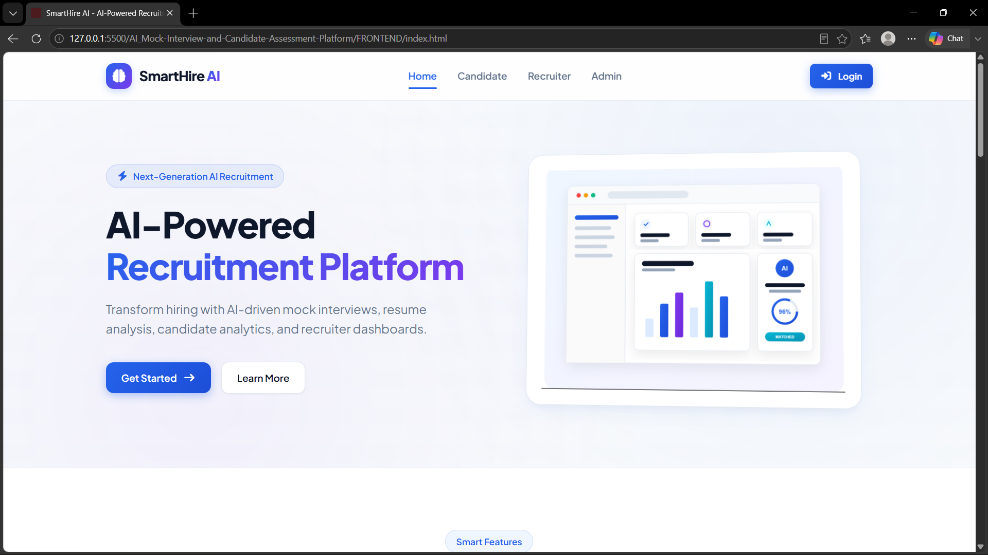
01 • GETTING STARTED

Welcome to SmartHire
Your first steps from sign-in to your role-based workspace.
Open SmartHire AI in a supported web browser. The welcome and login interface provides access to the application. After authentication, users are directed to the dashboard associated with their role.
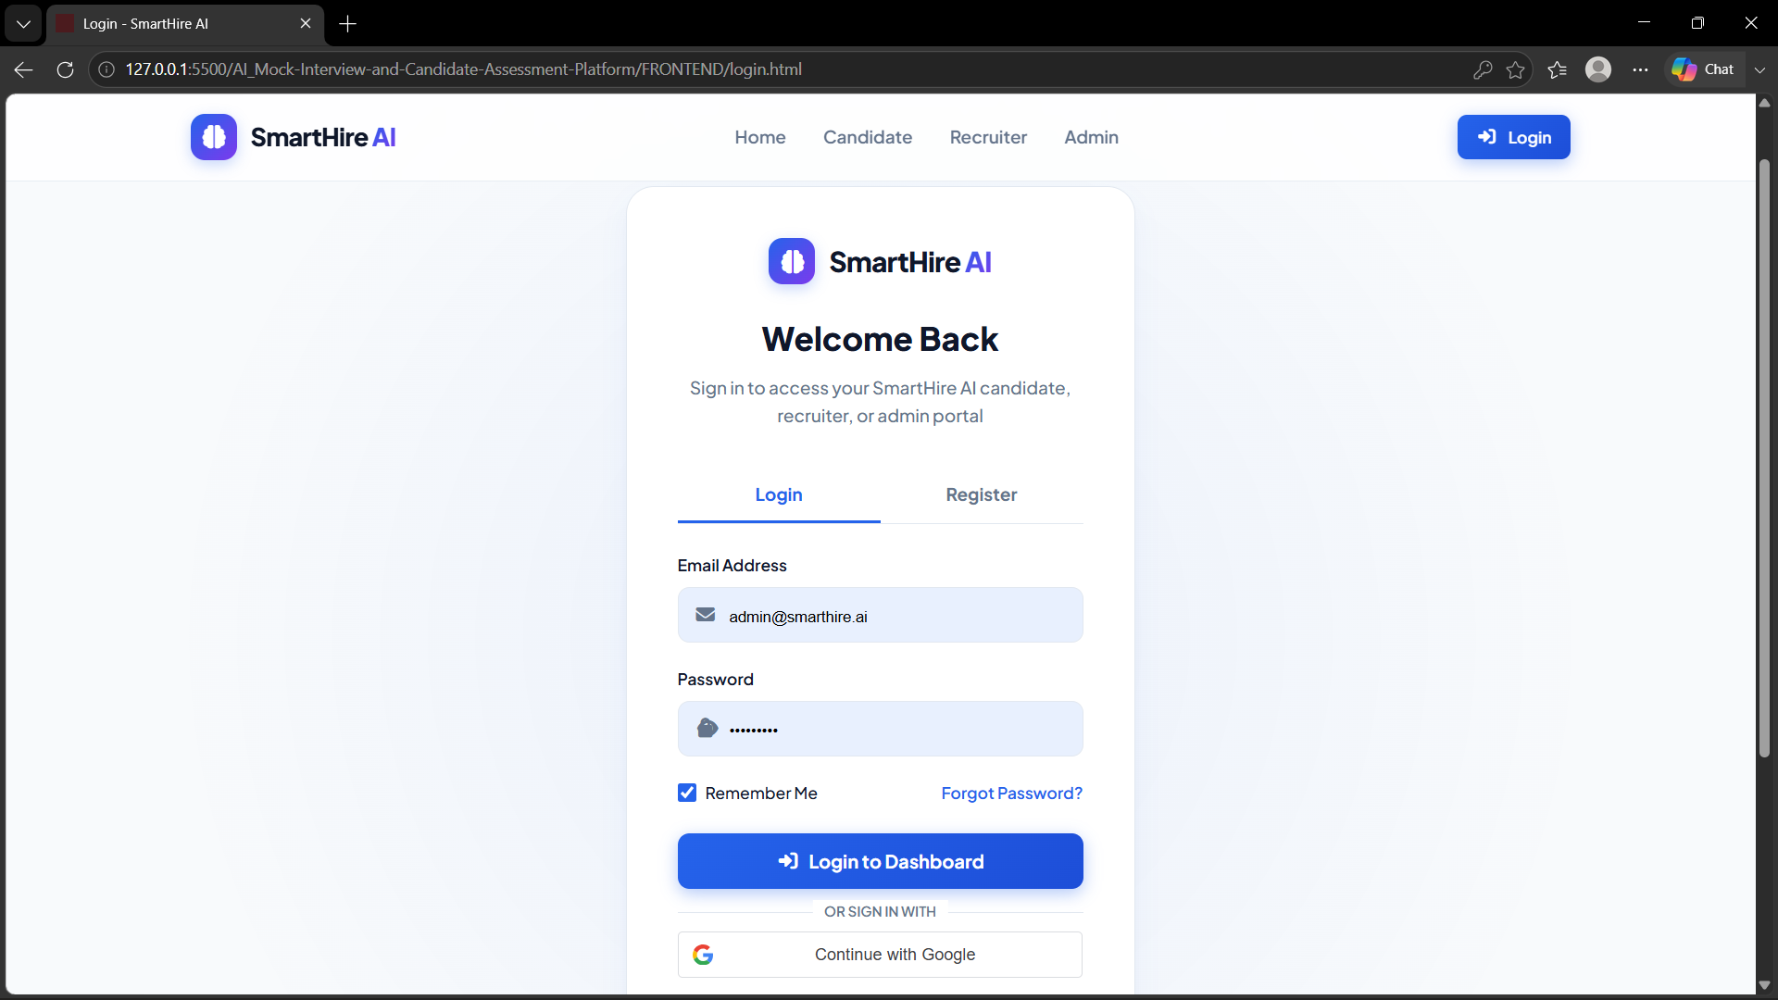

Create an account
1 | Choose registration — Select the registration option and enter the required account information.
2 | Submit details — Complete the form and submit it to create your account.
3 | Sign in — Use your registered credentials to access SmartHire.

Role-based access
• Candidates access interview and performance features.
• Recruiters access candidate and interview review features.
• Administrators access platform monitoring and management features.
TIP • Keep your credentials private and use the registered email address when signing in again.

02 • CANDIDATE

Your Interview Journey
From an assigned interview to a completed assessment.
LOGIN | DASHBOARD | ASSIGNED  INTERVIEW | SETUP | AI  INTERVIEW | EVALUATION | REPORT

Candidate Dashboard
The candidate dashboard is the starting point for assigned interviews, interview status, notifications, and performance-related information. Select an available interview to continue.
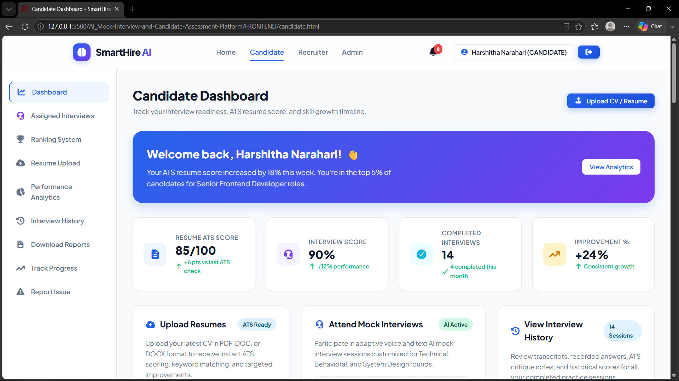

Starting an interview
1 | Open the assigned interview — Select an available interview from the dashboard.
2 | Review instructions — Read the requirements before entering the interview environment.
3 | Check permissions — Allow camera and microphone access when requested by the browser.
4 | Begin — Start the interview when you are ready.

03 • CANDIDATE

Step Into Your AI Interview
Prepare well, follow the interview rules, and answer naturally.

Before you begin
• Choose a quiet, well-lit environment.
• Make sure your camera and microphone are working.
• Read the on-screen instructions carefully.
• Be prepared to remain in the required interview view/full-screen mode.
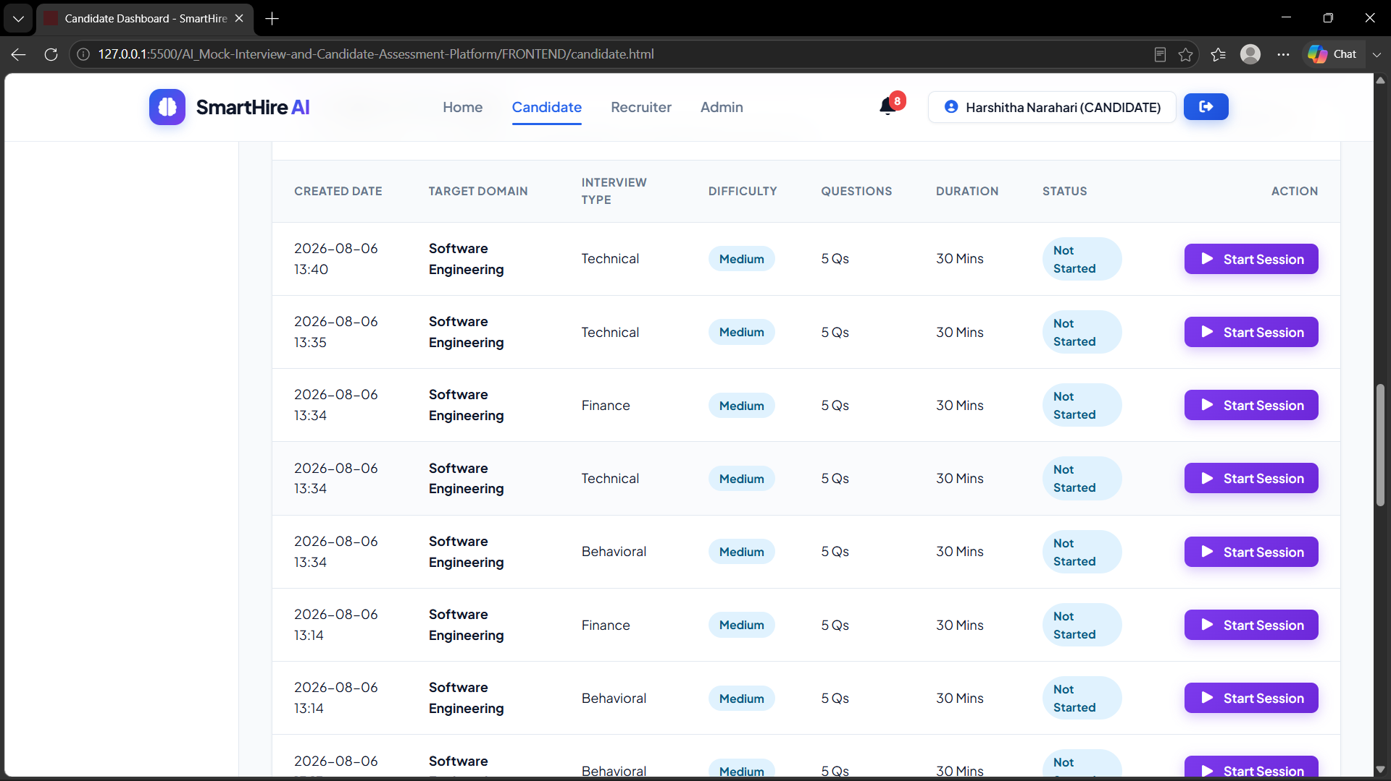

During the interview
• Read each question carefully and provide your response.
• Keep track of the interview timer and answer within the allowed duration.
• The platform may analyze speech and relevant visual/behavioral signals used for assessment.
• Interview-related violations or interruptions may be recorded according to configured rules.
INTERVIEW TIP • Speak clearly, maintain a professional posture, and focus on the question.

Completing the session
When the interview is complete, submit or end the session using the available control. SmartHire then processes the available interview evidence and prepares the candidate performance evaluation.

04 • CANDIDATE

Understand Your Performance
Turn interview results into practical areas for improvement.

Performance breakdown
ASSESSMENT AREA | WEIGHT
Communication | 30%
Technical | 30%
Confidence | 25%
Professionalism | 15%

Your report
• Overall performance summary.
• Category-level assessment across communication, technical ability, confidence, and professionalism.
• Strengths and areas that may need improvement.
• AI-assisted feedback based on the evidence available from the completed interview.
• Downloadable PDF report when the report is available.
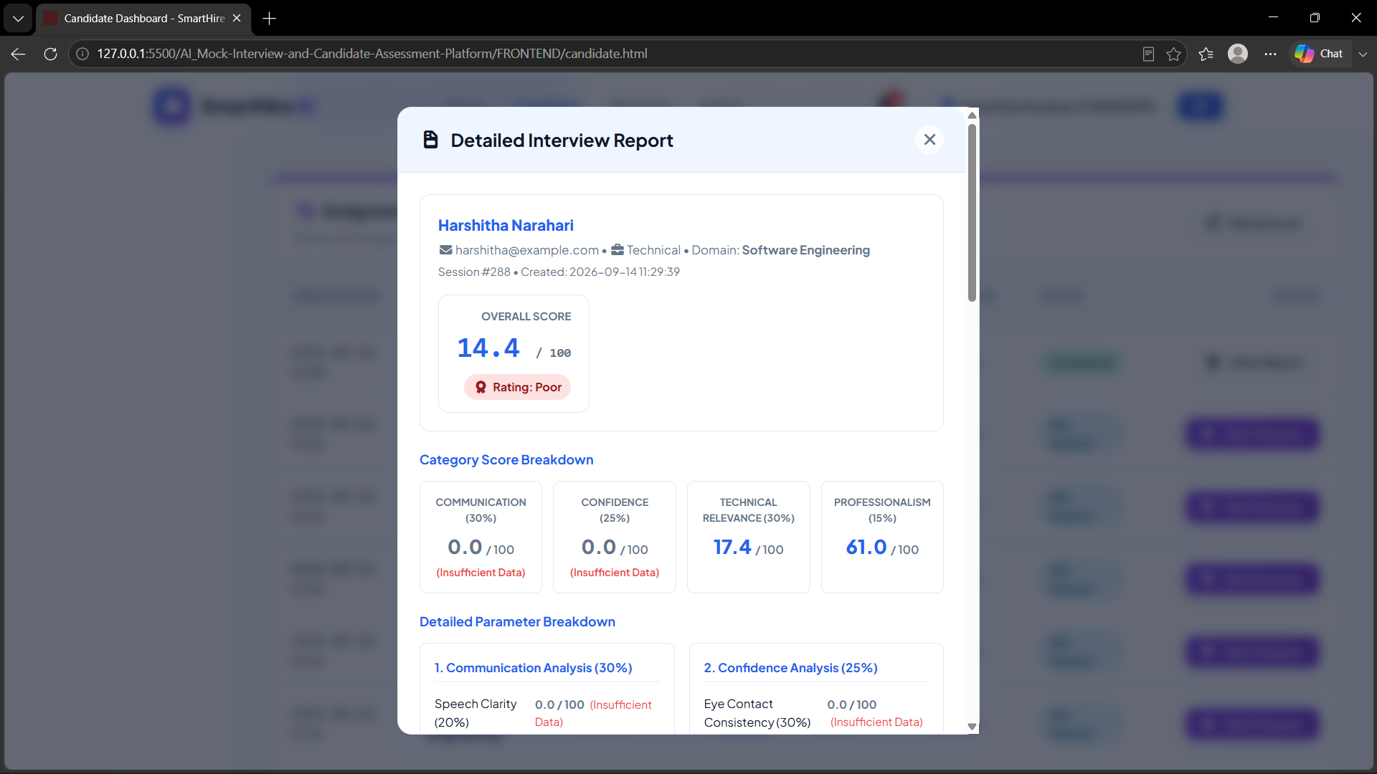

Your results, your choice
After completing the interview, the candidate can choose whether protected performance information may be shared with the recruiter.
YES → Protected results can be made available to the recruiter.
NO / REVOKED → Protected scores remain private from recruiter access.
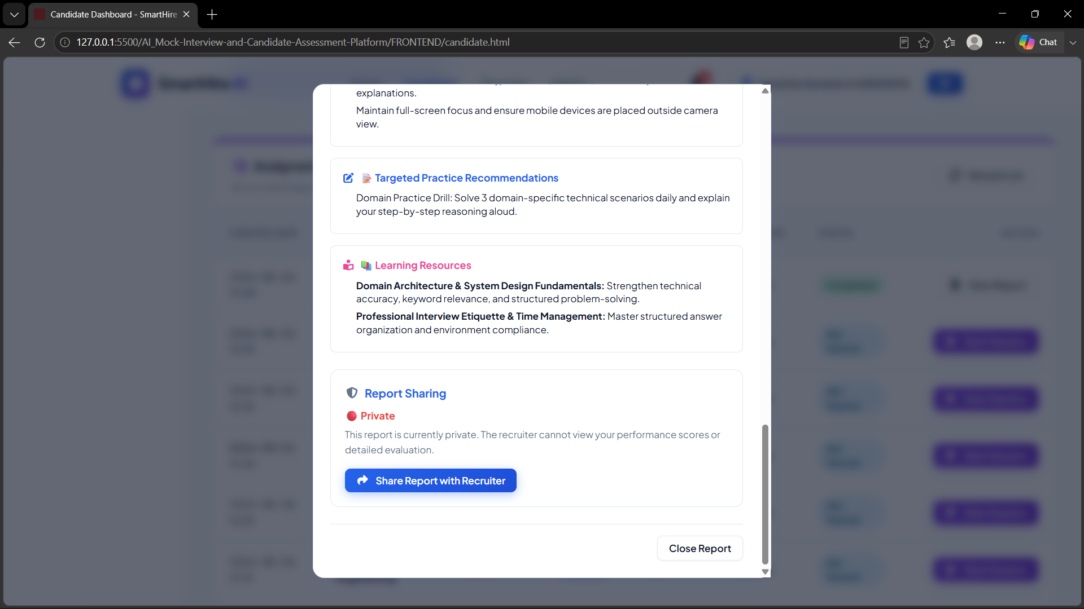
05 • RECRUITER

Discover & Review Candidates
Use the recruiter workspace to monitor interviews and review permitted candidate information.
The recruiter dashboard provides an overview of candidates and interview activity. Recruiters can review candidates, compare performance, support ranking, and shortlist suitable candidates.
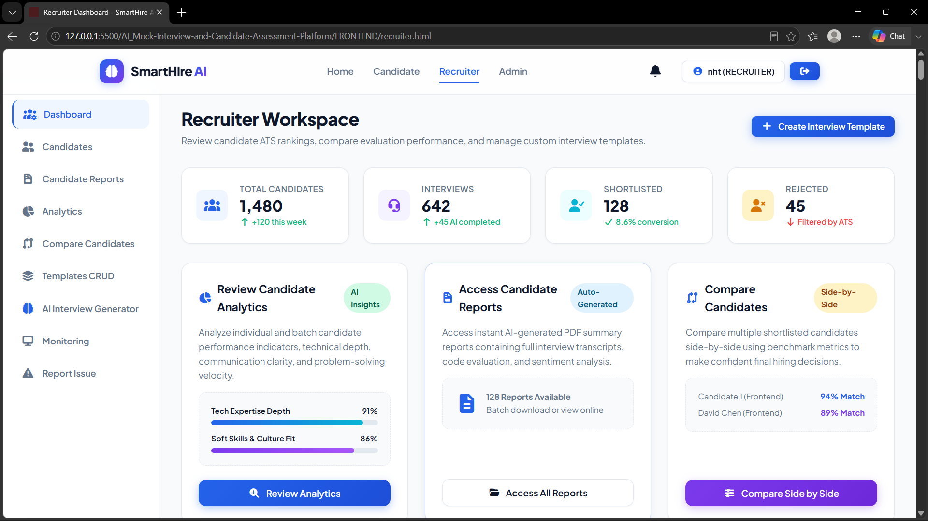

Candidate review workflow
1 | Find the candidate — Open the relevant candidate from the recruiter workspace.
2 | Review interview status — Check the candidate's permitted interview and workflow information.
3 | Review performance — View protected scores or reports only when the required candidate consent is available.
4 | Compare & shortlist — Use available comparison, ranking, and shortlisting functions to support recruitment decisions.

Privacy-aware access
If the candidate has not granted the required consent, protected performance information is not exposed to the recruiter. The interface may indicate that scores are private while still showing permitted workflow information.
SCORES PRIVATE • Candidate consent controls access to protected performance information.

06 • ADMIN & NOTIFICATIONS

Manage, Monitor & Stay Informed
A quick guide to platform oversight and important alerts.

Admin workspace
Administrators can use the admin dashboard to monitor platform activity and review available operational information.
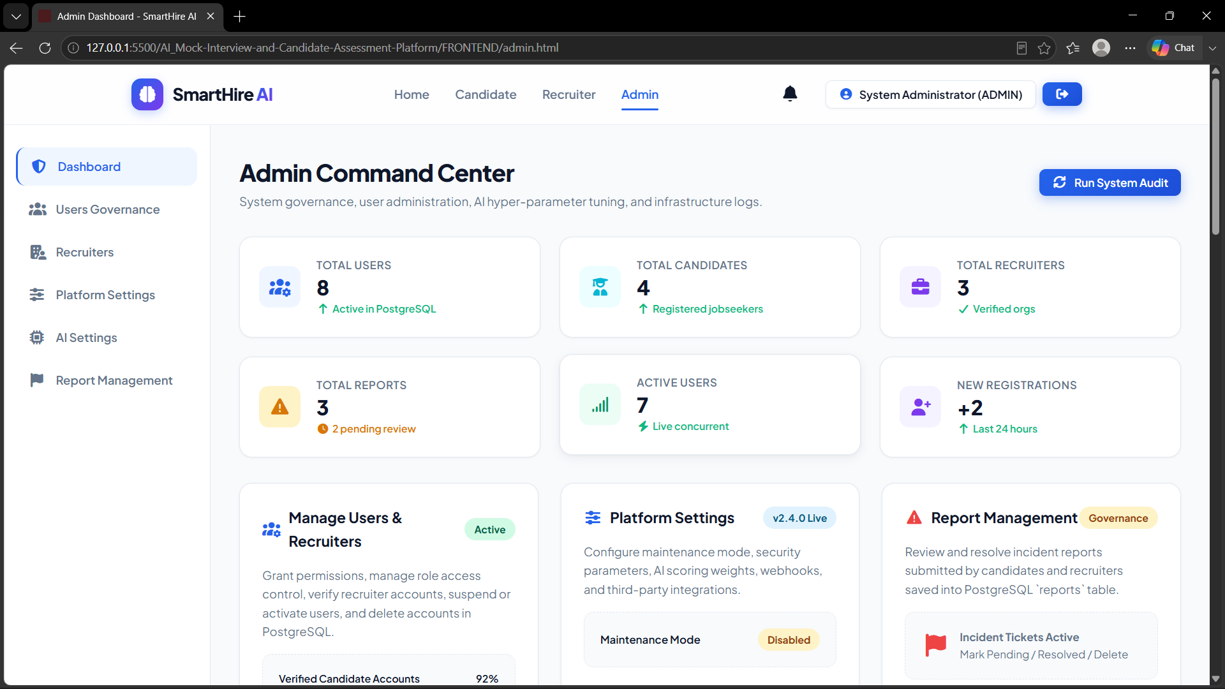
• Monitor users and interview activity.
• Review available platform usage statistics.
• Check system health and operational status.
• Identify issues that require attention.

Notifications
SmartHire can provide notifications that help users keep track of interview-related events and system activity.
INTERVIEW REMINDERS  Helps users keep track of upcoming interview activity. | SESSION & REPORT ALERTS  Provides relevant alerts around sessions, completion, and reports.

07 • QUICK HELP

Need a Little Help?
Common issues and quick actions before contacting support.

Troubleshooting
IF YOU EXPERIENCE… | TRY THIS…
Can't log in | Check the registered email and password, then try again.
Camera unavailable | Allow camera permission in the browser.
Microphone unavailable | Allow microphone permission and check the input device.
Interview won't start | Confirm the interview is assigned/available and refresh the application.
Report keeps loading | Refresh the page and verify the application connection.
PDF won't download | Retry the download and check browser download permissions.
Recruiter can't see scores | The candidate may not have granted consent; protected scores remain private.

Final note
SmartHire AI brings interview practice, intelligent assessment, performance reporting, and recruiter review together in one platform. Follow the on-screen instructions, protect your credentials, and use interview feedback as an opportunity to improve.
THANK YOU FOR USING SMART HIRE AI • Practice with purpose. Interview with confidence.

