Design Document Report

Project Title:
Climate Scope: Visualizing Global Weather Trends and Extreme Events

Design Document:
Climate Scope Dashboard

Name:
Manepalli Naga Sai Sitaram

Internship Program:
Infosys Springboard Virtual Internship

Mentor:
Arya Abhishek

1. Introduction
The Climate Scope Dashboard is an advanced data visualization system developed to analyses and interpret global weather patterns and air quality indicators. With the increasing importance of environmental monitoring, this dashboard provides a centralized platform to explore climate trends, pollution levels, and their interrelationships.
The system transforms raw environmental data into meaningful visual insights, enabling users to understand seasonal variations, identify pollution hotspots, and evaluate the impact of atmospheric conditions on air quality. The dashboard is designed with a user-friendly interface, allowing both technical and non-technical users to interact with the data efficiently.

2. Problem Statement
Environmental data is often large, complex, and difficult to interpret in raw form. Traditional methods of analysis do not provide clear insights into how weather conditions and pollution levels interact over time and across regions.
There is a need for:
- A unified platform to visualize climate and air quality data
- Easy identification of trends and anomalies
- Comparative analysis across locations and time periods
- Actionable insights for environmental awareness
The Climate Scope Dashboard addresses these challenges by providing interactive and visually intuitive representations of environmental data.
3. Objectives
The primary objectives of this project are:
- To design an interactive dashboard for analyzing global climate data
- To monitor air quality using multiple pollutant indicators
- To study seasonal and monthly variations in temperature and rainfall
- To identify highly polluted cities and regions
- To analyze relationships between weather conditions and pollution levels
- To provide a clear and structured summary of environmental insights
4. Data Description
The dataset used for this project is sourced from a Global Weather Repository. It consists of structured data containing multiple environmental parameters.
Key Attributes:
- Temperature Metrics: Minimum, Maximum, and Average Temperature
- Humidity: Percentage of moisture in the air
- Wind: Wind speed and direction indicators
- Rainfall: Rain occurrence and percentage distribution
- Air Quality Index (AQI): Overall air quality indicator
- Pollutants: PM2.5, PM10, CO, NO2, and Ozone levels
- Location Details: Country, city, and geographical identifiers
- Time Dimension: Month-wise data for trend analysis
Data Processing:
- Data cleaning to remove inconsistencies and missing values
- Data transformation for aggregation and analysis
- Creation of calculated measures using DAX
- Structuring relationships between different data tables

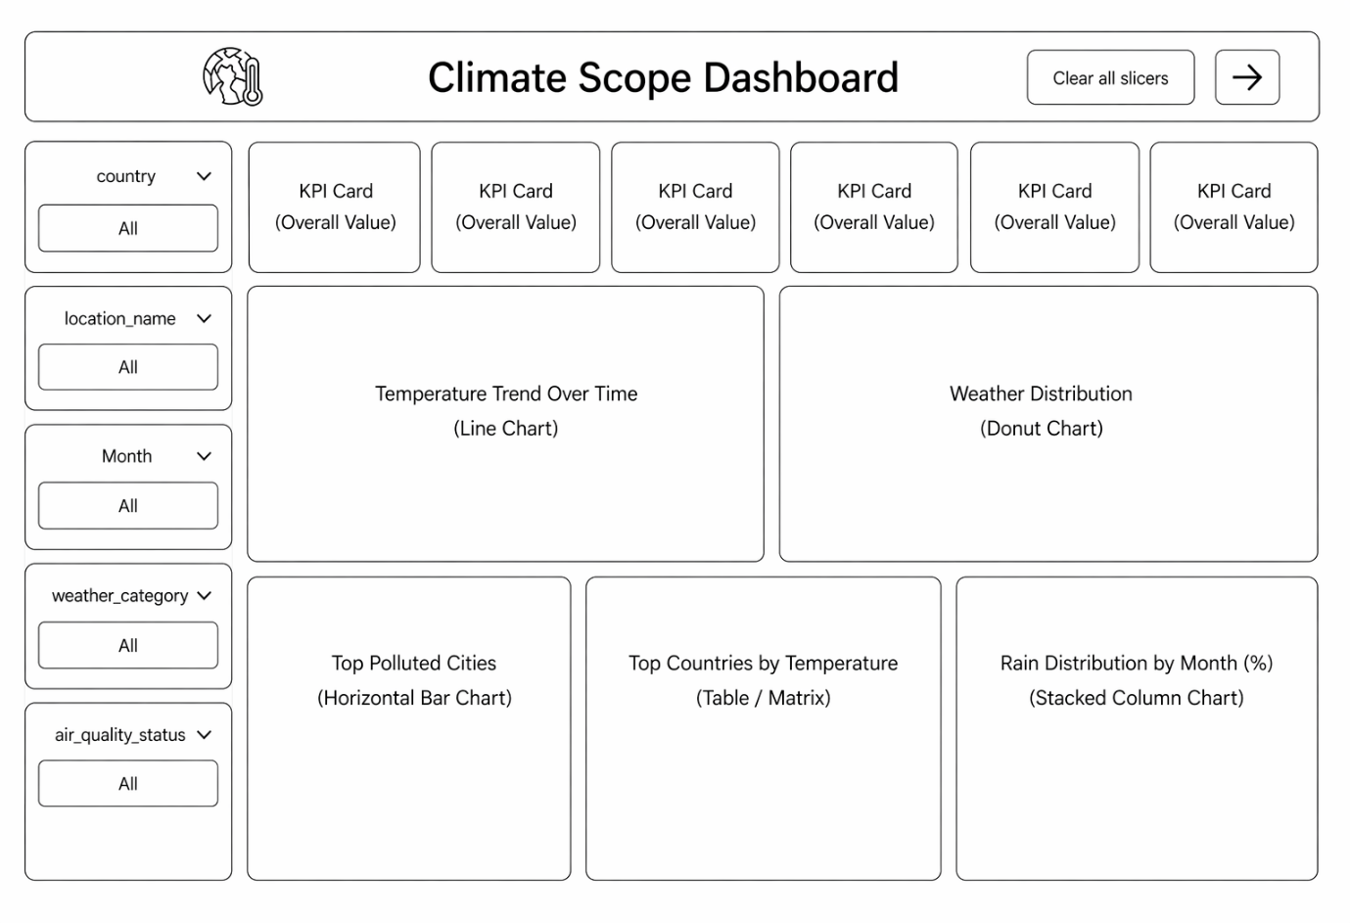
Page1: Overview Dashboard
The Overview page provides a high-level summary of the entire dataset, allowing users to quickly understand key environmental metrics.
Key Performance Indicators (KPIs):
- Average PM2.5: Indicates fine particulate pollution levels
- Average Humidity: Reflects atmospheric moisture
- Average Temperature: Represents general climate conditions
- Rain Percentage: Shows rainfall distribution
- Average Wind Speed: Indicates atmospheric movement
- Average AQI: Represents overall air quality
Visual Components:
- Temperature Trend Over Time: Displays how temperature changes across months, highlighting seasonal patterns
- Weather Distribution Chart: Shows the proportion of weather categories such as cloudy, clear, and sunny
- Top Polluted Cities: Identifies cities with the highest pollution scores
- Rain Distribution by Month: Illustrates how rainfall varies across different months

Filters (Slicers):
- Country
- Location Name
- Month
- Weather Category
- Air Quality Status
Purpose:
This page acts as a summary dashboard, enabling users to quickly assess environmental conditions and navigate to detailed analysis.
The purpose of this Climate Scope Dashboard is to provide a clear and interactive overview of weather and air quality data across different locations and time periods. It helps users quickly understand key environmental metrics such as average temperature, humidity, PM2.5 levels, rainfall, wind speed, and air quality index (AQI). By using filters like country, location, month, weather category, and air quality status, users can explore specific trends and patterns. The dashboard also highlights insights through visualizations such as temperature trends over time, weather distribution, rain patterns, and the most polluted cities, enabling better analysis, comparison, and decision-making related to climate conditions.

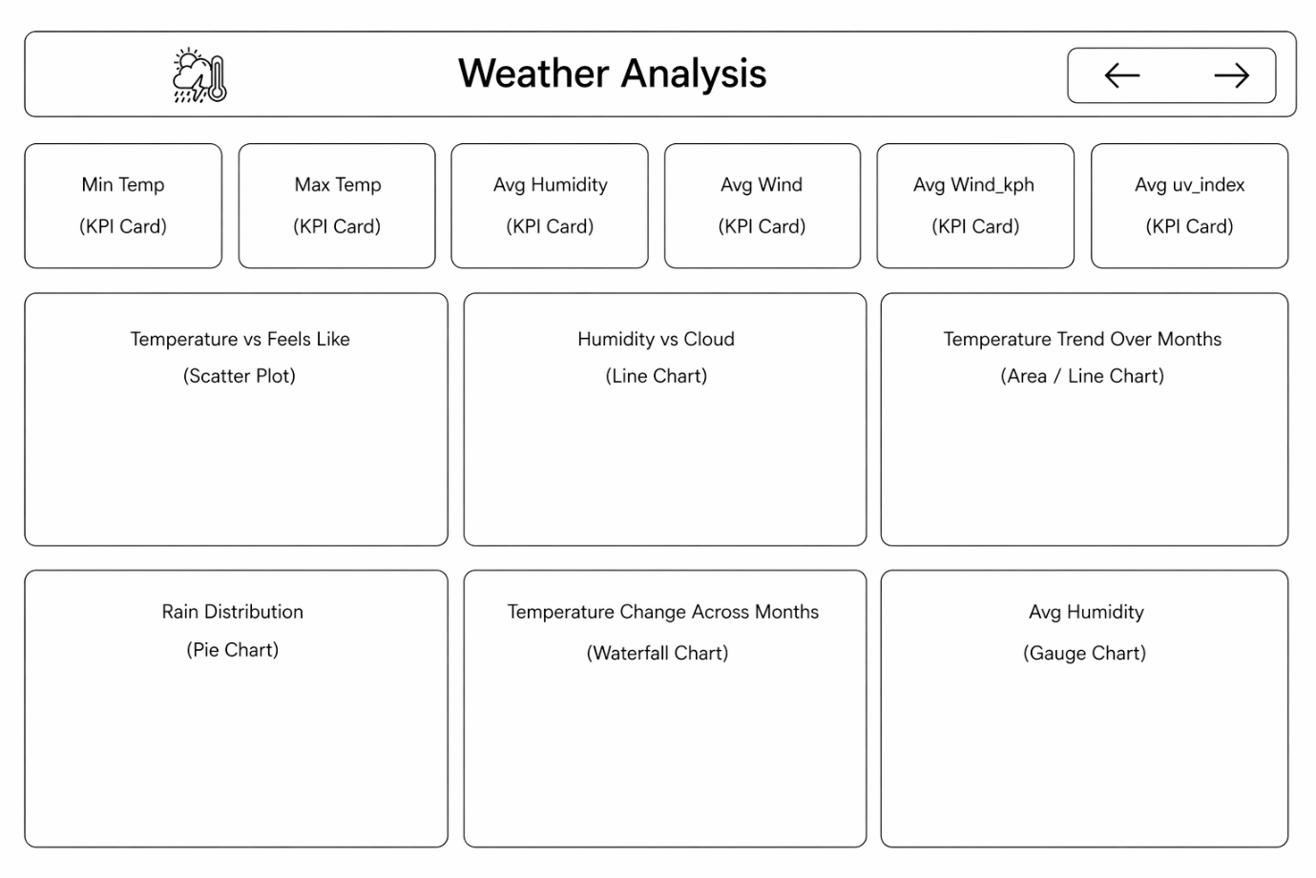

Page2 : Weather Analysis Dashboard
This page focuses on analyzing weather patterns and their variations over time.
Visual Components:
- Temperature vs Feels Like:
Shows the relationship between actual temperature and perceived temperature, helping to understand human comfort levels.
- Humidity vs Cloud Conditions:
Demonstrates how humidity levels vary with different weather conditions such as clear, cloudy, and sunny.
- Temperature Trend Over Months:
Displays seasonal temperature changes, identifying peak and low temperature periods.
- Rain Distribution:
Shows the proportion of rainy versus non-rainy conditions.
- Temperature Change Across Months:
Highlights incremental increases and decreases in temperature over time.
- Average Humidity Gauge:
Provides a quick visual indicator of overall humidity levels.
Insights:
- Temperature follows a cyclical pattern with peaks during mid-year
- Humidity increases with cloud coverage
- Rainfall shows moderate variation across months
- Weather conditions remain relatively stable over time
Purpose:
This page helps in understanding climate behavior and seasonal changes in weather conditions.
The purpose of this Weather Analysis dashboard is to provide a detailed and focused examination of key weather conditions and their relationships over time. It helps users monitor important metrics such as minimum and maximum temperature, average humidity, wind speed, and UV index through KPI cards for quick insights. The dashboard also enables deeper analysis by visualizing relationships like temperature versus “feels like” conditions, humidity versus cloud cover, and monthly temperature trends. Additionally, it highlights rainfall patterns, temperature variations across months, and overall humidity levels using different chart types. This allows users to better understand weather behavior, identify patterns, and make informed decisions based on climatic changes.

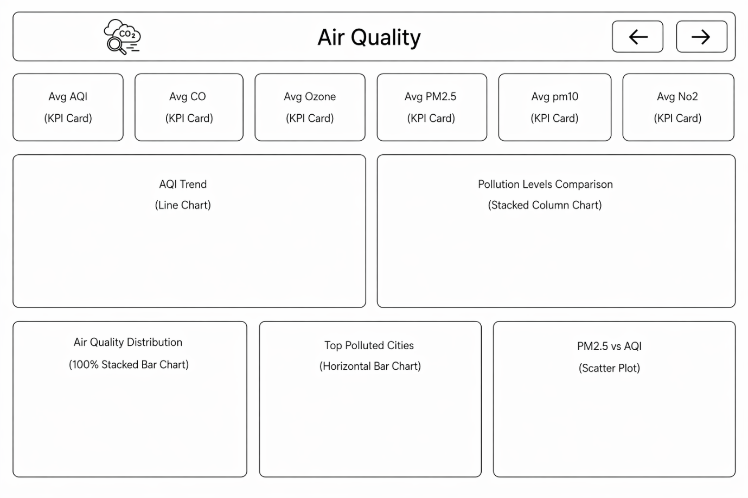
Page 3 : Air Quality Dashboard
This section provides a detailed analysis of air pollution and its contributing factors.
Key Metrics:
- Average AQI
- Average CO
- Average Ozone
- Average PM2.5
- Average PM10
- Average NO2
Visual Components:
- AQI Trend:
Shows how air quality changes over time.
- Pollution Levels Comparison:
Compares different pollutants to understand their contribution to overall air quality.
- Air Quality Distribution:
Categorizes air quality into Good, Moderate, and Unhealthy levels.
- Top Polluted Cities:
Identifies cities with consistently high pollution levels.
- PM2.5 vs AQI Scatter Plot:
Shows the strong relationship between particulate matter and AQI.

Insights:
- PM2.5 is a major contributor to AQI
- Pollution levels vary significantly across regions
- Urban areas show higher pollution concentrations
- Air quality often falls in moderate to unhealthy categories
Purpose:
This page enables detailed monitoring of pollution trends and helps identify critical areas requiring attention.

The purpose of this Air Quality dashboard is to provide a comprehensive analysis of pollution levels and air quality conditions across different locations and time periods. It allows users to monitor key indicators such as AQI, carbon monoxide (CO), ozone, PM2.5, PM10, and nitrogen dioxide (NO₂) through KPI cards for quick understanding. The dashboard also presents trends in AQI over time, compares different pollutant levels, and shows how air quality is distributed across regions. Additionally, it highlights the most polluted cities and explores the relationship between PM2.5 and AQI using visualizations. This helps users identify pollution patterns, assess environmental risks, and support informed decisions for improving air quality and public health.

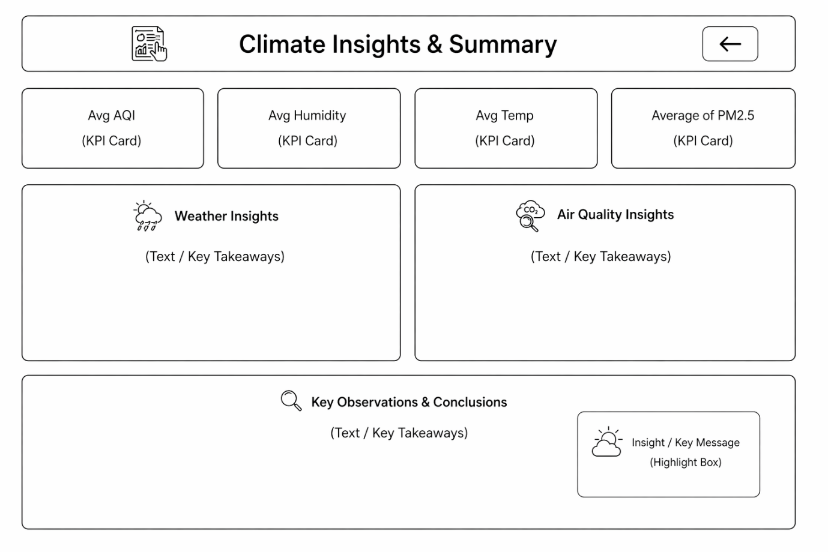
Page 4: Climate Insights and Summary
This page consolidates all findings into meaningful insights and conclusions.
Weather Insights:
- Temperature shows clear seasonal variation
- Humidity increases with atmospheric conditions
- Rainfall is moderately distributed
- Wind speed remains stable
Air Quality Insights:
- Higher pollutant levels increase AQI
- Pollutants significantly impact environmental conditions
- Pollution is concentrated in specific regions
Key Observations:
- Strong correlation between PM2.5 and AQI
- Seasonal changes influence environmental conditions
- Pollution levels are higher in densely populated areas
Conclusion Statement:
Weather patterns are cyclical and predictable, while air quality is largely influenced by human activities and pollutant concentration.
Purpose:
This page provides a summarized interpretation of all analyses, helping users quickly understand the overall findings.

7. Design Principles
The dashboard is designed based on the following principles:
- Simplicity and clarity in layout
- Consistent color theme aligned with environmental context
- Logical grouping of related visuals
- Interactive filtering for better exploration
- Balanced use of charts and KPIs
- Clear labeling and titles for all visuals

8. Limitations
- The analysis is dependent on the available dataset
- Real-time data updates are not included
- Some environmental factors may not be captured in the dataset
- Regional variations may require additional data sources

9. Future Enhancements
- Integration of real-time weather and pollution data
- Inclusion of predictive analytics using machine learning
- Addition of geographic map visualizations
- Advanced filtering and drill-down capabilities
- Mobile-friendly dashboard design

10. Conclusion
The Climate Scope Dashboard provides a comprehensive platform for analyzing weather and air quality data. By combining multiple environmental parameters into a single interactive system, it enables users to explore trends, identify patterns, and derive actionable insights.
The dashboard not only enhances understanding of climate behavior but also supports informed decision-making for environmental monitoring and sustainability.

