Face Recognition Based Attendance System
Project Documentation

Introduction
Attendance management is an essential activity in educational institutions and organizations. Traditional methods such as manual roll calls or paper registers are time-consuming, error-prone, and allow proxy attendance. With advancements in computer vision and machine learning, face recognition has emerged as a reliable and contactless solution.
This project implements a Face Recognition Based Attendance System that automatically identifies individuals using a camera and records their attendance digitally.

What is the Project?
The Face Recognition Based Attendance System is an automated application that uses a camera to:
- Detect human faces
- Recognize registered individuals
- Mark attendance automatically with date and time
- The system eliminates manual intervention and improves accuracy and efficiency.
- It provides an interactive interface where users can register faces, train the model, and take attendance.

Code Structure

Face-Recognition-Attendance/
│
├── streamlit_app.py # Streamlit web interface
├── dataset_creator.py # Captures face images
├── trainer.py # Trains the face recognition model
├── recognizer.py # Recognizes faces & marks attendance
├── haarcascade_frontalface_default.xml
├── attendance.csv # Attendance log file
├── requirements.txt
└── dataset/ # Stored face images (local)

Code Explanation (Module-wise)

🔹 dataset_creator.py
Reminder to capture 100 face images per user
Converts images to grayscale
Stores images in the dataset folder

🔹 trainer.py
Reads images from the dataset
Extracts student IDs
Trains the LBPH face recognition model
Saves the trained model

🔹 recognizer.py
Detects faces using Haar Cascade
Recognizes faces using LBPH
Marks attendance with timestamp in CSV file

🔹 streamlit_app.py
Provides user interface
Navigation panel for Register, Train, Attendance
Displays face gallery and results interactively

Output Screenshots

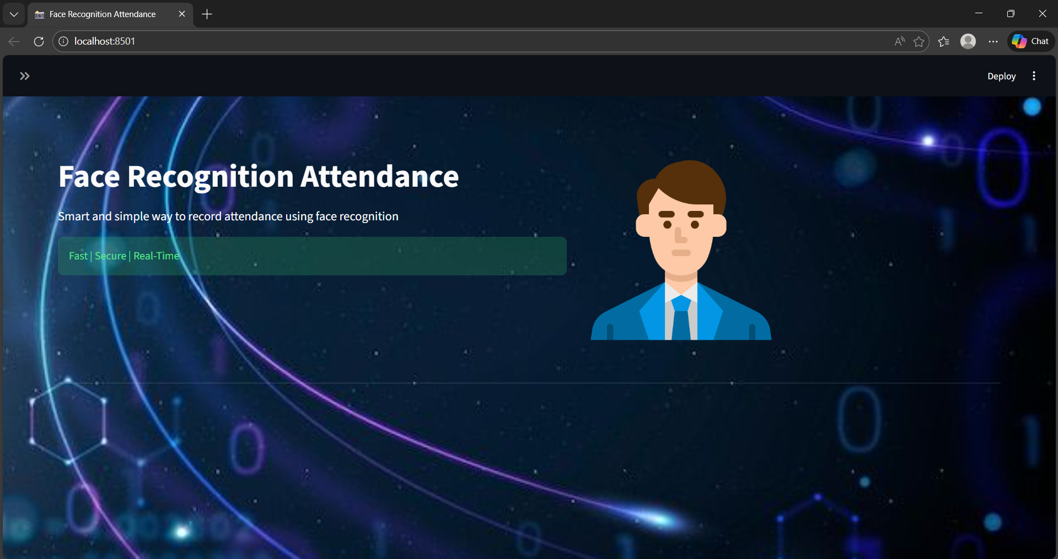
Home Page of Application

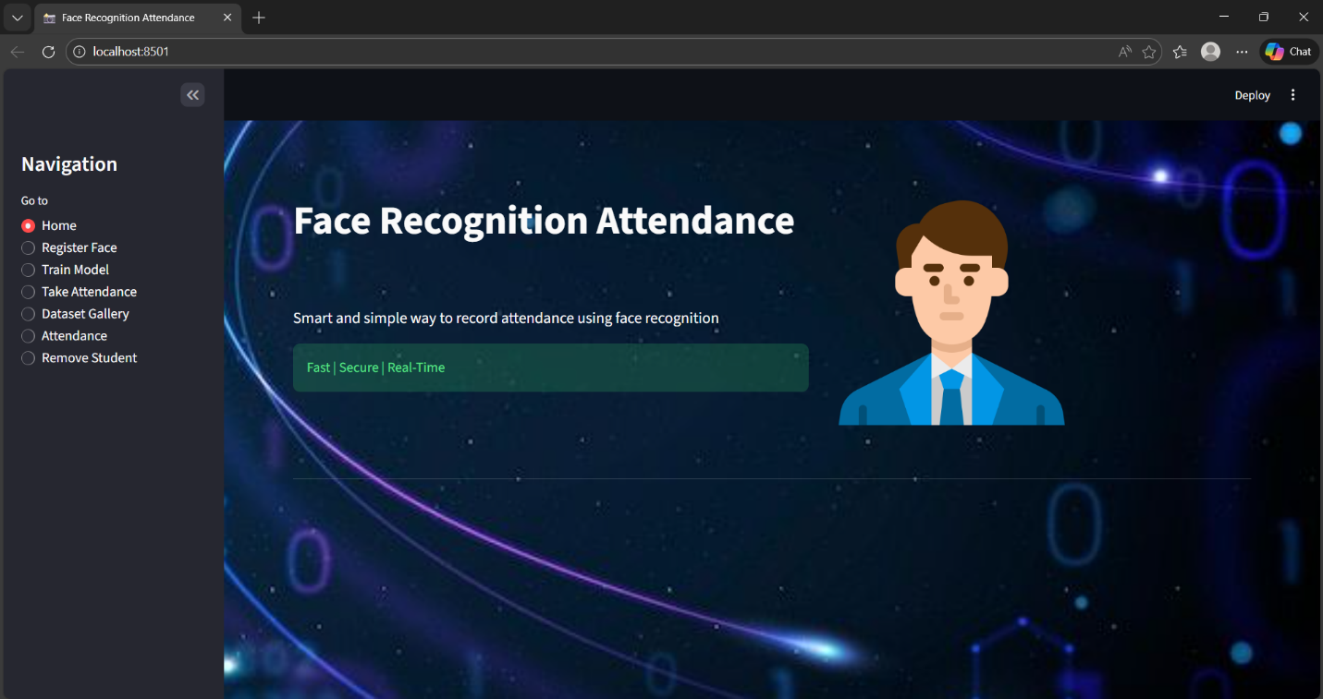
Side Navigation Panel

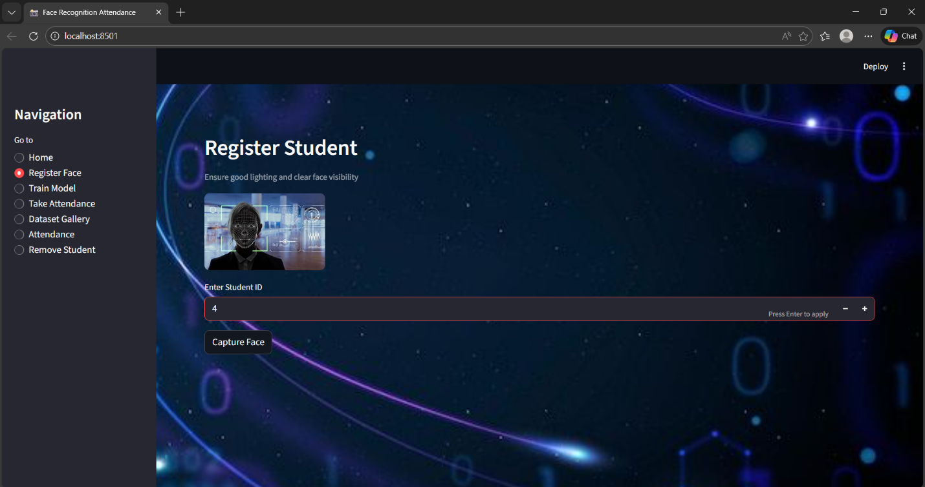
Face Registration Screen

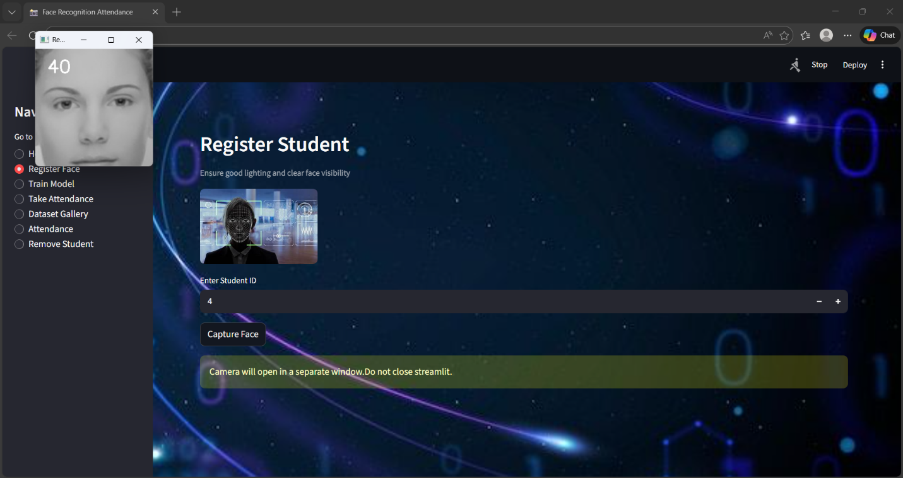
Capturing Face

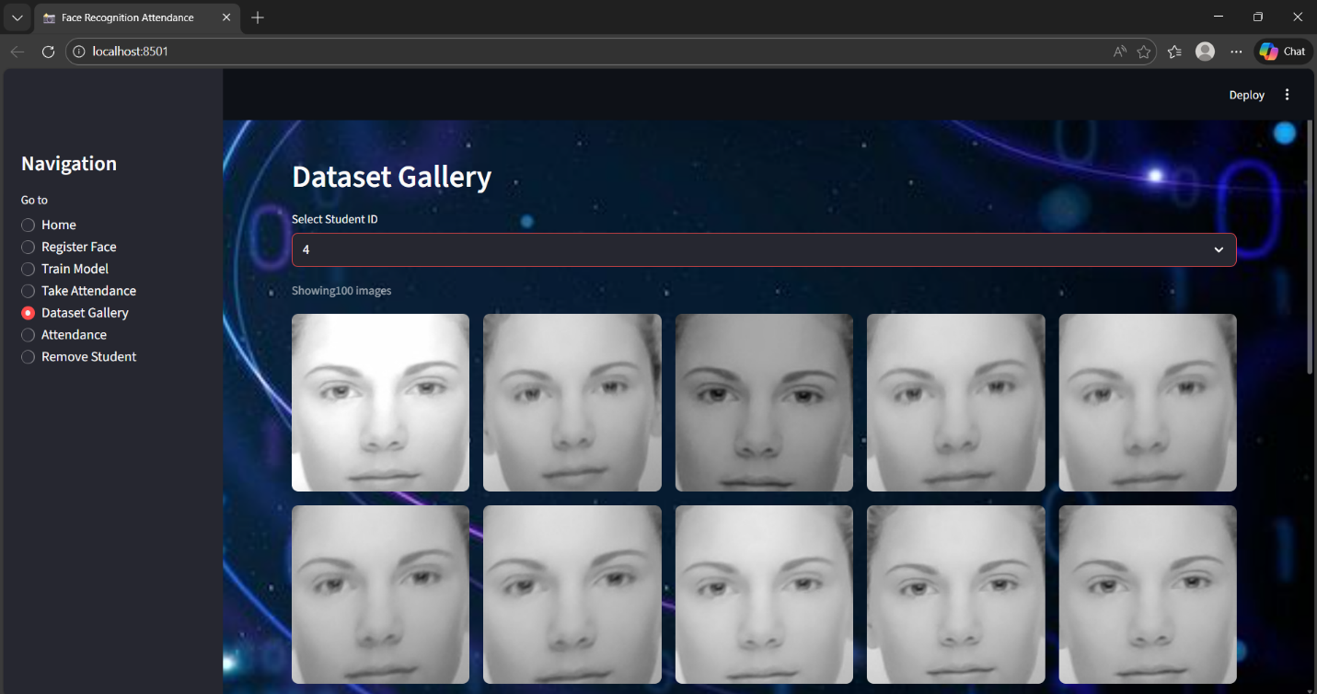
Dataset Gallery View

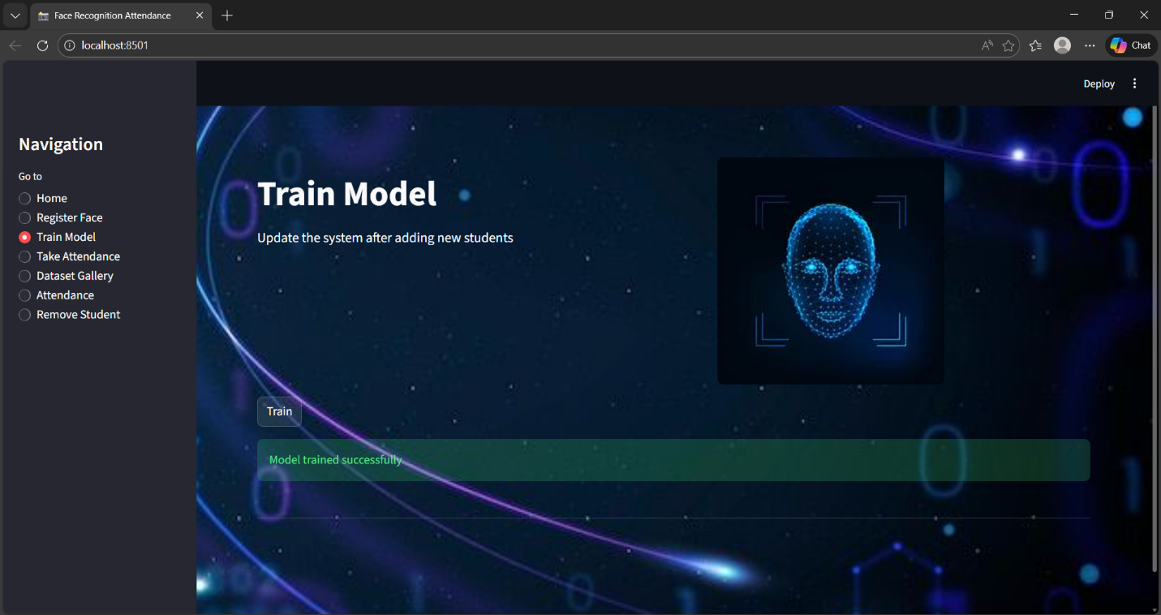
Training Completed Message
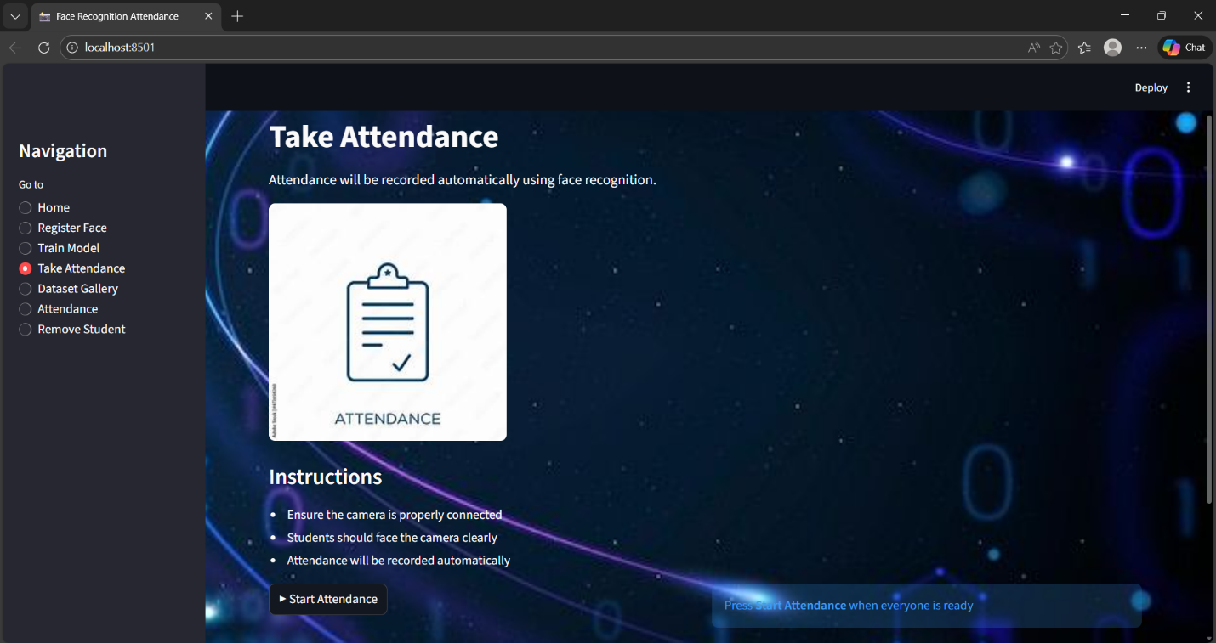
Take Attendance Screen

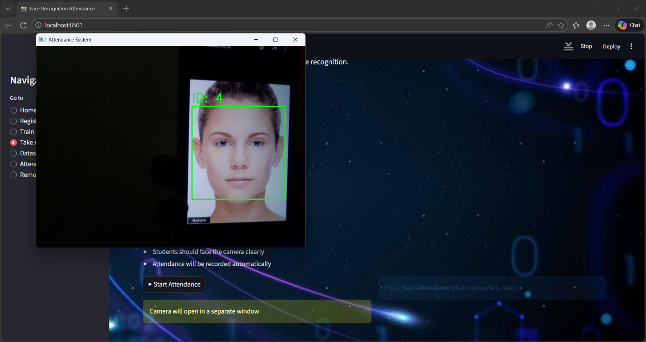
Live Face Recognition

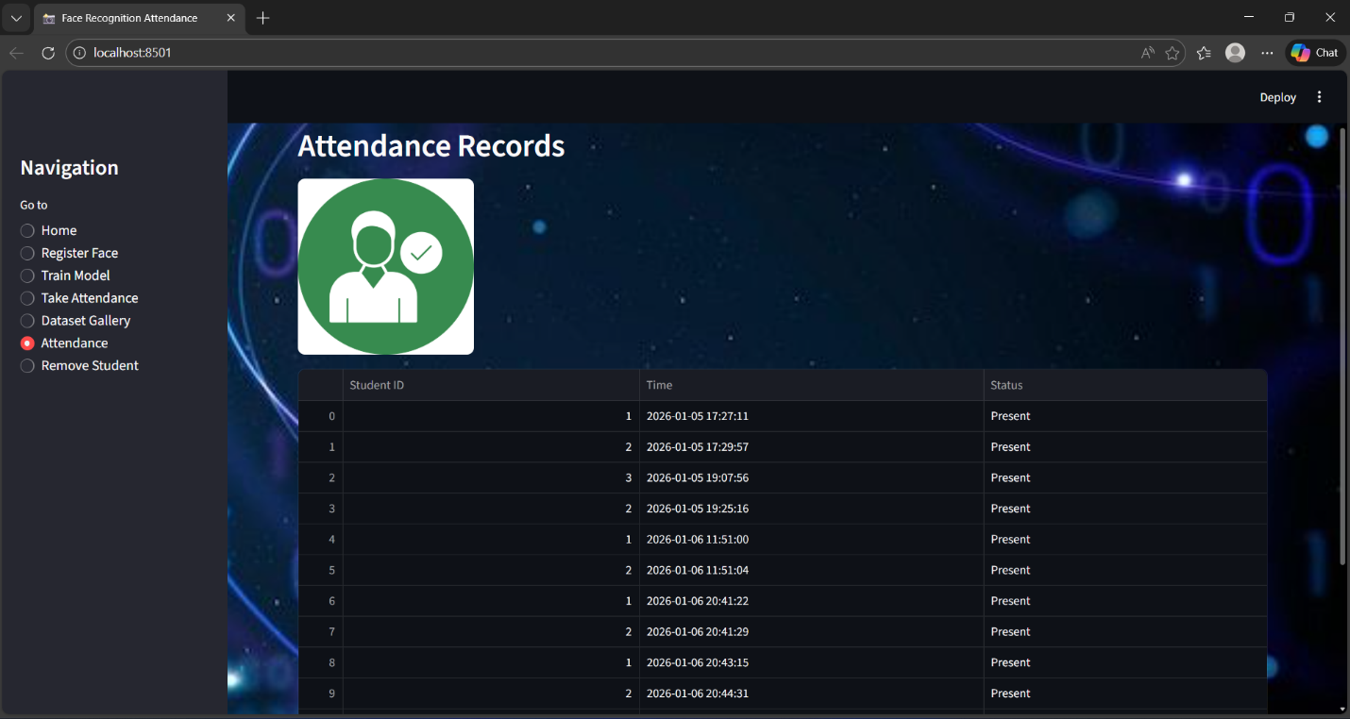
Attendance Record

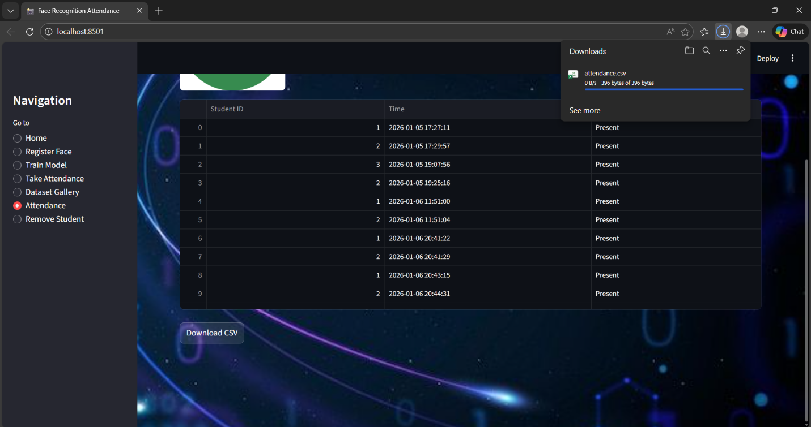
Attendance CSV File Download
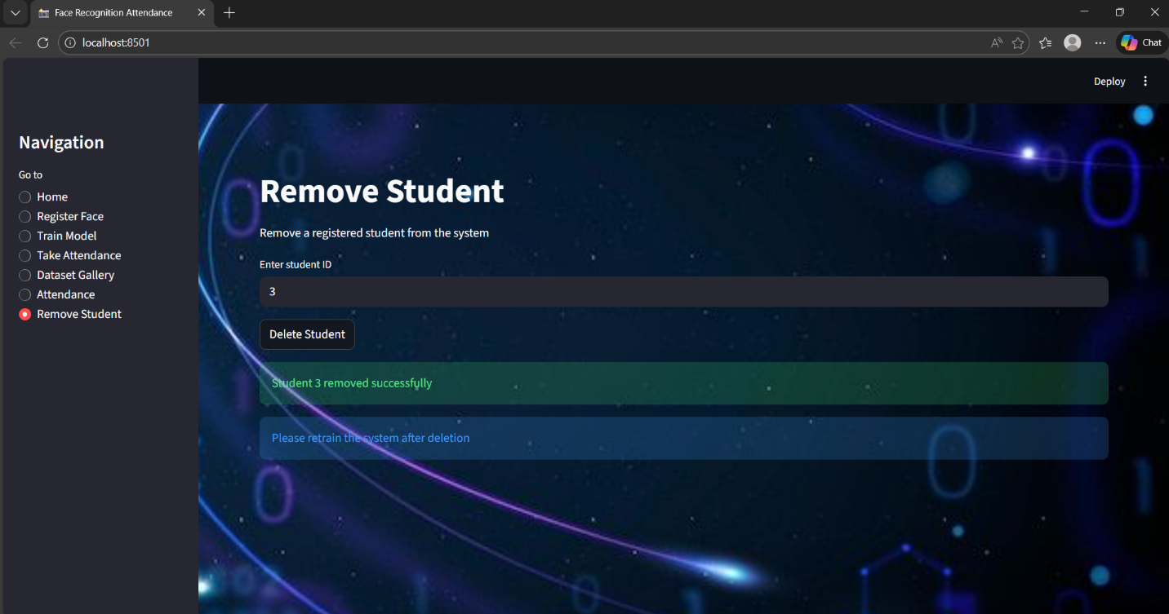
Deleting data

Problems Faced
1.Poor face detection under low lighting
2.Camera access permission issues
3.Dependency conflicts (OpenCV & protobuf)
4.Dataset images not loading correctly in gallery
5.Streamlit black screen during run

Problems Rectified
1.Improved lighting and camera positioning
2.Installed correct OpenCV contrib version
3.Fixed dataset folder structure
4.Used sorted image loading for gallery
5.Debugged Streamlit layout and navigation

Conclusion
This project successfully demonstrates the use of face recognition technology for automated attendance management. The system reduces manual effort, improves accuracy, and offers real-world applicability in educational and organizational environments.
The project enhanced understanding of computer vision, machine learning, and web application development. With further improvements such as cloud integration and deep learning models, this system can be deployed at a larger scale.
This internship project provided hands-on experience in building intelligent systems and applying theoretical concepts to solve real-world problems.

