DASHBOARD TESTING REPORT
Hospital Operations & Patient Analytics Dashboard
Module | Module 7: Testing and Validation
Milestone | Milestone 4: Testing and Delivery – Weeks 7–8
Testing Status | 97.5 %PASS WITH MINOR FIXES
KPI Validation Status | All previously validated KPIs match; Total Inventory requires revalidation

1. Objective
The objective of Module 7 is to validate the accuracy, reliability and usability of the final Tableau hospital dashboards. Testing covered KPI calculations, healthcare metrics, patient-flow analytics, dashboard interactions, filters, navigation, visualizations and key data-quality checks.

2. Dashboards Tested
- Hospital Overview
- Patient Flow
- Department Analytics
- Resource Utilization

3. Testing Methodology
Independent validation was performed using the cleaned hospital dataset and Pandas calculations. The independently calculated results were compared with values displayed in Tableau. Dashboard filters, cross-interactions and navigation were also tested manually.

4. Hospital Overview Dashboard
The Hospital Overview dashboard was checked for the main hospital-level KPIs, trends, state-level admissions and readmission analysis.
- Total Admissions: 10,000
- Total Revenue: ₹2,496,841,664 (displayed approximately as ₹2.50B)
- Average LOS: 78.7819 days (displayed as 79)
- Readmission Rate: 49.87%
- Efficiency Score: 47.90%
- Total Departments: 10

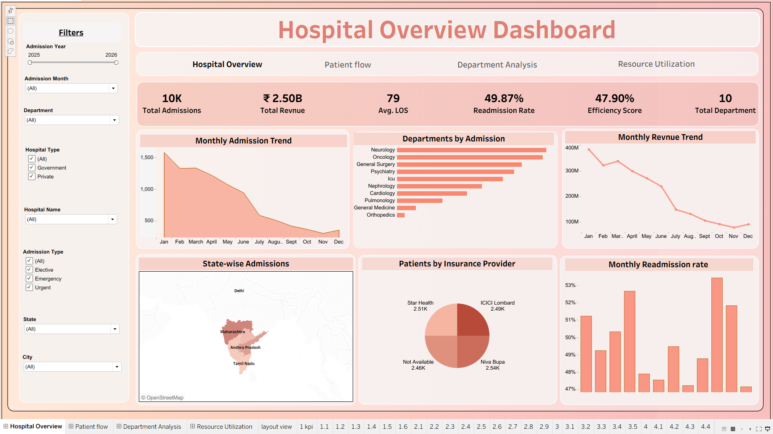
Figure 1. Hospital Overview Dashboard

5. KPI Validation
Major KPI values were independently calculated using Pandas and compared with Tableau. Rounding differences in displayed values were accepted where the underlying values matched. The main KPI table below remains validated; the Resource Utilization Total Inventory KPI is flagged separately in Section 9 for definition/value revalidation.
KPI | Independent Result | Tableau Result | Difference | Status
Total Admissions | 10,000 | 10,000 | 0 | PASS
Total Revenue | ₹2,496,841,664 | ≈ ₹2.50B | Display rounding | PASS
Average LOS | 78.7819 days | 79 days | Display rounding | PASS
Average Age | 45.3039 years | 45 years | Display rounding | PASS
Readmission Rate | 49.87% | 49.87% | 0 | PASS
Efficiency Score | 47.8987% | 47.90% | ≈0.0013 pp | PASS
Staff Utilization | 57.92486% | 57.92% | Display rounding | PASS
Bed Occupancy | 36.757% | 36.76% | Display rounding | PASS
Equipment Utilization | 33.55% | 33.55% | 0 | PASS
Transfer Rate | 17.60% | 17.60% | 0 | PASS
Average Daily Admissions | 19.0476 | 19.05 | Display rounding | PASS
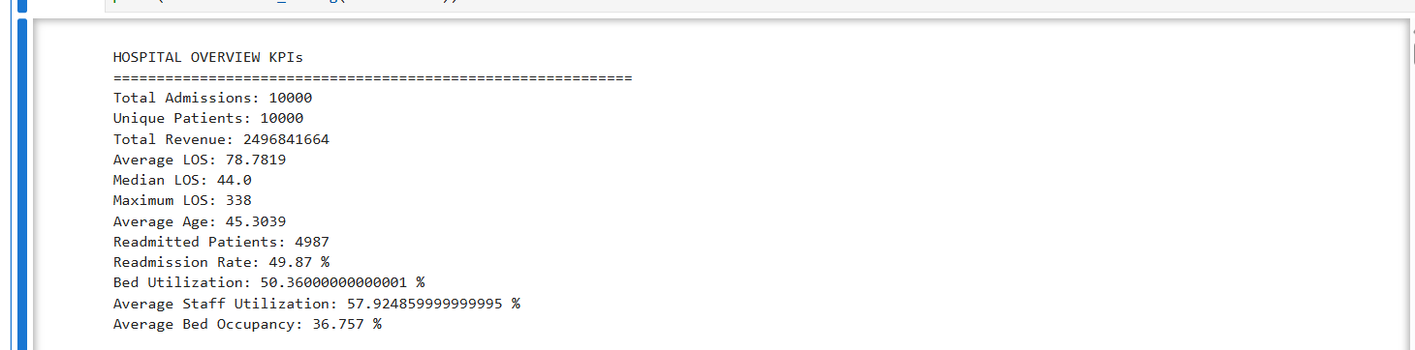
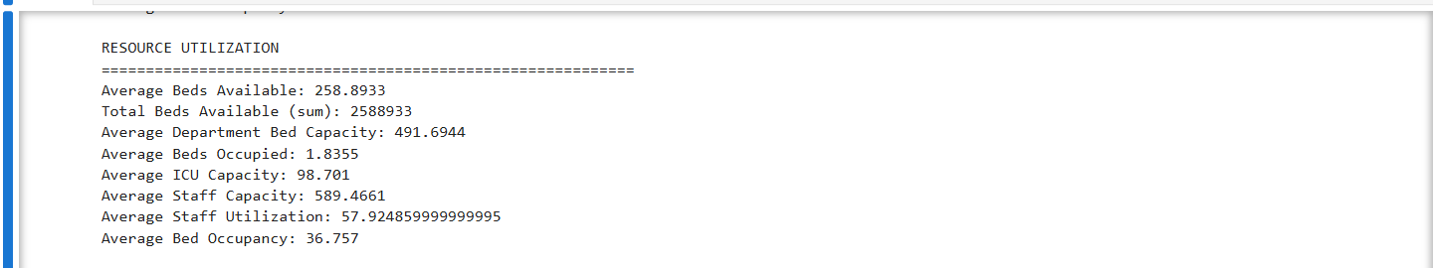
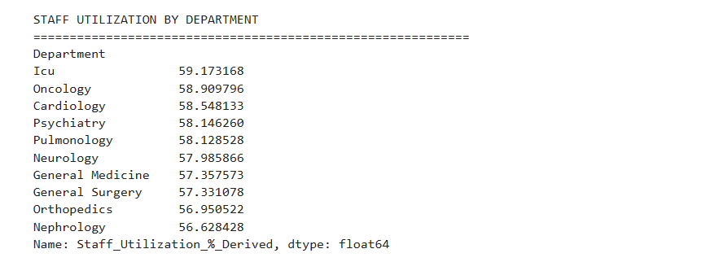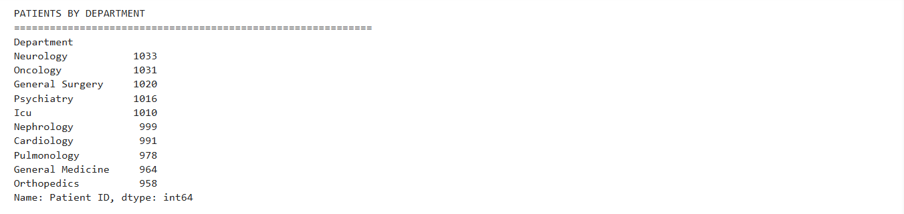
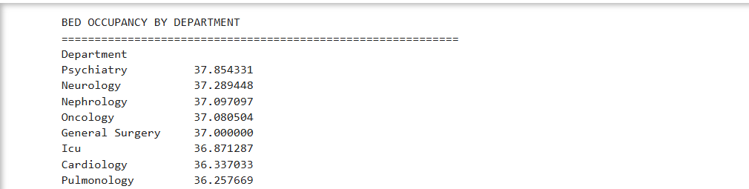
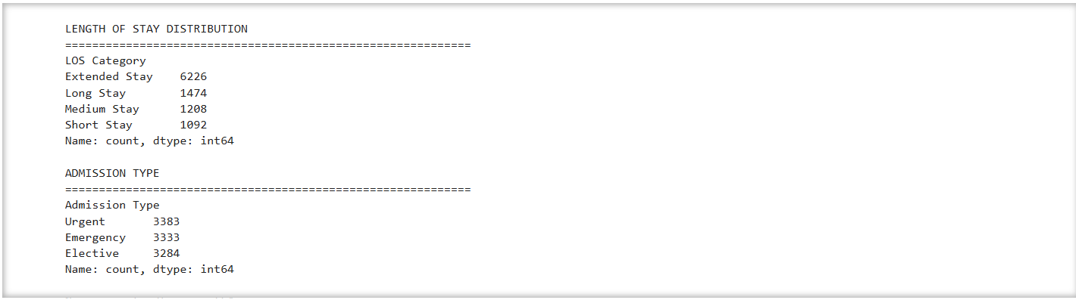
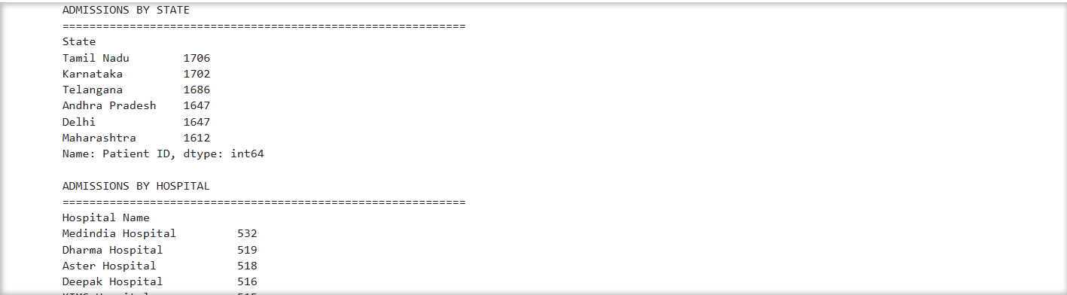
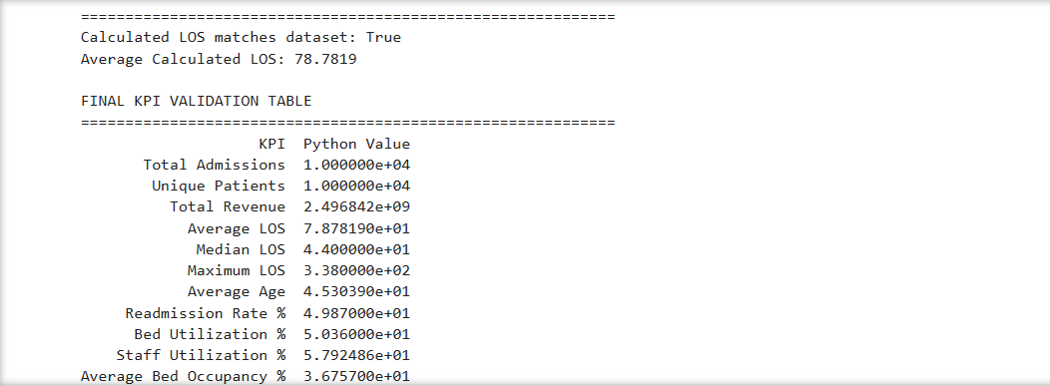
Figure 2. Independent Python/Pandas KPI Validation Output

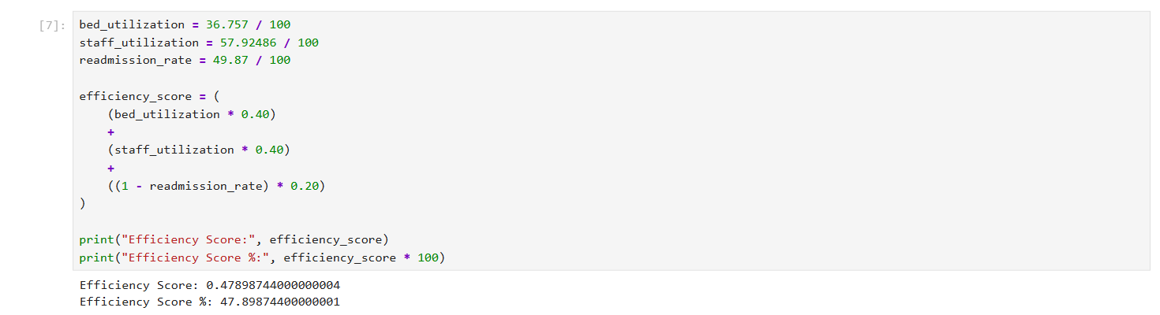
Figure 3. Efficiency Score Calculation / Validation

6. Healthcare Metrics Validation
Metric | Validation Result | Status
Length of Stay | Average 78.7819 days; median 44 days; maximum 338 days | PASS
Readmission Rate | 49.87% | PASS
Bed Occupancy Rate | 36.757%, displayed as 36.76% | PASS
Staff Utilization | 57.92486%, displayed as 57.92% | PASS
Transfer Rate | 17.60% | PASS
Equipment Utilization | 33.55% | PASS
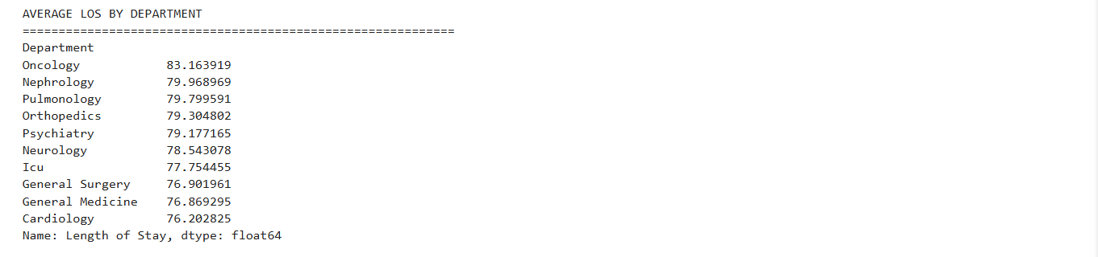
Figure 4. Length of Stay Validation Output

7. Patient Flow Validation
- Total admissions: 10,000.
- Patients transferred: 1,760; transfer rate: 17.60%.
- Average daily admissions: 19.0476, displayed as 19.05.
- Admission type distribution: Urgent 3,383; Emergency 3,333; Elective 3,284.
- LOS distribution: Short 1,092; Medium 1,208; Long 1,474; Extended 6,226.
- Monthly admission and discharge trends were checked against independent date aggregation.
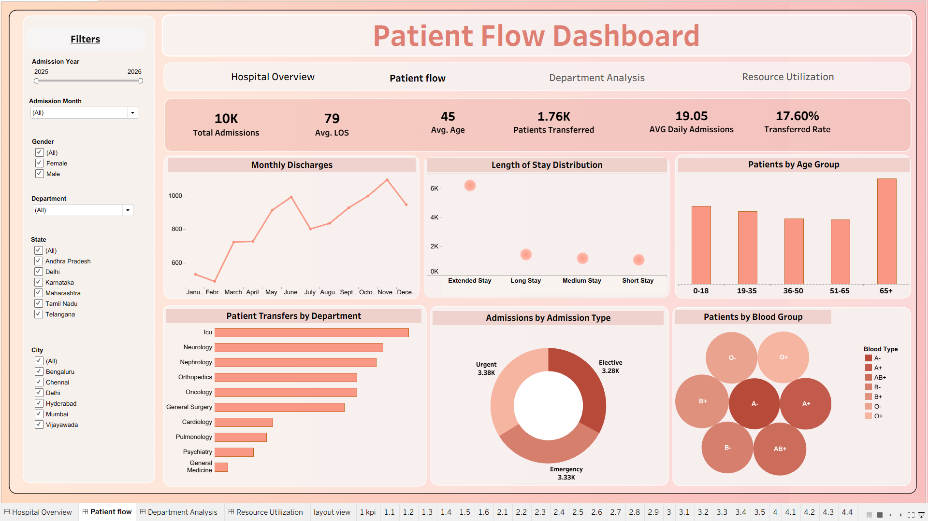
Figure 5. Patient Flow Dashboard

8. Department Analytics Validation
Department-level patient volume, average LOS, staff utilization and test-result distributions were cross-checked against independent aggregations.
- Total departments: 10.
- Average doctors: approximately 4.
- Maximum nurses: 50.
- Average department bed capacity: 491.6944, displayed as 492. The dashboard KPI should be labelled 'Avg. Department Bed Capacity'.
- Department charts and values were validated. Minor naming cleanup remains: use 'Department Analytics' consistently in the dashboard title and navigation.
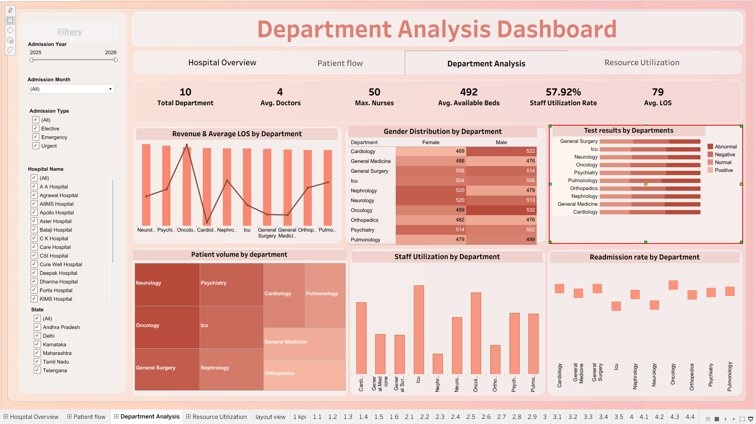
Figure 6. Department Analytics Dashboard

9. Resource Utilization Validation
- Bed occupancy rate: 36.757%, displayed as 36.76%. Use the label 'Bed Occupancy Rate' for consistency with the validated metric.
- Staff utilization rate: 57.92486%, displayed as 57.92%.
- Average ICU capacity: 98.701, displayed as 99.
- Equipment utilization: 33.55%.
- Total inventory: testing report/checklist value = 23; current dashboard screenshot = 132,620. The KPI definition/value requires revalidation before final submission.
- Resource visuals were validated except for the Total Inventory KPI review and minor label/wording cleanup.
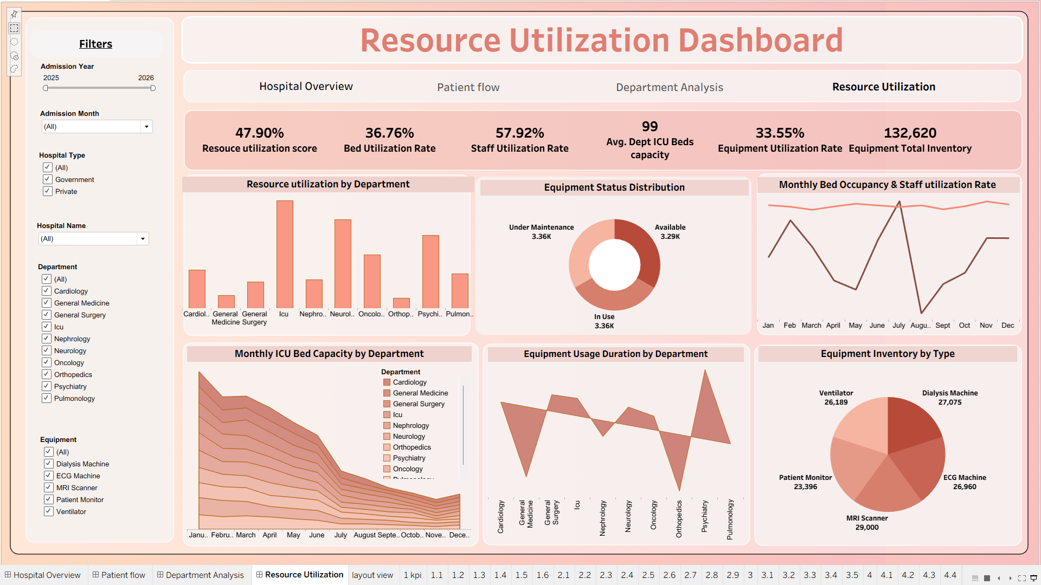
Figure 7. Resource Utilization Dashboard

10. Dashboard Interaction Testing
Test | Status | Observation
State Filter | PASS | Relevant visuals update correctly.
Hospital Filter | PASS | Relevant visuals update correctly.
City Filter | PASS | Relevant visuals update correctly.
Department Filter | PASS | Relevant visuals update correctly.
Chart Cross-Filtering | PASS | Linked visuals respond correctly.
Dashboard Navigation | PASS - MINOR FIX | Navigation works; use 'Department Analytics' consistently in the navigation tab and dashboard title.
Tooltips / Labels | PASS - MINOR FIX | Values are readable; minor label, wording and capitalization cleanup is required.
Full-screen / Presentation Fit | PASS | Dashboard remains readable and fitted.

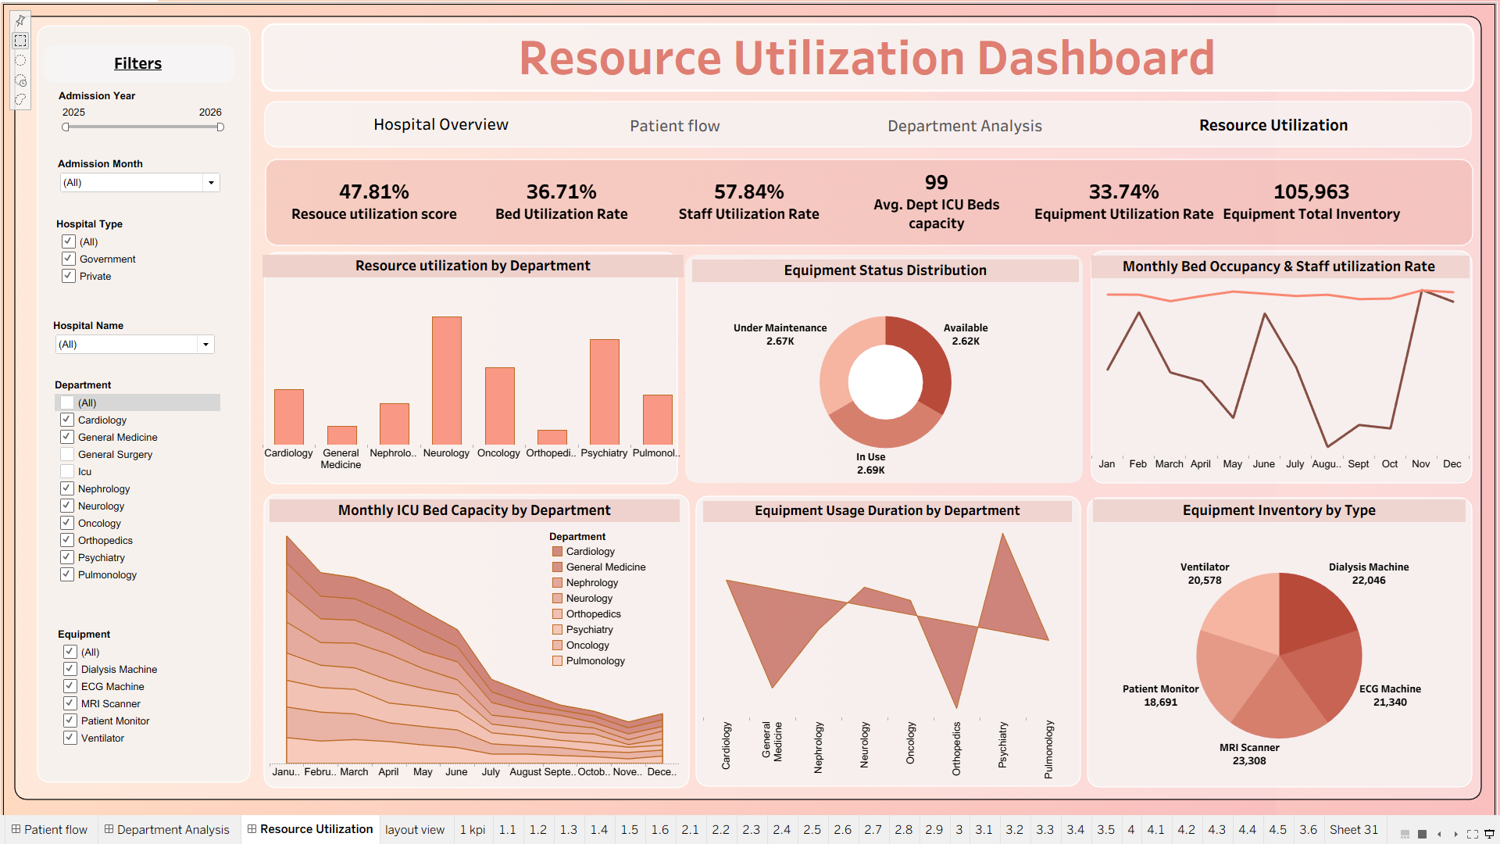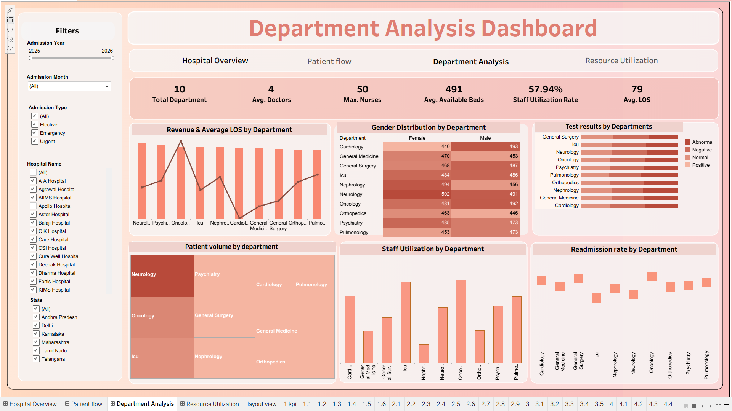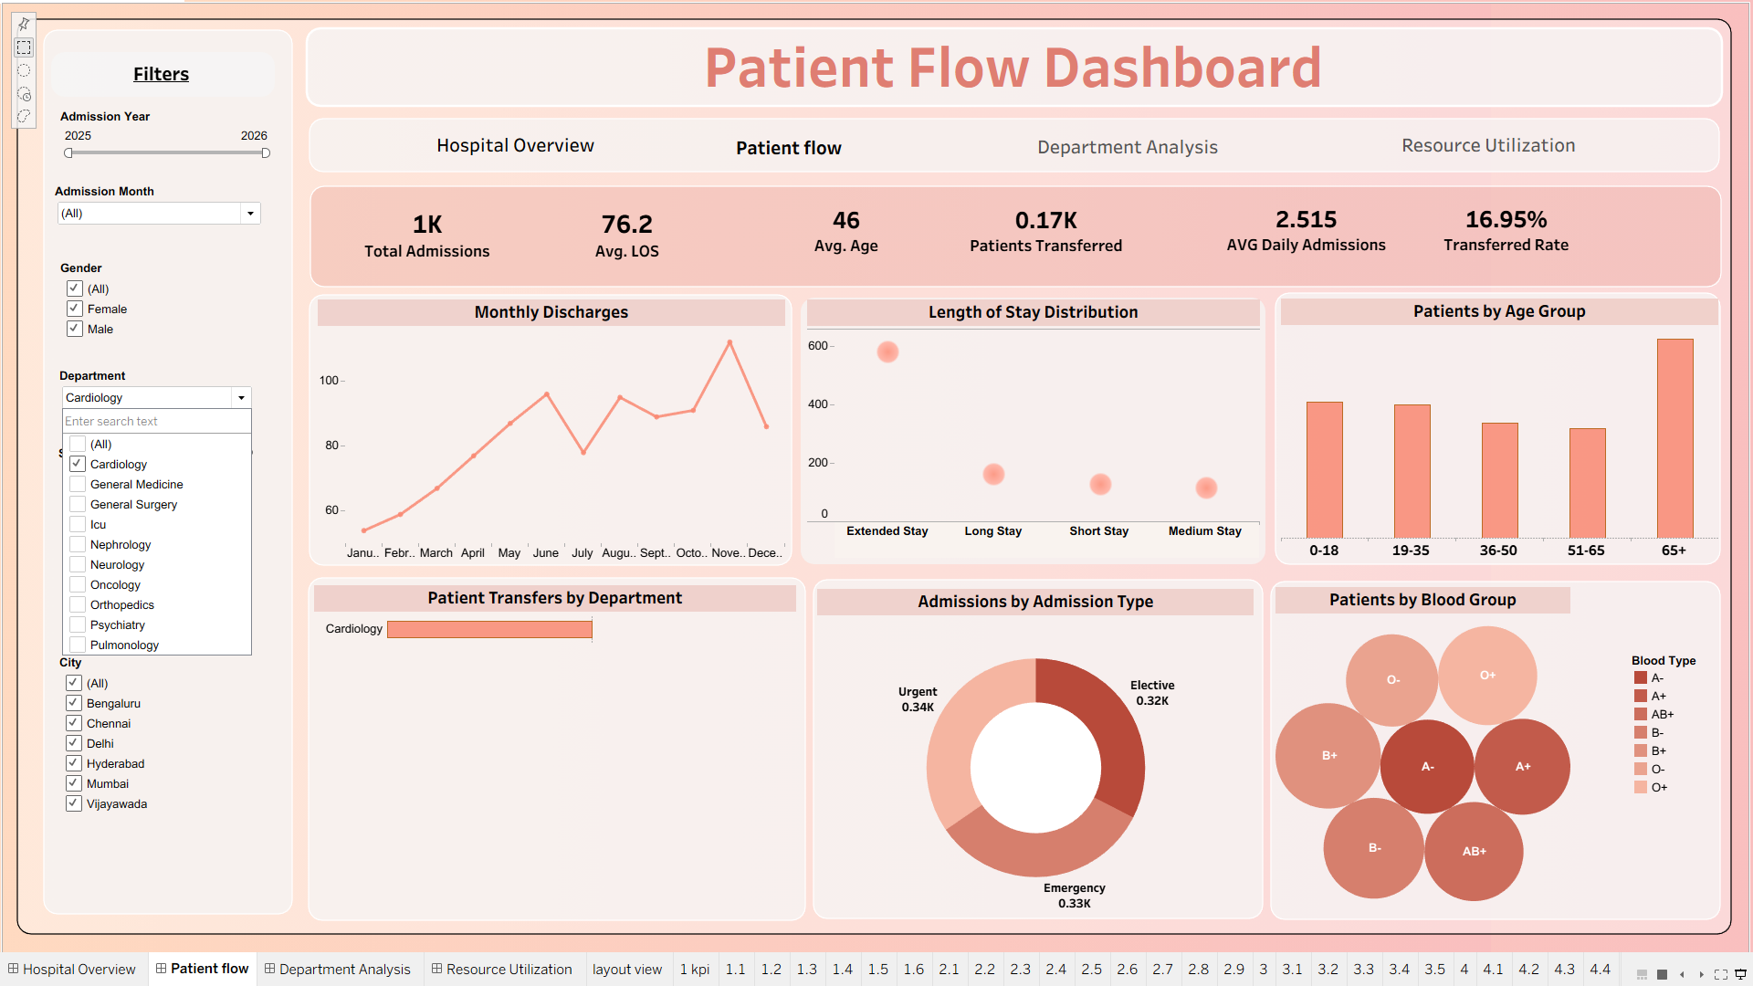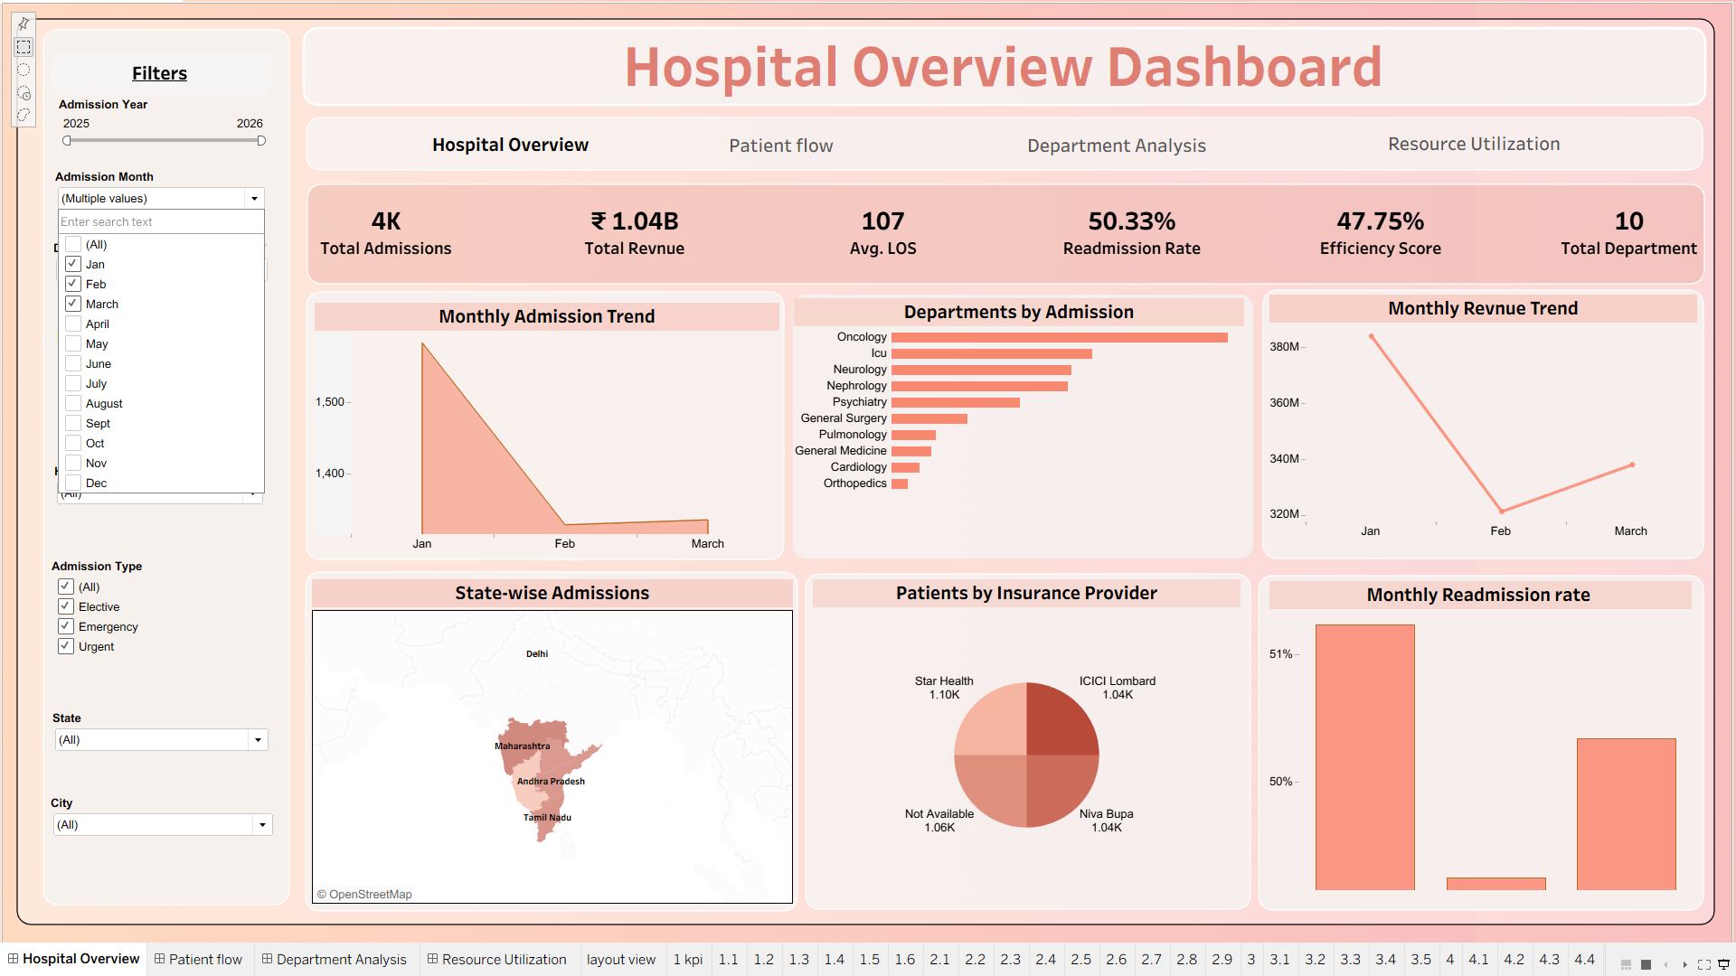
Figure 8. Filter / Dashboard Interaction Test

11. Data Quality Testing
- Record checks were performed for issues affecting dashboard calculations.
- LOS consistency was validated using admission and discharge dates.
- Duplicate-record checks did not identify an issue affecting final dashboard results.
- Chart/data checks were correct overall; the Resource Utilization Total Inventory KPI remains open for definition/value revalidation.

12. Defects and Observations
No major dashboard defects were identified. Minor label/naming corrections remain. The Tableau value of 492 represents the average Dept_Bed_Capacity_Derived field (491.6944), so the KPI should be labelled 'Avg. Department Bed Capacity' rather than 'Avg. Available Beds'. Use 'Department Analytics' consistently in the dashboard title and navigation.
The 36.76% bed KPI matches the Bed_Occupancy_Rate_% metric, so the label should be 'Bed Occupancy Rate'. The current Resource Utilization screenshot shows Equipment Total Inventory = 132,620, while the testing report/checklist validates 23. Confirm whether the intended KPI is inventory record count or summed inventory quantity, then display/rename and revalidate it. Also standardize wording/capitalization such as Resource Utilization Score, Avg. Department ICU Bed Capacity, Total Departments, Test Results by Department, Monthly Readmission Rate and Admissions by Department.

13. Test Summary
Testing Measure | Result
Total Test Cases | 40
Passed | 39
Requires Fix / Review | 1
Pass Rate | 97.5%
Major Dashboard Issues | 0
KPI Validation | All previously validated KPIs match; Total Inventory requires revalidation
Overall Status | PASS WITH MINOR FIXES

14. Conclusion
The final Tableau hospital analytics dashboards passed the Module 7 testing and validation process with minor fixes remaining. A total of 39 out of 40 test cases passed, giving an overall test pass rate of 97.5%. Major KPIs and healthcare metrics were independently validated, patient-flow analytics were checked, and dashboard filters and interactions were tested successfully. No major dashboard issues were found. Before final submission, the Resource Utilization Total Inventory KPI should be revalidated against its intended definition, and the listed label/naming corrections should be applied.

15. Evidence Checklist
☑ Hospital Overview screenshot inserted
☑ Python/Pandas KPI validation screenshot inserted
☑ Efficiency Score validation screenshot inserted
☑ LOS validation screenshot inserted
☑ Patient Flow screenshot inserted
☑ Department Analytics screenshot inserted
☑ Resource Utilization screenshot inserted
☑ Filter/interaction screenshot inserted

