HOSPITAL OPERATIONS & PATIENT ANALYTICS DASHBOARD
Internship Project Documentation Report
Intern Name | Vidhisha Nitin Sonar
Program | Infosys Springboard Internship
Start Date | 28 July 2026
End Date | 17 September 2026
Duration | 8 Weeks
Domain | Healthcare Analytics
Tools | Kaggle,Tableau, Power BI, Python, Excel, GitHub, GitHub Desktop.
Project | Hospital Operations & Patient Analytics Dashboard

1.Introduction
This internship project focused on converting raw healthcare operational data into meaningful business intelligence dashboards. The project covered the complete analytics lifecycle including data collection, cleaning, KPI development, dashboard storyboarding, dashboard development, testing, validation, documentation, and final delivery. Four dashboards were developed in both Tableau and Power BI.
2.Problem Statement
Hospital administrators often face challenges in monitoring operational performance due to fragmented datasets and limited analytical visibility.
This project aims to create a centralized analytics platform capable of tracking:
- Patient Admissions
- Hospital Revenue
- Bed Occupancy
- Department Performance
- Resource Efficiency
- Emergency Cases
- Doctor Utilization
The solution provides a comprehensive overview of hospital operations through data-driven dashboards.

3.Project Objectives

Primary Objectives
- Analyze hospital operational data.
- Identify key healthcare KPIs.
- Develop interactive dashboards.
- Monitor hospital performance.
- Improve visibility into hospital operations.
- Support data-driven decision-making.

Secondary Objectives
- Learn healthcare analytics concepts.
- Gain practical experience in Tableau and Power BI.
- Improve data visualization skills.
- Understand GitHub project management workflows.
- Build an end-to-end analytics project.

4.Internship Timeline
Week | Module | Activities
Week 1 | Module 1 | Data Collection
Week 2 | Module 2 | Data Cleaning & Transformation
Week 3 | Module 3 | KPI Development
Week 4 | Module 4 | Dashboard Storyboarding
Week 5 | Module 5 | Dashboard Development
Week 6 | Module 6 | Department Analytics & Resource Utilization
Week 7 | Module 7 | Dashboard Integration & Testing
Week 8 | Module 8 | Documentation & Project Delivery

5. Tools & Technologies Used
Tool | Purpose
Kaggle | Dataset Source
Excel | Data Inspection
Python | Data Cleaning & Transformation
Tableau | Dashboard Development
Power BI | Dashboard Development
GitHub | Version Control
GitHub Desktop | Repository Management

6. Dataset Description
The project uses hospital operations and patient admission datasets containing information related to patient records, hospital departments, revenue generation, admissions, discharges, and resource allocation.

Dataset Categories
Category | Description
Patient Information | Patient records and demographics
Admission Data | Admission and discharge details
Department Data | Department activities
Revenue Data | Financial records
Resource Data | Staff and resource allocation

Module 1 – Data Collection
The first stage of the project focused on collecting and understanding healthcare datasets required for hospital operations analysis and patient analytics. Relevant datasets were explored and evaluated based on completeness, usability, and business relevance. The hospital operations dataset and patient admission dataset were selected as the primary data sources. Initial data exploration was performed to understand dataset structure, available attributes, record distribution, and overall data quality. This phase established the foundation for all subsequent analysis and dashboard development activities.
Module 2 – Data Cleaning & Transformation
After data collection, the datasets were cleaned and transformed to ensure consistency and reliability. Missing values were identified and handled appropriately, duplicate records were removed, and formatting inconsistencies were corrected. Department names, date fields, and numerical values were standardized to maintain uniformity across the dataset. Validation checks were performed to ensure data accuracy before moving to the analysis stage. These activities helped create a clean and analysis-ready dataset suitable for dashboard development.

Module 3 – KPI Development
In this phase, key performance indicators were identified and developed to measure hospital performance effectively. Business requirements were analyzed to determine the most important metrics for monitoring patient activity, operational efficiency, and resource utilization. KPIs such as Total Patients, Total Revenue, Bed Occupancy Rate, Average Length of Stay, Department-wise Patient Count, Resource Utilization Percentage, Doctor Utilization Percentage, and Emergency Cases were designed and validated. These KPIs became the core analytical measures used throughout the dashboards.
Total Patients | Patient volume
Total Revenue | Financial performance
Bed Occupancy Rate | Capacity utilization
Average Length of Stay | Stay duration
Department-wise Patient Count | Department performance
Resource Utilization % | Resource efficiency
Doctor Utilization % | Doctor efficiency
Emergency Cases | Emergency monitoring

Module 4 – Dashboard Storyboarding
Before dashboard development began, a detailed storyboard was created to define the overall structure and user experience of the solution. Dashboard layouts were planned by determining the placement of KPI cards, charts, filters, and navigation components. Different visualization techniques were evaluated to ensure information could be presented clearly and effectively. Color themes, design consistency, and user interaction flow were also planned during this stage, providing a structured blueprint for dashboard implementation.
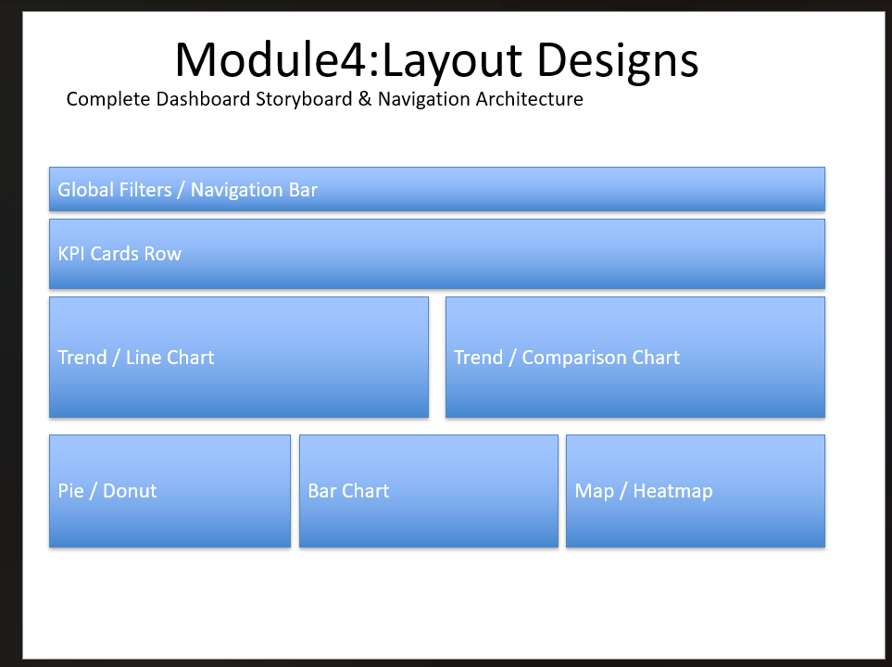
Module 5 – Dashboard Development
This module focused on building the initial dashboards using Tableau and Power BI. Interactive visualizations were created to transform healthcare data into meaningful insights. The Hospital Overview dashboard was developed to provide a high-level summary of hospital performance through KPIs, revenue analysis, occupancy monitoring, emergency case tracking, and monthly trends. The Patient Flow dashboard was developed to analyze admissions, discharges, patient movement, and average length of stay. Interactive filters and drill-down functionality were implemented to improve usability and analytical flexibility.
Hospital Overview
Provides an overall view of patients, revenue, occupancy, and emergency cases.
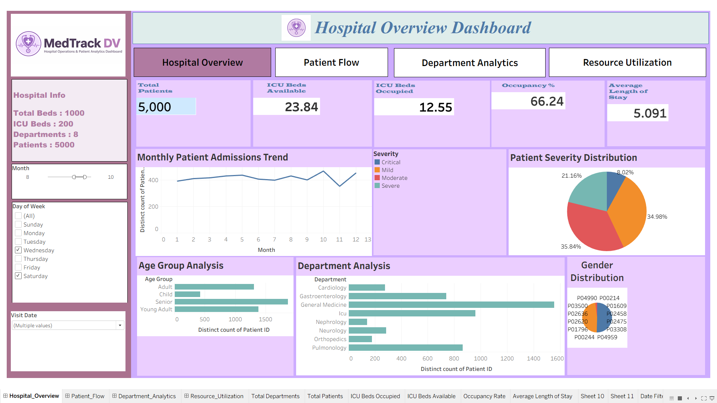

Patient Flow Analysis
Tracks admissions, discharges, and average length of stay.
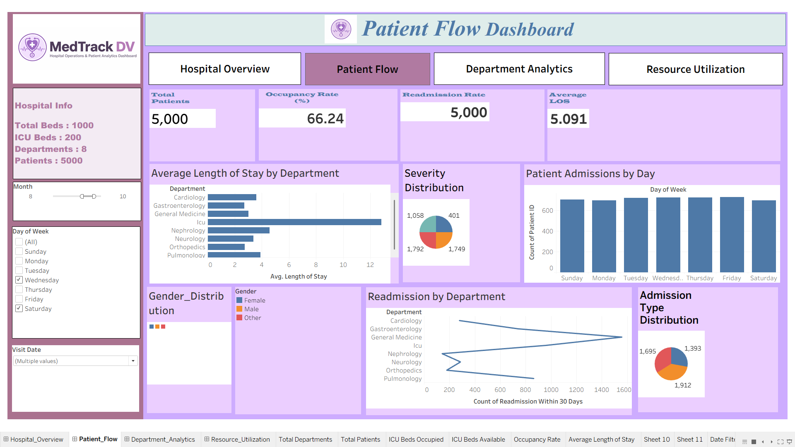

Module 6 – Department Analytics & Resource Utilization
The focus of this phase was to develop advanced analytical dashboards that provide deeper insights into departmental performance and hospital resource management. The Department Analytics dashboard was designed to compare patient volumes, evaluate department performance, and analyze resource distribution across different departments. The Resource Utilization dashboard was created to monitor hospital capacity, doctor utilization, resource allocation efficiency, and overall utilization trends. These dashboards provided detailed operational insights that support better decision-making and resource planning.
Department Analytics
Compares department performance and patient distribution.
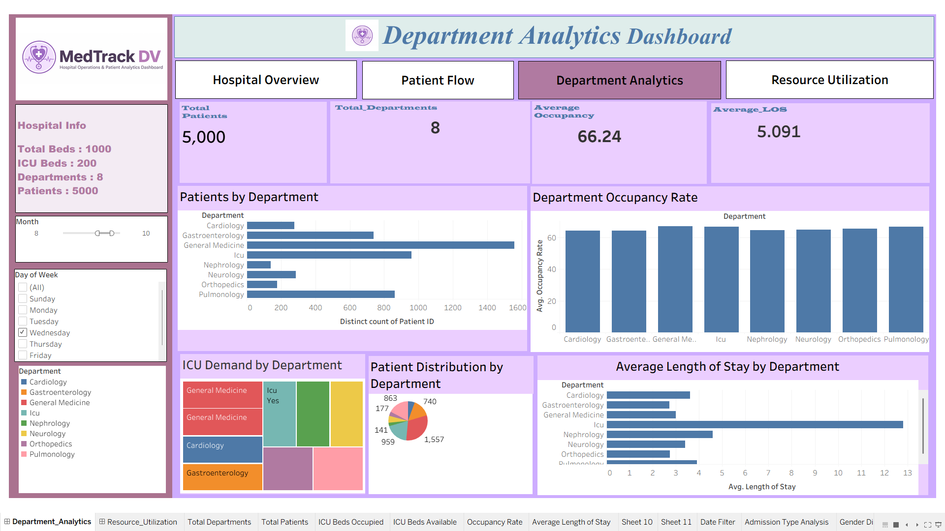

Resource Utilization
Monitors resource allocation and doctor utilization.
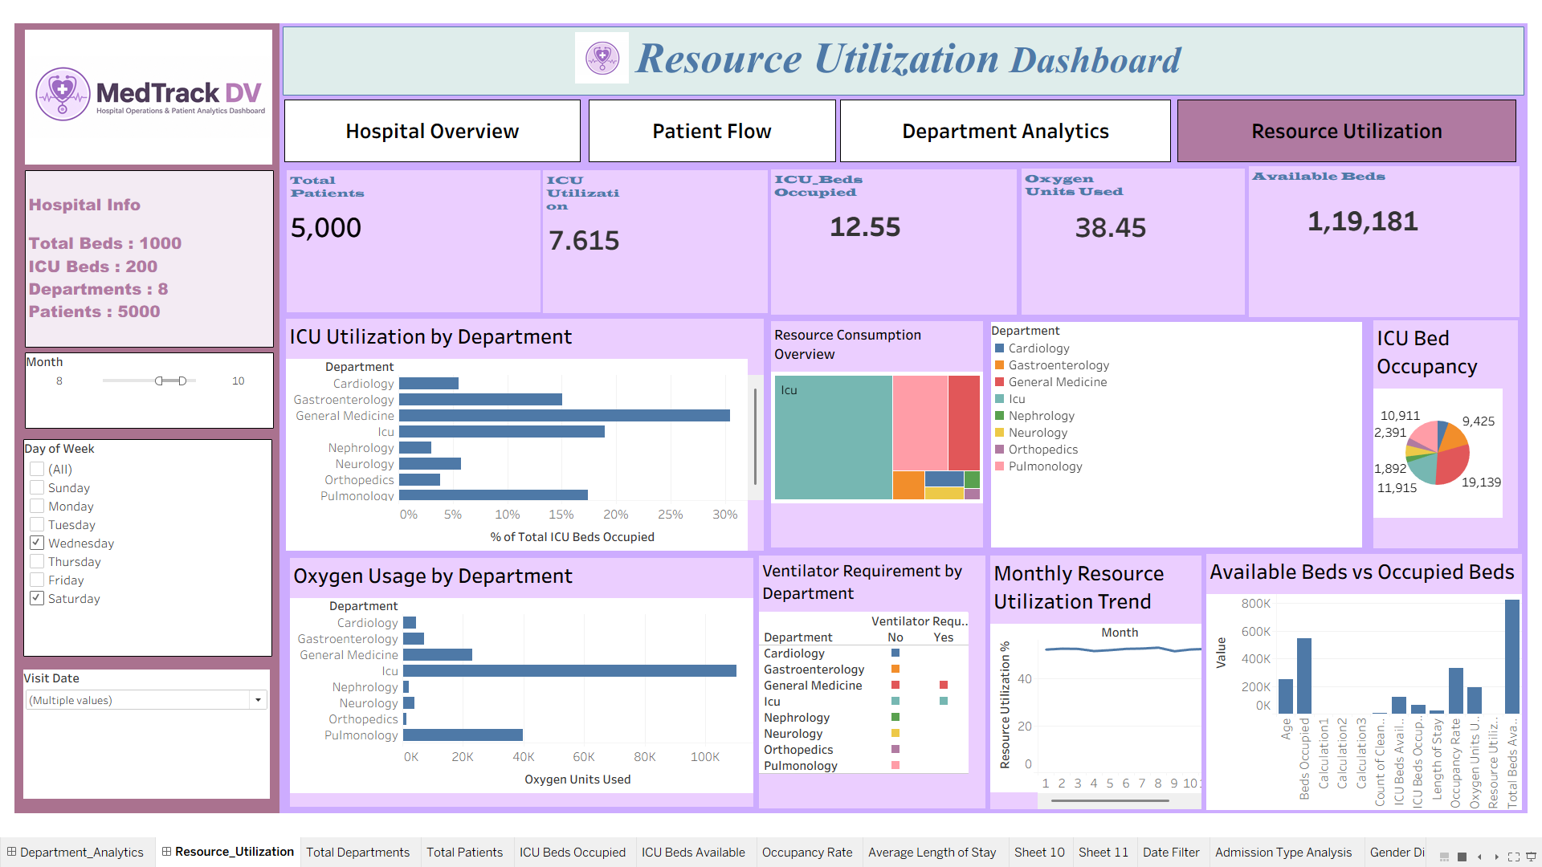

Module 7 – Dashboard Integration & Testing
Once all dashboards were completed, they were integrated and thoroughly tested to ensure accuracy and functionality. KPI calculations were validated against source data, interactive filters were verified, and navigation elements were tested across all dashboards. Visualizations were reviewed to ensure consistency and accuracy, and user interactions were checked to confirm smooth dashboard performance. Testing was conducted in both Tableau and Power BI environments, and all validation checks were successfully completed before project finalization.
Module 8 – Documentation & Project Delivery
The final phase of the internship focused on documenting the complete project lifecycle and preparing all deliverables for submission. A comprehensive project report was created covering data collection, cleaning, KPI development, dashboard design, testing activities, challenges faced, and key learnings. Dashboard screenshots, project timelines, GitHub repository structure, and final dashboard files were organized and included as part of the documentation package. This phase ensured that the complete healthcare analytics solution was professionally documented and ready for presentation and final delivery.

Challenges Faced
• Handling missing healthcare records
• KPI validation and verification
• Dashboard optimization
• Tableau and Power BI synchronization
• GitHub repository organization
Key Learnings
• Healthcare Analytics
• Data Cleaning & Transformation
• KPI Engineering
• Tableau Dashboard Design
• Power BI Dashboard Design
• GitHub Workflow Management
• Data Storytelling
• Business Intelligence Reporting

GitHub Repository Structure
Hospital-Operations-and-Patient-Analytics-Dashboard
├── Module_01_Data_Collection
├── Module_02_Data_Cleaning
├── Module_03_KPI_Development
├── Module_04_Dashboard_Storyboarding
├── Module_05_Dashboard_Development
├── Module_06_Department_Analytics_Resource_Utilization
├── Module_07_Dashboards
│ ├── PowerBI
│ └── Tableau
└── Module_08_Documentation
Dashboard Gallery
📌 Dashboard 1 – Hospital Overview Screenshot
📌 Dashboard 2 – Patient Flow Analysis Screenshot
📌 Dashboard 3 – Department Analytics Screenshot
📌 Dashboard 4 – Resource Utilization Screenshot
📌 GitHub Repository Screenshot
Conclusion
The project successfully transformed raw healthcare data into interactive dashboards that support operational monitoring, resource management, and data-driven decision making. The internship provided practical experience in analytics, dashboard development, visualization, documentation, and project management.

