Snapshot of implemented apis for

* List all products
* Add product to cart
* Remove product from cart
* Checkout
* Payment
* Add product to database

1. Get all products with valid customer credentials:

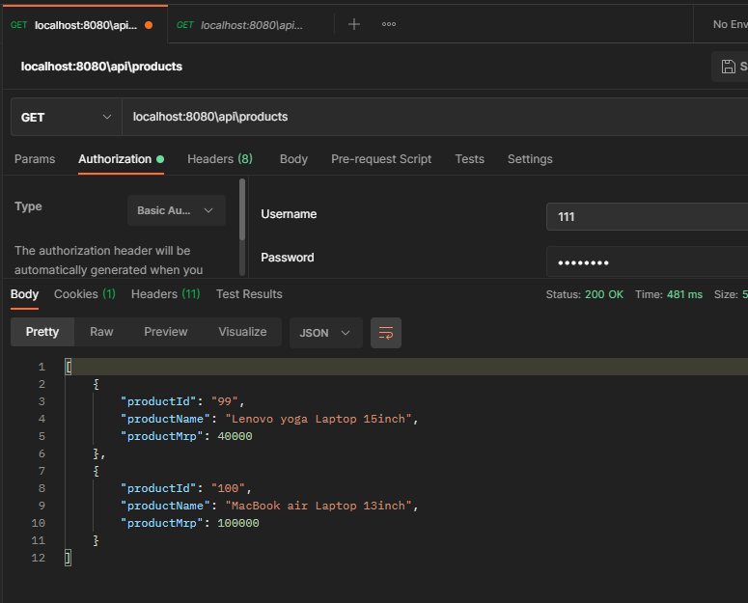

Get all products from seller credentials:

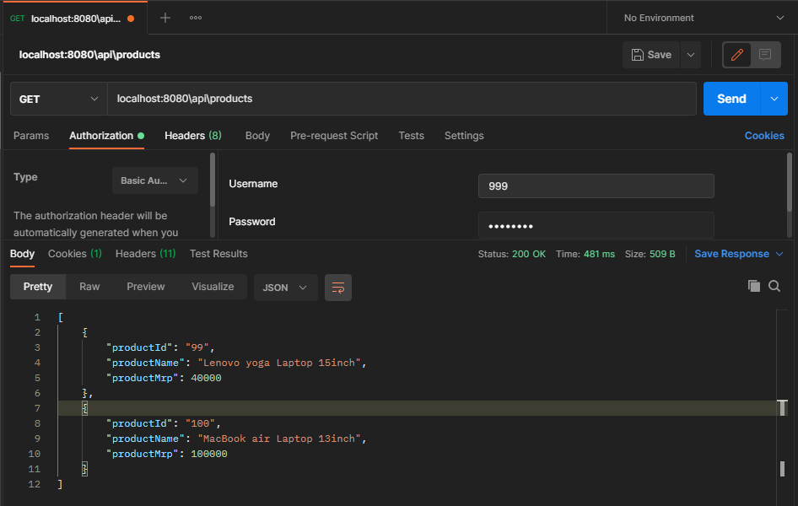

Call with Invalid credential

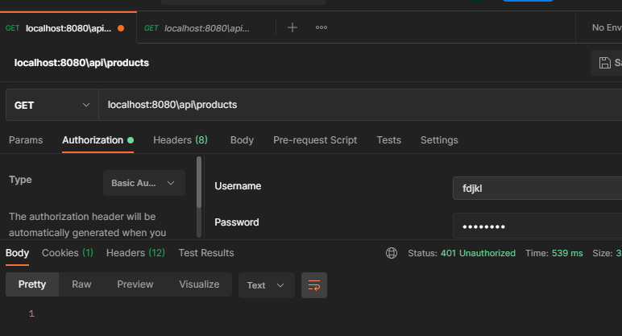

1. Add product to the cart by customer. Seller can’t do this – role based access control

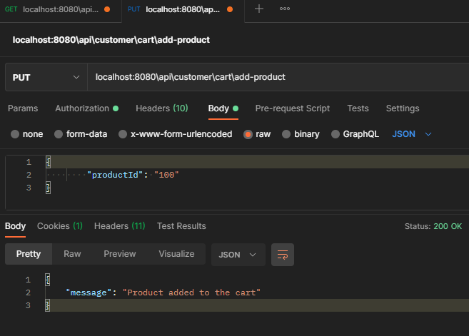

1. Remove product from cart

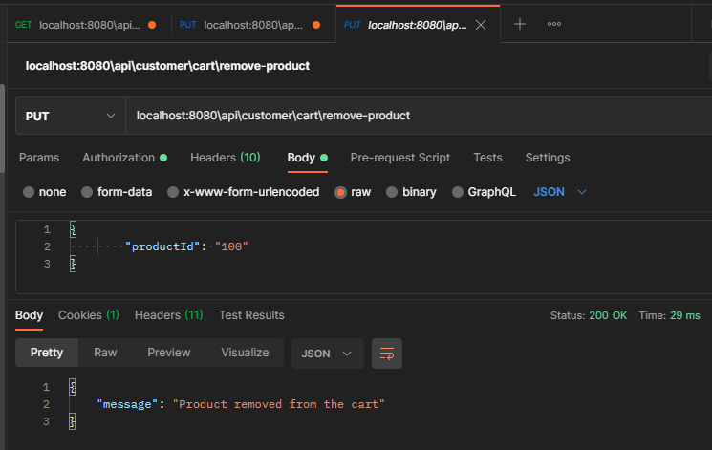

1. Get all products present in cart

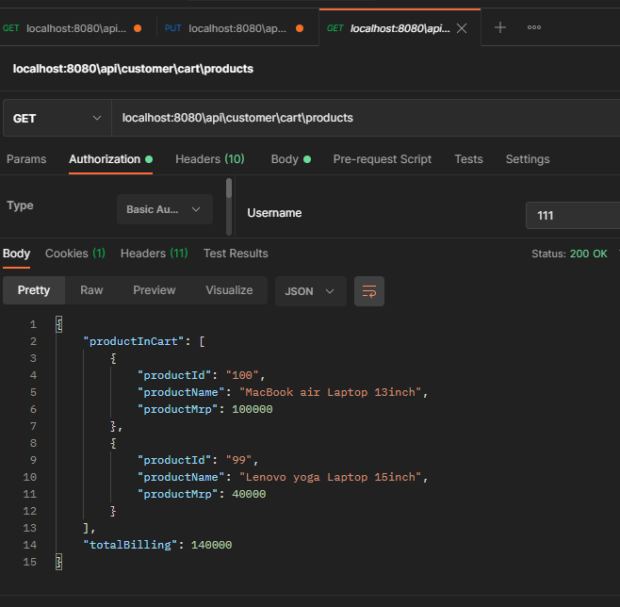

1. Checkout

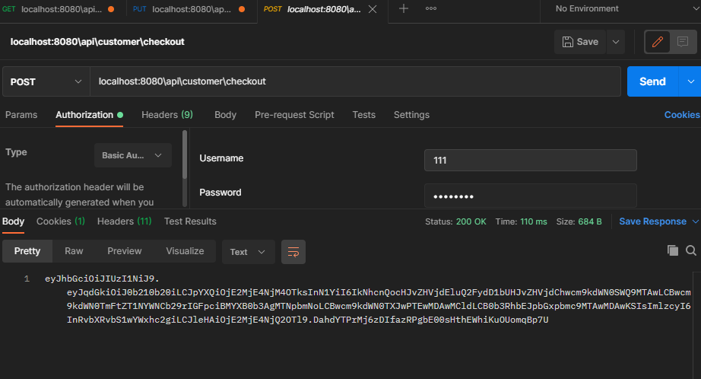

1. Make payment

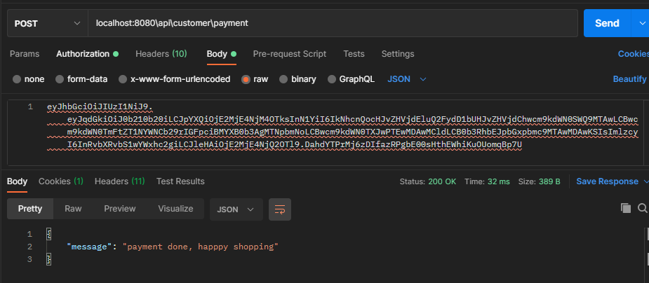

1. Add product by Seller

