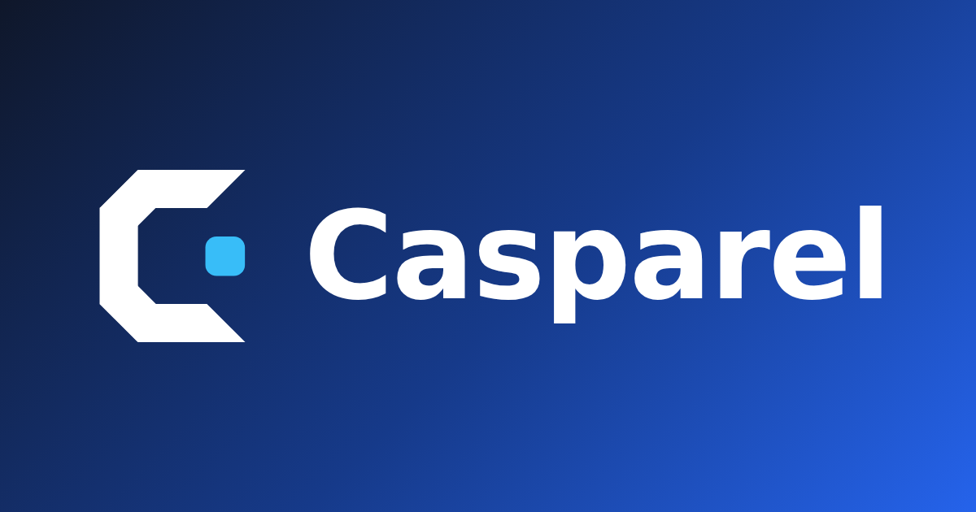

Product Handbook & Technical Audit
  - Product truth, architecture, operations, quality evidence, risks, and release guidance
Verified 15 August 2026 | Version 1.0 | casparel.com
4  CLIENT SURFACES | 173  API TESTS | 39/39  BROWSER RENDERS | 224 ms  HTTP P95

Executive brief
PRODUCT POSITION Casparel is strongest when it moves a learner from discovery to source evaluation, organized study, and evidence. It should not position itself as a generic AI chatbot or social feed.

The web/API foundation is materially stronger than a typical hackathon prototype: the production service is reachable, the automated API suite passes, a broad browser matrix is exercised, and teacher/resource workflows are unusually complete. The audit also found genuine release blockers in mobile packaging, quota behavior, product claims, public discovery, ownership controls, load-test safety, and coverage. Those findings were corrected rather than merely documented.
Area | Assessment | What matters now
Web + API | Production-capable | Keep monitoring; expand interaction and contract coverage.
Mobile | Code-complete subset | Prove signed builds, devices, stores, and purchases.
Desktop | Controlled shell | Signing, notarization, updater, and offline expectations remain.
Product evidence | Synthetic evidence strong | Run moderated student and teacher sessions.

What was verified
- 23 API test files and 173 tests passed in the isolated final run.
- The web production build completed across 2,734 transformed modules.
- The browser matrix passed 39 of 39 public/signed-in, theme, and viewport renders.
- Session handling passed valid, expired, and server-rejected token journeys.
- The desktop package compiled and passed four real Electron smoke scenarios.
- A production-safe HTTP smoke returned 20 of 20 HTTP 200 checks with 224 ms overall p95.
EVIDENCE BOUNDARY No real account was created, no purchase was made, no recruited participant was tested, and no destructive production load was applied. Store distribution, RevenueCat dashboard state, and concurrent capacity remain unverified.

Contents
A navigational overview of this report. Section headings are preserved as real Word headings for the document outline and accessibility tools.
Section | What it covers
01 | Product definition and user value
02 | User-facing surfaces and journeys
03 | Architecture, repository, and request lifecycle
04 | Identity, plans, limits, discovery, and research
05 | Data model, integrations, and configuration
06 | Development, deployment, and operations
07 | Security, privacy, and accessibility
08 | Quality, performance, and task-based user review
09 | Implemented improvements
10 | Risk register and prioritized next steps
A | Operator command reference and source register

01 · Product definition and user value
Casparel is a cross-platform learning workspace for students and teachers. Students discover credible educational material, organize it around goals, schedule study, collaborate, and preserve evidence of progress. Teachers manage classes, recommend resources, create learning activities, and use evidence to support students.
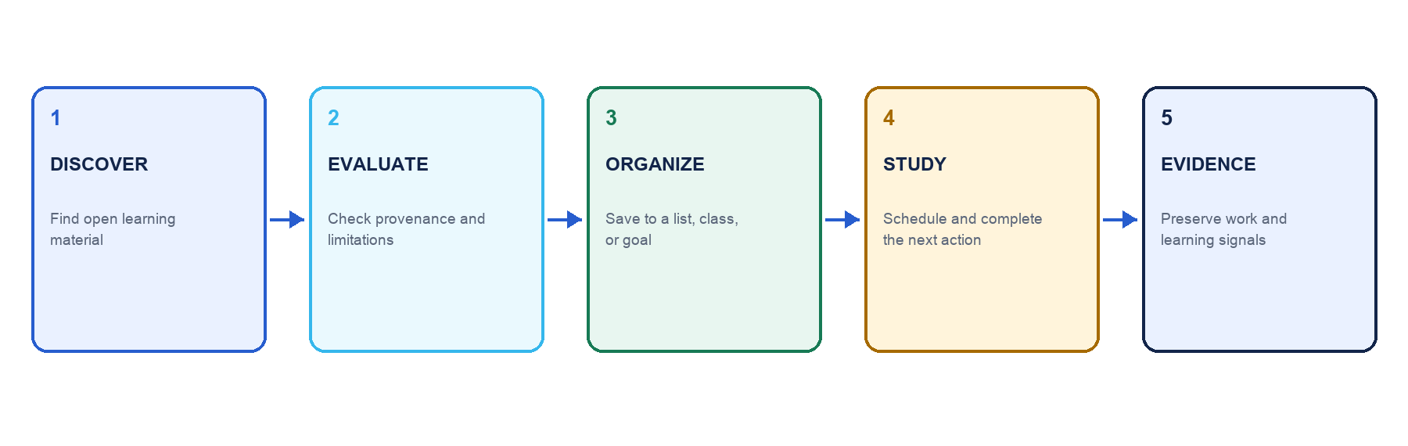
The product's durable differentiation is the complete credibility-to-action loop.

Primary audiences
Audience / state | Needs | Casparel response
Signed-out visitor | Understand value and browse safely | Landing, public resource library, details, legal, and account entry.
Student | Find trustworthy material and turn it into action | Goals, schedules, resources, lists, classes, activities, canvases, collaboration, and evidence.
Teacher | Guide classes and inspect learning | Class management, assignments, recommendations, notes, seating, and Google Classroom integration.
Administrator | Moderate and operate the system | Verification queues, user/class controls, reports, and usage/cost visibility.
Premium account | Use deep live-web research without account limits | Unlimited account-level deep source research; server-wide safety budget still applies.

Product promise and boundaries
- The public learning-resource library and quick source check remain useful without Premium.
- Premium removes account-level limits from deep, cited, live-web source research; it does not remove the global emergency budget.
- Mobile is intentionally narrower than web and must never advertise missing native capabilities.
- Source reports are research aids, not objective trust scores; limitations and supporting links must remain visible.
- Desktop is a controlled online shell, not an offline-native product.

02 · User-facing surfaces and journeys

Web application
Area | Representative pages | Purpose
Public | Landing, login, registration, legal, Resources, Support | Acquisition, public discovery, trust, and account entry.
Home | Dashboard, adaptive dashboard, guide | Orientation, recommended action, and onboarding.
Learning | Goals, activities, schedule, canvases | Planning, focused work, and evidence.
Resources | Search, detail, lists, catalog | Discovery, evaluation, citation, and collections.
Community | People, profiles, messages, forum | Safe discovery and collaboration.
Teaching | Classes and class detail | Membership, assignments, resources, goals, notes, and seating.
Account | Profile and settings | Identity, integrations, privacy, and plan state.
Operations | Admin | Verification, moderation, support, and AI-usage visibility.

Mobile application
The Expo Router app focuses on onboarding/login, dashboard, classes, schedule, resource browse/detail, quick and deep source review, profile, usage, and the Premium paywall. Native identifiers are com.casparel.app; the Expo slug and scheme are casparel. RevenueCat uses entitlement identifier premium and logs in with the numeric Casparel user ID.
TRUTHFUL SCOPE Goals, canvases, lists, messaging, forum, activities, admin, and AI-assisted catalog discovery are not complete native experiences. Paywall and store copy must describe only what the submitted binary actually provides.

Desktop and shared design system
The Electron package wraps CASPAREL_URL, validates navigation and deep links, preserves the window on embed failure, and has a real-window smoke test. The historical schoolar-edu package provides shared tokens and components across web and mobile; its legacy package name remains a compatibility detail.

Critical journeys
- Public discovery: open Resources, inspect starter material, search, and open a resource without registering.
- Credibility-to-action: run a quick or deep review, interpret strengths/limitations, then save or connect the resource to study work.
- Student organization: create a goal, plan time, complete activity, and preserve evidence.
- Teacher loop: create or manage a class, recommend/assign material, and review learning evidence.
- Subscription loop: use the free allowance, view the honest paywall at the effective limit, purchase/restore, and reconcile entitlement server-side.
- Session recovery: expire or reject a token, clear local state, and return safely to login.

03 · Architecture, repository, and request lifecycle
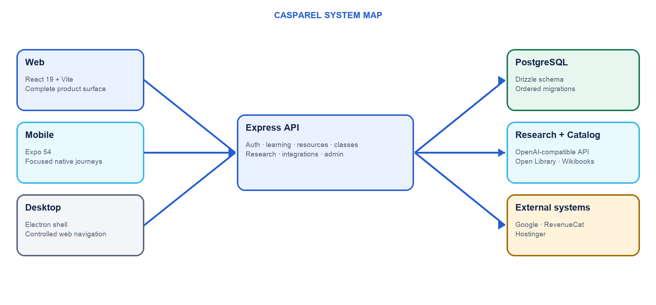
Client surfaces share one API and data model; desktop delegates to the web experience.

Repository map
Path | Responsibility
artifacts/api-server | Express 5 API, authentication/authorization, integrations, and startup migrations.
artifacts/app | React 19 + Vite SPA, production pages, and browser/session audit fixtures.
artifacts/mobile | Expo 54 / React Native native client and RevenueCat adapter.
artifacts/desktop | Electron shell, deep links, packaging, and runtime smoke.
artifacts/schoolar-edu | Shared design tokens and web/native components.
lib/api-spec | OpenAPI source of truth and code generation entrypoint.
lib/api-client-react | Generated React Query client; never hand-edit generated files.
lib/api-zod | Generated request/response schemas; never hand-edit generated files.
lib/db | Drizzle schema and ordered migrations.
load-tests | k6 smoke, public, and authenticated profiles with production guards.

Request lifecycle
- A web or native client calls an endpoint below /api.
- The server applies security headers, CORS/body limits, and rate controls.
- Protected routes validate the signed bearer token; teacher/admin routes apply stronger authorization.
- Typed core routes validate payloads with generated Zod schemas.
- Data is read or written through Drizzle or parameterized SQL.
- Startup applies ordered migrations and checks database reachability/schema health before serving traffic.
CONTRACT DEBT Forum, messaging, workflow, activity, canvas, expanded admin, and webhook surfaces are not all represented in OpenAPI. Migrate them spec-first in bounded domain batches to recover generated-client drift protection.

04 · Identity, plans, limits, discovery, and research

Authentication and session behavior
- Registration and login return a signed bearer token.
- The compatibility token key is schoolar_token on web and mobile; renaming it would break existing sessions.
- Expired or server-rejected tokens are cleared and redirect to login.
- Logout clears local session state; account deletion anonymizes/disables identity.
- The mobile user cache now uses casparel_user and migrates the legacy schooler_user value.

Plan reconciliation and quotas
Control | Current rule | Purpose
AI discovery fallback | 3 per user/day by default | Contain optional fallback cost.
Deep research - day | 2 per free user/day | Give every account a meaningful trial.
30-day research | 2 per free user/30-day window | Longer-window cost control.
Global deep research | 20/day by default, including Premium | Emergency server-wide budget.
Premium | Account-level deep limits removed | Monetized convenience; global safety remains.

RevenueCat drives immediate native entitlement state and posts signed webhook events to POST /api/webhooks/revenuecat. The server records premium plan/expiry state. Persistent event idempotency and authoritative TRANSFER reconciliation remain release-critical work.

Layered discovery
- Query Casparel's stored public library.
- Query the locally stored open-education catalog.
- Fetch and cache Open Library or Wikibooks material when the first catalog page is sparse.
- Only when no catalog result exists and a feature flag permits it, use the paid AI fallback.

Source research
Quick mode uses model knowledge. Deep mode performs live-web research and returns cited strengths, concerns, limitations, currency, and reputation analysis. Results are cached; concurrent work is restricted by user/resource; both account and global quotas apply. The interface must preserve uncertainty and supporting links.

05 · Data model, integrations, and configuration

Data domains
Domain | Representative records
Identity + safety | Users, preferences, reports/safety state, activity log.
Teaching | Classes, members, invitations, assignments, recommendations.
Learning | Goals, evidence, workflow events, sessions, schedule blocks.
Resources | Public/catalog resources, reviews, source-review cache, lists/items.
Collaboration | Conversations, messages, forum content, comments/reports, canvases.
Integrations | Google OAuth and Calendar tokens; subscription account state.

MIGRATION INVARIANT Every database schema change requires both the TypeScript schema edit and its generated Drizzle migration. Do not use drizzle push or direct ALTER TABLE. Timestamp fields feeding string schemas use mode: "string".

External integrations
Integration | Purpose | Required configuration
PostgreSQL | Persistent state and quota counters | DATABASE_URL
OpenAI-compatible | Discovery fallback and source research | Base URL + API key
Google Classroom | Course import, students, resource sharing | Client ID/secret + redirect
Google Calendar / iCal | Connected/exported scheduling | OAuth settings + calendar redirect
RevenueCat | Products, offerings, entitlement | Public SDK keys + webhook auth
Hostinger | Production hosting and smoke verification | Deployment secrets + SITE_URL

Required server configuration
DATABASE_URL=...
SESSION_SECRET=...
AI_INTEGRATIONS_OPENAI_BASE_URL=...
AI_INTEGRATIONS_OPENAI_API_KEY=...
Optional controls cover RevenueCat webhook authentication, Google OAuth, admin allowlists, CORS origins, catalog remote fetch, AI flags/quotas, logging, and strict database readiness. Secrets belong in host-managed environment variables or gitignored .env files, never source or committed documentation.

06 · Development, deployment, and operations

Local startup
pnpm install --frozen-lockfile
pnpm --filter @workspace/api-server run dev
pnpm --filter @workspace/app run dev
pnpm --filter @workspace/mobile run dev
pnpm --filter @workspace/edu-ds run dev

Service boundaries
Service | Default | Rule
API | 8080 Replit / 5000 local | Read PORT; server process remains separate.
Web | 23863 | Read PORT and API_URL; proxy /api to API.
Design system | 20495 | Run only for design-system development.
Mobile | 18115 | Expo development server; native store builds use EAS.

Quality gates
pnpm run typecheck
pnpm --filter @workspace/api-server exec vitest run
pnpm --filter @workspace/api-server run build
pnpm --filter @workspace/app run build
node artifacts/app/scripts/audit-pages.mjs
node artifacts/app/scripts/audit-session.mjs
pnpm --filter @workspace/desktop run compile
pnpm --filter @workspace/desktop run smoke

Contract and schema workflow
- API change: edit lib/api-spec/openapi.yaml, run the api-spec code generator, then add/register the Express handler.
- Generated React Query and Zod directories are output-only; never hand-edit them.
- Database change: edit the Drizzle schema, generate a migration, inspect and add safety guards, commit both together.
- The authentication token key and port/environment contracts are compatibility boundaries, not cosmetic naming opportunities.

Deployment and incident first checks
- Call GET /api/healthz and inspect deployment logs.
- Confirm required environment variables are bound.
- Confirm migrations ran cleanly and the expected schema exists.
- Verify DATABASE_URL reachability and readiness diagnostics.
- Inspect RevenueCat webhook responses during entitlement incidents.
- Use only the bounded production smoke; run public/authenticated capacity profiles on staging with telemetry.

07 · Security, privacy, and accessibility

Implemented controls
- Password hashing, signed tokens, route-level authorization, input/body limits, and request throttling.
- Parameterized data access, CORS policy, security headers, upload validation, and startup readiness checks.
- Moderation/reporting controls, minimal OAuth scope handling, signed RevenueCat webhooks, and redaction-aware logs.
- Public terms/privacy/support pages and an account deletion path.
- Automated browser assertions for runtime failures, contrast, accessible names, labels, headings, alt text, and overflow.

Residual security findings
Finding | Severity | Mitigation / resolution
RevenueCat TRANSFER reconciliation | P1 | Persist event IDs and reconcile both subscriber aliases against authoritative state.
image-size ICNS denial of service | High / build-time | Avoid untrusted ICNS input; upgrade when a fixed release is available.
image-size JXL/HEIF denial of service | High / build-time | Avoid untrusted JXL/HEIF input; upgrade when a fixed release is available.
Newer routes outside OpenAPI | P1 | Migrate domains spec-first and remove duplicate manual types.

Manual accessibility gates
Automated checks cannot establish comprehension, focus usability, or screen-reader quality. Before native release, run VoiceOver and TalkBack on physical devices, Dynamic Type, reduced motion, keyboard/switch control, poor-network behavior, and package-selection/restore journeys.

08 · Quality, performance, and task-based user review

Verification dashboard
Check | Result | Evidence
API tests | PASS | 23 files; 173 tests.
Web + mobile TypeScript | PASS | Workspace and focused final checks.
Expo public configuration | PASS | Casparel slug/scheme, IDs, production origin.
Web build | PASS | 2,734 modules transformed.
Browser matrix | PASS | 39/39 route/theme/viewport renders.
Session journeys | PASS | Valid, expired, and server-401 flows.
Desktop | PASS | Compile + four real-window smoke cases.
Production HTTP smoke | PASS | 20/20 checks; 0% failures.
Dependency audit | PARTIAL | Three high findings fixed; two image-size highs remain.
Store install | NOT VERIFIED | Signed binaries/store credentials required.
Moderated usability | NOT RUN | Participant recruitment required.
Concurrent capacity | NOT RUN | Staging with database/CPU telemetry required.

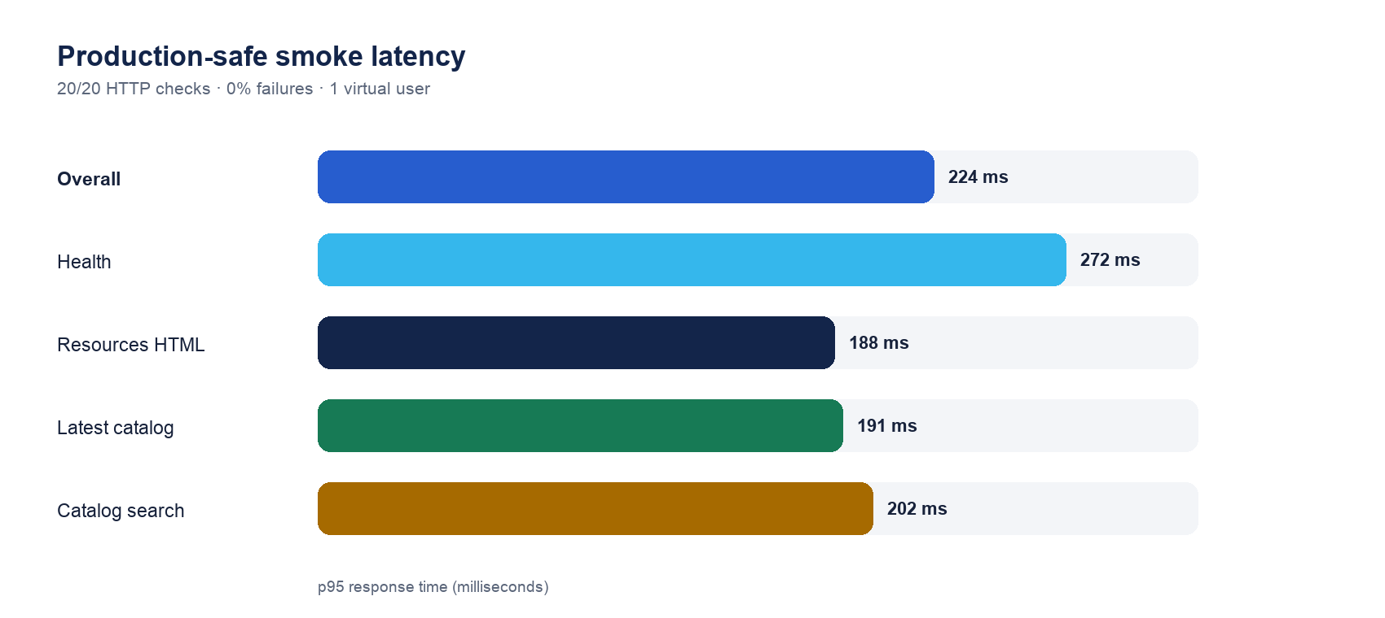
Read-only, one-user latency sample; not a capacity claim.

Web bundle profile
Chunk | Raw | Gzip | Interpretation
Entry | 72.5 kB | 24.8 kB | Healthy application entry.
React vendor | 185.8 kB | 58.6 kB | Expected framework cost.
Radix vendor | 148.0 kB | 45.9 kB | Shared accessible primitives.
Canvas | 203.6 kB | 65.9 kB | Feature-specific; keep lazy.
Three.js | 617.4 kB | 157.0 kB | Heavy but isolated.
p5 | 1,129.2 kB | 331.0 kB | Largest lazy dependency; measure before optimizing.

Task-based expert and synthetic review
Task | Result | Finding
Understand landing | PASS | Clear audiences and actions; no observed runtime errors.
Browse Resources signed out | FIXED | Starter cards now load from the existing top-rated API.
Clear search accessibly | FIXED | Explicit accessible name added.
Recover expired session | PASS | Token clears and login appears.
Remove own resource | FIXED | Remove control now appears only to the submitter.
Use free deep research | FIXED | Mobile consumes the server allowance before paywall.
Understand Premium | FIXED | Unsupported discovery/priority claims removed.
Select/restore accessibly | PARTIAL | Semantics improved; physical assistive-tech pass remains.
Teacher/admin workflow | PARTIAL | Major views render; live end-to-end creation/moderation was not executed.

Moderated research plan
Recruit at least five students and five teachers, including keyboard-only and screen-reader representation where possible. Give tasks rather than tours; measure completion, time, misclicks, comprehension, confidence, and unaided recall.
- Find a credible resource for a real topic and explain why it is trustworthy.
- Save it, cite it, and connect it to a goal.
- Schedule study and find the plan again the next day.
- Join or manage a class and explain what is private versus shared.
- Compare quick and deep research and explain the Premium allowance.

09 · Implemented improvements
- Added mobile and api-spec to the pnpm workspace; regenerated a complete lockfile.
- Separated Expo runtime dependencies from build/type-only dependencies.
- Corrected Expo slug, scheme, and production Router origin to Casparel.
- Made root CI typecheck responsible for mobile instead of a redundant npx workaround.
- Let free mobile users consume their deep allowance before showing the paywall.
- Made usage reporting respect both day and 30-day deep counters.
- Removed unsupported Premium claims and strengthened native labels, roles, and selected state.
- Added public starter resources, public Support, and browser audit coverage.
- Restricted web resource removal controls to the submitting user.
- Corrected environment flags, budgets, and production origins.
- Protected casparel.com from accidental non-smoke k6 profiles and bounded smoke iterations.
- Made the Electron runtime smoke portable across Linux, macOS, and Windows layouts.
- Raised PostCSS and nanoid security floors, clearing three high-severity advisories.
- Added canonical product, audit, and Shipaton documentation.

10 · Risk register and prioritized next steps
Priority | Risk | Required action | Exit evidence
P0 | No verified iOS/Android store release | Configure EAS/credentials, build, install on devices, pass review. | Public US listing + clean install.
P0 | RevenueCat lifecycle unproven | Test purchase, renewal, restore, cancellation, expiry, transfer. | Transaction matrix + server entitlement.
P1 | TRANSFER/idempotency gap | Persist event IDs and reconcile authoritative subscriber state. | Replay-safe tests and incident diagnostics.
P1 | No moderated user evidence | Run five student + five teacher sessions and fix top failures. | Task metrics + consented evidence.
P1 | Manual native accessibility incomplete | VoiceOver, TalkBack, Dynamic Type, motion, keyboard/switch passes. | Device checklist with no P0/P1 defects.
P1 | No client RUM/error funnel | Add privacy-conscious telemetry and define SLOs. | Activation/crash/performance dashboard.
P1 | Contract coverage incomplete | Move newer API domains into OpenAPI in batches. | Generated clients and drift tests.
P2 | Generic SPA metadata | Add route-aware metadata or prerender/SSR. | Crawl validation per public route.
P2 | Heavy specialist chunks | Define route budgets and optimize from measured impact. | RUM-backed performance regression budget.

RELEASE RECOMMENDATION Web/API can continue in production with normal monitoring. Mobile is not yet store- or Shipaton-ready: signed builds, RevenueCat transaction proof, public publication, manual accessibility, and moderated usability are release gates.

Appendix A · Operator command reference

Install and validate
pnpm install --frozen-lockfile
pnpm run typecheck
pnpm --filter @workspace/api-server exec vitest run
pnpm --filter @workspace/api-server run build
pnpm --filter @workspace/app run build

Browser and desktop
node artifacts/app/scripts/audit-pages.mjs
node artifacts/app/scripts/audit-session.mjs
pnpm --filter @workspace/desktop run compile
pnpm --filter @workspace/desktop run smoke

Production-safe smoke
BASE_URL=https://casparel.com SMOKE_ITERATIONS=5 pnpm run loadtest:smoke

Generate typed API clients
pnpm --filter @workspace/api-spec run codegen

Appendix B · Source register
Casparel production: https://casparel.com/
RevenueCat Shipaton 2026 rules: https://revenuecat-shipaton-2026.devpost.com/rules
RevenueCat preparation guide: https://revenuecat.github.io/codelabs/shipaton-2026-prep.html
RevenueCat webhook event fields: https://www.revenuecat.com/docs/integrations/webhooks/event-types-and-fields
RevenueCat webhook event flows: https://www.revenuecat.com/docs/integrations/webhooks/event-flows
Expo Router production origin: https://docs.expo.dev/versions/latest/sdk/router/
image-size ICNS advisory: https://github.com/advisories/GHSA-w3rx-r6r6-pgpr
image-size JXL/HEIF advisory: https://github.com/advisories/GHSA-5p2g-fcmc-qvqq
Repository evidence is tied to commit e0dfa942d425f05fa4a65f439d0a890bbf1b4bb6. Competition rules and external service behavior can change; re-verify them before release or submission.

