
EXECUTIVE COMPETITION REVIEW

Shipaton 2026
  - Readiness, winning strategy, submission plan, and future roadmap
54/100  CURRENT READINESS | Decision: enter only if store publication and transaction proof are completed by early September.
Assessment date
15 August 2026
Official deadline
30 September 2026, 11:45 PM PDT | 1 October, 09:45 Istanbul

Executive decision
VERDICT Casparel is a credible product, but it is not submission-ready today. Enter only if public store availability and RevenueCat transaction proof can be completed by early September.

The strongest assets are a working public product, an unusually complete education workflow, a real mobile codebase, RevenueCat integration code, and a memorable trust-before-study story. The largest blockers are evidence: no verified store-published binary, no demonstrated purchase lifecycle, no revenue or retention data, no two-minute demo, and no final submission asset pack.
Decision lens | Today | Winning-state requirement
Eligibility | Blocked / unverified | Signed public iOS/Android app accessible in the US.
Monetization | Partial | Verified products, offering, purchase, restore, renewal, expiry, and transfer.
Category | Design is best fit | One sharp credibility-to-action experience with native polish.
Evidence | Insufficient | Real user outcomes, activation/retention/conversion, and first revenue.
Story | Promising | A sub-two-minute on-device narrative supported by proof.

Contents
A navigational overview of this report. Section headings are preserved as real Word headings for the document outline and accessibility tools.
Section | What it covers
01 | Official rule baseline and eligibility gates
02 | Readiness score and probability bands
03 | Category strategy and winning narrative
04 | Two-minute demo plan
05 | 46-day execution roadmap
06 | Evidence dashboard and submission kit
07 | Post-Shipaton product roadmap
A | App-store/Devpost copy, assets, and final checklist

01 · Official rule baseline and eligibility gates
The official rules require a qualifying native iOS, iPadOS, macOS, or Android app that integrates RevenueCat and is fully published by the deadline. The app must be accessible in the United States. Judges require free trial or promotional access when the experience is paid or gated.
Official item | Requirement used for this plan
Deadline | 30 September 2026, 11:45 PM PDT (1 October, 09:45 Istanbul).
Native availability | Fully published qualifying native app, accessible in the United States.
RevenueCat | Integrated and demonstrably tied to the submitted paid/gated experience.
Demo | Public YouTube or Vimeo video under two minutes.
Competition screenshot | 1179 × 2556 pixels, without a device frame.
Icon | 1024 × 1024 pixels.
Judge access | Free trial, promo code, or equivalent access for gated content.
Next Gen exception | Conditional; includes public open-source repository and other category-specific rules.

RULE CAUTION Next Gen is not a shortcut for the current private repository. Use it only if the entrant independently qualifies, intentionally makes the project public under an appropriate license, and satisfies every category-specific condition.

Gate checklist
Gate | Status | Required proof
Qualifying native platform | PARTIAL | Installable signed iOS/Android release candidate.
RevenueCat integration | PARTIAL | Dashboard offering, sandbox transaction, and entitlement evidence.
Fully published | BLOCKED | Public US store listing and downloadable build.
Judge access | PARTIAL | Clean reviewer account and trial/promo path.
Demo under two minutes | NOT STARTED | Public YouTube/Vimeo URL.
Screenshot and icon | NOT COMPLETE | Exact final exports with no device frame.
Submission evidence | DRAFT | Final text, URLs, screenshots, metrics, and claims.

02 · Readiness score and probability bands
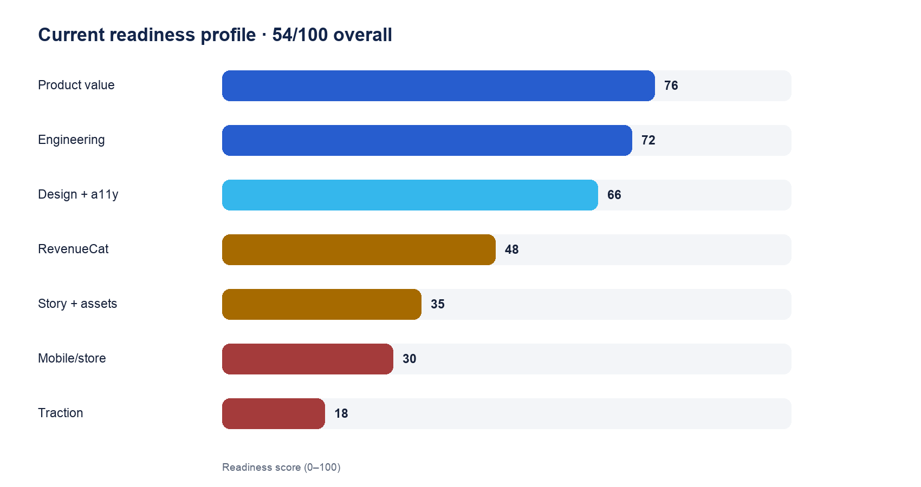
The 54/100 overall score is a prioritization model, not an official judging score.

Winning probability bands
Scenario | Judgment range | Reason
Submit today | <1% | A missing publication gate can make the entry ineligible.
Complete minimum gates | 1–3% | Functional, but weak differentiated evidence and traction.
Execute recommended plan | 5–10% category | Polished native journey, transactions, demo, and real user evidence.
Grand Prize | <2% without revenue | The rules emphasize revenue shortlist and growth evidence.

INTERPRETATION These percentages are judgment bands, not statistical forecasts: no entrant count, judge distribution, or historical base rate is available. The goal is to become installable, provable, understandable, and memorable in two minutes.

03 · Category strategy and winning narrative
Category | Fit today | Recommendation | Proof needed
Design | MEDIUM | PRIMARY | Native hierarchy, trust communication, accessibility, continuous screenshot story.
Replit Idea to Income | CONDITIONAL | SECONDARY IF PROVEN | Required Replit workflow, three public posts, launch/growth/revenue evidence.
Peace | MEDIUM-LOW | EVIDENCE-DEPENDENT | Measured information-literacy outcome; avoid overstated impact.
HAMM | LOW | DO NOT PRIORITIZE | Conversion craft, pricing evidence, and diverse revenue streams.
Productivity Influencer | POOR | SKIP | Product is not an Apple power-user content utility.
Next Gen | CONDITIONAL | ONLY IF ELIGIBLE | Entrant criteria plus public open-source repo and license.

Recommended positioning
ONE-SENTENCE PITCH Casparel helps students move from ‘I found a resource’ to ‘I know why to trust it, what its limits are, and what to do next.’

Design is the strongest primary target because Casparel can make a complex credibility report immediately understandable to a student. The opportunity is not decorative polish: it is evidence, limitations, confidence, and next action arranged with exceptional clarity.
- Make the source-review reveal the visual center of the submitted app.
- Show evidence and limitations without fear-based or falsely objective scoring.
- Finish native accessibility, motion, empty/loading/error states, and package selection.
- Use screenshots that tell one continuous learner journey.
- Remove every claim that cannot be observed in the submitted binary.

04 · Two-minute demo plan
Time | Beat | What the judge sees and understands
0:00–0:12 | Problem | Search results are abundant; confidence is not.
0:12–0:35 | Discover | Find a learning resource and show provenance.
0:35–1:05 | Evaluate | Run deep source research; surface citations, concerns, and limitations.
1:05–1:25 | Act | Save the resource and schedule the next study step.
1:25–1:42 | Teacher | Recommend or assign it and expose learning evidence.
1:42–1:52 | Business | Show the truthful paywall and a successful entitlement.
1:52–2:00 | Outcome | Informed learning, not another AI answer box.

CREATIVE RULE Do not list every feature. The product breadth proves execution; the demo must make one credibility-to-action journey unforgettable.

05 · 46-day execution roadmap
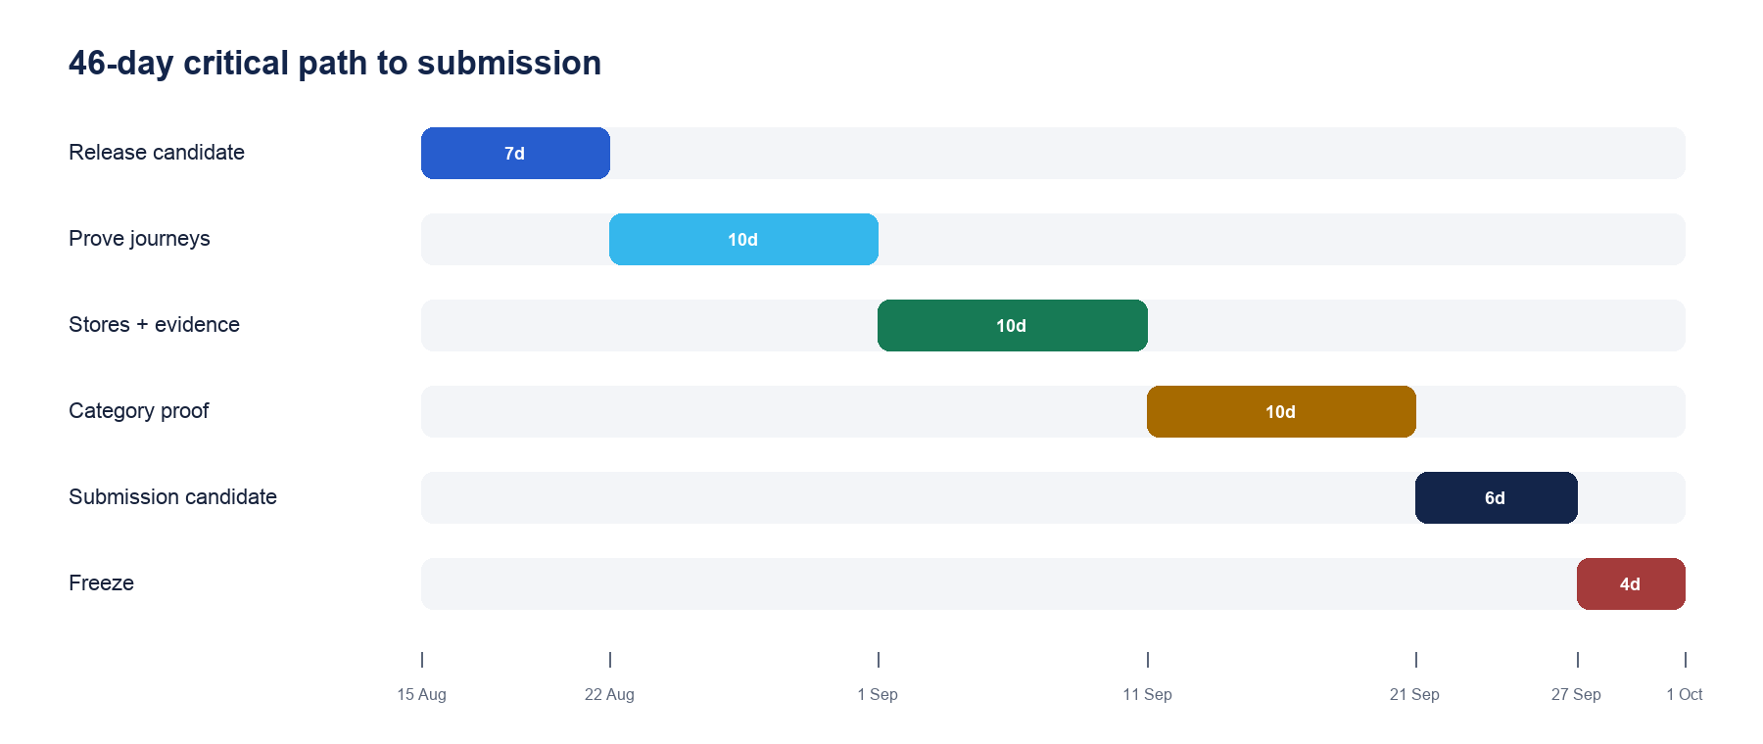
Critical path from technical eligibility to a verifiable submission.

15–21 August · Release candidate
- Require green CI on the audited baseline.
- Create or verify EAS project, Apple/Google identifiers, signing, and store accounts.
- Configure RevenueCat products, entitlement, offering, packages, public SDK keys, and webhook secret.
- Add persistent webhook idempotency and authoritative transfer reconciliation.
- Install internal iOS and Android builds on physical phones; freeze product truth and plan limits.
EXIT GATE A new reviewer can install, log in, restore, and see the same entitlement on client and server.

22–31 August · Prove critical journeys
- Execute purchase, cancellation, renewal, billing issue, expiry, restore, and transfer tests.
- Run VoiceOver/TalkBack, Dynamic Type, reduced motion, keyboard, and poor-network checks.
- Recruit five students and five teachers for task-based sessions; fix the top breakdowns.
- Move the first newer API domain into OpenAPI; add privacy-conscious crash and funnel measurement.
EXIT GATE No P0/P1 defect in onboarding, research, purchase/restore, or account access.

1–10 September · Stores and evidence
- Submit stable builds early to both stores and budget for rejection/remediation.
- Prepare reviewer notes, demo access, privacy forms, and support URLs.
- Instrument registration → resource → review → goal/save → paywall → purchase.
- Collect explicit, consented user quotes and trust-comprehension evidence.
EXIT GATE At least one store approved; the other has no known policy blocker; evidence grows daily.

11–20 September · Category proof
- Lock the primary category and one honest secondary category.
- Produce screenshot narrative, icon, landing copy, and a 110–150 second rough demo.
- Show activation, return, research completion, paywall conversion, and first revenue.
- Complete any required public posts with useful build lessons and transparent metrics.
EXIT GATE Every judging claim has a URL, screenshot, metric, transaction, or user quote.

21–26 September · Submission candidate
- Record the final demo below two minutes and export exact assets.
- Complete Devpost fields and category-specific answers.
- Test every public link signed out and from the US when possible.
- Run clean-install iOS/Android, production smoke, CI, and backup account tests.
EXIT GATE An unfamiliar reviewer can install, understand, and verify Casparel from the submission alone.

27–30 September · Freeze
- No new features after 27 September; ship only release-blocking fixes with full regression.
- Re-check official rules and store availability; submit at least 24 hours early.
- Retain final media and answers offline; verify the saved submission after logout.
EXIT GATE Submission is live, independently verifiable, and backed up before the deadline.

06 · Evidence dashboard and submission kit

Metrics to track daily
Metric | Definition | Direction
Activation | New users completing a first source review in 24 hours | UP
Trust comprehension | Users explaining two strengths and one limitation | UP
Time to value | Registration to useful report | DOWN
Save-to-goal | Reviewed resources connected to a goal | UP
D1 / D7 return | Activated users returning | UP
Paywall conversion | Unique viewers starting trial or purchasing | UP
Restore success | Valid prior purchases restored | 100%
Crash-free sessions | Native sessions without fatal error | >99.5%
Research failure | Deep requests ending in timeout/error/ambiguous limit | DOWN
Support response | Time to resolve judge or user access issue | DOWN

EVIDENCE RULE Do not invent submission numbers. A small real cohort with precise definitions is more credible than a large unsupported claim.

Submission asset set
Asset | Specification | Content
Icon | 1024 × 1024 | No alpha or pre-rounded corners.
Competition screenshot | 1179 × 2556 | No device frame; resolved UI state.
Store screenshots | 5–6 coherent frames | Dashboard → Resources → research → Premium → schedule → plan.
Demo | 110–150 seconds; hard max under 2:00 | Real on-device discovery, evaluation, action, and transaction.
Judge access | Stable account + trial/promo | No dependence on founder intervention.
Proof pack | Links + screenshots + metrics | Every category claim backed by evidence.

07 · Post-Shipaton product roadmap
Horizon | Objective | Priority outcomes
0–3 months | Reliability and learning loop | Finish OpenAPI coverage; authoritative subscriptions; human-rated source research; goal-linked mobile actions; SLOs and retention cohorts.
3–6 months | Teacher-led distribution | Small class/school pilots; consent/admin controls; teacher credibility rubrics; collaborative evidence; institution-sponsored Premium test.
6–12 months | Durable differentiation | Provenance/evidence graph; curriculum alignment; privacy-preserving institution analytics; language/accessibility expansion; evaluate B2B licensing.

STRATEGIC PRINCIPLE Build durable evidence infrastructure and teacher-led distribution only after student value, safety, subscription reliability, and trust comprehension are proven.

Decision checkpoints
- At three months, continue only the mobile and research bets that improve activation, trust comprehension, or subscription reliability.
- At six months, expand teacher distribution only when pilot classes show repeat use and privacy/consent operations are sustainable.
- At twelve months, evaluate school licensing only after learner value, safety, retention, and support economics are demonstrated.

Roadmap guardrails
- Do not chase broad mobile parity before the credibility-to-action loop is excellent.
- Do not describe AI outputs as objective truth; measure citation validity and human calibration.
- Do not add institution analytics until consent, minimization, export, and deletion controls are ready.

Appendix A · Ready-to-use submission copy

App identity
Field | Recommended value
App name | Casparel
iOS subtitle | Learn. Organize. Study.
Play short description | Vetted open-education resources, classes, schedules, and AI research.
Category | Education
Bundle/package | com.casparel.app
Support | https://casparel.com/support
Marketing | https://casparel.com
Privacy | https://casparel.com/privacy

Store description
Casparel is where students and teachers find trustworthy learning materials and stay organized while they study.
Discover open education. Browse a vetted catalog drawn from Open Library, Wikibooks, and other open sources. Every resource is free to open.
Organize everything. Join classes, build reading lists, plan your schedule, and connect study work to the tools you already use.
Research with AI. Casparel's Source Research helps explain who is behind a resource, what its strengths and limitations are, and how current the evidence appears. Use a quick check or request deep, cited live-web research.
Casparel Premium. Upgrade for unlimited account-level deep source research. The core library stays free; Premium helps fund it.

Devpost tagline
TAGLINE A free, vetted open-education platform for students and teachers: organize your studies, evaluate any source with cited AI research, and keep the core library open with Premium.

Screenshot narrative
# | Screen | Caption
1 | Dashboard | Your studies, organized.
2 | Resources | A vetted, free open-education library.
3 | Source Research | Know who's behind any source.
4 | Paywall | Go unlimited with Premium.
5 | Schedule | Plan classes and study time.
6 | Profile / Plan | Track your usage; upgrade anytime.

Final submission checklist
☐ Signed iOS/Android release candidate installed and tested on physical devices.
☐ App publicly live and accessible in the United States before the deadline.
☐ RevenueCat products, premium entitlement, offering, and webhook live and mapped.
☐ Judge promo code or trial verified end-to-end.
☐ Purchase, restore, cancellation, expiry, renewal, billing issue, and transfer tested.
☐ 1024 × 1024 icon and required 1179 × 2556 screenshot exported.
☐ Privacy policy and Support URLs live and accurate.
☐ Public demo under two minutes shows a real on-device transaction.
☐ Devpost categories selected only where every requirement is proven.
☐ Submission completed and verified at least 24 hours before the deadline.

Appendix B · Sources and assumptions
Official Shipaton 2026 rules: revenuecat-shipaton-2026.devpost.com/rules
RevenueCat submission preparation guide: revenuecat.github.io/codelabs/shipaton-2026-prep.html
Readiness scoring and probability ranges are independent strategic judgments, not official RevenueCat scoring or statistical forecasts. Rules can change; repeat a full eligibility check immediately before submission.
FINAL RECOMMENDATION Choose Design as the product-quality target. Enter Replit Idea to Income only when the required workflow, public-post, growth, and revenue evidence are real. Spend the remaining runway on release proof, user evidence, and narrative discipline—not feature count.

