Transferable multi-material topology prediction with mechanics-interpretable quantum observables
Dahyun Joo^{1,†}, Naruethep Sukulthanasorn², Kenjiro Terada^{2,3}, and Do-Nyun Kim^{1,4,5}
¹ Department of Mechanical Engineering, Seoul National University, Seoul 08826, Republic of Korea
² International Research Institute of Disaster Science, Tohoku University, Sendai 980-8572, Japan
³ Department of Civil and Environmental Engineering, Tohoku University, Sendai 980-8579, Japan
⁴ Institute of Advanced Machines and Design, Seoul National University, Seoul 08826, Republic of Korea
⁵ Institute of Engineering Research, Seoul National University, Seoul 08826, Republic of Korea
†E-mail: clairda@snu.ac.kr
Extended Abstract
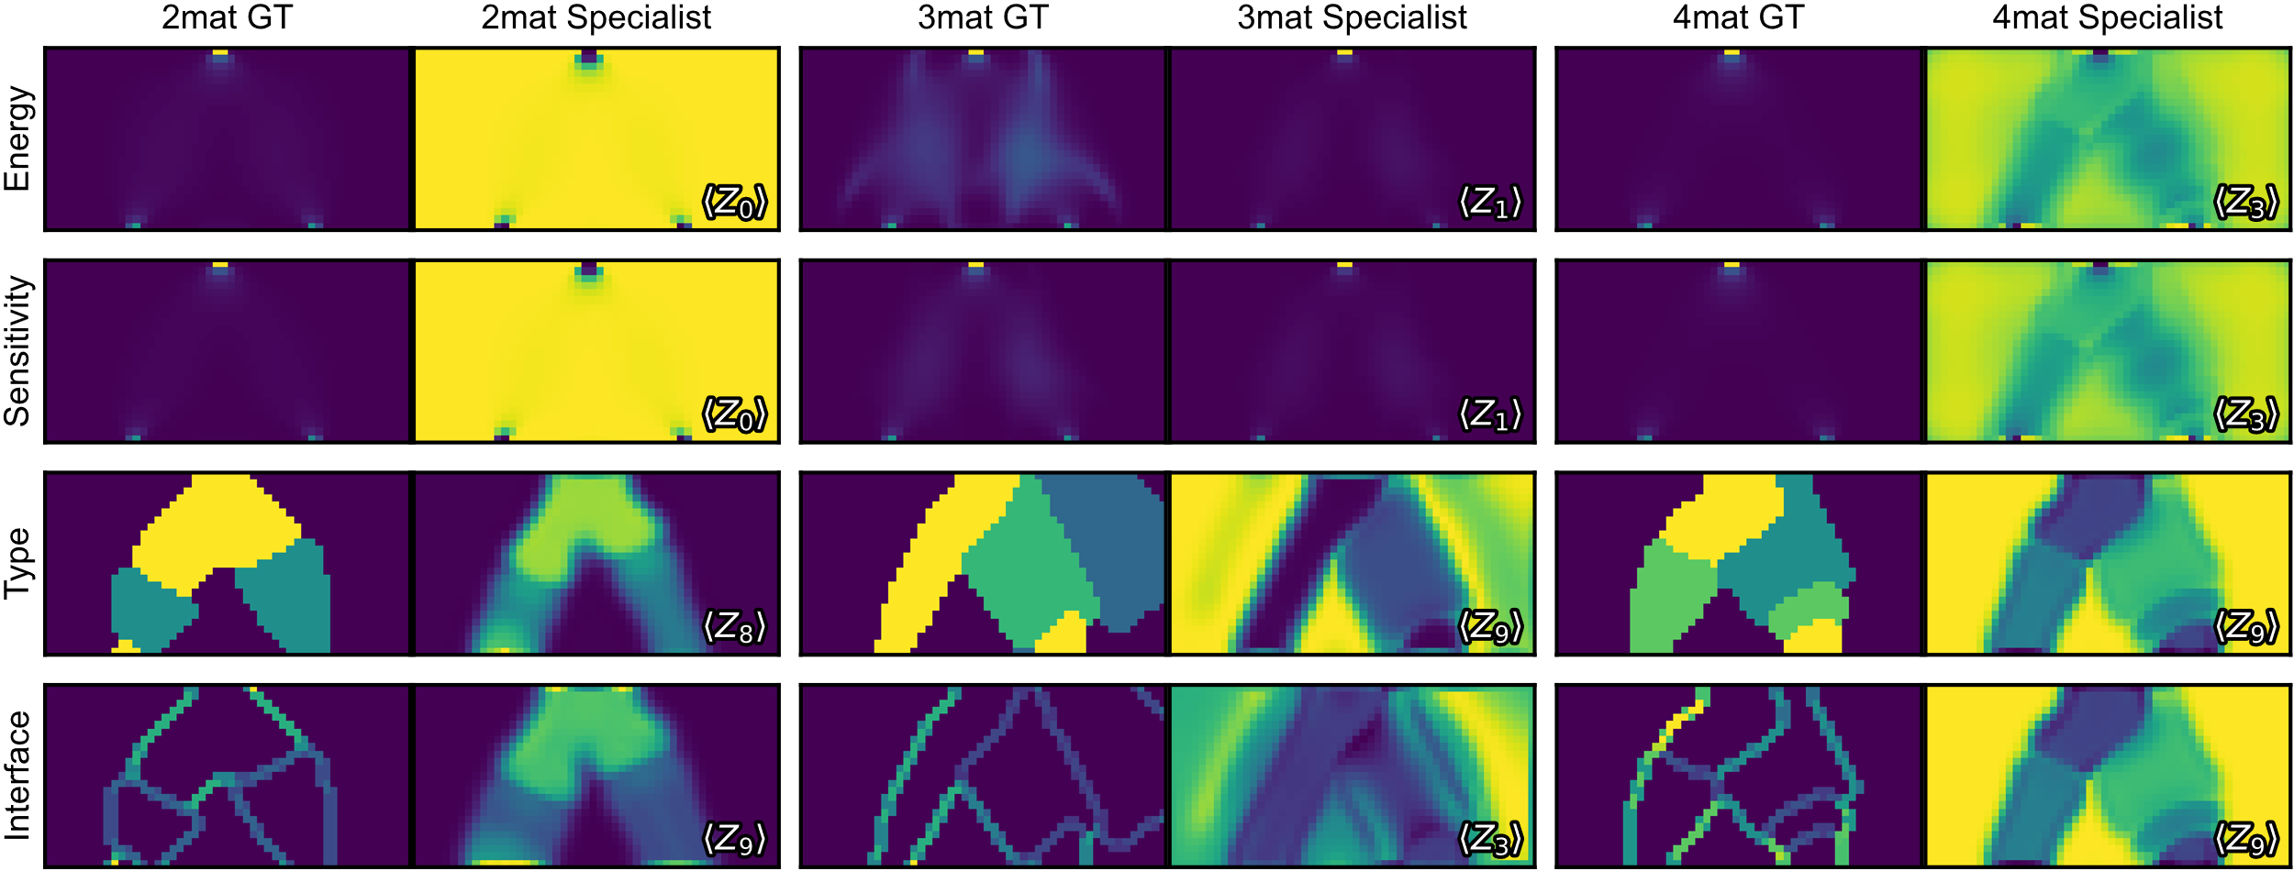
Multi- material topology optimization (MMTO) jointly determines load-carrying geometry and local material assignment, but repeated optimization becomes expensive as loading, mesh resolution, and dimensionality vary [1]. We present an explainable quantum neural network (XQNN) that predicts converged material layouts from partially evolved method-of-moving-asymptotes histories. For each element, strain energy, sensitivity, and density at three mechanically selected iterations, together with a Sobel boundary descriptor, are encoded in a ten-qubit parameterized circuit. Rather than compressing the circuit output to a scalar, the model retains ten qubit-wise Pauli-Z expectations and maps them to material classes through a linear softmax readout, extending quantum-assisted topology prediction to multi-material design [2]. Trained on only three 50 x 25 two-dimensional problems, XQNN transfers without retraining to unseen boundary/loading conditions, meshes up to 200 x 100, and voxel-wise three-dimensional cases. It preserves the principal load paths and material regions, with high-resolution three- and four-material accuracies of 73-91% and mean three-dimensional accuracies of 89.3%, 79.6%, and 73.6% for two, three, and four materials, respectively. The retained observables also support direct interpretation: margin decomposition and specialist analysis connect decision-relevant channels to strain energy, sensitivity, material type, and interface regions (Fig. 1). These results show that measured quantum observables can serve simultaneously as predictive features and auditable mechanics-facing variables [3].
Fig. 1. Validation-selected specialist observables of XQNN. Ground-truth (GT) strain energy, sensitivity, material type, and interface fields are compared with the qubit-wise Pauli-Z observable having the largest absolute Pearson correlation for representative two-, three-, and four-material out-of-distribution cases.
Acknowledgement
This work was supported by the National Research Foundation of Korea (NRF) grant funded by the Ministry of Science and ICT (RS-2024-00346176) and the Development of Core Technologies for Manufacturing Foundation Models Program (RS-2025-25458052) funded by the Ministry of Trade, Industry & Energy (MOTIE, Korea).
References
1. O. Sigmund and K. Maute, Structural and Multidisciplinary Optimization 48, 1031-1055 (2013).
2. N. Sukulthanasorn and K. Terada, Computer Methods in Applied Mechanics and Engineering 448, 118411 (2026).
3. D. Joo, N. Sukulthanasorn, K. Terada, and D.-N. Kim, Explainable quantum neural networks for multi-material topology optimization, arXiv:2607.00438 (2026), https://arxiv.org/abs/2607.00438.

