# Automating Zooplankton Classification Using Geometric and Environmental Features

## 1. Introduction

* **Research Question**: Make machine learning model to classify zooplankton species based on their images and features like geometric environmental.
* **Significance**: Zooplankton are vital indicators of freshwater ecosystem health. Current manual classification is labor-intensive and prone to observer bias.

## 2. Data Description

* **Source**: Ministry of Natural Resources and Forestry, Ontario.
* **Structure**:
  + **Images**: .tif mosaics containing zooplankton images.
  + **Features**:
    - **Geometric**: Transparency, symmetry, compactness, etc.
    - **Environmental**: Latitude, longitude, depth, distance to shore.
  + **Response Variable**: Manually assigned to 31 classes in “Class” column (focusing on key species like Calanoid_1, Cyclopoid_1, Bosmina_1, etc.).
* **Challenges**:
  + Missing .csv data.
  + Erroneous image dimensions.
  + Class imbalance.

## 3. Methods and Tools

* **Tools**:
  + **Data Preprocessing**: Pandas library from Python for handling missing values and cleaning data.
  + **Modeling**: TensorFlow or PyTorch for classification tasks.
  + **Analysis**: Pandas for exploratory data analysis and visualization.

## 4. Preliminary Analysis

* **Summary Table**:
  + A table summarizing species distributions and highlighting data imbalances (to be included).
* **Visual Example**:
  + The same species can have different shapes due to variations in camera angle, lighting, and positioning.
  + Below is an example of 22 images of Bosmina_1 plankton, showing the morphological differences within a single species. 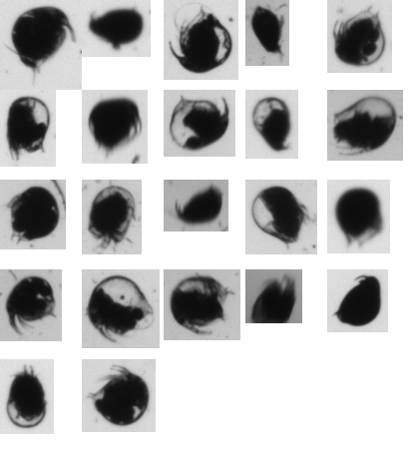

## 5. Timeline

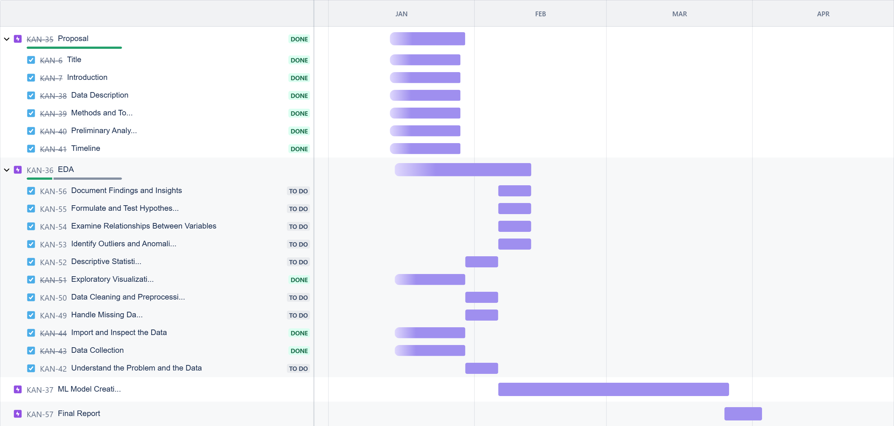

Jira Board