E-Procura: Digital Signature and Verification
Summary of the sign and verify process for Project Registration and Recruitment

1. The idea
- Sign at the user's end. Each action is signed with the user's private key (a .pem file). The key is used in the browser only and is never uploaded.
- Verify at the server. The server checks every signature with the user's public key from the Users collection, and checks again when a record is opened.
- Chain the steps. Each approval signs a SHA-256 fingerprint of what came before, so changing an earlier step breaks every later check.
Algorithms: RSA signatures with SHA-256 (RSA-SHA256), and SHA-256 hashes as fingerprints.

2. Sign and verify
Sign (in the browser) | Verify (on the server)
1. payload = canonicalPayload(data)  2. key = importPrivateKey(readPem(file))  3. signature = signData(key, payload)  4. send(payload, signature)  (the private key is never sent) | 1. publicKey = Users[signer].publicKey  2. message = JSON.stringify(payload)  3. RSA-SHA256 verify(publicKey,  message, signature)  4. invalid -> reject (400/401)  5. bindings differ -> reject (400/409)  6. else save payload, signature,  signer id, server time
Bindings are extra fields inside the signed payload (record id, action, hash of an earlier signature, project code) so that a signature is valid for one record only.

3. Data flow (Level 1)
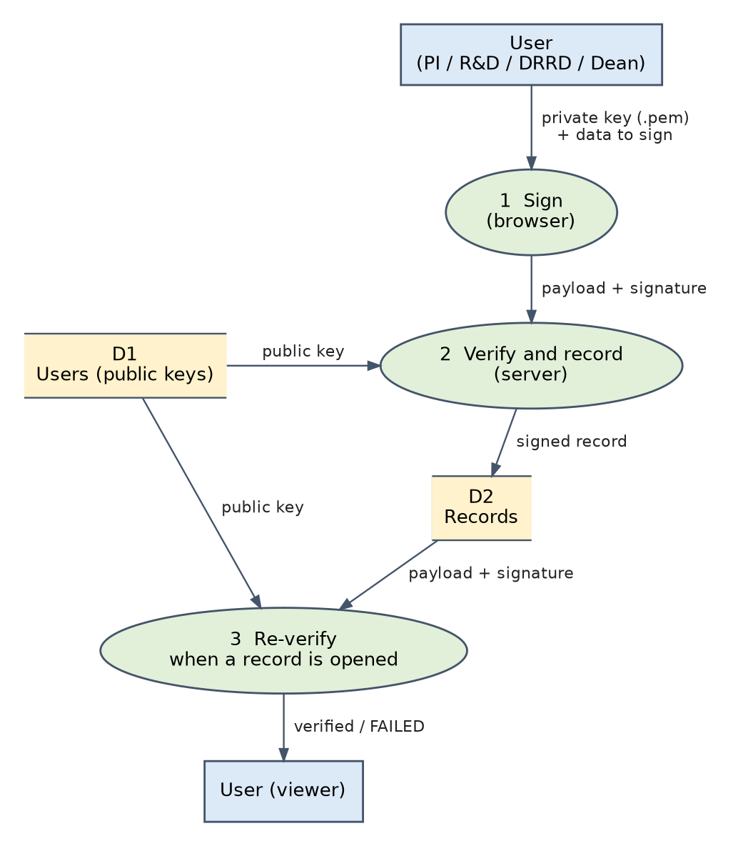
Figure 1. Sign, verify and record, then re-verify. Same flow for both processes.

4. Project Registration
- PI submits. The form carries pdfHash (SHA-256 of the PDF) and is signed by the PI. The server verifies the signature, recomputes the PDF hash, and saves the submission as PENDING.
- R&D reviews. verify-pi re-checks the PI signature. If it fails, Approve and Reject stay locked.
- R&D generates the project code. The Generate button only previews the next number (year/department/sequence). Nothing is saved yet.
- R&D signs the decision. The payload holds projectId, action, a hash of the PI signature and, for an approval, the project code.
- Server verifies and saves. It re-verifies the PI signature, verifies the R&D signature, checks the bindings, and recomputes the code. A changed code returns 409 and R&D generates again.
- Later checks (verify-rnd). The signature is valid, and the signed project, action, PI-signature hash and project code all match the stored record. The PI page and Fund Booking rely on this.
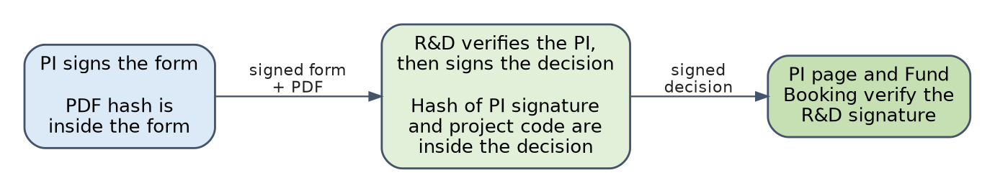
Figure 2. Project Registration chain: each step signs a hash of the one before it.

5. Recruitment
A request moves through fixed stages. At each stage one office acts and signs its own action.
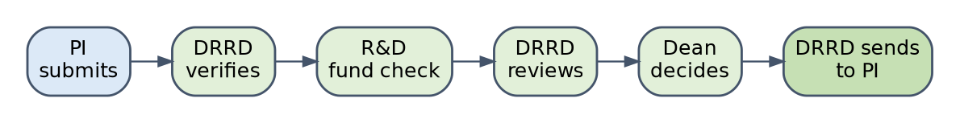
Figure 3. Recruitment stages. DRRD can also reject at verification or review, which returns the request to the PI.
- PI submission: the whole request is signed. The server verifies it, checks the available fund, and starts the workflow.
- Every later action goes through the same checks: right role and stage; earlier signatures re-verified; this signature verified with the acting user's own public key and bound to this request, this action and the form; then a history entry is saved with the signature.
- Viewing: verifyRecruitmentHistory re-checks every step against its signer's public key.
- Fund blocking is kept outside the signed data (blockedFunds), so the PI signature stays valid. It is protected by role checks and atomic updates.

6. What it stops
Attempt | What happens
PI's form edited in the database after submission | Stored signature no longer matches, so verify-pi fails and R&D cannot approve.
Uploaded PDF replaced | Its SHA-256 differs from the signed pdfHash and the upload is rejected.
R&D signature copied to another project | The signed projectId does not match.
PI submission replaced after approval | The signed hash of the PI signature no longer matches, so verify-rnd fails.
Project code edited after approval | The signed code differs from the stored one, so verification fails.
Signing with the wrong key, or as another office | Verified against the logged-in user's own public key, so it fails.
Skipping a stage or editing an earlier recruitment step | Stage rules reject it, and earlier signatures are re-verified before each action.
Limits: public keys in the Users collection are the trust anchor, so write access to it must be restricted. Browser timestamps are not trusted; the server time (actionAt) is. Signatures prove who approved what, they do not hide the data.

